PARKme System

Analysis of Alternatives (AoA)

George Mason University

SYST 798, Prof. Speller

Craig Emmerton

Earl Morton

Shaun McDonald

David Richards

Nikki Torres-Avila

Table of Contents

1.1 Definition 4
1.2 Goals 4
1.2.1 Rank Alternatives 4
1.2.2 Selecting The Best Alternative For Our Project 4
1.2.3 Other Non-Parking Benefits Considered 4
2.0 HIGH-LEVEL ARCHITECTURE 5
2.1 Analysis of Alternatives Methodology 5
2.1.1 DoDAF 5
2.1.2 TOGAF 5
2.1.3 Setup 5
2.1.4 Alternatives 5
2.1.4.1 Current Parking Conditions 5
2.1.4.2 Valet Parking 6
2.1.4.3 Automatic System 7
2.1.4.4 Sub-Component System 7
2.2 The Selected High Level Architecture 8
2.2.1 Our System 8
2.2.2 System Diagram 8
3.0 SUBCOMPONENTS ARCHITECTURE 9
3.1 AoA Methodology 9
3.2 AoA Tool Analysis 9
3.2.1 Using the LDW Tool 9
3.2.2 Our Criteria 9
3.2.2.1 General Definition 9
3.2.2.2 Start-Up Cost 10
3.2.2.3 Maintenance Cost 10
3.2.2.4 Construction 10
3.2.2.5 Maturity 10
3.2.2.6 Reliability 10
3.2.2.7 Time Between Failures 10
3.2.3 Weighting Schema 10
3.3 Sub-Component Alternatives 11
3.3.1 Main System 11
3.3.2 Parking Space Sensor System 11
3.3.2.1 General Definition 11
3.3.2.2 Weight Plates 11
3.3.2.3 Ultra-sound Sensor 11
3.3.2.4 Camera 12
3.3.2.5 RFID Microchip 12
3.3.2.6 Light Sensor 12
3.3.2.7 Motion Detector 12
3.3.3 Communications Network 13
3.3.1 General Discussion 13
3.3.3.2 Wi-Fi Network 13
3.3.3.3 Cell Phone Towers 13
3.3.3.4 T/R Antenna 13
3.3.3.5 Cables 13
3.3.4 Human Interfacing 14
3.3.4.1 General Discussion 14
3.3.4.2 Kiosks 14
3.3.4.3 Electronic Signs 14
3.3.4.4 Internet 14
3.3.4.5 Cell Phones 14
3.3.4.6 GPS Units 15
3.3.4.7 PDA’s 15
3.3.4.8 Patriot Web 15
3.4 LWD Setup 16
3.4.1 General To All Subcomponents 16
3.4.2 Sensors 17
3.4.3 Human Interface 17
3.4.4 Connectivity 17
3.5 Top Alternatives 18
3.5.1 Sensors 18
3.5.2 Human Interface 18
3.5.3 Connectivity 18
3.6 Selected Alternatives 19
3.6.1 Sensors 19
3.6.2 Human Interface 20
3.6.3 Connectivity 21
3.7 Final Architecture 22
1.0 INTRODUCTION

1.1 Definition

An Analysis of Alternatives (AOA) is an analysis of the proposed system’s operational effectiveness related to its life-cycle costs compared to various other alternatives to meet the customer’s needs (minimize the time to find available parking within the nearest proximity of desired destination).

1.2 Goals

1.2.1 Rank Alternatives

Ranking of alternative began with a general search to determine the various systems current on the market.

We looked at utilizing the existing parking system with minor updates and maintenance. Initial search on “Parking Systems” on the Web resulted in a number of alternatives. Everything from Valet Parking, “Robotic” automated parking systems, and Electronic devices (Sensors) used in current parking Systems.

1.2.2 Selecting The Best Alternative For Our Project

"Are we getting the greatest value for the resources expended?"
"Is the proposed system the best approach to meet this need?"
“Is the proposed system actually implementable and feasible?”

1.2.3 Other Non-Parking Benefits Considered

Wi-Fi to campus!
Data collection on parking patterns!
Tracking of fire lane parking!

2.0 HIGH-LEVEL ARCHITECTURE

2.1 Analysis of Alternatives Methodology

We will be using the DoDI 5000.2 Defense Acquisition Guidebook for our AOA Documentation. We will also be utilizing pieces of the Department of Defense Architecture Framework (DoDAF) and The Open Group Architecture Framework (TOGAF)

2.1.1 DoDAF

DODAF is an operational, system, and technical standards view. It utilizes UML for its representations.

2.1.2 TOGAF

TOGAF is more focused on the design, planning, and implementation of enterprise information architecture. It is modeled at four levels: Business, Application, Data, and Technology. TOGAF is complimentary to DoDAF

2.1.3 Setup

Research via the Internet what the current state of the art is in vehicle parking. Research specific implementation of these alternatives and how they would apply to a large multiple parking lot facility. Analyze the benefits and constraints of each of these researched systems. Come to a conclusion of a high level approach to the multiple parking lots over a large area scenario.

2.1.4 Alternatives

2.1.4.1 Current Parking Conditions

- 16 Parking lots (A-P)
- 3 Parking Deck Garages)
- Types of lots/spaces available include (reserved, staff/faculty, motorcycle, west campus, visitor, and general)
- At least 12 main campus entry points

2.1.4.2 Valet Parking

Professional Parking Services

Propark specializes in creating customized parking management systems for each of our clients. Every parking system incorporates all parking-related functions including our award-winning service delivery, seamless employment administration and industry leading safety standards. Let Propark assume, and then improve, your parking operations while you are freed up to focus on your own key business objectives.

2.1.4.3 Automatic System

Automatic Parking
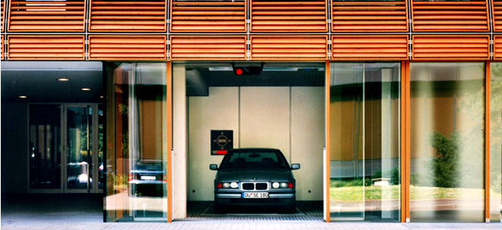

The parking process is Simple, Safe, and Convenient for a driver. A driver drives into an entry cabin, turns off the engine, and walks away. Sensors measure the height, length and width of the vehicle and confirm that no person remains inside the entry cabin. The parking equipment moves the vehicle to the computer assigned parking space. Nothing ever touches the vehicle and the vehicle engine is off during the entire parking and retrieval process

2.1.4.4 Sub-Component System

Architecture consists of many independent plug-and-play sub-architectures. These could include the Main System, Parking Space Sensors, Communication Network, and Human Interface. Each of these sub-components would be an individual AoA effort in itself to determine appropriate sub-component architecture.

2.2 The Selected High Level Architecture

2.2.1 Our System

Our high level architecture will be the sub-component architecture. It will consist of a sensor that will be our means to determine the availability of parking spaces. Another sub-component will be the human interface. This is the means that will inform the user of which parking spaces are available. A main control system will process the incoming signals from the sensors and supply this data to the human interface. Finally, a network will be required to interface each of these systems together.

2.2.2 System Diagram

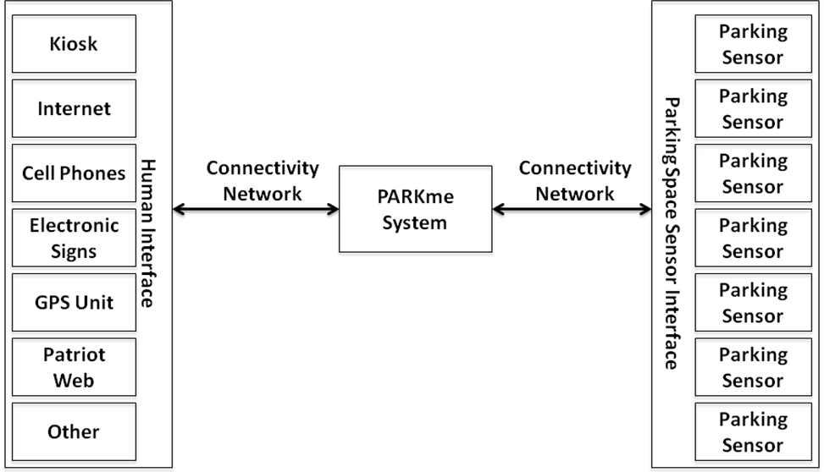
3.0 SUBCOMPONENTS ARCHITECTURE

3.1 AoA Methodology

As discussed in the high level architecture we are still using the DoDI 5000.2 Defense Acquisition Guidebook, DoDAF, and TOGAF. We will be using the COTS (Commercial off the shelf) features of these architectures as well. The major components are interchangeable and future technology easily incorporated.
For our sub-component architecture we will also be using 'Value Focused Thinking‘; aka ‘Multiple Attribute Utility Theory'. This is based on the ‘Multiple Objective Decision Analysis’ mathematical technique. It is also implemented in the Logical Decision for Windows tool Used at GMU, used in SYST 573.

3.2 AoA Tool Analysis

3.2.1 Using the LDW Tool

LDW (Logical Decisions for Windows) is the toll we will be using to model our alternatives. It will be used to model the high-level architecture, which will include each of the independent sub-components. LDW assigns the weight to each of the alternatives in the criteria they will be ranked upon. It also allows the sponsors to rank and weight each of these criteria against each other. LDW includes many metrics to assists with the selection of the best alternatives and many means of displaying these results.

3.2.2 Our Criteria

3.2.2.1 General Definition

Each of our subcomponents has a variety of alternatives that can be implemented to meet the requirements of the subcomponents. Each of these alternatives has a list of criteria that we are using to weight their value in the specified criteria. These values are assigned by the nature of the alternative. An example would be using cost as an alternative then given five alternatives they would be ranked 1 to 5 based on their cost relative to each other.

We asked each of our sponsors to rank these criteria and their relative importance to one another. We have also asked the inputs of the class in ranking and weight these criteria. We have six criteria that are being used in each of our subcomponents. The six criteria will be explained in detail and are ‘Start Up Cost’, ‘Maintenance Cost’, ‘Construction’, ‘Maturity’, ‘Reliability’, and ‘Time Between Failures’.

3.2.2.2 Start-Up Cost

What is the initial cost to implement the system? The cost of purchasing the components and constructing the systems

3.2.2.3 Maintenance Cost

The reoccurring maintenance cost. This is the cost to operate the system on a regular interval.

3.2.2.4 Construction

This is the feasibility of implementing the system. It is a measure of how much construction will be required to implement a system. An extreme case could put a parking lot out of commission for a few weeks or require parking garages to be rebuilt.

3.2.2.5 Maturity

This is a measure of the maturity of a system. A system that has been around for decades and is implemented in parking facility would rank very well here. A new arising technology that has never been implemented in a parking environment would rank fairly bad. Maturity can affect the availability but new technologies may provide better performance.

3.2.2.6 Reliability

This is the measure of how well the systems perform a given task. Consider RADAR system. The RADAR has a false alarm value, this is the percentage that the system informs the user that is has detected an object but there is no real object there. In the parking environment this would be reflected as reporting an empty space as occupied

3.2.2.7 Time Between Failures

This is a measure of how long until a component fails. Think of light bulbs, each brand attempts to predict the average life of any individual light bulb.

3.2.3 Weighting Schema

The importance of each of these criteria is weighted relative to each other. The values of each of the alternatives to particular criteria are also defined. The statistical value of each of the alternatives within criteria is used to weight the alternatives values within criteria against the other criteria. The values are noted below.

BEST (5: Very High)
(4: High)
(3: Average)
(2: Low)
WORST (1: Very Low)

3.3 Sub-Component Alternatives

3.3.1 Main System

The main system will be the interface between the parking space sensors and the rest of the world. It will collect the status of the parking spaces at the location. It will use this status to collect statistics on the available parking at varied locations and times of the day. If user information is available this information will be collected as well. This could include the users parking habits and the schedule. This system will also act as a means to relay the status of parking availability to the human interface component. If the human interface component has the ability to identify a specific user then more detailed information will be relayed. This more detailed information could include the closest parking space to the identified user’s specified destination.

3.3.2 Parking Space Sensor System

3.3.2.1 General Definition

The parking space sensor is the component that will determine if each individual parking space is empty or occupied

3.3.2.2 Weight Plates

Start Up Cost: 1 (Very Low)
Maintenance Cost: 5 (Very High)
Construction Effort: 1 (Very Low)
Maturity: 5 (Very High)
Reliability: 5 (Very High)
Time between Failures: 5 (Very High)

3.3.2.3 Ultra-sound Sensor

Start Up Cost: 4 (High)
Maintenance Cost: 2 (Low)
Construction Effort: 4 (High)
Maturity: 4 (High)
Reliability: 3 (Average)
Time between Failures: 1 (Low)

3.3.2.4 Camera

Start Up Cost: 3 (Average)
Maintenance Cost: 4 (High)
Construction Effort: 4 (High)
Maturity: 5 (Very High)
Reliability: 2 (Low)
Time between Failures: 2 (Low)

3.3.2.5 RFID Microchip

Start Up Cost: 2(Low)
Maintenance Cost: 2 (Low)
Construction Effort: 3 (Average)
Maturity: 2 (Low)
Reliability: 5 (Very High)
Time between Failures: 5 (Very High)

3.3.2.6 Light Sensor

Start Up Cost: 4 (High)
Maintenance Cost: 3 (Average)
Construction Effort: 3 (Average)
Maturity: 4 (High)
Reliability: 4 (High)
Time between Failures: 4 (High)

3.3.2.7 Motion Detector

Start Up Cost: 4 (High)
Maintenance Cost: 3 (Average)
Construction Effort: 3 (Average)
Maturity: 4 (High)
Reliability: 4 (High)
Time between Failures: 2 (Low)

3.3.3 Communications Network

3.3.1 General Discussion

The communications network is the connectivity between the varied systems.

3.3.3.2 Wi-Fi Network

Start Up Cost: 3 (Average)
Maintenance Cost: 3 (Average)
Construction Effort: 3 (Average)
Maturity: 2 (Low)
Reliability: 3 (Average)
Time between Failures: 3 (Average)

3.3.3.3 Cell Phone Towers

Start Up Cost: 2 (Low)
Maintenance Cost: 1 (Very Low)
Construction Effort: 5 (Very High)
Maturity: 5 (Very High)
Reliability: 5 (Very High)
Time between Failures: 3 (Average)

3.3.3.4 T/R Antenna

Start Up Cost: 2 (Low)
Maintenance Cost: 3 (Average)
Construction Effort: 2 (Low)
Maturity: 5 (Very High)
Reliability: 5 (Very High)
Time between Failures: 4 (High)

3.3.3.5 Cables

Start Up Cost: 1 (Low)
Maintenance Cost: 4 (High)
Construction Effort: 1 (Low)
Maturity: 4 (High)
Reliability: 5 (Very High)
Time between Failures: 4 (High)

3.3.4 Human Interfacing

3.3.4.1 General Discussion

The human interface is the means the main system uses to relay the parking status to the persons seeking parking spaces.

3.3.4.2 Kiosks

Start Up Cost: 1 (Very Low)
Maintenance Cost: 2 (Low)
Construction Effort: 1 (Very Low)
Maturity: 3 (Average)
Reliability: 3 (Average)
Time between Failures: 2 (Low)

3.3.4.3 Electronic Signs

Start Up Cost: 3 (Average)
Maintenance Cost: 3 (Average)
Construction Effort: 3 (Average)
Maturity: 5 (Very High)
Reliability: 5 (Very High)
Time between Failures: 4 (High)

3.3.4.4 Internet

Start Up Cost: 4 (High)
Maintenance Cost: 4 (High)
Construction Effort: 4 (High)
Maturity: 3 (Average)
Reliability: 1 (Very Low)
Time between Failures: 1 (Very Low)

3.3.4.5 Cell Phones

Start Up Cost: 3 (Average)
Maintenance Cost: 4 (High)
Construction Effort: 4 (High)
Maturity: 3 (Average)
Reliability: 4 (High)
Time between Failures: 1 (Low)
3.3.4.6 GPS Units

Start Up Cost: 3 (Average)
Maintenance Cost: 4 (High)
Construction Effort: 4 (High)
Maturity: 1 (Low)
Reliability: 4 (High)
Time between Failures: 1 (Low)

3.3.4.7 PDA’s

Start Up Cost: 4 (High)
Maintenance Cost: 4 (High)
Construction Effort: 5 (Very High)
Maturity: 4 (High)
Reliability: 3 (Average)
Time between Failures: 3 (Average)

3.3.4.8 Patriot Web

Start Up Cost: 1 (High)
Maintenance Cost: 5 (High)
Construction Effort: 1 (High)
Maturity: 5 (Average)
Reliability: 5 (Very Low)
Time between Failures: 5 (Very Low)

3.4 LWD Setup

3.4.1 General To All Subcomponents

All criteria are present for each sub-component but only the criteria for the connectivity sub-component have been expanded.
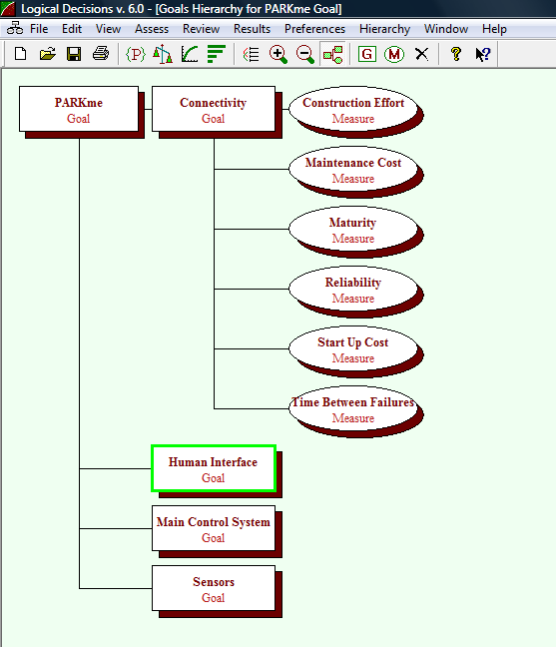

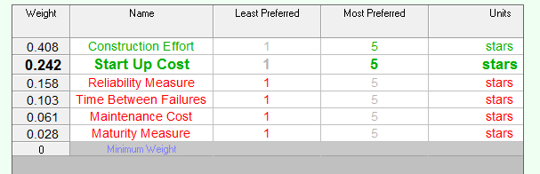

3.4.2 Sensors

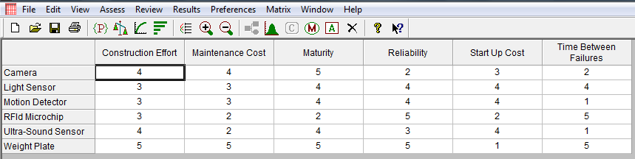

3.4.3 Human Interface

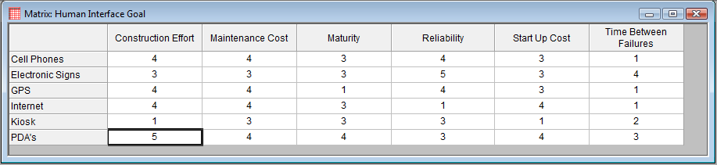

3.4.4 Connectivity

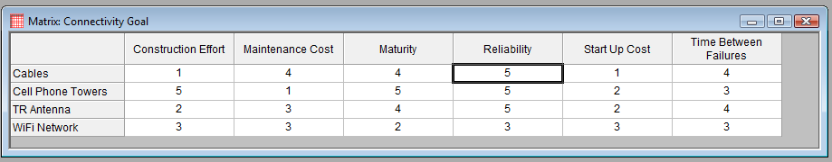

3.5 Top Alternatives

3.5.1 Sensors

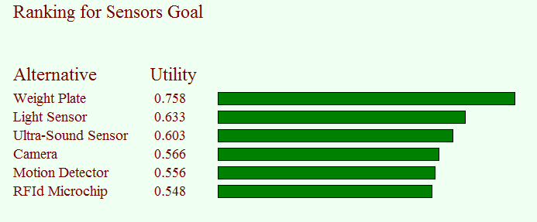

3.5.2 Human Interface

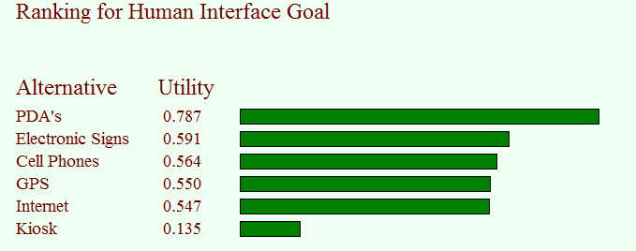

3.5.3 Connectivity

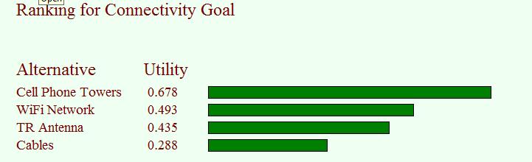

3.6 Selected Alternatives

3.6.1 Sensors

Sensors
Pros/Cons | Weight  Plate | RFID | Sensor | Rational
Implementation | 1 | 5 | 5 | Weight plates may be impossible to implement in parking garages.
Weather Interference | 5 | 2 | 1 | Snow or rain may interfere with ground imbedded systems.
Plowing/Mowing | 5 | 5 | 1 | If sensors were pole mounted to avoid weather problems it would impair plowing or mowing over the area.
Repairs | 1 | 5 | 5 | Weight plates could put a parking lot out of commission for a timed duration if a repair is required.

LDW ranked three sensors at a preference level of over 60 percent. The top selection of the weight plate has a very low value in the construction criteria. Our student survey weighted the construction criteria as very high. The second highest ranking is the light sensor. The light sensor has a very low value in the reliability criteria. Our sponsor weighted these criteria higher.
3.6.2 Human Interface

Human Interface
Pros/Cons | Personal  Electronic  Device | Electric  Sign | Rational
Ease of use while driving | 1 | 5 | PED’s require a greater level of interaction and in some states there use is restricted during driving.
User incurred some cost | 1 | 5 | User would have to supply and maintain there own PED’s and all required operating accounts.
Access to hardware | 1 | 5 | Not everyone may have access to a PED or remember to bring it with them.
Cell phone signals | 1 | 5 | Electronic Signs do no require a third party signal to always be available.
Readability | 1 | 5 | PED’s often have small view screens and an Electronic Sign could be a simple as an arrow.
Accuracy or Information | 1 | 5 | PED’s only show you that status at the last moment you were able to access them. Electronic Signs would be updated every thirty seconds and could be at every intersection.
Technical Experience | 1 | 5 | Everyone can read, some users may be technology impaired or reluctant.
Access to system | 5 | 1 | PED’s can be accessed from anywhere.  This could be beneficial in choosing to enter the campus from a different direction closer to an internal location.
User Profiles | 5 | 1 | PED’s could be programmed to supply user specific information. This would require an interface to a user profile and varied accounts to be setup and maintained.

The kiosk option ranked very low and the PDA option ranked very high. Most of the remaining options were very closely ranked. These remaining options include portable devices such as cell phones and laptops with Internet connectivity, and electronic signs. Further study may be required on this subset of options.

3.6.3 Connectivity

Sensors
Pros/Cons | Cable | Wi-Fi | Cell Tower | T/R  Tower | Rational
Wireless networking to area | 0 | 5 | 1 | 2 | Wi-Fi free to the regional area.
Weather Interference | 5 | 1 | 1 | 2 | Weather may interfere with wireless signals
Dependency on third party | 5 | 4 | 1 | 1 | Cell towers availability would be dependent on the service provider.
Signal interference | 5 | 3 | 1 | 1 | A cabled network is not disrupted by any other transmitting source that may come online in a research environment

LDW ranked the Wi-Fi network as the second preferred selection. Our student survey showed that the added perk of Wi-Fi availability on Campus was very highly desired.

3.7 Final Architecture

The sub-component architecture has been selected as our high-level system architecture. The sensors will be implemented as a sensor imbedded in the ground at each parking space. The human interface will be modeled as well as the PED variant. It is possible to implement both units. Also one variant can be implemented and other variants added later to provide the users with more options. Electronic signs would initially be implemented at the main entrances. Later upgrades could include intersections and entrances to parking lots and garages. Further upgrades could be added to each level of a garage or each row of a parking lot. The varied PED devices supported could start with basic Internet and be upgraded to send this signal to the various PED’s.

