PARKme System

Concept of Operations (CONOPS)

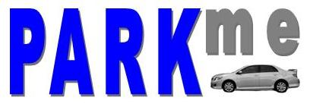

George Mason University

SYST 798, Prof. Speller

Craig Emmerton

Earl Morton

Shaun McDonald

David Richards

Nikki Torres-Avila

Table of Contents

1.0 Scope 4
1.1 Identification 4
1.2 Document Overview 4
1.3 System Overview 4
2.0 Reference Documents 5
3.0 Current System 5
3.1 Background, Objectives, and Scope 5
3.2 Operational Policies and Constraints 6
3.3 Description of Current System 6
3.4 Modes of Operation for the Current System 7
3.5 User Classes and Other Involved Personnel 7
3.6 Support Environment 8
4.0 Justifications and Description of Changes 8
4.1 Justification of Changes 8
4.2 Description of Desired Changes 8
4.3 Priorities Among Changes 9
4.3.1 Essential Features: 9
4.3.2 Desirable Features 10
4.3.3 Optional Features 10
4.4 Changes Considered But Not Included 10
4.5 Assumptions and Constraints 10
5.0 Concepts for the Proposed System 11
5.1 Background, Objectives, and Scope 11
5.2 Operational Policies and Constraints 11
5.3 Description of the Proposed System 11
5.4 Modes of Operation 12
5.5 User Classes and Other Involved Personnel 13
5.6 Support Environment 13
6.0 Operational Scenarios 14
6.1 Provide PARKme Services to Driver 14
6.2 Find Available Spaces 14
6.3 Update Parking Availability 15
6.4 Report Parking Violations 16
6.5 Generate Parking Usage Report 17
6.6 Provide PARKme Maintenance 18
7.0 Summaries of Impacts 19
7.1 Operational Impacts 19
7.2 Organizational Impacts 20
7.3 Impacts During Development 21
8.0 Analysis of the Proposed System 21
8.1 Summary of Improvements 21
8.2 Disadvantages and Limitations 22
8.3 Alternatives and Trade-offs Considered 22
APPENDIX A - ACRONYMS 23

1.0 Scope

1.1 Identification

The PARKme system Concept of Operations (CONOPS) follows the Parking Proposal by Shaun McDonald.

1.2 Document Overview

This document establishes an overview of current college campus parking systems implemented in different locations used to assist a driver in finding an empty parking space. In addition, this document proposes a new system for assisting drivers in locating empty parking spaces, called PARKme. The PARKme system will alleviate the frustration experienced by drivers in trying to locate an empty parking space on George Mason University’s (GMU) campus. The intended audiences for this CONOPS are college administrators and anyone else interested in implementing the PARKme system.

1.3 System Overview

The PARKme system is motivated by the need for decreasing the time it takes drivers to locate parking spaces on the GMU campus. Drivers can waste a significant amount of time and gas driving around a facility locating an empty parking space. The PARKme system will utilize sensors and computer networks to provide real time parking space usage to users of the system. The system will include a main server that stores parking usage data that can be utilized by operators of the system to optimize the parking capability of the university. An overview of the system is shown in Figure 1-1.

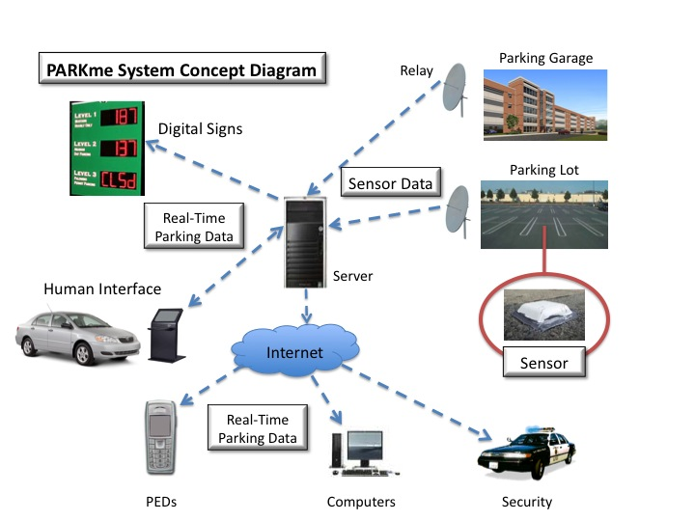
Figure 1-1: PARKme system Concept Diagram

2.0 Reference Documents

IEEE Guide for Information Technology – System Definition – Concept of Operations (ConOps) Document, IEEE (1998).

Markoff, John (2008). “Can’t Find a Parking Spot? Check Smartphone “, New York Times (online edition), July 12 2008. (http://www.nytimes.com/2008/07/12/business/12newpark.html?_r=2&ref=technology&oref=slogin&oref=slogin)

3.0 Current System

3.1 Background, Objectives, and Scope

Finding a parking spot on the George Mason University campus can be a frustrating and time consuming process. Students and faculty risk being late for class and visitors to meetings.

The idea for the PARKme system came when reading an article in the New York Times on July 12, 2008 about the parking system being implemented by the city of San Francisco. San Francisco is using a wireless sensor network and street sign displays to inform drivers of open parking spaces on city streets. The system San Francisco is designing can also alert users via smartphones.

The PARKme system will alleviate the frustration associated with parking in large parking areas such as a college campus. The system will provide drivers with the location of the best available parking spaces at the time they enter the parking complex. The PARKme system is modular in design to allow easy expansion as parking complexes grow in size.

This CONOPS will define a system that could be implemented at GMU to alleviate the frustration experienced by drivers searching for an empty parking space.

3.2 Operational Policies and Constraints

The PARKme system is designed so that the drivers are not required to utilize the PARKme system in locating a parking space. Drivers may pick any available empty space without help from the PARKme system. The PARKme system is to be used as a guide and is not designed to be mandatory for parking at GMU.

The PARKme system will be required to follow all university policies with regards to wireless communication. The PARKme system will also follow any university privacy policies.

3.3 Description of Current System

Currently, GMU does not implement any parking system other than assigned parking lots for faculty, visitors, and freshman students. A map of the George Mason University campus including parking lots is shown in Figure 3-1.

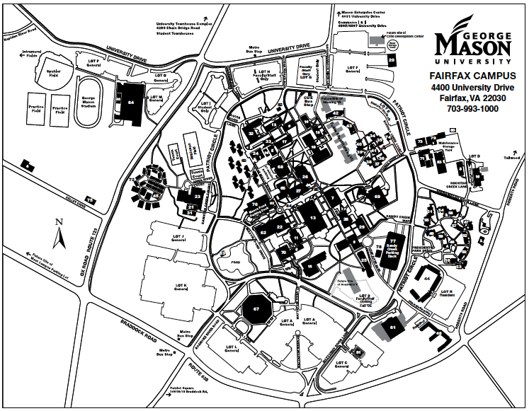Figure 3-1: GMU Campus Map

3.4 Modes of Operation for the Current System

The modes of operation for the current system include assigned parking enforced by parking security. GMU students and faculty must have parking permits to park in certain parking lots.

3.5 User Classes and Other Involved Personnel

The user classes of the current system is comprised of the following:

- Students: Students use the GMU parking lots to park their vehicles to attend classes.

- Faculty: Faculty uses the GMU parking lots to park their vehicles. Faculty includes professors and administrators.

- Visitors: Visitors use the GMU parking lots to park their classes. They can be at GMU for a multiple of reasons (meetings, attending a lecture, etc).

- Maintenance: The maintenance crew maintains the multiple parking facilities located at GMU.

- GMU Parking Enforcement: The GMU parking enforcement ensure all parking facility rules and regulations are followed.

- Parking Administration: The parking administration oversees the parking facilities at GMU.

3.6 Support Environment

The support environment for the current GMU parking facilities includes the maintenance personnel. The maintenance on the GMU parking facility is contracted out to an outside company. The Director of Parking at GMU oversees all parking-related issues.

4.0 Justifications and Description of Changes

4.1 Justification of Changes

The current system for parking at GMU is frustrating to users of the university’s parking facilities. Most students are required to park in parking lots far from campus and take a shuttle to the main campus. Other students are required to circle the campus in hopes of finding a lot with an empty space. The traffic around the main campus gets congested during popular class times and during rush hour traffic. Students arriving to night classes get stuck in this congestion and arrive late to class. Visitors who are not familiar with the campus layout have an even harder time locating an empty parking space. Faculty has an easier time due to dedicated faculty parking lots. The congestion caused by students locating a parking space affect the faculty arriving on campus since this clogs the roads around campus. The PARKme system is designed to help students and visitors locate empty parking spaces quickly to alleviate this congestion.

4.2 Description of Desired Changes

The following is a description of changes to the current parking system to implement the PARKme system:

- Capability Changes: Several functions will need to be added to the GMU parking facilities in order to meet the requirements of the PARKme system. The capability to monitor parking spaces is essential to the PARKme system. Adding sensors at each parking space will allow the PARKme system to status whether each parking space is vacant. A wireless network will need to be installed on campus. The network will transmit the sensor data to the PARKme system server and transmit parking status to the user interfaces.

- System Processing Changes: A computer server and database will need to be installed for the PARKme system to process sensor data and calculate parking data for the users.

- Interface Changes: A wireless network will need to be installed on the GMU campus to interface with the parking space sensors, computer server, and user interfaces. The computer server will need to interface with the Internet so students can view the current parking situation from their computers or cell phones.

- Personnel Changes: A system / database administrator will need to be hired to monitor and update the computer server and databases needed for the PARKme system.

- Environment Changes: The PARKme system will require user interfaces to be setup around campus (such as kiosks or digital signs) to report the current parking status to users. If kiosks are to be used, the ability for drivers to drive up to the kiosks must be taken into account. The method for clearing the parking spaces may need to be modified depending on the type of parking space sensor used.

- Operational Changes: The PARKme system will require access to the system at all times.

- Support Changes: The PARKme system will require maintenance support with the ability to fix the hardware of the system. The system will also require a system / database administrator who can troubleshoot any issues with the computer server.

4.3 Priorities Among Changes

4.3.1 Essential Features:

The parking space sensors are essential to the PARKme system. The system requires these sensors to track whether a vehicle occupies the current space.

The wireless network is an essential change to the current system. Without the wireless network the PARKme system could not communicate with the parking space sensors.

The computer server and database is essential to the PARKme system. The computer server and database communicates with the sensors to track parking space status. Additionally, the server communicates with the user interfaces to report empty parking spaces to the user of the system. The server and database will store parking statistical data to be used for future system optimization.

The user interface is an essential feature of the PARKme system. The users of the system must have a method to interface with the PARKme system to be informed of empty parking spaces.

4.3.2 Desirable Features

A desired feature of the PARKme system is the capability for the user to interface with the system online via the Internet. The intent of this feature is it allows students to check for the location of empty parking spaces before leaving for class.

The ability to receive parking information via text messaging on a cell phone is another desired feature of the PARKme system. The intent of this feature is to allow students to setup alerts to be sent to their cell phones at predefined times reporting the availability of parking.

A desirable feature for the PARKme system would be the capability to analyze the parking data stored on the server and develop reports to be used for parking optimization.

4.3.3 Optional Features

An optional feature of the PARKme system would be to integrate the shuttle schedules into the system. This would allow students to track the current location of shuttles.

The ability to view parking maps that indicate empty parking spaces on a smartphone such as the iPhone would be an optional feature of the PARKme system.

4.4 Changes Considered But Not Included

A feature not included in the PARKme system is the system directing the user to a parking space. The PARKme system will inform the user of the location of an empty parking space but not direct the user to the parking space while driving. This feature would require the PARKme system to track the driver’s car. This feature could be implemented in future versions of the PARKme system.

4.5 Assumptions and Constraints

The PARKme system will operate under the assumption that users can choose whether to utilize the system or just find a parking space on their own. The PARKme system is meant as an informational tool and not mandatory for parking at GMU. The PARKme system shall be available at all times for use.

5.0 Concepts for the Proposed System

5.1 Background, Objectives, and Scope

The objective of the PARKme system is to improve the amount of time required for drivers to locate an empty parking space on the GMU campus. The PARKme system will use commercial-off-the-shelf (COTS) components integrated in a network environment to provide real-time parking space status. The PARKme system will be modular in design with the ability to easily expand the system as needed.

5.2 Operational Policies and Constraints

The PARKme system is designed so that the drivers are not required to utilize the PARKme system in locating a parking space. Drivers may pick any available empty space without help from the PARKme system. The PARKme system is to be used as a guide and is not designed to be mandatory for parking at GMU.

The PARKme system will be required to follow all university policies with regards to wireless communication. The PARKme system will also follow any university privacy policies.

5.3 Description of the Proposed System

The following is a description of the proposed PARKme system:

- Operational Environment: The operational environment of the PARKme system is the GMU campus. The PARKme system will have user interfaces to the system setup around campus for easy access by drivers.

- Major System Components & Interconnections Among Components: The PARKme system is comprised of several key components. The first being the imbedded sensor located at each parking space that is intended to be monitored. The imbedded sensor is connected to relay units strategically placed within the parking lot or garage. The sensor will send a status signal via wireless communication with the relay unit. The relay unit will send the status of all parking sensors located within the lot onto a wireless network. A computer server will be connected to the wireless network via a wireless router. The computer server will store the parking status data in a database. Software on the computer server will have the capability to analyze the parking space status data. The computer server will be connected via the wireless network to electronic displays and human interface components located around the parking facility. The electronic displays and human interfaces will interact with user and provide current parking space availability status.

- Interfaces to External Systems: The PARKme system will interface with the Internet. This connection is necessary for users to access the system via personal computers or personal electronic devices.

- Capabilities of Proposed System: The PARKme system has one central capability, to report parking space usage to users of the system. The PARKme system also has the capability to save parking usage data to a database for future analysis.

- Operation Risk Factors: The PARKme system is completely safe to operate. The only operational risk of using the PARKme system is if a driver is accessing the system via a personal electronic device while driving.

- Performance Characteristics: The PARKme system shall provide updated parking information on as close to real-time basis as possible. This will be determined by the speed of the wireless network utilized and the speed of the processor of the computer server.

5.4 Modes of Operation

The PARKme system will have four modes of operation: normal, degraded, inactive and maintenance. The four modes are described as following:

- Normal: In this mode the PARKme system is operational and functioning at optimal levels. All sensors are reporting their status via the network to the server. The server is interfacing with the user interfaces and fulfilling all user requests. The server is saving all parking data to the PARKme system database for future analysis.

- Degraded: In this mode the PARKme system is not fully operational and functioning at optimal levels. This may be due to some sensors not reporting their status or some user interfaces not functioning. A degraded mode of operation for the PARKme system should lead to the system (at least partially) being put in maintenance mode.

- Maintenance: In this mode the PARKme system is either completely or partially unavailable to users as maintenance actions are performed on the system. These actions may include a database back up, software upgrade, or hardware maintenance.

- Inactive: In this mode the PARKme system is not operational and not available to users. Parking would be conducted as prior to the system being implemented on campus.

5.5 User Classes and Other Involved Personnel

The user classes of the PARKme system include students, faculty, visitors, maintenance, system administrators, GMU parking enforcement, operation research students and professors, and GMU parking administration. The following is a description of each class of users:

- Students: GMU students can employ the PARKme system to locate an empty parking space via one of several user interfaces.

- Faculty: GMU faculty and administration can employ the PARKme system to locate an empty parking space via one of several user interfaces.

- Visitors: GMU visitors can employ the PARKme system to locate an empty parking space via one of several user interfaces.

- Maintenance: Maintenance personnel perform maintenance activities on the PARKme system.

- System Administrators: System administrators ensure the PARKme system server and databases are operating in accordance with specification.

- GMU Parking Enforcement: GMU Parking Enforcement upholds all parking facility rules and regulations. The GMU Parking Enforcement can employ that PARKme system to verify drivers are not parking illegally (i.e. in fire lanes).

- Operation Research Students & Professors: Operation research students and professors can utilize the parking data on the PARKme system to perform statistical analysis on the parking system. The analysis can be used to optimize the entire campus parking system.

- GMU Parking Administration: The GMU parking administration oversees the operations of the GMU parking system.

5.6 Support Environment

The PARKme system shall be supported by the use of routine maintenance cycles. The maintenance support and cycles on the components shall be agreed upon in the installation contract for the system. The components should be maintained according to directions provided by each component’s manufacturer. The PARKme system software shall be maintained by software updates provided by the PARKme system development company as prescribed in the PARKme Technology Strategy.

6.0 Operational Scenarios

The following use cases were developed to demonstrate the different operational scenarios of the PARKme system. These use cases can also be found in the PARKme System Stakeholder Analysis Report.

6.1 Provide PARKme Services to Driver

The Provide PARKme Services to Driver super use case is composed by the following use cases: Determine User Preferences, Find Parking, and Update Parking Availability. Figure 6-1 presents the use case diagram for Provide PARKme Services to Driver super use case.
<<include>>

Driver

Find Parking

Update parking
Availability

<<include>>

Determine User
Preferences

PARKme System

Figure 6-1: Provide PARKme Services to Driver Use Case Diagram

6.2 Find Available Spaces

The Find Available Spaces use case covers the interaction of the PARKme system with the driver. It starts with the arrival of the driver to the GMU parking lot and it ends with the driver parking at the desired location.

Use Case: | Find available spaces
Goal In Context: | Driver uses PARKme to find empty spaces close to desired location
Scope: | PARKme System
Level: | Sea Level
Pre-Condition: | PARKme is active
Success End Condition: | Driver parks in the desired location.
Primary Actor: | Driver: Uses PARKme Services
Trigger Event: | Driver arrives at the parking lot
 | Main Success Scenario
Step | Actor | Action Description
1 | Driver | Driver approximates to PARKme System
2 | PARKme | PARKme determine user data
3 | PARKme | PARKme retrieves user preferences
4 | PARKme | PARKme provides a list of parking spaces based on user preferences
5 | Driver | Driver parks in the desired parking space
 | Related Information
Schedule: | Release 1.0
Priority: | Must
Super Use Case: | Provide PARKme Services to Driver

6.3 Update Parking Availability

This use case is triggered by a change in a parking availability. It updates the parking database when a driver arrives or leaves a specific parking space.

Use Case: | Update Parking Availability
Goal In Context: | PARKme updates parking availability
Scope: | PARKme System
Level: | Sea Level
Pre-Condition: | PARKme is active
Success End Condition: | Driver keeps up to date parking availability
Primary Actor: | PARKme
Trigger Event: | A change in a parking availability occurs
 | Main Success Scenario
Step | Actor | Action Description
1 | Driver | Driver parks in parking space
2 | PARKme | PARKme detects the parking space is occupied
3 | PARKme | PARKme updates the state of the parking
4 | Driver | Driver leaves parking space
5 | PARKme | PARKme detects the parking space is empty
6 | PARKme | PARKme updates the state of the parking
 | Related Information
Schedule: | Release 1.0
Priority: | Must
Super Use Case: | Provide PARKme Services to Driver

6.4 Report Parking Violations

The Report Parking Violations use case presents the interaction of the PARKme system with the campus police. It starts with the system’s detection that a driver parked in a non-authorized zone and it ends with the campus police taking the appropriate action. Figure 6-2 presents the use case diagram for this use case.

Campus Police

PARKme System
Report Parking
Violations

Figure 6-2: Report Parking Violations Use Case Diagram

Use Case: | Report Parking Violations
Goal In Context: | PARKme notifies campus police of parking violation
Scope: | PARKme System
Level: | Sea Level
Pre-Condition: | PARKme is active
Success End Condition: | Campus Police is notified a violation occurred
Primary Actor: | PARKme
Trigger Event: | Driver parks in a restricted zone
 | Main Success Scenario
Step | Actor | Action Description
1 | Driver | Driver parks in a prohibited zone (close to a hydrant, parking designated for disabled)
2 | PARKme | PARKme detects the parking violation
3 | PARKme | PARKme informs the campus police of the violation.
4 | Campus Police | Campus Police takes correspondent action
 | Related Information
Schedule: | Release 1.0
Priority: | Must
Super Use Case: | Provide PARKme Services

6.5 Generate Parking Usage Report

The Generate Parking Usage Report use case shows the interaction of the PARKme system with the GMU administration. The GMU can request usage reports and specify to what media the report will be sent. Figure 6-3 depicts the Generate Parking Usage Report use case.
Generate Parking Usage Report
GMU Administrator

PARKme System

Figure 6-3: Generate Parking Usage Report Use Case Diagram

Use Case: | Generate Parking Usage Report
Goal In Context: | GMU Administrator uses PARKme to generate parking usage report
Scope: | PARKme System
Level: | Sea Level
Pre-Condition: | PARKme is active
Success End Condition: | PARKme generates park report and send it to specified media
Primary Actor: | GMU Administrator: Uses PARKme Services
Trigger Event: | GMU Administrator needs a report
 | Main Success Scenario
Step | Actor | Action Description
1 | GMU Administrator | GMU Administrator request a parking report
2 | PARKme | PARKme inquires the type of report to be generated and the media type
3 | GMU Administrator | GMU Administrator provides report and media type
4 | PARKme | PARKme generates parking report and send it to the desired media
 | Related Information
Schedule: | Release 1.0
Priority: | Must
Super Use Case: | Provide PARKme Services

6.6 Provide PARKme Maintenance

The Provide PARKme Maintenance use case covers the interaction of the PARKme system with the GMU maintenance personnel. PARKme will alert the maintenance personnel of any maintenance milestone achieved or asynchronous events that require them to provide services to the system. The Provide PARKme Maintenance use case diagram is presented in Figure 6-4.

Provide Parkme
Maintenance

Maintainer

PARKme System

Figure 6-4: Provide PARKme Maintenance Use Case Diagram

Use Case: | Provide Parkme Maintenance
Goal In Context: | Maintainer provide maintenance to PARKme System
Scope: | PARKme System
Level: | Sea Level
Pre-Condition: | PARKme is active
Success End Condition: | PARKme does not need, maintenance and is in good working condition
Primary Actor: | Maintainer
Trigger Event: | PARKme System needs maintenance
 | Main Success Scenario
Step | Actor | Action Description
1 | PARKme | PARKme reports maintenance is needed
2 | Maintainer | Maintainer enables maintenance mode
3 | PARKme | PARKme transitions to maintenance mode
4 | Maintainer | Maintainer starts performing tests to determine the cause of the failure
5 | PARKme | PARKme responds to the tests
6 | Maintainer | Maintainer perform repairs
7 | PARKme | PARKme
 | Related Information
Schedule: | Release 1.0
Priority: | Must
Super Use Case: | Provide PARKme Services

7.0 Summaries of Impacts

7.1 Operational Impacts

- Administration Impacts: The campus administration will be impacted by the PARKme system, as they will be responsible for ensuring the system remains operational and funded. The administration will be impacted in a positive manner as they now have a feature of the campus that can be used as a selling point for recruiting students to the university.

- User Impacts: The users will only be impacted by the installation of the PARKme system if they choose to use the PARKme system interfaces. The most important impact to the users is the expected decrease in time it will take to find an empty parking space.

- Support Impacts: The support personnel will be impacted by the installation of the PARKme system, as they will need to monitor the computer server and wireless network that hosts the PARKme system. If the computer server or wireless network is not fully functional the support personnel will be expected to take appropriate action to restore the computer server or wireless network to a fully functional state.

- Maintenance Impacts: The maintenance personnel will be impacted by the installation of the PARKme system, as they will need to constantly monitor the current operational conditions of the PARKme system components. If a component is not fully operational the maintenance personnel will be expected to take appropriate action to restore the component to a fully operational state.

- Campus Security Impacts: Campus security may be impacted by the installation of the PARKme system if the administration decided to utilize several features of the PARKme system. If security cameras were installed on the PARKme system network then campus security may be required to monitor the video from these cameras. If the fire lane sensors were installed then campus security may be alerted when the fire lane sensors report a status of occupied. The campus security will be expected to take appropriate action.

7.2 Organizational Impacts

- User Impacts: The users of the PARKme system will need very little training to use the system. All PARKme system human interfaces will have intuitive graphical interfaces. A simple electronic presentation such as Microsoft PowerPoint slides or pamphlet can be made available to users of the system on how to use all of the features of the PARKme system. The features of the PARKme system will vary depending on the components installed at each facility.
- Support Impacts: The PARKme system will require some support to be operational. The addition of a system administrator for the computer server will be required. This system administrator does not need to be a full-time position. If the organization already has system administrators on staff then they could easily support the PARKme system computer server. The system administrator(s) will need to be trained to maintain the PARKme system computer server. The PARKme system computer server will come with a manual for training purposes.

- Maintenance Impacts: The PARKme system will have an impact on the maintenance support for the organization. The organization will have to fund regular maintenance on the PARKme system. The components must be maintained by the organization (being university maintenance or an outside contractor). The organization must also maintain the wireless network and computer server. A university should already have an information technology staff to help maintain these components. A recommendation is a backup of the computer server’s data is maintained. The PARKme development team will deliver any maintenance updates to the computer server software for free.

7.3 Impacts During Development

- Administrator Impacts: The development of the PARKme system will require regular meetings with the facility administrators prior to the signing of the installation contract. The administration of the university will need to choose all the components and features they want installed at the facility. The administration of the university will need to set an installation schedule for the PARKme system.

- User Impacts: The users of the facility parking lots and garages will be impacted during development of the system when the sensors are being installed at the parking spaces. Ideally, this would occur when as few users as possible use the parking facilities. A small group of users may be asked to help test the system during initial installation.

- Support Impacts: The system administrators and network administrators may be impacted during development of the PARKme system. They may be asked to participate in planning meetings and help troubleshoot any installation issues. This may be the case if the PARKme system is being operated over an existing Wi-Fi network available on campus. Campus maintenance personnel may be impacted due to construction taking place due to the installation of any of the PARKme system components.

8.0 Analysis of the Proposed System

8.1 Summary of Improvements

- New Capabilities: The PARKme system will add the capability of tracking the current status of all parking spaces in a parking lot or garage. This information can be displayed to users via digital signs or human interface components such as a kiosk. The PARKme system provides the capability to report this information to users via the Internet. Users can obtain parking status using personal electronic devices or personal computers. A feature of the PARKme system is the capability for campus security to monitor fire lanes. The PARKme system’s wireless network can also be utilized for a free Wi-Fi network for students and faculty. The PARKme system adds the capability to save parking usage data for future analysis and optimization.

- Enhanced Capabilities: All capabilities provided by the PARKme system are new capabilities not found in the previous system.

- Deleted Capabilities: No capabilities will be removed from the current system.

- Improved Performance: The PARKme system will significantly reduce the amount of time it takes a driver to locate a parking space on the GMU campus.

8.2 Disadvantages and Limitations

- Disadvantages: A disadvantage of installing the PARKme system is the additional cost maintaining the system. This includes ensuring all components are fully functional and the computer server is operating at a nominal level. A disadvantage of the PARKme system is during installation of the parking space sensors some parking spaces/lots may not be available. This should only be temporary as the parking sensors can be installed in minutes with an experienced installation team.

- Limitations: The PARKme system may be affected by inclement weather. This may include degradation of the wireless network and sensor radio frequency.

8.3 Alternatives and Trade-offs Considered

The PARKme system can be customized for the facility where it is being installed. No operational alternatives were discussed with the exception of being able to direct a driver to a particular parking space. This is still possible with the PARKme system but a device would be needed to identify the user’s vehicle. This could be a card or device with an imbedded RFID tag. A discussion of the alternative systems and components can be found in the PARKme Analysis of Alternatives document.

APPENDIX A - ACRONYMS

The following acronyms appears in this document:

CONOPS – Concept of Operations
COTS – Commercial-Off-The-Shelf
IEEE – Institute of Electrical and Electronic Engineers
GMU – George Mason University
RFID – Radio Frequency Identification

