**PARKme System**

**Final Report**



George Mason University

SYST 798, Prof. Speller

**Craig Emmerton**

**Earl Morton**

**Shaun McDonald**

**David Richards**

**Nikki Torres-Avila**

**Table of Contents**

1.0 Executive Summary 6

2.1 Applicable Documents 8

2.2 Appendices Content 8

3.0 Proposal 9

4.0 Concept of Operations 10

4.1 Problem Statement 10

4.2 Mission, Values, and Goals 10

4.3 System Overview 10

4.4 Essential Features 11

4.5 Desirable Features 12

5.0 Project Development Plan 12

5.1 Systems Engineering Management Plan 12

5.2 Work Breakdown Structure 12

5.3 Schedule 12

5.4 Action Items 13

5.5 Architecture Framework 13

5.6 Website 13

6.0 Risks 13

7.0 Stakeholder Analysis 15

7.1 Stakeholder Identification 15

7.1.1 End User 15

7.1.2 GMU Administration 15

7.1.3 GMU Police/Security 15

7.1.4 Project Manager 15

7.1.5 GMU Maintainer 16

7.1.6 Engineers 16

7.1.7 Project Sponsors 16

7.2 Key Stakeholder Identification 16

7.3 Need Analysis and Value Mapping 18

7.3.1 Use Cases 18

7.3.1.1 Provide PARKme Services to Driver 19

7.3.1.2 Find Available Spaces 19

7.3.1.3 Update Parking Availability 19

7.3.1.4 Report Parking Violations 19

7.3.1.5 Generate Parking Usage Report 19

7.3.1.6 Provide PARKme Maintenance 19

7.3.2 Value Mapping 19

8.0 Analysis of Alternatives 20

8.1 Introduction 20

8.1.1 Goals 20

8.1.2 Additional Features 20

8.1.3 Setup 21

8.2 High Level Architecture 21

8.2.1 Current Parking Conditions 21

8.2.2 Alternatives 21

8.2.2.1 Valet Parking – Professional Parking Services 21

8.2.2.2 Automatic Parking 21

8.2.2.3 The PARKme System 21

8.3 Criteria to Analyze Architectures 22

8.3.1 General Definition 22

8.3.2 Weighing Schema 22

8.3.3 Architecture Comparison Results 23

8.4 Final Architecture 25

9.0 Functional Architecture 25

10.0 System Design 26

11.0 System Models 27

11.1 General Overview 27

11.2 Previous Academic Research Efforts 27

11.3 Scalability 27

11.4 Timing 28

11.5 Intellectual Property 28

11.6 The CPN Model 28

11.7 The Timing Analysis Model 29

11.7.1 Model Definition 30

11.7.2 Results of the Model 30

11.7.3 GMU Data Compared to Model 31

12.0 Technology Strategy 33

12.1 Technology Readiness Levels 33

12.2 Intellectual Rights 33

12.2 Proprietary Software 33

12.3 Proprietary Data 34

12.4 Hardware Upgrades 34

12.5 Software Upgrades 34

13.0 Business Case 35

14.0 Conclusion 37

15.0 APPENDICES 38

APPENDIX A - Tasks, Considerations, and Best Practices Checklist 38

APPENDIX B - System Development Plan Figures 45

B.1 PARKme Work Breakdown Structure 45

B.2 Schedule 45

B.3 Action Items 49

B.4 Website 50

The PARKme website is located at: 50

APPENDIX C - Initial PARKme System Risks 51

APPENDIX D - Stakeholder Use Cases 59

APPENDIX E - Functional Architecture Diagrams 64

APPENDIX F - Functional Design Diagrams 75

APPENDIX G - Intellectual Property Rights 77

APPENDIX H - Business Tables 83

APPENDIX I – Documents on the Website 99

APPENDIX J - Acronyms 100

1.0 Executive Summary

The PARKme system utilizes current technology to help alleviate the problem of finding an empty parking space in a parking facility. The PARKme system was initially designed for use on a college campus parking lot and will utilize George Mason University as the initial test bed for the PARKme system. The system has been designed utilizing a flexible architecture and uses modular components providing reconfigurability with many different parking configurations. Locations such as airports, hospitals, and shopping malls, where parking congestion is a common problem could benefit from the PARKme system. The designers of the PARKme system envision marketing this system to these different types of facilities as a way to grow and expand sales. Imagine arriving at an airport and being able to quickly find a parking space nearest your terminal. Or imagine finding a parking space at a hospital closest to the radiology department without knowing the layout of the hospital or parking lot. These and other scenarios are all possible with the PARKme system.

As initially stated the PARKme system will enter the market with a focus on college campuses. College administrators will benefit greatly with the installation of a PARKme system. The university will be viewed as modern and high-tech with an efficient and easily accessible parking system. This will appeal to students and visitors of the campus who have become accustomed to having access to information anywhere. The students will be able to access the current parking situation via personal electronic devices such as a cell phone. A student can receive a text message 15 minutes before their class starts that the lot closest to their class is full and inform the student of the next closest lot with empty spaces. Thus saving the student the frustration of searching for a lot containing an empty parking space. The university will also receive recognition as embracing the green movement for installing the PARKme system. Shortening the time it takes a driver to find a parking space lessens their fuel usage. Universities, like any consumer product, are always looking for ways to improve their brand recognition. The PARKme system can be installed on a medium-size campus for a little over a million dollars. This is a reasonable price to pay for enhancing the progress image of the university and providing enhanced parking convenience.

The PARKme system has additional benefits to a college and university stakeholders. The PARKme system’s plug & play architecture allows components such as video cameras to easily be integrated into the system. This will help increase the safety of the campus by monitoring the parking lots. The campus parking patrol will also benefit because the sensors used to monitor parking spaces can also be used to monitor fire lanes. A patrol car can quickly be alerted if a fire lane is being blocked. The major benefit to the students is the reduction in the amount of time it takes to locate an empty parking space when arriving to campus. The PARKme development team has modeled the system using network and timing analysis models to verify that the average time to locate a parking space will be cut in half. The PARKme system is the ideal solution to campus parking problems.

College and university stakeholders are not the only users capable of deriving benefit from the PARKme system. Airport, hospital, and shopping mall management can all benefit from the better parking system implemented by the PARKme system. The PARKme system is a reasonable investment that will increase customer satisfaction. An excellent example of the benefits of the PARKme system is travelers. The ease of parking is a major consideration for many travelers for choosing an airport. Knowing that the traveler can always find a parking space closest to their gate by using their cell phone on the way to the airport will increase the chances they continue to use that airport. This return business means the PARKme system will quickly pay for itself.

Drivers will soon expect to have parking information at their fingertips. Facilities without such a system will be passed over for those with this system. The PARKme system will play a significant role in the future of parking.

2.0 Reference Material

2.1 Applicable Documents

* PARKme Statement of Work (SOW)
* Stakeholders Analysis Report
* PARKme Concept of Operations (CONOPS)
* PARKme System Engineering Management Plan (SEMP)
* Analysis of Alternatives (AoA)
* PARKme Risk Management Plan (RMP)
* PARKme System Requirements Specification (SRS)
* PARKme System Design Document (SDD)
* PARKme Technology Strategy
* PARKme Business Case
* PARKme CPN Description Document
* PARKme Monte Carlo Analysis

2.2 Appendices Content

The appendices found at the end of this document contain reference material, figures, and tables not includes in the main portion of the document. The content of the appendices is as follows:

* APPENDIX A – Tasks, Considerations, and Best Practices Checklist
* APPENDIX B – System Development Plan Figures
* APPENDIX C – Initial PARKme System Risks
* APPENDIX D – Stakeholder Use Cases
* APPENDIX E – Functional Architecture Diagrams
* APPENDIX F – Functional Design Diagrams
* APPENDIX G – Intellectual Property Rights
* APPENDIX H – Business Tables
* APPENDIX I – Documents on the Website
* APPENDIX J – Acronyms

3.0 Proposal

The current PARKme System as developed by the PARKme project group was not the original idea for the system. The original idea of the PARKme System was limited to multi-level parking garages. The system would assist in directing the driver to an empty parking space within a parking garage. A description from the original proposal is quoted below:

“I propose a more complete system for a parking garage to help drivers locate empty spaces. This system will actually direct the driver to an empty parking space. The system will utilize the parking space sensors previously mentioned to determine if a space is empty or occupied. When a driver pulls into the parking garage the system will locate the closest empty parking space. This space might be the closest to the elevator, stairs, or exit. The system will direct the driver to this space by using electronic signs throughout the garage that display arrows for the driver to follow. How will the system know where the driver’s car is in relation to the space? One possibility is to utilize RFID tags imbedded into the cards the driver receives when initially pulling into the garage at the main gate. These RFID imbedded cards allow the system’s sensors to determine where in the garage the driver’s car is located and calculate the path to the empty space. This system could also be used to direct traffic during busy times.” (Project Proposal for SYST 798, Shaun McDonald)

Selecting this proposal to work for the group project was not straightforward. Nikki’s proposal of an electric car rental system actually had more votes within the group. After much deliberation, the group decided that the proposal of the electric car rental system had to large a scope for a semester project. The decision was made to go with the parking garage space locator. Soon after the project decision was made a complication arose. How would the group obtain a sponsor for the project? Craig came up with the idea that we re-scope the project and expand the system to include entire parking facilities. His reasoning was his experience parking at the University of Central Florida, which he attended for a year. Craig explained that the best way of obtaining a parking space was to give a student leaving the campus a ride to his car and then take their spot. The group decided to develop a parking system that would work at a University setting such as George Mason.

The Director of Parking for George Mason University was contacted soon after the agreement was made by the team to re-scope the system. Josh Cantor, the Director of Parking at GMU, agreed to sponsor our project and was very interested in our idea. Josh had recently attended a parking conference where new technology was being implemented in parking facilities to better optimize parking situations. Josh agreed to help us and turned out to be a key asset in the development of the PARKme System.

4.0 Concept of Operations

4.1 Problem Statement

The PARKme team utilized the Six Sigma method for developing a problem statement. The Six Sigma method focuses on the following rules:

Define the problem

Identify where the problem is appearing

Identify the impact the problem is having on an organization

The PARKme system problem statement is stated as following:

“Finding a parking space at George Mason University is a common frustration for commuters. Campus parking lots are often overcrowded during certain times of the day and week making parking a guessing game. This leads to students, faculty, and visitors being late for classes and appointments.”

4.2 Mission, Values, and Goals

The mission of the PARKme System is to provide current parking availability of the different parking lots around the GMU campus, reduce the average time it takes drivers to reach their destination once they enter the boundary of the GMU campus, collect parking information for future parking optimization, and decrease the use of gas needed to find a parking space.

4.3 System Overview

The PARKme System is motivated by the need for decreasing the time it takes drivers to locate parking spaces on the GMU campus. Drivers can waste a significant amount of time and gas driving around a facility locating an empty parking space. The PARKme System will utilize sensors and computer networks to provide real time parking space usage to users of the system. The system will include a main server that stores parking usage data that can be utilized by operators of the system to optimize the parking capability of the university. An overview of the system is shown in Figure 4-1.

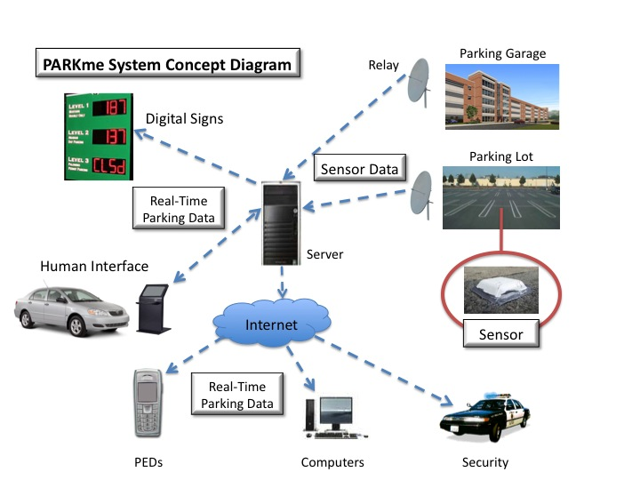

Figure 4-1: PARKme System Concept Diagram

4.4 Essential Features

The parking space sensors are essential to the PARKme System. The system requires these sensors to track whether a vehicle occupies the current space.

The wireless network is an essential change to the current system. Without the wireless network the PARKme system could not communicate with the parking space sensors.

The computer server and database is essential to the PARKme System. The computer server and database communicates with the sensors to track parking space status. Additionally, the server communicates with the user interfaces to report empty parking spaces to the user of the system. The server and database will store parking statistical data to be used for future system optimization.

The user interface is an essential feature of the PARKme System. The users of the system must have a method to interface with the PARKme System to be informed of empty parking spaces.

4.5 Desirable Features

A desired feature of the PARKme System is the capability for the user to interface with the system online via the Internet. The intent of this feature is it allows students to check for the location of empty parking spaces before leaving for class.

The ability to receive parking information via text messaging on a cell phone is another desired feature of the PARKme System. The intent of this feature is to allow students to setup alerts to be sent to their cell phones at predefined times reporting the availability of parking.

A desirable feature for the PARKme System would be the capability to analyze the parking data stored on the server and develop reports to be used for parking optimization.

5.0 Project Development Plan

The following is a description of the project development plan for the PARKme System. The PARKme team utilized these components to organize and develop the project.

5.1 Systems Engineering Management Plan

The PARKme team developed a Systems Engineering Management Plan that governs the systems engineering activities to support the development of the PARKme system. The SEMP addresses all engineering topics during the total life cycle, from concept to deployment, of the PARKme System. The SEMP covers subjects such as developing a work breakdown structure (WBS) and a statement of work (SOW), performing program risk analysis, and technical performance measurements (TPMs). The SEMP was developed as a guide for all systems engineering processes that occur during the development of the PARKme system.

5.2 Work Breakdown Structure

The PARKme team developed a work breakdown structure early on in the process to organize the work needed to be down on the project. The PARKme system WBS underwent minor changes throughout the semester as items were added to the list. The PARKme WBS can be seen in Appendix B.

5.3 Schedule

Once the WBS was completed the items were put into a project schedule. Developing a schedule for a project turned out to be much more difficult than originally thought. Estimating the number of days to work on a task and linking them to other tasks from scratch was very time consuming. Developing a project schedule is an area where experience is very helpful. Items on the schedule had to be moved around and added as the project progressed. The team learned that developing a good schedule requires some flexibility. Further information about the schedule is available in Appendix B.

5.4 Action Items

During each week that the PARKme team met, the group members would be assigned tasking by the project manager. The tasking was tracked in an action item spreadsheet. This spreadsheet was updated on a weekly basis. The project manager would get the status of current tasking and close completed tasking. Each task was assigned a due date and a percentage complete would be tracked weekly. Any completed tasks were colored in green and any overdue tasks in red. A screenshot of a sample action item list is shown in Appendix B.

5.5 Architecture Framework

The PARKme team utilized both the Department of Defense Architecture Framework (DoDAF) and The Open Group Architecture Framework (TOGAF) as a standard way to organize an enterprise architecture of the PARKme system. The PARKme team all work for the Department of the Navy (DON) and are familiar with DoDAF. DoDAF is ideal for developing different views of system that are complex both from an integration and interoperability point-of-view. The PARKme team also decided to incorporate some of the TOGAF views as TOGAF was designed in the implementation of an enterprise information architecture that is the core of the PARKme system. It is common practice to intermix these two architectures on projects and many papers have been written on this subject.

5.6 Website

The PARKme team developed a website hosted by GMU for our project. The website contains the goal of the project and hosts documentation developed for the PARKme system. The website is located at <http://mason.gmu.edu/~cemmerto>. A screen capture of the website is available in Appendix B.

6.0 Risks

The mitigation of risk is an important step in the system engineering process. Risks that turn into problems cause cost increases, schedule delays, and unnecessary rework that could have been avoided if a risk management process was agreed upon early in project development. The process of risk management is to identify, assess, and determine what (if any) mitigation steps can be taken to increase the probability of a successful project completion. The PARKme System will focus on the essential elements outlined in the Risk Management Guide for DOD Acquisition (Risk Management Guide for DOD Acquisition, 6th edition, version 1.0 August 2006).

* Risk Identification
* Risk Analysis
* Risk Mitigation Planning
* Risk Mitigation Plan Implementation
* Risk Tracking

Risk management is a program management tool to assess and mitigate events that might adversely impact the program. Therefore, risk management increases the probability/likelihood of program success. The PARKme project group decided to develop a Risk Management Plan (RMP) to outline the process for implementing risk management for the PARKme System. The team decided to undertake developing risks for the PARKme System from the perspective of the development and installation of the initial system at GMU. The team developed a PARKme System Risk Assessment Guide as a method for defining risk and the impact the risk would have on system development if the risk evolved into a problem. Figure 6-1 below shows the risk grid used to define risks and how risks are scored.

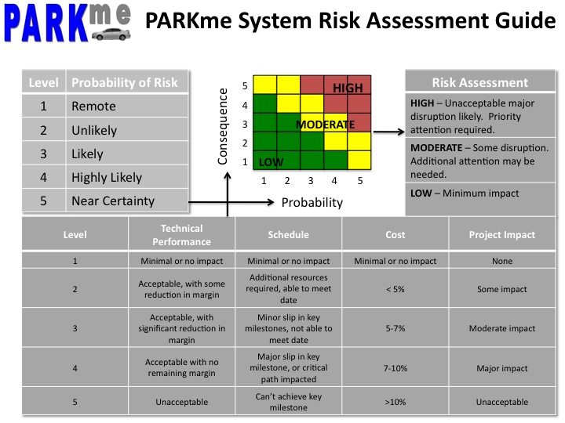

Figure 6-1: PARKme System Risk Assessment Guide

For each risk identified in the PARKme System, the probability the risk will occur must be determined. The higher the probability, the more likely the team feels the risk will occur. The consequence of each risk if it occurs also must be determined. Four areas will be evaluated when determining consequence: technical performance, schedule, cost, and project impact. At least one of the four consequence areas needs to apply for the issue to be classified as a risk. For a more detailed explanation of the consequence areas refer to the PARKme system RMP. For each risk associated with the PARKme System, a risk-handling plan must be written to mitigate the risk. Detailed steps must be taken to lower the probability and consequence of each risk occurring. The PARKme team developed a format for describing each risk and the steps necessary to mitigate the risk. Example risks for the PARKme system are available in Appendix C as Figures C-1 to C-8.

Risk management will be the responsibility of the entire system development team. The project manager will be responsible for ensuring all risk processes defined in the PARKme RMP are followed. Risk management must occur throughout the entire system development process to ensure the projects stays on schedule and within costs.

7.0 Stakeholder Analysis

This section identifies and describes the stakeholders for the PARKme system. It addresses their influence, interest, and their interaction with the system.

7.1 Stakeholder Identification

7.1.1 End User

The end user is the person that interacts with the operational system. The end user obtains current parking availability of the different lots around the campus. The end users for the PARKme System are students, faculty, visitors, and administrative personnel from the GMU Campus.

7.1.2 GMU Administration

These are the “Executive stakeholders.” Their role in the development of the system is to provide funding for the design, development, testing, installation, and maintenance of the system. They’re interested in improving the parking problem in the university on a commercial level. They will compile data from the system to continually improve the system. They will also be in charge of getting support/“buy-in” from the stakeholders involved.

7.1.3 GMU Police/Security

The system notifies the university police of any parking violation. In the event that an unauthorized driver parked in a disabled area or in forbidden zones, a message will be sent for the police to take the appropriate action.

7.1.4 Project Manager

The program manager manages the project development, interacts with the customer, and leads a team to produce the end-item with the available resources and within the constraints of time, cost, and performance/technology. Additional responsibilities include:

Identifying, tracking, managing and resolving project issues

Proactively disseminating project information to all stakeholders

Identifying, managing, and mitigating project risk

Ensuring that the solution is of acceptable quality

Proactively managing scope to ensure that only what was agreed on is delivered, unless changes are approved through scope management

Defining and collecting metrics to give a sense for how the project is progressing and whether the deliverables produced are acceptable

7.1.5 GMU Maintainer

The system maintainer is in charge of conducting tests and repairs to ensure the effective performance of the system. Must be equipped with the appropriate skill set to be able to repair the system within the designated constraints.

7.1.6 Engineers

They are the part of the team in charge of defining the system requirements, decomposing the system requirements down to sub-system levels, maintaining interfaces between sub-system and rest of system, integrating the system and define system-level testing.

7.1.7 Project Sponsors

The sponsor for the PARKme system is Josh Cantor. Josh Cantor is the director of Parking and Transportation the GMU and represents the GMU administration. As director of Parking and Transportation, he has been assigned the task of improving the parking problem at GMU.

7.2 Key Stakeholder Identification

To identify the key stakeholders for the PARKme System an Influence-Interest matrix was used. The interest-influence grid [Imperial College of London. Project Stakeholder Analysis, 2008] is a mapping tool developed by Imperial College of London. A similar version of this mapping tool is widely used in the government and private industry. The level of influence and importance of each stakeholder was established. The level of interest was determined by how the stakeholder is affected by decisions or success of the project. In a similar way, the level of influence was determined by the power of a stakeholder to affect the success of the project. For example, the GMU administration has a high influence and interest on the system. While the campus police have a low interest on the development of the system, they will be affected positively upon its successful deployment.

|  |  |  |
| --- | --- | --- |
| Stakeholder | Influence | Interest |
| End User | H | H |
| GMU Administration | H | H |
| GMU Police | L | M |
| GMU Maintainer | M | H |
| Engineers developing/testing the system | H | M |
| Project Manager | H | H |
| Project Sponsors | H | H |

Table 7-1: Stakeholder Influence and Interest

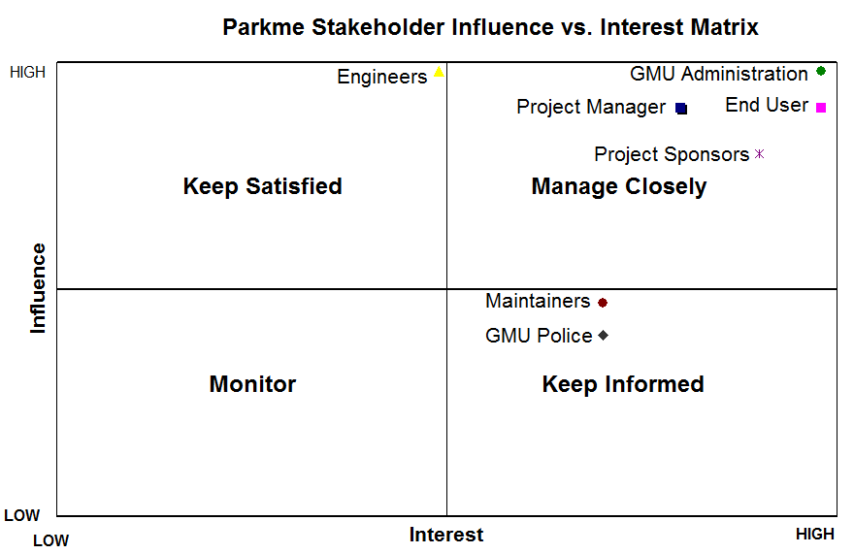

Figure 7-1: Stakeholder Influence vs. Interest Matrix

After establishing each stakeholder influence and interest and plotting the stakeholder in the grid, each stakeholder, is found to belong to one of the following groups:

Manage Closely Quadrant - High influence, interest stakeholders: End User, GMU Administration, Project Sponsors, and Project Manager. For this group of people we must put most of our efforts and fully engage them.

Keep Satisfied Quadrant - High influence, less interest stakeholders: Engineers. Enough information must be provided in order to keep them satisfied.

Keep Informed Quadrant - Low influence, high interest stakeholders: GMU Police, GMU Maintenance Personnel. They need to be kept informed adequately.

Monitor Quadrant – Low influence, low interest stakeholder – They need to be observed closely but minimal effort is required.

From the Influence - Interest Grid, the relative importance of each stakeholder was also established. The stakeholders are listed below in descending order of importance:

* End User
* Project Sponsors
* GMU Administration
* Project Manager
* GMU Maintenance
* Engineers
* GMU Police

7.3 Need Analysis and Value Mapping

The translation of stakeholder needs is one of the most important tasks of system engineering. Understanding the needs is an iterative process that was refined during several stages as we defined the behavior of the PARKme System. The idea is to obtain a current and future vision for the system from each stakeholder perspective. Some of the techniques used to elicit stakeholder’s needs for the PARKme system include: interviews, use cases, and end user surveys.

7.3.1 Use Cases

The use cases developed for the system intent to demonstrate how the system interacts with different users and actors. They constitute a set of actions that provide measurable value to the actor. The following sections provide a general description for each use case. For more detailed information about each use case please refer to Appendix D.

7.3.1.1 Provide PARKme Services to Driver

The Provide PARKme Services to Driver super use case is composed by the following use cases: Determine User Preferences, Find Parking, and Update Parking Availability.

7.3.1.2 Find Available Spaces

The Find Available Spaces use case covers the interaction of the PARKme system with the driver. It starts with the arrival of the driver to the GMU parking lot and it ends with the driver parking at the desired location.

7.3.1.3 Update Parking Availability

This use case is triggered by a change in a parking availability. It updates the parking database when a driver arrives or leaves a specific parking space.

7.3.1.4 Report Parking Violations

The Report Parking Violations use case presents the interaction of the PARKme system with the campus police. It starts with the system’s detection that a driver parked in a non-authorized zone and it ends with the campus police taking the appropriate action.

7.3.1.5 Generate Parking Usage Report

The Generate Parking Usage Report use case shows the interaction of the PARKme system with the GMU administration. The GMU can request usage reports and specify to what media the report will be sent.

7.3.1.6 Provide PARKme Maintenance

The Provide PARKme Maintenance use case covers the interaction of the PARKme system with the GMU maintenance personnel. PARKme will alert the maintenance personnel of any maintenance milestone achieved or asynchronous events that require them to provide services to the system.

7.3.2 Value Mapping

After developing use cases and analyzing the data from the interviews and surveys the stakeholder needs were identified. The main needs for the PARKme system are:

* Determine user preferences
* Display parking locations
* Find parking spaces
* Maintain and update parking availability
* Reserve parking spaces
* Report parking violations
* Monitor parking spaces usage
* Collect parking fees
* Enable effective maintenance and servicing

Each need was ranked using a combination of the weight of the relative importance of the stakeholder and the need.

The stakeholders considered when conducting the need analysis are the end user, the GMU administration, the GMU Maintainer and the GMU Police. The stakeholder relative importance was determined using the Influence-Interest Grid. The most important stakeholder is the end user while the least important stakeholder is the campus police.

The value added for each activity was determined using the data obtained from the interviews and surveys conducted among the stakeholders. Each need was ranked on a scale of 0 to 5. Level 0 corresponds to a capability not used by the stakeholder; level 5 corresponds to a capability that provides an excellent value.

The priority of each need was obtained from the ranking of the needs. A project will have a limited budget and limited time; therefore, it is very important to know what capabilities are more important to provide the most value to the stakeholder. The most important capabilities are: to maintain and update parking availability, determine user preferences and find parking spaces. These capabilities constitute the core of PARKme System. The capabilities that provide least value to the stakeholder are: collect parking fees and reserve parking spaces. It makes sense that these capabilities are ranked lower since only a small group of the stakeholders are concerned with them. For example, only GMU administration considered the collect fees capability to provide an excellent value.

8.0 Analysis of Alternatives

8.1 Introduction

8.1.1 Goals

Research of the available technologies currently being employed for use with “Parking Systems” resulted in a number of alternatives with vast differences in complexity. This included valet parking, “Robotic” automated parking systems, and Electronic devices (Sensors).

8.1.2 Additional Features

Additional system characteristics to help stakeholders and users would include: WIFI on campus, data collection on parking patterns (historical information on student parking habits), and tracking of fire lane parking (Security information).

8.1.3 Setup

Researched current state-of-the-art vehicle parking, implementation of the alternatives, and how they would apply to a large multiple parking lot facility. Analyzed the benefits and constraints of each of the researched systems, which resulted in our high level approach to the multiple parking lots at GMU.

8.2 High Level Architecture

8.2.1 Current Parking Conditions

There are currently 16 Parking lots (A-P), and 3 Parking Deck Garages. The types of lots/spaces available include (reserved, staff/faculty, motorcycle, west campus, visitor, and general). There are at least 12 main campus entry points.

8.2.2 Alternatives

The following is a summary of the different high-level architectures examined during our development of the PARKme System architecture.

8.2.2.1 Valet Parking – Professional Parking Services

Propark is one vendor specializing in creating customized parking management systems. Each of their systems incorporates all parking-related functions to include receipt and delivery of users automobiles, to and from parking areas.

8.2.2.2 Automatic Parking

The parking process is simple, safe, and convenient for a driver. A driver drives into an entry cabin, turns off the engine, and walks away. Sensors measure the height, length, and width of the vehicle and confirm that no person remains inside the entry cabin. The parking equipment moves the vehicle to the computer assigned parking space. Nothing ever touches the vehicle and the vehicle engine is off during the entire parking and retrieval process

8.2.2.3 The PARKme System

Our high level architecture will be based on a sub-component architecture in which the architecture itself is derived of smaller stand-alone component level architectures. The architecture consists of multiple sensors that relay parking space information to our main control system. Another sub-component will be the Human Interface (HI). The HI provides parking space information to the user via the main control system. Finally, a network will be required to interface between each of the sub-components

8.3 Criteria to Analyze Architectures

8.3.1 General Definition

Each of our subcomponents has a variety of alternatives that can be implemented to meet our requirements. Each alternative has a list of criteria that we are using to weight their value in the specified criteria. An example would be using cost as an alternative, and then given five alternatives they would be ranked 1 to 5 based on their cost relative to each other.

We asked each of our sponsors to rank these criteria and their relative importance to one another. We have also asked the inputs of the class in ranking and weighting these criteria, resulting in six criteria being used in each of our subcomponents. The six criteria will be explained in detail and are ‘Start Up Cost’, ‘Maintenance Cost’, ‘Construction’, ‘Maturity’, ‘Reliability’, and ‘Time Between Failures’.

* Start-up Cost – The initial cost to implement the system. This includes purchasing the components and constructing the system.
* Maintenance Cost – Cost to operate the system on a regular interval.
* Construction – How much construction will be required to implement the system.
* Maturity – The maturity of the technology used in the system.
* Reliability – The measure of how well the system performs a given task.
* Time Between Failures – Measure of how long until a component fails.

8.3.2 Weighing Schema

The importance of each of these criteria is weighted relative to each other. The values of each of the alternatives to particular criteria are defined below. The statistical value of each of the alternatives within the criteria is used to weight the alternatives values within criteria against the other. The values are noted below.

BEST (5: Very High)

(4: High)

(3: Average)

(2: Low)

WORST (1: Very Low)

Logical Decision for Windows (LDW), taught at GMU in Systems Engineering 573, was the tool used to compare the sub-components of the different system architectures. Figure 8-1 below shows typical output from LDW.

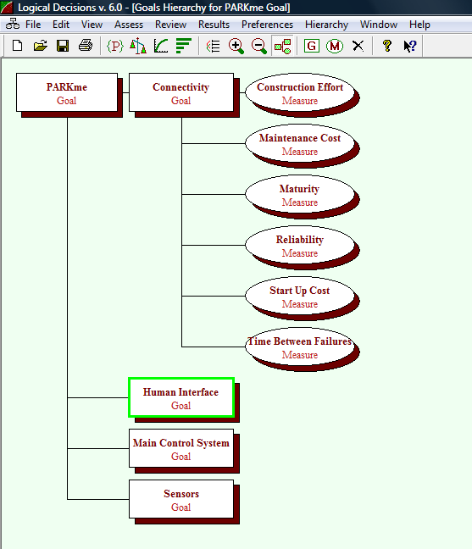

Figure 8-1: LDW Output Used for Architecture Comparison

8.3.3 Architecture Comparison Results

The following are the results obtained from utilizing LDW. Figures 8-2 to 8-4 show the rankings for the sensor, human interface, and connectivity sub-components.

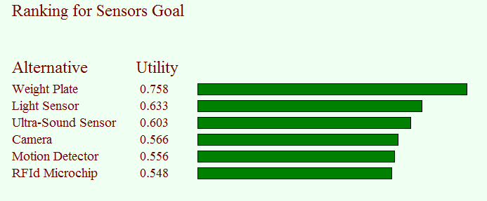

Figure 8-2: Ranking of Sensors

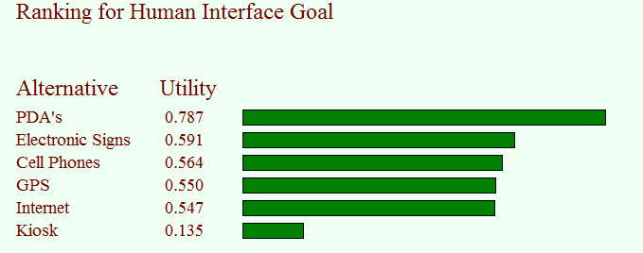

Figure 8-3: Ranking of Human Interfaces

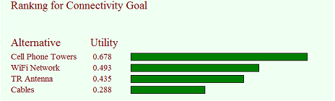

Figure 8-4: Ranking of Connectivity

8.4 Final Architecture

Utilizing LDW and our set of criteria from the user surveys, we have selected our final architecture for the system. The sensors will be imbedded in the ground at each parking space. The Human Interface (HI) will be either electronic signs, or other PEDs that can be added in the future. Electronic signs can be implemented initially and other PEDs can be added later to provide the users with more options. Electronic signs would initially be installed at the main entrances of each of the parking lots. Later upgrades could include intersections and entrances to parking lots and garages. Further upgrades could be added to each level of a garage or at each row of a parking lot.

9.0 Functional Architecture

The development of the system architecture for the PARKme system was created using the structure analysis process, in particular the development of the Functional Architecture. Because of the time constraint only the activity and state transition models were developed. The use cases developed during the stakeholder analysis served to make more concrete the initial operational concept.

The development of the functional decomposition is the first step. It is an iterative process and it is more concrete as the definition of the system becomes clearer. Its output constitutes the backbone of the architecture since all the models are generated using the system activities. The models mentioned in this section are available in Appendix E, Figures 1 to 11.

The activity modeling was achieved by using both IDEF0 and Data Flow Diagrams (DFD). IDEF0 is a method focused in the functions and their inputs, outputs and constraints. It shows relationships that hold regardless of sequence. The use of CORE software facilitated the use of this methodology. The A0 box is the context diagram, which is the highest-level view of a system. It corresponds to Provide PARKme Services in the system. The context diagram shows the external inputs, outputs, and constraints of the system. For example, the activity Provide Parking Services the input is user access and preferences, the constraints are the university regulations, state laws, parking availability, and weather. The user access and preferences is transformed into parking reports and available parking spaces.

While IDEF0 is focused on the activities, DFD is focused on the data. This diagram shows the movement of data throughout the system. It also represents all external entities that may interact with the PARKme. The external entities for the system are the driver, the sensors that detect the parking availability, the GMU administration, the maintainer and, the campus police. The 0-DIAGRAM for the PARKme System shows how the user information flow is transformed by Process Service Request activity into user level access and preferences and how the related information flow into the system until the available spaces data is sent back to the driver.

The behavioral model captures the dynamics of the system. It shows the different states of the system and the conditions that can cause the system to transition to different states. The PARKme System begins in idle, waiting for user requests. As soon as a valid driver approaches the system, the system starts to obtain information from the driver. If there are no parking spaces available, the system reports this to the driver and the system returns to idle and waits for user requests. Otherwise the system transitions to find the spaces available and to display the available parking spaces to the user. Finally the system returns to idle when the system detects the departure of the driver.

10.0 System Design

The PARKme system design began with the Analysis of Alternatives hammering out what technologies were available for use and would meet the requirements set forth for the PARKme system. System design was divided into the hardware side and software side. From this point we were able to then decompose the hardware and software to lower levels allowing us to address the design needs at a more manageable level. For example, we were able to look at how to implement and design the portion of the system that would handle the monitoring of the parking spaces.

Design for the hardware side was heavily focused on the communications between the components. Many of the hardware components were narrowed down prior to the design but the interfaces between them were not yet defined. Laying out how each piece of hardware was going to communicate along with what it was going to communicate and with who was a critical aspect of the design and an emphasis was placed on using standard protocols in order to increase modularity and promote an open architecture design. Figure F-1 in Appendix F shows a top-level hardware interface diagram.

Software design was broken down into functions. These functions were then decomposed another level when necessary to provide enough detail to cover all the requirements that were software driven. By decomposing the software into these functions the software could easily be put into work packages. Another additional benefit of this break down is that it helped produce Source Lines of Code (SLOC) estimates in order to provide cost estimates for the software development portion of the system. After defining the software functions the interfaces between them were identified. In the same model as the hardware, the software also focused on using standard protocols in order to facilitate operability between functions. Figure F-2 in Appendix F shows an example software interface diagram.

The software must also communicate with hardware components. These interfaces are the glue that ties the system together. Getting the information from the hardware to the software and vice versa ties directly to the most basic requirement of the system, which is to provide information to the user.

11.0 System Models

11.1 General Overview

Two models were developed for the PARKme system. A proof of concept model for validation and verification was developed using Colored Petri Nets (CPN) as the modeling language. A timing analysis model was also created.

11.2 Previous Academic Research Efforts

Two operations researchers wrote a study about selecting a parking space, “A Probabilistic Approach to Evaluate Strategies for Selecting a Parking Space,” Dr. C. Richard Cassady of the Department of Industrial Engineering at Mississippi State University, and Dr. John E. Kobza of the Department of Industrial and Systems Engineering at Virginia Polytechnic Institute and State University in Blacksburg, VA. It appears in an issue of the journal *Transportation Science*, a publication of INFORMS. The study showed that drivers who parked in the first available parking space saved time over drivers who searched for a closer parking space. The experiment was performed in a shopping mall parking lot. Initially, the experiment appears to go against the purpose of the PARKme system. However, a college campus and shopping mall have different layouts. It might not be the fastest to take the first available parking space at a college campus if the parking lot is 2 miles from the driver's class. Therefore, this experiment really only holds if the parking lots are not spread out over great distances. This is not always the case when it comes to a college campus.

Asad Khattak and John Polak wrote another study of parking entitled, "Effect of Parking Information on Traveler's Knowledge and Behavior," published on January 20th, 1993 by the University of Oxford. Khattak and Polak state "parking congestion causes delays and inconvenience to motorists, wastes resources, and degrades the environment." This point makes an excellent case for the need for the PARKme system. After conducting a study in Nottingham the paper concludes that the "provision of parking information seems beneficial and is likely to improve the travel experience of some drivers." The paper does state that certain types of people were more willing to use parking information than others. This point is another good case for the PARKme system. The PARKme system has been designed as an information aide and use of the system is not necessary to park at a parking facility utilizing the system.

11.3 Scalability

The models assume the system is fully scalable. Thus, the models represent a limited number of entryways into the facility. A limited number of parking lots and spaces are modeled. Also, a limited number of users and their preferred buildings will be represented.

11.4 Timing

The models include time, but time is relative and not true time. The time it takes for the user to walk from the parking space to their destination building is reflected. Time is noted to begin when the user enters the facility perimeter and to end when they arrive at their preferred building. Time is not a factor in the sensors, main system, or communication network. Any differences in these sub-architectures are relatively small compared to human perception. However, time may be a factor in the human interface component. Two variants of the CPN model were created. The Human Interface sub-architecture was modeled as both electronic signs and as PDA’s.

11.5 Intellectual Property

Both the CPN model and the timing analysis model can be used in testing the full system. The CPN model reflects users traversing the system and data flowing through the system. The timing model predicts system performance and relational issues.

11.6 The CPN Model

Both the personnel electron devices (PED’s) and electronic signs variants will be modeled. The models are implemented as timed colored Petri Nets using the CPN tools software. The models are fully executable from within the CPN tools software. Both variants of the models are included as CPN files on the PARKme website. Output of the model is shown in Figure 11-1.

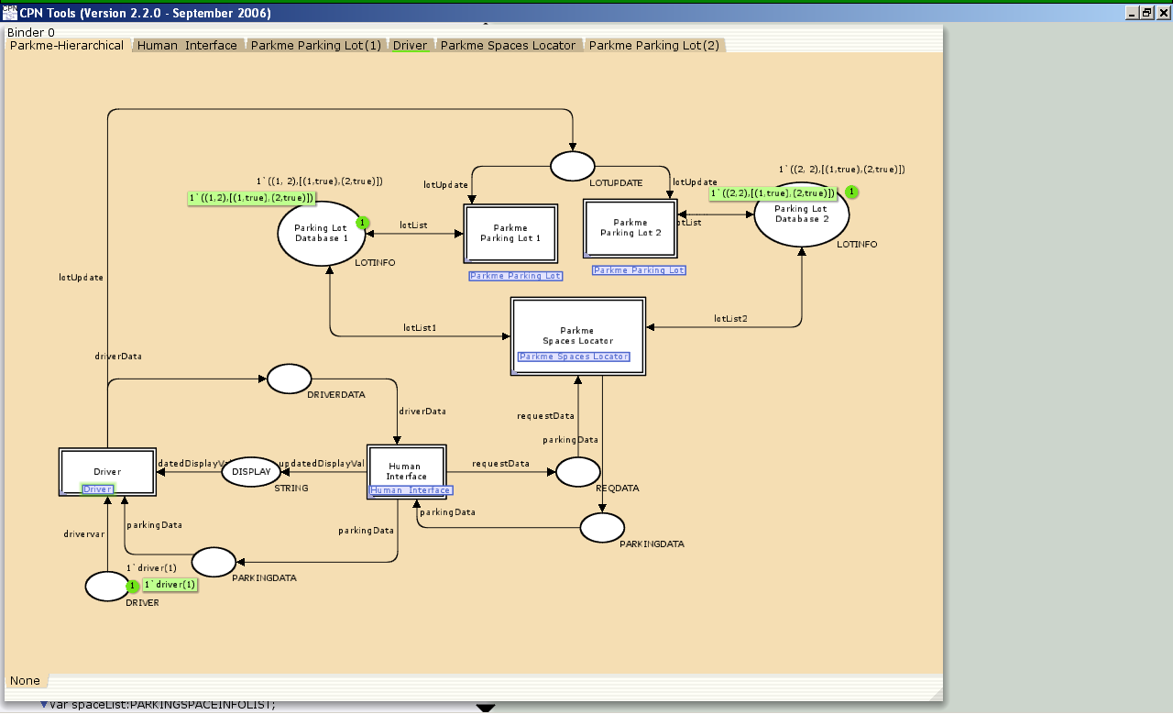

Figure 11-1: The PARKme System as a CPN Model

The CPN model is the proof of concept model. It shows how data should flow through the system. This model can be scaled up to reflect the specific system to be implemented. It could then be used to verify the operation of the intended implemented system.

11.7 The Timing Analysis Model

The Mathworks Matlab® software was used to provide a Monte Carlo timing analysis of the PARKme system. The complete Matlab® code and the timing model documentation are provided on the PARKme website.

11.7.1 Model Definition

In the timing analysis model time was noted to represent the total time passed in finding a parking lot with an available parking space and then walking to the user’s preferred building. Time begins once the user enters the perimeter of the facility. Time ceases when the user arrives at the preferred building location. Time increased relative to the travel time spent proceeding from the facility perimeter to the first parking lot and by traveling from a previous full parking lot. Time will advance to represent a user searching the current lot. Time will also advance to represent the user walking to a preferred building using the average human walking speed of 60 ft/minute.

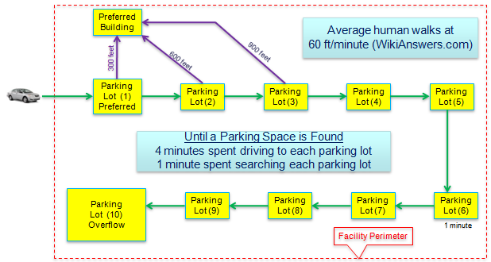

Figure 11-2: The PARKme System Timing Analysis Model

11.7.2 Results of the Model

The following results are reflective of a system with a 90% probability of each lot being full and an additional 10% probability that the lots fill up before the user arrives. Five minutes are spent driving to a new lot and searching it. Each lot is 300 feet further away from the user’s preferred building. Using ten lots, it was determined that 1,000 Monte-Carlo runs was sufficient but 100,000 was used as the time to run the model using 100,000 runs was not significantly. The larger run count would provide added confidence in the results. The results of the model vs. the data provided by GMU are shown in Figure 11-3.

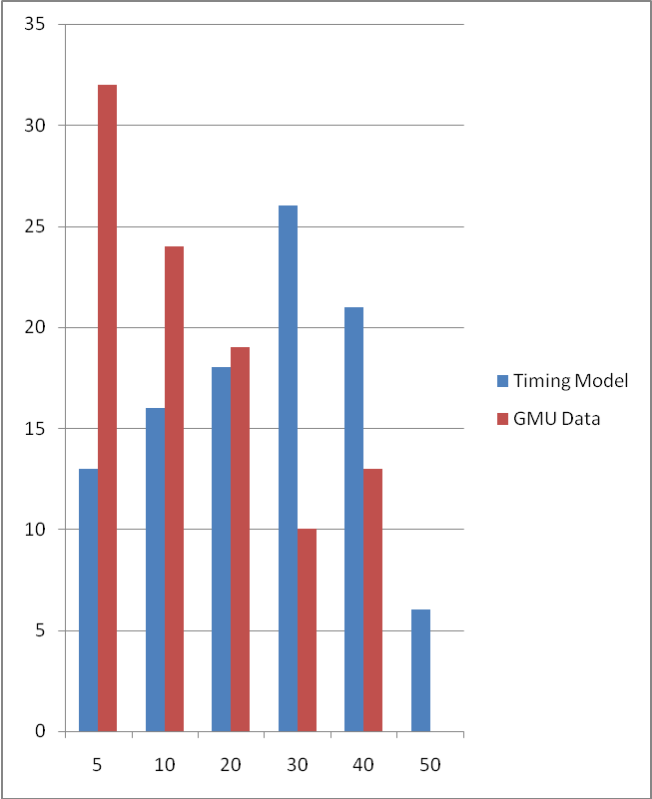

Figure 11-3: The PARKme System Timing Analysis Model

11.7.3 GMU Data Compared to Model

The goal of this model was to first develop a model that could provide similar results to the currently active parking system based on the GMU survey results. Once a sufficient model was developed it would then be modified to include aspects of the PARKme system in order to compare the two results. Development of the model resulted in differences between the model and the GMU data. These differences may be caused by varying factors such as GMU students choosing to park somewhere other than the closest space to their first class. Also the first students on campus always get to park in their preferred lot. Finally the users may have insight from past experience and could go directly to other lots including the overflow lots. The important thing to note is that the model does capture an average of 30 minutes spent looking for a parking space which correlates to what many of the GMU students noted in their survey results. When applying the changes to the model to incorporate the PARKme system the results were significant. By simply adding the tools necessary to avoid having to perform search after search of parking lots the time needed to find parking is greatly reduced. Model results show a reduction of 10 minutes on the average case and up to 30 minutes of savings when looking at the worst possible cases. This model provided some validation as to the effectiveness of implementing the PARKme system and could be further expanded to include other variables and factors in order to better justify the need for PARKme.

11.8 PARKme Issues

The PARKme system can direct a user directly to a parking lot with free spaces. This removes all search times. Also, positioning interior signs at intersections could redirect users to a new lot if the initial lot fills up while they are in transit. A final known issue is that for near full lots there could be a greater number of users searching for the remaining empty spaces. In this scenario users could be searching for a space that has been taken and consume valuable time and resources because of lack of more up-to-date information. Possible mitigations for this could be to use information that informs the users of more specifics as to where the empty spaces are and if the user knew the space was in row 1 and no spaces are open in row 1 then they would be able to conclude that the space has just been occupied. These mitigation strategies would need extra time and money spent on Human System Interface testing in order to best design the informative and user-friendly display systems.

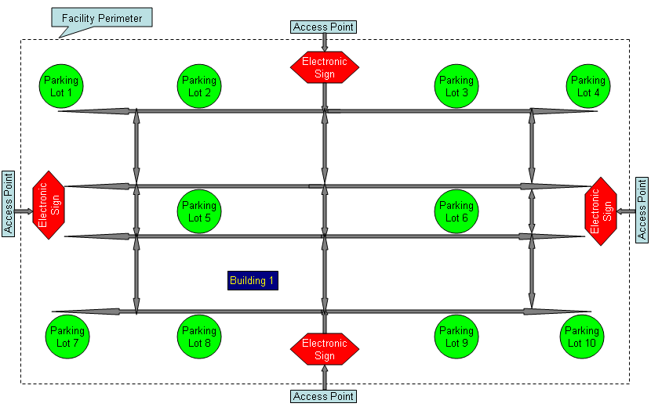

Figure 11-4: A Conceptual System Layout

12.0 Technology Strategy

12.1 Technology Readiness Levels

Technology Readiness Levels (TRLs) is a measurement system that supports the assessment of the maturity of a particular technology. The nine levels of TRLs start from TRL 1, the lowest level of technology maturation, to TRL 9, the highest level of technology maturation. The TRL of all technology integrated into the PARKme System must be at least on level 7 on the TRL scale with the goal of TRL 8. The technology must be near ready for an operational system. The PARKme System utilizes current technology and integrates it into a System-of-Systems environment. The underlying technology must be ready to be integrated into this environment, as it will not be cost feasible to wait for the technology to mature to TRL 7.

The PARKme System shall utilize TRLs to assist in risk management of developing the system. Any proposed technology to be used in the PARKme System must meet TRL 7 or the program risks schedule and cost increases.

12.2 Intellectual Rights

The PARKme system is comprised of components that will be purchased for use to be integrated in the system. The individual components’ rights belong to the patent holder and/or company that manufacturers the component.

The PARKme system will apply for a patent for the concept of the parking locator system. The first step before applying for a patent was to do a search of patents for similar systems. The PARKme team accessed the United States Patent and Trademark Office (USPTO) via Google Patent Search to perform this search. The results of the search included four similar systems. An explanation of these results is available in the PARKme Technology Strategy and Appendix G of this document.

12.2 Proprietary Software

The PARKme system development company will license the software source code and executables that run the PARKme system to PARKme system customers. The license will allow the software to only be used on PARKme systems. The source code will be restricted to software developers working on developing the PARKme system as established by the development company. The source code and executables will be restricted for use only on PARKme systems or systems deemed appropriate by the development company. The customers of the PARKme system will not have access at any level to the underlying software that runs the PARKme system beyond any normal user interfaces. The PARKme system development company will have exclusive legal rights to the software. Any customer who requires access to the code will be handled on a case-by-case basis.

Any underlying software used within the PARKme system such as, but not limited to, database software, server software, operating system software, and analysis software are the exclusive rights of the owners of that software and will be licensed through the PARKme system development company. See the individual software’s license agreements for further information and restrictions.

12.3 Proprietary Data

The PARKme system will have the capability to record parking space usage data for the facility where the system is implemented. This data can be in binary, text, or XML format. The facility that purchased the PARKme system will have exclusive rights to this data and can store and use the data freely. The PARKme system development company is not responsible for the contents or usage of this data. The format of the parking space usage data will be agreed upon in the initial contract when purchasing the system.

12.4 Hardware Upgrades

The PARKme system development company will upgrade the hardware of the PARKme system when deemed necessary due to a technology maturation or end of life cycle for current hardware. Customers who wish to upgrade their PARKme system can do so by signing an upgrade contract. No hardware upgrades will be included as part of the initial installation contract of the PARKme system. This is to keep the initial cost of the system down. All warranty repairs on the installed hardware will be included in the initial installation contract.

Hardware upgrades will include, but limited to, hardware that increases the capability of the PARKme system or upgrades current hardware. An example of an upgrade of current hardware may be new parking space sensors that demonstrate increase resistance to the effects of inclement weather.

12.5 Software Upgrades

The PARKme System development company will define software upgrades into two distinct categories:

Software Updates: This is software that fixes software “bugs” or security holes in previous versions of the PARKme System software. Software bugs are defined as any current functioning of the software that is not working as intended. The software updates will be available from the PARKme System development company’s website at no cost to any current PARKme System customer. The software updates can be downloaded for free from the website and installed by the system administrator of the PARKme System.

Software Upgrades: This is software that updates the current PARKme System with new features and capabilities. These new features could range from interface software that allows new technology to integrate into the PARKme System to better user interface capabilities. The PARKme System development company will determine the cost of the software upgrades. The software upgrades may be available on the PARKme System development company’s website or may need to be installed on-site. Software upgrades may be site specific and not available to all owners of the PARKme System.

13.0 Business Case

The PARKme business case was focused on providing information to the PARKme developers/product integrators good in order to facilitate the decision to continue with implementation of the PARKme system. The business case provided the options available for development and deployment along with a 10-year plan as well as the expectations that can be realized with the PARKme development. The business case also set out to provide the cost analysis to our primary customer, George Mason University. GMU is researching systems for their Fairfax campus and are focused on the main general parking lots closest to the campus where demand is highest. The PARKme system was conceived with this customer in mind, as there was a problem at hand and a customer looking to address this problem.

As the PARKme personnel are small in numbers, the development and deployment of the system will start on a small scale and then provide a steady projected profit over the next five years. Several options exist in terms of how to proceed with development of the system.

Option 1 addresses the need for start-up funds. Initiating a partnership with GMU where GMU would provide start up investment funds for development and in return cost discount would be provided. This option provides the greatest utility for both parties in that GMU would receive breaks on software licensing costs and discount installation and set up fees. PARKme on the other hand would be provided with start up funds and could begin development right away. By partnering with GMU PARKme would also not have to produce the funds in order to purchase hardware components for testing. In this option PARKme would only need to produce $13,000 in funds for development and testing as shown in Figure H-1 in Appendix H. This option would provide a system that would be delivered in increments. GMU on the other hand would save approximately $45,000 at the end of system deployment. Total cost to GMU in broken out in Figure H-2 in Appendix H.

Option 2 was investigated to develop and have the PARKme system ready for deployment before a GMU purchase. In this option PARKme would need to raise approximately $69,000 investment capital for software development costs and purchases of hardware components for testing as shown in Figure H-3 in Appendix H. For this option, GMU would end up paying $1,060,737 for a completed system, which is about $45,000 more than with option 1. Figure H-4 in Appendix H shows the cost to GMU for this option. This option poses a risk to PARKme as our primary customer might decide against or delay the purchase of the system. This risk is identified and addressed in the PARKme Risk Management Plan (RMP).

Either option will provide PARKme with net profits by month 9 but having GMU participate as an investor would help to provide sustainment through the development process. As seen in Figures H-5 and H-6 in Appendix H is the PARKme expenses and sales forecast over a ten-year span for both options. Net Present Value for both options is approximately 1.9 million. Sales estimates are based on initially providing 4 systems to the market and losing one sale a year until stable 1 or 2 sales per year is realized. This loss of sales is due to the entrance of competitors in the market. Initially we will have the competitive advantage as our software is developed and ready and over the following years it is expected that some market share will be lost as competitors complete their development cycles.

Sensitivity analysis was conducted in order to investigate the contributing factors that provide that are most sensitive to change and would have the largest impact on PARKme profits. Looking at the tornado diagram in Figure H-7 in Appendix H it can be seen that sales are the biggest player followed by expected profits. As our sales model is not based on a large quantity then any lose of sales will impact the bottom line. Profits expectations are also sensitive and play an important role in the overall profits for the PARKme system. Having identified the variables and investigated their sensitivity, the impact variables were investigated using a decision tree. This decision tree was important in that it would display the many different paths that the future could hold for the PARKme system. The most important piece of information gained from the tree was by following the most pessimistic path the tree contained. In this path the PARKme system still contained a positive net present value. This tree was very large and comprehensive and a portion of it can be viewed in Appendix H Figures H-8 and H-9.

As the technology is modular and COTS based, the entrance of PARKme into the market will also provide a knowledge base that would allow PARKme developers to apply the technologies to other markets. Examples of how the PARKme technologies could be leveraged into other markets include using the wireless networking components to build and install large-scale Wi-Fi or security monitoring systems for customers. The PARKme system could also be marketed to facilities such as hospitals that want to provide users with a system that can tell the best place to park based on their destination. By expanding the initial scope, the PARKme system could provide a longer overall sustainment in the marketplace. These potential new markets are not included in the overall sales forecast, as the market analysis has not yet been performed.

Having conducted the development cost, breakdown of cost for both GMU and PARKme as it pertains to GMU purchase price and PARKme profit expectations, and ten year cash flows along with investigation of the sensitivity of the different variables that could affect the bottom line and then building a decision tree to map out the many different scenarios possible, it can be concluded that introducing the PARKme system into the market is the correct decision to make. Based on the information provided in the PARKme Business Case having GMU provide progress payments during development leading into the purchase of the system for the parking facilities on campus would provide the most utility for both GMU investors and PARKme engineers.

14.0 Conclusion

The outputs of the system engineering processes applied to the PARKme System, although an arduous task, constitute just the beginning of the development of the system. Significant effort and support is still required to translate those outputs into a cost effective and working system. The GMU Administration, as the primary investor needs to provide support and funding for the project. The acquisition of the PARKme system will position GMU at the leading edge of technology, since it will be leading other universities in the use of a system of this nature. It will also alleviate the parking problem at GMU, which may attract more students who are deciding on their preferred university to attend. The engineers need to implement and integrate the different components. They will also have to verify and validate the system to ensure it is built in accordance with the requirements. They must write operator manuals for the maintainer. In return, they will obtain a valuable experience by developing a complex system. The PARKme maintainer will have assist training seminars and keep up to date in PARKme system updates and modifications. The maintainer will be responsible to install and keep the different components of the PARKme system in good running condition. This will provide additional skills and experience in technologically advanced systems. The GMU police will take adequate action upon receiving violation reports from the PARKme System. The presence of the system will reduce the time required to patrol the parking areas. Regardless of how good a system works and how much functionality it provides, it does not have any value if it does not satisfy the end user. The end user will have to utilize the system and provide feedback to the GMU administration, any important findings will be considered for future improvement. The users will benefit greatly because the system will reduce the time spent searching for a parking space and arriving to the desired location.

15.0 APPENDICES

APPENDIX A - Tasks, Considerations, and Best Practices Checklist

|  |  |  |
| --- | --- | --- |
| Task | Consideration | Best Practice |
| Project Selection | Individual Proposals presented  Peer selection processed used to select project  Identify Project | Present projects for consideration  Voted on best choice for a project |
| Project Planning  Develop problem statement  Identify and Prioritize the stakeholders  Concept of Operations | Team Organization  Identify Team Members  Identify Roles and Responsibility  Team communication  Define the problem and the process to be followed  Identify Stakeholders  Key Stake holders Information  Stakeholder Value Mapping  Create Work Breakdown Structure (WBS)  Functional Decomposition  Explore Alternative Architecture  Needs and mission goals identified | The creation of an Integrated Product Team (IPT) was critical for the successful development of the PARKme System. An IPT is an interdisciplinary team formed of people involved in different stages of the development of the system (end users, engineers, project sponsors, management). They have different backgrounds and expertise and work in a collaborative environment. The IPT is also focused on understanding the stakeholders’ needs. As a result of the benefits of using an IPT, its use is highly encouraged in the government.  Create an environment where team members feel comfortable to expose possible problems and discuss any risks associated with program. The team members should not fear being penalized for voicing their opinions. Maintain constant email communication to ensure each team member is on the same page. Schedule personal meetings  Use business management strategy or process improvement approaches like Six Sigma or CMMI to define the problem.  The mind map software is very useful because it represents graphically the brainstorming process and …  Identify stakeholder needs and wants. Use interviews, surveys, and scenario development to elicit stakeholder requirements. The data gathered can be formalized using Use Cases. The use cases help to describe the operation of the system and its interactions with the different actors. Rational Rose is an excellent tool to create use case diagrams.  A WBS can effectively aid the planning process. It assigns responsibility to an organizational element and establishes budget and schedules for the accomplishment of the work. |
| Develop Schedule | Initial Schedule  Update Schedule as needed | Identify each activity to be executed and develop a comprehensive schedule that that identifies deliveries and major milestones. Use a Gantt chart to show current schedule status and interdependencies between activities. The implementation of a scheduling technique like an event-oriented system like PERT could be used. The team needs to determine the activities with slack times and those included in the critical path. By identifying the critical path the project leader will identify activities that must be done one time to avoid having slips in the planned schedule. This can also help to effectively manage the risks in the project. |
| Develop Risk Management | Risk Management | Move away from a mentality of avoiding risks to one that make emphasis in managing risks. Risk management is a fundamental program management tool for effectively managing future uncertainties associated with projects. Effective risk management includes early and aggressive risk identification through the collaboration and involvement of the stakeholders. Risk avoidance focuses on selecting alternatives that meet the risk acceptance criteria of a project without any changes or management effort involved. Risk management is an event driven process focused in solving potential problems before they occur. All feasible alternatives are analyzed and the most cost effective is selected. The risk management approach requires a close communication, coordination, and greater management effort. |
| Develop Analysis of Alternatives | Analysis of Alternatives | Start research early about the different alternatives available; get familiarized with similar systems if they are available. Use creativity techniques such as a morphological box. It will help to divide the problem into segments and propose solutions for each segment. Use Utility Analysis to narrow down the solution space for your project. Our team used Logical Decision for Windows (LDW) as the tool used to compare the sub-components of the different system architectures. Obtain stakeholder input to help guide the selection of a particular architecture, especially if the utility values are very similar. |
| Architecture Development | Architecture | Follow a model or architecture. Performing tasks in a certain order helps to guide the system development in a logical manner. Tailor the architecture depending on the need of the system; create those models that are meaningful for your project. Our team used the Structured Analysis approach to analyze and communicate the functional aspect of the system during the development life cycle. Create a Functional architecture composed of the activity, data, and Rule model. Since the individual models contain overlapping information create an Integrated System Dictionary to verify models concordance and correct any issues. The PARKme team used CORE software to develop IDEF0 models and Visio/PowerPoint to develop the Data Flow diagrams and State Transition diagrams. |
| Modeling | Model Project for “Proof of Concept” | Create an executable model of the selected architecture. This will help to examine the behavior of the architecture and compare it against the user requirements. The executable model can reveal errors/omissions in the model.  The nature of the PARKme System allowed us to simulate two instances of the architectures using Colored Petri Nets (CPN). |
| Best Practice | Communications between members working on related portions of systems. Keep everyone on the same page. | Mostly utilized email and action item list to track which team member was working on what portions of the system. |
| Best Practice | Define a configuration management system early on before the work piles on. This will help in keeping track of any changes to documentation and other products.  Make sure to document, track, and controlling changes. Annotate any changes required and incorporate them promptly. Maintain the documentation up to date and create incremental version of documents. Designate one person to compose the presentations to avoid having several persons changing the presentations at the same time. | This did not occur until later when we used revisions for documents and presentations. This was a lesson learned for the group. |
| Best Practice | Follow a model or architecture. Performing tasks in a certain order helps move the system along in a logical manner. Not all parts and pieces of architecture are necessary but the model can be tailored to the uniqueness of the system. | Utilized DODAF due to familiarity from work since all team members work DOD. Used some TOGAF due to nature of the system. |
| Best Practice | Define a common format for presentations. This will help to ensure the slides look similar and flow properly within the presentation. | Developed master slides early on in the project, which helped. Should have defined a more structured look of slides for presentations earlier on in the project |
| Consideration | Methods of communication. Investigate different methods of communicating between members. Try to be flexible as it makes for better morale. | Utilized email heavily. Group met in person after work as much as possible. Never had much luck with online collaboration except for online chat programs. |
| Consideration | Clearly define the goals and expectations up front before any work is completed so all team members are working toward the same objective. | Needed to do a better job clearly defining objectives early on in the project. Too much confusion early in the project caused the project to veer off schedule. Definitely a lesson learned here. |
| Consideration | Ensure all members are willing to make the same time sacrifices to prevent some team members from doing all the work. Also makes it easier to schedule meetings. | Some members of the group were more flexible with their time than others. This caused some scheduling issues. Need to get buy-in from all group members of the time sacrifices required for a project class. |
| Tasks | Requirements creep. This seemed to occur after every status brief. We would go in with an idea of what was needed and what to work on. After a status brief new requirements would be added which would change the schedule and workloads. Requirements creep management is needed so group can meet scheduled products | This seemed to be a big problem because the team tended to do work based on the classes they had at GMU while the professor included a lot of work outside the scope of GMU classes. While this was a great learning experience for the team members, it caused a lot of extra work that was not originally scheduled. In the end, the schedule had to be more flexible. |
| Tasks | Performing the scheduling work upfront and following it in terms of event driven tasking provides a roadmap for completion. | One of the hardest parts of the class was coming up with a schedule. Needed to be more flexible earlier on as requirements creep added much more tasking than originally planned. Utilizing both a schedule and action item list helped track completed tasks. |
| Tasks | Use an action item list to track all tasking. Link the action item list to the schedule. | Attempted this one early on after seeing an action item list being used very successfully at meetings at work. Aligned with the schedule, this helped keep the project on track. |

APPENDIX B - System Development Plan Figures

B.1 PARKme Work Breakdown Structure

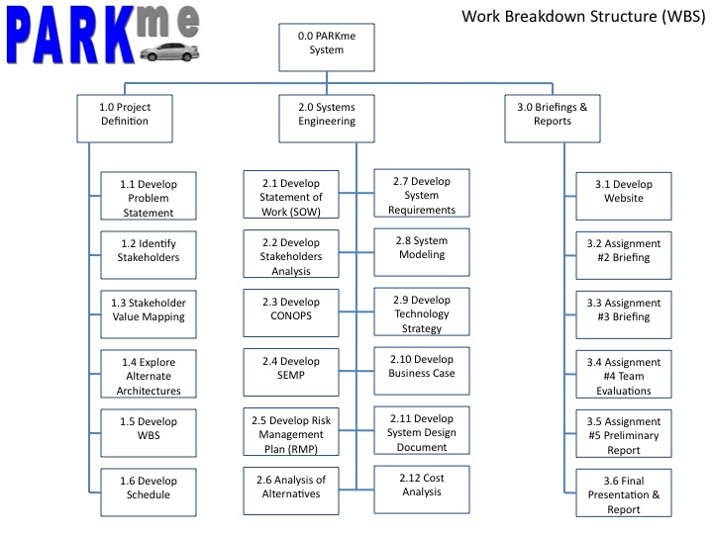

Figure B-1: PARKme Work Breakdown Structure

B.2 Schedule

The schedule was developed in OpenProj. OpenProj is an open source software program that is similar to the more popular Microsoft Project. The initial reason for using OpenProj was because it is free to use. Not everyone in the group had access to Microsoft Project. OpenProj allows the user to develop both GANTT and PERT charts. The PERT charts were fairly basic and attempts later were made to upload the data to Microsoft Project for more detailed PERT charts. A screenshot of the PARKme System schedule is shown below in Figure B-2.1. Screenshots of the PARKme PERT Charts are shown below in Figures B-2.2 & B-2.3.

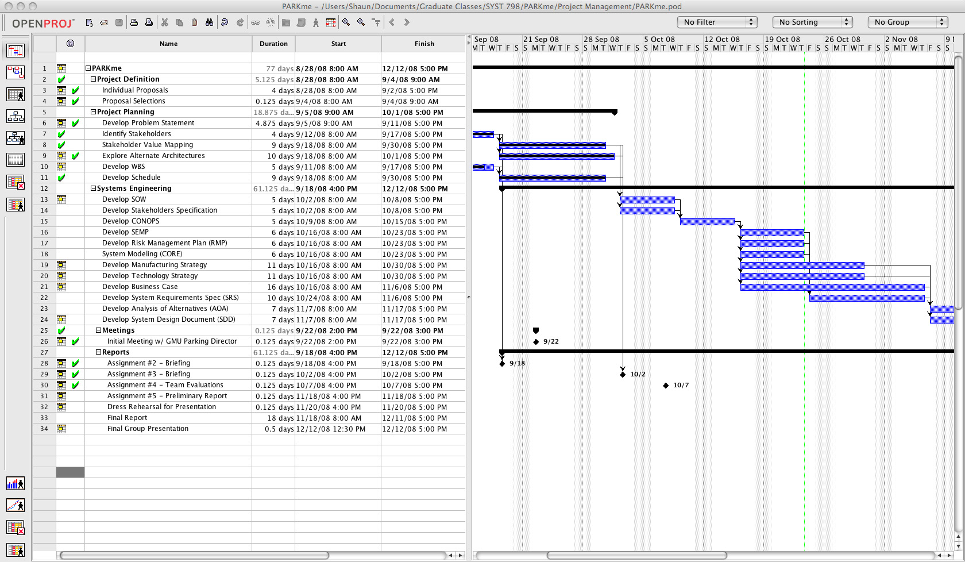

Figure B-2.1: OpenProj Screenshot of the PARKme Schedule

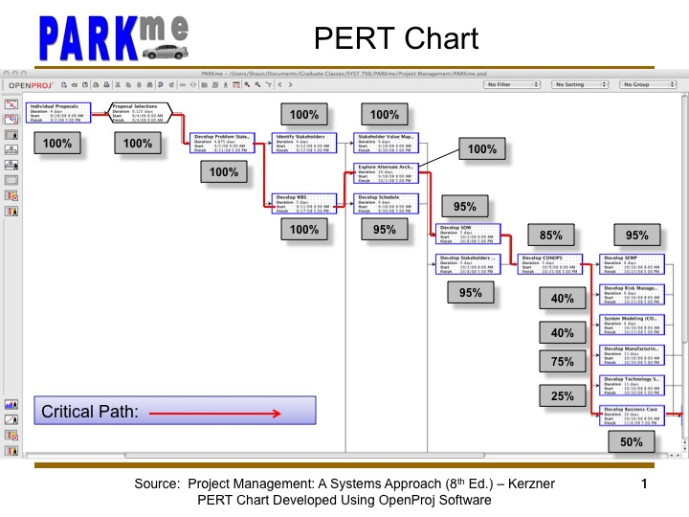

Figure B-2.2: PERT Chart (First Half)

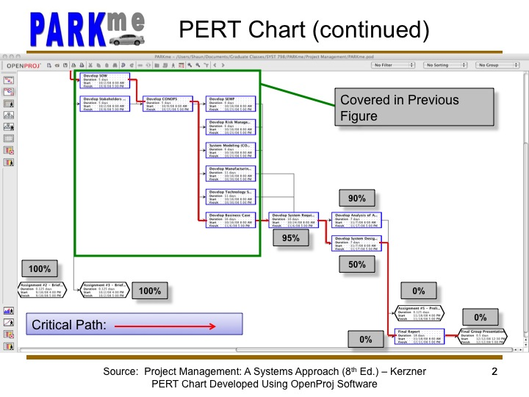

Figure B-2.3: PERT Chart (Second Half)

B.3 Action Items

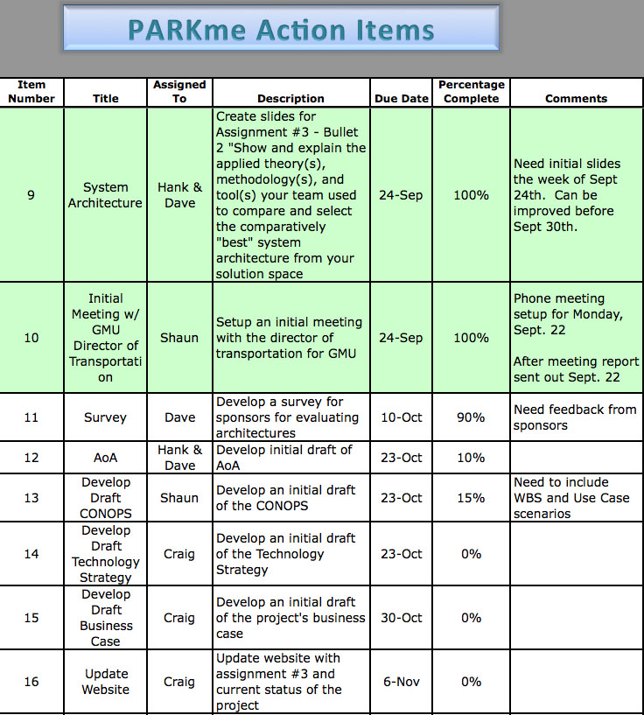

Figure B-3: Screenshot of PARKme Action Items

B.4 Website

The PARKme website is located at:

<http://mason.gmu.edu/~cemmerto/>

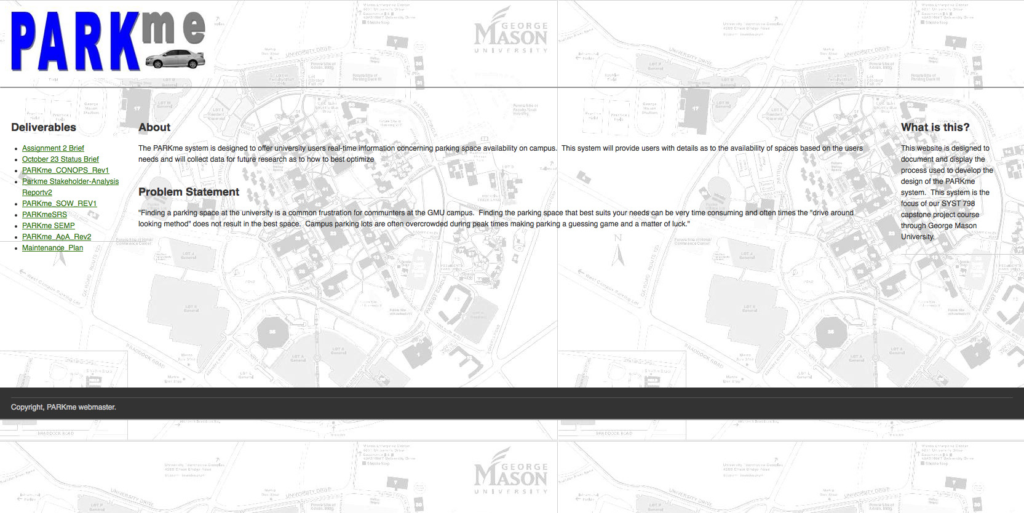

Figure B.4-1: Screenshot of PARKme Website

APPENDIX C - Initial PARKme System Risks

The following screenshots are the initial risks developed for the PARKme System. These are also available in the PARKme Risk Management Plan.

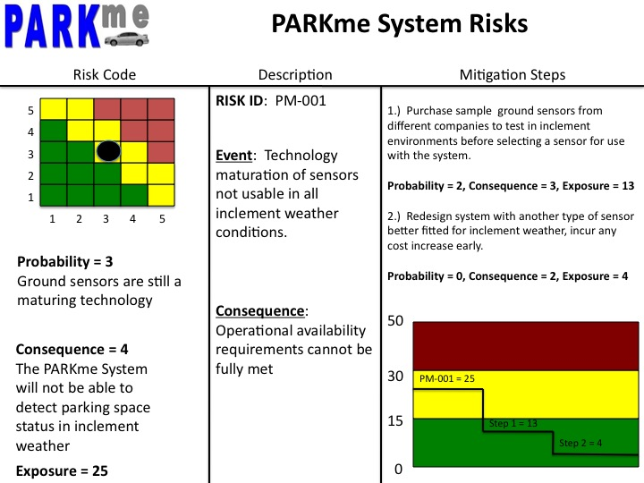

Figure C-1: Risk PM-001

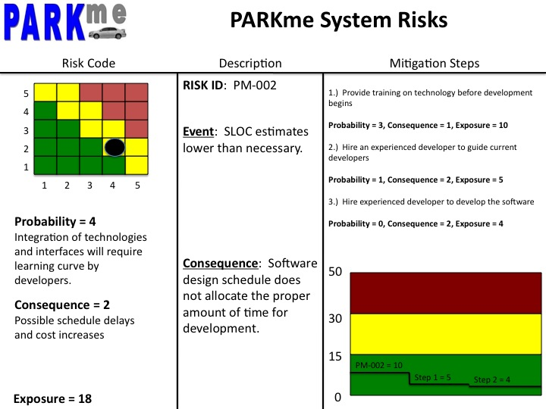

Figure C-2: Risk PM-002

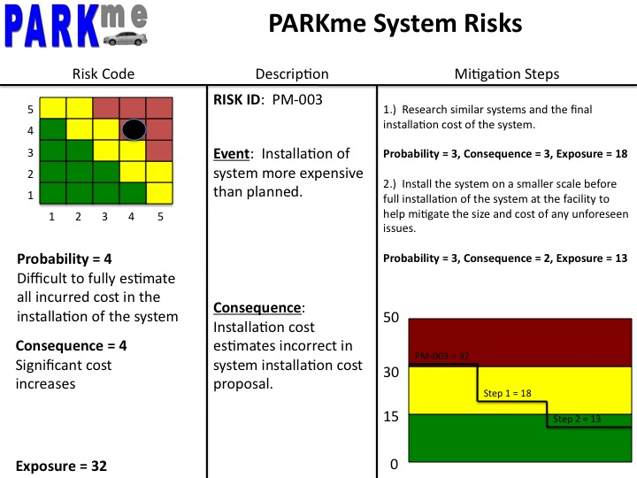

Figure C-3: Risk PM-003

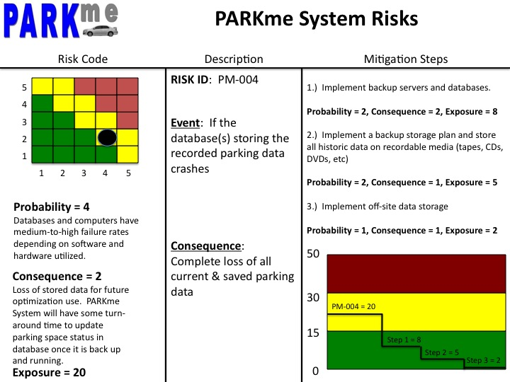

Figure C-4: Risk PM-004

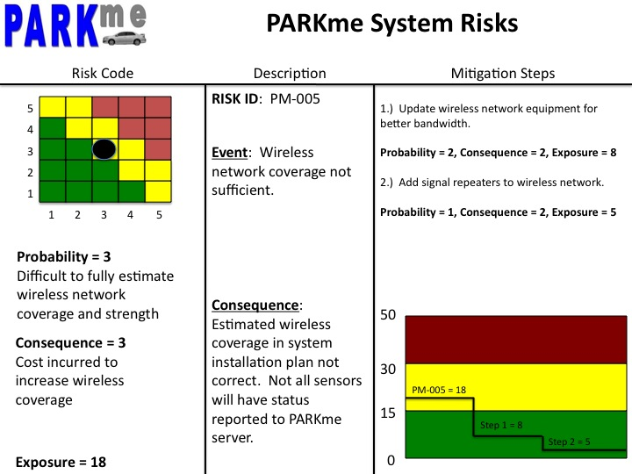

Figure C-5: Risk PM-005

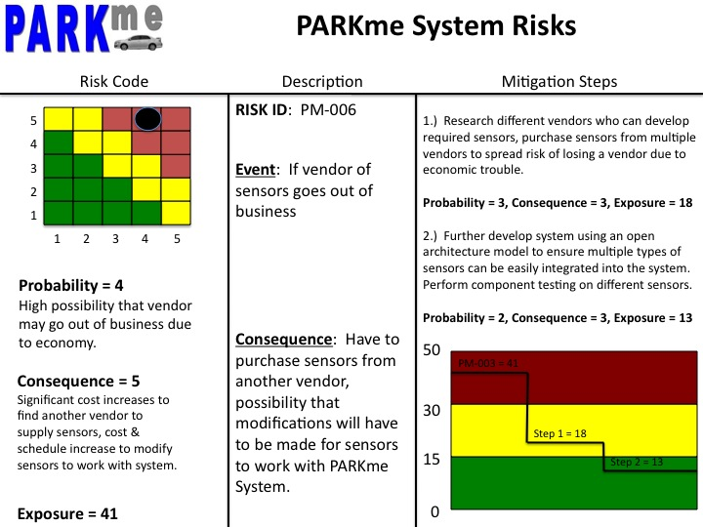

Figure C-6: Risk PM-006

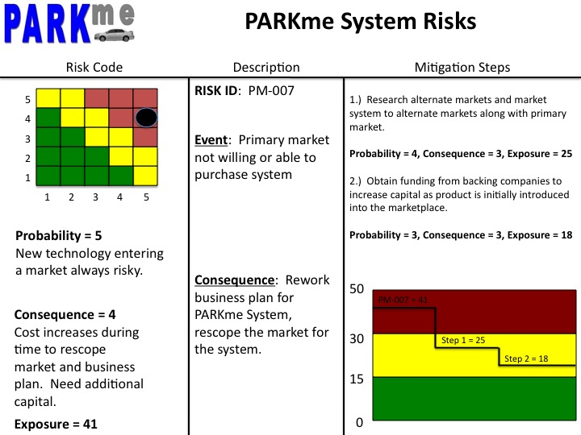

Figure C-7: Risk PM-007

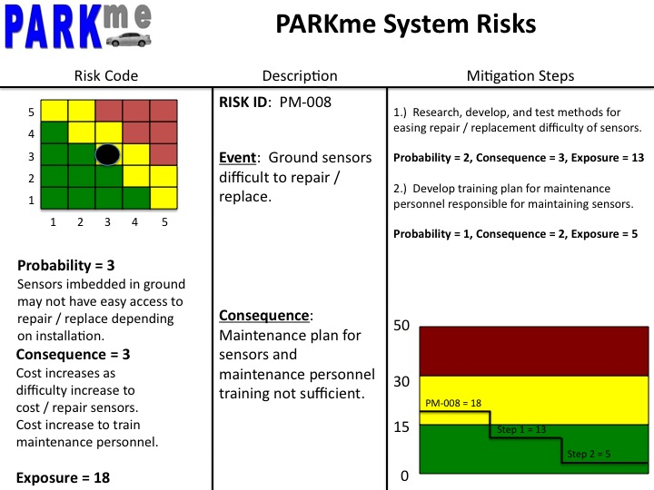

Figure C-8: Risk PM-008

APPENDIX D - Stakeholder Use Cases

The following screen captures are of the PARKme Use Cases that were developed for the Stakeholder’s Analysis document.

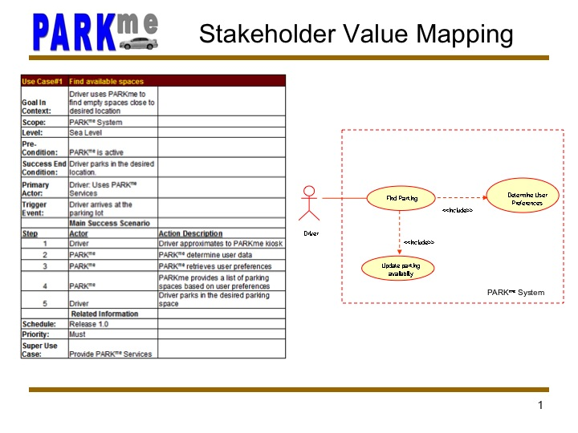

Figure D-1: Use Case Scenario #1

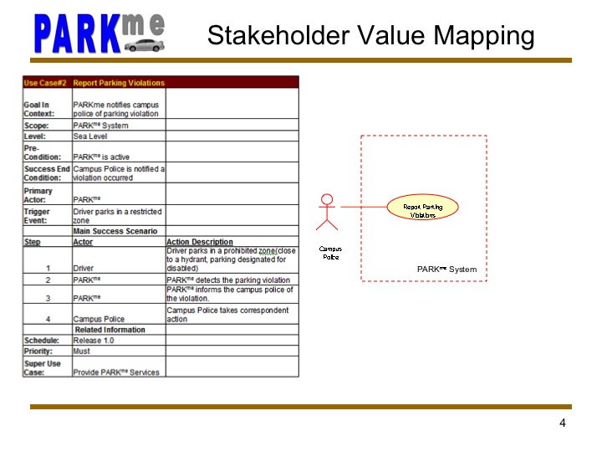

Figure D-2: Use Case Scenario #2

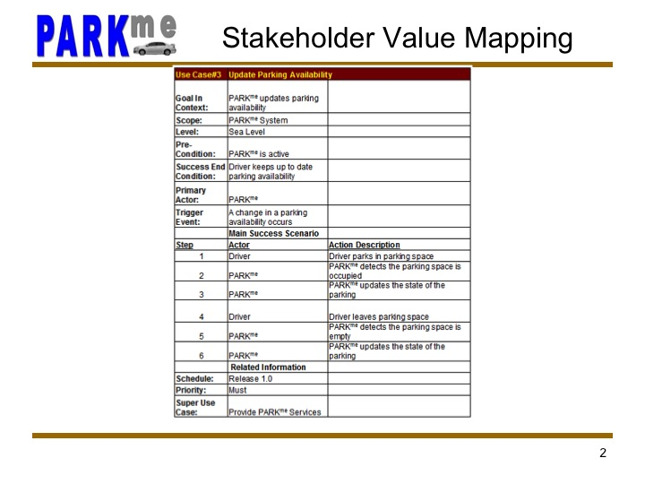

Figure D-3: Use Case Scenario #3

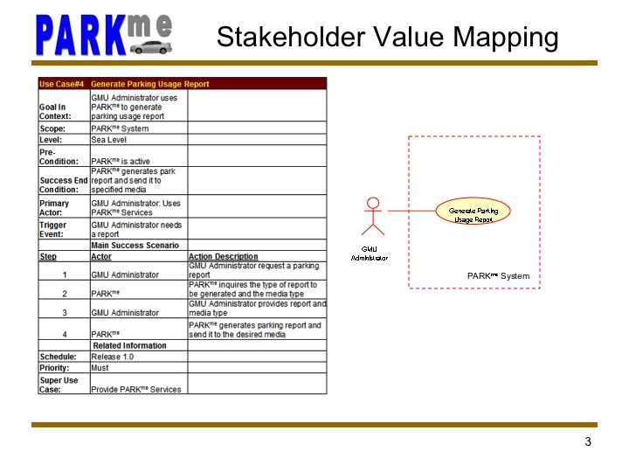

Figure D-4: Use Case Scenario #4

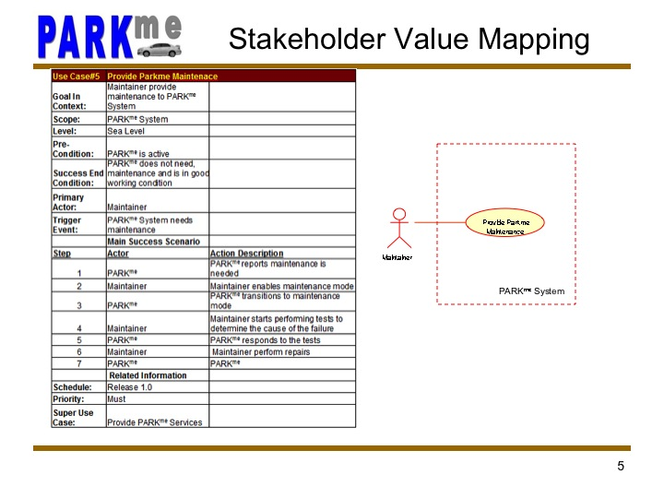

Figure D-5: Use Case Scenario #5

APPENDIX E - Functional Architecture Diagrams

The following are functional architecture diagrams used to functionally diagram the PARKme system. The breakdown includes IDEF0, Data Flow, and State diagrams. The IDEF0 diagrams were developed using the CORE software program.

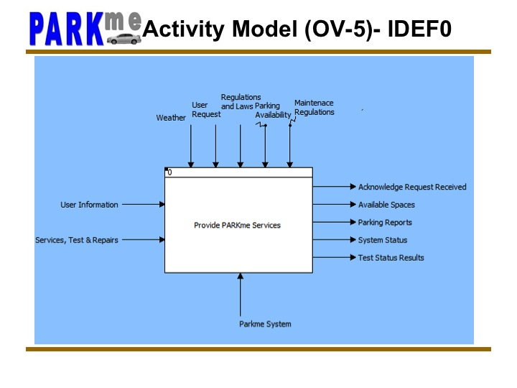

Figure E-1: IDEF0 Diagram of PARKme System

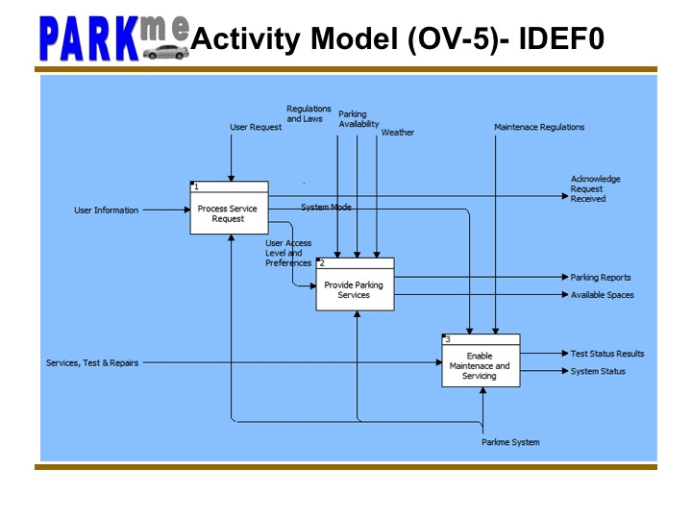

Figure E-2: IDEF0 Diagram of Top Level Functions

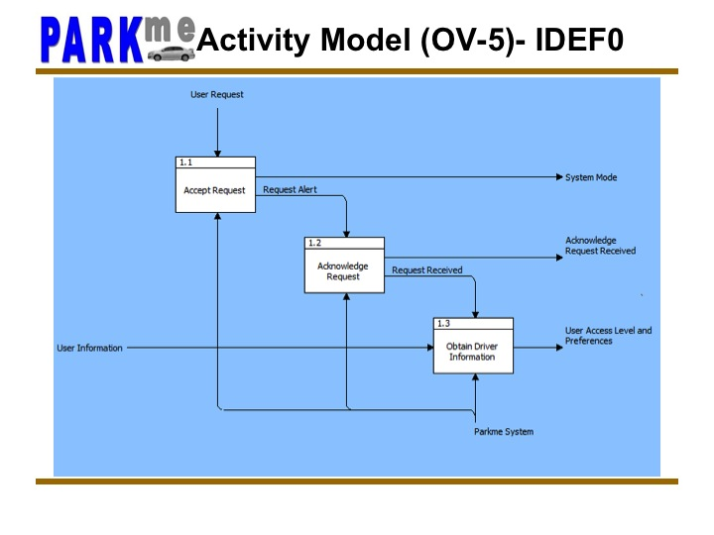

Figure E-3: IDEF0 Diagram of Top Level Function – Process Service Request

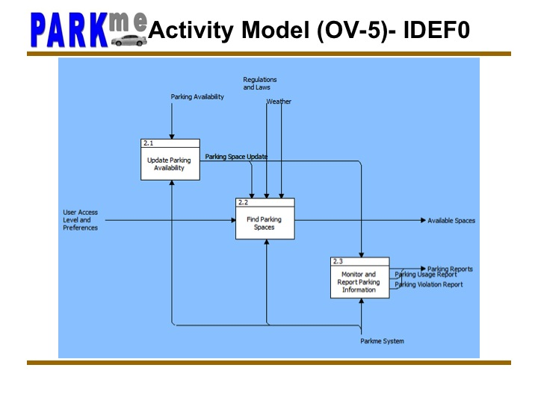

Figure E-4: IDEF0 Diagram of Top Level Function – Provide Parking Services

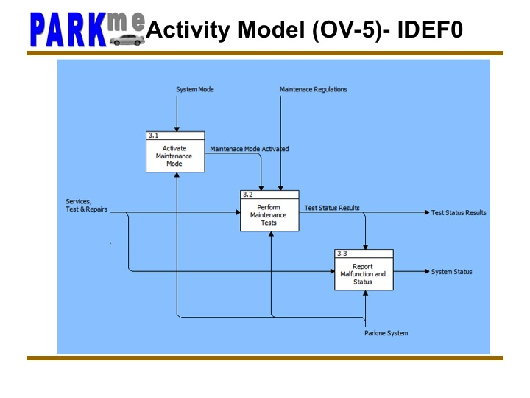

Figure E-5: IDEF0 Diagram of Top Level Function – Enable Maintenance & Servicing

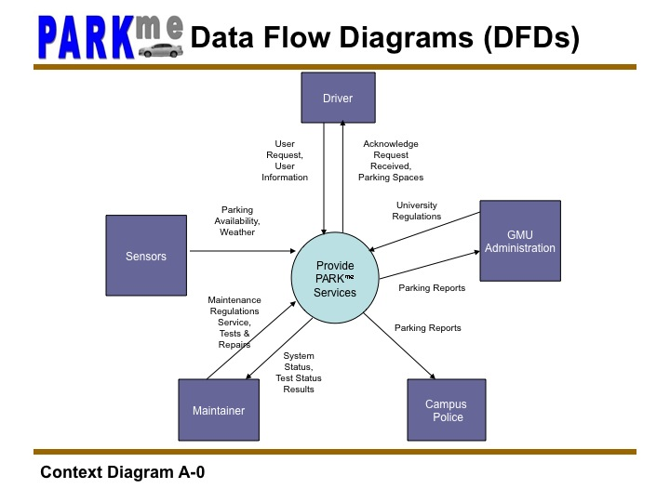

Figure E-6: Data Flow Diagram of PARKme Services

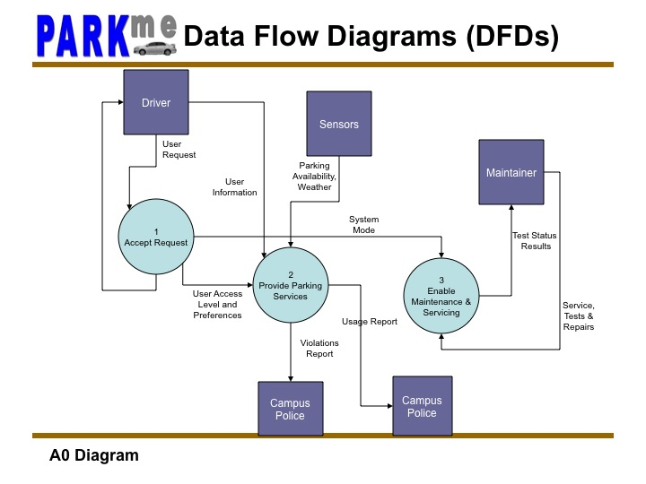

Figure E-7: Data Flow Diagram Top-Level PARKme Functions

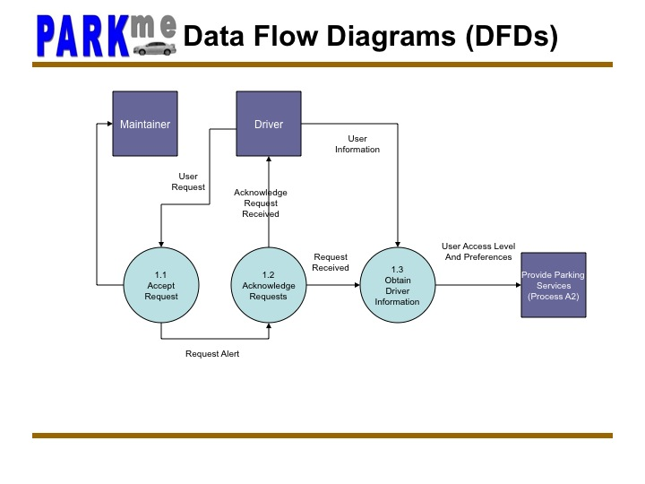

Figure E-8: Data Flow Diagram of Process Request Function

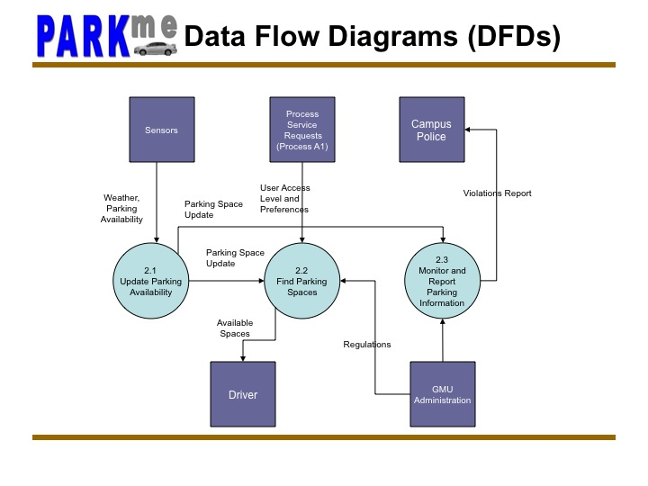

Figure E-9: Data Flow Diagram of Provide Parking Services Function

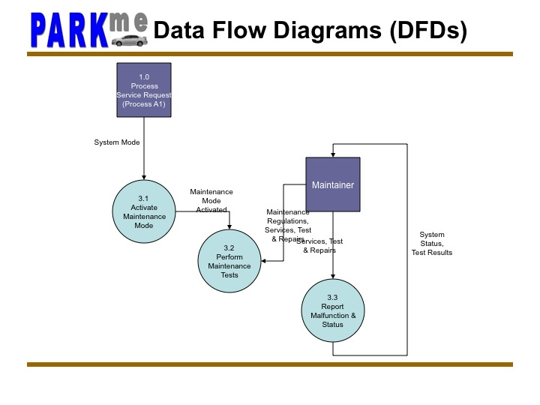

Figure E-10: Data Flow Diagram of Maintenance Function

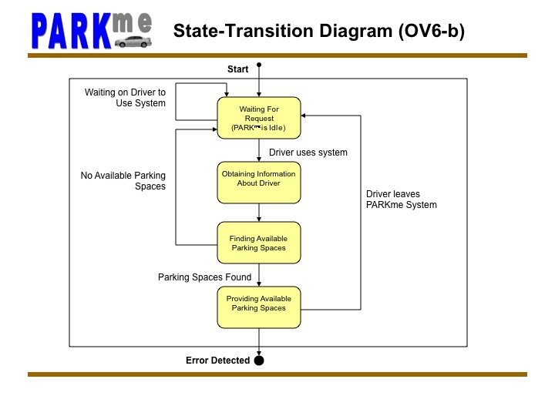

Figure E-11: State Diagram of PARKme System

APPENDIX F - Functional Design Diagrams

The following are the diagrams referred to in section 10.0 System Design.



Figure F-1: Top-Level Hardware Interface Diagram



Figure F-2: Server Mode Software Interface Diagram

APPENDIX G - Intellectual Property Rights

The PARKme system is comprised of components that will be purchased for use to be integrated in the system. The individual components’ rights belong to the patent holder and/or company that manufacturers the component.

The PARKme system will apply for a patent for the concept of the parking locator system. The first step before applying for a patent was to do a search of patents for similar systems. The PARKme team accessed the United States Patent and Trademark Office (USPTO) via Google Patent Search to perform this search. The results of the search included four similar systems.

The first result was US Patent Application No. 10/012,750 filed on December 7, 2001. Titled, “Automated Space Availability Coordinator,” the patent application was filed by George A. Drennan. A summary of the system is as follows: “Implement an automated available unit locator for a multiple unit network comprising an occupancy sensor for determining an occupancy status of each unit in a multiple unit network.” The patent application describes a high-level system and uses a parking facility as an example of utilizing the idea. See Figure 14.7-1 below for an example of the system.

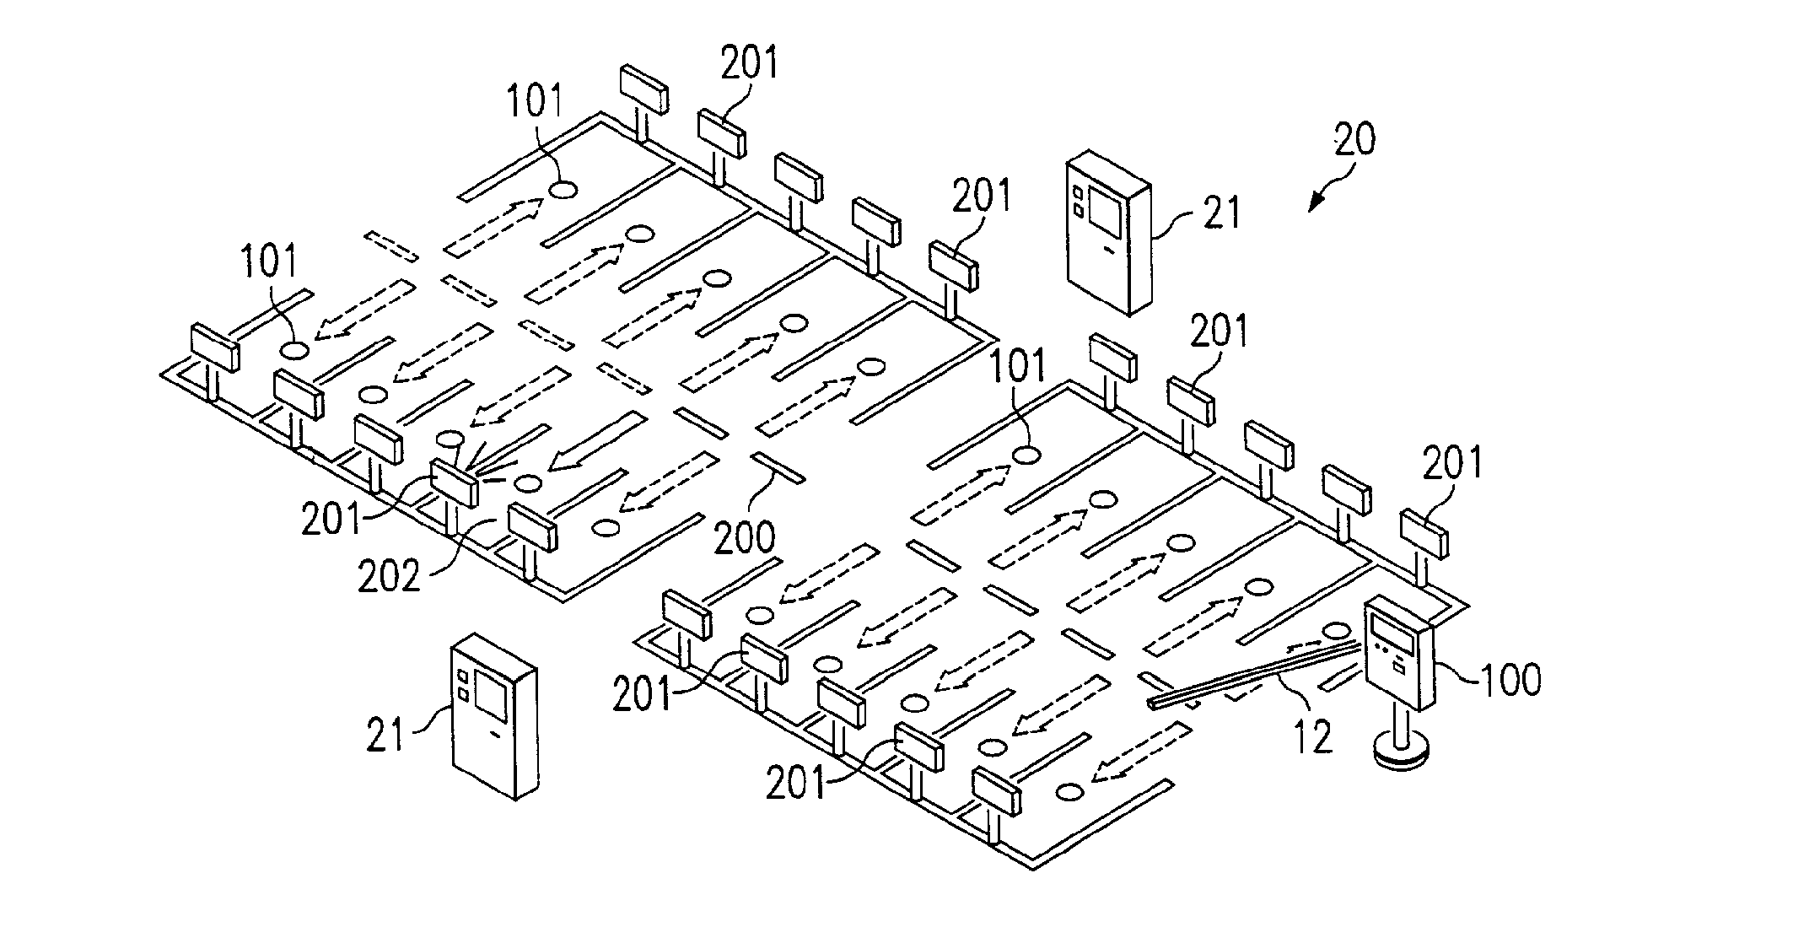

Figure G-1: Drawing of the Automated Space Availability Coordinator

This idea does include the space sensor and describes a locator device for locating a space. The parking example described in the patent application includes lift gates and access stations. The access stations examples includes airports where the user could enter the airline they are flying and the system would give them the closest available parking space. This is very similar to the PARKme idea of a kiosk helping the driver find a parking space. This patent application would have to be further analyzed by a patent attorney to see if there are enough differences between this system and the PARKme system to allow the PARKme team to file a patent without infringing on this patent application. It should be noted that this patent application is still awaiting approval for a patent.

The second result was US Patent Application No. 09/736,355 filed on December 14, 2000. Titled, “Method and Systems for Space Reservation on Parking Lots with Mechanisms for Space Auction, Over-booking, Reservation Period Extensions, and Incentives,” the patent application was filed by Andrew J. Dillon. A summary of the system is as follows: “A computer-driven reservation system for reserving spaces in a parking facility at an airport terminal. System comprised of a central server, database of locations, associated spaces, and one or more computer terminals. A GUI for receiving customer reservations and an interlinked network via a WAN such as the Internet.” Figure 14.7-2 shows a concept drawing of the system.

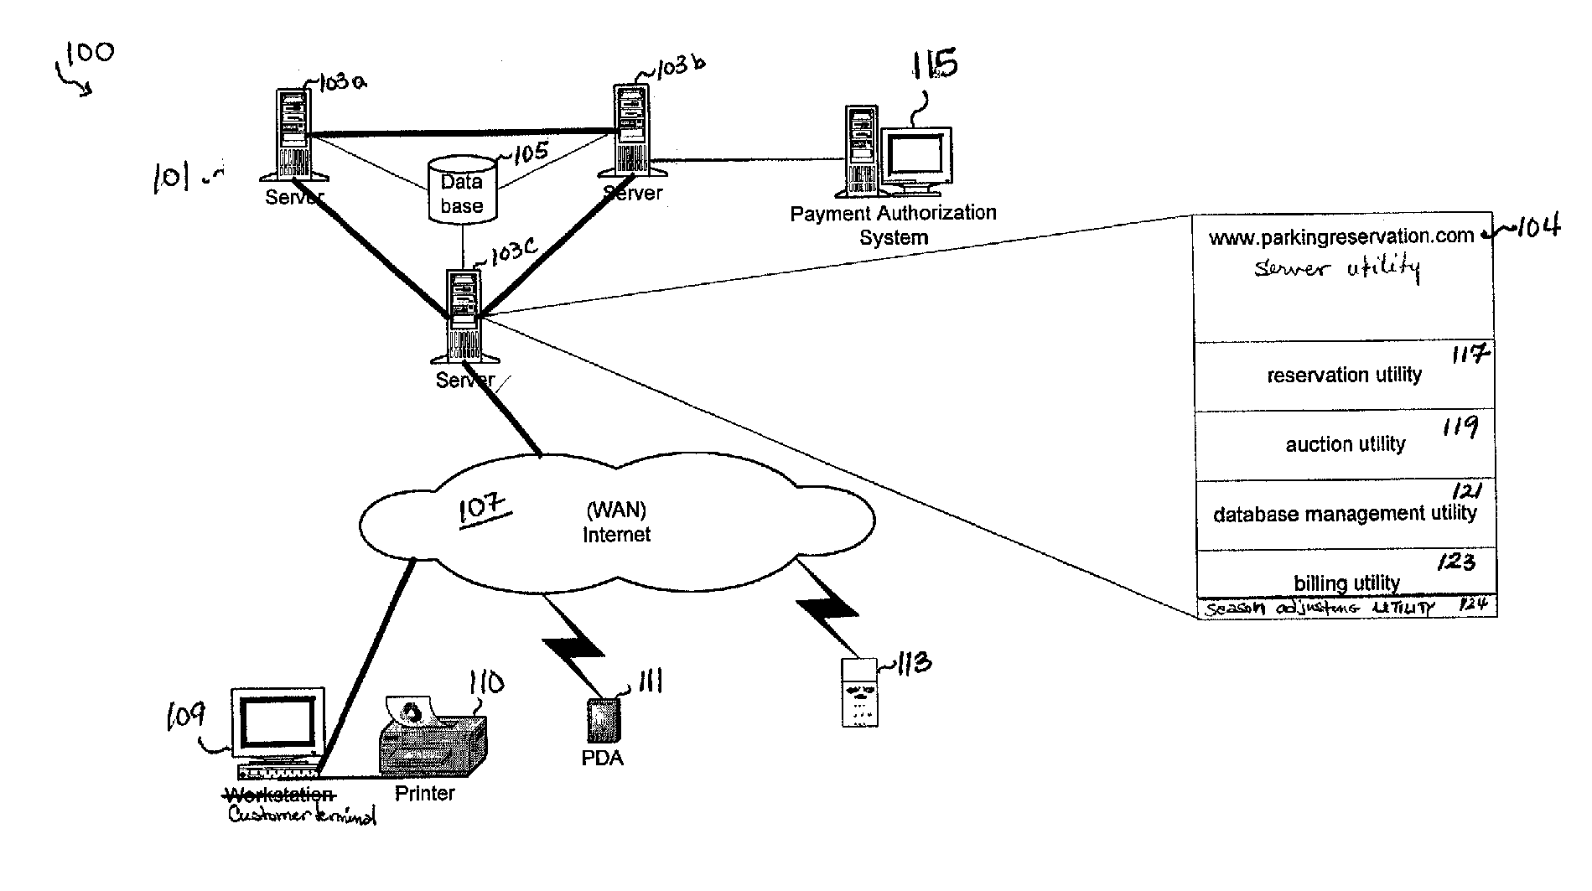

Figure G-2: Concept Drawing of Reservation Patent Application

This patent application has several capabilities contained within the PARKme system such as a central server, database of locations, computer terminals, and interlinked via a WAN. This patent application describes a reservation and auction system and the PARKme system is not designed to reserve or auction parking spaces. The PARKme system would not infringe on this patent application if the application for a patent were approved.

The third result was US Patent Application No. 11/022,442 filed on December 22, 2004. This patent application was approved and is Patent No. US 7,289,903 B2. Titled, “Methods, Systems, and Computer Program Products for Implementing a Locator Service,” the patent application was filed by Maria Adamczyk and Edward Silver. A summary of the system is as follows: “Receiving object identification information from a mobile object and receiving location identification information from the mobile object. The location identification information indicates the presence of the mobile object at a location. Also, includes associating the object identification information with the location identification information and creating an occupancy record including result of the associating. Storing the occupancy record in a storage device.” A concept of the patent is shown in Figure 14.7-3.

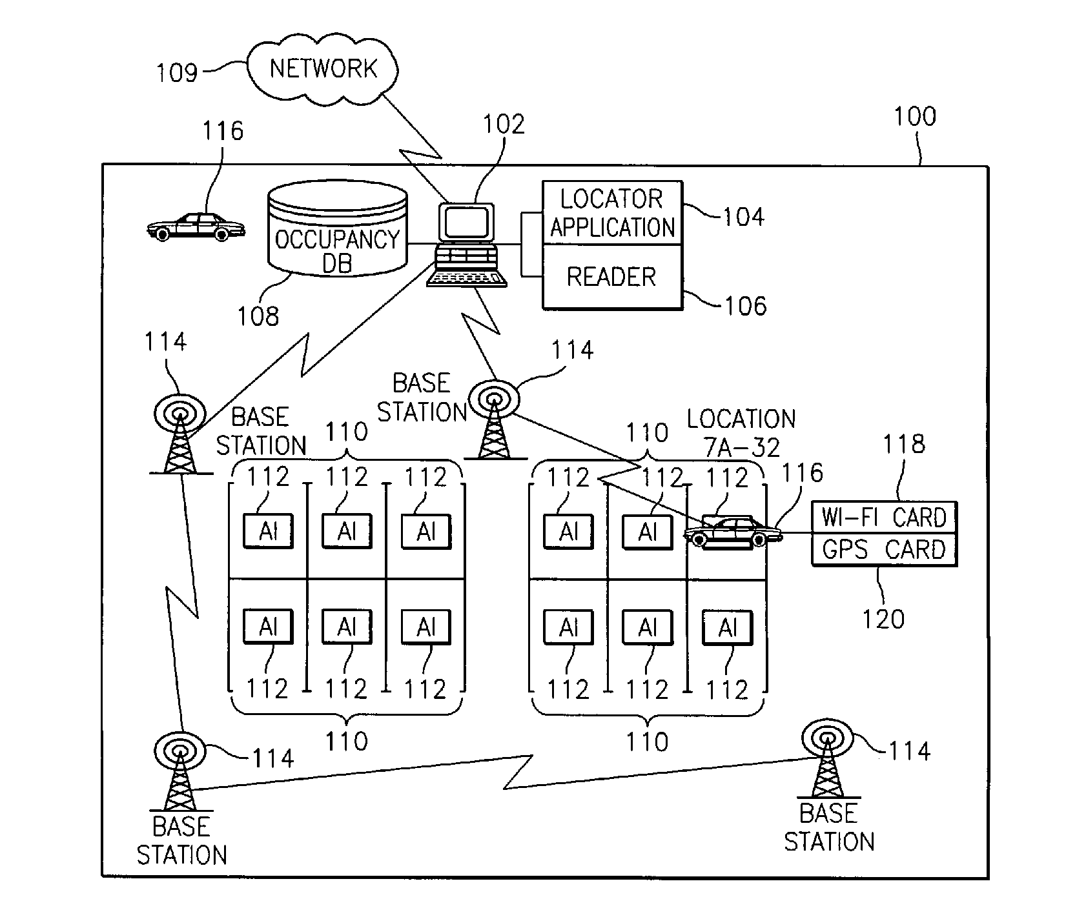

Figure G-3: Concept Drawing of Locator Service Patent

This patent has several components similar to the PARKme system such as an occupancy database, network, and object identification. The key difference between the patented system and our system is our system does not depend on receiving information from the vehicle. The patented system requires obtaining object identification from the vehicle, which is not required in the PARKme system. The patent system has each vehicle containing a Wi-Fi or GPS card to identify itself. This system also details collecting parking fees, which is also not part of the PARKme system. The PARKme system has some similarities with this patent but enough differences that the PARKme team feels a patent attorney could argue that the PARKme system does not infringe on the patent holder’s rights.

The final result of the search was US Patent Application No. 11/207,514 filed August 19, 2005. Titled, “Parking Space Locator,” the patent application was filed by Alan L. Browne, Osman D. Altan, and Douglas P. Rheaume. A general description of the patent application is as following: “Method for identifying available parking spaces. Receive data about a parking space from a vehicle including geographic indicator associated with the parking space. Storing the data in a database of available parking spaces. Receiving a geographic location from a parking space requestor. Searching a database for an available space. If a space is available, transmit a geographic indicator to the requestor.” A concept diagram of this patent application can be viewed in Figure 14.7-4.

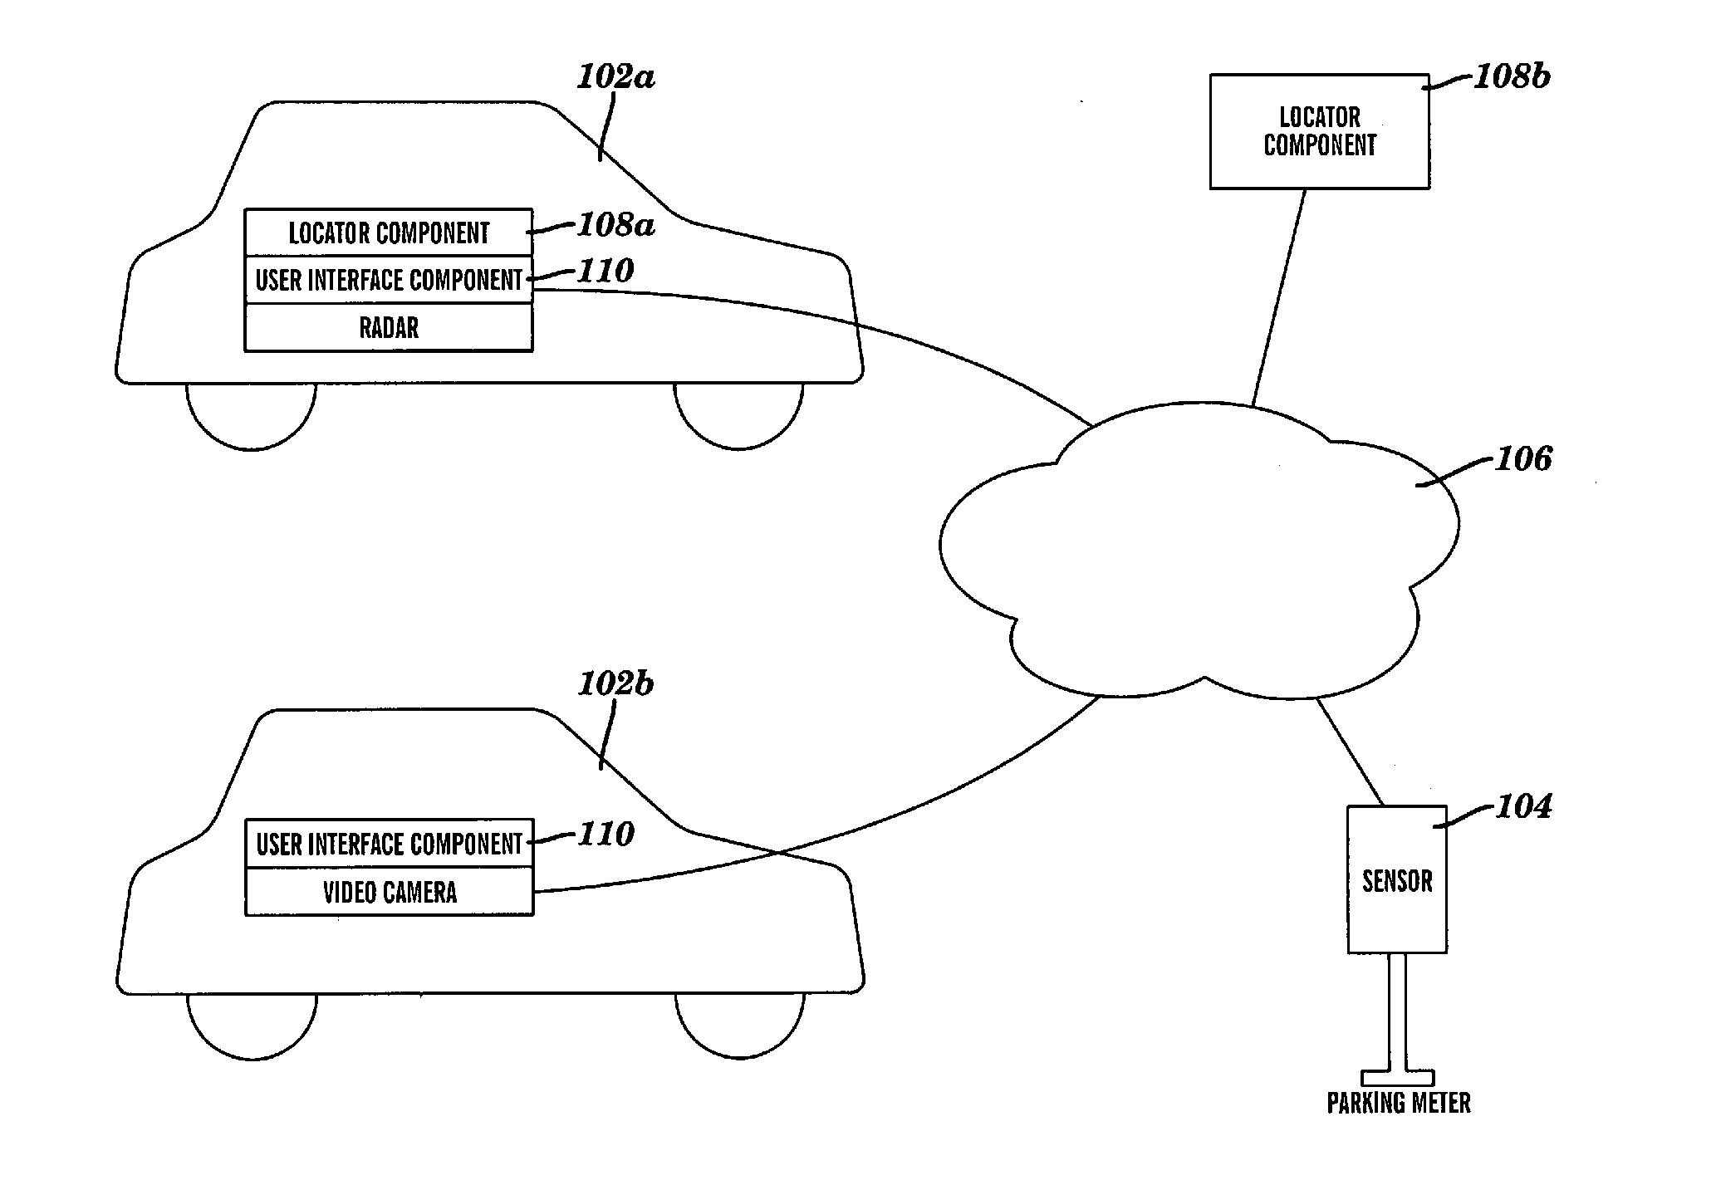

Figure G-4: Concept Drawing of Parking Space Locator Patent Application

Similar to the other patent applications discussed, this patent application describes components that are part of the PARKme system such as parking space sensors and a database of available parking spaces. This patent application describes finding parking spaces via a GPS-like device located within the vehicle. The GPS device would locate nearby parking spaces. The database accessed by the GPS device would charge a usage fee or require a mobile subscription. The system described by the patent is different from the PARKme system in that the PARKme system does not rely on a car’s GPS device to find available parking spaces. A PARKme system patent application would not infringe on the rights of this patent application if the application is accepted and becomes a patent.

The PARKme system is a unique concept and a patent application will be submitted to the USPTO. The PARKme team understands that the system has some similar capabilities as the parking systems mentioned in the four patent applications. The PARKme team believes there are significant differences between the PARKme system and the described parking systems in the patent applications that the PARKme system would not infringe on the rights of the patent holders.

What the PARKme system patent shall claim is:

1. A system to monitor the current occupancy status on every parking space in a facility comprising:

* + - An imbedded wireless sensor located at each parking space;
    - A relay device to transmit the status signal from the sensor onto a wireless network;
    - A computer server to store and analyze the parking space status data;
    - Capability to integrate external components into the system with access to this parking data.

2. The computer server of claim 1 further comprising:

* + - A connection to the wireless network that communicates with the relays and external components;
    - A connection to the Internet to communicate with personal electronic devices;
    - Database software installed on the server to store the parking space status data;
    - Software to perform analysis on the parking space status data;
    - Web application software to communicate with devices connected to the Internet;
    - Software to perform system back-ups, maintenance, and security of the server.

3. The external components of claim 1 further comprising:

* + - Any form of digital signs that displays parking information;
    - Any form of human interface that interacts with the server;
    - Any type of electronic device that can transmit or accept electronic data (i.e. a video camera).

4. The human interface of claim 3 further comprising:

* + - Any form of computer terminal that accepts user input and displays system output (an example being a kiosk);
    - Any form of portable electronic device that accepts user input and displays system output;
    - Any components utilizing a RFID chip to identify itself to the system.

APPENDIX H - Business Tables

The following are the business tables referred to in section 13.0 Business Case.

|  |  |  |  |  |  |  |
| --- | --- | --- | --- | --- | --- | --- |
|  |  |  |  |  |  |  |
| |  |  |  |  |  | | --- | --- | --- | --- | --- | | Expenses |  | Month | Cost |  | | Software Development | Coding | 1 | 2,800.00 |  | |  | Coding | 2 | 2,800.00 |  | |  | Coding | 3 | 2,800.00 |  | |  | Coding | 4 | 2,800.00 |  | |  | Coding | 5 | 2,800.00 |  | | Total |  |  | 14,000.00 |  | |  |  |  |  |  | | Software Testing | Testing | 4 | 2,000.00 |  | |  | Testing | 5 | 2,000.00 |  | |  | Testing | 6 | 2,000.00 |  | | Total |  |  | 6,000.00 |  | |  |  |  |  |  | | Hardware Components | Server | 1 | 8,200.00 | GMU Cost | |  | LAN Controller | 2 | 14,000.00 | GMU Cost | |  | Access Points 3 units @ $3000 | 2 | 9,000.00 | GMU Cost | |  | Parking Sensors Purchase 5 units @ $150 | 2 | 750.00 | GMU Cost | |  | Directional Sign | 3 | 10,000.00 | GMU Cost | | Total |  |  | 41,950.00 | GMU Cost | |  |  |  |  |  | | Hardware Testing | Server Testing | 2 | 500.00 |  | |  | Hardware integration | 2 | 1,000.00 |  | |  | Hardware integration | 3 | 1,000.00 |  | |  | Hardware integration | 4 | 1,000.00 |  | | Total |  |  | 3,500.00 |  | |  |  |  |  |  | | Integration Testing | SW/HW integration | 5 | 2,000.00 |  | |  | SW/HW integration | 6 | 1,000.00 |  | |  | SW/HW integration | 7 | 500.00 |  | | Total |  |  | 3,500.00 |  | |  |  |  |  |  | |  |  |  |  |  | | Total needed for development |  |  | 27,000.00 |  | |  |  |  |  |  |  |
|  |  |  |  |  |  |  |

Figure H-1: Cost Breakdown To PARKme - GMU Providing The 14K Investment Funds

|  |  |  |  |  |
| --- | --- | --- | --- | --- |
| Location | General Spaces Total | Sensor Cost $150 Per Unit | Sensor Install Cost $45 per unit. Cost waived | Total |
| Lot J | 389 | 150 | 0 | 58,350 |
| Lot M | 159 | 150 | 0 | 23,850 |
| Totals | 548 |  |  | 82,200 |
|  |  |  |  |  |
| Location | General Spaces Total | Sensor Cost $150 Per Unit | Sensor Install Cost $45 per unit. | Total |
| Lot A | 1040 | 150 | 45 | 202,800 |
| Lot C | 601 | 150 | 45 | 117,195 |
| Lot K | 1485 | 150 | 45 | 289,575 |
| Lot L | 337 | 150 | 45 | 65,715 |
| Lot O | 223 | 150 | 45 | 43,485 |
| Lot P | 228 | 150 | 45 | 44,460 |
| Totals | 3914 |  |  | 845,430 |
|  |  |  | Equipment Fee for install | 500 |
|  |  |  |  | 845,930 |
| Directional Signs | 3@10,000K per plus $500 each installation. Install cost waived for 1st unit | 31,000 |  |  |
|  |  |  |  |  |
| Location | Access Points @ $3000 | LAN Controllers @ 14K |  |  |
| Lot J | 1 | 1 | installation costs waived |  |
| Lot M | 1 | 0 |  |
|  |  |  |  |  |
| Lot A | 3 | 1 |  |  |
| Lot C | 1 | 1 |  |  |
| Lot K | 3 | 1 |  |  |
| Lot L | 1 | 1 |  |  |
| Lot O | 1 | 1 |  |  |
| Lot P | 1 | 1 |  |  |
|  | 10 | 6 |  |  |
|  | 30,000 | 84,000 |  |  |
|  | install costs @ $125 per | install costs @ $200 per |  |  |
| Totals | 31,000 | 85,000 |  |  |
|  |  |  |  |  |
|  |  |  |  |  |
| Server Cost | 8,200 |  |  |  |
| Server Set up | 200 | waived |  |  |
|  | 8,200 |  |  |  |
|  |  |  |  |  |
| Software Cost | 10,000 | waived |  |  |
|  |  |  |  |  |
| Initial Setup Cost | <5000>1000 Spaces @ .75 Per Space | Lots J and M cost waived |  |  |
|  | 2,935.50 |  |  |  |
|  |  |  |  |  |
|  |  |  |  |  |
| Total Cost to GMU | 1,014,066 |  |  |  |

Figure H-2: Cost To GMU If Investment Funds Are Provided

|  |  |  |  |
| --- | --- | --- | --- |
| Expenses |  | Month | Cost |
| Software Development | Coding | 1 | 2,800.00 |
|  | Coding | 2 | 2,800.00 |
|  | Coding | 3 | 2,800.00 |
|  | Coding | 4 | 2,800.00 |
|  | Coding | 5 | 2,800.00 |
| Total |  |  | 14,000.00 |
|  |  |  |  |
| Software Testing | Testing | 4 | 2,000.00 |
|  | Testing | 5 | 2,000.00 |
|  | Testing | 6 | 2,000.00 |
| Total |  |  | 6,000.00 |
|  |  |  |  |
| Hardware Components | Server | 1 | 8,200.00 |
|  | LAN Controller | 2 | 14,000.00 |
|  | Access Points 3 units @ $3000 | 2 | 9,000.00 |
|  | Parking Sensors Purchase 5 units @ $150 | 2 | 750.00 |
|  | Directional Sign | 3 | 10,000.00 |
| Total |  |  | 41,950.00 |
|  |  |  |  |
| Hardware Testing | Server Testing | 2 | 500.00 |
|  | Hardware integration | 2 | 1,000.00 |
|  | Hardware integration | 3 | 1,000.00 |
|  | Hardware integration | 4 | 1,000.00 |
| Total |  |  | 3,500.00 |
|  |  |  |  |
| Integration Testing | SW/HW integration | 5 | 2,000.00 |
|  | SW/HW integration | 6 | 1,000.00 |
|  | SW/HW integration | 7 | 500.00 |
| Total |  |  | 3,500.00 |
|  |  |  |  |
|  |  |  |  |
| Total needed for development |  |  | 68,950.00 |

Figure H-3: Development Cost Without Investor Funds

|  |  |  |  |  |
| --- | --- | --- | --- | --- |
| Location | General Spaces Total | Sensor Cost $150 Per Unit | Sensor Install Cost $45 per unit. Cost waived | Total |
| Lot J | 389 | 150 | 0 | 58,350 |
| Lot M | 159 | 150 | 0 | 23,850 |
| Totals | 548 |  |  | 82,200 |
|  |  |  |  |  |
| Location | General Spaces Total | Sensor Cost $150 Per Unit | Sensor Install Cost $45 per unit. | Total |
| Lot A | 1040 | 150 | 45 | 202,800 |
| Lot C | 601 | 150 | 45 | 117,195 |
| Lot K | 1485 | 150 | 45 | 289,575 |
| Lot L | 337 | 150 | 45 | 65,715 |
| Lot O | 223 | 150 | 45 | 43,485 |
| Lot P | 228 | 150 | 45 | 44,460 |
| Totals | 3914 |  |  | 845,430 |
|  |  |  | Equipment Fee for install | 500 |
|  |  |  |  | 845,930 |
| Directional Signs | 3@10,000K per plus $500 each installation. Install cost waived for 1st unit | 31,000 |  |  |
|  |  |  |  |  |
| Location | Access Points @ $3000 | LAN Controllers @ 14K |  |  |
| Lot J | 1 | 1 | installation costs waived |  |
| Lot M | 1 | 0 |  |
|  |  |  |  |  |
| Lot A | 3 | 1 |  |  |
| Lot C | 1 | 1 |  |  |
| Lot K | 3 | 1 |  |  |
| Lot L | 1 | 1 |  |  |
| Lot O | 1 | 1 |  |  |
| Lot P | 1 | 1 |  |  |
|  | 10 | 6 |  |  |
|  | 30,000 | 84,000 |  |  |
|  | install costs @ $125 per | install costs @ $200 per |  |  |
| Totals | 31,000 | 85,000 |  |  |
|  |  |  |  |  |
|  |  |  |  |  |
| Server Cost | 8,200 |  |  |  |
| Server Set up | 200 | waived |  |  |
|  | 8,200 |  |  |  |
|  |  |  |  |  |
| Software Cost | 10,000 | waived |  |  |
|  |  |  |  |  |
| Initial Setup Cost | <5000>1000 Spaces @ .75 Per Space | Lots J and M cost waived |  |  |
|  | 2,935.50 |  |  |  |
|  |  |  |  |  |
|  |  |  |  |  |
| Total Cost to GMU | 1,014,066 |  |  |  |

Figure H-4: GMU Cost For The PARKme System Without Providing Investment Funds

|  |  |  |  |  |  |  |
| --- | --- | --- | --- | --- | --- | --- |
|  |  |  |  |  |  |  |
| Month | Expenses | Income | Net | Total Net |  | # of Systems |
| 1 | 11,000.00 | 0.00 | 11,000.00 | 11,000.00 |  | 1 |
| 2 | 28,050.00 | 0.00 | 28,050.00 | 39,050.00 |  |  |
| 3 | 13,800.00 | 0.00 | 13,800.00 | 52,850.00 |  |  |
| 4 | 5,800.00 | 0.00 | 5,800.00 | 58,650.00 |  |  |
| 5 | 6,800.00 | 0.00 | 6,800.00 | 65,450.00 |  |  |
| 6 | 3,000.00 | 0.00 | 3,000.00 | 68,450.00 |  |  |
| 7 | 500.00 | 0.00 | 500.00 | 68,950.00 |  |  |
| 8 | 0.00 | 54,305.00 | 54,305.00 | 14,645.00 |  |  |
| 9 | 0.00 | 54,305.00 | 54,305.00 | 39,660.00 |  |  |
| 10 | 0.00 | 54,305.00 | 54,305.00 | 93,965.00 |  |  |
| 11 | 0.00 | 0.00 | 0.00 | 93,965.00 |  |  |
| 12 | 0.00 | 0.00 | 0.00 | 93,965.00 |  |  |
| Year |  |  |  |  |  |  |
| 2 | 8,000.00 | 651,660.00 | 643,660.00 | 737,625.00 |  | 4 |
| 3 | 6,000.00 | 488,745.00 | 482,745.00 | 1,220,370.00 |  | 3 |
| 4 | 4,000.00 | 325,830.00 | 321,830.00 | 1,542,200.00 |  | 2 |
| 5 | 2,000.00 | 162,915.00 | 160,915.00 | 1,703,115.00 |  | 1 |
| 6 | 4,000.00 | 325,830.00 | 321,830.00 | 2,024,945.00 |  | 2 |
| 7 | 2,000.00 | 162,915.00 | 160,915.00 | 2,185,860.00 |  | 1 |
| 8 | 4,000.00 | 325,830.00 | 321,830.00 | 2,507,690.00 |  | 2 |
| 9 | 2,000.00 | 162,915.00 | 160,915.00 | 2,668,605.00 |  | 1 |
| 10 | 4,000.00 | 325,830.00 | 321,830.00 | 2,990,435.00 |  | 2 |
|  |  |  |  |  |  |  |
|  |  |  |  |  |  |  |
|  |  |  |  |  |  |  |
|  |  |  |  |  |  |  |
| Rate |  | NPV Over 10 years | |  |  |  |
| 10% |  | 1,906,495.00 |  |  |  |  |
|  |  |  |  |  |  |  |
|  |  |  |  |  |  |  |
| Estimate $2000 worth of Software Mods per system |  |  | |  |  |  |
|  |  |  |  |  |  |  |

Figure H-5: Sales Forecast And Expenses Over 10 Years Without Investment Funds

|  |  |  |  |  |  |  |
| --- | --- | --- | --- | --- | --- | --- |
| Month | Expenses | Income | Net | Total Net |  | # of Systems |
| 0 | 0.00 | 14,000.00 | 14,000.00 | 14,000.00 |  | 1 |
| 1 | 2,800.00 | 0.00 | 2,800.00 | 11,200.00 |  |  |
| 2 | 4,300.00 | 0.00 | 4,300.00 | 6,900.00 |  |  |
| 3 | 3,800.00 | 0.00 | 3,800.00 | 3,100.00 |  |  |
| 4 | 5,800.00 | 0.00 | 5,800.00 | -2,700.00 |  |  |
| 5 | 6,800.00 | 0.00 | 6,800.00 | -9,500.00 |  |  |
| 6 | 3,000.00 | 0.00 | 3,000.00 | -12,500.00 |  |  |
| 7 | 500.00 | 0.00 | 500.00 | -13,000.00 |  |  |
| 8 | 0.00 | 45,093.00 | 45,093.00 | 32,093.00 |  |  |
| 9 | 0.00 | 45,093.00 | 45,093.00 | 77,186.00 |  |  |
| 10 | 0.00 | 45,093.00 | 45,093.00 | 122,279.00 |  |  |
| 11 | 0.00 | 0.00 | 0.00 | 122,279.00 |  |  |
| 12 | 0.00 | 0.00 | 0.00 | 122,279.00 |  |  |
| Year |  |  |  |  |  |  |
| 2 | 8,000.00 | 651,660.00 | 643,660.00 | 765,939.00 |  | 4 |
| 3 | 6,000.00 | 488,745.00 | 482,745.00 | 1,248,684.00 |  | 3 |
| 4 | 4,000.00 | 325,830.00 | 321,830.00 | 1,570,514.00 |  | 2 |
| 5 | 2,000.00 | 162,915.00 | 160,915.00 | 1,731,429.00 |  | 1 |
| 6 | 4,000.00 | 325,830.00 | 321,830.00 | 2,053,259.00 |  | 2 |
| 7 | 2,000.00 | 162,915.00 | 160,915.00 | 2,214,174.00 |  | 1 |
| 8 | 4,000.00 | 325,830.00 | 321,830.00 | 2,536,004.00 |  | 2 |
| 9 | 2,000.00 | 162,915.00 | 160,915.00 | 2,696,919.00 |  | 1 |
| 10 | 4,000.00 | 325,830.00 | 321,830.00 | 3,018,749.00 |  | 2 |
|  |  |  |  |  |  |  |
|  |  |  |  |  |  |  |
|  |  |  |  |  |  |  |
|  |  |  |  |  |  |  |
|  |  |  |  |  |  |  |
| Rate |  | NPV Over 10 years | |  |  |  |
| 10% |  | 1,932,235.00 |  |  |  |  |
|  |  |  |  |  |  |  |
|  |  |  |  |  |  |  |
|  |  |  | |  |  |  |
|  |  |  |  |  |  |  |
| Estimate $2000 worth of Software Mods per system |  |  |  |  |  |  |

Figure H-6: Sales Forecast And Expenses Over 10 years With GMU Investment Funds



Figure H-7 Tornado Diagram

The following graphs are taking from the decision tree designed for the PARKme system. As the tree is extremely large only pieces of it will be shown. The first section is from the side of the tree where GMU provides investments. The second section is from the section where no investors are used. The decision trees were designed using the treeagePRO software package.

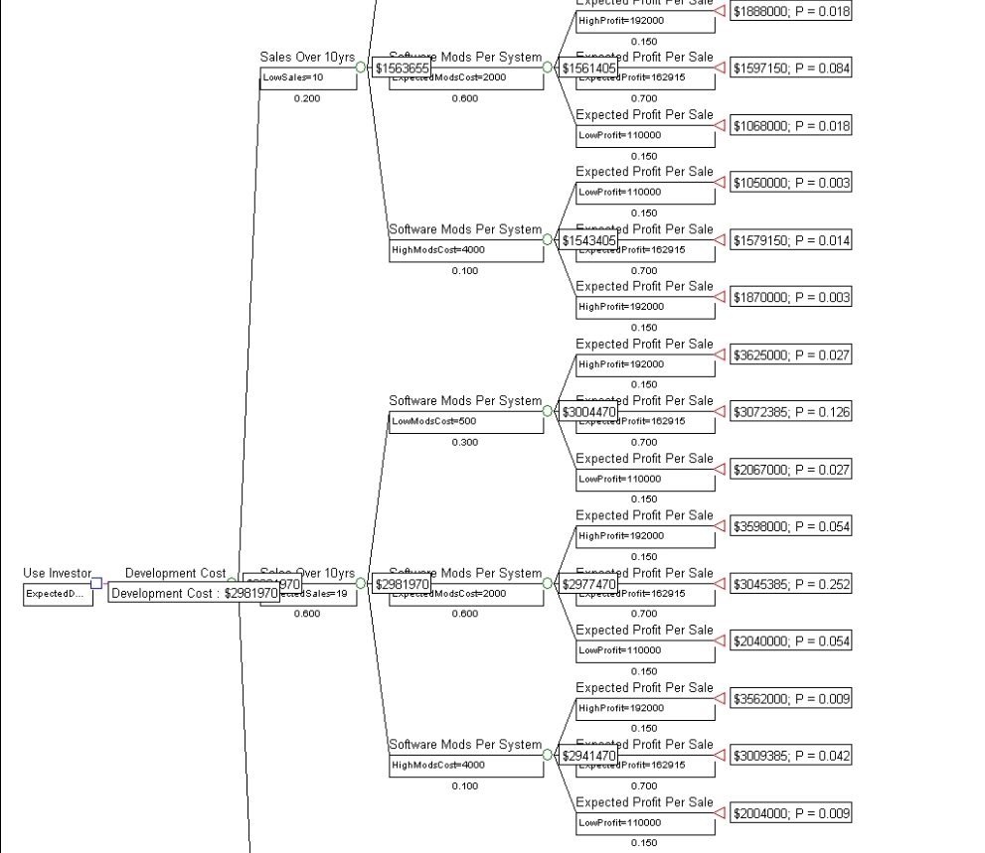

Figure H-8: Portion of Decision Tree with GMU as Investor

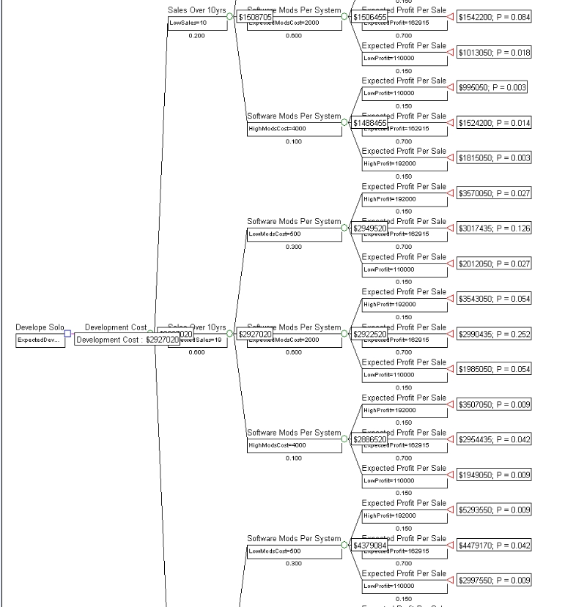

Figure H-9: Portion of Decision Tree with No Investors

APPENDIX I – Documents on the Website

PARKme Analysis of Alternatives – <http://mason.gmu.edu/~cemmerto/PARKme_AOA.docx>

PARKme Business Case – <http://mason.gmu.edu/~cemmerto/PARKme_BusinessCase.docx>

PARKme CONOPS – <http://mason.gmu.edu/~cemmerto/PARKme_CONOPS.docx>

PARKme Proof-of-Concept Model - <http://mason.gmu.edu/~cemmerto/PARKme_ProofConceptModel.docx>

PARKme RMP - <http://mason.gmu.edu/~cemmerto/PARKme_RMPdocx>

PARKme SDD - <http://mason.gmu.edu/~cemmerto/PARKme_SDD.docx>

PARKme SEMP - <http://mason.gmu.edu/~cemmerto/PARKme_SEMP.docx>

PARKme SOW - <http://mason.gmu.edu/~cemmerto/PARKme_SOW.docx>

PARKme SRS - <http://mason.gmu.edu/~cemmerto/PARKme_SRS.docx>

PARKme Stakeholder Analysis Report - <http://mason.gmu.edu/~cemmerto/PARKme_StakeholderAnalysisReport.docx>

PARKme Technology Strategy - <http://mason.gmu.edu/~cemmerto/PARKme_TechnologyStrategy.docx>

PARKme Timing Analysis - <http://mason.gmu.edu/~cemmerto/PARKme_TimingAnalysis.docx>

APPENDIX J - Acronyms

AoA – Analysis of Alternatives

CONOPS – Concept of Operations

CPN – Colored Petri Net

DOD – Department of Defense

DODAF – Department of Defense Architecture Framework

GMU – George Mason University

HI – Human Interface

LDW – Logical Decisions for Windows

PDA – Personal Digital Assistant

PM – Project Manager

RFID – Radio Frequency Identification

RMP – Risk Management Plan

SDS – System Design Specification

SEMP – Systems Engineering Management Plan

SLOC – Source Lines of Code

SOW – Statement of Work

SRS – System Requirements Specification

TOGAF – The Open Group Architecture Framework

TPM – Technical Performance Measurements

TRL – Technology Readiness Levels

WBS – Work Breakdown Structure