PARKme System

Risk Management Plan (RMP)

George Mason University

SYST 798, Prof. Speller

Craig Emmerton

Earl Morton

Shaun McDonald

David Richards

Nikki Torres-Avila

Table of Contents

1.0 INTRODUCTION 4
1.1 Purpose 4
1.2 PARKme System Program Summary 5
1.2.1 PARKme System Description 5
1.2.2 Program Management Approach 6
1.3 Definitions 6
1.3.1 Risk 7
1.3.2 Risk Analysis 7
1.3.3 Risk Management 7
1.3.4 Technical Risk 7
1.3.5 Schedule Risk 7
1.3.6 Cost Risk 7
1.3.7 Risk Ratings 8
1.3.8 Issue 8
1.3.9 Independent Risk Assessor 8
1.3.10 Metrics 8
1.3.11 Critical Program Attributes 8
2.0 RISK MANAGEMENT APPROACH 9
2.1 General Approach 9
2.2 Risk Management Strategy 9
2.2.1 Project Manager (PM) 9
2.2.2 Independent Risk Assessors 10
2.2.3 Risk Training 10
3.0 RISK MANAGEMENT PROCESS AND PROCEDURES 10
3.1 Overview 10
3.2 Risk Planning 11
3.2.1 Process 11
3.2.2 Procedures 11
3.2.2.1 Responsibilities 11
3.2.2.2 Resources and Training 11
3.2.2.3 Documentation and Reporting 11
3.2.2.4 Metrics 12
3.2.2.5 Risk Planning Tools/References 12
3.2.2.6 Risk Management Plan Updates 12
3.3 Risk Assessment 12
3.3.1 Process 12
3.3.1.1 Identification 12
3.3.1.2 Analysis 13
3.3.2 Procedures 13
3.3.2.1 Assessments-General 13
3.3.2.2 Identification 13
3.3.2.3 Analysis 14
3.3.2.4 Risk Rating 16
3.4 Risk Handling 16
3.4.1 Process 16
3.5 Risk Monitoring 17
3.5.1 Process 17
3.5.2 Procedures 17
4.0 RISK MANAGEMENT DOCUMENTATION 18
4.1 Risk Documentation 18
4.1.1 Risk Assessment Documentation 18
4.1.2 Risk-Handling Documentation 19
4.1.3 Risk Monitoring Documentation 19
4.2 Reports 19
5.0 INITIAL PARKME SYSTEM RISKS 19
APPENDIX A – RISK INFORMATION BRIEFING FORM 28
APPENDIX B – ABBREVATIONS & ACRONYMS 29

1.0 INTRODUCTION

1.1 Purpose

This Risk Management Plan (RMP) outlines the process for implementing risk management for the PARKme system.

Risk management is a program management tool to assess and mitigate events that might adversely impact the program. Therefore, risk management increases the probability/ likelihood of program success

The process of risk management is to identify, assess, and determine what (if any) mitigation steps can be taken to increase the probability of a successful project completion. The PARKme system will focus on the essential elements outlined in the Risk Management Guide for DOD Acquisition (Risk Management Guide for DOD Acquisition, 6th edition, version 1.0 August 2006)

- Risk Identification
- Risk Analysis
- Risk Mitigation Planning
- Risk Mitigation Plan Implementation
- Risk Tracking

The PARKme system RMP will look at procurement, testing, integration, and operational events. This plan will:

- Establish the PARKme system risk management organization and responsibilities

- Describe the methods for identifying, analyzing, prioritizing, and tracking risk drivers

- Provide risk information to support program decisions

- Recommend the documentation, monitoring and reporting processes associated with PARKme system risk management

- Smooth the progress of the development of risk-mitigation plans (with identified resource plans), and

- Allow monitoring the health of the program as it proceeds.

Any changes to this plan shall be forwarded to the PARKme system Project Manager (PM) for consideration. Any changes to the PARKme system RMP shall be reviewed and approved by the PM.

1.2 PARKme System Program Summary

The PARKme system is motivated by the need for decreasing the time it takes drivers to locate parking spaces on the GMU campus. Drivers can waste a significant amount of time and gas driving around a facility locating an empty parking space. The PARKme system will utilize sensors and computer networks to provide real time parking space usage to users of the system. The system will include a main server that stores parking usage data that can be utilized by operators of the system to optimize the parking capability of the university. An overview of the system is shown in Figure 1-1.

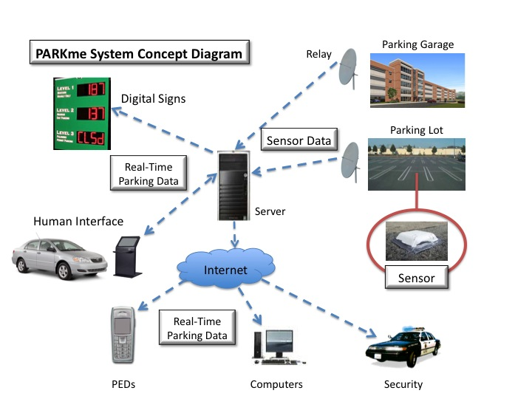
Figure 1-1: PARKme System Concept Diagram

1.2.1 PARKme System Description

The following is a description of the proposed PARKme system:

- Operational Environment: The operational environment of the PARKme system is the GMU campus. The PARKme system will have user interfaces to the system setup around campus for easy access by drivers.

- Major System Components & Interconnections Among Components: The PARKme system is comprised of several key components. The first being the imbedded sensor located at each parking space that is intended to be monitored. The imbedded sensor is connected to relay units strategically placed within the parking lot or garage. The sensor will send a status signal via wireless communication with the relay unit. The relay unit will send the status of all parking sensors located within the lot onto a wireless network. A computer server will be connected to the wireless network via a wireless router. The computer server will store the parking status data in a database. Software on the computer server will have the capability to analyze the parking space status data. The computer server will be connected via the wireless network to electronic displays and human interface components located around the parking facility. The electronic displays and human interfaces will interact with user and provide current parking space availability status.

- Interfaces to External Systems: The PARKme system will interface with the Internet. This connection is necessary for users to access the system via personal computers or personal electronic devices.

- Capabilities of Proposed System: The PARKme system has one central capability, to report parking space usage to users of the system. The PARKme system also has the capability to save parking usage data to a database for future analysis.

- Operation Risk Factors: The PARKme system is completely safe to operate. The only operational risk of using the PARKme system is if a driver is accessing the system via a personal electronic device while driving.

- Performance Characteristics: The PARKme system shall provide updated parking information on as close to real-time basis as possible. This will be determined by the speed of the wireless network utilized and the speed of the processor of the computer server.
1.2.2 Program Management Approach

A formal Project Manager (PM) shall manage the PARKme system. The PM will oversee development and installation of the PARKme system.

1.3 Definitions

Most of the definitions listed below are taken from Risk Management Guide for DOD Acquisition, 6th edition, version 1.0, August 2006. As the program matures, some definitions may be added and /or expanded to fit particular needs as allowed by DOD directives. (Risk Management Guide for DOD Acquisition, 6th edition, version 1.0 August 2006)

1.3.1 Risk

A measure of future uncertainties in achieving program performance goals within defined cost and schedule constraints.

1.3.2 Risk Analysis

The activity of examining each identified risk to refine the description of the risk, isolate the cause, and determine the effects and aiding in setting risk mitigation priorities. It refines each risk in terms of likelihood, its consequence, and its relationship to other risk areas or processes.

1.3.3 Risk Management

Risk management is defined as an overarching process that encompasses identification, analysis, mitigation planning, mitigation plan implementation, and tracking of future root causes and their consequence.

1.3.4 Technical Risk

Technical risk is associated with the evolution of the design and the production of the PARKme system affecting the level of performance necessary to meet the operational requirements. Contractor and subcontractor design, test, and production processes (process risk) influence the technical risk and the nature of the product.

1.3.5 Schedule Risk

Schedule risk is associated with the adequacy of the time estimated and allocated for the development, production, and fielding of the PARKme system. Two risk areas bearing on schedule risk are:
The risk that the schedule estimates and objectives are not realistic and reasonable, and
The risk that program execution will fall short of the schedule objectives for any reason.

1.3.6 Cost Risk

Cost risk is associated with the ability of the program to achieve its life-cycle cost objectives for development, production, and fielding of the systems. Two risk areas bearing on cost are:
The risk that the cost estimates and objectives are not accurate and reasonable, and
The risk that program execution will not meet the cost objectives as a result of a failure to handle cost, schedule, and performance risks during any phase of development.

1.3.7 Risk Ratings

This is the value that is given to a risk event (or the program overall) based on the analysis of the probability/likelihood and consequences/impacts of the event. For the PARKme system program, risk ratings of Low, Moderate, or High will be assigned based on the following criteria.

Low Risk: Has little or no potential for degradation of technical performance, and/or disruption of schedule, and/or increase in cost, and/or impact on other team(s), and/or detrimental impact on mission capability. Actions within the scope of the planned program and normal management attention should result in controlling acceptable risk.

Moderate Risk: This may cause some increase in cost, disruption of schedule, degradation of technical performance, and/or degradation of mission capability. Special action and management attention may be required to handle risk.

High Risk: Likely to cause significant or unacceptable increase in cost, disruption of schedule, and degradation of technical performance and/or degradation of mission capability. Significant additional action and high priority management attention will be required to handle risk.

1.3.8 Issue

A problem or consequence that has occurred due to the realization of a root cause is defined as an issue. A current issue was likely a risk in the past that was ignored or not successfully mitigated.

1.3.9 Independent Risk Assessor

An independent risk assessor is a person who is not in the management chain or directly involved in performing the tasks being assessed. Use of independent risk assessors is a valid technique to ensure that all risk areas are identified and that the consequence/impact and probability/likelihood (or process variance) are properly understood.

1.3.10 Metrics

Metrics are the measures used to indicate progress or achievement.

1.3.11 Critical Program Attributes

Critical Program Attributes are the programmatic cost, schedule and technical performance properties or values that are vital to the success of the PARKme system project. These properties are derived from multiple sources, such Key Performance Parameters (KPPs), test plans, experimentation, Subject Matter Experts (SMEs) judgment, etc.

2.0 RISK MANAGEMENT APPROACH

2.1 General Approach

DODI 5000.2 states: “Risks must be well understood, and risk management approaches developed, before decision authorities can authorize a program to proceed into the next phase of the acquisition process.” This policy is implemented in DOD Regulation 5000.2-R, with more detailed guidance provided in the individual Service regulation. The Defense Acquisition Deskbook (Section 2.5.2) provides additional guidance, advice, and wisdom on the management of risk.

The PARKme system project will use a centrally developed risk management strategy throughout the acquisition process and decentralized risk planning, assessment, handling, and monitoring. Risk management is applicable to all acquisition functional areas.

2.2 Risk Management Strategy

The risk management strategy is intended to identify critical areas and risk events, both technical and non-technical, and take necessary action to handle them before they can become problems that cause serious cost, schedule, technical performance, or mission capability impacts.

The Project Manager will accomplish risk management in the PARKme system project. The PM will use a structured assessment approach to identify and analyze those processes and products that are critical to meeting the program objectives. They will then develop risk-handling options to mitigate the risks and assess the cost, schedule, technical performance, and mission impact risks associated with the options. The key to success of the risk management efforts is the identification of the resources required to implement an experiment or other risk-handling options. Once selected and implemented, a risk-handling option will be monitored for its effectiveness.

Risk information will be included in all program reviews, and as new information becomes available, the PARKme system project team will conduct additional reviews to ascertain if new risks exist. The goal is to be continuously looking to the future for areas that may severely impact the program.

2.2.1 Project Manager (PM)

The PM is responsible for the overall coordination of the PARKme system RMP. The PM’s responsibilities include:
Maintaining the PARKme system RMP
Briefing the project team on the status of the PARKme system RMP, as appropriate
Preparing risk management briefings, reports, and documents required for Program Reviews
Analyzing and prioritizing all risks, risk-handling actions and drafting a consolidated PARKme System Risk Handling Plan
Recommending revisions to PARKme System Risk Handling Plan, as appropriate
Advising management on the use of independent risk assessors
Providing local risk management training
Facilitating risk assessments and risk-handing strategies at all levels of the risk management program

2.2.2 Independent Risk Assessors

As recommended by the PM and when deemed appropriate by management, independent assessors may be used to ensure all risk areas are identified and properly assessed.

2.2.3 Risk Training

The key to the success of the PARKme system program is the degree to which all members of the risk management organization are trained and participate. The PM is responsible for providing risk training as part of the initial implementation of this risk management plan and then as needed/requested to maintain the desired level of training. At a minimum, all project members shall receive basic risk training so that an equitable level of working knowledge of risk identification and assessment practices is affected throughout the PARKme system program.

The PM shall develop a training package for the PARKme system project team. The package shall include the risk assessment process, analysis criteria, documentation requirements, and a program overview. The PARKme system project team shall be trained together in an integrated manner with the use of a facilitator.

3.0 RISK MANAGEMENT PROCESS AND PROCEDURES

3.1 Overview

This section describes PARKme system project’s risk management process and provides an overview of the risk management approach. The process includes risk planning, assessing risk areas, developing risk-handling options, monitoring risks to determine how they have changed, and documenting the overall risk management program.

3.2 Risk Planning

3.2.1 Process

Risk planning consists of the up-front activities necessary to execute a successful risk management program. It is an integral part of the PARKme system program planning and management. The planning addresses each of the other risk management functions, resulting in an organized and thorough approach to assess, handle, and monitor risks. It should also assign responsibilities for specific risk management actions and establish risk reporting and documentation requirements. This RMP serves as the basis for all detailed risk planning, which must be continuous.

3.2.2 Procedures

3.2.2.1 Responsibilities

Each project member is responsible for conducting risk planning, using this RMP as the basis. The planning will cover all aspects of risk management to include assessment, handling options, and monitoring of risk handling activities. Each person involved in the design, production, operation, support, and eventual disposal of the PARKme system is a part of the risk management process. This involvement is continuous and should be considered a part of the normal management process.

3.2.2.2 Resources and Training

An effective PARKme System RMP requires resources. As part of its planning process, each project member will identify the resources required to implement the risk management actions. These resources include time, material, personnel, and cost. Training is also a major consideration. The PM is responsible for ensuring members of the PARKme system team are properly trained. All project members should receive instruction on the fundamentals of risk management and special training in their area of responsibility, if necessary. Project members should also become familiar with the Risk Management Guide for DOD Acquisition (currently 6th edition) and the Operational Risk Management Policy. See paragraph 2.3.7 Risk Training for further information.

3.2.2.3 Documentation and Reporting

This RMP establishes the basic documentation and reporting requirements for the - program. The PM should identify any additional requirements that might be needed to effectively manage risk at their level. Any such additional requirements must not conflict with the basic requirements in this RMP.

3.2.2.4 Metrics

The PM should establish metrics that will measure the effectiveness of their planned risk-handling options.

3.2.2.5 Risk Planning Tools/References

The following are tools and references to facilitate PARKme system risk management:

DOD Manual 4245.7-M, a DOD guide for assessing process technical risk.
Defense Acquisition University web-based support.
Risk Management Guide for DOD Acquisition, Sixth Edition (Version 1.0)

3.2.2.6 Risk Management Plan Updates

This RMP shall be updated, as necessary, on the following occasions:
Whenever the acquisition strategy changes, or there is a major change in program emphasis;
In preparation for major decision points;
In preparation for and immediately following technical audits and reviews; and
Concurrent with the review and update of other program plans.

3.3 Risk Assessment

The risk assessment process includes the identification of critical risk events/processes, which could have an adverse impact on the PARKme system program, and the analyses of these events/ processes to determine the probability/likelihood of occurrence/process variance and consequences/impacts. It is the most demanding and time-consuming activity in the risk management process.

3.3.1 Process

3.3.1.1 Identification

Risk identification is the first step in the assessment process. The basic process involves searching through the entire PARKme system project to determine those critical events that would prevent the program from achieving its objectives. All identified risks will be documented with a statement of the risk and a description of the conditions or situations causing concern and the context of the risk. Risks will be identified the PM and by any individual in the program. Individuals involved in the detailed and day-to-day technical, cost, and scheduling aspects of the PARKme system program must be aware of the potential problems (risks) that need to be managed.

3.3.1.2 Analysis

Risk analysis should be supported by test results, trade study, the opinion of a qualified expert (to include justification of his or her judgment), or any other accepted analysis technique. The Defense Acquisition Deskbook, Section 2524.2 describes a number of analysis techniques that may be useful. Evaluators should identify all assumptions made in assessing risk.

Systems engineering analysis, risk assessments, and manpower risk assessments provide additional information that must be considered. This includes, among other things, environmental impact, system safety and health analysis, and security considerations.

3.3.2 Procedures

3.3.2.1 Assessments-General

Risk assessment is an iterative and continuous process, with each assessment building on the results of previous assessments. The primary source of information for the next assessment will be the current assessment baseline.

The PM should continually assess the risks of the project, reviewing risk-handling actions and the critical risk areas whenever necessary to assess progress.

The risk assessment process is intended to be flexible enough so that field activities may use their judgment in structuring procedures considered most successful in identifying and analyzing all risk areas.

3.3.2.2 Identification

Following is a description of step-by-step procedures that evaluators may use as a guide to identify program risks.

- Understand the requirements and the program performance goals.

- Determine the engineering and manufacturing processes that are needed to design, develop, produce, and support the system.

- Assign a probability and consequence/impact to each risk event
- Prioritize the risk events.

There are a number of techniques and tools available for identifying risks. Among them are:

- Best Judgment: The knowledge and experience of the collective, multi-disciplined project members and the opinion of subject-matter experts (SMEs) are the most common source of risk identification.

- Lessons Learned from similar processes can serve as a baseline for the successful way to achieve requirements. If there is a departure from the successful way, there may be risk.

- DOD 4245.7-M, Transition from Development to Production, is often called the “Templates” book because it identifies technical risk areas and provides, in “bullet” form, suggestions for avoiding those risks. It focuses on the technical details of product design, test, and production to help managers proactively manage risk. It also includes chapters on facilities, logistics, and management. This makes the manual a useful tool in identifying weak areas of the PARKme system program planned processes early enough to implement actions needed to avoid adverse consequences/impacts. A copy of this manual is available at: http://www.dtic.mil/whs/directives.

- Critical Program Attributes are metrics that the program office developed to measure progress toward meeting objectives.

- Requirements Documents describe the output of our efforts. Project efforts need to be monitored continuously to ensure requirements are met on time and within budget. When they aren’t, there is risk and eventually a problem.

3.3.2.3 Analysis

Risk analysis is an evaluation of the identified risk events to determine possible outcomes, critical process variance from known best practices, the probability/likelihood of those events occurring, and the consequences/ impacts of the outcomes. Once this information has been determined, the risk event may be rated against the program’s criteria and an overall assessment of low, moderate, or high assigned.

For each process risk related event identified, the variance of the process from known standards or best practices must be determined. As shown in figure 3.1 below, there are five levels (1-5) in the PARKme system risk assessment process. If there is no variance then there is no risk.

For each risk area identified, the probability the risk will happen must be determined. As shown in the figure below, there are five levels (1-5) in the PARKme System risk assessment process, with the corresponding subjective criteria of Remote, Unlikely, Likely, Highly Likely, and Near Certainty. If there is zero probability of an event, there is no risk per our definition.

For each risk area identified, the following question must be answered: Given the event occurs, what is the magnitude of the consequence? As shown in the figure below, there are five levels of consequence (1-5). For this program, there are four areas that will be evaluated when determining consequence: technical performance, schedule, cost, and project impact. At least one of the four consequence areas needs to apply for a risk to present. If there is no adverse consequence in any of the areas, then there is no risk.

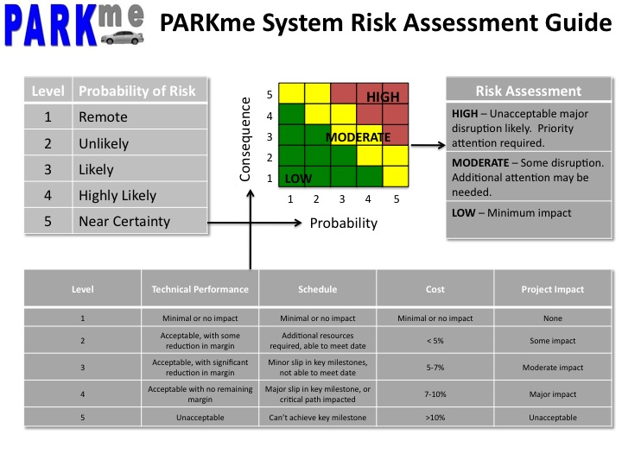
Figure 3.1: PARKme System Risk Assessment Guide

Technical Performance: This category includes all requirements that are not included in the other three metrics of the Consequence table. The wording of each level is oriented toward design processes, production processes, life cycle support, and to retirement of the system. For example, the word “margin” could apply to weight margin during design, safety margin during testing, or machine performance margin during production.

Schedule: Schedule consequence is the expected delay that will result directly from the risk occurring, and is not the time it is expected to take to mitigate the risk. Risk mitigation schedule is part of the risk mitigation assessment, and not the risk assessment.

Cost: Since costs vary from component to component and process to process, the percentage criteria shown shall be applied to the major system cost. When the major system is the risk itself, then the cost percentage is applied against the total system cost.

Project Impact: The mission consequence of a risk is associated with an inability of the PARKme System to meet its operational performance capabilities.

3.3.2.4 Risk Rating

Probability and consequence should not always be considered equally; for example, there might be consequences so severe that an event is considered high risk even though the probability to achieve a particular outcome is low. After deciding a level of probability (1 through 5) and a level of consequence (1 through 5), enter the Assessment Guide portion of the figure below to obtain a risk rating (green = LOW, yellow = MOD, and red = HIGH). For example, likelihood-consequence level 2-2 corresponds to LOW risk, level 3-4 corresponds to MODERATE risk, and level 5-3 corresponds to HIGH risk. After obtaining the risk rating, make a subjective comparison of the risk event with the applicable rating definition in the figure (e.g., High= unacceptable, major disruptions, etc.). There should be a close match. If there isn’t, consider reevaluating the level of probability/likelihood or consequence/impact. Those risk events that are assessed as moderate or high should be updated in any risk documentation and submitted to the PM.

3.4 Risk Handling

3.4.1 Process

After the program’s risks have been identified and assessed, the approach to handling each significant risk must be developed the PM. There are essentially four techniques or options for handling risks:

(1) Avoidance;
(2) Control;
(3) Transfer; and
(4) Assumption.

For all identified risks, the various handling techniques should be evaluated in terms of feasibility, expected effectiveness, cost and schedule implications, and the effect on the system’s technical performance, and the most suitable technique selected. The results of the evaluation and selection will be included and documented by the PM. This documentation will include: what must be done, the level of effort and materials required, the estimated cost to implement the plan, a proposed schedule showing the proposed start date, the time phasing of significant risk reduction activities, the completion date, and their relationship to significant Program activities/milestones, recommended metrics for tracking the action, a list of all assumptions, and the person responsible for implementing and tracking the selected option.

3.4.2 Procedures

The PM is responsible for evaluating and recommending the risk-handling options that best fit the program’s circumstances. Once approved, the risk-handling options are included in the program’s acquisition strategy or management plans, as appropriate. For each selected risk-handling option, the PM will develop specific tasks that, when implemented, will handle the risk. The task descriptions should explain what has to be done, the level of effort, and identify necessary resources. It should also provide a proposed schedule to accomplish the actions including the start date, the time phasing of significant risk reduction activities, the completion date, and their relationship to significant PARKme System program activities/milestones, and a cost estimate. The description of the handling options should list all assumptions used in the development of the handling tasks. Recommended actions that require resources outside the scope of official tasking should be clearly identified; and the risk area, or other risk handling plans that may be impacted should be listed. Reducing requirements as a risk avoidance technique will be used only as a last resort.

3.5 Risk Monitoring

3.5.1 Process

Risk monitoring systematically tracks and evaluates the performance of risk-handling actions. Essentially, it compares predicted results of planned actions with the results actually achieved to determine status and the need for any change in risk-handling actions. The effectiveness of the risk-monitoring process depends on the establishment of a management indicator system (metrics) that provides accurate, timely, and relevant risk information in a clear, easily understood manner. The metrics selected to monitor the PARKme System program status must adequately portray the true state of the risk events and handling actions. Otherwise, indicators of risks that are about to become problems will go undetected.

3.5.2 Procedures

The PM is responsible for monitoring and reporting the effectiveness of the handling actions for the risks assigned. Overall PARKme System program risk assessment reports will be prepared by the PM working with the appropriate SME.

Many techniques and tools are available for monitoring the effectiveness of risk-handling actions, and the PM must ensure that they select those that best suit their needs. No single technique or tool is capable of providing a complete answer. A combination must be used. At a minimum, the PM will maintain a watch list of identified high priority risks.

Risks rated as Moderate or High will be reported to the PM, who will also track them, using information provided by the appropriate SME, until the risk is considered Low and recommended for “Close Out.” The project team member(s) that initially reported the risk retains ownership and cognizance for reporting status and keeping the information current. Close out of a risk shall only be authorized by the PM. Ownership means implementing handling plans and providing periodic status of the risks and their handling plans. Risk will be made an agenda item at each management or design review, providing an opportunity for all concerned to offer suggestions for the best approach to managing risk. Communicating risk increases the program’s credibility and allows early actions to minimize adverse consequences/impacts.

The risk management process is continuous. Information obtained from the monitoring process is fed back for reassessment and evaluations of handling actions. When a risk area is changed to Low, it is put into a “Historical File” by the PM, and it is no longer tracked by the RMLT. The “owners” of all Low risk areas will continue monitoring Low risks to ensure they stay Low. The status of the risks and the effectiveness of the risk-handling actions will be reported to the PM:

- Bi-Monthly at staff meetings

- The PM determines that the status of the risk area has changed significantly (as a minimum when the risk changes from high to moderate to low, or vice versa) and when requested by the Program Manager.

4.0 RISK MANAGEMENT DOCUMENTATION

The PARKme System PM will be in charge of all information necessary to satisfy the program documentation and reporting requirements. The collection, analysis and dissemination of pertinent information are essential to a successful PARKme System RMP. The PARKme System RMP shall have easy and widespread access to all members of the organization to ensure commonality of information.

4.1 Risk Documentation

All program risk management information will be documented by the PM. The following paragraphs provide guidance on documentation requirements for the various risk management functions.

4.1.1 Risk Assessment Documentation

Risk assessments form the basis for many program decisions. From time to time, the PM will need a detailed report of any assessment of a risk event. It is critical that all aspects of the risk management process are documented.

4.1.2 Risk-Handling Documentation

Risk-mitigation documentation will be used to provide the PM with the information they need to approve recommended risk mitigation strategies.

4.1.3 Risk Monitoring Documentation

The PM needs a summary document that tracks the status of high and moderate risks. The PM will use the Risk Tracking Report/Watch List to produce a risk-tracking list that uses information that has been approved by the project team.

4.2 Reports

Reports are used to convey information to decision makers and team members on the status of the PARKme System program and the effectiveness of the risk management program. Risk information briefs to the PM will be conducted periodically. One way to quickly and effectively present information is by using the quad-chart format (Figure A-1) provided by Appendix A.

5.0 INITIAL PARKME SYSTEM RISKS

The following is the initial list of PARKme System risks. Each risk has an event that could occur and its possible consequence. A risk code is derived for each risk event using the risk assessment guide in Figure 3.1. For each risk event a mitigation plan is described. The change to the risk code as a result of the enacted mitigation plan is also listed. This list along with any additional risk events shall be tracked by the PM.

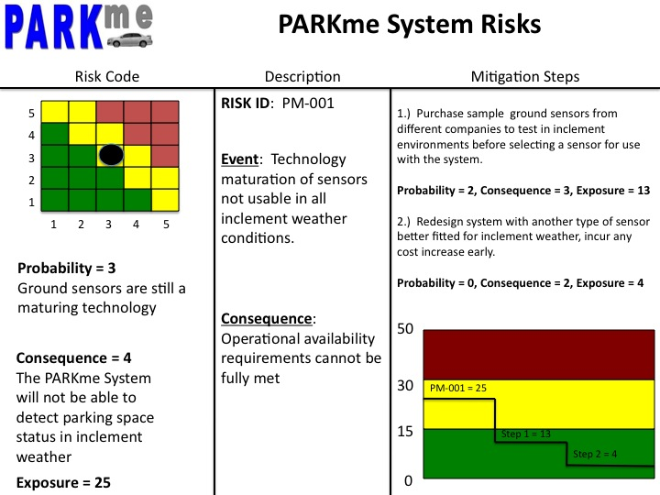
Figure 5-1: Risk PM-001

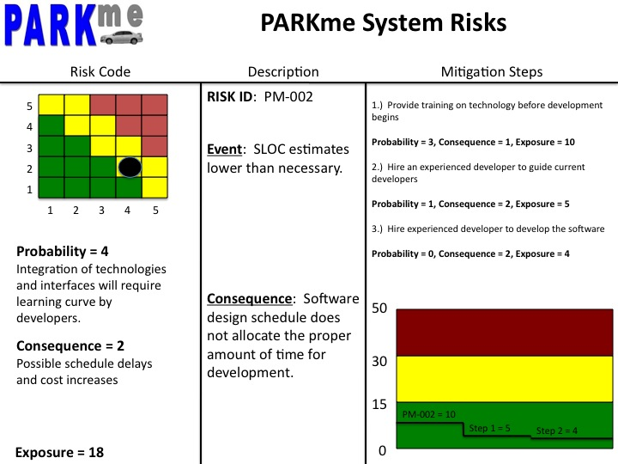Figure 5-2: Risk PM-002
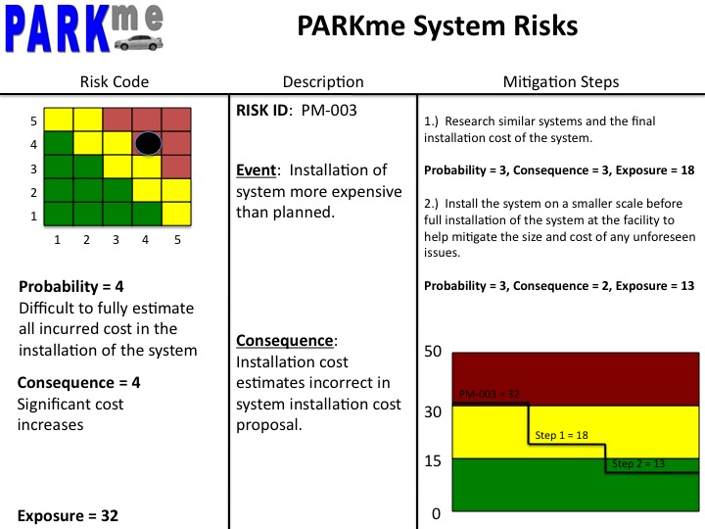
Figure 5-3: Risk PM-003

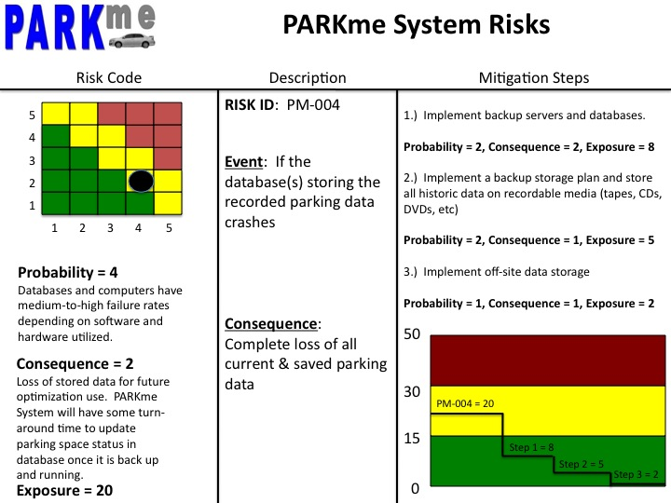Figure 5-4: Risk PM-004
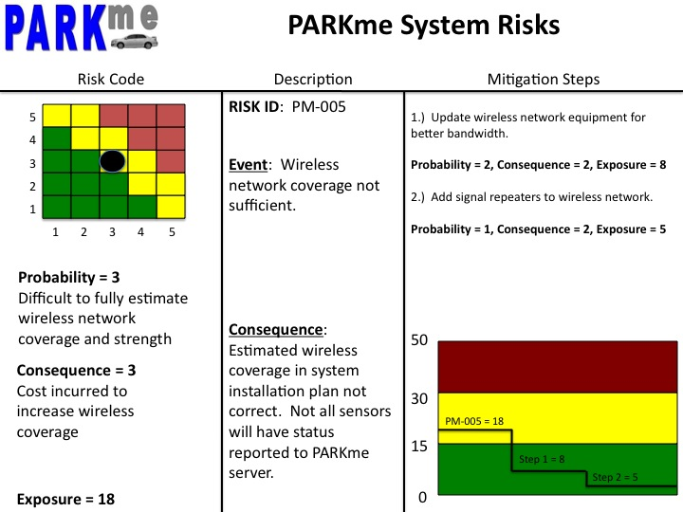
Figure 5-5: Risk PM-005
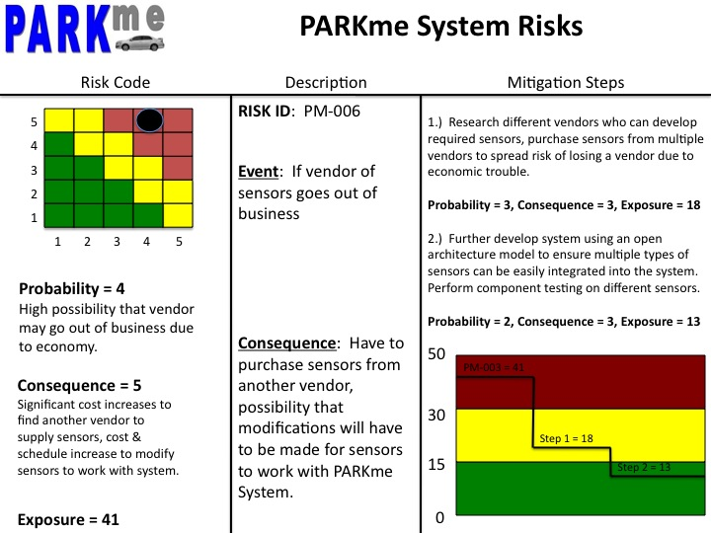
Figure 5-6: Risk PM-006
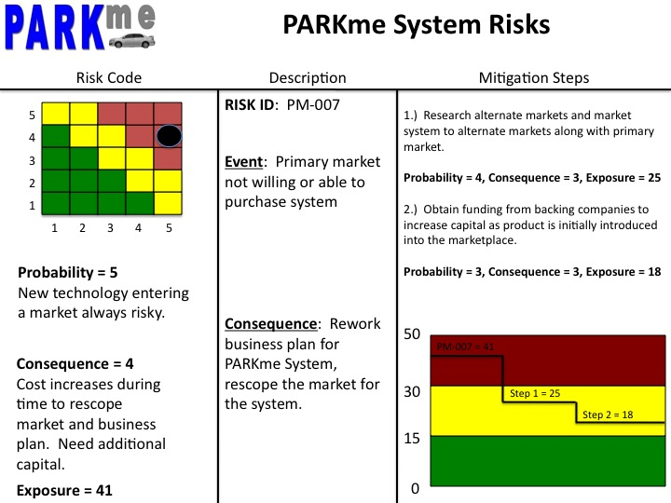Figure 5-7: Risk PM-007
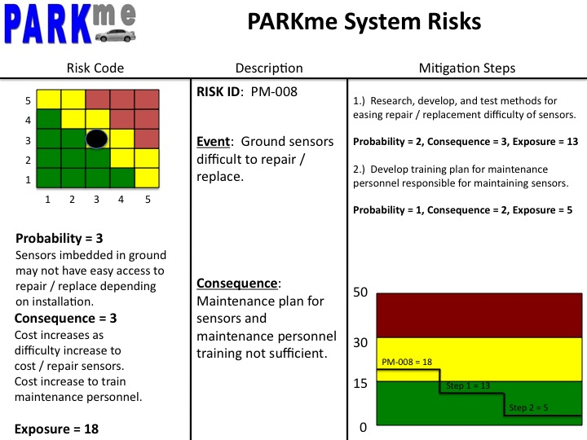Figure 5-8: PM-008

APPENDIX A – RISK INFORMATION BRIEFING FORM

The risk information briefing form provides a convenient template for displaying risk information pertinent to an individual risk. Basic required elements for successful risk identification, assessment, and handling strategies are provided on the risk information briefing form.

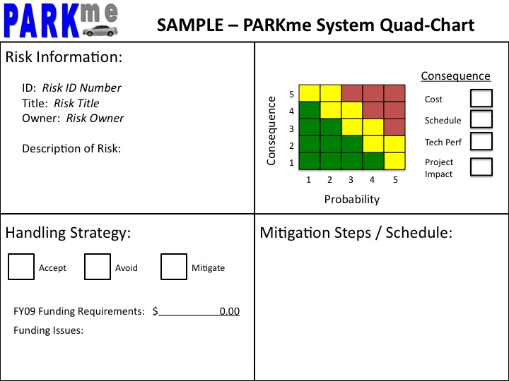
Figure A-1: Sample PARKme System Quad-Chart

APPENDIX B – ABBREVATIONS & ACRONYMS

The following are abbreviations and acronyms used in this document

DOD – Department of Defense
IA – Information Assurance
IPPD – Integrated Product & Process Development
KPP – Key Performance Parameters
PM – Program Manager
RMP – Risk Management Plan
SME – Subject Matter Expert

