**PARKme System**

**System Design Document (SDD)**



George Mason University

SYST 798, Prof. Speller

**Craig Emmerton**

**Earl Morton**

**Shaun McDonald**

**David Richards**

**Nikki Torres-Avila**

**Table of Contents**

1.0 INTRODUCTION 4

1.1 Background, Objectives, Scope 4

1.2 Constraints 4

1.3 PARKme System Description 5

1.3.1 Functions and Features 6

1.4 Modes of Operation 7

1.5 User Definitions 7

1.6 References 7

2.0 SYSTEM ARCHITECTURE 7

2.1 Top Level Subsystems 7

2.1.1 Data Network Subsystem 9

2.1.2 Parking Space Monitoring Subsystem 9

2.1.3 User Interface Subsystem 9

2.2 Hardware 9

2.2.1 Data Network Subsystem 9

2.2.1.1 Server 9

2.2.1.2 Wireless Network 10

2.2.2 Parking Monitoring Subsystem 10

2.2.2.1 Sensors 11

2.2.3 User Interface Subsystem 11

2.2.3.1 On Campus Terminal 11

2.2.3.2 Directional Signs 12

2.3 Hardware Interface Design Requirements 13

2.3.1 Directional Signs 14

2.3.2 Kiosks/Terminals 15

2.3.3 Parking Sensors 15

2.3.4 Access Point 16

2.3.5 LAN Controller 17

2.3.6 Server 17

2.4 Software 19

2.4.1 Kiosk Mode 20

2.4.1.1 Graphical User Interface (GUI) 20

2.4.1.2 Transmit/Receive 21

2.4.2 Server Mode 21

2.4.2.1 Graphical User Interface (GUI) 22

2.4.2.2 Transmit/Receive 22

2.4.2.3 Monitor Parking 22

2.4.2.3.1 Update Database 23

2.4.2.3.2 Update Directional Signs 23

2.4.2.3.3 Package Data 23

2.4.2.4 System Set-Up 23

2.4.2.4.1 Initialize Parking Zones 23

2.4.2.4.2 Initialize Map 24

2.4.2.5 User Scheduling 25

2.4.2.5.1 Email Notification Setup 25

2.4.2.5.2 Text Message Notification Setup 25

2.4.2.5.3 Notifications 26

2.4.2.6 Report Generation 26

2.5 Software Interface Design Requirements 27

2.5.1 Kiosk Mode Software Interfaces 28

2.5.1.1 GUI 28

2.5.1.2 Transmit Receive 29

2.5.2 Server Mode Software Interfaces 30

2.5.2.1 Report Generation 30

2.5.2.2 System Set-Up 30

2.5.2.3 GUI 30

2.5.2.4 User Scheduling 31

2.5.2.5 Monitor Parking 31

2.5.2.6 Transmit Receive 32

APPENDIX A – ACRONYMS 34

1.0 INTRODUCTION

1.1 Background, Objectives, Scope

This document is defines the tasks necessary to implement the PARKme system. This document describes the hardware, software and interfaces of the system along with a description of the requirements that drive the need for each component. The requirements will trace to the system level requirements described in the System Requirements Specification (SRS).

The objective of the PARKme system is to reduce the time and frustration associated with finding a parking space at the George Mason University campus. Often times the campus parking is near it max capacity and users spend valuable time casing the parking areas in order to find available parking, resulting in lost time, added stress and frustration, and wasted natural resources (fuel).

The official system problem statement is as follows:

"Finding a parking space at the university is a common frustration for commuters at the GMU campus. Finding the parking space that best suits your needs can be very time consuming and often times the “drive around looking method” does not result in the best space. Campus parking lots are often overcrowded during certain times of the day and week making parking a guessing game and a matter of luck."

Helping users find available parking is the primary focus of the PARKme system and as a secondary focus providing users with data that will help them find the best parking space based on their parking needs.

The scope of the PARKme system extends to the George Mason University campus parking facilities. Initial proof of concept can be scaled down to as little as two parking spaces but would best be proofed using at least two parking areas in separate geographical locations. The design of the system lends itself to modularity and therefore expanding the system to the entire campus and even to similar markets outside of the George Mason campus can easily be accomplished.

1.2 Constraints

The PARKme system must adhere to all wireless communication standards and information assurance initiatives in order to protect the integrity of data transmitted by the PARKme system.

1.3 PARKme System Description

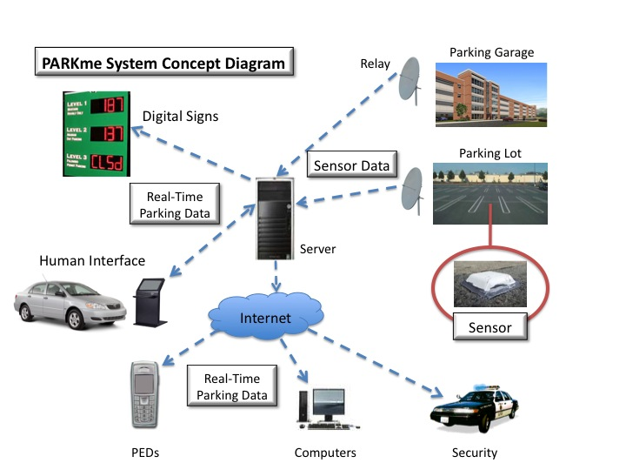

Figure - OV-1 DODAF Diagram

Figure 1 shows the operation view of the PARKme system. The PARKme system will utilize sensors to monitor parking space availability and will transmit this information to the main server of the system. From the server the data will be sent to on-campus kiosks and to users through text messages and emails. In addition to monitoring parking spaces the sensors are capable of monitoring loading zones and fire lanes and would send alerts to campus authorities to when violations are occurring.



Figure - P-Diagram

Figure 2 shows the P-Diagram for the PARKme system.

1.3.1 Functions and Features

Because of the modularity of the components of the system there are many extra functions that are provided as well as some features that are of value to the users.

Primary functions are to monitor parking spaces, fire lanes, and loading zones and send this data to the server where it is then processed and provided to the users of the system.

Because the server collects the data used for monitoring it can save this data to a database where it can then be sorted and used for research to help in areas such as course schedule optimization to best utilize the parking facilities as well help guide further parking facility upgrades.

A feature provided by the system due to the need for wireless data transmission is the ability to provide wireless Internet throughout all the parking facilitates equipped with the PARKme system. The PARKme system will not provide this feature unless directed to do so by the customer, but the customer will be able to setup the network if desired.

1.4 Modes of Operation

The PARKme system will provide several modes of operation to the customer:

* Auto – In this mode the server will update the user displays the clock.
* Manual – This mode will allow the customer to schedule different update rates for the system. This mode is used to turn off signage updates during hours when parking facilities are closed or to send less updates to the displays during non-peak hours when parking is abundant. Sending less updates saves electricity and reduces the bandwidth load over the wireless network.

1.5 User Definitions

The Customer is defined as the owner of the system. Customer roles include maintenance of the system to include administration of system components. Customers are also the group that will use the system for data collection.

The User is defined as the group that uses the system to find parking spaces and receive alerts concerning loading zones and fire lanes. This group would include students, visitors, faculty, and campus authorities.

1.6 References

PARKme Statement of Work (SOW)

PARKme Concept of Operations (CONOPS)

PARKme Systems Engineering Master Plan (SEMP)

PARKme System Requirements Specification (SRS)

PARKme Analysis of Alternatives (AOA)

2.0 SYSTEM ARCHITECTURE

The PARKme system design is focused on using current COTS hardware and using a modular focus for the components of the system in order to facilitate different operational layouts. The modular components of the system are broken down into three major subsystems.

2.1 Top Level Subsystems

Figure 3 shows the level 1 subsystem breakdown. These include the Data Network, Parking Space Monitoring, and User Interface.



Figure - Top Level Subsystems

Furthermore figure 4 shows the SV-1 (DODAF) diagram of these subsystems. This diagram show high level simplified inputs and outputs for each of the subsystems. Further detail for interfaces and data IO will be described later in this document.



Figure - SV-1 DODAF

2.1.1 Data Network Subsystem

The data network is comprised of the equipment necessary to store all the necessary data passed through the system as well as run the software necessary for system operation. The data network is also comprised of the equipment necessary to transmit data throughout the system.

2.1.2 Parking Space Monitoring Subsystem

The Parking Space Monitoring subsystem is responsible for the detection of all parking spaces at the campus and determining if they are occupied or empty.

2.1.3 User Interface Subsystem

The User-Interface subsystem is the portion of the system where users interact with the PARKme system in order to view data contained by the system. This will include the on-campus kiosk (user interface to the system). The kiosks will initially be a terminal provided on campus for users to interface with system but can be adapted to provide a terminal for users to access from their vehicles. This subsystem will also include the signage that will be placed throughout the parking facilities to display PARKme information to users and provide guidance as to where to park.

2.2 Hardware

This section of the SDD describes the hardware that will be used for design of the PARKme system. Each piece of hardware is traceable to a system level requirement.

2.2.1 Data Network Subsystem

Primary Hardware Components:

* Server
* Wireless Network

2.2.1.1 Server

The server that will be used for the PARKme system must be able to process real time data received from other subsystems and be able to dynamically update database entries as well as produce user notifications to as many users with minimal delays. The server needs to be able to communicate over the wireless network (also part of this subsystem). The server also to interface with the customer and therefore must allow for a human interface. Interface requirements from the server to other components will be described later in this document and will also provide hardware constraints on the server hardware.

2.2.1.2 Wireless Network

The wireless network for the PARKme system will be used to transmit near real-time data concerning the availability of parking spaces and parking violations. The wireless network will utilize a mesh outdoor solution provided by Cisco systems. This network was chosen because of the vendors highly regarded reputation for providing networking solutions and the network meets all PARKme requirements while providing a solution capable of expansion for future PARKme developments. The wireless network will consist of Cisco Aironet 1500 series lightweight outdoor mesh access points mounted throughout the parking facilities and will be centrally controlled using a series of wireless LAN controllers which will act as a repeater and transmit received data to the data network subsystem server. Figure 5 contains photos of the Cisco hardware.

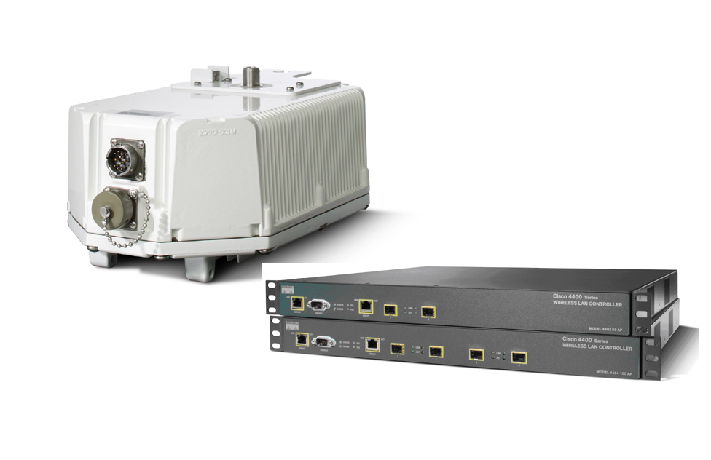

Figure - Cisco Access Point and LAN Controller

2.2.2 Parking Monitoring Subsystem

Primary Hardware Components:

* Sensors

2.2.2.1 Sensors

The sensors that will be used for the PARKme system will be the Streetline Vehicle Sensor provided by Streetline Networks. This sensor is designed for outdoor use and will need to be mounted flush in each area that is to be monitored (every parking space, fire zone, and loading zones) with the exception of areas that will not be subjected to environmental elements such as the covered areas of parking garages.. These sensors provide 5-10 years maintenance free operation and transmit a signal that provides the occupancy status of the zone monitored as well as the sensor id (needed in order to identify the space that is being monitored). Photo of sensor provided below.



Figure - Streetline Vehicle Sensor

2.2.3 User Interface Subsystem

Primary Hardware Components:

* On Campus Terminal
* Directional Signs

2.2.3.1 On Campus Terminal

This portion of the system can either be a kiosk(s) stationed at strategic locations around campus parking facilities in order to provide users an access point for accessing the system from their cars OR this can simply be a computer terminal stationed on campus that will allow users to access the system and set their preferences.

The first option of placing a drive/walk up outdoor access point (kiosk) would utilize the KDOME Outdoor Kiosk Unit provided by MDKS. These are the kiosks of choice as they provide a turnkey solution. Load the PARKme software and the units are ready for use. These units provide a weatherproof casing with an anti-sun glare touch screen. These units are designed to provide easy access for maintenance and can be custom configured to include PARKme interface requirements. Figure 7 shows a picture of the unit that would be used.

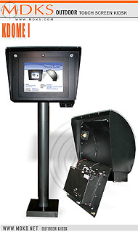

Figure - MDKS Kiosk

The second option for providing users a terminal for accessing the PARKme system while on campus would be to provide any standard PC with connection to the Internet or containing a wireless connection to the Data Network. The PARKme system installation team would most likely not provide this as the university could most likely use a surplus computer. Could be provided if necessary.

2.2.3.2 Directional Signs

Directional signs are provided in order for users to visually capture the current state of campus parking by simply glancing at the signs. These signs could be place at several locations around campus and would provide the user with available parking spaces by lot and suggest the best place to find a suitable parking space. These signs would show a proprietary display created by PARKme engineers and in order to provide the display the signs would need to have a compatible video in port. These signs would also need to be all weather and plug and play. For this reason the PARKme system would utilize the GS 5700 or GS 7000 all weather LCD display provided by SuntronicsLCD. This would provide all weather 56-inch or 79-inch display with top of the line sun glare reducing technology. Figure 8 shows the LCD that is to be used.

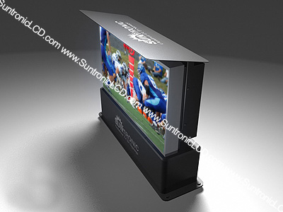

Figure - SuntronicsLCD GS5700 Sign

2.3 Hardware Interface Design Requirements

This section will discuss the interface requirements that are necessary for the design and integration of all the hardware components. Figure 9 shows a diagram of the interfaces and flows of information sent between hardware components. As shown in the diagram most of the information for the system is inherent to the system itself with the exception of information that is sent and received over the Internet. Standard protocols are used in order to promote an open architecture environment. Each hardware component interface will be discussed in subsequent sections of this document.



Figure - Hardware Interface Diagram

2.3.1 Directional Signs

In the following table the direction column can take two forms: to or from. Column 1 describes the direction of the interface, from describes an interface that is coming from another component where to describes an interface that goes to another component. The second column lists the connecting component and the third column contains a description of the interface.

|  |  |  |
| --- | --- | --- |
| Direction | Connecting Component | Description |
| From | Server | The directional sign will receive display updates from the server. These updates will occur on a periodic rate. The interface will utilize the wireless network and all data will be transmitted wirelessly using the Transmission Control Protocol/Internet Protocol (TCP/IP) protocols. |

2.3.2 Kiosks/Terminals

In the following table the direction column can take two forms: to or from. Column 1 describes the direction of the interface, from describes an interface that is coming from another component where to describes an interface that goes to another component. The second column lists the connecting component and the third column contains a description of the interface.

|  |  |  |
| --- | --- | --- |
| Direction | Connecting Component | Description |
| From | Server | The kiosks and terminals will receive system data from the server as requested by the receiving component. This data will contain current parking availability as retrieved from the server database at the time of request. All data will be transmitted wirelessly using the Transmission Control Protocol/Internet Protocol (TCP/IP) protocols. |
| To | Server | The kiosks and terminals will send request to the server. These requests will include user submissions for setting up their preferences as well as request for current parking availability. All data will be transmitted wirelessly using the Transmission Control Protocol/Internet Protocol (TCP/IP) protocols. |

2.3.3 Parking Sensors

In the following table the direction column can take two forms: to or from. Column 1 describes the direction of the interface, from describes an interface that is coming from another component where to describes an interface that goes to another component. The second column lists the connecting component and the third column contains a description of the interface.

|  |  |  |
| --- | --- | --- |
| Direction | Connecting Component | Description |
| To | Access Point | The parking sensors will monitor a local area and determine if a car is parked in that area. The sensors will transmit the status of that area whenever a change in status is detected. Transmission will include a 1 for occupied or a 0 for unoccupied and will be accompanied by the id of the sensor transmitting the data. All data will be transmitted wirelessly using the Transmission Control Protocol/Internet Protocol (TCP/IP) protocols. |

2.3.4 Access Point

In the following table the direction column can take two forms: to or from. Column 1 describes the direction of the interface, from describes an interface that is coming from another component where to describes an interface that goes to another component. The second column lists the connecting component and the third column contains a description of the interface.

|  |  |  |
| --- | --- | --- |
| Direction | Connecting Component | Description |
| From | Parking Sensors | The Access Point will receive the parking sensors data and act as a repeater in order to route the data to its final destination. All data will be transmitted wirelessly using the Transmission Control Protocol/Internet Protocol (TCP/IP) protocols. |
| To | LAN Controller | The Access Point will forward the parking sensors data to the LAN Controller, acting as a repeater in order to route the data to its final destination. All data will be transmitted wirelessly using the Transmission Control Protocol/Internet Protocol (TCP/IP) protocols. |

2.3.5 LAN Controller

In the following table the direction column can take two forms: to or from. Column 1 describes the direction of the interface, from describes an interface that is coming from another component where to describes an interface that goes to another component. The second column lists the connecting component and the third column contains a description of the interface.

|  |  |  |
| --- | --- | --- |
| Direction | Connecting Component | Description |
| From | Access Point | The LAN Controller will receive the parking sensors data via the Access Point and will route the data to its final destination. All data will be transmitted wirelessly using the Transmission Control Protocol/Internet Protocol (TCP/IP) protocols. |
| To | Server | The LAN Controller will route the data to its final destination at the Server. All data will be transmitted wirelessly using the Transmission Control Protocol/Internet Protocol (TCP/IP) protocols. |

2.3.6 Server

In the following table the direction column can take two forms: to or from. Column 1 describes the direction of the interface, from describes an interface that is coming from another component where as to describes an interface that goes to another component. The second column lists the connecting component and the third column contains a description of the interface.

|  |  |  |
| --- | --- | --- |
| Direction | Connecting Component | Description |
| From | LAN Controller | The server will receive data from the LAN Controller. This data will contain the parking sensor id and status. All data will be transmitted wirelessly using the Transmission Control Protocol/Internet Protocol (TCP/IP) protocols. |
| From | Kiosks/Terminals | The kiosks and terminals will send the server requests. These requests will include user submissions for setting up their preferences as well as request for current parking availability. All data will be transmitted wirelessly using the Transmission Control Protocol/Internet Protocol (TCP/IP) protocols. |
| To | Kiosks/Terminals | The server will send the kiosks and terminals system data as requested by the receiving component. This data will contain current parking availability as retrieved from the server database at the time of request. All data will be transmitted wirelessly using the Transmission Control Protocol/Internet Protocol (TCP/IP) protocols. |
| To | Directional Signs | The Server will send the directional sign display updates. These updates will occur on a periodic rate. The interface will utilize the wireless network and all data will be transmitted wirelessly using the Transmission Control Protocol/Internet Protocol (TCP/IP) protocols. |
| To | Internet | This is the only external interface for the PARKme system. Information will be sent over the internet on a regular basis, as access to the PARKme system is available from remote locations. Data that is sent over the internet includes emails using the Simple Mail Transfer Protocol (SMTP), text messages to users cell phones using Short Message Service (SMS) and system data to remote locations using the Transmission Control Protocol/Internet Protocol (TCP/IP) protocols. |
| From | Internet | The Server will receive request from remote location concerning PARKme system statuses. These requests will use the Transmission Control Protocol/Internet Protocol (TCP/IP) protocols. |

2.4 Software

Software design includes all in house code that must be developed by PARKme engineers. Software development will focus on developing one software program that depending on its installed location will run in one of two modes. The two modes include: Kiosk mode and Server mode. The administrator will set the mode when the software is installed and initialized for the first time.

Figure 10 shows the top-level software of the PARKme software. Each function will be described in detail in this document along with the interfaces and interactions between the functions. Software design will be broken down to another level when necessary.



Figure - Top Level Software Functions

2.4.1 Kiosk Mode

This section will describe the functions inherent to the software when initialized to run in kiosks mode. These functions are the same regardless of the hardware that the software is installed on (terminal vs. kiosk). Kiosk mode will be designed such that all user requests are sent to the server for processing and the server will return results as necessary. The reasoning behind this is it will allow for the terminal or kiosk the capability of using machines with low processing and storage requirements, also resulting in lower power consumption.

2.4.1.1 Graphical User Interface (GUI)

The GUI for the Kiosk mode will only contain two options for users. The first is to search available parking and the second is to allow the users to set-up their user preferences. Figure 11 shows a notional GUI. Further Human System Integration (HSI) testing is necessary in order to finalize the user interface. Figure 11 shows a notional GUI screen that would be displayed in kiosk mode.



Figure - Nominal GUI Welcome Screen

It is important to note that the two options to the user are calling functions that reside on the server. The kiosk/terminal is basically acting as a monitor for the server application.

2.4.1.2 Transmit/Receive

This function is responsible for sending user request to the server as well as receiving information from the server. When users are setting up their preferences from a kiosk/terminal the users preferences will not be sent to the server for processing until the user presses the submit button. This will reduce network traffic and demand for the server processor.

2.4.2 Server Mode

This section will describe the software functions that are native to the server. This portion of the software provides the major functionality of the PARKme system from a software perspective and will be the major element on the critical path.

2.4.2.1 Graphical User Interface (GUI)

The GUI for the server will provide administrators with multiple options. The GUI will provide quick access for viewing the current parking status, will allow access to the initialize menus (these are where initial setup of the PARKme system takes place), allow for the creating of reports from the parking data collected, flag certain parking spaces as out of commission as well as provide administration to the user preferences portion of the system (this would be needed to troubleshoot user errors with setting up preferences).

2.4.2.2 Transmit/Receive

This function is responsible for transmitting data to on campus kiosk/terminals and accepting user request from the campus kiosk/terminals. This function also provides a critical feature in that is responsible for sending parking status messages to users and on campus directional signs. These messages include emails, text messages to cellular phones, and updated display information for the directional signs. The receive portion of this function will be responsible for accepting the data from the parking sensors sent over the wireless network.

2.4.2.3 Monitor Parking

This function is responsible for the activities associated with the monitoring of parking areas as well as loading zones and fire lanes. This function is broken down into three sub functions: Update Database, Update Directional Signs, and Package Data as shown in figure 12.



Figure - Monitor Parking Functions

2.4.2.3.1 Update Database

The purpose of this function is to update the database that holds all the parking information for system. This function will be called every time new information arrives to the server. As mentioned with the sensor technology used for the hardware portion of monitoring the system only when a state change occurs will data be sent over the network and therefore this function will receive the node id (parking space number) and changes its status from occupied to unoccupied or vice versa. This function will also add entries into the database for data collection purposes.

2.4.2.3.2 Update Directional Signs

As the directional signs will be updated on a regular basis (customer setting during initialization) this function will package the data that is to be displayed on the directional signs.

2.4.2.3.3 Package Data

This function will queue the database and package the data results into the proper formats. Queue requests will come from another function that is responsible for managing user preferences. Several types of data packages are possible. These include: text message format, and email format. Each format will contain different results due to the constraints of each. Text messages will not provide as much detail as emails.

2.4.2.4 System Set-Up

This portion of the software is focused on the first time initialization of the software for use. This function will also allow changes after the initial initialization in order to make changes to better suit customer needs.

2.4.2.4.1 Initialize Parking Zones

The primary purpose of this function is setup the system in relation to the parking spaces and zone to monitor. This is the function that will correlate the id tags of the parking monitoring sensors with database record locators. This function will also be where the customer places the parking spaces on maps. After a campus map containing all the parking spaces is loaded this function will designate which record locator correlates to each individual space. Currently there is a George Mason campus-parking map that would need to be modified in order to account for each and every space that is going to be monitored. For demonstration purposes figure 13 shows a satellite photo of two campus parking lots in order to clarify what initializing the parking zones entails.



Figure - Sample Initialize Zones

As seen in figure 13 each and every parking space would need to be labeled with its corresponding lot and each lot would need to be labeled and put into groups (groups being student, general, faculty staff, or visitor)

2.4.2.4.2 Initialize Map

This function allows for the map of the area to be monitored to be loaded. The map must contain all the buildings, parking facilities, and any other places of interests that might be used for optimizing parking. As seen with the sample George Mason campus map most of this information is available it would just need to be ported to the PARKme format. Figure 14 shows the map, the PARKme software would need a similar version but would need all the parking spaces and monitoring areas labeled as well.

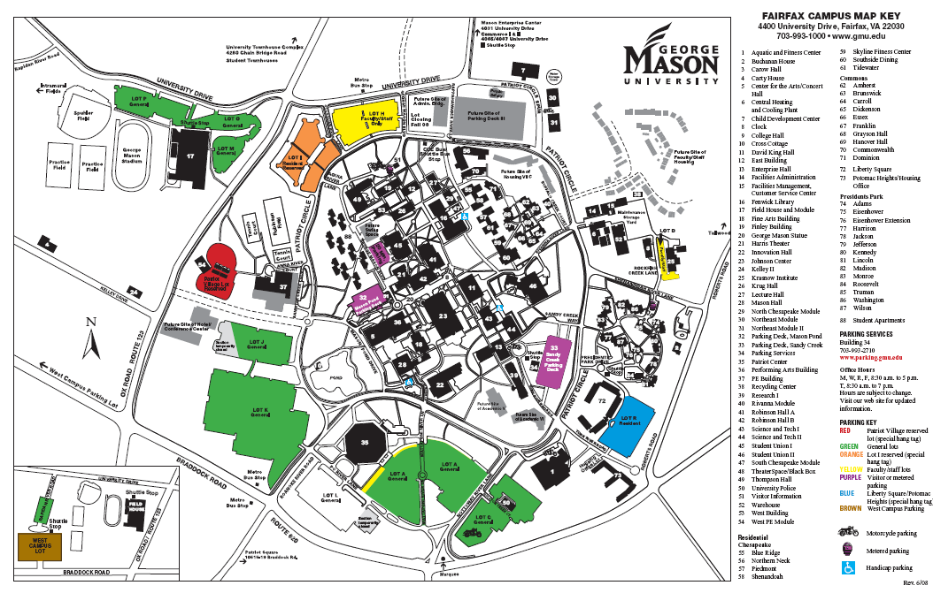

Figure - GMU Campus Map

2.4.2.5 User Scheduling

This function is responsible for allowing users to set preferences as to how they would like to receive parking information and the type and method to receive the information. This function will be coordinated with George Mason email accounts to uniquely identify each user.

2.4.2.5.1 Email Notification Setup

This function will allow users to log in and set up their email notification schedule and preferences. Each user will be able to set criteria as to what they want sent to them and when they want it sent. For instance, a user could want an email with a status of all the campus parking lots email to his Gmail account at 16:12, while another user might only want the status of student parking lots near the science building and want that sent at 11:45 but on Tuesdays they do not want any email notifications. A maximum of 10 emails per day per account will be the default value.

2.4.2.5.2 Text Message Notification Setup

Much like the email notifications, the text message setup will allow users to schedule text messages to be sent that contain information about the current parking status. Unlike emails this format will be much more restrictive in terms the information that can be displayed. And unlike emails users will need to agree to the text message policies, which include acceptance that the user will acknowledge that standard text message rates apply. Figure 15 shows a sample text message and demonstrates the limited information that can be displays through a text message.



Figure - Sample Text Message

2.4.2.5.3 Notifications

This function will monitor user notification scheduling and when a notification needs to be sent this function will package the preferences into a request and forward this on to pull the information from the database and sent out to the user.

2.4.2.6 Report Generation

As stated before being able to track and record the usage of parking spaces allows for analysis and optimization for future decision-making that will affect parking or will be affected by parking. In order to provide this data to the customer this function will allow several database queues to be performed in order to obtain only the data that is desired. This function will use the use queues and generate the data to a format that can be saved to external devices or can be printed directly. Reports will also be available for email directly from the server or through logging in to the PARKme system from an external location.

2.5 Software Interface Design Requirements

This section describes the software interface requirements for the design of the PARKme system. As the software has two modes that can be used this section will be divided into each part respectively. Figure 16 shows the interfaces associated with the software while running in kiosk mode. Figure 17 shows the interfaces associated with the software while running in Server mode. These two modes communicate with each other through hardware interfaces but the data that is sent over the hardware interface gets packaged at the software level. This packaging happens in the Transmit Receive function.



Figure - Kiosk Mode Software Interfaces



Figure - Server Mode Software Interfaces

2.5.1 Kiosk Mode Software Interfaces

2.5.1.1 GUI

In the following table the direction column can take two forms: to or from. Column 1 describes the direction of the interface, from describes an interface that is coming from another function where to describes an interface that goes to another function. The second column lists the connecting function and the third column contains a description of the interface.

|  |  |  |
| --- | --- | --- |
| Direction | Connecting Component | Description |
| From | User Input | The GUI will receive input from users through standard keyboard and mouse. An alternative to this is through the use of a touch screen. |
| To | Transmit/Receive | The GUI will take the user input and forward it to the transmit receive function to send it on to the server. |
| From | Transmit/Receive | The GUI will receive updates and data from the transmit receive function in the form of display updates for the user to view. |

2.5.1.2 Transmit Receive

In the following table the direction column can take two forms: to or from. Column 1 describes the direction of the interface, from describes an interface that is coming from another function where to describes an interface that goes to another function. The second column lists the connecting function and the third column contains a description of the interface.

|  |  |  |
| --- | --- | --- |
| Direction | Connecting Component | Description |
| From/To | Transmit Receive (Server) | Transmit Receive function will send and accept data from the Transmit Receive function of the server (Two way communication). The sending and receiving is done through hardware but the packaging of the data is done through the software. All data will be transmitted wirelessly using the Transmission Control Protocol/Internet Protocol (TCP/IP) protocols. |
| To | GUI | Transmit Receive will updates and data as it receives them from the server in the form of display updates for the user to view. |
| From | GUI | Transmit Receive will accept user input data from the GUI  and forward it to the transmit receive function of the server. |

2.5.2 Server Mode Software Interfaces

2.5.2.1 Report Generation

In the following table the direction column can take two forms: to or from. Column 1 describes the direction of the interface, from describes an interface that is coming from another function where to describes an interface that goes to another function. The second column lists the connecting function and the third column contains a description of the interface.

|  |  |  |
| --- | --- | --- |
| Direction | Connecting Component | Description |
| From | Operator (User) | External interface that will provide the operator a means to access the system data. This will be done through standard qwerty keyboard and mouse. |
| To | Operator (User) | Reports displayed to the user. These will interface directly with printers and memory for storage. |

2.5.2.2 System Set-Up

In the following table the direction column can take two forms: to or from. Column 1 describes the direction of the interface, from describes an interface that is coming from another function where to describes an interface that goes to another function. The second column lists the connecting function and the third column contains a description of the interface.

|  |  |  |
| --- | --- | --- |
| Direction | Connecting Component | Description |
| From | Operator (User) | This function will accept input from the operator using standard qwerty keyboard and mouse. |

2.5.2.3 GUI

In the following table the direction column can take two forms: to or from. Column 1 describes the direction of the interface, from describes an interface that is coming from another function where to describes an interface that goes to another function. The second column lists the connecting function and the third column contains a description of the interface.

|  |  |  |
| --- | --- | --- |
| Direction | Connecting Component | Description |
| From | Operator (User) | This function will accept input from the operator using standard qwerty keyboard and mouse. |
| To | User Scheduling | This function will pass along user requests (data) to the User Scheduling function for processing. |

2.5.2.4 User Scheduling

In the following table the direction column can take two forms: to or from. Column 1 describes the direction of the interface, from describes an interface that is coming from another function where to describes an interface that goes to another function. The second column lists the connecting function and the third column contains a description of the interface.

|  |  |  |
| --- | --- | --- |
| Direction | Connecting Component | Description |
| From | GUI | This function will receive user request (data) for processing from the GUI. |
| To | Monitor Parking | When a scheduling event occurs this function will package the necessary notification and preference data and forward on to the Monitor Parking function for processing. |

2.5.2.5 Monitor Parking

In the following table the direction column can take two forms: to or from. Column 1 describes the direction of the interface, from describes an interface that is coming from another function where to describes an interface that goes to another function. The second column lists the connecting function and the third column contains a description of the interface.

|  |  |  |
| --- | --- | --- |
| Direction | Connecting Component | Description |
| From | User Scheduling | This function will receive scheduling event data packages and will run a queue based on the preferences in the data package and append the queue results making a new data package. |
| To | Transmit Receive | Completed Data Packages will be sent to the Transmit Receive function in order to be passed along to the recipient. |
| From | Transmit Receive | Parking Sensor Data will be forwarded from the Transmit Receive function. |
| To | Transmit Receive | Directional Sign Data Packages (contains display updates) will be sent to the Transmit Receive function for forwarding on to the Directional Signs. |

2.5.2.6 Transmit Receive

In the following table the direction column can take two forms: to or from. Column 1 describes the direction of the interface, from describes an interface that is coming from another function where to describes an interface that goes to another function. The second column lists the connecting function and the third column contains a description of the interface.

|  |  |  |
| --- | --- | --- |
| Direction | Connecting Component | Description |
| From | Monitor Parking | Directional Sign Data Packages (contains display updates) will be received from the Monitor Parking function for forwarding on to the Directional Signs. |
| To | Monitor Parking | As Parking sensor data is received it will be forwarded on to the Monitor Parking function. |
| From | Data Network | External interface that receives wireless data transmissions with parking sensor data. All data will be transmitted wirelessly using the Transmission Control Protocol/Internet Protocol (TCP/IP) protocols. |
| To | Directional Sings | External interface that sends wireless data transmissions to the directional signs. All data will be transmitted wirelessly using the Transmission Control Protocol/Internet Protocol (TCP/IP) protocols. |
| To/From | Kiosk/Terminal | External interface with the kiosks/terminals where data communications are both sent and received. All data will be transmitted wirelessly using the Transmission Control Protocol/Internet Protocol (TCP/IP) protocols. |

APPENDIX A – ACRONYMS

The following are acronyms used in the document:

AOA – Analysis of Alternatives

CONOPS – Concept of Operations

COTS – Commercial-Off-The-Shelf

DOD – Department of Defense

DODAF – Department of Defense Architecture Framework

GMU – George Mason University

GUI – Graphical User Interface

LAN – Local Area Network

SDD – System Design Document

SEMP – System Engineering Management Plan

SMS – Short Message Service

SMTP – Simple Mail Transfer Protocol

SRS – System Requirements Specification

TCP/IP – Transmission Control Protocol / Internet Protocol