
GMU SYST 798
Capstone Project
“Role of Aviation in Urban Warfare”
By
Michael Bovan, Bryan Driskell
Michael Ingram, Jay Stewart, &
Damian Watson
For
Sikorsky Aircraft Corporation


Table of Contents
I Executive Summary 1
II Introduction & Concept of Operations 3
a) Background 3
b) Problem Statement 3
c) Project Objective 3
d) Deliverables 3
e) Schedule 4
f) Project Challenges 6
g) Assumptions & Scope 6
h) Stakeholders 7
III System Definition, Analysis, & Development 8
a) Building Analysis 8
b) Street Width Analysis 8
c) Use Case Analysis 9
d) Analysis of Alternatives (Scorecard) 12
d) Requirements Analysis 26
i) System Requirements Model 28
IV System Architecture 31
a) System Interface Description 31
b) System Functionality Description 32
c) Physical Architecture 34
V Business & Technology Assessment 36
a) Business Plan 36
b) Critical Technology 38
VI Conclusions and Recommendations 42
VII References & Resources 43
a) Conceptual Foundation 43
b) Operations Research Articles: 43
Appendix A: GIS Open Source Mapping Technologies 45
Appendix B: VTOL Research 47
Appendix C: System Architecture Model 47
Appendix D: System Requirements Specification Document 47
Appendix E: Design Solution Analysis 47

List of Figures
Figure 1: Project Schedule – Gantt Chart 4
Figure 2: Project Schedule - Network Diagram 1 of 2 5
Figure 3: Project Schedule - Network Diagram 2 of 2 6
Figure 4: Street Widths (All Streets) in Vancouver, BC 9
Figure 5: Urban Environment Decomposition 12
Figure 6: Missions within the Urban Canyon 13
Figure 7: Means Objectives 13
Figure 8: Objectives Hierarchy 15
Figure 9: Weightings for CASEVAC Use Case 20
Figure 10: Weightings for SAR Following Destruction Use Case 22
Figure 11: Weightings for BOLO Use Case 23
Figure 12: Weightings for Hostage Rescue Use Case 25
Figure 13: External Systems Diagram 29
Figure 14: SV-1 Systems Interface Description 31
Figure 15: Search & Rescue Use Cases Package 32
Figure 16: Search & Rescue Following Destructive Event Use Case 33
Figure 17: Receive SITREP Activity 33
Figure 18: VTOL Functional Decomposition 34
Figure 19: Function to Form Map (Top-Level) 34
Figure 20: Function to Form Map (Lower-Level Example) 35
Figure 21: Visual Representation of a Performance Measurement Baseline 36
Figure 22:Choose to invest if TRL > 6 and choose not to invest if TRL < 5. 37
Figure 23: In the Canyon Urban Air Vehicle Predicted Time to Markets 38
Figure 24: Critical Technologies 39
Figure 25: Rooftop Obstructions in the Urban Canyon 45
Figure 26: Urban Canyon Street Obstructions and Complexities 46

List of Tables
Table 1: Tallest New York City Buildings 8
Table 2: Measures of Effectiveness 1 16
Table 3: Measures of Effectiveness 2 17
Table 4: Measures of Effectiveness 3 17
Table 5: Engineering level Decision Support System. 18
Table 6: Means Objectives measurement factors weighted. 18
Table 7: Vehicle Specification tab, Means Objectives measurement factors’ values applied to Vehicles. 19
Table 8: Urban Canyon VTOL High Level Attribute Ranking 28
Table 9: Morphological Box of Design Solutions 40
Table 10: (Excerpt from) Combination Feasibility Table 41
Table 11: Promising Design Solution Combinations 41

Executive Summary
It has been well documented that the populations of the world have been relocating from farms, towns, and rural areas, to live in cities or other densely populated areas (mega-cities). It has been estimated that by the year 2030, five billion of the world’s 6.5 billion people will live in cities. The densely populated cities that are being produced by this population shift have been given the name ‘Urban Canyons.’
There has been an increase in the number of militaristic organizations and groups willing to use violence or terror to achieve an ideological objective. In some ways, this is related to a change in the type of organizations that heretofore engaged in armed conflict. There has been a transition from warring nations to nation-states, and now to non-state groups. Some groups have determined that densely populated cities or Urban Canyons create an ideal arena for achieving violent objectives, since the capability of organizations to stop or limit their activities can be reduced.
The idea that densely populated cities have become and will continue to be targets for major criminal activity, terrorist violence, or even war has prompted governments, military and law enforcement organizations to contemplate and assess how to best respond to threats of violence within the Urban Canyon.
This report focuses on a particular area of the Urban Canyon conflict: The future role of Vertical Take Off and Land (VTOL) aircraft in responding to potential Urban Canyon conflicts. It has been recognized that the spatial and vertical architecture of cities combined with dense populations would limit the capability and operating effectiveness of VTOLs in an Urban Canyon. This report has been prepared by the GMU-Sikorsky Team under the sponsorship of the George Mason University Systems Engineering and Operational Research Graduate Program, and the Sikorsky Aircraft Corporation. Through discussions with our sponsors, and given the limitations of time, the project team narrowed its assessment to analyzing the capability of VTOLs to conduct Search and Rescue (SAR) missions in an Urban Canyon environment.
Although many significant documents have been prepared to support this project, the overall analysis resulted in three principle deliverables: A set of Requirements for the Urban Canyon VTOL; A System Architecture for the VTOL; and a Quantitative Analysis of the capability of current VTOLs as well as a Gap Analysis and Technology Assessment. The Urban Canyon VTOL requirements were developed through an elicitation process from high-level System Attributes, Urban Canyon VTOL Scenarios, and Use Cases. These activities identified VTOL Safety, Maneuverability, and Operational Effectiveness as the most important attributes for the Urban Canyon VTOL.
The VTOL System Architecture process was also built upon VTOL scenarios, Use Cases, Activity Diagrams and Requirements in order to develop a System Functionality Description and also to map Functions to Logical Physical Components of the VTOL. The System Architecture includes a System View, which details the communication and data interfaces that the Urban Canyon VTOL will share with external systems.
Perhaps most interesting is the development of the Quantitative Analysis of the capability of current VTOLs to conduct SAR missions within an Urban Canyon. This analysis compared weighted preferences for attributes of an Urban Canyon VTOL to similar attribute specifications of currently available VTOLs. The results were showed that most existing VTOLs exhibit some operational difficulty in the urban canyon. However, the data identified capability gaps and helped the team characterize technology deficiencies. The deficiencies appear to be in the attributes of Maneuverability and Operational Effectiveness. These are the VTOL attribute areas that should be pursued with future technology enhancements.
As a byproduct of the VTOL Selection analysis and Gap analysis, this report includes an assessment of future technology needs for the attributes of attributes of Maneuverability and Operational Effectiveness. Using a “Function-to-form” decomposition approach, we speculate on design solutions that would make the VTOL more capable for use in a SAR mission. This assessment shows that limitations in propulsion systems, energy, material flexibility and weight vs. strength; are technology areas that should be addressed in the future.
Lastly, the GMU-Sikorsky Team would like to thank Sikorsky Aircraft Corporation, and especially Mr. Chris VanBuiten, Mr. John Burton, and Mr. David Kingsbury, for their guidance, insight, and support in the fulfillment of this assignment. We would also like to thank Dr. Speller for many hours of technical leadership in support of this project.

Introduction & Concept of Operations

Background
It is predicted that eighty percent of the world’s population will live in urban environments by 2030. Whether terrorists attack the United States or military forces are deployed to other countries, the urban environment is where terrorists can blend in among the population and have adequate infrastructure to hide within and attack from. In November 2008, Mumbai terrorists laid siege to the Taj Mahal Hotel in India, killing approximately one hundred and fifty people. This is a perfect example of terrorist activities that utilized infrastructure to aid the accomplishment of their mission. Uses for VTOL vehicles in urban environments include Search & Rescue (SAR), Attack & Target Designation, Troop Transport, Reconnaissance, and Logistical Resupply missions. This incorporates troop extraction missions, evacuation scenarios - such as the 9-11 terrorist attack on the World Trade Center, along with enemy surveillance support to track the location and activities of enemy combatants, while providing the opportunity to gather additional intelligence data. With sensor technology maturing rapidly, open architecture will play an important role to ensure that the most accurate enemy detection and precision non-collateral weapons are integrated onto the vehicle platform.

Problem Statement
The battlefield of the future is increasingly urban. The urban environment poses unique challenges as a battlefield, especially for aviation assets. The old model of Red versus Blue simply does not apply to urban warfare. In the future urban combat environment, the role of VTOL aviation in military missions is largely undefined.

Project Objective
The objective of this project is to analyze the role of vertical takeoff and landing (VTOL) aviation for future military missions in urban environments. To meet this objective, the team evaluated current aviation platforms such as the Blackhawk and F-22, as well as current prototypes such as the Sikorsky Cipher and X2 platforms. The evaluation focused on the role of those assets in future urban missions, and sought to identify technology gaps. With a goal of influencing the design of future urban warfare VTOL platforms, the team developed mission and system requirements and conducted trade-off analysis.

Deliverables
The objective stated above implies the delivery of certain products. Those are tentatively listed here, pending sponsor approval:
- Quantitative analysis of relevance of current aviation systems in urban fight
- Requirements for VTOL in urban fight in 2050
- Architecture for urban warfare VTOL aviation

Schedule
Team Sikorsky developed two views of the Project Schedule. Figure 1 shows the schedule as a Gantt chart with a description of tasks. We used both a Gantt Chart view and a Network Diagram view to display our schedule. We developed these views because they provide different insights into the project schedule. The use of these two schedule views allowed us to effectively track and manage our project effectively from start to finish.
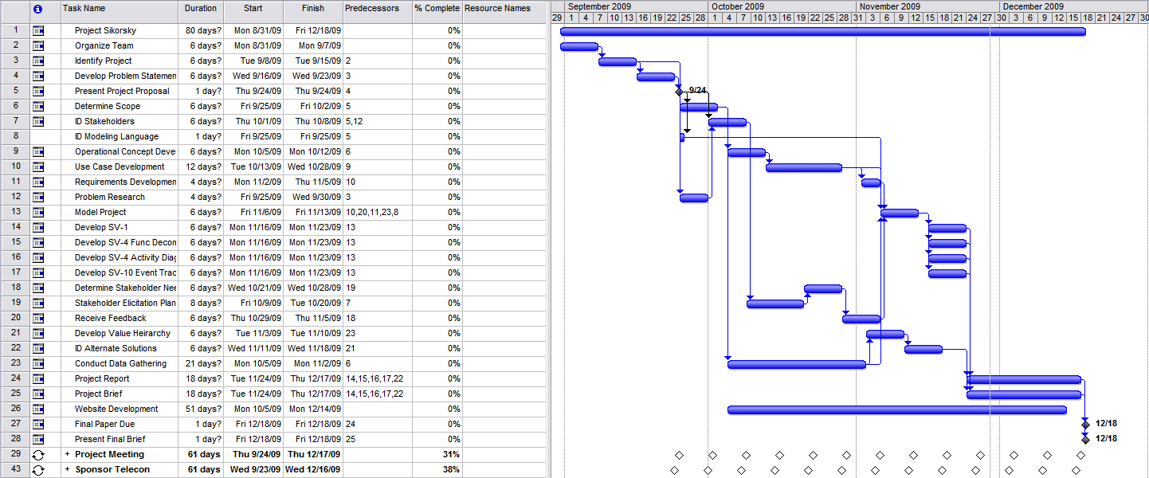
Figure 1: Project Schedule – Gantt Chart
The Gantt Chart view allowed us to keep track of the progress we made on each task. It depicts the scheduled start and finish dates of each tasks. Additionally, it highlighted milestones and weekly meetings with the sponsor. Lastly, it depicts the predecessors and successors of each task in the project schedule.
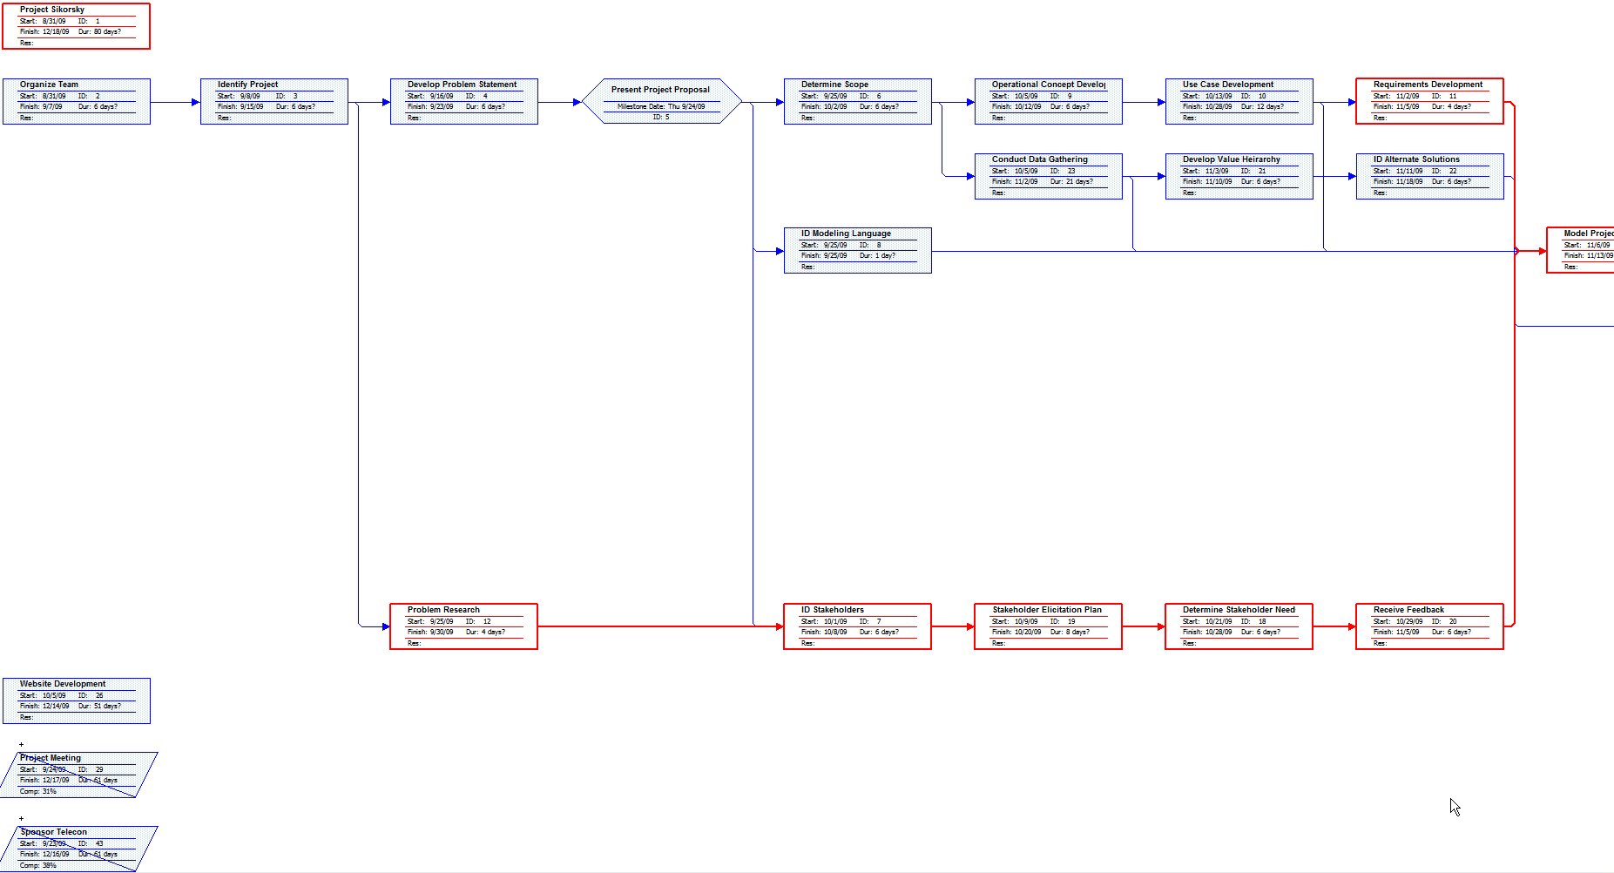
Figure 2: Project Schedule - Network Diagram 1 of 2
Figure 2 shows schedule elements as a Network Diagram. The Network Diagram view allowed us to identify our critical path tasks. The tasks which were on the critical path were mainly project research tasks, task which involved receiving feedback from the stakeholder, and the tasks of modeling the project in Enterprise Architect. Laying the schedule out in this view drew our attention to these critical tasks and helped us manage their completion more closely to prevent any major slips to the schedule.
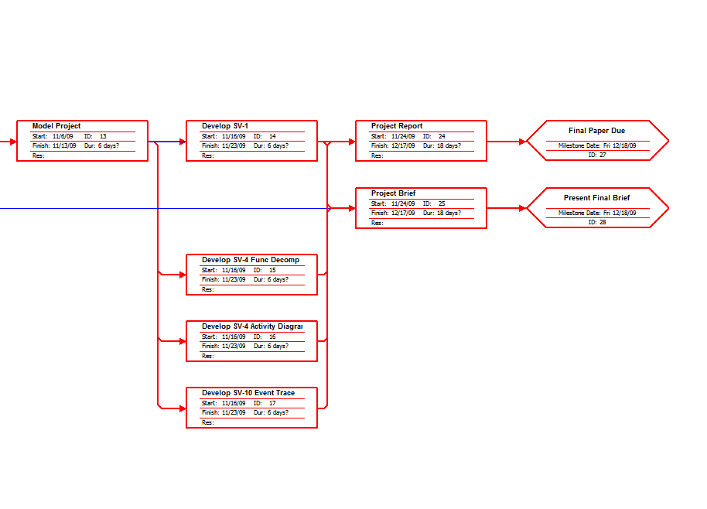
Figure 3: Project Schedule - Network Diagram 2 of 2

Project Challenges
The problems that urban canyons present must be analyzed due to their affect on the success of the proposed missions. Some examples include the risk of failure (causing damage or death), wind tunnels, and turbulence, autonomous navigation without global position systems due to the canyon effect or precise three-dimensional building maps. Urban geometry (tall, closely spaced infrastructure) also presents obvious challenges in the physical design of an aviation asset, affecting size and weight specifications.

Assumptions & Scope
Due to time constraints for the project to be complete in fourteen weeks, the problem was appropriately scoped so a well-defined output is achieved for successful completion of the project.
      - Focus on military operations and military vehicles. The same concepts of search and rescue can be applied to DHS national emergency and local EMS missions.
      - Focus on VTOL vehicles. Fixed wing, linear flight vehicles will not be the optimal vehicles for within the urban canyon.
      - Focus on operations within the urban canyon, which may include dropping a “system” within the canyon. Current operations today include operations above the urban canyon, but have limitations. In-canyon operations are the problems that need to be analyzed for future technology to progress.

Stakeholders
- US Navy and Marine Corps - Potential user of the Urban Canyon VTOL to resolve conflicts in coastal cities
- Sikorsky Aircraft - Potential designer and builder of an Urban Canyon VTOL and Sponsor our Development efforts
- US Army - Potential user of the Urban Canyon VTOL to resolve conflicts in cities
- Department of Homeland Security - Potential user of the Urban Canyon VTOL to resolve conflicts in CONUS Border cities and towns
- US Air Force - Potential user of the Urban Canyon VTOL to resolve conflicts in cities
- US Dept. of State - Provider of National and International Policy regarding the use of the Urban Canyon VTOL in densely populated cities
- Other VTOL Aircraft Manufacturers
- Other providers of national and international security organizations

System Definition, Analysis, & Development

Building Analysis
A key consideration to help understand the problem is an analysis of the urban geospatial environment. The table below represents the height of the tallest New York City skyscrapers in meters and number of floors.
Tallest New York City Buildings (pinnacle heights used)
Name | Height (m) | Floors
One World Trade Center | 527 | 110
Two World Trade Center | 415 | 110
Singer Building | 187 | 47
7 World Trade Center | 174 | 47
Deutsche Bank Building | 172 | 40
Trinity Church | 85 | 1
World Building | 106 | 20
Manhattan Life Insurance Building | 106 | 18
Park Row Building | 119 | 30
Metropolitan Life Insurance Company Tower | 213 | 50
Woolworth Building | 241 | 57
Bank of Manhattan Trust Building | 283 | 70
Chrysler Building | 319 | 77
Empire State Building | 449 | 102
Bank of America Tower | 370 | 54
New York Times Buildings | 319 | 52
American International Building | 290 | 66
40 Wall Street | 283 | 70
Citigroup Center | 279 | 59
Trump World Tower | 262 | 72
GE Building | 259 | 70
CitySpire Center | 248 | 75
One Chase Manhattan Plaza | 248 | 60
Conde Nast Building | 341 | 48
MetLife Building | 246 | 59
Bloomberg Tower | 287 | 54
Average | 262.6154 | 58.38462
Table 1: Tallest New York City Buildings

Street Width Analysis
According to a survey assembled in 1997 and conducted by Alan Cohen and commissioned by the Transportation Task Force of the Congress for the New Urbanism, street widths prior to WWII for a traditional US neighborhood street was in the range of 28'-30' wide with corner radius of 5'-10'. Since then the typical local neighborhood street width has grown to 36’ with a corner radius of 25’. An in-depth analysis of the City of Vancouver in Canada was conducted which breaks down their city into the following pie chart. The pie chart for Vancouver verifies the survey conducted by Alan Cohen showing that 54% of the streets are less than 36’ wide. Therefore, we believe that a VTOL should be able to navigate through Streets as narrow as 36’ and have the ability to turn around in such a tight space. A VTOL, which can navigate through these tight spaces, will be able to complete most of the mission sets required of Operations in an Urban Canyon.
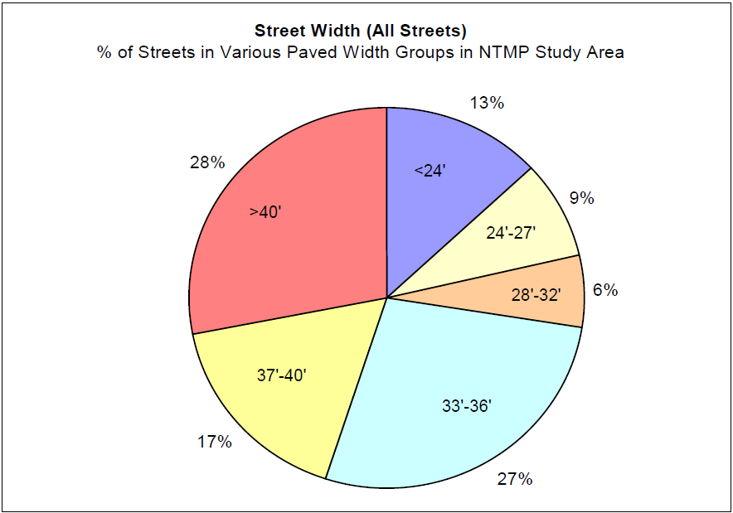
Figure 4: Street Widths (All Streets) in Vancouver, BC

Use Case Analysis
A majority of the systems engineering work performed on this project stemmed from an initial use case analysis (as taught in GMU SYST 520). The insight gained from our use case analysis led to the definition and refinement of system requirements. The use case analysis also helped the team to identify the system interfaces and system functionality documented in the system architecture. Finally, the use case analysis heavily influenced our quantitative analysis of current systems. This section describes our use case analysis process, and highlights some examples. The complete use case analysis is included in appendices to this document (both in text form as part of the requirements specification Appendix D: , and as a part of the system architecture Appendix C: .
In order to gain insight about how a VTOL platform would perform its mission in its intended environment, the team identified a broad range of scenarios in which the system could be called upon for employment. We started with a basic vision of how the system would be used. That vision, as documented in the System Requirements Specification (SRS), is:
“The Urban Canyon Vertical Take-off and Landing System (UC-VTOL) will conduct Search and Rescue (SAR) missions in the urban environment, below the city building rooflines. The UC-VTOL defies the conventional notion of airspace limitations, operating where traditional aircraft cannot go. The UC-VTOL will fly through the narrow urban canyon, between buildings, and above the city streets in the execution of the SAR mission.”
From that basic vision, nine operational scenarios were identified:
- Be On Look Out (BOLO) Search Operations
- Tsunami
- Hurricane
- Terrorist in Building Before Terrorism Event
- Search and Evacuation of Building After Terrorism Event
- Contested Casualty Evacuation (CASEVAC)
- Hostage (Bank Robbery)
- Foreign Embassy Evacuation
- Building/Bridge Collapse
The team vetted this list of scenarios with the sponsor, Sikorsky, to ensure accuracy and sufficient breadth. It was agreed that the proposed list represented an adequate range of possible scenarios for the system in its intended scope (in fact, subsequent analysis, and discussion even revealed a certain amount of overlap). The team then used these scenarios to explore “a day in the life of” the system. Initially, the team worked with narrative descriptions of the scenarios. Next, each scenario was elaborated as a use case, defining a sequence of actions performed by actors. In some cases, alternate flows of events were documented, to allow for potential variations in the scenarios. To illustrate the product of our analysis process, an example is given below, the Contested Military Evacuation.

Description
In this scenario, a friendly force and an enemy force are engaged in armed conflict in an urban area. The setting for the scenario is the 30th story of a 50-story building in the downtown region of a densely populated city. Two friendly individuals are seriously injured, but alive. The site of the conflict is still contested, with neither the friendly nor the hostile forces controlling the “indoor battlefield”. Assume that there is no egress from the ground or from the roof; an aerial evacuation of the casualties is the only option.
The VTOL platform would be called in from a nearby landing zone, with basic tasking information provided by a ground control station. Given general coordinates, and possibly little else, the aircraft would need to locate the precise position of the conflict. This could be as simple as the operator visually spotting the site, or using some type of digital location (e.g., Blue Force Tracking (BFT)). Once in position, the aircraft would need to open a route to the building, by either breaking a window or even blowing a hole in the building façade and structure. The platform would likely be marked as a medical unit, but the rules of engagement could be ignored, leaving the aircraft subject to attack. Given that the hostile forces are inside a building, it is assumed that heavy artillery is not a threat, but small fires and rocket-propelled grenades (RPG) are plausible from within the building. Hostile forces could also engage from the ground, a nearby building, or the rooftop. Given such threats, the VTOL aircraft would likely need some means of knowing when a threat is present (surveillance), and at least some means of self-defense. Finally, the VTOL would need some method of extracting the casualties, either in a group, or individually. This would be no trivial matter, given that the platform is hovering outside the window, 30 stories up. Some type of retractable boom, basket, or extending arm could assist.
The contested CASEVAC scenario poses serious challenges for a single urban VTOL platform. This scenario involves elements of other mission areas, including reconnaissance and possibly even attack (from a self-defense perspective).

Example Use Case
Summary: The UC-VTOL system is tasked with a CASEVAC in a contested urban environment. The UC-VTOL approaches the 30th floor of a 50-story building, in which friendly and hostile forces are engaged in ongoing conflict. The UC-VTOL retrieves two injured friendly combatants, and transports them to a medical facility.
Actors:
- UC-VTOL
- UC-VTOL operator
- UC-VTOL crew (1 person)
- Injured friendly combatants (2 persons)
- Un-injured friendly combatants
- Hostile combatants
Normal Flow of Events:
- Via Communication system, the UC-VTOL receives a command from ground controller to perform CASEVAC at given location (50-story building at coordinates x, y).
- The UC-VTOL operator responds WILCO.
- The UC-VTOL operator launches.
- The UC-VTOL maneuvers to given coordinates.
- The UC-VTOL searches area for precise location of activity.
- The UC-VTOL operator/crew confirms visual identification of activity on 30th floor.
- The UC-VTOL checks in with friendly forces in building via Communication system.
- The UC-VTOL gains physical access to the building floor (e.g., breaks window(s), creates hole in building).
- The UC-VTOL employs Retrieval system (e.g., basket, mechanized arm, cable and pulley) to retrieve injured friendly combatants. (Note: the mechanics of the Retrieval system are not specified at this stage in project).
- The UC-VTOL retreats with injured friendly combatants.
- The UC-VTOL operator reports mission status to ground controller.
- The UC-VTOL delivers injured friendly combatants to medical facility.
- The UC-VTOL returns to base (RTB).
- The UC-VTOL lands at base.
Alternate Flows of Events:
Hostile Combatants engage UC-VTOL with small fires
- The UC-VTOL gains physical access to the building floor (e.g., breaks window(s), creates hole in building).
- The hostile combatants engage the U-VTOL with small fires.
- The UC-VTOL armor system absorbs/deflects the effects of the small fires.
- The UC-VTOL Self-Defense system returns fire on hostile combatants, temporarily neutralizing threat.
- Return to Normal Flow of Events, step 9.
Hostile Combatants engage U-VTOL with Rocket Propelled Grenade (RPG)
- The UC-VTOL gains physical access to the building floor (e.g., breaks window(s), creates hole in building).
- The hostile combatants engage the UC-VTOL with RPG.
- The UC-VTOL surveillance system detects the incoming RPG.
- The UC-VTOL surveillance system classifies the incoming RPG as a threat.
- The UC-VTOL Self-Defense system engages the incoming RPG, neutralizing the threat.
- Return to Normal Flow of Events, step 9.
U-VTOL sustains critical damage
- The UC-VTOL gains physical access to the building floor (e.g., breaks window(s), creates hole in building).
- The hostile combatants engage the U-VTOL.
- The UC-VTOL sustains critical damage.
- The UC-VTOL Communication system emits distress beacon.
- End Use Case.
U-VTOL retrieves injured friendly combatants individually (1 at a time)
- The UC-VTOL employs Retrieval system to retrieve 1 of the injured friendly combatants.
- The UC-VTOL employs Retrieval system to retrieve the second injured friendly combatant.
- Return to Normal Flow of Events, step 10.
To reiterate, the above example is one of nine scenarios that comprise the use case analysis. The complete use case analysis is provided in Appendix C: of this document. In addition to the text format illustrated above, each use case was modeled in a diagram format, providing the basis of the system functionality description of the system architecture, which will be discussed in detail in a later section. The next section, however, describes the analysis completed to examine the possibility for current and proposed systems to operate in scenarios like those describe above.

Analysis of Alternatives (Scorecard)

Operational Phases
One of the key deliverables from this project is an analysis of current aviation systems. The primary stakeholder, Sikorsky Aircraft Corp., expressed interest in a quantitative assessment of the suitability and effectiveness of current VTOL platforms in the urban environment. In essence, the task was to develop a “scorecard” of current options. Even before any analysis began, it was generally understood that no current platform is suitable for urban operation (hence, the need for the project). Thus, the analysis was less about finding the “best” current option, and more about identifying strengths and gaps in the current technologies.
To provide a structure to the analysis, the team applied the methodology of Ralph Keeney’s value-focused thinking (as taught in GMU SYST 571, as well as several other courses, including SYST 680, SYST 542, and SYST 520). The basic premise of Keeney’s value focused thinking is to identify and analyze the stakeholder’s values before sorting out possible outcomes. For this exercise, Sikorsky was our primary stakeholder. As will be seen below, we used a multi-attribute utility hierarchy (MUH, which we refer to as the “objectives hierarchy”) to organize the stakeholder’s values. Before we discuss the evaluation of platforms against the values, the following paragraphs briefly describe the value elicitation process.
The elicitation of values from our stakeholder was an interactive process. Early work in this area helped to refine our scope, setting the framework for later deliverables. The fundamental value in this analysis involved the ability to conduct airborne operations in the urban environment. We quickly discovered that the term “urban environment” needed some refinement. The figure below illustrates a basic decomposition of the environment.
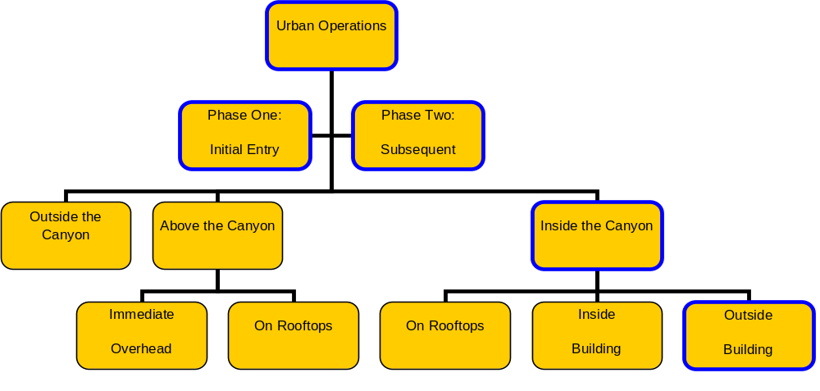
Figure 5: Urban Environment Decomposition
The team scoped the effort to focus on “inside the canyon” (i.e., below the rooflines, between buildings). We also agreed that the vehicle would not need to be able to operate on rooftops or inside of buildings.
Originally, our vision of the system encompassed a full range of conceivable mission areas, which we outlined as the following:
- Search and Rescue (SAR)
- Attack and Target Designation
- Troop Transport
- Reconnaissance
- Logistical Resupply
However, after collaboration with the sponsor, it was agreed that this scope was too large; clearly, different missions would call for different system attributes. For example, an Unmanned Aerial System (UAS) could make an excellent (arguably even the optimal) reconnaissance VTOL platform for urban areas. That same UAS VTOL platform would do very poorly at troop transport, however. It is unlikely that a single VTOL platform could efficiently perform all of the missions listed above, especially within the urban canyon; one size would not fit all. For this reason, the scope of the analysis (and consequently, the entire project) was limited to a single mission area, SAR. The figure below illustrates the refinement in mission scope:
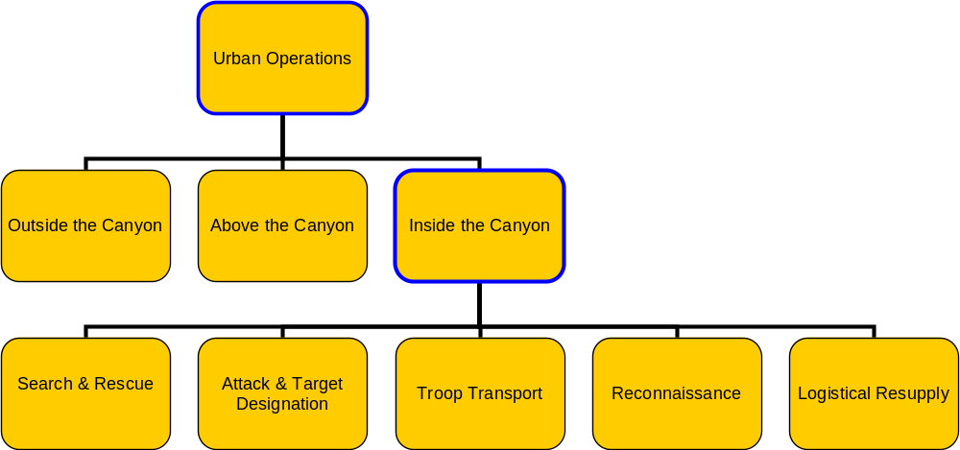
Figure 6: Missions within the Urban Canyon
With the refinement in scope, in terms of both mission and environment, we could state the fundamental objective: “Conduct SAR within the Urban Canyon”. The elicitation of values could then begin to proceed to more detailed values (a.k.a., means objectives), which decompose the fundamental objective into lower levels of the objectives hierarchy. We began to consider which attributes of a VTOL would make it suitable and effective for SAR operations within the urban canyon. Again, this was an interactive process, involving elicitation, review, and revisions from the stakeholder. After some iteration, the means objectives emerged:
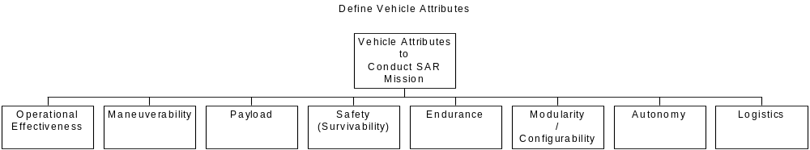
Figure 7: Means Objectives

Agreed upon Definitions for VTOL System Characteristics
Through collaboration with our primary stakeholder, the means objectives were defined as:
- Operational Effectiveness - This value area is concerned with measuring how well the Urban Canyon VTOL can perform its various missions.
- Maneuverability - The ability of a VTOL to move easily in three-dimensional space in the tight confines of an Urban Canyon.
- Payload - The VTOL system will posses an adaptable configuration capability to accommodate different payloads.
- Safety (Survivability) - The VTOL system will provide “armor-level” protection to personnel. The system will be capable of exhibiting safe escape strategies, and posses personnel protection and deflection systems.
- Endurance - The VTOL system will have fuel economy to support a three (3) hour flight time mission and will be refuel-able by air. All electrically powered systems will be capable of battery backup power. The system batteries will support a 24 hour mission without charge and a thirty day mission under charge. The system batteries will be rechargeable.
- Modularity (Configurability) - This value area describes how well the Urban Canyon VTOL is adaptable as a modular system in critical system areas.
- Autonomy - The VTOL system will be fully mission operable by a crew of three (3) persons. The VTOL system will be configured for autonomous flight. All sensors and weapons will be capable of automated operation.
- Logistics - This value area describes the life cycle support and material network needed for the Urban Canyon VTOL.
The final stage of the value elicitation was the decomposition of the means objectives into measurable levels. The figure below illustrates the final objective hierarchy:
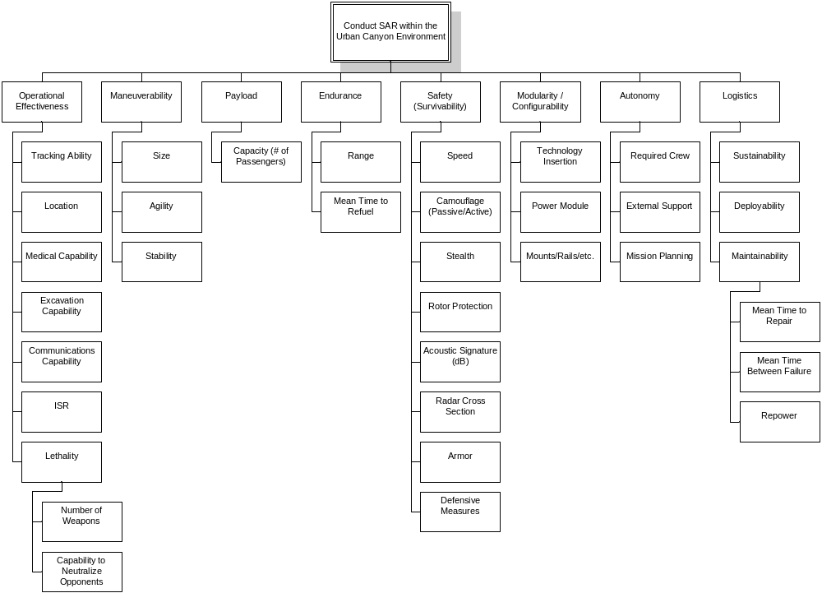
Figure 8: Objectives Hierarchy
Using the objectives hierarchy, we assessed the current systems against the stakeholder’s values. To make it a quantitative assessment, however, we had to define relative weighting of each branch (set of siblings) in the hierarchy. We also had to define scoring functions and criteria for each of the lowest-level measures.
At this point, the team agreed that, even with the refined mission scope, some variability would still exist in value weights. In one type of use case scenario, certain values could be more important than they would be in other scenario types. For example, a search for a missing person on the crowded streets would be quite different from a rescue from a 30-story building occupied by enemies. Given this variability, the team decided to weight the objectives hierarchy differently for different types of scenarios. The use case scenarios (previously described) were grouped into categories for which the values would be similarly weighted. Those Search and Rescue categories are:
- Contested Evacuation
- SAR Following Destruction
- Be on the Look Out (BOLO)
- Hostage Rescue
In effect, there are four versions of the objectives hierarchy. The values and their structure remained constant in each of the four versions, but the weighting varied. Because of this breakout, each VTOL assessed against the objectives hierarchy was given four scores, corresponding to its suitability and effectiveness to conduct the four types of SAR scenarios in the Urban Canyon.
Given the complexity and relative subjectivity of the problem, we determined that direct weighting was the most appropriate weighting method for the values. As with all previous steps, we proposed notional weighting to the sponsor, and Sikorsky responded with adjusted results. Finally, scoring functions were additive; the lowest level branches were scored as the weighted averages of each score on that level, and higher level branches were simply the weighted averages of their children’s weighted averages.
The following paragraphs describe the mechanism for scoring different VTOL platforms (referred to herein as “candidates”) against the objectives hierarchy, and the results.
Each measure has discrete numerical preference values. The provided measures are used to define and calculate each means category.
The table below defines factors and measures to evaluate their relative importance. The higher the weighted value the more desirable that feature is to the users. It is possible for two attributes to apply to the same vehicle, if this is the case; the higher weighted value is applied to the vehicle. For example, if a vehicle can excavate a people AND rubble, the value applied is the “excavate people” value carrying a weight of 1.0 (the highest possible).
Note that the third tier values were not considered for this analysis and would be considered “rolled-up” into their respective second tier parent.
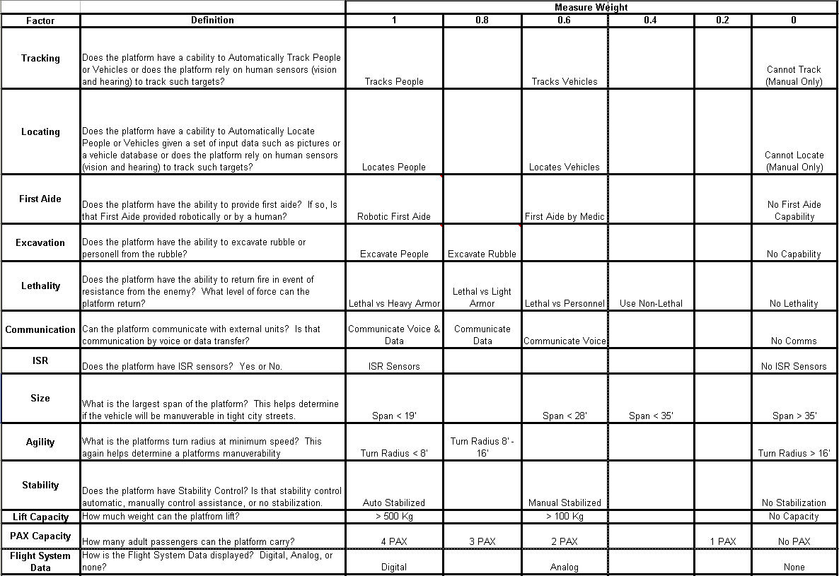
Table 2: Measures of Effectiveness 1
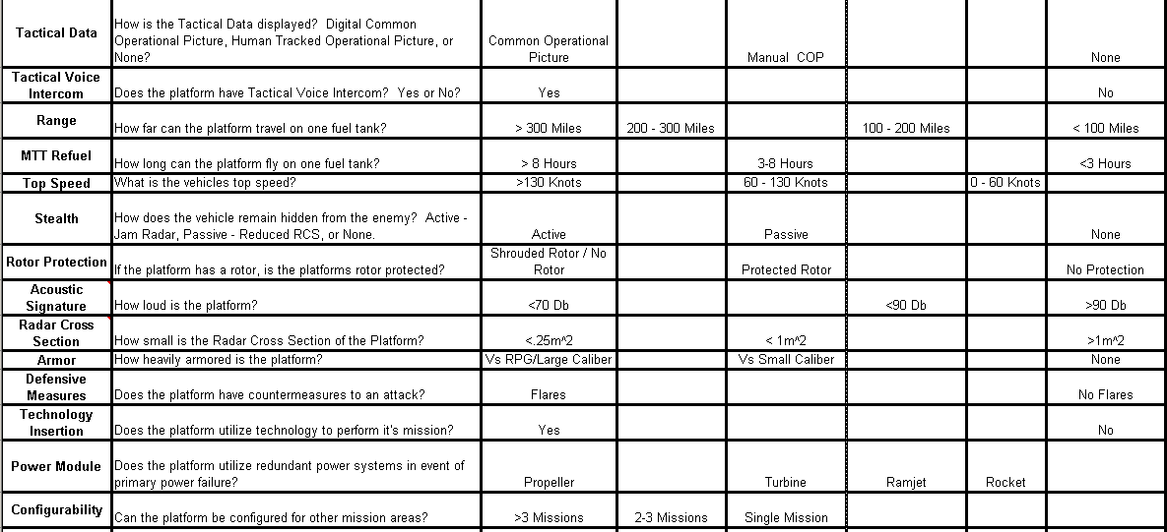
Table 3: Measures of Effectiveness 2
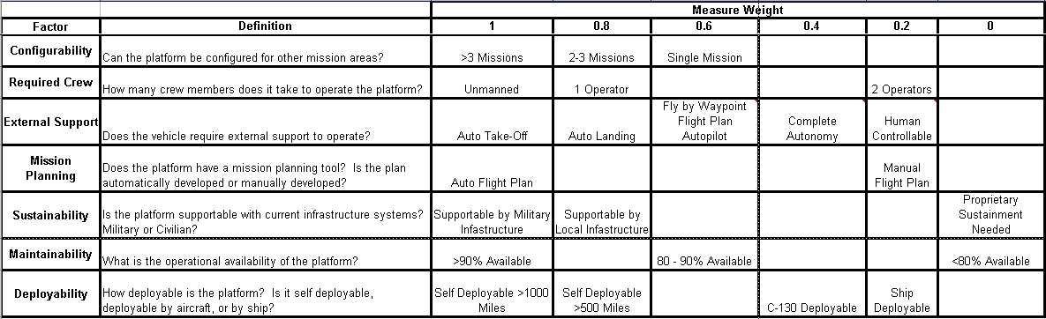
Table 4: Measures of Effectiveness 3
In order to begin the assessment, the team had to understand how we were going to obtain data for our analysis. The team conducted internet searches on current vehicles. Comparing the actual specifications would be a good initial way to determine how one vehicle compared to another. This current vehicle analysis would help to identify gaps in current vehicle capabilities specific to flying in the urban canyon. These gaps would then be the hallmark of where Sikorsky can focus their efforts via technology investments to develop a vehicle to perform these missions.
The analysis was developed in Microsoft Excel format per the direction of the sponsor. Microsoft Office products were preferred so that they could open the files and trace our analysis process. The spreadsheets were also designed so that the user could go in and manipulate the vehicle attributes using dropdowns or weight values via percentage values and obtain immediate results without having to learn how to use an analysis tool such as Matlab or Minitab.
The team took the actual vehicle specifications and developed a Decision Support System using direct weighting in accordance with the techniques learned in SYST 542, the team called this the low level “engineering”. We did this because of the availability of the raw data on the Internet. The downside to this is that there are few available technical specifications for the futuristic prototype vehicles, so they were not evaluated in this manner.
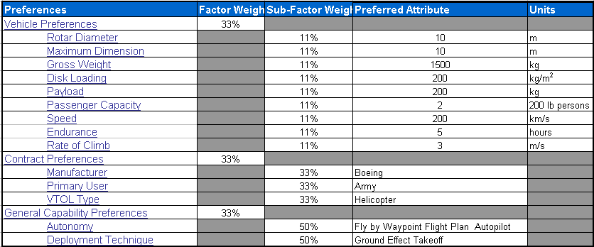
Table 5: Engineering level Decision Support System.
Note that the user has the flexibility to select the preferred attribute, and weight the values appropriately.
As discussed previously, the nine use cases were combined into four high level scenarios. To evaluate how each vehicle scored in its ability to support each of the four scenarios, a new high level, Objective Decision Support System was developed.
The team then weighted each of the means objectives and their factor measures with an appropriate weighting value for each scenario based on the importance of that factor’s contribution to the scenario success. The reasoning behind the weightings was validated by Sikorsky and is described in detail in Table 2,Table 3, and Table 4. The graphic below shows how two of the four scenarios were evaluated.
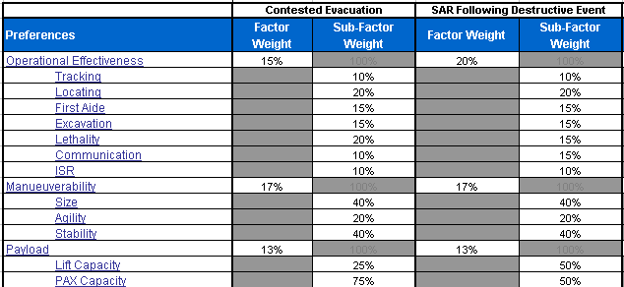
Table 6: Means Objectives measurement factors weighted.
The weights are used to signify factor importance among the different scenarios.
To score each vehicle, the user does not get to pick in the DSS itself the “preferred attribute/factor” as was done in the original engineering DSS. If the user wishes to pick a different value as more relevant than another value for the same factor, the user would re-evaluate the measurement weights on the “Field Definitions” tab (refer to Table 2,Table 3, and Table 4, Measures of Effectiveness). Values with a probability score for each of the high-level means objectives’ measurement factors were developed so that they could be applied and matched to each vehicle.
This allows the user to spend more time evaluating the operational effectiveness through operational testing. The results obtained are then used to refine the values that were applied on the “Vehicle Specification” table, shown below. Since the team did not have access to the operational test results for these vehicles the team used the original internet research of the detailed specifications, and the detailed specifications were taken into account where possible. For example, this was the case for vehicle size, which was now discretized into a category rather than a specific numerical value. However, applying some of the values was very subjective due to the lack of information that could be obtained about the vehicle (such as Lethality, Communication, and ISR as examples). In the absence of known data, engineering experience and judgment was applied to obtain sponsor review, feedback, and concurrence.
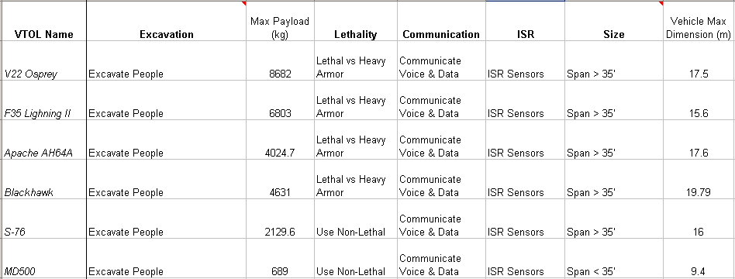
Table 7: Vehicle Specification tab, Means Objectives measurement factors’ values applied to Vehicles.
Note that the non-bold columns were the original engineering specifications that were taken into account when applying the more subjective (or discretized) means objective measurements such as the ability to evacuate people using max payload factor and specify the ability of a vehicle to fly in-between buildings using size factor.
The following paragraphs describe the specific results see section.

Consolidated Areas of Analysis
This section will lay out how each consolidated scenario will have a different effect on the importance of the means objectives to achieve the Search and Rescue mission.
Note that initial application of measured values to the specific vehicles for this project was a subjective process and will need to be refined as further research time and reliable data sources are available.
Also note that the percentages applied to each scenario were set for this analysis report, but if the stakeholders desire, they can conduct what-if questions to change their preference options by easily modifying the fields in the DSS. For each scenario the objective hierarchy is shown with certain attributes highlighted in red to convey the most important factors.

Contested Evacuation
Contested Evacuation is a combination of the main features found in the Foreign Embassy Evacuation scenario and the CASEVAC scenario. A contested Evacuation has to be analyzed for the hostile nature of the environment due to enemy combatants.
The main features to take away from the distribution of importance percentages below is are the following points agreed to by all stakeholders:
- Safety and Survivability is the main means objective considered within a hostile evacuation environment.
- Within Operational Effectiveness means objective, the ability to return fire and kill accurately without collateral damage. In order to do this, the location of the hostile forces must be very precise (consistent), and reliable.
- The vehicle must be stable to evacuate soldiers and be able to handle human weight load shifts.
- The ability to evacuate multiple human personnel weighing 200+ lbs is highly desirable.
- The range of the vehicle is important to reach the safe zone.
- Stealth by having a very low acoustic signature is of most importance, since it falls under the Safety and Survivability category, in order to safely rescue people in need in a covert manner without drawing unnecessary attention.
- An unmanned vehicle is highly preferred if possible, to maximize human payload for extraction.
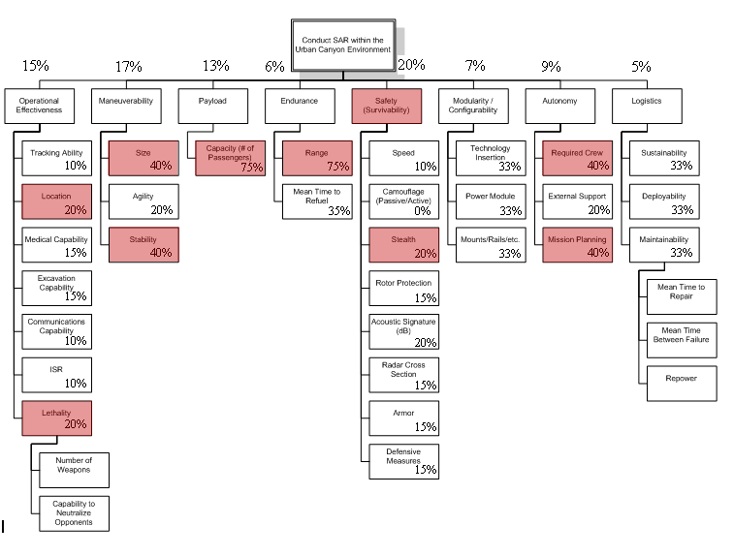
Figure 9: Weightings for CASEVAC Use Case
Analysis Results
Top results:
- V22 Osprey
- MD500
- Blackhawk
- S-76
- F35 Lightning II

Search & Rescue Following Destructive Event
Search and Rescue Following a Destructive Event is a combination of the main features found in the Building/Bridge Collapse scenario and both the Tsunami and Hurricane natural disaster scenarios. The analysis will focus on the ability for the VTOL vehicle system to search and provide help for humans in need once chaos has occurred.
The main features to take away from the distribution of importance percentages below is are the following points agreed to by all stakeholders. Note that these objectives are highlighted in red in the table below.
- Operational Effectiveness is the main means objective considered within a non-hostile evacuation environment where the vehicle needs to perform and save lives.
- Within Operational Effectiveness means objective, the ability to locate the people in need must be very reliable. If people in need cannot be accurately located then the vehicle is not much value. In addition, the rescued people must be moved to safe locations each rescue, which may or may not be the same area.
- The vehicle must be stable to evacuate people in need and be small enough to perform in the urban canyon, by moving people to a safe location.
- The ability to evacuate multiple human personnel weighing 200+ lbs is highly desirable.
- The range of the vehicle is important to reach the safe zone and provide the proper services in the event of a huge explosion, which could cause building damage over a wide city area.
- Protecting the vehicle which is flying through a disturbed building layout (could be different from the 3d preplanned mapping systems) with dangerous debris is of most importance, since it falls under the Safety and Survivability category.
- A vehicle which has support mounts for multiple different sensors and equipment for search & rescue of human life. This is more focused on harnesses and ropes that can lowered for rescuing or an external system that may be mounted that can break windows and provide resources for people to survive longer.
- An unmanned vehicle is not preferred, but a vehicle with some autonomy in searching, flying, and hovering so the pilot could help with the rescue would be desirable. In addition, the ability for the vehicle to continue to keep track of people in need and receive reports and tasks from the Mission Control Center.
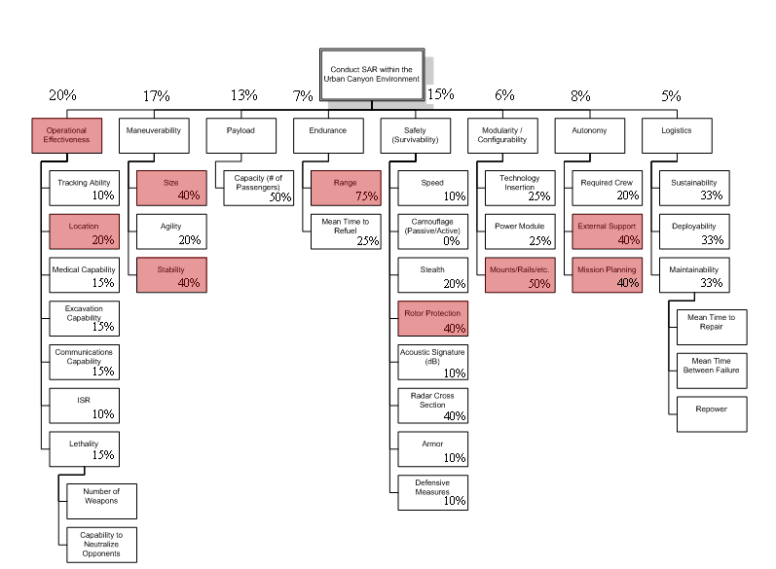
Figure 10: Weightings for SAR Following Destruction Use Case
Analysis Results
Top results:
- V22 Osprey
- F35 Lightning II
- Blackhawk
- S-76
- MD500

Be On the Look Out (BOLO)
The analysis will focus on the ability for the VTOL vehicle system to track down the bad guy and its capacity to interdict or stop the bad guy from carrying out his plan.
The main features to take away from the distribution of importance percentages below is are the following points agreed to by all stakeholders. Note that these objectives are highlighted in red in the figure below.
- Operational Effectiveness is the main means objective considered within a non-hostile search & tracking environment within the urban canyon.
- Within Operational Effectiveness means objective, the ability to track the good or bad guy is desired. The person may be in a car or on foot, but sophisticated feature recognition & tracking of the target is necessary.
- The vehicle must be agile to hover and turn building corners sharply.
- The vehicle may have to track a person or vehicle across a city and beyond into the suburbs, thus the further the vehicle can go the better, thus range is a very important attribute.
- Since the vehicle will be flying in the canyon and it will be closer to the target vehicle, it will need to have a reduced acoustic signature. In addition, the reduced acoustic signature will be necessary to reduce noise pollution to city residents since the vehicle may be used in a constant patrol capability rather than less frequent emergency situations.
- A patrol vehicle which has support for standards compliance of existing interfaces which allow multiple different sensors (and upgrades) for search & tracking of objects.
- An unmanned vehicle is not preferred, but a vehicle with some autonomy in searching, tracking, flying, and hovering to relieve the pilot so he can focus on other duties such as fighting the affects of turbulence in the urban canyon. In addition, the ability for the vehicle to continue to keep track of multiple targets of interest, and communicate and receive reports and tasks to/from the Mission Control Center.
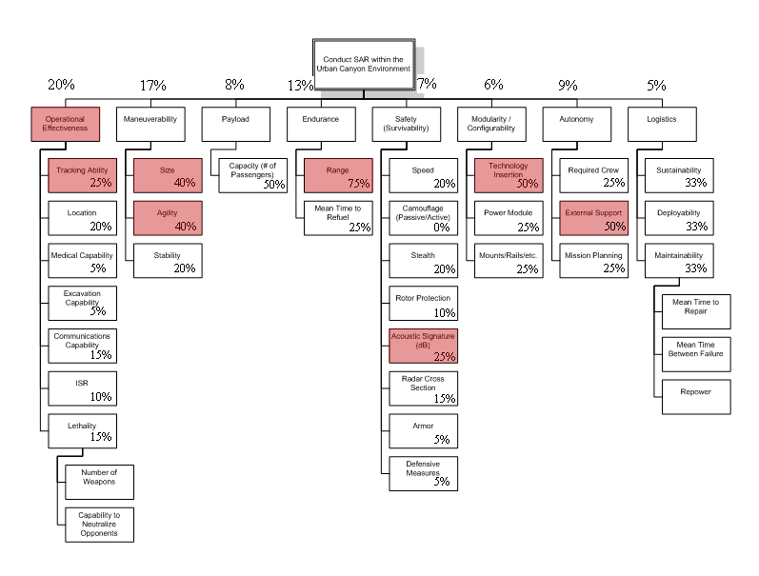
Figure 11: Weightings for BOLO Use Case
Analysis Results
Top results:
- V22 Osprey
- Fire Scout MQ8
- Blackhawk
- S-76
- A-160 Hummingbird

Hostage Rescue
Hostage Rescue is a combination of the main features found in the Terrorist in Building Before Event scenario and the Bank Robbery scenario. A contested rescue has to be analyzed for the life saving benefits of innocent people in need.
The main features to take away from the distribution of importance percentages below is are the following points agreed to by all stakeholders.
- Operational Effectiveness is the main means objective considered within a hostile rescue & evacuation environment within the urban canyon.
- Within Operational Effectiveness means objective, the ability to provide lethal fire against enemy strong holds such as a fortified bank or building structure when the time calls. Importance in the lethality category also places high importance against light armor and “unstoppable” humans, which may be using drugs.
- The vehicle will need to save as many hostages as possible when it gets the opportunity to, thus passenger payload capacity is highly rated for this scenario.
- The vehicle may have to provide a perimeter or fly a distance to get to the location of interest, thus range track a person or vehicle across and city and beyond into the suburbs, thus the farther the vehicle can go the better, thus range is a very important attribute.
- Since the vehicle will be flying in the canyon and it will be closer to the target buildings, it will need to have a reduced acoustic signature.
- The ability for the vehicle to continue to keep track of multiple targets of interest if spotted within the buildings with the mission planning onboard software. In addition, communicate the intelligence and receive reports and tasks to/from the Mission Control Center using the mission planning software.
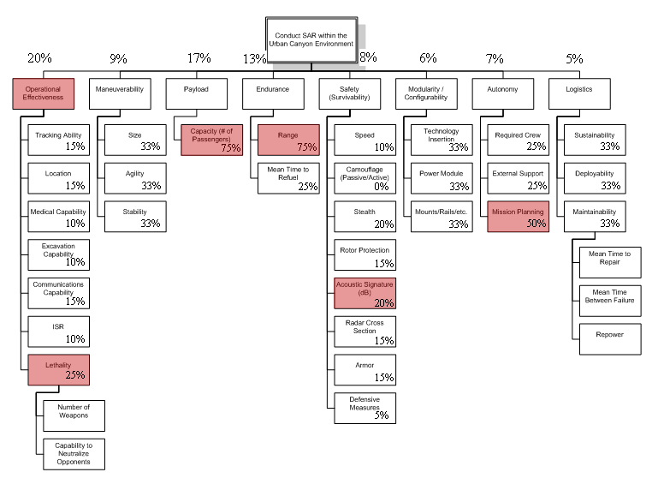
Figure 12: Weightings for Hostage Rescue Use Case
Analysis Results
Other Top 5 results:
- V22 Osprey
- Blackhawk
- S-76
- MD500
- F35 Lightning II

Discussion of Results
The result of the analysis shows that the traditional helicopters scored higher than the smaller UAVs. However, it is important note that none of the systems analyzed would be suitable to support in the canyon operations; each system has at least one mission deficiency. Note that the Sikorsky helicopter fleet may be able to continue to support the future in the canyon missions. The analysis must consider that while the current vehicle may have been selected to perform the mission, there is still the possibility that it cannot in its current form. Due to percentage weighting of a factor such as size, it may be evaluated high or low, but it is not 100%. While it would be favorable for every factor to be weighted 100%, this is not feasible for the trade-off analysis because there would be no vehicle that meets all factors exactly.
In the analysis, there is a certain amount of subjectivity in applying the factor values to the actual vehicles. This project has tried to reduce the engineering-subjectivity, by allowing the vehicle subject matter experts (the sponsors) review and modify the values for the means objective factors.

Requirements Analysis

Requirements Elicitation
Requirements elicitation is recognized as one of the most critical, knowledge-intensive activities of system development; poor execution of the elicitation process will almost guarantee that the final project is a failure in some way. Elicitation has been defined as learning, uncovering, extracting, surfacing, and/or discovering needs of customers, users, and other potential stakeholders. Elicitation is all about determining the needs of stakeholders.
Elicitation methodologies may include the use of interviews, surveys, modeling, prototypes, and use cases. Four phases are usually involved as the elicitation process leads to requirements generation:
- Understand the stakeholders and ‘capture’ their requirements
- Analyzing stakeholder selections
- Communicating stakeholder ideas: transfer knowledge between stakeholders
- Agreeing on selections/requirements: negotiate with stakeholders about selections/requirements

Conversational methods
- Verbal communication (interviews)
  - Practical and efficient to elicit non-tacit knowledge
    - Labor intensive
    - Examples: Interview, Workshop, Focus groups, Brainstorming

Observational methods
- Observing human activities (Role playing)
  - Elicit tacit knowledge and understand complex societies
    - Time -consuming, normally hard to specify and analyze observer’s perception
    - Examples: Observation, Social science, Ethnographic study, Protocol analysis

Analytic methods
- Exploring documentation and expert’s knowledge (non user)
  - Elicit domain requirements for a product family
    - Lack of user involvement
    - Examples: Documentation studies, Content analysis, Requirements reuse, Laddering, Card sorting, Repertory grid

Synthetic methods
- Combining conversation, observation, and analysis into a coherent method
  - Examples: Scenarios, Passive storyboards, Prototyping, Interactive storyboards, JAD/RAD session, Contextual inquiry
- A checklist for the Requirements Elicitation is provided below:
  - Define the project’s vision and scope.
  - Identify user classes.
  - Identify appropriate representatives from the user classes.
  - Identify the requirements decision-makers and their decision-making process.
  - Select the elicitation technique(s) that you will use.
  - Apply the elicitation techniques to develop and prioritize the attributes/requirements for a portion of the system.
  - Gather information about quality characteristics and nonfunctional requirements from users.
  - Elaborate the attributes/use cases into the necessary functional requirements and document them.
  - Review the use case descriptions and the functional requirements.
  - Develop analysis models if needed to clarify the elicitation participants’ understanding of portions of the requirements.
  - Develop and evaluate user interface prototypes for portions of the requirements that are not clearly understood.
  - Develop conceptual test cases from the use cases (if needed).
  - Use the test cases to verify the quality of the use cases, functional requirements, analysis models, and prototypes.
  - Repeat steps 6 through 14 for the other portions of the system until the team concludes that requirements elicitation is as complete as it needs to be.
  - Baseline the documented requirements.

Requirements Elicitation Discussions
As part of the Requirements Elicitation discussions, we revisited the Problem Statement, Scope and Deliverables and assumptions.

Stakeholder Elicitation of System Attributes and Characteristics
For the VTOL Project, Requirements Elicitation was accomplished primarily through:
- Weekly Meetings with Prime Stakeholder
- Use of Interviews, Brain Storming Sessions
- Scenario Discussions
- Use Case Development
- Requirements Document Reviews and Negotiations
The table below contains a ranked list of attributes which apply to the VTOL system under consideration for development. Based on our requirements elicitation process and using the attribute definitions provided above for the VTOL system considered for development. The table below ranks the attributes according to the degree of importance or favorability (1 = most important/favorable).
Attribute | Rank
Endurance | 5
Autonomy | 6
Safety(Survivability) | 1
Payload | 4
Modularity | 7
Maneuverability | 3
Logistics | 8
Operational Effectiveness | 2
Table 8: Urban Canyon VTOL High Level Attribute Ranking

System Requirements Model

Vision
The Urban Canyon Vertical Take-off and Landing System (UC-VTOL) will conduct Search and Rescue (SAR) missions in the urban environment, below the city building rooflines. The UC-VTOL defies the conventional notion of airspace limitations, operating where traditional aircraft cannot go. The UC-VTOL will fly through the narrow urban canyon, between buildings, and above the city streets in the execution of the SAR mission.

External Systems Diagram
The figure below provides context for the UC-VTOL:
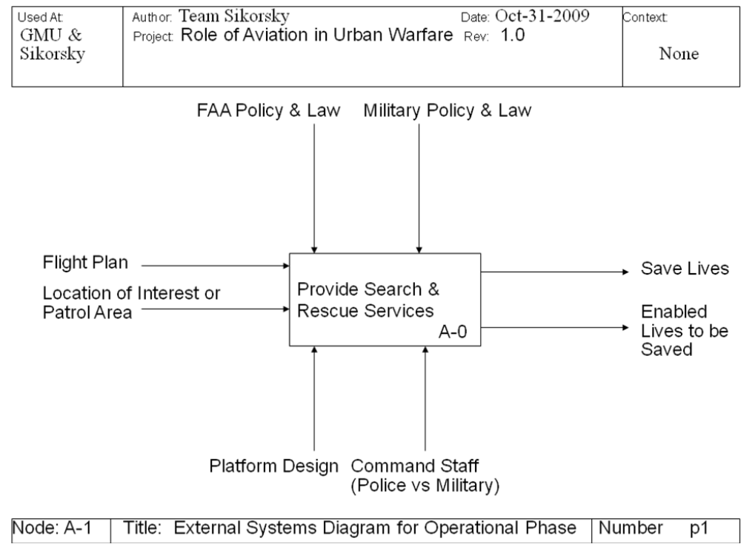
Figure 13: External Systems Diagram
The basic function of the UC-VTOL, as represented by the central box in Figure 13 above, is to provide search and rescue services. The arrows entering the box from above represent controls, factors that guide or constrain the system. In this diagram, FAA and Military guidelines govern the execution of the system’s basic function. The arrows entering the box from below represent the mechanisms that enable the system to perform its function. The VTOL platform, along with crew, is the mechanism for this system function. The arrows entering the box function from the left are data inputs, which at the highest level, are the flight plan and position information. The top-level output of the SAR function is life preservation.

System Requirements
The system requirements are documented in the System Requirements Specification (SRS), Appendix D: . The requirements are organized into six categories, as follows:
- External Interface Requirements
- Functional Requirements
- Input Requirements
- Operational Concepts
- Output Requirements
- Technology and System-Wide Requirements
In addition to paragraph numbering, unique identifiers (e.g., r2.26) are assigned to each requirement. This facilitates configuration management, as well as requirements traceability with other documents and artifacts. Should the SRS change at any point in the future, resulting in paragraph renumbering or other formatting modifications, the unique identification numbers will remain unchanged. The unique identification numbers, vice the paragraph numbers, should be used for all cross-referencing of requirements in other engineering documentation for this system.

System Architecture
One of the key deliverables for this project is the System Architecture. The team used the DoD Architecture Framework (DoDAF) v1.5 as the guiding reference for architecture development. It was agreed that the architecture should describe the system interfaces, the system functionality, and the physical composition of the system. Accordingly, the views that describe system interfaces and functionality were selected from the set of views described in DoDAF v1.5. A non-DoDAF view was also used to describe the physical architecture of the system. The following subsections describe the three system architecture views.
Note: All diagrams were developed in a software tool called Enterprise Architect (EA) v7.1. In addition to modeling system architecture, EA is capable of modeling requirements. Hence, the team added the requirements from the SRS to the EA model. The entire system architecture, as well as the requirements model, is available in HTML format in Appendix C: of this document. The HTML version shows the model exactly as it appears in EA, with the added benefit of being compatible with a standard web browser, rather than the proprietary architecture tool, EA.

System Interface Description
In DoDAF v1.5, the Systems and Services View (SV-1) is the System Interface Description. It depicts the system interfaces between the Urban Canyon VTOL and other external systems. The SV-1 shows the system in the larger context of external systems with which system data must be exchanged.
The SV-1for the UC-VTOL, in the figure below, shows that the system will share communications, data, and video interfaces with most systems. SWAT Teams and Police will share only voice communications.
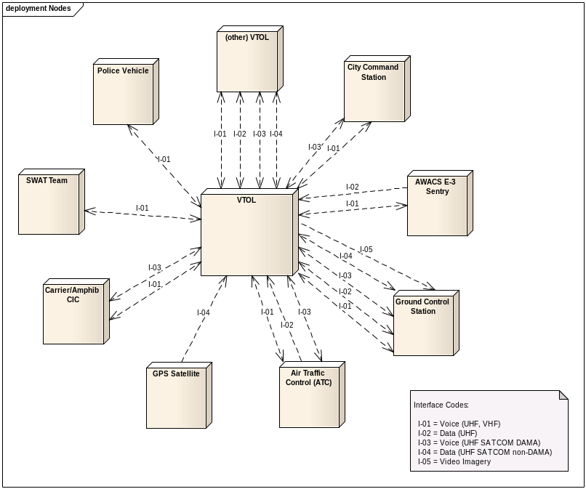
Figure 14: SV-1 Systems Interface Description

System Functionality Description
The DoDAF view that describes system functionality is the SV-4, the System Functionality Description. Team Sikorsky began modeling the SV-4 using a structured modeling approach. The initial plan was to develop a functional decomposition to document all system functions, and then use IDEF0 to model the flow of data between those functions. On the advice of the professor, however, the team concurred that Unified Modeling Language (UML) would be a more appropriate language than IDEF0. The UML was considered more user-friendly for the non–systems engineer (including our sponsor).
In accordance with DoDAF v1.5, the team used two types of UML diagrams to represent the SV-4: use case diagrams and activity diagrams. The use cases modeled for this project directly correspond to the Use Case analysis described in Section II, above. In general terms, the use case diagrams represent system functionality at a very high level. The activity diagrams, however, show a lower level of detail about what the system does. As a rule, many activity diagrams are linked to a single use case diagram.
Following are three example diagrams that depict the SAR use cases inside the urban canyon, a view of the SAR following a destructive event use case, and an activity flow diagram from within the said use case.
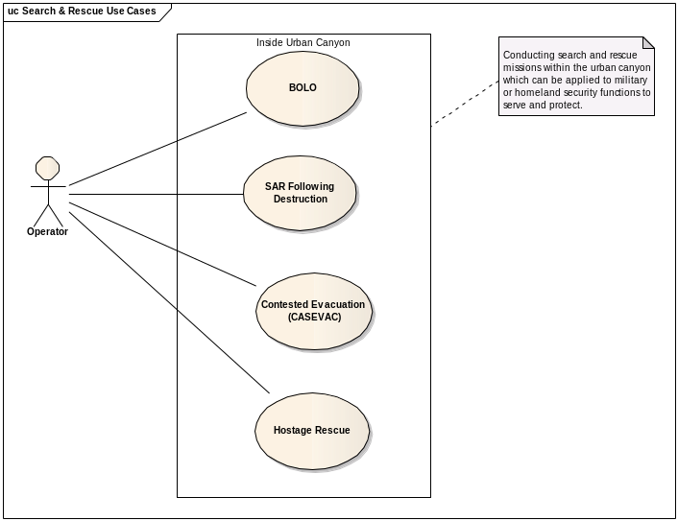
Figure 15: Search & Rescue Use Cases Package
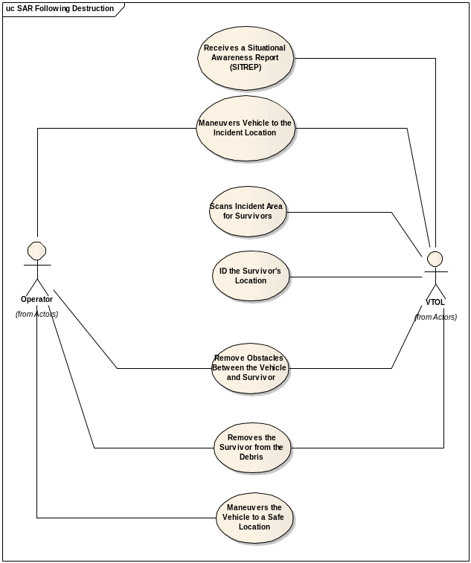
Figure 16: Search & Rescue Following Destructive Event Use Case
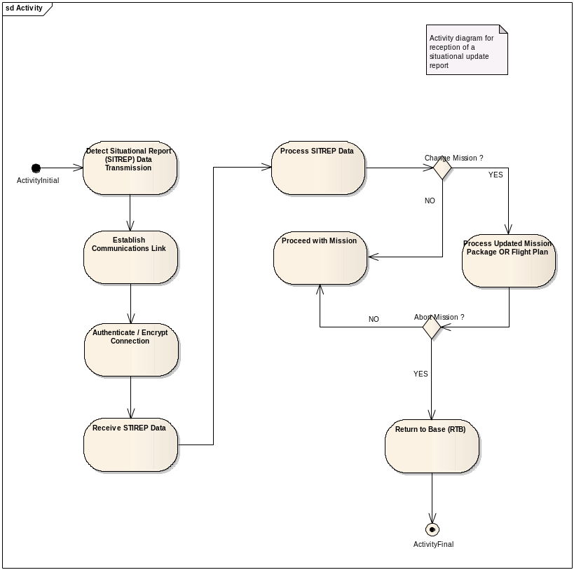
Figure 17: Receive SITREP Activity
Again, the diagrams above are only included as examples. The complete SV-4 is available for review as part of the overall System Architecture in Appendix C: .

Physical Architecture
The last step in the architecture process was the development of the physical architecture. The team employed a methodology described by Ed Crawley, known as Function to Form mapping. Function to Form mapping starts with an analysis of the system functionality. Leveraging the SV-4 products, the team organized the system functions into logical groups. The groups were modeled in a class diagram, showing high-level functions decomposed into lower-level functions. The diagram below illustrates:
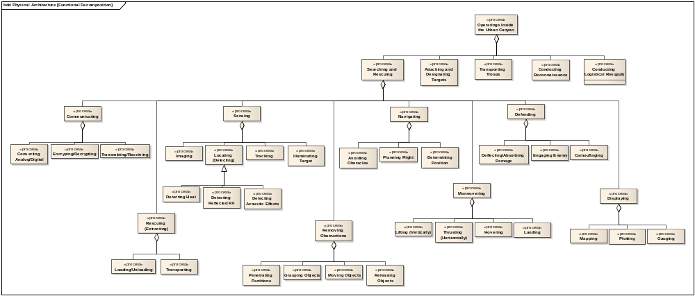
Figure 18: VTOL Functional Decomposition
Next, the team defined logical subsystems that would satisfy the functional groups, as shown in the diagram below:
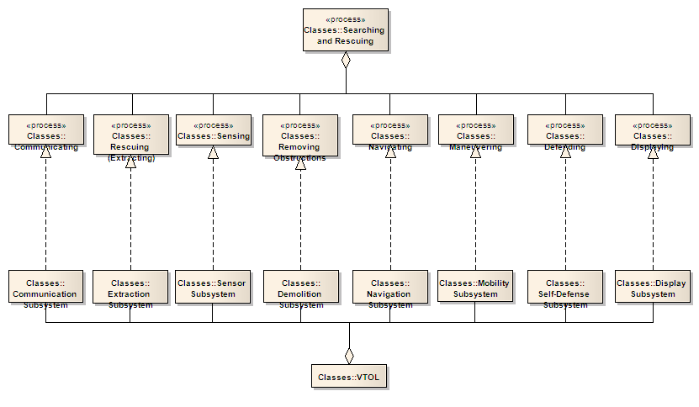
Figure 19: Function to Form Map (Top-Level)
In turn, the logical subsystems were decomposed into lower-level components. The figure below is an example:
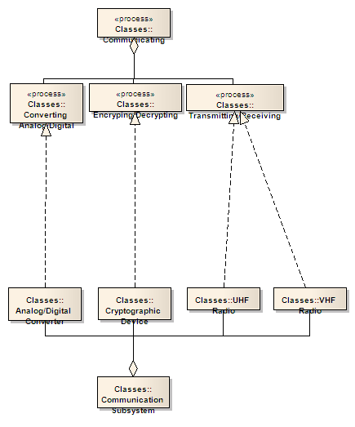
Figure 20: Function to Form Map (Lower-Level Example)
The complete physical architecture is available as part of the System Architecture in Appendix C: . The analysis of design solutions for the components of the physical architecture is included in Section b), below.

Business & Technology Assessment

Business Plan
Business planning is extremely important to the Sikorsky Corporation. The Sikorsky Technology group has a Product Lifecycle Management Program to improve product design & innovation. As DoD customers, Sikorsky must run their projects through the DoD acquisition process, thus they support the work packages required to go through that process. The work packages make up the Performance Management Baseline which forms the basis for Earned Value Management which is an extremely important tool of the technical assessment process. The work packages are broken up based on the project timeline, so only the near term work packages are developed in detail. Program Managers review this performance management baseline to understand risks in the plans and the control systems. Given that Sikorsky has made the decision to choose a technology to develop and start the process, they will develop the contracting portion of the Work Breakdown Schedule (4th level on down).

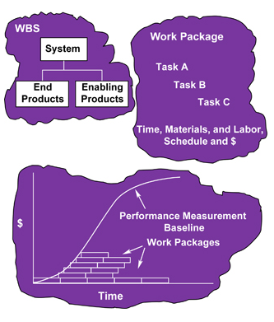
Figure 21: Visual Representation of a Performance Measurement Baseline
Reference DAU SYS202
Sikorsky’s main business goal is to make a profit, as should any successful business that plans to stay alive and competitive to continue to support its customers and the American people. Sikorsky watches how its competitors are developing new technologies, as does their competitors. Sikorsky can use their previous history of choosing technologies to predict whether future business decisions will be fruitful. This can be conducted many ways. One way which we explored is using Sikorsky’s existing Technology Readiness Level analysis process. Using the history of the TRL of the technology pursued and the resulting outcome of the projected (whether it was a successful business decision or not) and developing two distribution graphs for each. It was found that technologies with a TRL of 5 had a certain probability that they turned out good and bad. So when Sikorsky has to make future decisions on a technology with a TRL of 5 they can use this decision analysis technique to determine the amount of risk they are taking.
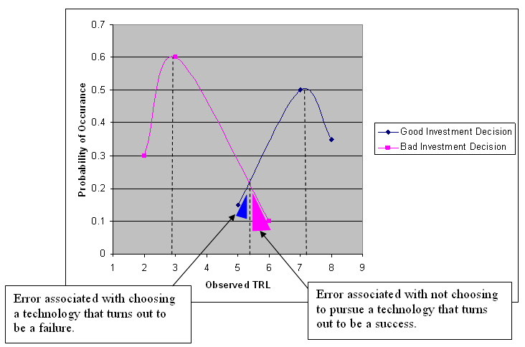
Figure 22:Choose to invest if TRL > 6 and choose not to invest if TRL < 5.
In addition, this analysis technique can be extended to other business decisions beyond TRLs. Thus, Sikorsky can compare many of their historical decision making factors, and then analyze them using a best attribute technique such as an ID3 learning algorithm or combine them into a multi attribute decision analyzer. We propose future teams use an elicitation technique to understand and document Sikorsky’s business decision workflow in order to build a decision tree or influence diagram in which a very detailed decision analysis can be conducted using Bayesian Network calculators such as MSBNx and DPL.

Usage
The initial usage of such a a system would be for urban military missions. As the technology is proven through successful military missions, it will become more readily available for internal Homeland Security missions for local governments to use, much like the traditional helicopter has been used for police missions. Proof of success to the American people will be through humanitarian efforts much the same way that helicopters are used in MEDEVAC situations to save the critically injured typically in automobile accidents. As pilots retire they will demand for the technology on a personal basis much like how the jeep was introduced as a vehicle into the American car fleet. Laws will have to be made for a class of vehicles that has never been available to the general public, much like new laws are being written for hybrid compact vehicles that are being classified as motorcycles.
The usage of this project package of Systems Engineering products can be used to develop advertisements and television commercials for the Sikorksy Corporation.

Marketability
While the initial research of this project is on military missions, and the scenarios considered are thought to be “rare” occurrences, the marketability of an air vehicle product that can navigate urban canyons can dramatically impact the lives of humans. Since it is predicted that 80% of the world’s population will live in urban areas by 2030, the majority population’s ideas will win. And people will want ways to use airspace to travel efficiently. Today’s current airline industry is struggling, because demand is relatively low to fly from airport to airport. The demand is significantly higher for local urban traffic which demands point to point travel, and this is reflected in the number of people that drive carpools or take taxis, busses, trains, and metro/subways daily to commute and conduct daily business.

Investment
Like the hybrid vehicles and other emerging technologies there will be a number of investments by governments (at all levels, federal, state, and local) national and foreign. This will allow partnerships and pooled investments for directed designs to be built for specific purposes whether for military, humanitarian, or personal use. The majority of American taxpayer does not pay much attention to military vehicles, despite the quantity of money which is invested in military vehicles, thus congress and the GAO will keep the military honest. Taxpayers will become more involved when these vehicles will interface more with their lives on a personal level to provide taxi and carpool services to alleviate congestion on major city highways, and when the vehicles will be used to save lives at a local level.

Forecasting
Currently, the U.S. military and commercial corporations are developing a host of small VTOL UAVs. There are some micro prototype helicopters designed that could be unmanned or carry one pilot. The next 10 years is predicted that the scale of the vehicles will need to be increased to perform the missions required for urban military operations. In the next twenty years, the U.S. military will develop and produce the first line of urban combat VTOL vehicles which can be manned or unmanned to support insurgent terrorist activities in urban areas. The life of this vehicle will extend 30-40 years over which there will be other lines of vehicles by other companies and various design modifications.
The numbers of these vehicles that can be produced will be 10 times the current day helicopters such as the V22 Osprey, which 458 are planned to be produced at $110 million each. To support operations world wide, over 4000 vehicles, at a predicted value of $30 million each will be needed to support urban operations.
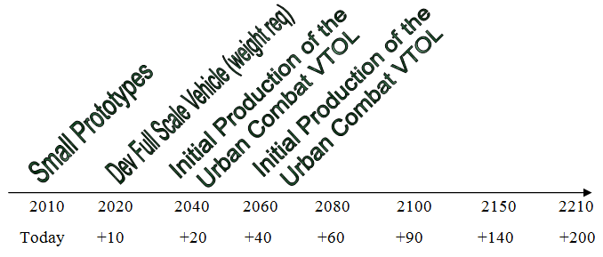
Figure 23: In the Canyon Urban Air Vehicle Predicted Time to Markets

Critical Technology
In a previous section, a generic physical architecture was discussed; functions were mapped to generic (logical) components, such as a UHF radio. The instantiated architecture takes the next step, identifying design solutions for each logical component. To extend the previous example, an actual UHF radio system, say the AN/ARC-164, could be selected as the design solution for meeting the UHF communications functionality. In this case, the UHF radio is a commercially available, technically mature item, a Non-Developmental Item (NDI). For many components in the generic physical architecture, NDI solutions are readily available. In fact, this is the case for most of the avionics, the electronic components of the system (e.g., radio, display). There are a few components, however, for which the technology is not yet mature and no design solutions exist. Based on the scorecard analysis of current systems, as well as the use case analysis, the team has designated certain components as depending on “Critical Technologies.” The critical technology components include:
- Extraction Subsystem
- Demolition Subsystem
- Mobility Subsystem
Successful fielding of the system depends on scientific advancement and innovation in these critical technology areas. Accordingly, the remaining design solution analysis focuses on these critical technologies, rather than the mature technologies; the instantiated physical architecture is discussed only in terms of the critical technologies. The critical technologies, extracted from the overall generic physical architecture, are shown in the following figure:
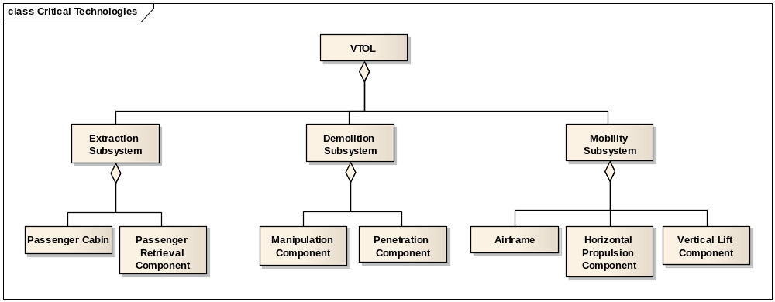
Figure 24: Critical Technologies
The process for generating and analyzing design solutions for the instantiated architecture was adapted from SYST 520. The team used a morphological box to capture possible instantiations of the logical components. The table below illustrates:
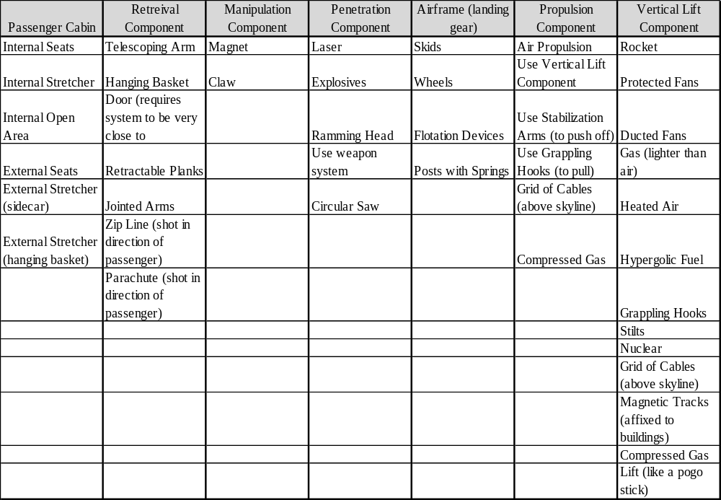
Table 9: Morphological Box of Design Solutions
Each column represents possible solutions for the corresponding logical component (stated in the first row of each column). The logical components are taken directly from the generic physical architecture (see Figure 24). The possible solutions represent the results of team brainstorming sessions (in which no idea was considered too absurd, clearly). The next stage of the process involved the examination of feasible combinations. Again, this was analyzed in a simple spreadsheet format:
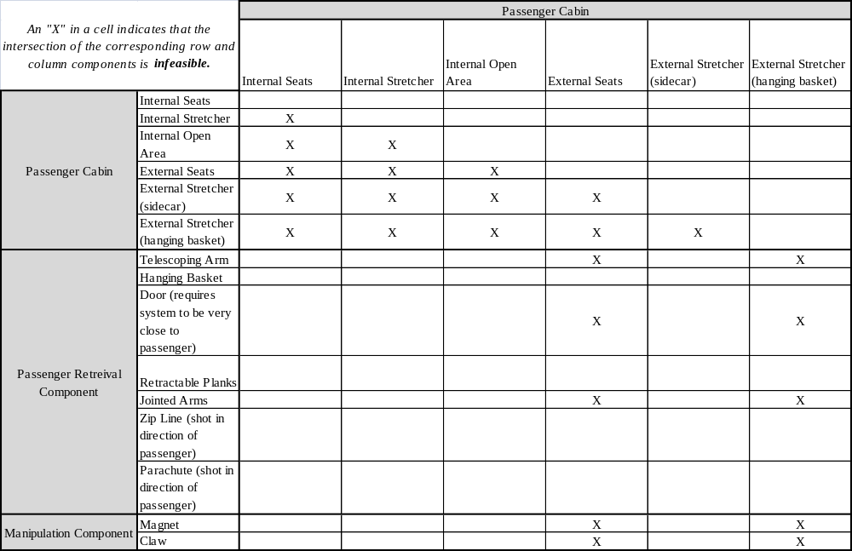
Table 10: (Excerpt from) Combination Feasibility Table
Table 10 above, is only an excerpt of the larger table (which is a 43-by-43 matrix). The entire spreadsheet is available as a separate file. In the table, it is assumed that more than one solution for each component will not be combined together, hence the “X”s in the off diagonal for each logical component. Aside from those infeasibilities, certain solutions did not pair well with others. The external seats, for example, were not considered feasible combinations with several other potential components due to safety concerns. As can be seen in the table, there are very many feasible solutions. To narrow the field, the team selected a number of promising design solution combinations. Those are listed in the table below:
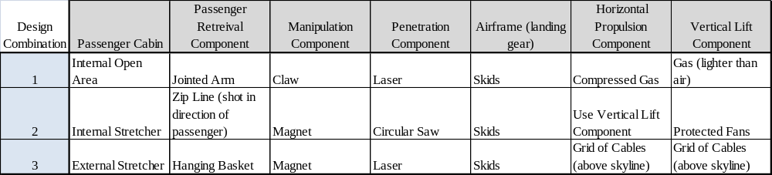
Table 11: Promising Design Solution Combinations
In each case, as noted earlier, the solution depends on considerable advancement in technology. The first design, for example, would hinge on the development of lightweight, durable material; it is assumed that any material that would be light enough to lift would have deficiencies in survivability and strength. The third design, on the other hand, would require a significant amount of mechanical and structural engineering. The basic premise of the “cable grid” would be that a grid of cables could be erected over an urban battle zone, from which a vehicle could be suspended.

Conclusions and Recommendations
The objective of the GMU-Sikorsky Team was to utilize a systems engineering methodology to analyze the role of VTOL aviation systems for future military missions in an Urban Canyon environment. Based on the research and analysis performed herein, and based on the deliverables provided, the following conclusions are offered:
Overall, the existing inventory of VTOLs are operationally unsuitable for conducting the full range of Search and Rescue (SAR) missions in an Urban Canyon.
Some VTOL technology areas such as Communications, logistics, and medical appear to be ready to support the conduct of SAR missions in an Urban Canyon.
The Gap Analysis shows that VTOL maneuverability, propulsion, and extraction systems represent the critical technology sectors that must be addressed to ensure operational success in future Urban Canyon missions.
Using Function to Form analysis, an idea generating process, the team identified potential design solutions to bridge the technology gaps.

Conduct Analysis of Alternatives on future innovative technologies.

Focus on modular VTOL designs to allow for future adaptability and modification.

References & Resources

Conceptual Foundation

Videos
  - Black Hawk Down
http://www.youtube.com/watch?v=9kuu2edvI4Q
  - The Fifth Element
http://www.youtube.com/watch?v=nn8y3w9XySY

Concept/Prototype Vehicle Designs
To provide inspiration, or artists rendition of the future design and operational scenarios
- Worlds First Flying Car, Terrfugia
http://www.terrafugia.com/aircraft.html
- Aerocopter
http://www.aerocopter.com/
- Gyrocopter
http://en.wikipedia.org/wiki/Autogyro
http://www.youtube.com/watch?v=52EWsrnItmc&feature=related
- Cypher Sikorsky UAV
http://en.wikipedia.org/wiki/Sikorsky_Cypher
http://www.globalsecurity.org/intell/systems/cypher.htm
http://www.spawar.navy.mil/robots/pubs/spie3577.pdf
http://www.youtube.com/watch?v=f1Y3ohmn-OU&feature=related
- X2 Sikorsky helicopter
http://en.wikipedia.org/wiki/Sikorsky_X2
http://www.youtube.com/watch?v=emDlELmXV-I
- Urban Aeronotics
http://www.urbanaero.com/Frame-X-Hawk.htm See films also.
- University of Maryland. 2003. “Urban Disaster Response System”. American Helicopter Society Winning Design sponsored by Sikorsky and NASA
http://www.ahs.umd.edu/design/

Operations Research Articles:

Helicopter Operational Applications in Urban Environments
- Light/Attack Helicopter Operations in the Three Block War. Major Harry J. Hewson. April 1999
http://www.geocities.com/pentagon/6453/mouthelo.html
- Mumbai Terrorist Siege Over, India Says. New York Times. November 2008
http://www.nytimes.com/2008/11/29/world/asia/29mumbai.html
http://news.bbc.co.uk/2/hi/south_asia/7751160.stm
http://www.foxnews.com/story/0,2933,458270,00.html

Population Estimates in Urban Areas
- The world’s largest cities and urban areas in 2020
http://www.citymayors.com/statistics/urban_2020_2.html
- United Nations Population Information Network
http://www.un.org/popin/data.html

Street Width Analysis
- Narrow streets Database
http://www.ci.vancouver.wa.us/transportation/ntmp/Maps/2-07%20to%202-08%20Street%20Widths%20in%20Study%20Area%20Map.pdf
- 2007-2008 Street Widths Study - City of Vancouver, WA - SE Neighborhood Traffic Management Plan (NTMP)
http://www.ci.vancouver.wa.us/transportation/ntmp/Maps/2-07%20to%202-08%20Street%20Widths%20in%20Study%20Area%20Map.pdf

GIS Open Source Mapping Technologies

Microsoft Bing Bird’s Eye

Google Earth

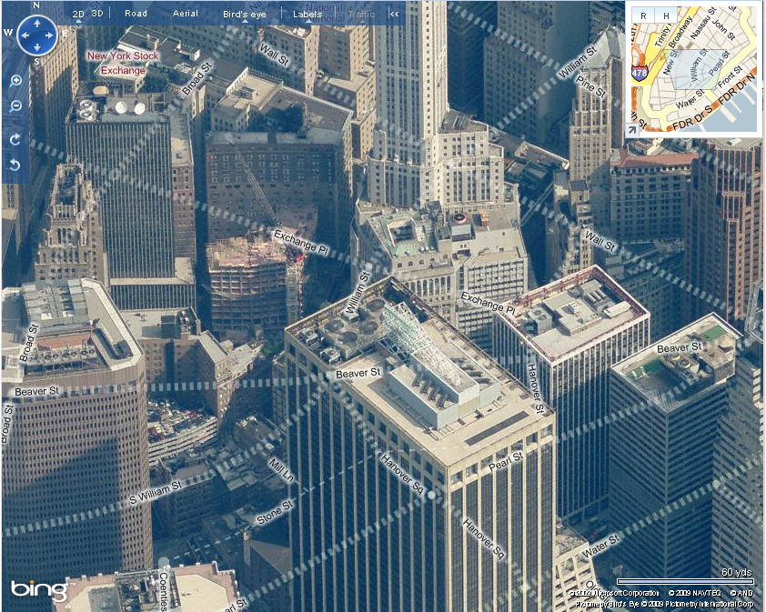
Yahoo Maps
Figure 25: Rooftop Obstructions in the Urban Canyon
It is clear that there are an unpredictable number of obstacles about the rooftops and architecture of the buildings. In addition, there may be wires and cranes that cause additional obstructions.

It is clear that there are an unpredictable number of obstacles about the rooftops and architecture of the buildings. In addition, there may be wires and cranes that cause additional obstructions.

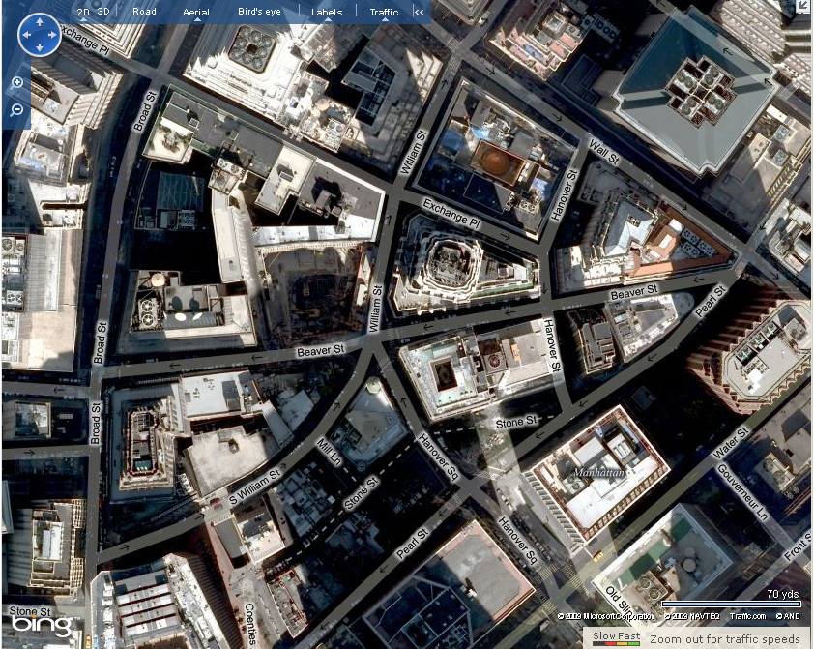
Figure 26: Urban Canyon Street Obstructions and Complexities
In the Financial District within Manhattan, New York, the one-way streets provide enough space for a single vehicle to fit down. The people walking down the streets provide obstacles and slow down the speed of travel to a crawl.

VTOL Research


System Architecture Model
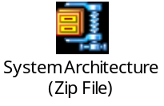
To view the system architecture as in HTML, click on the embedded object above and extract all files to a empty folder. Double click the index.html file to open.

System Requirements Specification Document


Design Solution Analysis


