**Unmanned Control & Tracking System (UCATS) Project Management Plan**

# Introduction

This plan describes the organization, tasking, schedule and processes used to develop the UCATS.

# Organization and Responsibilities

The Naval Surface Warfare Center Dahlgren Division (NSWCDD) SYST-798 Team DJ3K team will use the organization shown in Figure 1 to develop the system architecture for the UCATS. The NSWCDD SYST-798 Team DJ3K team consists of the following members:

* Kurt Chewning
* Jennifer Greene
* Dave Manley
* Jeanette Smith
* John Smith

**Program Manager**

Dave Manley

**Systems Engineer**

Jennifer Greene

**Functional Architect Lead**

Jeanette Smith

**Systems Problem Lead**

John Smith

**Instantiated Architect Lead**

Kurt Chewning

Figure 1: NSWCDD Team DJ3K Organization

# UCATS Tasking

Table 1 summarizes the UCATS tasking, due date, the Team DJ3K member (Point of Contact (POC)) responsible for coordinating the development of the deliverable, and whether this is a formal project deliverable of a systems engineering product used to develop the system. This POC is not necessarily responsible for generating the entire deliverable, but instead will collect and consolidate all the deliverables from the team.

| **WBS** | | **Dates** | | **POCs** | | | | |
| --- | --- | --- | --- | --- | --- | --- | --- | --- |
| **#** | **Name** | **Start** | **Finish** | **Chewning, Kurt** | **Greene, Jennifer** | **Manley, Dave** | **Smith, Jeanette** | **Smith, John** |
| 1. | Project Management | 31-Aug | 18-Dec |  |  | Lead |  |  |
| 1.1 | Organize Team | 31-Aug | 31-Aug | All | All | All | All | All |
| 1.2 | Select Concept | 1-Sep | 4-Sep | All | All | All | All | All |
| 1.3 | Generate Project Proposal | 5-Sep | 14-Sep |  |  |  | Lead |  |
| 1.3.1 | Project Proposal Presentation | 4-Sep | 13-Sep | SME |  |  |  |  |
| 1.3.2 | Project Proposal Summary | 4-Sep | 13-Sep |  |  |  |  | SME |
| 1.3.3 | Proposal Scoped and Approved | 14-Sep | 14-Sep | All | All | All | All | All |
| 1.4 | Project Management Plan | 5-Sep | 12-Sep |  |  | SME |  |  |
| 1.5 | Networked Schedule | 13-Sep | 20-Sep |  |  | SME |  |  |
| 1.6 | System Business Concept | 15-Sep | 23-Sep |  |  | SME |  |  |
| 1.7 | Stakeholder Value Mapping | 15-Sep | 23-Sep |  | SME |  |  |  |
| 1.8 | SOW | 15-Sep | 23-Sep |  |  |  | SME |  |
| 1.9 | Reporting | 17-Oct | 18-Dec |  |  |  | Lead |  |
| 1.9.1 | Final Presentation | 17-Oct | 18-Dec | SME |  |  |  |  |
| 1.9.1.1 | Rough Draft Presentation | 17-Oct | 13-Nov | SME |  |  |  |  |
| 1.9.1.2 | Final Draft Presentation | 14-Nov | 18-Dec | SME |  |  |  |  |
| 1.9.2 | Final Report | 17-Oct | 18-Dec |  | SME |  |  |  |
| 1.9.2.1 | Rough Draft Report | 17-Oct | 13-Nov |  | SME |  |  |  |
| 1.9.2.2 | Final Draft Report | 14-Nov | 18-Dec |  | SME |  |  |  |
| 2.0 | Systems Engineering Management | 15-Sep | 18-Dec |  | Lead |  |  |  |
| 2.1 | Systems Engineering Tools Selection | 15-Sep | 15-Sep | All | All | All | All | All |
| 2.2 | CM | 15-Sep | 18-Dec |  | SME |  |  |  |
| 2.3 | Systems Engineering Management Plan (SEMP) | 15-Sep | 5-Oct |  | SME |  |  |  |
| 2.4 | Risk Management Plan (RMP) | 15-Sep | 5-Oct |  | SME |  |  |  |
| 2.5 | Product Assurance Plan (PAP) | 15-Sep | 5-Oct |  | SME |  |  |  |
| 3.0 | System Design | 15-Sep | 16-Oct | All | All | All | All | All |
| 3.1 | Define System Level Problem | 15-Sep | 26-Sep |  |  |  |  | Lead |
| 3.1.1 | Develop Concept of Operations | 15-Sep | 16-Sep |  | SME |  |  |  |
| 3.1.2 | Develop Use Cases | 15-Sep | 23-Sep |  |  | SME |  |  |
| 3.1.3 | Develop External Systems Activity Diagram | 15-Sep | 23-Sep |  |  | SME |  |  |
| 3.1.4 | Develop External Systems Diagram | 15-Sep | 16-Sep |  |  |  |  | SME |
| 3.1.5 | Develop Systems Objectives Hierarchy | 15-Sep | 16-Sep |  |  | SME |  |  |
| 3.1.6 | Develop Analyze and Refine Requirements | 17-Sep | 25-Sep |  |  |  | SME | SME |
| 3.1.7 | Obtain Approval for Requirements | 25-Sep | 25-Sep | All | All | All | All | All |
| 3.1.8 | Document Final Requirements | 26-Sep | 26-Sep |  |  |  |  | SME |
| 3.2 | Develop System Functional Architecture | 27-Sep | 3-Oct |  |  | Lead |  |  |
| 3.2.1 | Create Simple Functional Concept | 27-Sep | 27-Sep |  |  | SME |  |  |
| 3.2.2 | Draft and Evaluate Functional Model | 28-Sep | 30-Sep |  |  | SME |  |  |
| 3.2.2.1 | Conduct Functional decomposition Brainstorming | 28-Sep | 28-Sep | All | All | All | All | All |
| 3.2.2.2 | Conduct Functional Decomposition Trade Study | 29-Sep | 29-Sep |  |  | SME |  |  |
| 3.2.2.3 | Select Functional Decomposition | 30-Sep | 30-Sep | All | All | All | All | All |
| 3.2.3 | Complete Functional and Data Models | 1-Oct | 1-Oct |  | SME |  |  |  |
| 3.2.3.1 | Generate Initial Functional Models | 1-Oct | 1-Oct |  | SME |  |  |  |
| 3.2.3.2 | Generate System Activity Diagrams | 1-Oct | 1-Oct |  |  | SME |  |  |
| 3.2.3.3 | Identify / Draft Sub-System Interface Requirements | 1-Oct | 1-Oct |  | SME | SME |  |  |
| 3.2.4 | Trace Input / Output Requirements | 2-Oct | 2-Oct |  | SME |  |  |  |
| 3.2.4.1 | Complete Draft IDEF A0 & A1 Diagrams | 2-Oct | 2-Oct |  | SME |  |  |  |
| 3.2.4.2 | Complete Draft IDEF A2 Diagrams | 2-Oct | 2-Oct |  |  | SME | SME | SME |
| 3.2.5 | Obtain Approval for Functional Architecture | 3-Oct | 3-Oct | All | All | All | All | All |
| 3.2.6 | Document Final Functional Architecture | 3-Oct | 3-Oct |  | SME | SME | SME | SME |
| 3.3 | Develop System Instantiated Architecture | 4-Oct | 16-Oct | Lead |  |  |  |  |
| 3.3.1 | Develop Generic Architecture | 4-Oct | 6-Oct | All | All | All | All | All |
| 3.3.1.1 | Brainstorm Architecture | 4-Oct | 4-Oct | All | All | All | All | All |
| 3.3.1.2 | Generate Trade-Offs | 5-Oct | 5-Oct | SME | SME | SME | SME | SME |
| 3.3.1.3 | Down-Select Generic Architecture | 6-Oct | 6-Oct | All | All | All | All | All |
| 3.3.2 | Develop Instantiated Architecture | 7-Oct | 15-Oct | All | All | All | All | All |
| 3.3.2.1 | Brainstorm Instantiated Architecture Components | 7-Oct | 7-Oct | All | All | All | All | All |
| 3.3.2.2 | Generate Morphological Box - Instantiated Sys Arch Sub-Sys | 8-Oct | 9-Oct | SME | SME | SME | SME | SME |
| 3.3.2.3 | Conduct Sub-System Trade-Off Analysis | 10-Oct | 12-Oct | SME | SME | SME | SME | SME |
| 3.3.2.4 | Down Select Instantiated Architecture | 13-Oct | 13-Oct | All | All | All | All | All |
| 3.3.2.5 | Finalize Sub-System Interface Requirements | 14-Oct | 14-Oct | SME | SME | SME | SME | SME |
| 3.3.2.6 | Document Instantiated Draft Design | 15-Oct | 15-Oct | SME | SME | SME | SME | SME |
| 3.3.3 | Obtain Approval for Instantiated Architecture | 15-Oct | 15-Oct | All | All | All | All | All |
| 3.3.4 | Final Instantiated Design | 16-Oct | 16-Oct | All | All | All | All | All |
| 4.0 | Refine / Update Design | 17-Oct | 15-Dec | All | All | All | All | All |
| 4.1 | System Requirements | 17-Oct | 15-Dec |  |  |  |  | Lead |
| 4.2 | Functional Design | 17-Oct | 15-Dec |  |  | Lead |  |  |
| 4.3 | Instantiated Design | 17-Oct | 15-Dec | Lead |  |  |  |  |

**Table 1: Task List**

## Project Management:

The project management tasking includes the generation of the project plan, providing progress briefings and reports, and providing the final briefing and report.

## Systems Engineering Management

The systems engineering tasking includes selecting the systems engineering tools NSWCDD Team DJ3K will use on the project and providing Configuration Management (CM) Functions.

## Systems Design:

The systems design tasking includes defining the system level problem, generating a functional architecture, and generating a physical architecture.

# Schedule

Figure 2 summarizes the draft Collaborative UAV Schedule. NSWCDD Team DJ3K will deliver a networked schedule as a deliverable for this project.

# Processes

NSWCDD Team DJ3K will develop the Collaborative UAV System Design by assigning one person to coordinate the development of a specific task or deliverable (See Table 1). This POC will not necessarily be responsible for developing the item, but they will be responsible for coordinating and consolidating all inputs. Team DJ3K will ensure the quality of the deliverable by using a peer review process. After the POC has developed a final draft of the task or deliverable, they will email it to the team for a peer review. The POC will be responsible for setting a peer review due date for inputs and coordinating the update of the deliverable and resolution of all team comments.

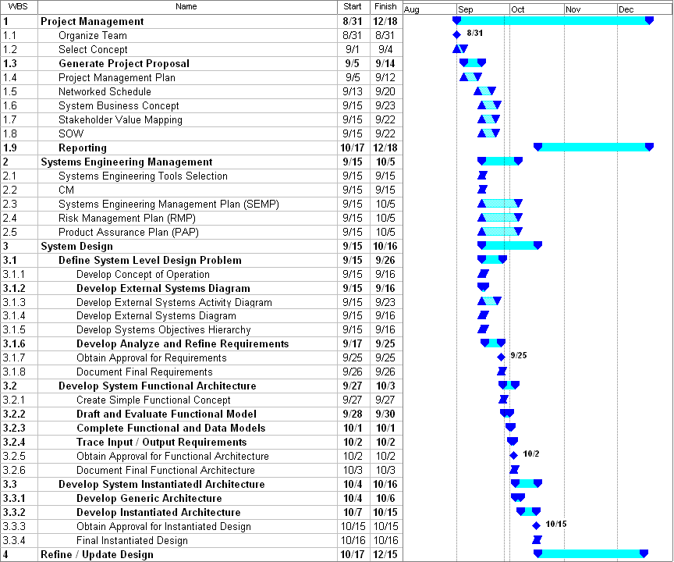

**Figure 2: UCATS Schedule**