1. **Business Case**
   1. **Business Need**

In today’s world, government, military, commercial, and privately owned facilities require security. This security often comes in the form of an intrusion detection system (or Sensor Suite). The system can provide early warning of impending intrusion or attack, which gives an opportunity for a security team to respond appropriately. In many cases, the intrusion detection system is set-up in an ineffective or inefficient configuration, resulting in gaps in surveillance ability and/or unnecessary costs. The Sensor Suite Evaluation System (SSES) solves this problem by incorporating data about a particular location, fusing this data with sensor specifications, and calculating a solution for the proper placement, type, and quality of the selected sensors. Our team brings a wide variety of experience from the private sector, government contracting companies, government civil service, and the military. The detection intrusion industry is likely to grow over the next several decades because of the ever-increasing threat of attack against “soft” facilities, particularly facilities of a sensitive nature. Governmental agencies and private businesses will look to increase security of these facilities while maintaining, or even reducing, overhead costs. These agencies and businesses will form the core of our customer base. The SSES is positioned to pioneer the development of intrusion detection evaluation software based on our unique quantitative approach, which removes guesswork and intuition and replaces it with data and expertise.

Mission Statement: The Sensor Suite Evaluation System (SSES) assists government, military, commercial, and privately owned facilities in the set-up of their intrusion detection systems (composition and location of sensors) to achieve a complete and reliable surveillance using the most cost effective means available.

* 1. **Marketing Introduction Strategy**

The marketing introduction strategy will occur in 3 phases. Our first targeted customers for this product are military base camps, small military installations worldwide, and small government facilities. Future markets will focus on sensitive utility sites such as water treatment facilities, electricity relay stations, nuclear reactors, airports, seaports, and other critical infrastructure as identified by Department of Homeland Security and local law enforcement agencies. Complete market penetration will include private and commercial customers. Our team will advertise the SSES, which will include an initial site survey, a renewable license to operate the SSES software, access to all future software updates, and initial training to allow customers to operate the SSES independently. The intent is to provide our customers with a new industry standard for user-friendly intrusion detection evaluation software, supported with unparalleled customer service. This specialized market segment offers a low-risk opportunity for the SSES to be introduced while continuing to be refined for wider market expansion. As our governmental customers gain an appreciation for a more efficient security system, and its associated lower overhead costs, we will begin to lobby Congress for an increased presence throughout all governmental agencies. The SSES team will develop advertisements, put them in industry magazines and publications, and participate in DOD/DHS conferences in order to highlight SSES capabilities. The team will make direct contacts to sales prospects in order to explain and demonstrate the system, attract attention, spread word-of-mouth, and obtain customer feedback to better target the sales opportunity and overall market penetration strategy. Sales proposal requests will be solicited from the prospects.

Currently, there appears to be no other entity that can offer a system to compete with the SSES directly. Our closest competition is the status quo system of a security expert designing the system manually. The quantitative approach taken by SSES will yield better-quality results. Aggressive system refinement and improvement will assure that our system remains technologically superior.

The strategy of offering the SSES as part of a package that includes a software license, an initial site survey, and software computer training is the result of several considerations. First, the intensive customer-service oriented approach will build an early reputation that will translate to higher growth rates in future years. Second, given the unique nature of the program, it would not be difficult for a novice used to misuse the program, which could result in less than optimal results and would unnecessarily harm the reputation of the SSES. Finally, by limiting the license to a relatively small number of users, we increase the chances for larger agencies to give the SSES repeat business. The option of selling an unlimited license at higher cost, but with only limited customer support was considered, but rejected as being too high risk. An early failure would devastate future growth, which is key to future net cash flows.

* 1. **Features and Benefits**

The following are the most important features and benefits of the SSES:

**Site Assessment Productivity and Accuracy.** The SSES begins with an exhaustive terrain mapping of the site to be secured, along with the immediate vicinity. The terrain data is entered into the SSES topographically using DTED data. Different terrain types, ranging from forest and fields to roads and buildings, are modeled into the terrain data as well, each with its own parameters of movement rates, visibility, and cover and concealment. Once this data is complete, the site exists in the SSES as a digital model in which sensors can be placed and evaluated. The model can also be updated should surrounding terrain be physically altered.

**Complete catalog of existing sensors.** The SSES team has gathered a wide array of existing sensors and their specifications and prices and has catalogued them into a single database. The SSES will examine the different sensors types when evaluating different array possibilities.

**Optimal placement of sensors.** The SSES software will analyze the site assessment results and use the database of sensors to create an array of sensors that provides the required level of security, as expressed in probability of detection, at a minimum cost.

**Reduction of recurring costs to customer.** Because the customer will purchase the minimum amount of sensors to achieve the desired probability of detection, and thus adequate security, customers will be able to reduce roving patrols and sentries, relying on the detection system instead.

* 1. **Competitive Analysis**

There is simply no existing computer software package that can assist customers seeking to install or improve an intrusion detection system. Current practices involve the use of a security expert to make a site visit and make recommendations based on a heuristic approach. A competitive analysis comparing the SSES with the traditional method is provided below.

| **Factor** | **SSES** | **Strength** | **Weakness** | **Status Quo** | **Importance to Customer** |
| --- | --- | --- | --- | --- | --- |
| **Ease of Use** | SSES will allow a person with rudimentary knowledge to design a security system. | X |  | Existing systems must be designed by a trained and experienced security expert. | 1 |
| **Price** | SSES users will have a significant initial cost of purchasing the license, but will reduce the initial cost of sensor purchases and greatly reduce manpower-related recurring costs | X | X | Existing systems may use a number of sensors that are unnecessarily redundant. Existing systems must be complemented with live sentries and patrols, increasing recurring costs. | 3 |
| **Complete Site Coverage** | SSES will identify any gaps in sensor coverage based on terrain analysis and weather variables and will allow the user to make sensor placement adjustments prior to installation | X |  | There is no way to identify positively all security gaps prior to installation. | 5 |
| **Adaptability** | SSES will feature a drag-and-drop user interface to allow users to fine-tune sensor placement. Changes to terrain (trees removed, road built, etc.) can be captured and a new solution calculated quickly. | X |  | The process must be started over again using a trained and experienced security expert. | 5 |
| **Probability of Detection** | The probability of detection for the entire system is calculated, allowing the user to determine whether the detection system as designed meets its required specifications. | X |  | This is generally not considered. With no digital representation of the system, calculations are unwieldy. | 5 |
| **False Alarm Rate** | The false alarm rate for the entire system is calculated, allowing the user to determine whether the detection system as designed meets its required specifications. | X |  | This is generally not considered. With no digital representation of the system, calculations are unwieldy. | 3 |

**Figure 1 - Competitive Analysis**

* 1. **Financial Goals**

The goal of the SSES team is to sell a complete SSES for approximately $35,000 to governmental agencies. This price includes a 10-user software license, an initial site assessment by a member of the SSES team, and initial training for users of the system. By comparison, a 20-user software license for Rockwell’s Arena simulation program (without on-site training) is valued at $270,000. The price breakout is shown in figure _ below:

|  |  |  |  |
| --- | --- | --- | --- |
| **Item** | **Quantity** | **Price** | **Total** |
| 10-User License | 1 | $25,000 | $25,000 |
| Software Training | 1 | $5,000 | $5,000 |
| Initial Site Survey | 1 | $5,000 | $5,000 |
| **Total** |  |  | **$35,000** |

**Figure 2 - Initial Product Costs**

* 1. **Cash Flow Analysis**

Our initial R&D costs will be approximately $525,000 with a maximum exposure of approximately $600,500. It will take about one year to complete the development activities of SSES. The SSES team’s objective is initially to sell systems for $35,000. This kit will be aimed towards military and government installations. During Phase 2, we will grow our business to a larger customer base, including sensitive sites as designated by DHS. During Phase 3, we will open our sales efforts to commercial and industrial interests. Associated costs with sales will be travel to specific sites as part of an initial site survey. We anticipate that during phase 1, the first 3 years, we will have 50% growth. We expect to sell at least five systems the first year, which will allow our initial product sales to be $175,000. During Phase 2 and 3, we expect 80% and 100% growth respectively, as shown in Figure _. After about 10 years, we hope to establish larger orders. Funds are allocated for additional R&D throughout all phases to retain a competitive advantage over other companies who may be late in arriving to the intruder detection analysis field.

|  |  |  |  |
| --- | --- | --- | --- |
| **Inputs / assumptions** |  |  |  |
| Initial Demand | 5 |  |  |
| Initial license sales* | 175000 |  |  |
| *includes training fee | 0 |  |  |
| *includes consulting fee | 0 |  |  |
|  | Phase 1 | Phase 2 | Phase 3 |
| License sales growth | 50% | 80% | 100% |
|  |  |  |  |
|  |  |  |  |
|  |  |  |  |
| Wages / salaries | 200000 | 300000 | 400000 |
| Marketing costs | 80000 | 100000 | 150000 |
| Payment processing fee | 4.5% |  |  |
| Discount rate | 10.0% |  |  |

**Figure 3 – Ten Year Cash Flow Baseline**

Figure _ shows the influence diagram that was generated using DPL. This deterministic model shows the main factors that affect the Net Present Value (NPV). The NPV expected value was calculated by DPL to be $27,381,512. This NPV expected value is based on a 10-year period.

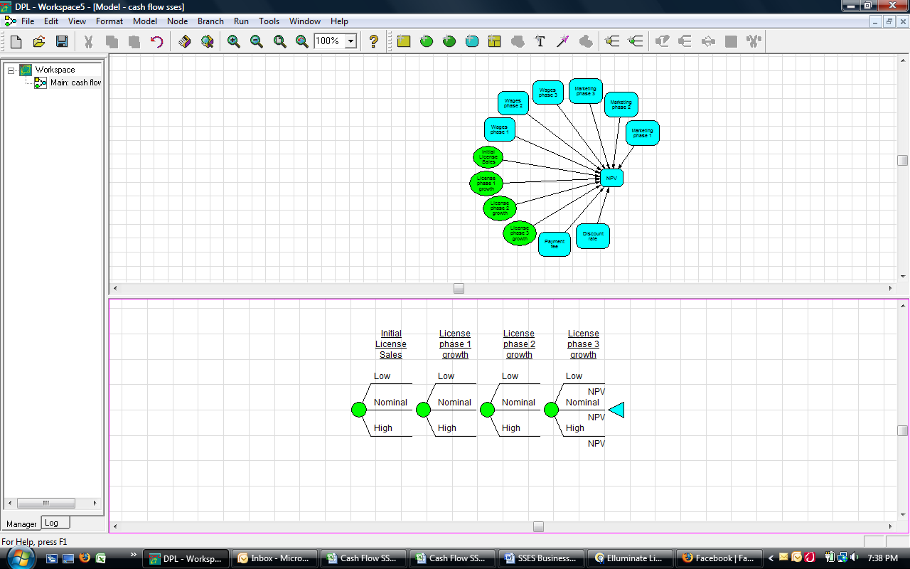

**Figure 4 - Influence Diagram**

The Business Case in Appendix _ and Figure _ below details our expected profit and loss over the next 10 years. After 10 years, we expect to sell 2319 systems resulting in total revenue of $74,002,600. In year 3, we begin to see a positive profit.

Positive Profit Point



**Figure 5 - Profit and Loss Analysis**

Figure _ shows the values for our baseline cashflow chart. We expect to achieve the breakeven point between year 4 and 5.

**Baseline Cashflow Chart**



The chart in Figure _ illustrates our yearly net cash, cumulative cash flow, and baseline NPV for each year within the 10 year period.

We changed the deterministic model to a probabilistic model and created discrete chance nodes for values of which the team was uncertain. The figure below shows the decision tree created by DPL with three chance nodes. DPL then calculates the expected value of the NPV using these discrete probability mass functions.



**Figure _ Cash Flow model with 4 Discrete Change nodes**

Depending on the initial license sales and the growth of future license sales during all three phases of our project, the NPV has a large range of possible values. In Figure 19, DPL has created three probabilistic outcomes for Low, Nominal, and High. We assigned probabilities of .3, .4, and .3 for the three chance outcomes. The tree is truncated to two levels for simplicity’s sake, but the values shown reflect the calculations using all four discrete change nodes. The far left node displays the expected value of the product sales phase 1 growth: $33,127,918. The worst-case scenario is that both initial license sales and subsequent growth are low. In this case, the NPV will be -$ -1,175,025. The best-case scenario is that both initial license sales and subsequent growth are high. In this case, NPV will be $182,308,868. These two extremes are very unlikely – in all probability, the NPV will be closer to its calculated expected value.

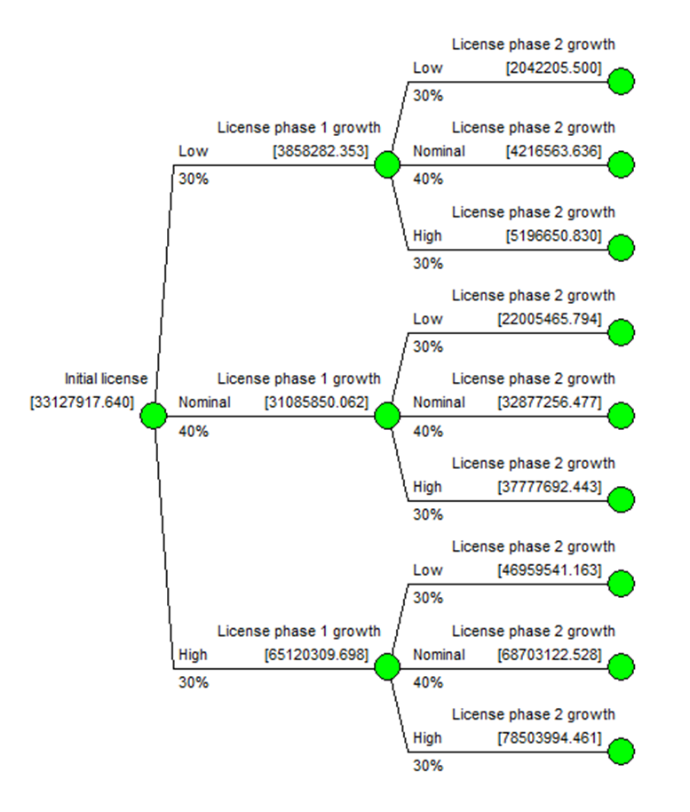

**Figure _ - Policy Tree**

The cumulative probability distribution of the NPV is shown in Figure _ below. The probability of a negative NPV is approximately 2.5%.

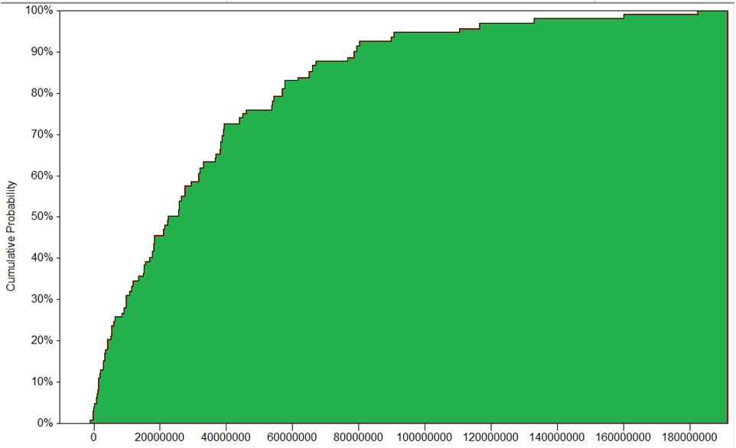

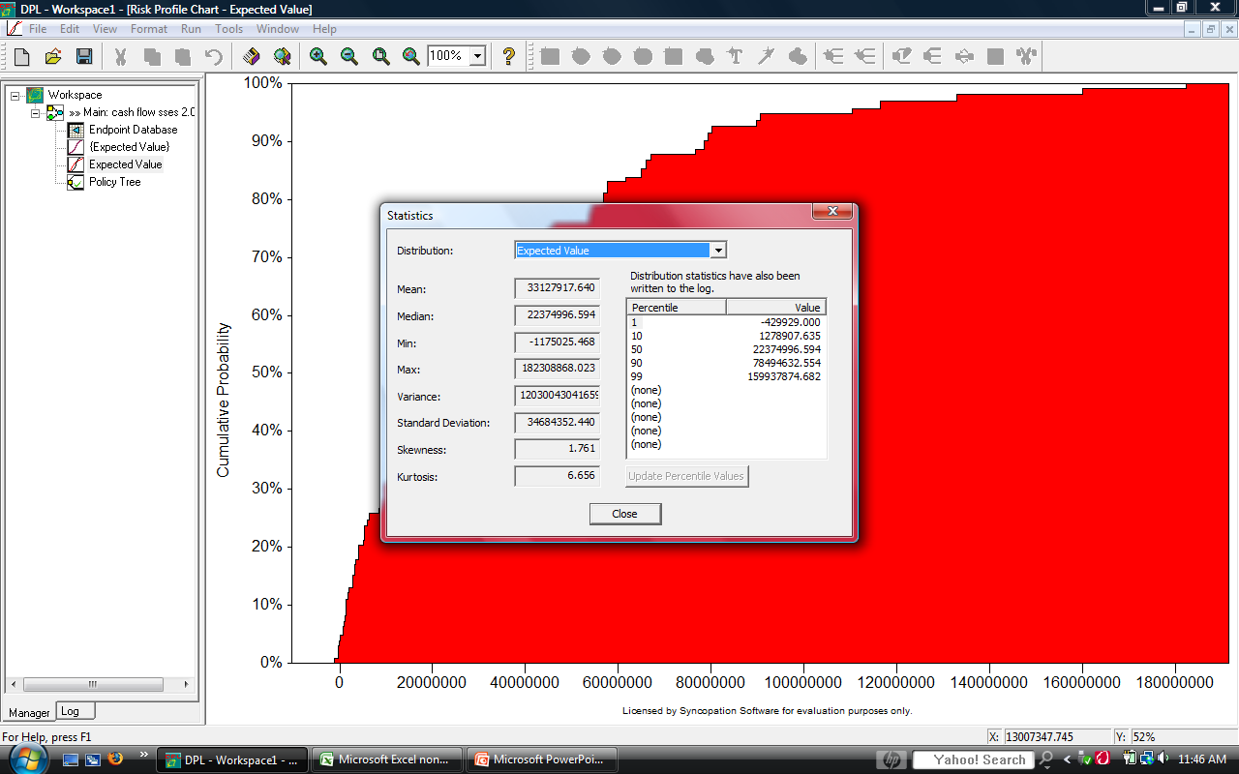

**1.7 Sensitivity Analysis.**

A value tornado was created to help identify which variables in the cash flow baseline have the biggest impact on our objective function. The following table shows the low, nominal, and high settings for each of the value nodes that are constant in our current model.

|  |  |  |  |
| --- | --- | --- | --- |
|  | **LOW** | **NOMINAL** | **HIGH** |
| **INITIAL SALES** | 1 | 5 | 10 |
| **PHASE 1 GROWTH** | 25% | 50% | 60% |
| **PHASE 2 GROWTH** | 50% | 80% | 100% |
| **PHASE 3 GROWTH** | 75% | 100% | 150% |

The x-axis of the value tornado diagram (Figure _) displays the change in the objective function of the model. Each of the variables on the left is changed from the low setting to the high setting.

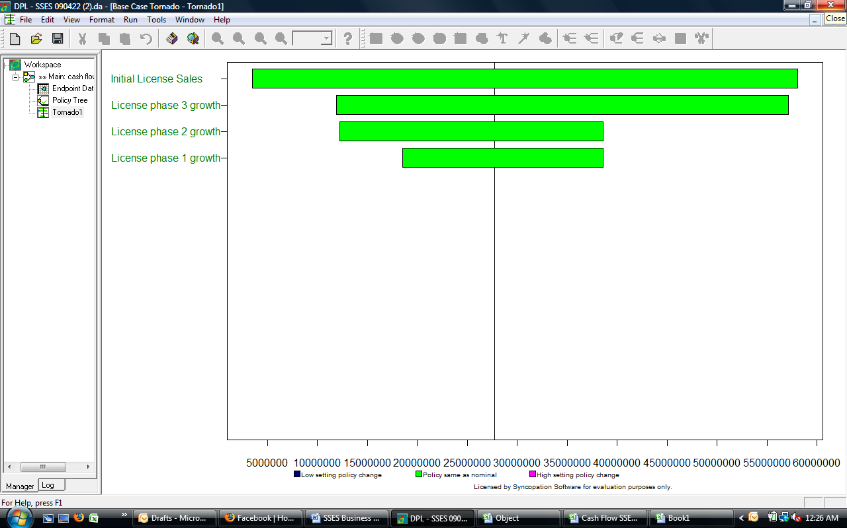

This sensitivity analysis shows that the one variable that impacts future NPV is initial sales. We will therefore focus on an aggressive initial marketing campaign that results in maximizing initial sales in year one.