PROGNOS TEAM
PROGNOS PROJEct plan and Proposal
Develop prognos exchange module interface

25 february 2010
Team members
richard rockweiler
nhan nguyen
CHEOL young park
lisa kim

Table of Contents
BACKGROUND 4
1. FORCENet 4
2. PROGNOS 4
PURPOSE 5
SPONSOR PROBLEM STATEMENT 5
SPONSOR 5
OBJECTIVE 6
SCOPE 6
LIMITATION 6
PRELIMINARY REQUIREMENTS 6
PROJECT APPROACH 7
1. Conduct Research and Data Collection 7
2. PROBLEM FORMULATION AND CHALLENGES 8
ESSENTIAL ELEMENTS OF ANALYSIS 8
PROJECT METHODOLOGY 8
1. Analyzing stakeholder requirements 9
2. Developing System architecture 9
3. Developing system 10
4. verification system 10
5. verification system architecture 11
6. validatioin stakeholder requirements 11
Performing Personnel 11
Literature Search and References 11
NESI:Net-centric Enterprise Solutions for Interoperability, http://nesipublic.spawar.navy.mil/ 12
PROJECT SCHEDULE (WBS) 12

BACKGROUND

FORCENet
FORCEnet is the US Navy/US Marine Corps alignment and integration effort for three major elements: (1) Department of Navy Transformation, Joint Interoperability, and Network Centric Warfare; (2) Innovation, demonstration, testing, and assessment to achieve Chief of Naval Operations’ (CNO) goal of “Speed to Capability”; (3) Operational requirements, architectures, standards, compliance, and oversight of Naval programs to achieve Joint War-fighting capability. FORCEnet is an operational construct composed of multiple different automation systems, network infrastructure systems, and telecommunications systems provided by multiple Navy program offices and contractors. It is not a homogenous network or program; rather it serves as a framework to define the Navy tactical network and to define the policies to support standards development, compliance, and interoperability. FORCEnet connects diverse automation systems that support multiple battlespace functions to include Intelligence, Surveillance, and Reconnaissance (ISR); operational Command and Control (C2); and logistical functions. These systems are connected via multiple transmission systems to include satellite, Line of Sight (LOS) radio systems, and fixed telecommunication infrastructure. The automation systems, network infrastructure, and transmission systems are supported by multiple Navy programs that were acquired and planned in a disjointed fashion resulting in “stovepiped” systems, custom designed for a specific purpose. The systems serve their defined purpose; however, since they were developed in a divergent fashion, sharing data between these systems is a significant technical challenge due to incompatible message formats and protocols. To improve operational efficiency and accelerate the decision cycle, the Navy must bridge the stovepipes and improve data and information interoperability. Compounding this challenge and contributing to the “fog of war” is the vast amount of data that must be processed to convert data to information and eventually to knowledge. FORCEnet and the network operational constructs from the other services such as Constellation C2 (Air Force) and Land WarNet (Army), need to bridge the “stovepipes” and convert the vast amount of data available to any combatant commander to actionable intelligence and enhanced situation awareness.

PROGNOS
PROGNOS, a system for Predictive Naval Situation Awareness currently being developed at George Mason University’s C4I Center, is a project to improve situation awareness for the U.S. Navy and to “enable predictive analysis with principled hypothesis management”. “PROGNOS will integrate four state-of-the-art enabling technologies into a distributed system architecture that represents domain knowledge as a modular collection of probabilistic ontologies, combine these “knowledge nuggets” dynamically into complex situation models, and apply theoretically sound, computationally efficient hypothesis management and inference to combine evidence and background knowledge to reason about the current situation. PROGNOS will also interoperate with other FORCEnet systems by interacting via semantically enabled services.” Figure 1 below illustrates the system overview diagram that depicts the modules and components of the two mentioned systems, FORCENet and PROGNOS, and their interface via some sort of shake hand between the PROGNOS Exchange Module and FORCENet.
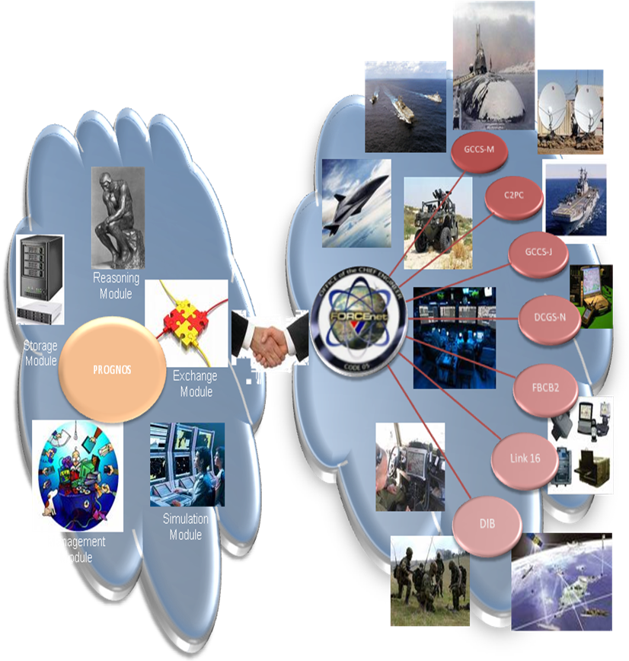
Figure 1- System Overview Diagram (OV-1)

PURPOSE
The purpose of this project is to support GMU's PROGNOS development on Knowledge Exchange Module by defining (1) the systems that PROGNOS must interface with and (2) the protocols and message formats that must be supported to interface with the identified systems.

SPONSOR PROBLEM STATEMENT
PROGNOS is a predictive naval situation awareness system being developed at GMU, whose main objective is to support decision makers by providing reliable high-level data fusion and situation awareness. It is currently being designed to integrate with Navy’s lower-level multi-sensor data fusion network, FORCEnet, which can manage thousands of tracks through many and diverse sensors. This integration will greatly improve the effectiveness of the human analysts, preventing cognitive overload which, among other issues, prevents optimal decision-making. However, there is no System Engineering approach to ensure this integration will ever happen. There is need to identify the main challenges and develop a formal methodology to achieve integration.

SPONSOR
The sponsor of this project is Dr. Paulo Costa and his PROGNOS development team from the George Mason University’s System Engineering Operations Research department.

OBJECTIVE
The team will research and define the PROGNOS Knowledge Exchange module external interfaces and provide and model development approach through simulation and analysis.

SCOPE
The team will focus on the PROGNOS Knowledge Exchange module and its interfaces to external Navy and Department of Defense (DOD) situation awareness systems and battle command applications.

LIMITATION
The limitations are time and the interfacing external systems. The PROGNOS team has only fourteen (14) weeks total to design the PROGNOS system model to allow integration with external systems. Also, the limited time will limit the number of external system interfaces modeled.

PRELIMINARY REQUIREMENTS
The requirements specified here are only thought out to be preliminary requirements that are required for the team in order to meet the customer objective. In another word, these requirements are not directly related to system requirements.

- The PROGNOS team shall provide an integration methodology to allow PROGNOS integration with other NAVY systems.
- The PROGNOS team shall provide a plan of action that will outline the necessary steps in order to meet sponsor objective.
- The PROGNOS team shall develop system requirements for PROGNOS exchange module.
- The PROGNOS team shall provide a Work Breakdown Structure (WBS) that will outline the effort required to accomplish customer objective.
- The PROGNOS team shall develop an Earn Value Management System (EVMS) to keep track of progress and accomplishment throughout the development process.
- The PROGNOS team shall develop a model using Sparx Enterprise Architect to represent system requirements, physical components, and system behavior.
- The PROGNOS team shall validate the developed model via simulation.
- The PROGNOS team shall develop an Interface Control Document (ICD) to define the signaling, protocols and message formats to support communication and the exchange of situation awareness information between PROGNOS and existing Command and Control systems the team will identify.
- The PROGNOS team shall document all work via George Mason provide webpage. The final report will include the webpage link.

PROJECT APPROACH

Conduct Research and Data Collection
In order to fully understand the PROGNOS interfaces, the PROGNOS team will conduct research and collect data from the following references:
- PROGNOS documentation provided by the developer, George Mason University
  - These documentations define the different modules within PROGNOS and the interfaces the modules will require for operation.
- FORCEnet Capability documentation
  - This will include FORCEnet Architecture Framework; FORCEnet specified Service Oriented Architecture (SOA) standards, and common protocols.
- Net Centric Enterprise Solutions for Interoperability (NESI)
  - NESI provides guidance for government and industry partners in developing net centric systems which require interoperability and compatibility. Specifically, its purpose is to provide software and system engineers with architectural, implementation and acquisition guidance for any net-centric interoperable system.
- Global Command & Control System – Maritime (GCCS-M)
  - The objective of the GCCS-M program is to satisfy Fleet C4I requirements through the rapid and efficient development and fielding of C4I capability. GCCS-M enhances the operational commander’s war-fighting capability and aids in the decision-making process by receiving, retrieving, and displaying information relative to the current tactical situation. GCCS-M receives, processes, displays, and manages data on the readiness of neutral, friendly, and hostile forces in order to execute the full range of Navy missions (e.g., strategic deterrence, sea control, power projection, etc.) in near-real-time via external communication channels, local area networks (LANs) and direct interfaces with other systems links.
- Distributed Common Ground System - Navy (DCGS-N)
  - The DCGS-N is the fleet variant of the Department of Defense (DoD) DCGS Family of Systems that provides integration of ISR support capabilities previously accessed from a variety of stand-alone systems.
  - It is developed for the following:
    - Increase interoperability
    - Ease of use with regard to C4I products
    - Share the actionable intelligence needed to identify and destroy targets

  - The DCGS-N system was designed to leverage commercial-off-the-shelf and mature government off-the-shelf software, tools and standards to provide a scalable, modular and extensible multi-source capability that operates at the General Service and Sensitive Compartmented Information security levels. DCGS-N uses an ashore Enterprise Point of Presence, accessible to all users via a Web interface, to facilitate sharing and receiving information with mission partners in a web-enabled, network-centric, joint-interoperable enterprise. This improvement also significantly reduces the stress on already limited bandwidth in the DCGS-N a float configuration.
  - The DoD DCGS Family of Systems access and ingest data from spaceborne, airborne, afloat ISR collection assets, intelligence databases and intelligence producers. The data is shared across the Joint Enterprise using DCGS Integration Backbone and Net-Centric Enterprise Services standards to optimize timeliness, quality, and multi-service integration of ISR information.
  - The first deliveries of DCGS-N-related systems are scheduled for 2007. Initial versions supports intelligence preparation of the battlespace for strike and fires missions by processing data from tactical sensors and platforms such as U-2 reconnaissance aircraft; Global Hawk unmanned aerial vehicles and satellite-based systems.
  - DCGS-N terminals, processing equipment and servers will be integrated into the command and control assets of Navy ships, allowing users to access intelligence databases. DCGS-N supports a variety of missions such as signals and communications intelligence, intelligence preparation of the battlespace, special operations and precision-guided engagement.
  - The DCGS-N is designed to serve across several echelons, or tiers, in the Navy. Tier 1 capabilities are shore- or command-ship-based systems serving as reach-back nodes for theater operations. Units fielding Tier 2 systems include carrier, strike and expeditionary task forces, with the main nodes installed on aircraft carriers and large-deck amphibious ships. The final category is Tier 3, which is tailored for individual ships. Future warships, such as the DDX, littoral combat ships and nuclear-powered guided-missile submarines may operate Tier 3 DCGS-N nodes.
- Also, the team will select a few more of mature Command and Control (C2) systems (i.e. GCCS-J, C2PC, FBCB2, Link-16, and DIB) and plan to research if necessary.

PROBLEM FORMULATION AND CHALLENGES
The PROGNOS team will utilize the information and data collected from the reference documentation to fully understand key aspects of the problem on three major areas: (1) how PROGNOS interoperates with external systems – the types of data or input that PROGNOS are accepting, the interaction of the different PROGNOS modules, and the compatibility of data exchanges, (2) how data information assurance could be an obstacle when security classification enters the picture, and (3) what is needed for communication between systems to systems without ambiguity. Due to large amount of external system potential and limited time, only a few of them will be chosen for interfacing with PROGNOS. Ultimately, a model of the designed system along with the external interfaces will be illustrated to provide analysis and requirements for integration.

ESSENTIAL ELEMENTS OF ANALYSIS
The essential element of Analysis for PROGNOS is the PROGNOS Knowledge Exchange Module that is designed to be the interfacing module with external systems. It must communicate with the outside environment as well as within itself. This will require data exchange interoperability, where it can understand and process the types of input data received from outside and convert/forward internally to different necessary modules.

PROJECT METHODOLOGY
The PROGNOS team will utilize a Department of Defense Architecture Framework (DODAF) to model the PROGNOS system, which allows all views from operation to technical and system visibility, ensuring completeness and comprehensiveness. The team will use Sparx Enterprise Architect to model the system requirements, interfaces, and behavior.
As a systems development model, we will use VEE Model that has a pair of process for each level. The product of this project will be the derived system requirements, the system architecture as the blueprint of the system, and the system ICD (Interface Control Document). These three products have their own evaluation process. The following diagram shows the VEE Model.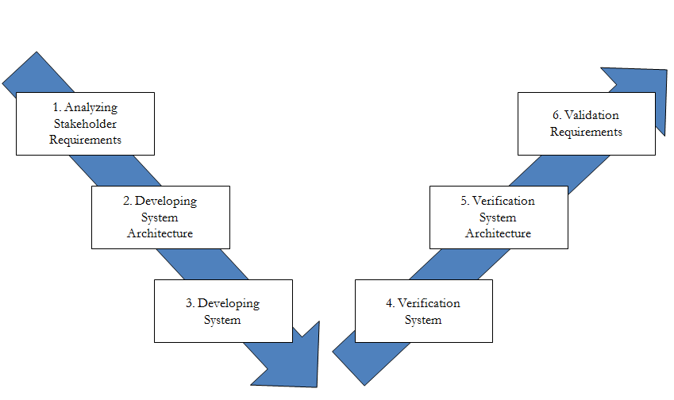
Figure 2 VEE Model

Analyzing stakeholder requirements
Requirements are the foundation for every systems design, the PROGNOS team will be tackling this by using the VEE model to make sure requirements and components are broken down in a logical order. The team foresees this being an iterative approach. As we learn more about the Navy and DoD C4ISR systems, we will generate more detailed requirements.

Developing System architecture
From the initial definition of the system boundaries to the final complete set of system specifications and required representations, system architecture will be modeled using Enterprise Architect to provide a visual representation in the physical architectural domain for hardware, software, people, facilities, and interfaces. The team plans on using the SysML modeling language and will use the DoD Architectural Framework (DODAF). We plan on creating an OV-1, OV-2, SV-1, and SV-2 diagrams as a minimum.

Developing The system
The team will develop an Interface Control Document (ICD) which will specify in detail the protocols and message formats for each of the key identified Command, Control, Communications, Computer, Intelligence, surveillance, and Reconnaissance (C4ISR) systems. For example, the document will have interface diagrams and information on the physical interfaces, electrical interfaces, timing, signal formats, and messages.

verification system
The team will use a scenario based approach to verify and validate our models and documentation due to the challenges in using simulation to verify and validate an interface design. The team will define a complex operational scenario that requires queries to multiple DoD C4ISR systems and will require communications between multiple PROGNOS instantiations. C4ISR systems likely to be in the scenario are DCGS-N, GCCS-M, and FBCB2. The team will describe in detail the step-by-step processes required to implement the scenario and an in-depth description of the protocols and format conversions required between PROGNOS and the other C4ISR systems

To provide further system verification, the team will use a java based interface simulation to evaluate system feasibility. We will base the java interface simulation scenario on the previously defined operational scenario. The java based interface simulation approach is shown in Figure 3 and may use existing software such as UnBBayes and Ground Truth Simulator. The team will base the interface simulation off the existing, proven query PROGNOS process. However, the PROGNOS team will add the capability to request information from external systems based on an ontology paradigm.

Figure 3 Verification Scenario
There are three major parts shown in Figure 3. First, the PROGNOS System in the left column will simulate the Reasoning Module. Second, the PROGNOS Ontology Interface System, located in the middle column, represents the PROGNOS Knowledge Exchange Module interface as defined in the ICD. Third, the PROGNOS Simulator, in the right column, simulates GCCS-M and DCGS-N.
The PROGNOS System will send a query to the PROGNOS Ontology Interface System. The PROGNOS Ontology Interface System will convert the query from the PROGNOS System into a message format acceptable for the GCCS-M or DCGS-N system. The PROGNOS Simulator in turn will simulate the GCCS-M or DCGS-N system. The PROGNOS simulator will accept the query and send back a “canned” response to the query. If the PROGNOS System accepts the query response, it will be a partial validation of our approach.

verification system architecture
The team will use the system requirements to verify the system architecture. The team will compare the system requirements with the system architecture to see the consistency.

validatioin stakeholder requirements
The team will validate all of the system and architecture based on stakeholder requirements. The team also will have weekly or bi-weekly review meetings with our sponsor to check the result of the project.

Performing Personnel
The following team members will work on this project:
- Richard Rockweiler – Master of Science in System Engineering
- Nhan Nguyen – Master of Science in System Engineering
- Cheol Young Park – Master of Science in System Engineering
- Lisa Kim – Master of Science in Operation Research

PROJECT SCHEDULE (WBS)
This Work breakdown Structure (WBS) will be based upon the team projection of the amount of effort needed to accomplish sponsor’s objective.
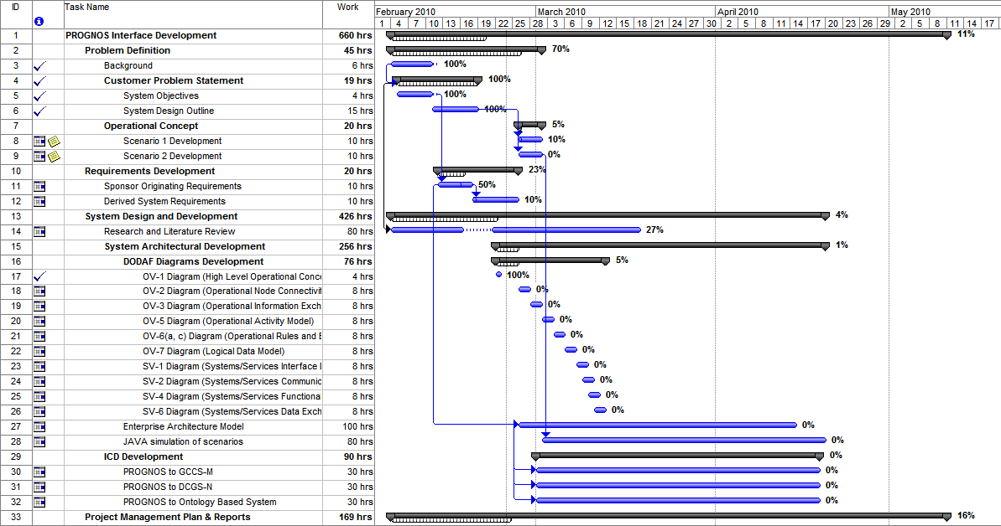

Literature Search and References
The following are documentations and literature that is used for references and to gather necessary information for this project.
- Costa, Laskey, Chang. PROGNOS: Applying Probabilistic Ontologies to Distributed Predictive Situation Assessment in Naval Operations.
- Costa, K.B. Laskey, K.J. Laskey, Wright. Probabilistic Ontology for Net-Centric Fusion
- FORCEnet: Official U.S. Navy Website, http://forcenet.navy.mil/
- NESI:Net-centric Enterprise Solutions for Interoperability, http://nesipublic.spawar.navy.mil/

George Mason University C4I Center / SEOR Department, “Probabilistic Ontologies for Net-Centric Operations Systems”, June 2009, slide 8.
Costa, Laskey, and KC Chang. PROGNOS: Applying Probabilistic Ontologies to Distributed Predictive Situation Assessment in Naval Operations, June 2009.

