|  |
| --- |
| George Mason University  GMU_PLogo_RGB |
| **Production Cost Savings at *Washington Post*** |
| Team Power WashPost |
|  |
| Thomas Kuklinski  Timothy Smith  Ling Wu  Vladimir Zivkovic |
| **May 2, 2011** |

|  |
| --- |
|  |

Table of Contents

[List of Figures 4](#_Toc292062822)

[List of Tables 4](#_Toc292062823)

[1 EXECUTIVE SUMMARY 6](#_Toc292062824)

[1.1 FOLLOW-ON STUDY OF PREVIOUS GROUP 6](#_Toc292062825)

[1.2 WHAT THEY DID 6](#_Toc292062826)

[1.3 THEIR RECOMMENDATIONS 6](#_Toc292062827)

[1.4 WHERE WE STARTED 6](#_Toc292062828)

[1.5 OUR METHOD 7](#_Toc292062829)

[1.6 OUR TECHNICAL APPROACH 7](#_Toc292062830)

[1.7 OUR RECOMMENDATIONS 7](#_Toc292062831)

[1.8 POSSIBLE FOLLOW-ON EFFORTS 8](#_Toc292062832)

[2 INTRODUCTION 9](#_Toc292062833)

[2.1 BACKGROUND 9](#_Toc292062834)

[2.2 NEED 10](#_Toc292062835)

[2.3 PROBLEM STATEMENT 10](#_Toc292062836)

[2.4 CLIENTS 10](#_Toc292062837)

[3 OBJECTIVES AND SCOPE 11](#_Toc292062838)

[4 TECHNICAL APPROACH 11](#_Toc292062839)

[4.1 ASSUMPTIONS 11](#_Toc292062840)

[4.1.1 MODEL ARCHITECTURE 11](#_Toc292062841)

[4.1.2 RESOURCES 11](#_Toc292062842)

[4.1.3 ARRIVAL PROCESSES 12](#_Toc292062843)

[4.1.4 SERVICE TIME DISTRIBUTIONS 12](#_Toc292062844)

[4.1.5 INTERNAL BUSINESS LOGIC 12](#_Toc292062845)

[4.2 LIMITATIONS 12](#_Toc292062846)

[4.3 METHODOLOGY 13](#_Toc292062847)

[4.3.1 PROCESS ANALYSIS 13](#_Toc292062848)

[4.3.2 DATA COLLECTION AND ANALYSIS 14](#_Toc292062849)

[4.3.3 MODEL SELECTION AND CONSTRUCTION 14](#_Toc292062850)

[4.3.4 OUTPUT ANALYSIS 14](#_Toc292062851)

[5 MODEL ARCHITECTURE 15](#_Toc292062852)

[5.1 PROCESS OVERVIEW 15](#_Toc292062853)

[5.2 GENERAL ARENA MODULE 17](#_Toc292062854)

[5.3 ARENA PROCESS COMPONENTS 18](#_Toc292062855)

[5.4 SCHEDULE MODULE 21](#_Toc292062856)

[5.5 OUTPUT ANALYSIS MODULE 21](#_Toc292062857)

[6 RESULTS and ANALYSIS 22](#_Toc292062858)

[6.1 INPUT ANALYSIS 22](#_Toc292062859)

[6.1.1 DATA COLLECTION 23](#_Toc292062860)

[6.1.2 ARENA INPUT ANALYZER 23](#_Toc292062861)

[6.1.3 LABOR ANALYSIS 25](#_Toc292062862)

[6.1.4 ROUTE ANALYSIS 26](#_Toc292062863)

[6.1.5 ARRIVAL ANALYSIS 28](#_Toc292062864)

[6.2 OUTPUT ANALYSIS 33](#_Toc292062865)

[6.2.1 MARKUP ANALYSIS 34](#_Toc292062866)

[6.2.2 UTILIZATION ANALYSIS 36](#_Toc292062867)

[6.2.3 HELPER MOVES ANALYSIS 37](#_Toc292062868)

[7 RECOMMENDATION 40](#_Toc292062869)

[8 FUTURE WORK 41](#_Toc292062870)

[8.1 GRAPHICAL USER INTERFACE OF A MODEL 41](#_Toc292062871)

[8.2 ANIMATION OF A PROCESS 41](#_Toc292062872)

[8.3 USE ARENA OPTIMIZATION AND MORE COMPLEX MODULES 41](#_Toc292062873)

[9 REFERENCES 42](#_Toc292062874)

[Appendix 43](#_Toc292062875)

[Appendix List of Tables 43](#_Toc292062876)

[Appendix List of Figures 44](#_Toc292062877)

[APPENDIX A: TASK BREAKDOWN STRUCTURE 45](#_Toc292062878)

[APPENDIX B: EARNED VALUE MANAGEMENT 47](#_Toc292062879)

[APPENDIX C: MODEL ANALYSIS 49](#_Toc292062880)

[Appendix C-1: Input/Output Analysis-Labor Analysis 49](#_Toc292062881)

[Appendix C-2: Input Analysis-Route Analysis 51](#_Toc292062882)

[Appendix C-3: Input Analysis-Arrival Analysis 53](#_Toc292062883)

[Appendix C-4: Output Analysis – Utilization 68](#_Toc292062884)

[Appendix C-5: Output Analysis – Helper Moves 69](#_Toc292062885)

[APPENDIX D: MODEL DETAILS 70](#_Toc292062886)

[Appendix D-1: Model Components 70](#_Toc292062887)

[Appendix D-2: Model Instructions 75](#_Toc292062888)

# List of Figures

[Figure 1 Actual Process Flow for the *Washington Post*’s Four Work Centers 16](#_Toc292062889)

[Figure 2 Process Flow for the *Washington Post*’s Four Work Centers with Team PWP’s Scope 17](#_Toc292062890)

[Figure 3 Basic System Construct within the *Post*’s Mailroom 18](#_Toc292062891)

[Figure 4 Sunday Packaging Raw Ads Are Terminated At the Collator Machines for Processing 19](#_Toc292062892)

[Figure 5 Finished Sunday Packaging Pallets Arrive at the Collator Machines for Transportation to the Docks 19](#_Toc292062893)

[Figure 6 The Schedule Module Determines How Many Helpers of Each Type are Available by Shift/Day 21](#_Toc292062894)

[Figure 7 Helper Idle Time Statistics Process 22](#_Toc292062895)

[Figure 8 Input Analyzer Result Window (Part 1) 24](#_Toc292062896)

[Figure 9 Input Analyzer Result Window (Part 2) 25](#_Toc292062897)

[Figure 10 Number of Helpers per Shift for Base Schedule 35](#_Toc292062898)

[Figure 11 Number of Helpers per Shift for Suggested Schedule 35](#_Toc292062899)

[Figure 12 Number of Helpers per Helper Zone in One WW that could be Reduces Based on Suggested Markup 36](#_Toc292062900)

[Figure 13 Utilization for Base Model 36](#_Toc292062901)

[Figure 14 Utilization for Suggested Model 37](#_Toc292062902)

[Figure 15 Average Number of Moves per Helper per Hour for Suggested Model 38](#_Toc292062903)

[Figure 16 Average Number of Moves per Helper per Hour for Suggested Model 38](#_Toc292062904)

[Figure 17 Total Number of Moves per Helper-Zone per WW for a Base Model 39](#_Toc292062905)

[Figure 18 Total Number of Moves per Helper-Zone per WW for Suggested Model 39](#_Toc292062906)

# List of Tables

[Table 1 Revised Pallet Summary Report Data 27](#_Toc292062907)

[Table 2 Arena Input Analyzer Results Compared with Estimated Data 27](#_Toc292062908)

[Table 3 Production Data Provided by *Washington Post* 29](#_Toc292062909)

[Table 4 Modified Production Data 29](#_Toc292062910)

[Table 5 Pallet Processing Arrival Statistics Obtained through Arena’s Input Analyzer 30](#_Toc292062911)

[Table 6 Count of Arrivals by Location by Shift/Day 33](#_Toc292062912)

[Table 7 Markup for Base Model 34](#_Toc292062913)

[Table 8 Utilization for Base Model 34](#_Toc292062914)

[Table 9 Markup for Suggested Model 35](#_Toc292062915)

[Table 10 Moves per Shift and Helper Zone for Base Model 37](#_Toc292062916)

[Table 11 Moves per Shift and Helper Zone for Suggested Model 38](#_Toc292062917)

# 1 EXECUTIVE SUMMARY

## 1.1 FOLLOW-ON STUDY OF PREVIOUS GROUP

In August 2010, a team of George Mason University (GMU) students, known as “I’m Pro WashPost”, from the Volgenau School of Engineering performed a research study to identify potential production cost savings for the Shipping and Receiving Department at the *Washington Post* plant in Springfield, Virginia. Their study focused on the material handling and labor processes within the plant. The team collected data on the routes and the labor force used during a one-week period to use in their analysis.

Their goal was to determine material handling routes and labor assignments that would allow the *Post* to move the required materials using a minimum number of resources. In this case, the minimum number of fork truck and deep reach fork truck drivers.

## 1.2 WHAT THEY DID

They gathered data for material movements from the Material Tracking and Control (MTC) system that the *Post* uses to schedule and track pallet moves within the plant. The *Post* also provided the workforce breakdown by Day/Shift/Location. The team documented all routes used during a one-week period and collected route times for each pallet move.

## 1.3 THEIR RECOMMENDATIONS

They conducted a process evaluation, a labor analysis, and an analysis of routes which resulted in three groups of recommendations:

* + - Labor reductions
    - Route simplifications
    - Improved data tracking

The *Post* began an incremental implementation of several recommendations in December 2010.

## 1.4 WHERE WE STARTED

A second team, known as Power Wash Post (PWP), began working with the *Post* in January 2011 with the goal of expanding the static analysis done by the previous group. This expansion provided a dynamic simulation model of the helper component of the *Post’s* four work centers. The work centers are composed of primarily two labor categories: helpers and mailers. The mailers operate the collators and inserting machines (SLS machines), while the helpers move the pallets to the various machines, staging areas, and storage racks.

## 1.5 OUR METHOD

Team PWP received a similar data set as the first team; a one-week period in February 2011. After a cleansing to remove anomalous routes, Team PWP mapped all of the remaining routes to specific helper zones within the system. Then, descriptive statistics were obtained on route times for model input to determine the best distribution and mean of the input data. From this, Team PWP determined that a significant amount of the route times received from MTC were invalid and they decided to use estimated route time data as recommended by the client instead. In addition, they collected data on markup helper schedules, arrival processes, and internal system business logic that were used to build a simulation model in Arena.

## 1.6 OUR TECHNICAL APPROACH

Based on an in-depth study of the operational process at the warehouse of the *Post* and thorough discussions with the customer, Team PWP decided the best approach was to build a discrete event simulation model in Arena platform after comparing alternative options, given the nature and complexity of the problem. Certain assumptions were made in the areas of model architecture, resources, arrival processes, service time distributions, and internal business logic. Team PWP first utilized the work from the previous group and then collected new data to perform process analysis on work centers quantitatively. Followed by process analysis on routes and operations, Team PWP obtained production data then performed input data analysis on statistics related to labor, routes and arrival process. Meanwhile, the model architecture was constructed in Arena. Once the model was complete, testing, evaluation, and sensitivity analysis indicated that it did in fact accurately model the system. Team PWP then conducted output analysis that demonstrated the capabilities of the model and how its statistics could be used to inform decision makings.

## 1.7 OUR RECOMMENDATIONS

Team PWP recommended the *post* to apply a modified labor markup schedule to the warehouse to save labor cost. A more efficient and optimized labor markup could be achieved by comparing the outputs after running the model against different labor markups. Utilizing the output analysis of the model for different schedule would help the *Post* to make labor markup decisions that meet production goals and reduce labor to cost the minimum. Furthermore, Team PWP suggested the *post* to develop stringent input data tracking mechanism to obtain accuracy in numeric values or distributions of input parameters. The values and distributions of input parameters of the model should be as realistic as possible for the model to produce accurate output.

## 1.8 POSSIBLE FOLLOW-ON EFFORTS

As a follow-on effort, Team PWP recommends several efforts that were discussed with the *Post*. First, a future team could provide a graphical user interface (GUI) for the Arena model. This interface would allow the direct use of the model and eliminate the need for either in-depth Arena experience or a theoretical understanding of simulations. It would help provide an easier way to enter input data and read output data. A second improvement would be the development of animation to assist the user with a visual representation of what is occurring within the system. Third, an optimization within the simulation to determine optimal schedule allocations of helpers to meet production targets could be implemented. Lastly, assumptions of the existing Arena model could be explored and eliminated by making model improvements such as seamless transitions of raw ad materials to finished pallets instead of breaking the process into two distinct flows.

# 2 INTRODUCTION

In the fall of 2010, a team of George Mason University (GMU) students from the Volgenau School of Engineering, known as “I’m Pro WashPost”, performed a research study to identify potential production cost savings at the *Washington Post* plant in Springfield, Virginia. They provided an initial, static analysis of the workforce and workload in the Shipping and Receiving Department, also known as the mailroom. Their purpose was to gain a better understanding of the workforce required to efficiently move materials within the plant.

The 2010 team conducted a process evaluation, an analysis of labor, and an analysis of routes which resulted in three groups of recommendations:

* + - Labor reductions
    - Route simplifications
    - Improved data tracking

Based on their work, a second GMU Team, Power Wash Post (PWP), developed a simulation of the workforce that helped provide insight about the movement of materials in the *Post’s* warehouse. This model was built using Arena (version 12.0) since the *Post* had previously acquired licenses for this version.

## 2.1 BACKGROUND

The *Post* maintains a daily circulation of approximately 540,000 papers and is the largest of the Washington D.C. metropolitan area newspaper operations. However, many readers have opted to obtain news and information from various electronic media outlets and this has caused the current circulation rate to decrease over the past decade. According to the Newspaper Association of America, this is expected to continue to be the trend.

The *Post* is confronted with a continuous adjustment of the workforce level required to support a decreasing production rate. Due to union agreements and their current workforce determination process, they can only adjust the workforce levels about four times each year. This leads to inefficiencies occurring as a larger workforce is employed to support the decreasing workload. A more optimal workforce could be determined by using a decision support tool that provides more real time responses to the impacts of workload assignments. With an appropriate tool set, Team PWP expected the *Post* could adjust as many as eight times each year.

The department essentially has two labor categories: mailers and helpers. The mailers operate the collators and inserting machines (SLS machines), while the helpers operate the material handling equipment and expedite the supply of raw ads and finished pallets to machines and shipping docks. For this project, Team PWP concentrated on the helper component only.

## 2.2 NEED

The *Post* needs a dynamic simulation model to determine the helper component workforce level required to support the desired workload of the work centers now and in the future.

* + Maximize the efficiency of the *Washington Post* materials handling process within the Shipping and Receiving Department and generate cost savings to the overall operation
  + Bring the static analysis done by previous group to life in a dynamic simulation model of the helper component of the work centers

## 2.3 PROBLEM STATEMENT

The purpose of this project is to provide a baseline simulation model in Arena to allow the *Post*  to accomplish the production target goals while minimizing the labor resources and cost. The baseline Arena simulation model would only focus on the helper component of the work centers and model the material handling process within the Shipping and Receiving Department at the *Post*.

## 2.4 CLIENTS

Mr. Kent Renk, Materials Handling Foreman, [renkk@wash*Post*.com](mailto:renkk@washpost.com), 703-916-2471.

Ms. Kim Hammett, Assistant Superintendent for Materials Handling, [hammettk@wash*Post*.com](mailto:hammettk@washpost.com), 703-916-2447.

# 3 OBJECTIVES AND SCOPE

Team PWP’s objective was to provide a baseline simulation model that helps the *Post* maximize the efficiency of the materials handling processes in an effort to generate cost savings to the overall operation. Team PWP intended to build upon the static analysis done of the previous group by modeling the helper component of the four work centers. Team PWP’s main deliverable would be a flexible simulation model that can be used by the *Post* to make workforce planning decisions.

# 4 TECHNICAL APPROACH

This section outlines the assumptions, limitations, and methodology behind the technical approach. The technical approach was critical in ensuring the model was sound and useful.

## 4.1 ASSUMPTIONS

Developing clear assumptions for a model is especially important when determining how it can be applied to real world decisions. It is extremely important that the user of a model be aware of the intricacies of what is being assumed when analyzing the model’s results. Simulation was Team PWP’s choice for model framework and with that come certain assumptions related to model architecture, resources, arrival processes, service time distributions, and internal business logic.

### 4.1.1 MODEL ARCHITECTURE

The model architecture assumptions will be covered in an in depth discussion of the framework in the next section. Specifically, they deal with the rack, Z-Loader loading/unloading processes, truck arrivals, and machine processing.

### 4.1.2 RESOURCES

The main resources in the model were helpers. Helpers were determined based on a markup of the previous workforce amounts. Loader/Unloader and Deep Reach helper types were in the markup, however, they also worked processes not represented in the model. Because of this, the client determined how many of these helper types to reduce from each shift. This discrete reduction of the labor force to accommodate the missing components not modeled works with the assumption that the components modeled and not modeled are independent of each other.

Additionally, assumptions were made about the routes assigned to helpers. Aggregating helpers into groups that all work with a different set of routes is something that the *Post* does not always do perfectly now, but would like to, so it was modeled that way. That said, assumptions about this process were based on client advice.

### 4.1.3 ARRIVAL PROCESSES

While a complete analysis of the data related to the arrival processes in the model determined their distributions were exponential in inter-arrival times and Poisson in terms of arrival rate, this distribution type is still an assumption. Shift/days with less than four pallet arrivals were not considered.

To develop the distributions, Team PWP used data from the week of February 7-12 2011, except for arrivals from the rack of Daily Insert and Sunday Packaging raw ads, which used data from a previous week (i.e. January 17-23, 2011) because of a lack of this data for the main week. It was assumed that the data from these weeks was representative of the system behavior over all weeks and captures the overall number of pallets that needed to be moved within the system over the course of a week.

### 4.1.4 SERVICE TIME DISTRIBUTIONS

Route velocities for each helper type and Z-Loader lifting times were assumed to follow a triangular distribution. Because of a lack of good historical data, Team PWP relied on the client subject matter expertise to determine this information. When dealing with subject matter experts to obtain mathematical distributions, the triangular distribution was used because it is was easy to define parameters.

Servicing time for entering and removing pallets from the rack was assumed to be 30 seconds and added to the end of the routes to and from the rack. This was provided to us by the client.

### 4.1.5 INTERNAL BUSINESS LOGIC

The internal business logic of the model was determined based on subject matter expertise and system states as well.

It was assumed that 50% of finished Daily Insert pallets went to the Concourse Shipping Dock and 50% went to the North Dock Shipping Lanes. Additionally, it was assumed that 50% of finished Sunday Packaging went to the rack and 50% went to the North Dock Shipping Lanes. It was also assumed that choosing between machines to use (i.e. SLS 1-4 and SLS 5-6) was done uniformly. Lastly, Team PWP assumed that helpers would always choose the Z-Loaders to use that were the least busy.

## 4.2 LIMITATIONS

With all models, certain limitations always exist. In the case of Team PWP’s model, time, changing business logic, and data availability were those limitations. Due to the limited time that Team PWP had to understand the system and then build a model, they were unable to explore every facet of the system such as the Run of Press component, which will be discussed in the next section. However, Tea, PWP were able to successfully build a working model used for decisions now and in the future.

The second limitation dealt with changing business logic. Even in the time that Team PWP was working on the model, the business logic of the four warehouses changed. Markups were switched and helpers assigned different routes, making it difficult for Team PWP to keep up. However, the model was constructed in such a way that the client will be able to easily update the model with new data and business logic to accommodate changes and test new strategies in the future.

Lastly, data availability was a limitation. While the *Post* does have a large scale data tracking system known as MTC, it is not always used correctly by the helpers, making the data sometime unusable. Relying on the client to fill in the gaps is not always ideal for a model and future efforts should be made to enforce correct usage of the MTC system to obtain better data inputs for the model.

## 4.3 METHODOLOGY

Our technical methodology consisted of four parts:

* Process Analysis
* Data Collection and Analysis
* Model Selection and Construction
* Output Analysis

### 4.3.1 PROCESS ANALYSIS

In the development of any model, it is important to obtain a strong understanding of the complexities of the system being modeled. In the case of the *Post’s* mailroom, this involved a detailed mapping of the flow of materials over the four work centers: Material Handling, Run of Press (ROP), Daily Insert, and Sunday Packaging. The four work centers handle the processing of newspaper head sheets and jackets from off the press and various forms of advertisements required for insertion or collation to make a finished product.

The overall process involves numerous routes, material types, machines, and labor. These four components interact throughout the four work centers based on extensive scheduling of both labor and materials. In an effort to model this system effectively, a strong understanding was required of how all of these interlocking components work together.

Team PWP’s approach for Process Analysis was first to utilize the work done by the previous group, which provided a detailed analysis of the way this system works for the purposes of static analysis. However, because the goal was for a more dynamic model, Team PWP needed to look further into some of the details of the system. Once this qualitative data was collected, they used it to look further into some of the data that describes the Process Analysis more quantitatively.

### 4.3.2 DATA COLLECTION AND ANALYSIS

For each component (e.g. route, machine, labor, etc.) of the system described in the Process Analysis, quantitative data was obtained. Fortunately, the *Post* has recently employed a robust material tracking system (i.e. MTC), which was used to provide historical data on things such as routes and processing times. However, this system does have shortfalls and did not explicitly capture qualitative data on every component within the system.

For components not captured by MTC, Team PWP relied on subject matter experts working in each of the four work centers to provide the appropriate estimates such as route times.

Lastly, labor data was needed. The client provided a labor markup, which documented the numbers of employees at the four work centers by type and shift.

Once all of the data was collected, preliminary analysis was conducted to identify gaps and shortfalls within the system. Team PWP looked at overall throughput throughout of the system based on labor, processing times, route times, and arrival processes. The goal was to obtain descriptive statistics for each of the components of the system. An understanding of the system from both a qualitative and quantitative perspective enabled Team PWP to determine what type of model to use to inform decision making.

### 4.3.3 MODEL SELECTION AND CONSTRUCTION

Based on knowledge of the system and the client expectations, Team GMU chose a discrete event simulation mode using Arena as the platform. Team PWP weighed the benefits of different types of models before settling on simulation first, but it was determined that simulation was best due to the nature of the problem and the data available.

After model selection, construction began. The first stage of this development involved a mapping of the system process to Arena modules. This was followed by further data analysis that identified appropriate distributions based on the data that best reflected the true nature of the system. Once the model was complete, testing, evaluation, and sensitivity analysis determined that it did in fact accurately model the system at hand. After this, Team PWP conducted output analysis.

### 4.3.4 OUTPUT ANALYSIS

While the main deliverable was a complete model to be used in the future, some output analysis was done to demonstrate the capabilities of the model and how its statistics could be used to inform decisions. Team PWP looked at helper idle time by helper by shift/day, helper moves by helper by shift/day by hour, and overall production for the whole week. Using these statistics, they were able to modify the existing markup schedule of resources to improve utilization and helper moves, while obtaining the same production targets. This process provided the client with a technique for evaluating markup schedules against production targets.

# 5 MODEL ARCHITECTURE

The model architecture exists as a simulation done within the Arena platform. The architecture within Arena models the system as it exists in the real world. The model runs Monday-Friday for 21 hours days, 7 hour shifts. It does not account for the 1 hour breaks between shifts that would make a 24 hour day. The following section details the *Post’s* overall process at their warehouses, the main module design used within the Arena model, and the basic processes occurring within the model. It closes with a discussion of the schedule and output modules used for input and output analysis.

## 5.1 PROCESS OVERVIEW

The overall process of the *Post’s* four work centers can be seen below. The mailroom consists of four work centers: Materials Handling, Daily Insert, Sunday Packaging, and Run of Press (ROP). The objective of the mailroom is to take advertisements and package them in such a way that they can be distributed to customers via distribution centers in conjunction with the *Post’s* newspaper prints.

The advertisements come in the form of Daily Insert and Sunday Packaging. Daily Insert materials arrive at the receiving docks in trucks and need to be inserted into newspaper jackets before they can be distributed. This happens three times during the course of the week. This process relies both on jackets and advertisements at the SLS machines where the insertion takes place. From there, the finished pallets are taken to the docks for shipping to the distribution centers, where the jackets are place inside the main head sheets and delivered to customers.

Sunday Packaging works little differently. These advertisements are collated over the course of the week at the Collator machines and delivered to the docks for shipping to the distribution centers. There, they are combined with the complete Sunday newspaper and delivered to customers.

As indicated in the picture below, both Daily Insert and Sunday Packaging materials arrive at the docks where they are unloaded and transported to the rack or their respective processing stations (i.e. Daily Insert or Sunday Packaging) by the Materials Handling work center. Raw ads are taken to the rack to await their processing schedules if machines are not ready for them. At the Daily Insert work center, the processing relies on both the Run of Press work center to provide the jacket and the delivered advertisement from the rack or receiving docks by the Materials Handling work center. Here, the processing takes place on SLS machines and then the finished good are taken back to the docks for shipping. Occasionally, they are taken to the rack for later shipping.

The Sunday Packaging follows a similar process, except it does not rely on the Run of Press component. Raw Sunday Packaging ads are taken to the Collator machines, collated, and returned to the docks for shipping. Because the Sunday Packaging only goes out on Sunday, many of the finished pallets are stored at the rack to await shipping.

The last process not represented in the model occurs with the Run of Press work center which is responsible for running all of the head sheets for the newspapers late in the evening for shipping to the distribution centers and compilation with the necessary advertisements. This was not represented because the client was not concerned about this process at this time.

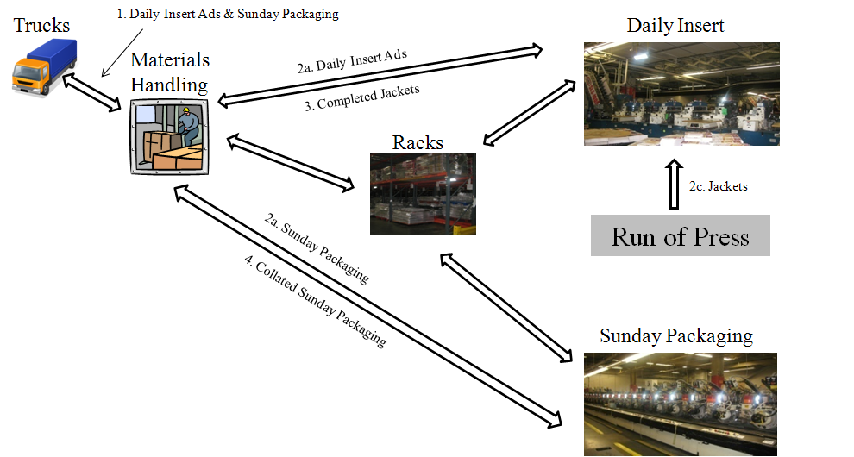

Figure 1 Actual Process Flow for the *Washington Post*’s Four Work Centers

To model everything described above would be infeasible and yields diminishing returns the more precise the model becomes. Because of this, Team PWP worked with the client to determine what components of the system should be modeled in order for the model to effectively inform decisions.

Because only 5% of raw materials traveled to processing machines from the trucks/receiving docks and the rest traveled straight to the rack for storage, Team PWP decided to cut this component out of the model and start the model at the rack. According to the client, the truck/receiving dock component would be very hard to capture accurately anyway. Additionally, very few of Daily Insert finished pallets were sent to the rack, so this flow was removed as well. Lastly, the Run of Press integration with the Daily Insert processing was removed because of an assumption of a consistent supply of jackets for this process. Instead, the Run of Press jackets that do not require advertisements and go straight to the docks were modeled instead. In fact, during the week Team PWP modeled, this ROP process did not happen so its arrival process was set to 0.

The client was comfortable with all of these model architecture assumptions. The scope of the process that Team PWP focused on can be seen below.

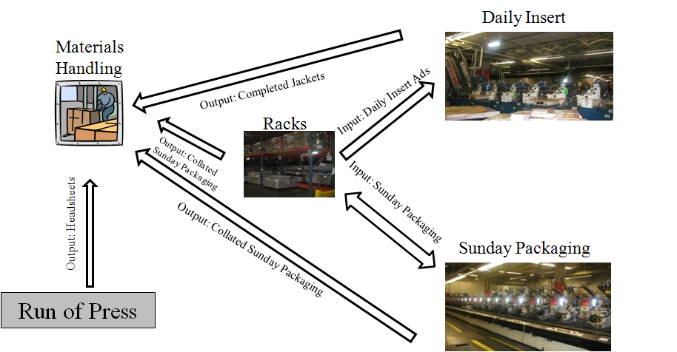

Figure 2 Process Flow for the *Washington Post*’s Four Work Centers with Team PWP’s Scope

Also note that the rack is one location. In the real warehouses, the rack takes on many locations all in the same general area. Team PWP, however, used a client-provided average location for all rack locations to simplify the model with little impact on the system.

## 5.2 GENERAL ARENA MODULE

The basic structure that existed within the *Post’s* four work centers involved entities in the form of pallets arriving at certain areas of the system and needing to be transported to new areas by helpers via routes. Helpers are responsible for multiple routes and they work together to ensure that the pallets get to where they need to go. Below is a basic design this construct.

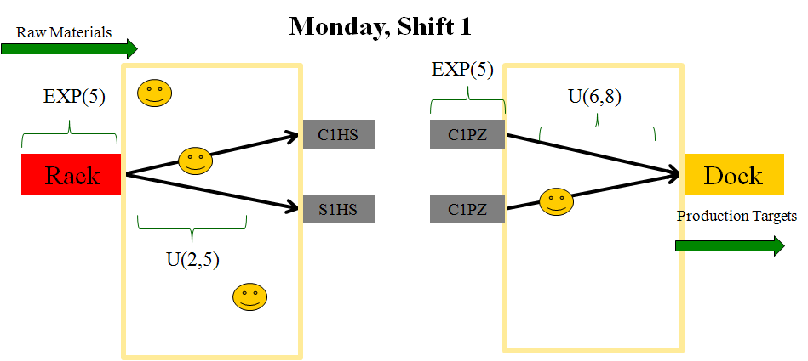

Figure 3 Basic System Construct within the *Post*’s Mailroom

As seen in the picture above, pallets arrive according to a distribution at a place (e.g. rack) and need to be taken to somewhere (e.g. processing). Various routes are used to transport the materials two the next destinations and helpers, who are assigned to the routes, do the moving. Helpers are responsible for routes within what are called “helper zones”.

As seen in the picture above, there is a lack of connection between the arrival of raw materials and finished pallets at the processing station. Due to the complexity of recipes for combining advertisements for Sunday Packaging and Daily Insert finished goods, it was very difficult to model this transition seamlessly. Instead, the process was broken down into two pieces, with raw materials terminating upon reaching the machines and a separate arrival process for finished pallets at each machine.

## 5.3 ARENA PROCESS COMPONENTS

The construct described above was used to model the majority of the flows within the model. Below are two pictures of part of the Collator process element of actual Arena model. The remaining model components can be viewed in the Appendix.



Figure 4 Sunday Packaging Raw Ads Are Terminated At the Collator Machines for Processing



Figure 5 Finished Sunday Packaging Pallets Arrive at the Collator Machines for Transportation to the Docks

As seen in the pictures above, the process is separated at the processing stage as described before.

Arrival processes were modeled using the non-stationary Poisson Process schedule module. Part of this module can be seen at the beginning of the second picture above. This module allowed Team PWP to vary the rates of arrivals by shift/day for each arrival process. Arrivals occurred at the rack for raw materials to go to SLS 1-6 machines and Collator 1-4 machines, and for finished Sunday Packaging to go to the North Dock Shipping Lanes and Concourse Docks. Arrivals also occurred at the SLS 1-6 machines and Collator 1-4 machines for delivery of finished pallets to the rack or docks. Lastly, arrivals from the Run of Press that did not require advertisements were modeled, but due to a lack of data during the week, their arrival process was set to 0.

Transportation processes used the Station, Transporter, Transport, Request, Enter, Expression, Delay, and Distance modules to properly request the appropriate helpers for a route and have them travel over it the correct distance at the correct velocity. In the pictures above, the pink modules indicate stations of delivery, while the aqua modules represent requests for helpers for movement.

Decide modules were used to make decision about which machine to deliver the raw ad to or which dock/rack to take the finished pallets to for distribution. These modules are triangular and can be seen in the pictures above.

The Z-Loader process, which moves Daily Insert pallets up and down between the upstairs and downstairs, were modeled as Seize Delay Release modules with one resource per Z-Loader. A queue would build up for the pallets waiting to be transported. It was assumed that when a pallet needed to be moved onto the Z-Loader and off of it, a helper delivering new pallets would do so while they waited for the next demand signal. Z-Loader processing time was taken to be 1.5 times the time it took to go one way because it was assumed that the Z-Loader would be at the location of the pallet needing to be moved 50% of the time and 50% of the time it would be at the further location.

Pallets were terminated using Terminate Modules. Termination occurred at the SLS 1-6 machines and Collator 1-4 machines for delivered raw ads. Termination also occurred at the rack for finished Sunday Packaging waiting to be taken to the docks, and at the trucks. Trucks were assumed to be unlimited at the Concourse Shipping Dock and North Dock Shipping Lanes. This was done because of the complexity of the truck arrival process.

## 5.4 SCHEDULE MODULE

The schedule model in Arena can be seen below.



Figure 6 The Schedule Module Determines How Many Helpers of Each Type are Available by Shift/Day

An easy to use schedule Graphical User Interface is not available for inputting helper availability over time. Therefore, Halt and Activate modules for each helper are used to turn them on and off to reflect the week’s markup. A single entity moves through the model over the course of the week at time intervals related to the shifts and days of the week.

## 5.5 OUTPUT ANALYSIS MODULE

Output analysis modules have been implemented to record valuable statistics about the system. These statistics are idle time by helper by shift/day and total moves by helper by shift/day. In addition, a markup is printed based on the Schedule module.

The Record and ReadWrite modules were used to record the statistics and print them to three MS Excel files: Markup.xls, HelperMoves.xls, and HelperUtil.xls. Below is a picture of a collection of these modules used to record idle time. The system generates an entity once a minute that captures how many of each type of helper are busy. The average of these numbers over the shift determines the average utilization for that helper during the shift.



Figure 7 Helper Idle Time Statistics Process

# 6 RESULTS and ANALYSIS

This section contains input data analysis and output data analysis. The analysis procedures and results are carefully examined and studied.

## 6.1 INPUT ANALYSIS

In order to define a working simulation model, the mathematical specifications on input parameters needed to be understood, such as processing time on routes and inter-arrival times of arrival processes in the plant. Different from structural modeling activities that deal with the business logic aspects of the model (as were described in the previous sections), making numerical specifications on input parameters is called quantitative modeling. These are just as important to the results as the structural modeling efforts.

To specify the numbers and distributions for the input parameters, Team PWP collected data first then analyzed the data to come up with the reasonable representations of the input data distributions.

The model inputs were modeled as random variables following probability distributions using the historical production data from MTC. The Input Analyzer, an Arena built-in tool, was used to facilitate the process of fitting probability distributions to the historical production data extracted from MTC. MTC generates and tracks records of material moving through the warehouses.

The input parameters required in the Arena simulation model for this project are broken out into three groups:

* Labor Data
* Route Data
* Arrival Data

The processes of data analysis on the above input parameters are carefully documented and examined in the rest of this section.

### 6.1.1 DATA COLLECTION

One of the very early steps in planning the Arena simulation model was to identify the data to support the model. There were many types of data to collect, such as inter-arrival times, processing time, travel times, and work schedules. Team PWP worked with the *Post* to define the data necessary for input analysis for the Arena model. The *Post* identified the data from the week February 7th to February 12th as a sample week of an average production week at the warehouses that we used to inform the Arena model. The *Post* provided Team PWP with the data in the form of an MS Excel spreadsheet extracted from MTC.

### 6.1.2 ARENA INPUT ANALYZER

The Input Analyzer is a standard tool in Arena designed specifically to fit distributions to a set of data, provide those distributions’ parameter estimates, and measure how close the distributions fit the data. Team PWP used the Arena Input Analyzer to provide numerical estimates of the input parameters such as route processing time and arrival processes at each location by fitting a probability distribution to the selected MTC data. In addition to providing a distribution fit to the data set, the Input Analyzer also provides the estimate of the distribution’s parameters (shifts or offsets required to formulate a distribution expression), as well as the measures of how close the distribution fits the data set. The Input Analyzer has the capability to provide many distribution expressions for a given set of data based on the user’s selections, or it can provide the best fit distribution expressions by selecting a “Fit All” option from the Fit menu.

There are four steps to use the Input Analyzer:

1. Create a data file in .txt format
2. Fit distributions to the data in the text file
3. Select the desired distribution
4. Copy the distribution expression in the Input Analyzer output window into the parameter fields in the Arena model

The screenshots shown in the two figures below are the Input Analyzer result windows. The fit menu drop list box displays all the available distribution types to select from, such as “Beta”, “Exponential” or “Lognormal”. “Fit All” returns the best fit distribution that has the minimum square error value. Square error is a measure of the quality of the distribution’s match to the data.

The top window displays a histogram of the data and the bottom window displays a summary of the data characteristics, including Distribution Summary, Chi-Square Test, Kolmogorov-Smirnov Test, Data Summary, and Histogram Summary. Distribution Summary displays the distribution type, distribution expression, and mean square error. The Chi-Sqaure Test and Kolmogorov-Smirnov Test are two standard statistical hypothesis tests used to measure the fit of a distribution to the data. Data summary displays the number of data points, minimum value, maximum value, mean, and standard deviation of the data set. Histogram Summary displays range and intervals of the histogram. For this project, Team PWP only used the results in the Distribution Summary and Data Summary sections. When comparing different distributions for a set of data, Team PWP used mean square error value as the primary measurement indicator of the quality of fit of a distribution to the data.

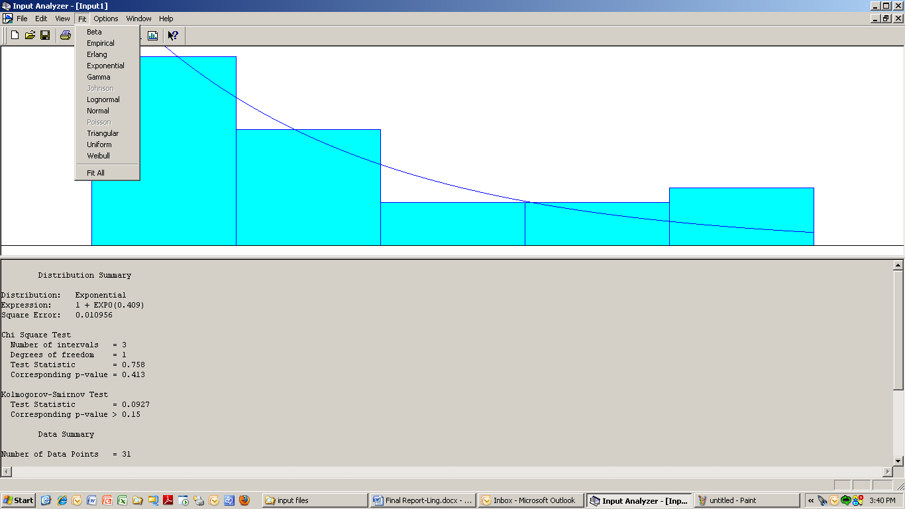

Figure 8 Input Analyzer Result Window (Part 1)

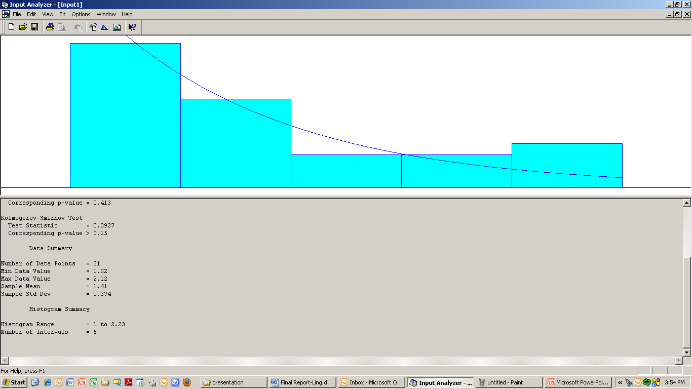

Figure 9 Input Analyzer Result Window (Part 2)

### 6.1.3 LABOR ANALYSIS

Labor comes in the form of a markup for the *Post*. The markup breaks labor down by the four work centers:

* Materials Handling
* Daily Insert
* Sunday Packaging
* Run of Press

For the purposes of this model, Team PWP did not look at the Run of Press component. For the remaining three components, Team PWP developed aggregate groups of the helpers specified in the markup.

Sunday Packaging Collator 1-4 helpers were broken down into a group of Collator-Deep Reach helpers and individual Collator-Fork Trucks helpers for each respective Collator machine (e.g. Collator 1 Fork Truck, Collator 2 Fork Truck).

Daily Insert SLS 1-6 helpers were grouped into two sets: SLS 1-4 and SLS 5-6. The SLS 1-4 helpers worked on the upstairs machines and the SLS 5-6 helpers worked on the downstairs machines.

Setup helpers were grouped together and worked to deliver pallets to the SLS 1-4 machines. Deep Reach helpers were grouped and worked with the transfer of pallets to and from the rack. Loader/Unloader helpers worked primarily with the docks, moving items to and from trucks. Lastly, Z-Loader helpers worked mainly with the Z-Loader machines.

Due to the fact that Loaders/Unloaders and Deep Reach helpers are responsible for tasks not represented in the model (i.e. Truck –> Receiving Dock –> Rack operations), the client reduced the number of these types of helpers from the markup over the course of the week, which assumed that the two components of the mailroom operated independently.

Each helper is assigned specific routes within the system that they work with. In addition to route assignments, each helper type had a specific velocity associated with it, which is discussed in the next section.

For a complete modified markup (i.e. base and suggested) and all the helper route assignments, please see the Appendix.

### 6.1.4 ROUTE ANALYSIS

#### 6.1.4.1 Route Time Statistics Analysis

One group of input parameters of the model was the route duration time for each unique route. In other words, it is the travel time of a pallet between the pickup location and the drop-off location defined on a route. The route time data could be obtained from the Pallet Summary Report extracted from MTC by calculating the differences between the pickup time and the drop-off time for each route. However, according to the *Post*, the majority of the pickup times and drop-off times recorded in MTC were inaccurate, since a pallet was often scanned as pickup and drop-off at the same location, the MTC production often did not capture the accurate route time.

The *Post* recommended that Team PWP use estimated data distributions on each route and they provided them in the form of the estimated minimum, mean, and maximum route duration time value for each route. These times were estimated to fit a triangular distribution, typically used on activity times in modeling applications.

We also decided to perform a data analysis on MTC production data using the Arena Input Analyzer to determine how close the MTC production data distributions were to the estimated data distributions. Team PWP would like to obtain conclusive results after comparing the estimated data distributions with the production data distributions.

To validate the clients provided distributions, Team PWP converted the Pallet Summary Report into a simpler format with only the needed information for route time. A portion of the modified data report is displayed below.

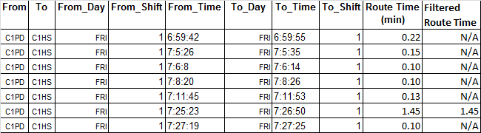

Table 1 Revised Pallet Summary Report Data

The route time column displays the results obtained by subtracting time in To\_Time from the time in From\_Time. The Filtered Route Time column displays “N/A” when the route time data was invalid, meaning the data was out of the estimated client range.

For each unique route, Team PWP collected the valid route time data and put them into Arena’s Input Analyzer. After running Arena’s Input Analyzer on the data set collected for each route, the distribution results were recorded side by side with the estimated data for comparison purpose as shown in the table below.

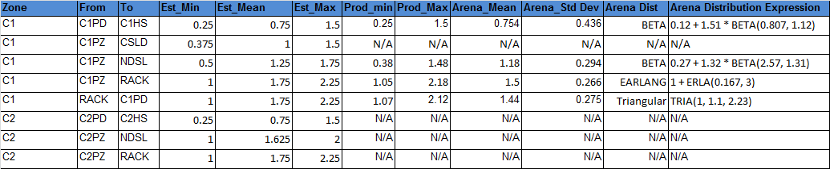

Table 2 Arena Input Analyzer Results Compared with Estimated Data

The first three columns define the unique routes from one location to another location. The following three columns define the estimated data by the sponsor. The next two columns represent the minimum and maximum value among the valid production data. The last four columns display the output results of Arena’s Input Analyzer.

For more than half of the routes, there was no valid production data and these were marked with “N/A” in the corresponding cells. For routes with valid production data, the minimum, maximum and mean values calculated by Arena’s Input Analyzer were close to the client estimated values. The best fit distributions were inconsistent between routes, but were dominated mainly by Triangular, Beta, Erlang, and Weibull distributions. When fitting triangular distributions to all of the routes data sets, the curve seemed to visually fit the data and the mean square error value indicated the triangular distribution was a reasonable fit.

Based on the results of Arena’s Input Analyzer, Team PWP decided to use the validated estimated data distributions for route times as recommended by the sponsor.

For a complete list of route times provided by the client, please see the Appendix. They were provided in the form of minimum, maximum, and mean to supply the parameters of the triangular distribution.

#### 6.1.4.3 Route Velocity and Distance Analysis

In addition to the travel time between the routes, the client also provided route distances for each route. The routes included all possible paths which helpers could take, not just those that pallets were moved over. The reason for this was because each helper might be called from one location to another to perform a task and the distance between the two locations must be known, even though a pallet would never be moved across that path.

Using the distances and the times, velocities of helpers over the routes were able to be calculated. For the Arena model, velocities by helper were needed. These were calculated by taking the average for each helper over all the backed-out route velocities for the routes of each helper.

Please see the Appendix for a complete list of all pallet routes and respective travel times, distances, and velocities by route and helper. Please note that the full list of all route distances is not present because of its magnitude, although it can be found in the Arena model.

### 6.1.5 ARRIVAL ANALYSIS

There are four groups of input parameters on arrival processes, they are:

* Pallet processing arrivals for each SLS and Collator machine
* Rack arrival time to Sunday Package/Daily Insert departments
* ROP arrival time of empty heads sheets to NDSL/CSLD
* Rack arrival times of collated Sunday packaging to NDSL/CSLD

According to the *Post*, the data recorded in MTC to calculate input data distribution on arrival processes was accurate and valid, unlike the data recorded for route duration time. The *Post* provided Team PWP with MTC production data relevant to arrival processes recorded in the past three months. For each group of the input parameters on arrival processes, Team PWP analyzed the data from the same sample week, which represented an average work week.

#### 6.1.5.1 PALLET PROCESSING ARRIVAL STATISTICS

Pallet processing arrivals is the time taken to process one pallet at a collator or a SLS machine. There are four collators and six SLS machines total, each of which processes one pallet at a time.

The MTC production data included a list of pallet processing timestamps for ten machines. The timestamps indicated the time of pallet creation after being processed at the machine. The table below is an example of the production data provided by *Post* (Note: C1PZ indicates Collator 1):

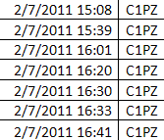

Table 3 Production Data Provided by *Washington Post*

Team PWP collected the data from the chosen week and added columns with information on day, shift and duration time. Duration time was calculated by subtracting the next pallet processing timestamp from the current timestamp. The modified data table is shown below:

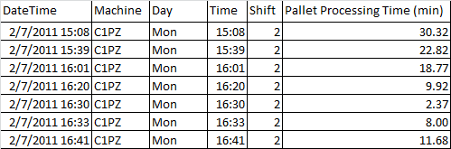

Table 4 Modified Production Data

Team PWP then created input text files using the data of pallet processing time per shift/day, broken out by machines. Some of the processing times for pallets processed close to the transition of two shifts were unrealistically larger than the other processing times during a shift, mainly caused by the machine idle period between shifts. Those unrealistic data points were discarded from the input text files because they did not capture the reasonable amount of pallet processing time. After running Arena’s Input Analyzer on those data files, the results such as mean and distribution per shift/day were recorded for each machine in a table. Below is the table for Collator 1:

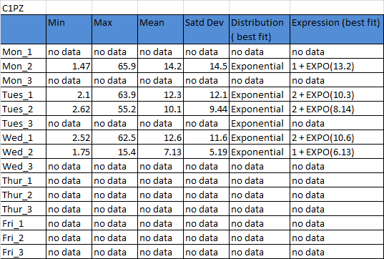

Table 5 Pallet Processing Arrival Statistics Obtained through Arena’s Input Analyzer

More than half of the best fit distributions on pallet processing times turned out to be exponential as expected, since exponential is the typical distribution used on inter-arrival times in modeling applications. The rest of the best fit distributions were Beta, Weibull, or Lognormal. However, fitting exponential distribution to the sets of data whose best fit distributions were non-exponential still yielded relatively small mean square error value. Therefore, the exponential distribution was considered a close enough fit. Team PWP decided to fit all pallet processing times with exponential distributions.

The pallet processing times followed the exponential distribution; therefore, the number of pallet arrivals in a given shift/day followed the Poisson distribution, as predicted by Team PWP. Poisson distribution expresses the probability of a number of events occurring in a fixed period of time if these events occur with a known average rate and [independently](http://en.wikipedia.org/wiki/Statistical_independence) of the time since the last event.

An alternative way to calculate the average arrival rate, other than using the mean processing time produced by the Arena’s Input Analyzer, was to use the number of arrivals that occurred during each shift/day. Because the input data, Arena’s Input Analyzer did not capture the large amount of idle time during shifts transitions. Team PWP decided the latter option was more accurate in turns of capturing the average arrival rate. However, a future enhancement could be to model the idle time between each shift separately from the peak time, which would increase the complexity of the model. Considering the model was intended to serve as a baseline model for the *Post,* Team PWP modeled each arrival process per shift/day as one piece.

#### 6.1.5.2 RACK ARRIVAL PROCESSES TO SUNDAY PACKAGE AND DAILY INSERT STATISTICS

Rack arrival processes was the arrival processes of raw ads from the rack to the Sunday Packaging Department or the Daily Insert Department. The *Post* requested that Team PWP divide the rack arrival processes into two groups: arrival times to Sunday Packaging and arrival times to Daily Insert. Within Daily Insert, the rack arrival processes were requested to be broken further into two groups by machine, SLS 1-4 as one group and SLS 5-6 as another group. Within Sunday Packaging, the rack arrival times were requested to be broken down further into four groups by machine: Collator 1, Collator 2, Collator 3, and Collator 4.

The MTC production data included a list of pallet arrival timestamps broken into ten machines. The timestamps indicated the arrival times of demand signals at the rack that were to be taken to the corresponding machine.

Team PWP collected the data from the chosen week and added columns with information on day, shift, and arrival duration time. Arrival duration time was calculated by subtracting the next pallet arrival timestamp from the current timestamp. Four tables were created for each of the Collators at Sunday Packaging. Two tables were created for Daily Insert, one for machines SLS 1-4, the other one for machines SLS 5-6. However, there appeared to be an insufficient amount of data from week February 7th to February 12th for Daily Insert so Team PWP chose a different week of data instead, January 17th to January 21st, for all Daily Insert arrivals.

Following the same procedures as route times, Team PWP created input data files, ran the Arena’s Input Analyzer and recorded the distribution statistics broken out by machines by shift/day in a table similar to the ones created for route times. It turned out the pallet arrival times from the rack to Sunday Packaging and Daily Insert followed an exponential distribution, which meant that the corresponding pallet arrival rate in a given shift/day followed the Poisson distribution. The number of pallet arrival occurrences was calculated per shift/day for each machine.

#### 6.1.5.3 ROP ARRIVAL PROCESS STATISTICS

ROP arrival time was the empty head sheets arrival process at the upper mailroom ready to be moved by SLS 1-4 helpers and Z-Loaders to the docks.

The MTC production data included a list of ROP pallet arrival timestamps. The timestamps indicated the times of demand signals of each ROP pallet ready to be picked up to be moved to the docks.

Team PWP collected the data from the week of January 31st to February 6th instead, because there weren’t enough data during the week of February 7th to February 12th to produce any valid distribution in Arena’s Input Analyzer.

Using the same data recording and analysis method as described for route times, Team PWP concluded that the ROP pallet arrival processes followed the exponential distribution. Thus, the number of ROP pallets arrivals in a given day-shift followed a Poisson distribution. The number of ROP pallet arrival occurrences was calculated per shift/day and was used to calculate the ROP pallet arrival rate. Unfortunately, due to such a limited number of arrivals in the weeks investigated, the GMU did not include these results in the model. There is however, a place in the model for the client to enter future parameters of this kind.

#### 6.1.5.4 RACK TO DOCK ARRIVAL PROCESSES STATISTICS

Rack to dock arrival times was the Sunday Packaging pallet arrival processes from the rack to one of the two docks. The rack to dock arrival times were divided into two groups: arrival processes to the North Dock Shipping Lanes and arrival processes to the Concourse Shipping Dock.

The MTC production data provided by the *Post* included a list of pallet arrival timestamps and the docks the pallets were moved to. The timestamps indicated the times of demand signals of each pallet ready to be picked up from the rack to be moved to the docks.

After running Arena’s Input Analyzer on the data, exponential turned out to be the best fit distribution for rack to dock arrival times. Rock to dock arrival rates was calculated using the number of arrival occurrences per shift/day.

#### 6.1.5.5 POISSON ARRIVAL PROCESSES

Using the exponential inter-arrival times, a Poisson arrival process was applied to each arrival in the Arena model. The required parameter for Arena was an hourly rate. To calculate this rate, Team PWP looked at a count of each arrival process by shift/day. The count is represented in the table below.

*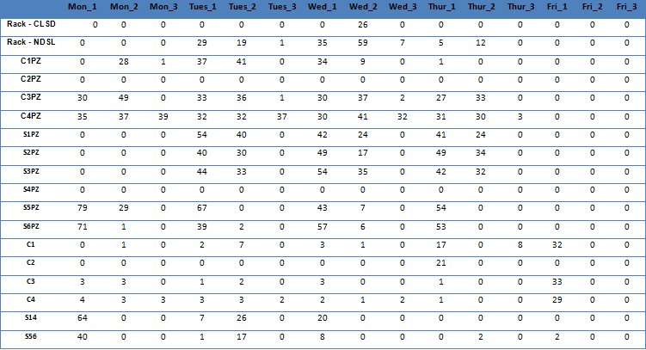*

Table 6 Count of Arrivals by Location by Shift/Day

Using these count statistics, Team PWP was able to determine the hourly rate of the seven hour shift by dividing the count by six hours. Six was chosen as opposed to seven because a lack of arrivals was detected during the last hour of each shift, indicating that the helpers were finishing up during this time. Therefore, the last hour of each shift had a zero rate and the full count of the shift was distributed over the first six hours of the shift.

For a complete list of the hourly rates by location by shift/day, please see the Appendix. Also please note that the numbers in the model are slightly different to account for some outliers in the data (e.g. the occurrence of a few pallets at the very end of a shift where no helper was assigned in the markup to move them were added to the next shift).

## 6.2 OUTPUT ANALYSIS

Team PWP analyzed an average working week from Monday to Friday. There are 11 helper types for each shift and there are 3 shifts in one day which means that there are 3\*5=15 shifts per week that were investigated. The primary goal of the output analysis was to validate the model, which it did. The total throughput numbers through the model matched what Team PWP had seen in the historical data. The remainder of this section details a potential process to be used in informing decisions for the *Post,* and discussed the results of that process on the current input data.

### 6.2.1 MARKUP ANALYSIS

After analyzing existing markup schedules for the average working week at *the Post,* Team PWP noticed that some helper zones have low utilization and some of these had 3 or 4 helpers assigned. Team PWP decided to use the model to try to make improvements to the markup as Team PWP believed that there is room for improvement. Team PWP made a suggested markup schedule and compared it to the base schedule.

First Team PWP looked at the number of assigned helpers per helper zone by shift/day in the base markup schedule as shown in the table below.

Table 7 Markup for Base Model

Team PWP checked the percent of utilization for the base markup for corresponding shift/days for each helper as shown in the table below.



Table 8 Utilization for Base Model

After analyzing these two tables as shown above, Team PWP made a suggested markup by reducing a workforce in places where Team PWP saw low utilization and high number of workers assigned, as shown in the table below. This was done by multiplying the number of helpers by their utilization and rounding up.



Table 9 Markup for Suggested Model

Graphical representations of the two schedules can be seen below.

Figure 10 Number of Helpers per Shift for Base Schedule

Figure 11 Number of Helpers per Shift for Suggested Schedule

From the two figures above, Team PWP saw that the workforce in the suggested schedule was reduced and through further analysis determined that it did not affect production.

The figure below represents the maximum possible savings of labor that could be achieved per work center in one work week.

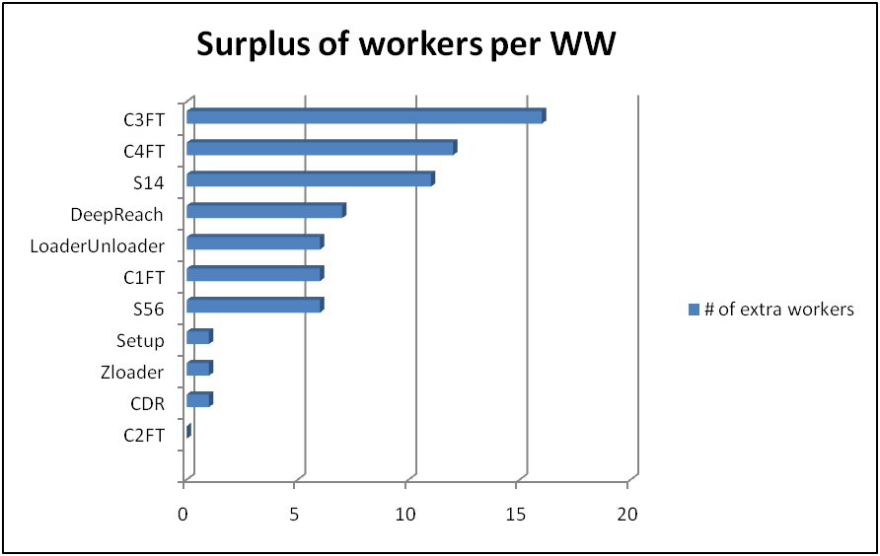

Figure 12 Number of Helpers per Helper Zone in One WW that could be Reduces Based on Suggested Markup

### 6.2.2 UTILIZATION ANALYSIS

Utilization for a Base model is shown in Table 8 (above). After making the suggested markup schedule, Team PWP ran the Arena model five times with that suggested markup data and took an average of the output data. Utilization of the suggested markup and base markup is shown below.

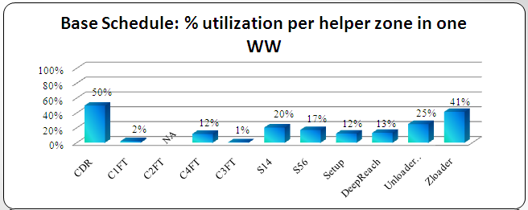

Figure 13 Utilization for Base Model

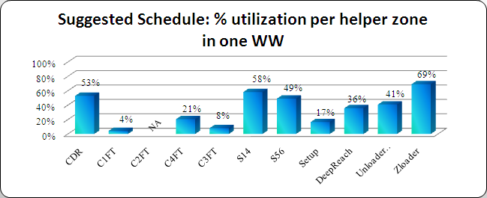

Figure 14 Utilization for Suggested Model

From the two figures above, Team PWP determined that utilization was better following the changed markup. Most improvements happened in the areas which had highest inefficiency (lowest utilization) and those areas were S14, C4FT, S56, and Deep Reach.

### 6.2.3 HELPER MOVES ANALYSIS

Team PWP wanted to analyze helper moves to make sure that number of helper moves stayed the same with the suggested model so they compared data and made two tables.

Moves per shift and helper zone for a base model:



Table 10 Moves per Shift and Helper Zone for Base Model

Moves per shift and helper zone for the suggested model:



Table 11 Moves per Shift and Helper Zone for Suggested Model

From the two tables above, Team PWP first calculated average number of moves per helper per hour (divided by zones) for a base markup and suggested markup and made a graphical representation of that data as shown below.

Figure 15 Average Number of Moves per Helper per Hour for Suggested Model

Figure 16 Average Number of Moves per Helper per Hour for Suggested Model

After comparing between the two figures above, Team PWP noticed that the average number of moves per helper per hour improved for the suggested model which lead them to conclude that actual were pallets moved where they were supposed to go in the expected timeframe.

Team PWP also wanted to check what was really happening by comparing the number of total moves per helper per work week. Based on Table 10 and Table 11, they calculated the total number of moves per helper zone for the base model as shown below.

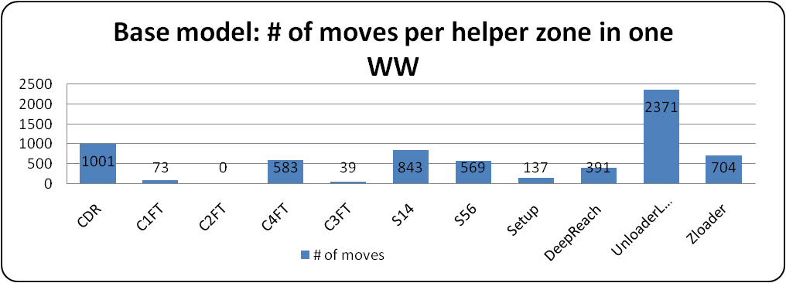

Figure 17 Total Number of Moves per Helper-Zone per WW for a Base Model

Figure 18 Total Number of Moves per Helper-Zone per WW for Suggested Model

Team PWP concluded that for both schedules 100% of the pallets were moved to where they needed to go during the expected timeframe. Therefore, Team PWP was confident that the suggested model required less labor and, therefore, saved labor cost for the *Post*.

Team PWP confirmed their output results by conducting sensitivity analysis on the input parameters to determine if there was an impact on the output results. They modified the arrival rates to occur over a seven hour period as opposed to a six and adjusted the helper velocity time down to half as fast. They also eliminated one of the three Z-Loaders from use. Team PWP ran the model five times for each scenario to ensure more statistically significant results. The modifications had negligible impact on production target results, which showed that there was a lot of flexibility within the model (i.e. the labor force was too large).

Output and sensitivity analysis could be expanded further. The above process was intended to be used as a template for conducting analysis with the model in the future. Output analysis other than validation of the model’s accuracy was not Team PWP’s primary focus. The main goal of Team PWP was to provide the *Post* with a usable Arena model as a decision making tool.

# 7 RECOMMENDATION

Team PWP recommended that helper moves, idle time and total work could be monitored by using an Arena model that provides schedule flexibility and incorporation of new ideas on process flow. The following recommendations are provided:

* + *Consider cutting labor according to the new optimal markup where drastic differences were seen*. Based on the statistical analysis of output data, Team PWP noticed that a Base markup could be improved and suggestion would be to focus first on areas that have the least utilization and high number of helpers assigned at the same time. That would be a good start and by using Arena model simulation, the performance of a system based on suggested schedule could be estimated before the change gets implemented in reality.
* *Utilize model’s output analysis to assist with future markup decisions.* Arena model gives enough output information for decision making. Any change in schedule would produce different output data. The output data would be reviewed and verified whether the planned change satisfy production goals.
* *Develop more stringent data tracking mechanisms for improved data input.* Not all data gathered from *the Post* represented the real system behavior. The cause of the bad data was on the helper side. For most of the time, helpers did not follow the standard procedure to enter dat. For example, helpers scanned pallets more than one time at the destination, instead of scanning the pallet one time at the departure location and scanned it again at the destination location. Improving the quality of data collection is important for the simulation model to produce output data closer to reality, leading to more accurate management decisions of new markups.

# 8 FUTURE WORK

## 8.1 GRAPHICAL USER INTERFACE OF A MODEL

The *Post* believes a Graphical User Interface would help with the changing of input parameters to facilitate analysis efforts and help make decisions more quickly. Future efforts could focus on building an Excel-based template that communicates with Arena’s input functionality using VBA. This would be especially helpful for changing arrival process distribution parameters and the markup schedule. This interface would allow the direct use of the model and eliminate the need for either in-depth Arena experience or a theoretical understanding of simulations. It would help provide an easier way to enter input data and read output data.

## 8.2 ANIMATION OF A PROCESS

A third piece that could be added to this model is animation of a process. Since Arena has capability of creating animation of process that is being modeled, it would be nice to have animation that would visually present suggested solutions and help managers of *the Post* to comprehend the results faster and easier. That could trigger new ideas in making process organization and decisions. This would help assist the user with a visual representation of what is occurring within the system. It would enable users to see how the statistics they see reported matched with what they saw visually during the model run.

## 8.3 USE ARENA OPTIMIZATION AND MORE COMPLEX MODULES

An optimization within the simulation to determine optimal schedule allocations of helpers to meet production targets could be implemented. Coupled with this complex addition would be a continuing effort to flesh out the assumptions of the existing Arena model and explore ways of eliminating them by making model general improvements such as seamless transitions of raw ad materials to finished pallets instead of breaking the process into two distinct flows. This effort would take advantage of the diverse functionality of Arena.

# 9 REFERENCES

1. Kelton, D., & Sadowski, R., & Sturrock D. (2007). Simulation With Arena (Fourth Edition). New York: McGraw-Hill.
2. Blaho, J. & Gomolka, K. & Graziano, R. & Lopez, L. (2010). I’m Pro WashPost. Fairfax, Virginia: George Mason University.

# Appendix

# Appendix List of Tables

[Table C-1 1 Base Schedule by Helper by Day/Shift 49](#_Toc292062704)

[Table C-1 2 Suggested Schedule by Helper by Day/Shift 50](#_Toc292062705)

[Table C-2 1 Zoning of Helpers to Routes/Travel Time Prameters for One Way/Total Distances between Routes/Calculated Velocities per Route 52](#_Toc292062711)

[Table C-2 2 Average Velocities for Each Helper Based on Route Statistics 52](#_Toc292062712)

[Table C-2 3 Average Time for Z-Loader Processing 53](#_Toc292062713)

[Table C-3 1 Count of Arrivals by Location by Day/Shift 53](#_Toc292062718)

[Table C-3 2 Arrival Rate by Hour of Pallets by Location by Day/Shift 54](#_Toc292062719)

[Table C-3 3 Arena Input Analyzer Distributions of Arrival Time for Collator 1 55](#_Toc292062720)

[Table C-3 4 Arena Input Analyzer Distributions of Arrival Time for Collator 2 55](#_Toc292062721)

[Table C-3 5 Arena Input Analyzer Distributions of Arrival Time for Collator 3 56](#_Toc292062722)

[Table C-3 6 Arena Input Analyzer Distributions of Arrival Time for Collator 4 56](#_Toc292062723)

[Table C-3 7 Arena Input Analyzer Distributions of Arrival Time for SLS 1 57](#_Toc292062724)

[Table C-3 8 Arena Input Analyzer Distributions for SLS 2 57](#_Toc292062725)

[Table C-3 9 Arena Input Analyzer Distributions of Arrival Time for SLS 3 58](#_Toc292062726)

[Table C-3 10 Arena Input Analyzer Distributions of Arrival Time for SLS 4 58](#_Toc292062727)

[Table C-3 11 Arena Input Analyzer Distributions of Arrival Time for SLS 5 59](#_Toc292062728)

[Table C-3 12 Arena Input Analyzer Distributions of Arrival Time for SLS 6 59](#_Toc292062729)

[Table C-3 13 Arena Input Analyzer Results on Route Time 61](#_Toc292062730)

[Table C-3 14 Pallet Arrival Counts per Machine by Day/Shift 61](#_Toc292062731)

[Table C-3 15 Arena Input Analyzer Distributions of Rack Arrival Time of Raw Materials to Sunday Package 62](#_Toc292062732)

[Table C-3 16 Arena Input Analyzer Distributions of Rack Arrival Time of Raw Materials to Daily Insert 63](#_Toc292062733)

[Table C-3 17 Rack Arrival Counts of Raw Materials to Sunday Package 64](#_Toc292062734)

[Table C-3 18 Rack Arrival Counts of Raw Materials to Daily Insert 65](#_Toc292062735)

[Table C-3 19 Arena Input Analyzer Distributions of ROP Arrival Time of Empty Head Sheets to NDSL/CSLD 66](#_Toc292062736)

[Table C-3 20 ROP Arrival Counts of Empty Head Sheets to NDSL/CSLD 66](#_Toc292062737)

[Table C-3 21 Arena Input Analyzer Distributions of Rack Arrival Time of Collated Sunday Packaging to CSLD 67](#_Toc292062738)

[Table C-3 22 Arena Input Analyzer Distributions of Rack Arrival Time of Collated Sunday Packaging to NDSL 67](#_Toc292062739)

[Table C-3 23 Rack Arrival Count of Collated Sunday Packaging to CLSD/NDSL 68](#_Toc292062740)

[Table C-4 1 Utilization for Base Model 68](#_Toc292062741)

[Table C-4 2 Utilization for Suggested Model 68](#_Toc292062742)

[Table C-5 1 Moves per Shift and Helper Zone for Base Model 69](#_Toc292062743)

[Table C-5 2 Moves per Shift and Helper Zone for Suggested Model 69](#_Toc292062744)

# Appendix List of Figures

[Figure A 1 Structure and Task Durations 45](#_Toc292062745)

[Figure B 1 Earned Value Management 48](#_Toc292062746)

[Figure D-1 1 SLS 1-4 and Collator 1-4 Rack Arrivals of Raw Ads 70](#_Toc292062753)

[Figure D-1 2 Daily Insert and Sunday Packaging Finished Pallets at the Loading Docks 70](#_Toc292062754)

[Figure D-1 3 Sunday Packaging Raw Ads are Terminated at the Collator Machines for Processing 71](#_Toc292062755)

[Figure D-1 4 Finished Sunday Packaging pallets Arrival at the Collator Machines for Transportation to the Docks 71](#_Toc292062756)

[Figure D-1 5 Termination of Finished Sunday Packaging at the Rack and Arrivals at the Rack of Finished Daily Packaging to be Taken to the Docks 72](#_Toc292062757)

[Figure D-1 6 Termination of Daily Insert Raw Ads at SLS 1-4 Machines 72](#_Toc292062758)

[Figure D-1 7 Arrival of Finished Daily Insert Pallets at SLS 1-4 for Transportation to the Docks 73](#_Toc292062759)

[Figure D-1 8 Termination of Daily Insert Raw Ads at SLS 5-6 73](#_Toc292062760)

[Figure D-1 9 Arrival of Finished Daily Insert Pallets at SLS 5-6 for Transportation to the Docks 74](#_Toc292062761)

[Figure D-1 10 The Schedule Module that Determines the Number of Available Helpers of Each Type are by Shift/Day 74](#_Toc292062762)

[Figure D-1 11 Helper Idle Time Statistics Module 75](#_Toc292062763)

# APPENDIX A: TASK BREAKDOWN STRUCTURE

The project was segregated into the following structure elements:

* Project Management
* Model Design
* Model Development
* Data Analysis
* Customer Interaction

The figure below describes the structure and task durations:

**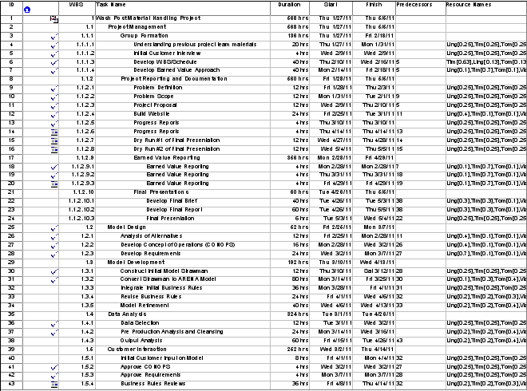**

Figure A 1 Structure and Task Durations

The Project Management section included all of the basic functions required to establish the project team and track progress. Team PWP included building the schedule, developing the resource plan, reporting progress and writing the final output analysis in this section.

The Model Design section described the requirements documentation for the project. The *Post* was inclined toward a simulation model using Arena software since they had experience with that approach and the tool. Given this preference, Team PWP basically confirmed this approach after considering other operations research techniques and tools.

Model Development included the building the strawman model. The strawman model was essentially an illustration of how Team PWP expected a model to eventually look in Arena. Team PWP used the strawman to build the each discrete section of the model before moving into Arena. Business rule incorporation was also described in this section.

The Data Analysis section tracked the initial data cleansing efforts. The *Post* provided data for 103 routes to be used in the model. Several of these routes had only a few moves for the entire week, including a few routes that were physically impossible due to the locations of the pickup and drop off points.

A separate section was included for Customer Interaction. This section tracked various customer reviews and business rule adjustments.

# APPENDIX B: EARNED VALUE MANAGEMENT

Team PWP members designated a leader for the tasks, but shared the workload of each one. This provided an opportunity for all members to understand the tasks in which others had a leading role.

The original estimate to complete the project was 646 hours beginning on January 27, 2011 and ending on May 6, 2011. The breakdown by task was:

Task Structure Hours Required

Project Management 254

Model Design 52

Model Development 192

Data Analysis 96

Customer Interaction 52

Total 646

Team PWP completed the project in just over 612 hours. This was under the estimated cost and an on-time project completion. In terms of Earned Value, Team PWP obtained a Cost Efficiency of 1.02 and a Schedule Efficiency of 1.00.

Figure B 1 Earned Value Management

# APPENDIX C: MODEL ANALYSIS

## Appendix C-1: Input/Output Analysis-Labor Analysis

Table C-1 1 Base Schedule by Helper by Day/Shift



Table C-1 2 Suggested Schedule by Helper by Day/Shift

## Appendix C-2: Input Analysis-Route Analysis

|  |  |  |  |  |  |  |  |  |  |
| --- | --- | --- | --- | --- | --- | --- | --- | --- | --- |
| Zone | Start | Finish | Min | Mean | Max | Distance | MaxVel  (ft/sec) | MeanVel  (ft/sec) | MinVel  (ft/sec) |
| C1-FT | C1PD | C1HS | 0.25 | 0.75 | 1.50 | 135.00 | 9.00 | 3.00 | 1.50 |
| C2-FT | C2PD | C2HS | 0.25 | 0.75 | 1.50 | 144.00 | 9.60 | 3.20 | 1.60 |
| C3-FT | C3PD | C3HS | 0.25 | 0.75 | 1.50 | 56.00 | 3.73 | 1.24 | 0.62 |
| C4-FT | C4PZ | MR1PD | 1.00 | 1.50 | 2.00 | 384.00 | 6.40 | 4.27 | 3.20 |
| C4-FT | MR1PD | C4HS | 1.00 | 1.50 | 2.00 | 435.00 | 7.25 | 4.83 | 3.63 |
| CDR | C1PZ | NDSL | 0.50 | 1.25 | 1.75 | 315.00 | 10.50 | 4.20 | 3.00 |
| CDR | C1PZ | RACK | 1.00 | 1.75 | 2.25 | 240.00 | 4.00 | 2.29 | 1.78 |
| CDR | RACK | C1PD | 1.00 | 1.75 | 2.25 | 345.00 | 5.75 | 3.29 | 2.56 |
| CDR | C2PZ | NDSL | 1.00 | 1.63 | 2.00 | 459.00 | 7.65 | 4.71 | 3.83 |
| CDR | C2PZ | RACK | 1.00 | 1.75 | 2.25 | 318.00 | 5.30 | 3.03 | 2.36 |
| CDR | RACK | C2PD | 1.00 | 1.75 | 2.25 | 450.00 | 7.50 | 4.29 | 3.33 |
| CDR | C3PZ | NDSL | 0.75 | 1.50 | 1.75 | 375.00 | 8.33 | 4.17 | 3.57 |
| CDR | C3PZ | RACK | 1.00 | 1.75 | 2.25 | 291.00 | 4.85 | 2.77 | 2.16 |
| CDR | RACK | C3PD | 1.00 | 1.50 | 2.25 | 405.00 | 6.75 | 4.50 | 3.00 |
| CDR | MR1PD | NDSL | 0.75 | 1.50 | 2.00 | 489.00 | 10.87 | 5.43 | 4.08 |
| CDR | MR1PD | RACK | 1.00 | 1.75 | 2.25 | 402.00 | 6.70 | 3.83 | 2.98 |
| CDR | RACK | MR1PD | 1.00 | 1.75 | 2.25 | 402.00 | 6.70 | 3.83 | 2.98 |
| Deep Reach | RACK | CSLD | 1.25 | 2.25 | 2.75 | 492.00 | 6.56 | 3.64 | 2.98 |
| Deep Reach | RACK | MR1DAILY | 1.00 | 1.75 | 2.25 | 402.00 | 6.70 | 3.83 | 2.98 |
| Deep Reach | RACK | NDSL | 1.00 | 1.50 | 2.25 | 264.00 | 4.40 | 2.93 | 1.96 |
| Deep Reach | RACK | ZL2 | 0.75 | 1.25 | 1.75 | 258.00 | 5.73 | 3.44 | 2.46 |
| Deep Reach | RACK | ZL3 | 0.75 | 1.25 | 1.75 | 258.00 | 5.73 | 3.44 | 2.46 |
| Loader/Unloader | CSLD | TRUCK | 0.38 | 0.63 | 0.88 | 81.00 | 3.60 | 2.16 | 1.54 |
| Loader/Unloader | MR1DAILY | CSLD | 0.25 | 0.38 | 0.50 | 90.00 | 6.00 | 4.00 | 3.00 |
| Loader/Unloader | MR1DAILY | NDSL | 0.75 | 1.25 | 1.50 | 489.00 | 10.87 | 6.52 | 5.43 |
| Loader/Unloader | NDSL | TRUCK | 0.38 | 0.63 | 0.88 | 81.00 | 3.60 | 2.16 | 1.54 |
| S14 | S1PZ | ZL1 | 0.50 | 0.75 | 1.00 | 114.00 | 3.80 | 2.53 | 1.90 |
| S14 | S1PZ | ZL2 | 1.25 | 1.75 | 2.25 | 303.00 | 4.04 | 2.89 | 2.24 |
| S14 | S1PZ | ZL3 | 1.25 | 1.75 | 2.25 | 303.00 | 4.04 | 2.89 | 2.24 |
| S14 | S2PZ | ZL1 | 0.75 | 1.00 | 1.25 | 177.00 | 3.93 | 2.95 | 2.36 |
| S14 | S2PZ | ZL2 | 1.00 | 1.50 | 1.75 | 258.00 | 4.30 | 2.87 | 2.46 |
| S14 | S2PZ | ZL3 | 1.00 | 1.50 | 1.75 | 258.00 | 4.30 | 2.87 | 2.46 |
| S14 | S3PZ | ZL1 | 1.00 | 1.25 | 1.75 | 291.00 | 4.85 | 3.88 | 2.77 |
| S14 | S3PZ | ZL2 | 0.75 | 1.00 | 1.50 | 114.00 | 2.53 | 1.90 | 1.27 |
| S14 | S3PZ | ZL3 | 0.75 | 1.00 | 1.50 | 114.00 | 2.53 | 1.90 | 1.27 |
| S14 | S4PZ | ZL1 | 1.25 | 1.75 | 2.50 | 354.00 | 4.72 | 3.37 | 2.36 |
| S14 | S4PZ | ZL2 | 0.50 | 0.75 | 1.00 | 30.00 | 1.00 | 0.67 | 0.50 |
| S14 | S4PZ | ZL3 | 0.50 | 0.75 | 1.00 | 30.00 | 1.00 | 0.67 | 0.50 |
| S5&6 | MR1DAILY | S5HS | 0.75 | 1.25 | 1.50 | 408.00 | 9.07 | 5.44 | 4.53 |
| S5&6 | MR1DAILY | S6HS | 0.75 | 1.25 | 1.50 | 456.00 | 10.13 | 6.08 | 5.07 |
| S5&6 | S5PZ | CSLD | 1.00 | 1.25 | 1.75 | 522.00 | 8.70 | 6.96 | 4.97 |
| S5&6 | S5PZ | MR1DAILY | 0.75 | 1.25 | 1.50 | 432.00 | 9.60 | 5.76 | 4.80 |
| S5&6 | S5PZ | NDSL | 1.50 | 2.25 | 3.00 | 921.00 | 10.23 | 6.82 | 5.12 |
| S5&6 | S6PZ | CSLD | 1.00 | 1.25 | 1.75 | 172.00 | 2.87 | 2.29 | 1.64 |
| S5&6 | S6PZ | MR1DAILY | 0.75 | 1.25 | 1.50 | 142.00 | 3.16 | 1.89 | 1.58 |
| S5&6 | S6PZ | NDSL | 1.50 | 2.25 | 3.00 | 305.00 | 3.39 | 2.26 | 1.69 |
| Setup | ZL2 | MR2DAILY | 0.50 | 0.75 | 1.50 | 165.00 | 5.50 | 3.67 | 1.83 |
| Setup | ZL3 | MR2DAILY | 0.50 | 0.75 | 1.50 | 165.00 | 5.50 | 3.67 | 1.83 |
| Z-Loader | ZL1 | CSLD | 0.75 | 1.00 | 1.50 | 165.00 | 3.67 | 2.75 | 1.83 |
| Z-Loader | ZL1 | NDSL | 1.25 | 2.00 | 2.50 | 744.00 | 9.92 | 6.20 | 4.96 |
| Z-Loader | ZL2 | CSLD | 0.75 | 1.00 | 1.50 | 303.00 | 6.73 | 5.05 | 3.37 |
| Z-Loader | ZL2 | NDSL | 1.00 | 1.50 | 2.00 | 348.00 | 5.80 | 3.87 | 2.90 |
| Z-Loader | ZL3 | CSLD | 0.75 | 1.00 | 1.50 | 303.00 | 6.73 | 5.05 | 3.37 |
| Z-Loader | ZL3 | NDSL | 1.00 | 1.50 | 2.00 | 348.00 | 5.80 | 3.87 | 2.90 |

Table C-2 1 Zoning of Helpers to Routes/Travel Time Parameters for One Way/Total Distances between Routes/Calculated Velocities per Route

|  |  |  |  |
| --- | --- | --- | --- |
|  | MaxVel  (ft/sec) | MeanVel  (ft/sec) | MinVel  (ft/sec) |
| C1-FT | 9.0 | 3.0 | 1.5 |
| CDR | 7.1 | 3.9 | 3.0 |
| C2-FT | 9.6 | 3.2 | 1.6 |
| C3-FT | 3.7 | 1.2 | 0.6 |
| C4-FT | 6.8 | 4.6 | 3.4 |
| Deep Reach | 5.8 | 3.5 | 2.6 |
| Loader/Unloader | 6.0 | 3.7 | 2.9 |
| S14 | 3.4 | 2.4 | 1.9 |
| S5&6 | 7.1 | 4.7 | 3.7 |
| Setup | 5.5 | 3.7 | 1.8 |
| Z-Loader | 6.4 | 4.5 | 3.2 |

Table C-2 2 Average Velocities for Each Helper Based on Route Statistics

|  |  |  |  |  |
| --- | --- | --- | --- | --- |
| Z-Loader Machine | Up  (sec) | Down  (sec) | Total  (sec) | Model  (sec) |
| Min | 30 | 30 | 60 | 45 |
| Mean | 45 | 45 | 90 | 67.5 |
| Max | 60 | 60 | 120 | 90 |

Table C-2 3 Average Time for Z-Loader Processing

## Appendix C-3: Input Analysis-Arrival Analysis

|  |  |  |  |  |  |  |  |  |  |  |  |  |  |  |  |
| --- | --- | --- | --- | --- | --- | --- | --- | --- | --- | --- | --- | --- | --- | --- | --- |
|  | Mon\_1 | Mon\_2 | Mon\_3 | Tues\_1 | Tues\_2 | Tues\_3 | Wed\_1 | Wed\_2 | Wed\_3 | Thur\_1 | Thur\_2 | Thur\_3 | Fri\_1 | Fri\_2 | Fri\_3 |
| Rack - CLSD | 0 | 0 | 0 | 0 | 0 | 0 | 0 | 26 | 0 | 0 | 0 | 0 | 0 | 0 | 0 |
| Rack - NDSL | 0 | 0 | 0 | 29 | 19 | 1 | 35 | 59 | 7 | 5 | 12 | 0 | 0 | 0 | 0 |
| C1PZ | 0 | 28 | 1 | 37 | 41 | 0 | 34 | 9 | 0 | 1 | 0 | 0 | 0 | 0 | 0 |
| C2PZ | 0 | 0 | 0 | 0 | 0 | 0 | 0 | 0 | 0 | 0 | 0 | 0 | 0 | 0 | 0 |
| C3PZ | 30 | 49 | 0 | 33 | 36 | 1 | 30 | 37 | 2 | 27 | 33 | 0 | 0 | 0 | 0 |
| C4PZ | 35 | 37 | 39 | 32 | 32 | 37 | 30 | 41 | 32 | 31 | 30 | 3 | 0 | 0 | 0 |
| S1PZ | 0 | 0 | 0 | 54 | 40 | 0 | 42 | 24 | 0 | 41 | 24 | 0 | 0 | 0 | 0 |
| S2PZ | 0 | 0 | 0 | 40 | 30 | 0 | 49 | 17 | 0 | 49 | 34 | 0 | 0 | 0 | 0 |
| S3PZ | 0 | 0 | 0 | 44 | 33 | 0 | 54 | 35 | 0 | 42 | 32 | 0 | 0 | 0 | 0 |
| S4PZ | 0 | 0 | 0 | 0 | 0 | 0 | 0 | 0 | 0 | 0 | 0 | 0 | 0 | 0 | 0 |
| S5PZ | 79 | 29 | 0 | 67 | 0 | 0 | 43 | 7 | 0 | 54 | 0 | 0 | 0 | 0 | 0 |
| S6PZ | 71 | 1 | 0 | 39 | 2 | 0 | 57 | 6 | 0 | 53 | 0 | 0 | 0 | 0 | 0 |
| C1 | 0 | 1 | 0 | 2 | 7 | 0 | 3 | 1 | 0 | 17 | 0 | 8 | 32 | 0 | 0 |
| C2 | 0 | 0 | 0 | 0 | 0 | 0 | 0 | 0 | 0 | 21 | 0 | 0 | 0 | 0 | 0 |
| C3 | 3 | 3 | 0 | 1 | 2 | 0 | 3 | 0 | 0 | 1 | 0 | 0 | 33 | 0 | 0 |
| C4 | 4 | 3 | 3 | 3 | 3 | 2 | 2 | 1 | 2 | 1 | 0 | 0 | 29 | 0 | 0 |
| S14 | 64 | 0 | 0 | 7 | 26 | 0 | 20 | 0 | 0 | 0 | 0 | 0 | 0 | 0 | 0 |
| S56 | 40 | 0 | 0 | 1 | 17 | 0 | 8 | 0 | 0 | 0 | 2 | 0 | 2 | 0 | 0 |

Table C-3 1 Count of Arrivals by Location by Day/Shift

|  |  |  |  |  |  |  |  |  |  |  |  |  |  |  |  |
| --- | --- | --- | --- | --- | --- | --- | --- | --- | --- | --- | --- | --- | --- | --- | --- |
|  | Mon\_1 | Mon\_2 | Mon\_3 | Tues\_1 | Tues\_2 | Tues\_3 | Wed\_1 | Wed\_2 | Wed\_3 | Thur\_1 | Thur\_2 | Thur\_3 | Fri\_1 | Fri\_2 | Fri\_3 |
| Rack - CLSD | 0 | 0 | 0 | 0 | 0 | 0 | 0 | 5 | 0 | 0 | 0 | 0 | 0 | 0 | 0 |
| Rack - NDSL | 0 | 0 | 0 | 5 | 4 | 0 | 6 | 9 | 1 | 1 | 2 | 0 | 0 | 0 | 0 |
| C1PZ | 5 | 5 | 0 | 6 | 7 | 0 | 6 | 1 | 0 | 0 | 0 | 0 | 0 | 0 | 0 |
| C2PZ | 0 | 0 | 0 | 0 | 0 | 0 | 0 | 0 | 0 | 0 | 0 | 0 | 0 | 0 | 0 |
| C3PZ | 5 | 8 | 0 | 6 | 6 | 0 | 5 | 6 | 0 | 5 | 6 | 0 | 0 | 0 | 0 |
| C4PZ | 6 | 6 | 7 | 6 | 6 | 6 | 5 | 7 | 6 | 5 | 5 | 0 | 0 | 0 | 0 |
| S1PZ | 0 | 0 | 0 | 9 | 7 | 0 | 7 | 4 | 0 | 7 | 4 | 0 | 0 | 0 | 0 |
| S2PZ | 0 | 0 | 0 | 7 | 5 | 0 | 8 | 2 | 0 | 8 | 6 | 0 | 0 | 0 | 0 |
| S3PZ | 0 | 0 | 0 | 7 | 6 | 0 | 9 | 6 | 0 | 7 | 6 | 0 | 0 | 0 | 0 |
| S4PZ | 0 | 0 | 0 | 0 | 0 | 0 | 0 | 0 | 0 | 0 | 0 | 0 | 0 | 0 | 0 |
| S5PZ | 13 | 5 | 0 | 12 | 0 | 0 | 7 | 1 | 0 | 9 | 0 | 0 | 0 | 0 | 0 |
| S6PZ | 12 | 0 | 0 | 7 | 0 | 0 | 9 | 1 | 0 | 9 | 0 | 0 | 0 | 0 | 0 |
| C1 | 0 | 0 | 0 | 0 | 1 | 0 | 0 | 0 | 0 | 2 | 0 | 1 | 6 | 0 | 0 |
| C2 | 0 | 0 | 0 | 0 | 0 | 0 | 0 | 0 | 0 | 4 | 0 | 0 | 0 | 0 | 0 |
| C3 | 0 | 0 | 0 | 0 | 0 | 0 | 0 | 0 | 0 | 0 | 0 | 0 | 6 | 0 | 0 |
| C4 | 1 | 0 | 0 | 0 | 0 | 0 | 0 | 0 | 0 | 0 | 0 | 0 | 5 | 0 | 0 |
| S14 | 11 | 0 | 0 | 1 | 5 | 0 | 4 | 0 | 0 | 0 | 0 | 0 | 0 | 0 | 0 |
| S56 | 7 | 0 | 0 | 0 | 2 | 0 | 1 | 0 | 0 | 0 | 0 | 0 | 0 | 0 | 0 |

Table C-3 2 Arrival Rate by Hour of Pallets by Location by Day/Shift

**(Note: Arrivals occurred over 6 hours with last hour containing no arrivals)**



Table C-3 3 Arena Input Analyzer Distributions of Arrival Time for Collator 1

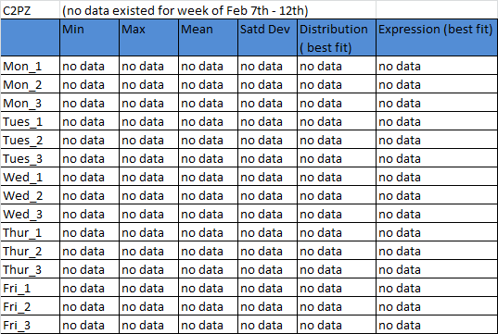

Table C-3 4 Arena Input Analyzer Distributions of Arrival Time for Collator 2

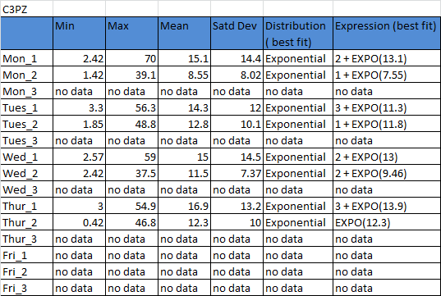

Table C-3 5 Arena Input Analyzer Distributions of Arrival Time for Collator 3

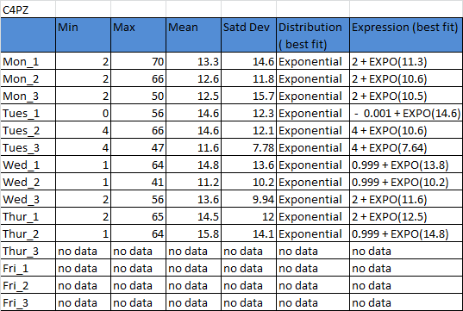

Table C-3 6 Arena Input Analyzer Distributions of Arrival Time for Collator 4

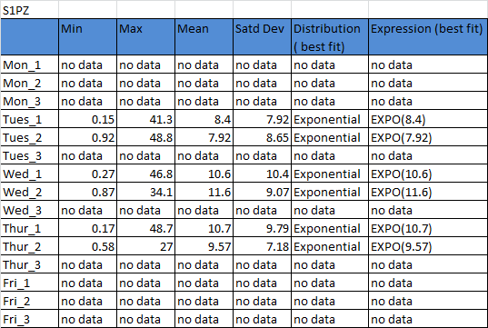

Table C-3 7 Arena Input Analyzer Distributions of Arrival Time for SLS 1

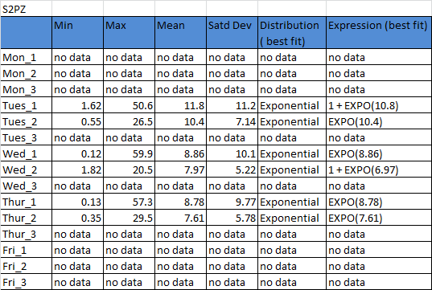

Table C-3 8 Arena Input Analyzer Distributions for SLS 2

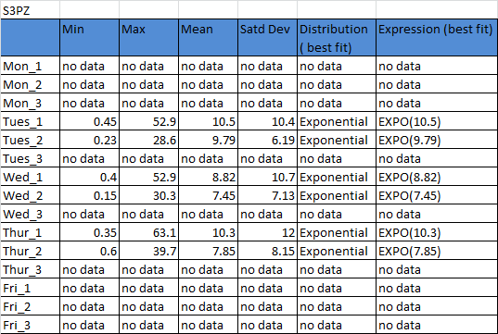

Table C-3 9 Arena Input Analyzer Distributions of Arrival Time for SLS 3

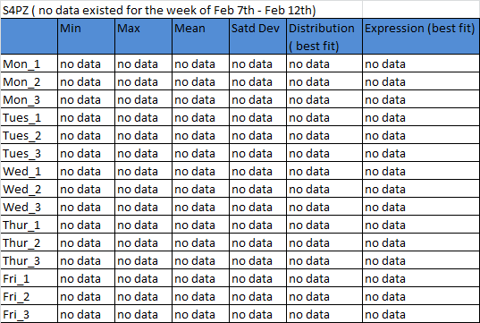

Table C-3 10 Arena Input Analyzer Distributions of Arrival Time for SLS 4

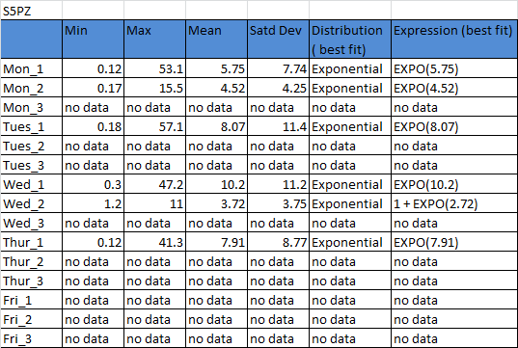

Table C-3 11 Arena Input Analyzer Distributions of Arrival Time for SLS 5

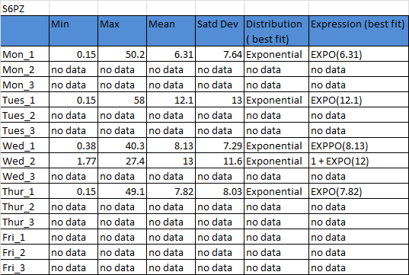

Table C-3 12 Arena Input Analyzer Distributions of Arrival Time for SLS 6

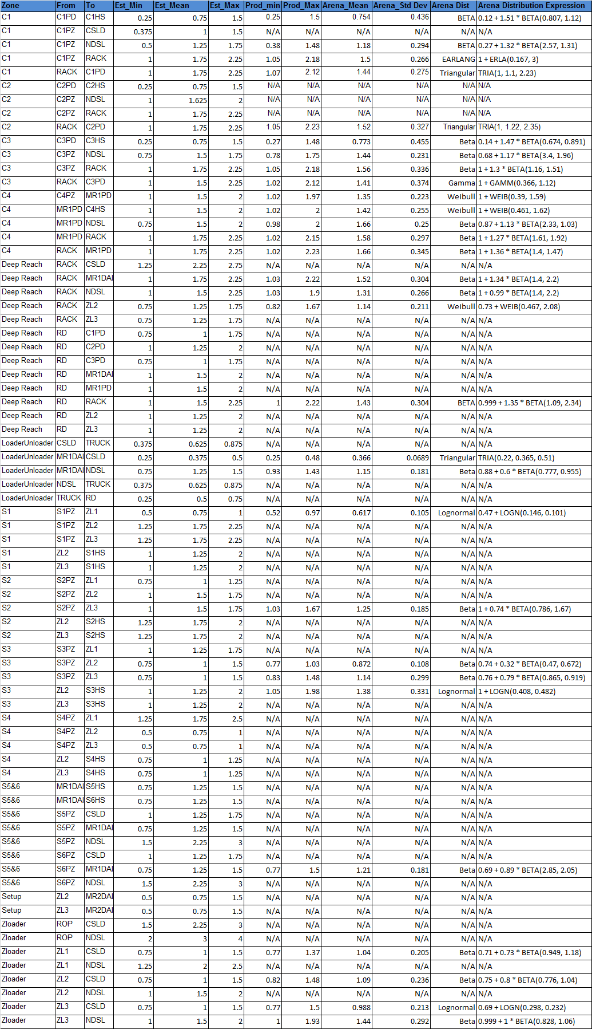

Table C-3 13 Arena Input Analyzer Results on Route Time

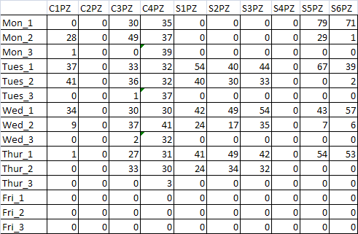

Table C-3 14 Pallet Arrival Counts per Machine by Day/Shift

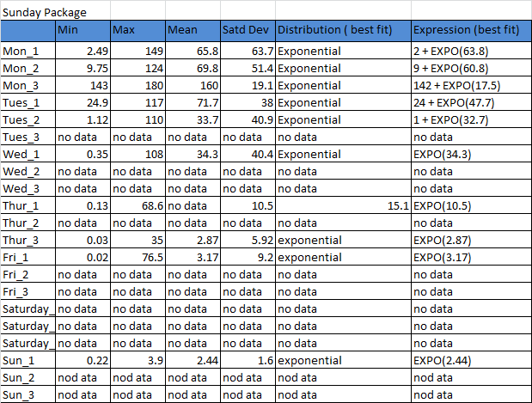

Table C-3 15 Arena Input Analyzer Distributions of Rack Arrival Time of Raw Materials to Sunday Package

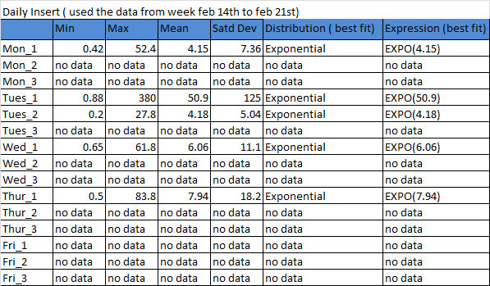

Table C-3 16 Arena Input Analyzer Distributions of Rack Arrival Time of Raw Materials to Daily Insert

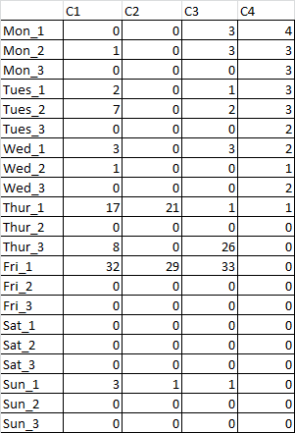

Table C-3 17 Rack Arrival Counts of Raw Materials to Sunday Package

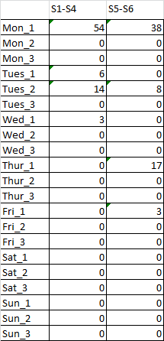

Table C-3 18 Rack Arrival Counts of Raw Materials to Daily Insert

**(Note: used the data from the week Jan 17th – Jan 21st)**

**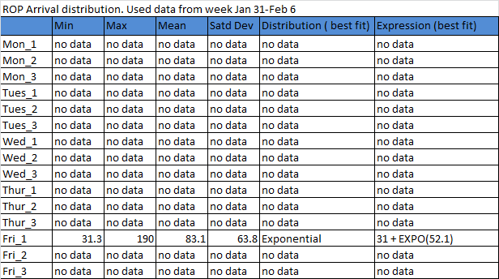**

Table C-3 19 Arena Input Analyzer Distributions of ROP Arrival Time of Empty Head Sheets to NDSL/CSLD

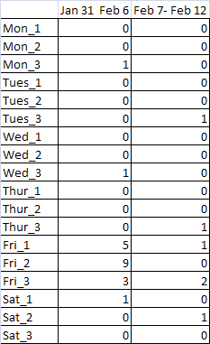

Table C-3 20 ROP Arrival Counts of Empty Head Sheets to NDSL/CSLD

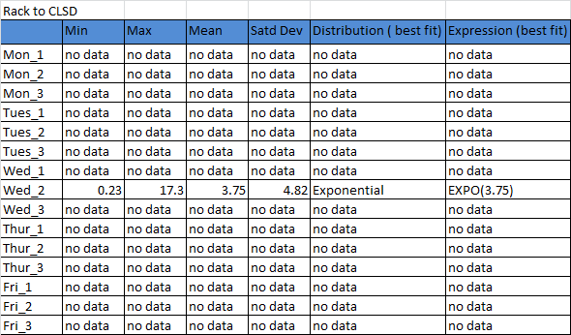

Table C-3 21 Arena Input Analyzer Distributions of Rack Arrival Time of Collated Sunday Packaging to CSLD

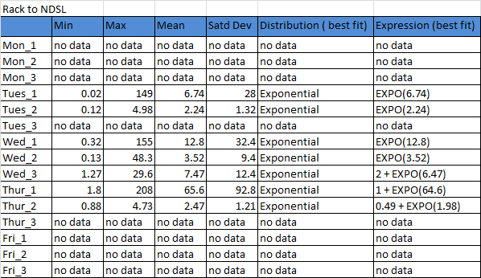

Table C-3 22 Arena Input Analyzer Distributions of Rack Arrival Time of Collated Sunday Packaging to NDSL

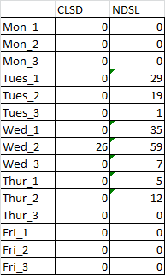

Table C-3 23 Rack Arrival Count of Collated Sunday Packaging to CLSD/NDSL

## Appendix C-4: Output Analysis – Utilization



Table C-4 1 Utilization for Base Model



Table C-4 2 Utilization for Suggested Model

## Appendix C-5: Output Analysis – Helper Moves



Table C-5 1 Moves per Shift and Helper Zone for Base Model



Table C-5 2 Moves per Shift and Helper Zone for Suggested Model

# APPENDIX D: MODEL DETAILS

## Appendix D-1: Model Components



Figure D-1 1 SLS 1-4 and Collator 1-4 Rack Arrivals of Raw Ads

*.*

Figure D-1 2 Daily Insert and Sunday Packaging Finished Pallets at the Loading Docks



Figure D-1 3 Sunday Packaging Raw Ads are Terminated at the Collator Machines for Processing



Figure D-1 4 Finished Sunday Packaging pallets Arrival at the Collator Machines for Transportation to the Docks

**

Figure D-1 5 Termination of Finished Sunday Packaging at the Rack and Arrivals at the Rack of Finished Daily Packaging to be Taken to the Docks

**

Figure D-1 6 Termination of Daily Insert Raw Ads at SLS 1-4 Machines

**

Figure D-1 7 Arrival of Finished Daily Insert Pallets at SLS 1-4 for Transportation to the Docks

**

Figure D-1 8 Termination of Daily Insert Raw Ads at SLS 5-6

**

Figure D-1 9 Arrival of Finished Daily Insert Pallets at SLS 5-6 for Transportation to the Docks



Figure D-1 10 The Schedule Module that Determines the Number of Available Helpers of Each Type are by Shift/Day



Figure D-1 11 Helper Idle Time Statistics Module

## Appendix D-2: Model Instructions

Below is a list of instructions for usage of the Arena model:

Getting the Model Ready to Run

1) Create a folder on your hard drive where the models and MS Excel output spreadsheets will live.

2) Save WashPost\_Base.doe, WashPost\_Sug.doe, Markup.xls, HelperMoves.xls, and HelperUtil.xls to the folder.

3) Open both models one at a time and click on “Advanced Process – File”. Here switch the browser location of the three MS Excel output files to where you have saved them on your hard drive.

4) Save the models. Now, you are ready to begin.

Changing the Schedule

The WashPost\_Base.doe model possesses the current markup schedule. The WashPost\_Sug.doe contains the suggested markup schedule. New schedules can be developed and saved as under different model names. To change the schedule:

1) Go to “Advanced Transfer – Transporter” and change the numbers of helpers to the maximum number you will have over the week. Keep in mind that you can start them off as all “Active” or all “Inactive”.

2) Use Halt and Activate modules in the “Advanced Transfer” panel in the Schedule component to turn the helpers off and on based on the shifts. In this component, you can see which sections are designated to which shift.

Changing Arrival Processes

1) Before changing the arrival processes in the model, first calculate them. Do this by summing the total number of pallets that arrive for each arrival process by shift/day. Then, divide this number by 6 to distribute the rate over 6 hours. You can round the number you get.

2) Go to “Basic Process – Schedule” and select the arrival process you would like to change. For each shift, enter the number you calculated for hourly rate across the first 6 hours in the shift. Make the last hour of the shift 0 to allow for helpers finishing up.

Changing the Helper Velocities

1) Go to “Advanced Process – Expression” and select a helper that you would like to change the velocity of.

2) Change the expression to any distribution you would like. Currently, a triangular distribution is used which take a minimum, mean, and maximum velocity as input. Use feet/second.

Changing/Updating the Distances

1) Go to “Advanced Transfer - Distance” and select the list, “All. Distance”. This list contains every combination of paths that a helper might traverse and their inverse, including those that are not ones that pallets would be taken on. This is necessary because every possible route a helper may travel must be represented.

2) You can go in individually and change a distance or copy the entire list to an MS Excel sheet and make a mass update, then copy it back in. Please note that when changing distances, different locations in the model have different names (e.g. NDSL C1.Station and NDSL C2.Station). When making a change in distance, you must make the change for all routes with titles for the locations involved. Also note that every distance has an inverse (e.g. MR1Daily - S5HS and S5HS – MR1Daily) and all of those inverses must be changed also.

3) For a complete list of stations elsewhere in the model than “Advanced Transfer- Distance”, go to “Advanced Transfer – Station” and select the “Name” field AND “Advanced Transfer – Enter” and select the “Station.Name” field. You need both lists to get the full set.

Changing the Internal Business Logic

1) Click on any “Decide” module within the model and change the decision logic to what you would like. It can be attribute-based or probability-based.

Running the Model

1) Click on “Run – Setup” at the top drop-down menus and change the parameters of the run. You must leave the day length parameter at 21 hours. The replication length must be kept between 1 and 5, which represents Monday-Friday. You can also adjust the number of replications to a maximum of 30, which is what the output analysis MS Excel sheets can hold.

2) Click on “Run – Go” at the top drop-down menus.

Using the Output Analysis

Each MS Excel output file has a different use. They are detailed below.

*Markup.xls*

This simply represents the markup you have selected in your Schedule component by helper by day/shift. It will help you ensure you have entered the markup in correctly.

*HelperUtil.xls*

This records the average number of helpers working by helper by shift/day. This is not in itself the utilization percentage. To calculate this percentage, take the number recorded and divide it by the markup amount of that day/shift.

*HelperMoves.xls*

This records the total numbers of moves by helper by shift/day. This can be used for many things such as determining the number of helper moves per helper per hour by helper by shift/day. To do this, divide the number recorded by the number of markup amount of that day/shift; then divide that number by 7 for 7 hours in the shift.

The “Totals” tab records the number of arrivals by varying locations and the number of them that were delivered to their appropriate locations. This is a full week count. A ratio of 1 between the numbers means that everything got to where it was going. This is a good way to measure whether production was met within the week. Remember that the end points are not just the docks, but also the HSs and the rack.

Calculating a New Markup

A good way to baseline a new markup would be to take the current markup used in the model and multiply each helper’s shift/day amount by the utilization. You can round this number up or down depending, but you want to make sure you have at least one helper during shifts when they are needed.

Using the new markup, take a look at how utilization and helper moves change, and see if overall production targets are still met.