Assessment of Migrating NOVEC’s Core Applications to Cloud

Volgenau School of Information Technology and Engineering Systems Engineering and Operations Research (SEOR)   
George Mason University (GMU)   
SYST699 – Fall 2013

Official Sponsors

Lockheed Martin (LM)

Northern Virginia Electric Cooperative (NOVEC)

Project Coordinator

Ahmed Abu Jbara (LM)



Cloud C

Computing Team (CCT)

Mehran Irdmousa  
Alireza Bitaraf  
Nahid Boustani  
Sanaz Jaraidi

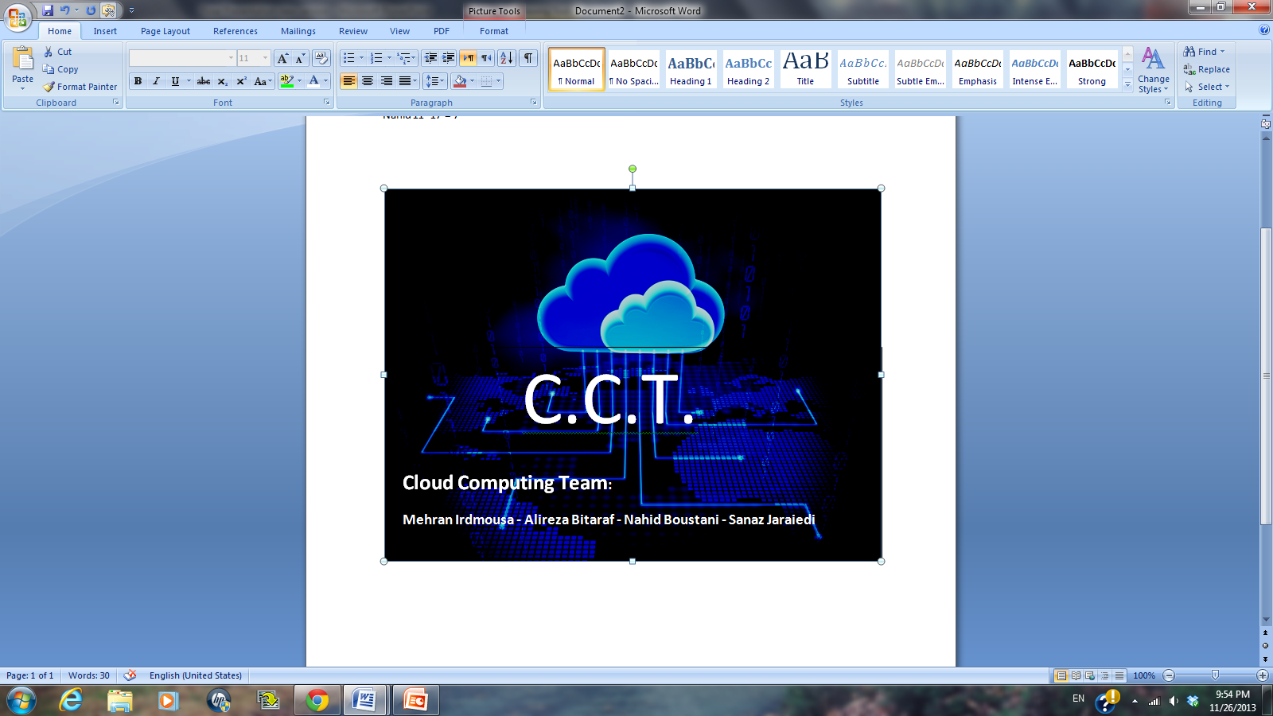

December 13, 2013

Version History

| Date | Document Version | Description | Author | Approving Manager |
| --- | --- | --- | --- | --- |
| 11/02/2013 | 0.1 | Initial Outline Draft | CCT | Irdmousa |
| 11/11/2013 | 0.2 | Completed all sections except 3.1.2, 3.2.2, 4.3.2, 4.3.3, and 4.5 | CCT | Irdmousa |
| 11/19/2013 | 0.3 | Completed all sections (draft) – no tech review | CCT | Irdmousa |
| 12/08/2013 | 0.4 | Incorporated Client’s and Dr. Hoffman’s comments | CCT | Irdmousa |
| 12/12/2013 | 1.0 | Final Draft | CCT | Irdmousa |

ACKNOWLEDGEMENTS

We acknowledge with thanks the assistance and advice of our project coordinator Ahmed Abu Jbara and our academic advisor Dr. Karla Hoffman.

TABLE OF CONTENTS

1 Introduction 1

1.1 Project Background 1

1.2 Cloud Computing Background 1

1.3 Document Outline 2

2 Stakeholders’ Need Investigation 3

2.1 Problem Statement 3

2.2 Statement of Need (SON) 3

2.3 Stakeholders 4

2.4 Statement of Work (SOW) 4

2.4.1 Background 4

2.4.2 Official Sponsors 4

2.4.3 Period of Contract & Place of Performance 5

2.4.4 Project Scope & Tasks 5

2.5 The Big Picture 6

2.6 Project Approach Overview 7

3 Technical Research 10

3.1 Cloud Computing Services & Technologies 10

3.1.1 Overview 10

3.1.2 Cloud Technology 10

3.1.3 Major Considerations 18

3.2 Current IT Infrastructure at NOVEC 42

3.2.1 Overview 42

3.2.2 Current IT infrastructure System Viewpoint 42

3.2.3 Core Applications 43

4 Technical Analysis 54

4.1 Challenges 54

4.2 Comparative Analysis 55

4.2.1 Methodology 56

4.2.2 Major Considerations-based Analysis 58

4.2.3 Applications-based Analysis 77

4.3 Utility Analysis 95

4.3.1 Methodology 96

4.3.2 Value Hierarchy (VH) 97

4.3.3 Utility Function (UF) 98

4.3.4 Alternatives 98

4.3.5 Scoring System 99

4.3.6 Utility Analysis Results 100

4.3.7 Sensitivity Analysis 102

4.4 Return on Investment (ROI) 104

4.4.1 ROI Calculation in the Industry 104

4.4.2 Hardware Cost 107

4.4.3 Input Data 108

4.4.4 Assumptions 110

4.4.5 Cost Results 110

5 Conclusions 113

5.1 Summary of Findings 113

5.2 Lessons Learned 113

5.3 Future Work 114

5.4 Resources Statistics 114

5.5 Authors’ Closing Remarks 114

6 Appendix A: Proposal 116

7 Appendix B: Bi-weekly Status Reports (BSRs) 117

8 Appendix C: Utility Analysis Survey 118

9 Appendix D: Utility Analysis Survey Results 119

LIST OF TABLES

Table 1 Cloud Consultants Example 18

Table 2 Major Considerations-based Analysis for Physical System Attack 60

Table 3 Major Considerations-based Analysis for Authentication Attack 60

Table 4 Major Considerations-based Analysis for Denial of Service Attack 61

Table 5 Major Considerations-based Analysis for Malicious Internet Content 62

Table 6 Major Considerations-based Analysis for Application Response Time 63

Table 7 Major Considerations-based Analysis for Technical Support 64

Table 8 Major Considerations-based Analysis for Fault Tolerance 65

Table 9 Major Considerations-based Analysis for Maintenance Burden 66

Table 10 Disaster Recovery Major Considerations-based Analysis 67

Table 11 Scalability Major Considerations-based Analysis 73

Table 12 Agility Major Considerations-based Analysis 76

Table 13 Major Considerations-based Comparative Analysis for Integration 77

Table 14 ERP Applications-based Results 81

Table 15 CIS Applications-based Results 83

Table 16 GIS Applications-based Results 84

Table 17 WMIS Applications-based Results 86

Table 18 NOVEC's Website Applications-based Results 88

Table 19 Document Imaging Applications-based Results 89

Table 20 Email Applications-based Results 90

Table 21 Microsoft Office Applications-based Results 91

Table 22 Applications-based Analysis Results Summary 93

Table 23 MAUA Pairwise Comparison Legend 100

Table 24 Utility Analysis Results 100

Table 26 Full Cloud Costing Alternative 107

Table 27 Partial Cloud Costing Alternative 108

Table 28 AWS TCO Calculator, Full Cloud 109

Table 29 Input for AWS TCO Calculator 109

Table 30 Utility Analysis Survey Results 119

LIST OF FIGURES

Figure 1 Statement of Need (SON) 4

Figure 2 Big Picture - The "Iceberg" Analogy 7

Figure 3 Project Approach 8

Figure 4 Cloud Computing Overview 11

Figure 5 Cloud Delivery Models 13

Figure 6 Cloud Deployment Models 14

Figure 7 Best CSPs 2013 - 2014 17

Figure 8 Steps of Integration 24

Figure 9 Disaster Recovery Architecture in Amazon Cloud 27

Figure 10 Cloud Agility Definition 27

Figure 11 Example of Scalable Deployment Model (image Source: Amazon S3 Website) 29

Figure 12 Jain's Performance Concepts 31

Figure 13 Performance Measurement Context Diagram 32

Figure 14 Performance Characteristics 33

Figure 15 Process of Matching Cloud ART with on-Premise ART 34

Figure 16 Application Response Time Components 35

Figure 17 AWS Support Response Time 37

Figure 18 AWS Fault Tolerance Architecture 39

Figure 19 Enterprise Cloud Adoption 41

Figure 20 NOVEC/LM current IT System Viewpoint (SV-1) 43

Figure 21 Interdependency of ERP with Other Applications 44

Figure 22 ERP Components 45

Figure 23 CIS Interdependencies with Other Applications 46

Figure 24 CIS Components 46

Figure 25 GIS Interdependencies with Other Applications 47

Figure 26 GIS Components 48

Figure 27 WMIS Interdependencies with Other Applications 49

Figure 28 WMIS Components 50

Figure 29 Website Components 51

Figure 30 Document Imaging Interdependencies with Other Applications 52

Figure 31 Core Applications Interface Diagram 53

Figure 32 Comparative Analysis in Project Approach 56

Figure 33 Comparative Analysis Methodology 58

Figure 34 Maintenance Burden Increase 67

Figure 35 Auto Scaling Example Model 70

Figure 36 Scalability (Number of Users) Advantages 71

Figure 37 The Relationship between the Agility and the Performance of the Company in Terms of Testing New Ideas and Implementation 74

Figure 38 Cost/Budget Allocation in Cloud 75

Figure 39 Complexity Analysis 79

Figure 40 Full Cloud Solution Based on Complexity Analysis 80

Figure 41 Utility Analysis in Project Approach 95

Figure 42 Utility Analysis Methodology 97

Figure 43 MAUA Value Hierarchy 98

Figure 44 MAUA Scoring System 100

Figure 45 Weight Sensitivity Analysis 103

Figure 46 Utility Sensitivity Analysis 104

Figure 47 ROI Cost components for Migration to Cloud Environment 106

Figure 48 Annual Expenditure for Full Cloud 111

Figure 49 Annual Expenditure for Partial Cloud 111

Figure 50 Findings Summary 113

Executive Summary

Northern Virginia Electric Cooperative (NOVEC) and Lockheed Martin (LM) have requested George Mason University (GMU) and Systems Engineering and Operations Research (SEOR) department to help with assessment of migrating some of NOVEC’s software applications to the cloud environment by analyzing the technical and financial perspectives of the migration. The Cloud Computing Team (CCT), composed of SEOR graduate students, has been tasked to work on this project. Official sponsors of this project are NOVEC and LM, with LM being charge of Information Technology (IT) management of NOVEC. Ahmed Abu Jbara, from LM, is the project coordinator of the migration assessment project.

CCT began working on this project by eliciting client’s needs and formulating a problem statement. Thereafter, a proposal with detailed project plan was drafted and approved by the client. CCT developed a plan composing of four major activities detailed in the next four paragraphs.

The first activity included elicitation of client needs as well as the problems LM was planning to attend to through this project. From that stage, CCT determined the systems engineering analytical approach to follow to meet client needs and address client’s problems. During this stage, per client’s suggestion, CCT scoped the project to only 6 areas of focus referred to as *major considerations* and only 8 software applications referred to as *core applications*. Furthermore, the client indicated that there was a need for studying technical and financial aspects of migration to cloud environment.

The second activity was about *technical research* involving in-depth research about cloud computing services and technologies, cloud advantages and disadvantages, cloud delivery models, cloud deployment models, and Cloud Service Providers (CSPs). This proved to CCT that cloud was a much more challenging technology than originally expected. Hence, CCT developed “the big picture” to bring into LM/NOVEC’s attention the complexity and the amount of details involved in migrating to cloud environment. The second part of this activity was to understand the current IT infrastructure at NOVEC. CCT utilized technical questionnaires, performed site visits, and interviewed stakeholders to understand the state of the current infrastructure at NOVEC along with hardware and software details of core applications. Throughout the technical research stage, more thorough understanding of major considerations and applications evolved, which better prepared CCT for the next activity.

The third activity was about *technical analysis*. During this activity, CCT faced many challenges such as unavailability of data due to CSPs and application vendors not willing to share necessary information, and CCT having limited domain knowledge. The CCT developed solutions to overcome these challenges through other methods than originally expected; which will be explained in section 4.1. Technical analysis has three parts. First part was *comparative analysis*. This analysis was designed to give an overview of the cloud technology versus the current infrastructure at NOVEC understanding the pros and cons for each of the major considerations while analyzing the possible cloud solutions for the core applications. This part also included architectural modeling and migration complexity analysis for each of the core applications. The second part of technical analysis was the *utility analysis*. This analysis provided a systems engineering methodology to make a decision about what cloud migration strategy alternative was the best one leveraging the major considerations. This analysis involved a survey that captured the importance of each of the major considerations and modeling the utility of each alternative. A detailed sensitivity analysis for utility was performed to determine sensitive attributes with respect to their weights and calculated utilities. The last part of the technical analysis involved *Return on Investment (ROI) analysis* to investigate the financial perspective of cloud migration. Because internal NOVEC cost data were not available, CCT only focused on costing the cloud solutions provided by comparative analysis applications-based analysis. However, CCT performed in-depth research about ROI in the industry and investigated *cost drivers* for ROI. These include IT labor and software migration costs. Technical analysis was performed under the following assumptions with client’s approval:

* Analysis on how migrating to cloud changes the current IT staffing is out of scope.
* The depth and quality of studying the core applications and assessing their cloud readiness depends on LM’s input regarding NOVEC’s IT infrastructure.
* Scope of the work is around the 8 core applications only, thus, any interface and integration with other applications is out of scope.
* Scope of work is around desired major considerations, and other attribute is considered out of scope of this project
* Where the word “System” is used, it indicates the 8 core applications and major considerations only.
* Cloud implementation schedule and timeline analysis is out of scope.
* NOVEC’s internet bandwidth can handle proposed cloud solutions and strategies.

The fourth activity under this project involved report and presentation development and a GMU SEOR CCT website as required for this course.

The high-level findings summary of this project includes:

* Cloud is a challenging environment with many advantages and disadvantages.
* Some of NOVEC’s core applications are complex for migration to cloud.
  + A phased strategy should be considered that will move the least complex applications to cloud first.
* Certain cloud solutions are not feasible for NOVEC to employ when migrating to cloud due to lack certain functionality
* The best cloud strategy option is “Full Cloud Alternative” to maximize NOVEC’s utility
* IT labor cost & Migration costs are the most prominent cost drivers when LM/NOVEC’s ROI comes into play for cloud migration
* It is possible to increase the efficiency of software maintenance, disaster recovery process, and security by migration to cloud if the right solutions are chosen

# Introduction

## Project Background

Northern Virginia Electric Cooperative (NOVEC) is a utility company in northern Virginia, providing electricity to more than 150,000 customers every day. To provide its service, NOVEC uses several software applications, which are locally hosted and maintained in its data center. Lockheed Martin (LM) is in charge of maintaining NOVEC’s Information Technology (IT) infrastructure (including hardware and software applications). In order to improve current IT quality and expenditures, LM would like to explore the assessment of moving some of NOVEC’S core applications to the cloud environment. Therefore LM, in coordination with NOVEC, has proposed this project to GMU to perform a high-level assessment study to evaluate the cloud options available and to provide financial and technical perspectives on the migration.

## Cloud Computing Background

Cloud computing is a type technology that works the concept of sharing and outsourcing computing resources rather than using local servers or personal devices to handle applications.

Based on Webpedia, an online term dictionary, cloud background is defined as following:

“In cloud computing, the word cloud (also phrased as "the cloud") is used as a metaphor for "the Internet," so the phrase cloud computing means "a type of Internet-based computing," where different services -- such as servers, storage and applications -- are delivered to an organization's computers and devices through the Internet.

Cloud computing is comparable to grid computing, a type of computing where unused processing cycles of all computers in a network are harnesses to solve problems too intensive for any stand-alone machine.”

The purpose of cloud computing is to use traditional high-performance computing power, to perform many processing per second.

In order to accomplish this, cloud computing uses networks of large groups of servers that are already virtualized and ready to be deployed to the internet[1].

## Document Outline

The remainder of this document is comprised of the following sections:

* Section 2: Stakeholders’ Need Investigation – Provides a description of problems statement, statement of need, stakeholders, statement of work, and project approach.
* Section 3: Technical Research – provides a detailed description of the research findings throughout this project.
* Section 4: Technical Analysis – provides a detail description of the analysis approach taken throughout this project along with its results.
* Section 5: Conclusions – provides the summary of the project, its results and suggests proposed follow-on work to this project for later semesters and catalogues lessons learned in CCT’s perspective.
* Appendices Section – includes various artifacts utilized throughout this project.

# Stakeholders’ Need Investigation

## Problem Statement

In the process of understanding the client needs and the problems the client is trying to solve, CCT elicited the following agreed upon problems that was requested to be investigated and responded to throughout this project:

* Software maintenance and patch updating have become cumbersome since an update in one application results in software bugs and inconsistency among other applications thus the process has become inefficient and time consuming. Can cloud provide a higher performance and more integrated solution?
* Upgrading the software applications as required by each vendor sometimes requires substantial effort and cost. Will moving to the cloud reduce the cost and effort?
* NOVEC has a warm Disaster Recovery (DR) site meaning data is backed up to a tape and then transported to a remote site increasing amount of data loss and recoverability time. Will it be more effective to look at a cloud solution for DR?
* Cyber-security is a major consideration for this client. Will cloud provide a more secured environment?
* What are the challenges of moving applications to the cloud?
* What are the ramifications of moving applications to the cloud in terms of NOVEC’s goals and cost?
* What cloud solutions should be considered for each of the applications?

## Statement of Need (SON)

In response to the problem statement (section 2.1) and identification of client’s needs, the CCT formulated the following Statement of Need (SON) shown in figure 1. Stakeholders’ needs are listed on the left side of the image. The analysis methodologies developed and performed by the CCT listed on the right were utilized to address stakeholders’ needs on the left. This image shows how the CCT addressed stakeholders’ needs.

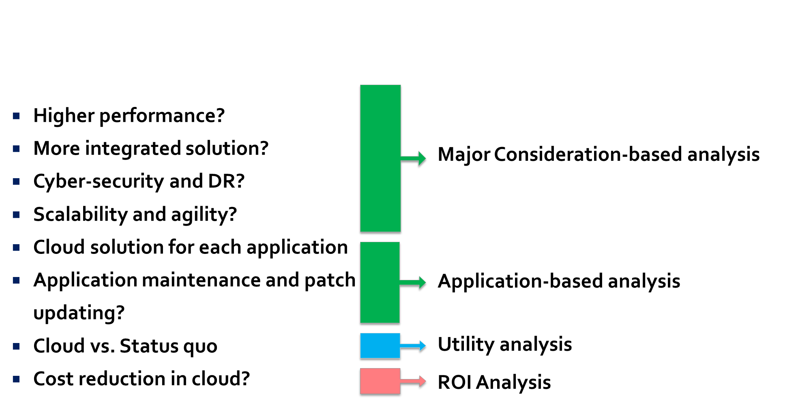

Figure 1 Statement of Need (SON)

## Stakeholders

Main stakeholders in this project are the following:

* NOVEC decision makers
* LM decision makers
* NOVEC’s core application users
* LM IT staff
* NOVEC’s customers
* Cloud Service Providers (CSPs)
* Core application vendors

## Statement of Work (SOW)

### Background

LM is initiating a research task to investigate the assessment of moving several of the core applications of their customer, NOVEC. LM would like to explore the assessment from both a technical and a financial perspective. It is important to note that this project is purely research-based and does not produce an outcome ready to be implemented. NOVEC/LM will be the final decision makers not the CCT.

### Official Sponsors

This project’s sponsors include:

* Lockheed Martin (LM)
* Northern Virginia Electric Cooperative (NOVEC)

### Period of Contract & Place of Performance

Period of performance for this project is 09/01/2013 to 12/13/2013. The activities will be performed by the CCT at GMU, Fairfax, VA, U.S. The CCT can attend NOVEC’s/LM’s locations per request.

### Project Scope & Tasks

#### Scope

NOVEC/LM is interested in understanding the assessment of migrating *only* core applications from NOVEC premise onto the cloud environment. These core applications include:

* ERP: Enterprise Resource Planning (Lawson/Infor)
* CIS: Customer Information System (Daffron)
* GIS: Geographical Information System (ESRI & Schneider)
* WMIS: Work Management Information System (CGI)
* NOVEC’s Web Site: [www.novec.com](http://www.novec.com/) (CommonSpot CMS)
* Document Imaging (Comsquared)
* Email (Microsoft Exchange)
* Microsoft Office Suite

All other applications used by NOVEC/LM are out of scope of this project. The core applications are further described in section 3.2.3.

It is also understood that NOVEC/LM has major focus areas for the CCT to work on. These include:

* **Cyber-security**: what happens to security when applications move to the cloud?
* **Integration**: being able to maintain the same level of integration among applications as they migrate to cloud.
* **Disaster Recovery**: level of data and functionality recoverability in cloud.
* **System Agility**: how easy it will be to make changes to applications as they move to cloud.
* **System Scalability**: how easy it is to increase resources to more efficiently run applications in the cloud.
* **Performance**: what happens to the performance of the system and core applications as they migrate to the cloud?
* **Industry Adoption**: how adaptable the idea of moving applications to cloud is in similar industries. This area of focus is just research-based and will not be part of the analysis though its research findings impact analysis results.

It is important to note that throughout this report; the main focus areas will be referred to as *major considerations*. Any other industry-related area of focus except above is out of scope of this project. These major considerations are further described along with their applicable characteristics in section 3.1.3.

It is important to note that this project is a research-based project assigned to students of graduate level with limited to medium knowledge about cloud computing. This indicates that results from this effort will not suggest a solution nor which solution is best. Rather it provides analysis and valuable artifacts that can facilitate the decision making process. Therefore, ultimately, LM/NOVEC will jointly make the decisions about moving any of the core applications to the cloud.

The following assumptions and scope statements apply to all the effort and analysis performed in this project.

* Analysis on how migrating to cloud changes the current IT staffing is out of scope.
* Scope of the work is around the 8 core applications only thus any interface and integration with other applications is out of scope.
* Where the word “System” is used, it indicates the 8 core applications and major considerations only.
* Cloud implementation schedule and timeline analysis is out of scope.
* NOVEC’s internet bandwidth can handle proposed cloud solutions and strategies.

#### Tasks

Given this context, the CCT will:

* Define the scope and the analysis that needs to be performed to reach LM’s goals
* Research cloud computing’s technical and financial aspects and provide comparative assessments for each.
* Research and study NOVEC’s current state of IT infrastructure for cloud computing migration.
* Analyze cloud readiness of the core applications and major considerations via comparative analysis.
* High-level Return on Investment (ROI) analysis if NOVEC were to move to cloud for its core applications

## The Big Picture

Research and analysis in this project have proved that cloud technology is a large, challenging, and complex environment. To explain this process, one should look at figure 2. One can imagine a big “iceberg” whose small tip is above the sea level and its base under the water (not visible). “The tip of the iceberg” analogy perfectly shows the cloud reality.

As shown in figure 2, what seems to be the common *perception* _ promoted by cloud business advertisers_ is that cloud technology is a “beautiful”, “seamless”, and “convenient” technology with few complexity ramifications. However, as one digs deeper (like the CCT has done for this project) into the bottom of the “iceberg”, the *reality* starts to show the real challenges of the cloud technology. There is no doubt, however, that the cloud technology has immense benefits as discussed in section 3.1.2.2.

Based on figure 2, there is significant infrastructure underlying any cloud technology in the industry. This infrastructure includes data centers, immense bandwidth requirements, detailed hardware and software architecture, security and management protocols, in-depth server and application management and maintenance, and necessary platforms to run the cloud services.

CCT developed the “Big Picture” image to show the implementation complexity of the cloud technology; which hints that the assessment and the migration processes would be more challenging and time consuming than perceived. Exposing the reality of cloud to the stakeholders has been the CCT’s mission throughout this project, so that the decision makers can make a more robust and informed decision about migration to the cloud. The CCT hopes that NOVEC/LM can find the aforementioned analogy applicable after reviewing this report.

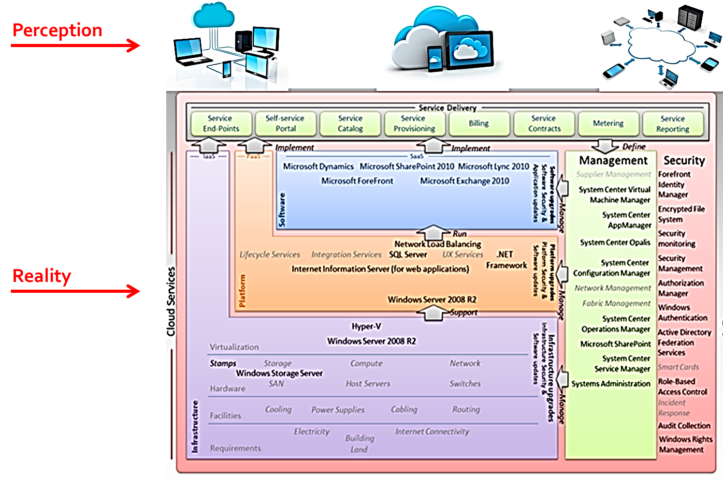

Figure 2 Big Picture - The "Iceberg" Analogy

## Project Approach Overview

In order to be able to complete this project and respond to the problem statement (section 2.1); the CCT developed a project approach shown on figure 3. This project approach is based on SOW elements described in section 2.4.

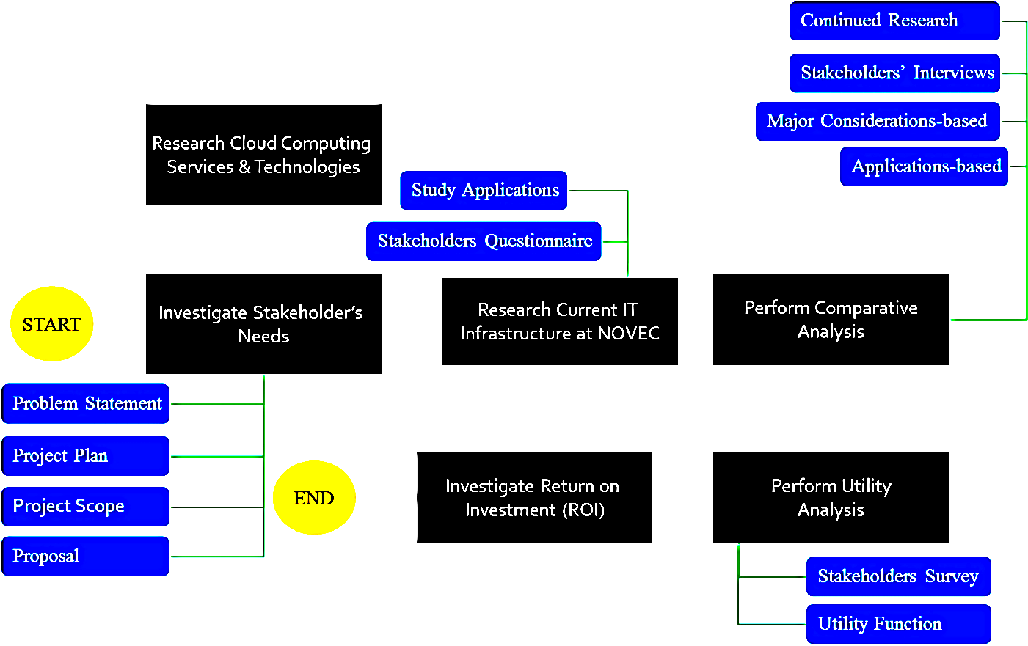

Figure 3 Project Approach

Figure 3 shows the flow of activities that the CCT performed throughout this project. The black boxes represent the major activities of this project and blue boxes represent certain artifacts, results, or outcomes from those activities. Furthermore, the following sections of this report focus on each of the black boxes except the first one, which is depicted in this section. A short description of each of the elements of the approach is provided below.

* **Investigate Stakeholder’s Needs**: in order for the CCT to be able to understand the client’s problems, it had to elicit the client’s needs in order to ensure that the project provided results that would help the client meet their needs. During this phase, the CCT formulated a problems statement (section 2.1), developed a project plan (section 2.4), developed a project scope (section 2), and drafted a proposal (Appendix A). This activity is described in section 2 of this report in more details.
* **Research Cloud Computing Services & Technologies**: after understanding the client’s needs and problems, the CCT needed to gain domain knowledge in cloud computing field. This meant that an extensive research study had to be performed. This activity is first part of the *technical research* stage. During this activity, the client’s needs (specifically, the major considerations) would be investigated. Furthermore, the challenges, advantages, and disadvantages of cloud would be researched. All of this research would be an input to the technical analysis activities. This activity is described in section 3.1 of this report in more details.
* **Research Current Information Technology (IT) Infrastructure at NOVEC:** this activity is the second part of the *technical research* phase. The CCT needed to fully understand the current infrastructure and core applications at NOVEC to perform the necessary analyses. This activity included development of core applications questionnaire for stakeholders to provide CCT with cloud-related information, site visits to understand IT infrastructure and each application at NOVEC. All of this research would be an input to the technical analysis activities. This activity is described in section 3.2 of this report in more details.
* **Perform Comparative Analysis:** this activity is the first of three activities under *technical analysis*. Comparative analysis is an activity that takes technical research output and findings and provides a robust comparison of status quo (current infrastructure) versus the cloud environment while considering major considerations and core applications. Comparative analysis is composed of two analyses: major considerations-based analysis (that compares status quo vs. cloud in terms of major considerations) and applications-based analysis (that compares the state of each of the core applications in terms of complexity, interdependency, and cloud solution options). Resultantly, comparative analysis provides the necessary output to the next stages of technical analysis: utility analysis and ROI analysis. Major considerations-based analysis results are inputs to utility analysis and applications-based analysis inputs are results to ROI analysis. This activity is described in section 4.2 of this report in more details.
* **Perform Utility Analysis:** this is the second activity under *technical analysis*. Utility analysis provides a methodology via which the client can make a decision over possible cloud implementation alternatives. These alternatives include staying with the current infrastructure (status quo), moving the least complex core applications to cloud and leaving the rest on premise (partial cloud), and moving all core applications to the cloud (full cloud). Utility analysis involves a stakeholder’s survey to capture importance (value) of each of the attributes. This activity utilizes output from major considerations-based analysis (under comparative analysis) to ultimately rank the three alternatives based on client’s utility (happiness). This activity is described in section 4.3 of this report in more details.
* **Investigate Return on Investment (ROI):** this is the third activity under *technical analysis*. ROI analysis provides high-level cost for each of the three alternatives. This includes identification of cost drivers, elements of ROI as used by the industry, and a hardware cost estimate of moving applications to the cloud. This activity utilizes output from applications-based analysis (under comparative analysis) to determine the cost of each alternative since applications are the cost drivers. This activity is described in section 4.4 of this report in more details.

The following sections in this document provide details about technical analysis (cloud and current infrastructure research) and technical analysis (comparative analysis, utility analysis, and ROI analysis).

# Technical Research

## Cloud Computing Services & Technologies

### Overview

This section provides in depth research that CCT performed throughout the duration of this project by review many scholarly articles, websites, and books while conducting interviews with GMU faculty members, cloud experts, and Cloud Service Providers (CSPs). This in-depth research contributed significantly to CCT’s technical analysis effort further described in section 4.

In the following sub-sections, the reader will find detailed information about cloud computing technology, its advantages and disadvantages, types of cloud, layers of cloud, major considerations that the client requested CCT to focus on with their associated characteristics.

### Cloud Technology

The following sections describe the cloud technology in more details.

#### Cloud Description

Cloud Computing is defined in the Oxford Dictionary as the practice of using a network of remote servers hosted on the internet, rather than a local server or a personal computer, to store, manage, and process data.[2] Some analysts and vendors define cloud computing narrowly as an updated version of utility computing. One can imagine cloud computing as an abundant treasury of computing resources, new technologies, frameworks, and applications available to all through the internet in exchange of money. All one needs to do is to connect to this virtual world via a device. Figure 4 depicts this concept.

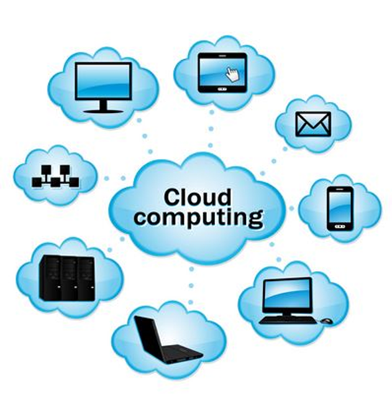

Figure 4 Cloud Computing Overview

#### Cloud Advantages

However cloud computing is defined, it comes into focus only when thinking about what IT always needs: the ability to increase computing capacity or add functional capabilities on the fly without having to pay for new infrastructure, licensing new software, or training new employees. What makes this technology so important today for business and enterprise IT is that it essentially gives them limitless computing capabilities that can be scaled on demand so quickly that it can make the competitors’ heads spin.[3]

The biggest advantage of the cloud is extending IT capabilities with actually condensing the IT department as a result of economies of scale. The idea is to outsource hardware and software to cloud service providers with the IT team only accessing them in the virtual world. This significantly increases the business agility since the enterprise’s focus shifts from building massive IT department for better serving their customers to building robust business plans and more innovative products in order to gain more market share.

Another main advantage of the cloud which is a strong drive for many enterprises to want to move to cloud environment is the overtime cost savings it promises. Rackspace with the help of the Manchester Business School and Vanson Bourne recently conducted a survey of 1,300 companies in the U.K. and U.S.[4] The study found that 88 percent of cloud users pointed to cost savings and 56 percent of respondents agreed that cloud services have helped them boost profits. Also, 60 percent of respondents said cloud computing has reduced the need for their IT team to maintain infrastructure, giving them more time to focus on strategy and innovation of new products. And indeed, 62 percent of the companies that have saved money are reinvesting those savings back into the business to increase personnel working on the key businesses, boost wages and drive product innovation.

#### Cloud Disadvantages

With Cloud Computing becoming the “phrase du jour”, it is impossible to overlook the backlashes against it; some of which create sufficient concerns for top managers of many corporations that they choose to delay their decision of moving to cloud.

Security is proven to be a big issue. It is still unclear how safe out-sourced data is and when using cloud services, ownership of data is not always clear.

Cloud requires constant and high speed internet connection as well as high bandwidth to support internet processes. Any issues with these two mean “no work”; not even accessing one’s own files and documents. Or, if the internet is not functioning well, cloud users would not get the instantaneous access they currently receive. Many web-based applications are simply not as full-featured as their desktop-based versions due to complications faced as a result of internet bandwidth and speed.

Moving to cloud means having less control over and less visibility of hardware and software; this can result in frustration at times. Cloud buyers have no control if a remote server goes down or if they get locked out of their account and are denied access to their data. These incidents, although not very frequently, occurred in the past and continue to occur. Despite replication across multiple machines, data can get lost. Basically, relying on cloud, puts companies at risk if those managing the cloud do not deliver on their promised responsiveness.

There are also issues relating to such policies as where the data is stored (within the US or abroad), who gets to see the data, how often updates are performed, how changes are determined, and, in general, whose policy cloud consumers should adhere to (US or foreign countries).

#### Cloud Delivery Models

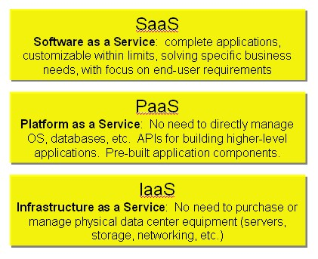

Figure 5 Cloud Delivery Models

Based on figure 5, the following delivery models are considered:

**SaaS**

Due to the nature of SaaS, it is not a new approach but rather it has been used for many years. First it was called application service provider (ASP) in the 1990′s. When looking at the technology behind SaaS one can assume that any application delivered over the internet and hosted remotely can be called SaaS i.e.: ADP’s hosted payroll services, QuickBooks online, and tens of thousands of applications from thousands of vendors.

**PaaS**

While SaaS has been around for a while, PaaS is a new phenomenon; PaaS offerings make possible the deployment of applications without the cost and complexity of buying and managing the underlying hardware and software and provisioning hosting resources.

**IaaS**

Providers of IaaS offer computers that will provide the following: physical and virtual machines and other resources. i.e.: A hypervisor, such as Hyper-V or Xen or KVM or VMware ESX/ESXi, runs the virtual machines as guests. IaaS clouds often offer additional resources such as a virtual-machine disk image library, raw block and file-based storage, firewalls, load balancers, IP addresses, virtual local area networks (VLANs), and software bundles.[5]

The interesting part of the IaaS-cloud is that the providers supply these resources on-demand from their large resource in their data centers. [6]

#### Cloud Deployment Models

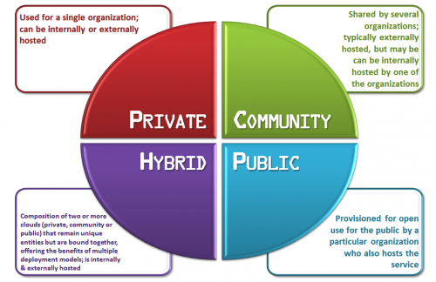

Figure 6 Cloud Deployment Models

Based on figure 6, the following deployment models are considered:

**Public**

Public clouds are made available to the public by a service provider who hosts the cloud infrastructure. Examples of public cloud providers are: Amazon AWS, Microsoft and Google. In this model, clients have no visibility or control over where the infrastructure is actually located. It is vital to make a note that all clients on public clouds share the same infrastructure pool with limited configuration, security protections and availability variances that can cause some security concerns.

Public Cloud customers benefit from “economies of scale”, due to the fact that the infrastructure costs are “spread across all users”, allowing each individual customer to operate on a low-cost, “pay-as-you-go” model (one of the main advantages of cloud is “on-demand” capabilities). The other positive point about the public cloud infrastructures is that they are typically bigger in scale than on premise cloud (i.e.: LM cloud vs. Amazon), which provides clients with seamless, on-demand scalability. These clouds offer a sufficient level of competence in shared resources; however, they are also more defenseless when it gets to cyber security than private clouds.

A public cloud is the obvious choice when:

* The standardized workload for applications is used by lots of people, such as e-mail.
* The need to test and develop application code exists.
* The need incremental capacity (the ability to add compute resources for peak times) exists.
* Collaboration projects are being done.

**Private**

Private cloud is cloud infrastructure devoted to a particular organization. Private clouds let businesses to host applications in the cloud, while taking into account the concerns regarding data security and control, which is often a concern in a public cloud environment.

There are two variations of private clouds:

* “On-Premise Private Cloud: This type of cloud is hosted within an organization’s own facility. A businesses IT department would incur the capital and operational costs for the physical resources with this model. On-Premise Private Clouds are best used for applications that require complete control and configurability of the infrastructure and security.
* Externally Hosted Private Cloud:  Externally hosted private clouds are also exclusively used by one organization, but are hosted by a third party specializing in cloud infrastructure. The service provider facilitates an exclusive cloud environment with full guarantee of privacy. This format is recommended for organizations that prefer not to use a public cloud infrastructure due to the risks associated with the sharing of physical resources.”

Adapting a private cloud project necessitates a considerable level and degree of engagement to virtualize the business environment, and it will require the organization to reevaluate decisions about existing resources. “Private clouds are more expensive but also more secure when compared to public clouds. An Info-Tech survey shows that 76% of IT decision-makers will focus exclusively on the private cloud, as these clouds offer the greatest level of security and control.”

Based on some research done by CCT and the information provided on a cloud provider site: IT is most appropriate to migrate to ‘private cloud’ when:

* The client needs data power but want cloud efficiencies
* The client needs consistency across services
* The client have more server capacity than the organization can use
* The client’s data center must become more efficient

**Hybrid**

Hybrid Clouds consist of two or more clouds (private, community or public) that remain unique entities but are bound together offering the advantages of multiple deployment models

Hybrid cloud architecture necessitates both on premise resources and off-site server based cloud infrastructure. By spreading things out over a hybrid cloud, one can keep each aspect of the business in the well-organized environment possible. The disadvantage is that it takes effort to keep track of multiple cloud security platforms and ensure that all aspects of the business can communicate with each other.

Here are a couple of situations where a hybrid environment is best:

* The company wants to use a SaaS application but is concerned about security.
* The company offers services that are tailored for different vertical markets.

**Community**

A community cloud is a multi-tenant cloud service model that is shared among several organizations and that is governed, managed and secured commonly by all the participating organizations or a third party managed service provider.

Cloud computing is about shared IT infrastructure or the outsourcing of a company's technology.  It is essential to examine the current IT infrastructure, usage and needs to determine which type of cloud computing can help to best achieve the goals of the client. [7]

#### Cloud Service Providers (CSPs)

The following (figure 7) shows the best of cloud computing service providers in the year 2013 – 2014:

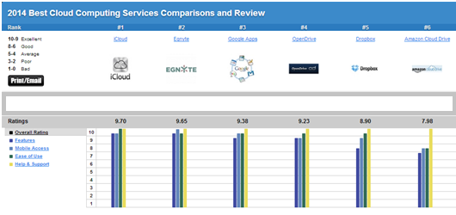

Figure 7 Best CSPs 2013 - 2014[8]

Based on Cloud Services Reviews the following are characteristic to look For when choosing the right CSP:

**“Features**

The most important factor to consider in a cloud service is features, including the type of content one can store. The best cloud computing services are those that allow one to upload and save any type of file one would save on their local hard drive, from word documents to music files and everything in between. Some services even allow people to keep email, contacts and their calendar in the cloud. Any cloud service one considers should also allow them to view, edit and share their content regardless of what computer or device they are using. Other features to look for include automatic syncing of the files across all devices, and password-protected sharing and file encryption to safeguard the content.

**Mobile**

Arguably one of the biggest [selling](http://cloud-services-review.toptenreviews.com/) points of cloud computing services is their wide-ranging access. Whether people are on their work computer at the office or at home on their iPad, cloud services allow them to access their content anywhere, anytime and on any one of their devices.

**Ease**

Considering how often people will likely be accessing their content in the cloud, it’s important to select a cloud service that is intuitive and straightforward. The service’s interface and tools should be easy to navigate and convenient to use.

**Help & Support**

Getting help when it is needed is crucial when using any type of technology, including cloud services. Available support options should include technical assistance via telephone, email and live chat. The service should also provide a knowledgebase and user forums as resources.

#### Cloud Consultants

Definition: An independent entity advising clients on Cloud implementation strategies.

There are many Cloud Consultant firms that offer services and advice regarding cloud migration strategies. A list of them after a quick Google search is mentioned below.

The customer shall choose the best consultant (if any) based on the consultant’s portfolio, prior experience, and area of expertise. Table 1 shows some of the leading cloud consultants in the industry.

Table 1 Cloud Consultants Example

|  |  |
| --- | --- |
| Name of the Consultant | Website |
| Anvil Cloud Solution | http://www.anvilcloudconsultants.com/ |
| IBM Cloud Consulting | http://www-935.ibm.com/services/us/gbs/cloud/ |
| Into Cloud | http://intocloudconsulting.com/intoCLOUD_Consulting/ICC.html |
| Cloud Consultants | http://cloudconsultants.biz/ |
| Blue Cloud Consultants | http://www.bluecloudconsultants.com/ |

### Major Considerations

The following sections describe each of the major considerations in more details along with their individual characteristics.

#### Cyber-security

Cyber-security is one of the major concerns of early adopters of cloud technology. Security can be discussed from different points of view. For instance, Gartner has counted seven risks for cloud as following[9]:

1. Privileged user access
2. Regulatory compliance
3. Data location
4. Data segregation
5. Disaster Recovery
6. Investigative support
7. Long-term viability

In this classification, data protection should take place in response to Data segregation risk and application protection should take place in response to regulatory compliance risk. Besides these, one can see that disaster recovery has also been discussed under security risks. Cloud Security Alliance has addressed cloud security in 14 areas of focus[10]:

Domain 1: Cloud Computing Architectural Framework

Domain 2: Governance and Enterprise Risk Management

Domain 3: Legal Issues: Contracts and Electronic Discovery

Domain 4: Compliance and Audit Management

Domain 5: Information Management and Data Security

Domain 6: Interoperability and Portability

Domain 7: Traditional Security, Business Continuity, and Disaster Recovery

Domain 8: Data Center Operations

Domain 9: Incident Response

Domain 10: Application Security

Domain 11: Encryption and Key Management

Domain 12: Identity, Entitlement, and Access Management

Domain 13: Virtualization

Domain 14: Security as a Service

If one wants to aggregate these areas of focus in cloud security one can classify them in 3 main areas[11]:

* Security and privacy
* Compliance
* Legal issues

For compliance and legal issues cloud adopters should research Cloud Service Providers certificates and transparency in order to make sure they can meet their requirements. The security and privacy of cloud environment has more similarities to the security risks of in-premise environment and therefore one focuses on this area so one can compare cloud environment with status quo later on in the analysis. Security and privacy of data can be discussed in the following main characteristics[12]:

* Attacks on Physical System
* Authentication and privilege attacks
* Denial of service
* Malicious Internet content

In the following the CCT presents the description of each threat as brought in GFI security threats paper[13].

**Attacks on Physical Systems**

Internet-borne attacks are not the only security issue that organizations face. Laptops and mobiles are entrusted with the most sensitive of information about the organization. These devices, whether they are company property or personally owned, often contain company documents and are used to log on to the company network. More often than not, these mobile devices are also used during conferences and travel, thus running the risk of physical theft. The number of laptops and mobile devices stolen per year is ever on the increase. Attrition.org had over 400 articles in 2008[14] related to high profile data loss, many of which involved stolen laptops and missing disks. If it happens to major hospitals and governments that have established rules on handling such situations, why should it not happen to smaller businesses?

Another threat affecting physical security is that of unprotected endpoints. USB ports and DVD drives can both be used to leak data and introduce malware on the network. A USB stick that is mainly used for work and may contain sensitive documents, becomes a security risk if it is taken home and left lying around and other members of the family use it on their home PC. While the employee may understand the sensitive nature of the information stored on the USB stick, the rest of the family will probably not. They may copy files back and forth without considering the implications. This is typically a case of negligence but it can also be the work of a targeted attack, where internal employees can take large amounts of information out of the company.

Small and medium-sized businesses may overlook the importance of securing the physical network and server room to prevent unauthorized persons from gaining access. Open network points and unprotected server rooms can allow disgruntled employees and visitors to connect to the network and launch attacks such as ARP spoofing to capture network traffic with no encryption and steal passwords and content.

**Authentication and Privilege Attacks**

Passwords remain the number one vulnerability in many systems. It is not an easy task to have a secure system whereby people are required to choose a unique password that others cannot guess but is still easy for them to remember. Nowadays most people have at least five other passwords to remember, and the password used for company business should not be the same one used for webmail accounts, site memberships and so on. High profile intrusions such as the one on Twitter (the password was happiness), clearly show that passwords are often the most common and universal security weakness and attacks exploiting this weakness do not require a lot of technical knowledge.

Password policies can go a long way to mitigate the risk, but if the password policy is too strict people will find ways and means to get around it. They will write the password on sticky notes, share them with their colleagues or simply find a keyboard pattern (1q2w3e4r5t) that is easy to remember but also easy to guess. Most complex password policies can be easily rendered useless by non-technological means.

In small and medium-sized businesses, systems administrators are often found to be doing the work of the network operators and project managers as well as security analysts. Therefore a disgruntled systems administrator will be a major security problem due to the amount of responsibility (and access rights) that he or she holds. With full access privileges, a systems administrator may plan a logic bomb, backdoor accounts or leak sensitive company information that may greatly affect the stability and reputation of the organization. Additionally, in many cases the systems administrator is the person who sets the passwords for important services or servers. When he or she leaves the organization, these passwords may not be changed (especially if not documented) thus leaving a backdoor for the ex-employee. A startup company called JournalSpace was caught with no backups when their former system administrator decided to wipe out the main database. This proved to be disastrous for the company which ended up asking users to retrieve their content from Google’s cache.

The company’s management team may also have administrative privileges on their personal computers or laptops. The reasons vary but they may want to be able to install new software or simply to have more control of their machines. The problem with this scenario is that one compromised machine is all that an attacker needs to target an organization. The firm itself does not need to be specifically picked out but may simply become a victim of an attack aimed at a particular vulnerable software package.

Even when user accounts on the network are supposed to have reduced privileges, there may be times where privilege creep occurs. For example, a manager that hands over an old project to another manager may retain the old privileges for years even after the handover! When his or her account is compromised, the intruder also gains access to the old project.

Employees with mobile devices and laptop computers can pose a significant risk when they make use of unsecured wireless networks whilst attending a conference or during their stay at a hotel. In many cases, inadequate or no encryption is used and anyone ‘in between’ can view and modify the network traffic. This can be the start of an intrusion leading to compromised company accounts and networks.

**Denial of Service**

In an attempt to minimize costs, or simply through negligence, most small and some medium-sized businesses have various single points of failures. Denial of service is an attack that prevents legitimate users from making use of a service and it can be very hard to prevent. The means to carry out a DoS attack and the motives may vary, but it typically leads to downtime and legitimate customers losing confidence in the organization - and it is not necessarily due to an Internet-borne incident.

In 2008 many organizations in the Mediterranean Sea basin and in the Middle East suffered Internet downtime due to damages to the underwater Internet cables. Some of these organizations relied on a single Internet connection, and their business was driven by Internet communications. Having such a single point of failure proved to be very damaging for these organizations in terms of lost productivity and lost business. Reliability is a major concern for most businesses and their inability to address even one single point of failure can be costly.

If an organization is not prepared for a security incident, it will probably not handle the situation appropriately. One question that needs to be asked is: if a virus outbreak does occur, who should handle the various steps that need to be taken to get the systems back in shape? If an organization is simply relying on the systems administrator to handle such incidents, then that organization is not acknowledging that such a situation is not simply technical in nature. It is important to be able to identify the entry point, to approach the persons concerned and to have policies in place to prevent future occurrences - apart from simply removing the virus from the network! If all these tasks are left to a systems administrator, who might have to do everything ad hoc, then that is a formula for lengthy downtime.

**Malicious Internet Content**

Most modern small or medium-sized businesses need an Internet connection to operate. If one removes this means of communication, many areas of the organization will not be able to function properly or else they may be forced to revert to old, inefficient systems. Just think how important email has become and that for many organizations this is the primary means of communication. Even phone communications are changing shape with Voice over IP becoming a standard in many organizations.

At some point, most organizations have been the victim of a computer virus attack. While many may have anti- virus protection, it is not unusual for an organization of more than 10 employees to use email or the Internet without any form of protection. Even large organizations are not spared. Recently, three hospitals in London had to shut down their entire network due to an infection of a version of a worm called Mytob. Most of the time one does not hear of small or medium-sized businesses becoming victims of such infections because it is not in their interest to publicize these incidents. Many small or medium-sized business networks cannot afford to employ prevention mechanisms such as network segregation. These factors simply make it easier for a worm to spread throughout an organization.

Malware is a term that includes computer viruses, worms, Trojans and any other kinds of malicious software. Employees and end users within an organization may unknowingly introduce malware on the network when they run malicious executable code (EXE files). Sometimes they might receive an email with an attached worm or download spyware when visiting a malicious website. Alternatively, to get work done, employees may decide to install pirated software for which they do not have a license. This software tends to have more code than advertised and is a common method used by malware writers to infect the end user’s computers. An organization that operates efficiently usually has established ways to share files and content across the organization. These methods can also be abused by worms to further infect computer systems on the network.

Computer malware does not have to be introduced manually or consciously. Basic software packages installed on desktop computers such as Internet Explorer, Firefox, Adobe Acrobat Reader or Flash have their fair share of security vulnerabilities. These security weaknesses are actively exploited by malware writers to automatically infect victim’s computers. Such attacks are known as drive-by downloads because the user does not have knowledge of malicious files being downloaded onto his or her computer. In 2007 Google issued an alert [15] describing 450,000 web pages that can install malware without the user’s consent.

There are also engineering attacks. This term refers to a set of techniques whereby attackers make the most of weaknesses in human nature rather than flaws within the technology. A phishing attack is a type of social engineering attack that is normally opportunistic and targets a subset of society. A phishing email message will typically look very familiar to the end users – it will make use of genuine logos and other visuals (from a well-known bank, for example) and will, for all intents and purposes, appear to be the genuine thing. When the end user follows the instructions in the email, he or she is directed to reveal sensitive or private information such as passwords, pin codes and credit card numbers.

Employees and desktop computers are not the only target in an organization. Most small or medium-sized companies need to make use of servers for email, customer relationship management and file sharing. These servers tend to hold critical information that can easily become a target of an attack. Additionally, the move towards web applications has introduced a large number of new security vulnerabilities that are actively exploited by attackers to gain access to these web applications. If these services are compromised there is a high risk that sensitive information can be leaked and used by cyber-criminals to commit fraud.

#### Integration

Cloud computing presents a number of integration challenges. Cloud service providers define architecture and users of public cloud services must integrate with that. Meaning cloud users must incorporate the providers’ specific parameters for working with cloud components. In general, integration includes merging with the cloud APIs for configuring IP addresses, subnets, firewalls and data service functions for storage. Control of these functions, however, is based on the cloud provider’s infrastructure services. Therefore, public cloud users must integrate with the cloud infrastructure. Will a newly-cloud-adopted corporation be able to keep the existing integration architecture between applications? Can applications still interact with each other and exchange data? Will the applications be able to talk using the same APIs and network protocols? Surely, it is not a matter of a simple yes or no answer. Whether using IaaS, Paas, or SaaS solutions, there will be need for changing the existing configurations, introducing many new ones, and careful watch over architecture differences. Following are brief overview of IaaS and SaaS integrations. “Making a leap from a physical infrastructure to an IaaS environment is overwhelming but there is a logical way to structure the move.” say the people of Biztech magazine.[16] Steps of integration are shown in Figure 8.

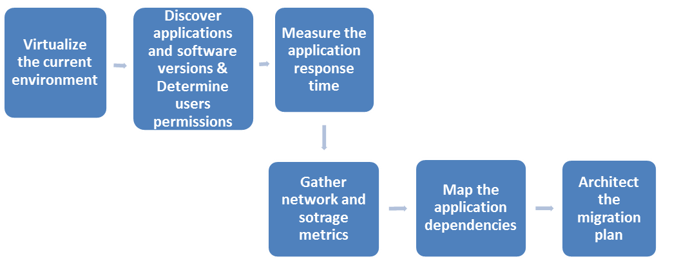

Figure 8 Steps of Integration

**First**, virtualize the current environment. Generally, servers first, followed by applications, and then desktops if applicable. By virtualizing as a first step, data and applications wind up separated from the physical machines on which they reside. IT managers and executives will then have a clearer understanding the interdependencies among the applications. Through this process, it becomes clear which applications make sense to migrate to the IaaS environment, which is itself based on a virtual infrastructure.

**Second**, the next step is to discover which applications and software versions are in use throughout the environment along with user permissions and the interdependencies among those applications.

**Third**, it is important to measure the application response time which is an indicator of each application’s resource utilization level.

**Fourth**, gather network and storage metrics, specifically as they describe throughput and latency. This data is crucial to determining how the applications will work in the new IaaS environment.

**Fifth**, map the application dependencies. This involves identifying dependencies between applications, as well as between applications and the data infrastructure. The idea is to find out how to architect the migration plan so that those dependencies aren’t disrupted.

It’s also important to note that the cloud-based infrastructure must be compatible with the organization’s existing server hardware and operating systems. If the hardware isn’t compatible, applications may have to be redeployed or recompiled for the new platform and if the operating systems are different, other changes may have to be made when the enterprise migrates its systems.

Replacing an in-house application with a SaaS version of it and integrating it with the rest of the system brings on a new set of challenges. The new SaaS application (especially if offered through a cloud service provider that is not the same as the vendor of the current in-house application) might not use the same data structure as the rest of the applications that it interacts with. Multiple applications can’t operate on different versions of the same data records (like the same customer record) without those records being updated and reconciled. Furthermore, a new SaaS system should not be obstructed and delayed by having to enter data twice or worse, by not having the correct data available when a core business process demands it. Without a robust integration technology, data quality easily becomes a problem. SaaS applications and core enterprise systems need to share data while dealing with the different ways that the data is structured. An example of data quality is when application X, on the cloud, refers to customer phone number as ‘Cust_Phone (char 10)’ and application Y, on premise, refers to it as ‘C_Phone (char 20)’. Data sent from application X to application Y needs to be transformed on the fly in order for application Y to receive it in its native structure.

The integration strategy should take into account developing or purchasing an integration technology which reacts to events of data being changed, such as a customer record being updated or a bill payment being recorded. In reacting to the event, it carries out some preprogrammed function, such as extracting the changed data from the local enterprise system, accounting for the differences in structure and content, and updating the remote cloud-based application with the changed data, typically in less than a second. These events can occur at a rate of hundreds or thousands a minute, or just a few per day. Mostly, SaaS providers take care of integration of the new service with the in-house applications. The integration technology can reside on cloud, be bolted into a rack in the enterprise’s data center, or installed on a server in the enterprise’s data center like conventional software.[17]

#### Disaster Recovery

Disaster recovery (DR) is the process, policies and procedures that are related to preparing for recovery or continuation of technology infrastructure, which are vital to an organization after a natural or human-induced disaster[18].

Prior to selecting a disaster recovery strategy, a disaster recovery planner first refers to their organization's business continuity plan which should indicate the key metrics of recovery point objective (RPO) and recovery time objective (RTO) for various business processes (such as the process to run payroll, generate an order, etc.). The metrics specified for the business processes are then mapped to the underlying IT systems and infrastructure that support those processes.

RPO and RTO definitions[19]:

A recovery point objective, or “RPO”, is defined by business continuity planning. It is the maximum tolerable period in which data might be lost from an IT service due to a major incident.

The Recovery Time Objective (RTO) is the duration of time and a service level within which a business process must be restored after a disaster in order to avoid unacceptable consequences associated with a break in continuity.

Figure 9 shows a sample DR architecture, which can be implemented in Amazon Cloud.

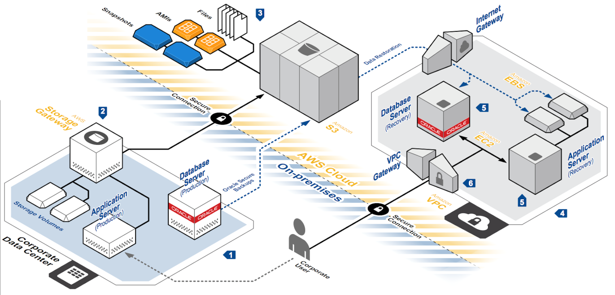

Figure 9 Disaster Recovery Architecture in Amazon Cloud

#### Agility

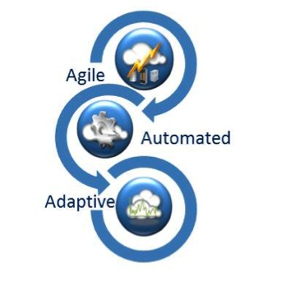

Figure 10 Cloud Agility Definition

“The concept of business agility originates from the manufacturing industry in the 1980s  In contrast to other concepts such as flexibility; agility refers to the capability of a firm to adapt swiftly to changing environments. Thus, business agility can be defined as the ability to sense and respond to opportunities and threats in an efficient, effective, and timely manner. Consequently, agility is crucial for firms especially in volatile environments in order to stay competitive.”[20] Figure 10 further describes this concept.

The agility is the results of the adaptive and automated IT that is gained due to virtualization.

**Types of Cloud Agility**

As one could imagine, the remarkable limitation of the timeframe enables work to commence much more quickly. Since agility may be defined as "the power of moving quickly and easily; nimbleness" it's easy to see how this fast provisioning is referred to advancing agility.

People conflate two different things under the term agility: “engineering resource availability, and business response to changing conditions or opportunity”.

Both types of agility are valuable, but the second type is the more appropriate for this topic and refers to the real agility associated with cloud computing.

Based on paper by Fremdt, S one can see that, if cloud computing comes to be known as an internal IT optimization with little effect on how quickly compute capability rolls out into mainline business processes, the potential exists for IT to never receive the business unit support it requires to fund the shift to cloud computing.

The second type of agility that affects how quickly business units can offer new offerings — suffers no such problems

In the regard of this project, IT specific agility plays an important role to increase responding capabilities.

Moreover, Sambamurthy et al. differentiate agility into three basic dimensions: customer agility, partnering agility, and operational agility. Whilst customer agility describes the ability to explore and exploit innovation opportunities by leveraging customers, partnering agility refers to the ability of accessing knowledge, assets, and resources in a partnership network. “Operational agility is the ability to redesign business processes to take advantage of innovative opportunities. Through the modularization of business processes, IT supports this ability of redesigning and creating new business processes.

**Agility in the Domain of This Project**

In this project the focus is on Operational Agility as focused on the business agility aspect of the cloud.

#### Scalability

**Scalability and IT Applications after Migration to Cloud**

Website traffic changes; few of the factors that affect this change is: Time of day, seasonality, promotions, popularity, and flash crowds can all drive peak volumes. While one can expect and plan for some of this volume, it is hard to be always right about the exact amount of the traffic increase. To complicate matters, the visitors expect steady, fast performance regardless of the traffic for example the company website receives.

Building LM’s infrastructure to handle peak traffic requires capital investment and facilities space – and no matter how big one can build it, it still may not be enough. “Having to choose between overspending or under-provisioning is a classic dilemma.”

But by deploying the web application in the cloud, one can avoid this dilemma. The customer can eliminate the upfront fixed investment, and still possess compute resources to meet peak loads with on demand scalability, while still paying only for the compute time one actually uses.

With the cloud hosting, the customer can deploy the entire (named: full cloud solution by CCT) web application infrastructure in the cloud or choose to only deploy the most ‘complex’ applications to the cloud which require more load (named: partial cloud solution by CCT).

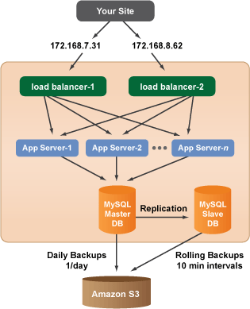

Figure 11 Example of Scalable Deployment Model (image Source: Amazon S3 Website)

The studied Website (Amazon S3 provider) shown in figure 11 has everything the customer need to run a full customer-facing website on cloud infrastructures with scalability and reliability. The diagram illustrates a typical configuration with two load balancers, multiple application servers, and redundant MySQL database servers with recovery, failover and replication, and rolling backups to cloud storage.

#### Performance

Performance is a broad term in computer industry being investigated in the computer science literature from varying viewpoints from load balancing to network intrusion detection to system fault tolerance. It is obvious that performance of a system, depending on how defined, could cross the line across scalability, security, and even cost of the system. In order to come up with distinct characteristics of performance that would suit the purpose of this project, the performance measurement metrics need to be studied as the first step.

Performance Measurement is the action or process of measuring the quality as well as the speed of carrying out or accomplishing an action, task, or function. A well-known point of view for system performance measurement is proposed by Jain [1991][21], who believes that a performance study starts with establishing a set of performance criteria (or characteristics) to help with carrying out measurement process. Here is an overview of his perspective on performance measurement. In a system performing a service correctly, performance is measured using three sub concepts: 1) responsiveness, 2) productivity, and 3) utilization. Jain then proposes a measurement process for each. In addition, he notes that for each service request made to a system, there are several possible outcomes, which can be classified in three categories: 1)The system may perform the service correctly 2) incorrectly, 3) it may refuse to perform the service altogether. System performance is then affected by three sub concepts associated with each of those possible outcomes. The sub concepts are: 1) speed, 2) reliability, and 3) availability. Figure 12presents the possible outcomes of a service request to a system and the sub concepts associated with them.

In addition to Jain’s performance concepts which mostly focus on the performance of the software, ISO 25010 Performance Concepts[22] provide standards on both system and software quality models, relating to both the static properties of the software and the dynamic properties of the system. Together, the properties of both determine the quality of the product in a particular system. For example, consider users who specialize in fields of content delivery, maintenance, or management. Performance efficiency and reliability can be specific concerns of such users. The performance efficiency concept proposed in ISO 25010 has three sub concepts: 1) time behavior, 2) resource utilization, and 3) capacity. The reliability concept has four sub concepts: 1) fault tolerance, 2) availability, 3) maturity, and 4) recoverability.

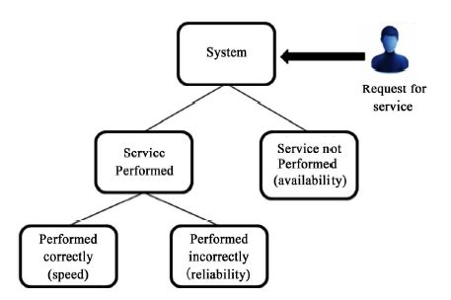

Figure 12 Jain's Performance Concepts[23]

Combining Jain’s definition and ISO 25010 standards, Bautista, Abran and April [2012][24] suggest the context diagram in Figure 13 as a framework for performance measurement in cloud computing.

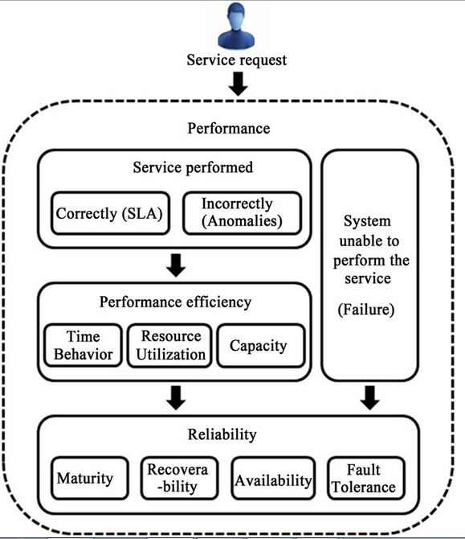

Figure 13 Performance Measurement Context Diagram[25]

When considering measuring the performance of a system in cloud, one can broadly classify it into 2 categories: measuring from the Cloud Service Provider’s view and measuring from the Cloud Consumer’s view, says Vineetha V of InfoSys. A Cloud Service Provider is interested in performance measurement of the various infrastructure components in cloud like the utilization percentage of storage, network, and virtual machines as well as disk usage and disk latency in order to be able to monitor and optimize them. Cloud Customers, who no longer keep their servers, platforms, or applications on their own premise, however, are more concerned about the end result: the daily experience of the direct users of the applications as well as the efficiency of the system which the application is a part of. Bringing LM’s problem statement into this context and keeping characteristics of the performance distinct from other major considerations, CCT proposes the 4 characteristics shown in figure 15 for the major consideration “performance”: 1) Application Response Time, 2) Fault Tolerance Maneuverability, 3) Application Maintenance Burden, 4) Technical Support.

Figure 14 Performance Characteristics

As shown in figure 14, performance characteristics include:

**Application Response Time**

Application Response Time is the interval, perceived by the end user, between the instant at which the user at a terminal enters a request and the instant at which the first character of the response to that request is received at the terminal.

NOVEC’s on premise data center is familiar and has been running successfully for years or decades. Transitioning distributed applications to the fast-changing environment of cloud without sacrificing the response time of applications is a complex and risky process. However, cloud's scalable capacity provides the means to meet the desired application response time both on peak and non-peak periods. Application response time is a function of machine capacity and application load (throughput). The almost unlimited capacity of cloud environment promises that nearly any desired application response time could be achieved for any desired load, and the question is a matter of how to ensure it rather than if it is possible. Arduous analysis is needed to make the transition successful. The suggested steps for each application are as follow in figure 15.

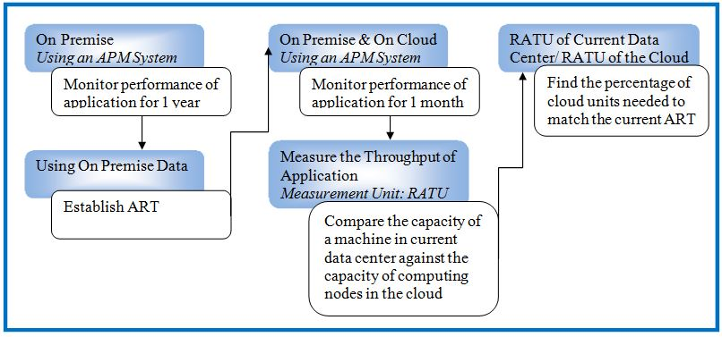

Figure 15 Process of Matching Cloud ART with on-Premise ART

**First**, monitor the application performance on premise using some sort of Application Performance Monitoring (APM) system with accessible data. The monitoring should continue for long enough time (about one year) to show the periodicity of typical steady state usage as well as the average and peak application throughput.

**Second**, establish an Acceptable Response Time (ART) using the data provided from the previous step.

**Third**, test the application with simulated load on the cloud environment that one intends to use. Note that the APM must run on both environments for an indicated amount of time (let’s say one full application lifecycle, the rule of thumb is one month) and record the performance characteristics.

**Fourth**, compare the capacity of a machine in current data center against the capacity of computing nodes in the cloud to discover just how many nodes are needed to match the performance of the data center. To do so, measure the throughput of the application running in current data center and the throughput of it in the cloud environment. The unit of measurement to use is RATU_ Response Acceptable Throughput per computing Unit. RATU is calculated by dividing the ART by the number of machines the application is running on. (Note: for simplicity the hardware is assumed uniform, but if it’s not then, compute a weighted average.)

**Fifth**, divide the RATU of current data center by the RATU of the cloud to see what percentage of more cloud units is needed to achieve the same performance as the current environment.[Livshutz, 2011][26]

**Drawback of this method**: Application Response Time is seen as the sum of Network Response Time (NRT) and Transaction Response Time (TRT) as explained in figure 16.

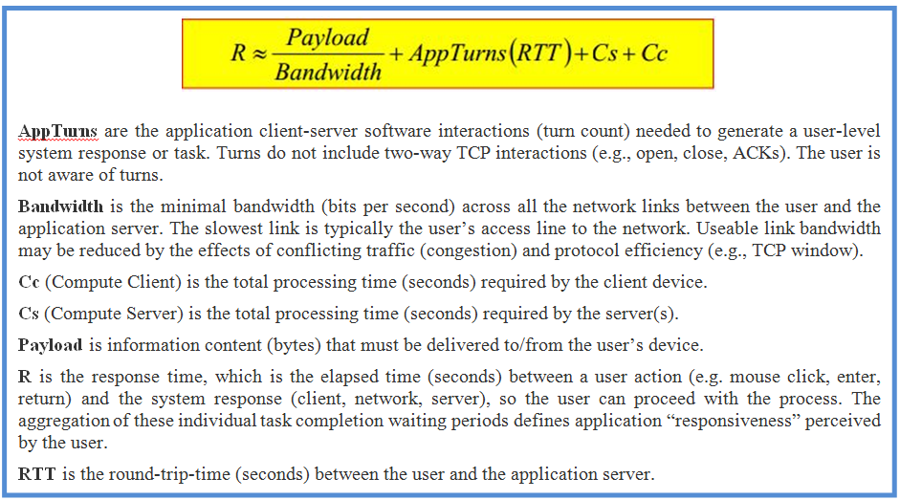

Figure 16 Application Response Time Components[27]

The second monitoring process monitors the network on both the client and the server sides. Measuring at the server provides Server Response time, hiding the Network Response time. Measuring at the client includes both Server Response and Network Response times.

Network Response = Client side latency measurement – Server Response

As the cliché goes, the devil is in the details. For more details, refer to the work of [Peter Sevcik and Rebecca Wetzel, 2006] of NetForecast.

Cloud service providers use two branches of technology to develop application acceleration services: 1- application acceleration and [wide area network (WAN) optimization](http://searchenterprisewan.techtarget.com/definition/WAN-optimization) appliances. 2-[content delivery networks](http://searchenterprisewan.techtarget.com/Content-delivery-networks-A-primer-of-CDN-providers-and-technology) (CDNs). Both focus on the network and they are not mutually exclusive. WAN optimization products improve throughput, reduce payload, and reduce round trip time and application turn. CDNs accelerate a subset of traffic, including web traffic by reducing payload, speeding server compute time, and retrieving content more efficiently. They are usually deployed in a data center as software or a standalone appliance.[28]

Amazon, for example, partners with Riverbed to use Cloud Steelhead appliances to optimize WAN for AWS infrastructure as a service. Also, amazon is a big-enough cloud provider to build its own CDN. Amazon’s CloudFront CDN service improves cloud application response time for AWS customers.[29]

**Technical Support**

When a technical difficulty arises, it is important to have support engineers that can address the problem and offer a solution as fast as possible. Many help desk responsibilities will be handed over to cloud service providers’ support team once the transition is made. As an example, the scope of the support for Amazon AWS is listed below:

* "How to" questions about AWS services and features
* Best practices to help one successfully integrate, deploy, and manage applications in the cloud
* Troubleshooting API and AWS SDK issues
* Troubleshooting operational or systemic problems with AWS resources
* Issues with the Management Console or other AWS tools
* Problems detected by EC2 Health Checks
* A number of 3rd Party Applications such as OS, web servers, email, vpn, databases, and storage configuration

Support response time is the interval between when the first contact is made to the CSP and when the first-contact response is received from the CSP. First contact may happen through email or phone call. Below is the summary of the response time packages available for AWS (figure 17).

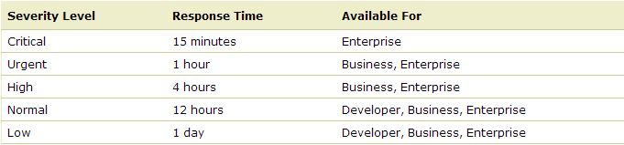

Figure 17 AWS Support Response Time

Developer-level customers can expect a support professional to be available Monday through Friday 8am-6pm in the customer time zone. Business and Enterprise-level customers can expect support any time, 24 hours a day, 7 days a week, and 365 days a year.[30]

**Fault Tolerance** **Maneuverability**

In the case of high availability or life-critical applications, fault tolerance is the property needed to enable them to continue operating properly in the event of one or more faults within some of its components. Failure of IT systems could be very costly. In order to minimize impact of failure on the system and application execution, faults should be anticipated and proactively handled before they interrupt the system and notify the end users.

Although it’s true that critical systems must be available at all times, today’s society also expect a much wider range of software to always be available to people. For example, people may want to send emails or pay online bills. Whether it is at 9:00am on a Monday morning or 3:00am on a holiday, they expect the site to be available and ready to process their inquiry. The cost of not meeting these expectations can be crippling for many businesses. Fault tolerant architectures are the very life blood of every company. Losing the IT infrastructure and/or losing data could equal losing the whole business.

When a server crashes or a hard disk runs out of room in an on-premise datacenter, immediately, a report is sent to administrators because these are noteworthy events that require at least their attention — if not getting them actively involved as well. The ideal state in a traditional, on-premise datacenter environment tends to be one where in case of a failure, a notification is passed reliably to a staff of administrators; who are ready to spring into action in order to solve the problem. Many organizations are able to reach this state of IT paradise – however, doing so is typically very costly as it requires extensive experience, up-front financial investment, and significant human resources. Monitoring and handling failures are significantly different in the cloud environment. Cloud computing uses fault tolerance techniques to proactively mitigate the risk of failure.

“Cloud fault tolerance is concerned with all the techniques necessary to enable a system to tolerate the software faults that are remained in the system after the software has actually been developed.”[31] The failures could arise from server, network, or power faults or from a mistake that an operational staff has made. The cloud service providers’ “99.9% uptime” is meaningless for the cloud consumers if “their applications” are part of the 0.1% that is down. CSPs understand this and have addressed the consumers’ concern by incorporating fault tolerance into cloud architectures. In fact, cloud consumers can enroll into various services in order to add onto the fault tolerance of the system or they can opt out of services if there needs to be a better balance between the high level of fault tolerance and budgetary constraints. Unlike on premise fault tolerance architecture that is built once and used for decades, the cloud fault tolerance architecture can be easily manipulated in order to balance the needs of the business.

Below is a description of how to achieve fault tolerance and high availability using Amazon Web Services (AWS). [32]

AWS provides services and infrastructure to build reliable and highly available systems in the cloud. These qualities have been designed into the services. Some of these aspects are handled without any special action by cloud users, while some others require explicit and correct use of specific features.

Just moving a system into cloud does not make it fault tolerant or highly available. In fact, complexity of the world of cloud makes it even more susceptible to failure. For example, Amazon Elastic Compute Cloud (EC2) provides infrastructure building blocks that, by themselves, may not be fault-tolerant. Hard drives, power supplies, and racks are susceptible to failure. Yet Amazon EC2 and Amazon Elastic Block Store (EBS), which provide basic infrastructure to cloud users, have specific features such as availability zones, elastic IP addresses, and snapshots that a system must use correctly in order to achieve fault-tolerance and highly availability.[33] Figure 18 along with the descriptions that follow refer back to Amazon’s pool of AWS reference architecture. They depict and explain the architecture of these services.

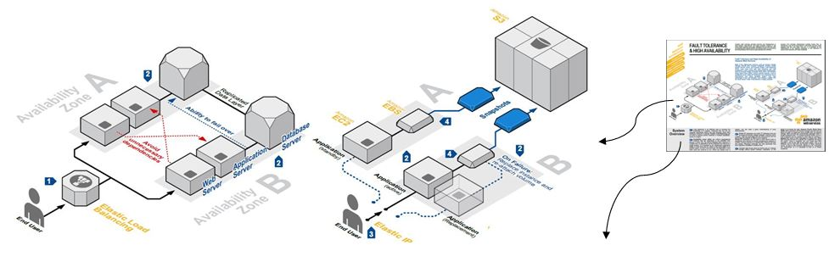

Figure 18 AWS Fault Tolerance Architecture[34]

**1**

Load balancing is an effective way to increase the availability of a system. Instances that fail can be replaced seamlessly behind the load balancer while other instances continue to operate. Elastic Load Balancing can be used to balance across instances in multiple availability zones of a region.

**Availability zones (AZs)** are distinct geographical locations that are engineered to be insulated from failures in other AZs. By placing **Amazon EC2** instances in multiple AZs, an application can be protected from failure at a single location. It is important to run independent application stacks in more than one AZ, either in the same region or in another region, so that if one zone fails, the application in the other zone can continue to run. When one designs such a system, one will need a good understanding of zone dependencies.

**3**

**2**

**Elastic IP** addresses are public IP addresses that can be programmatically mapped between instances within a region. They are associated with the AWS account and not with a specific instance or lifetime of an instance. **Elastic IP** addresses can be used to work around host or availability zone failures by quickly remapping the address to another running instance or a replacement instance that was just started. Reserved instances can help guarantee that such capacity is available in another zone.

Valuable data should never be stored only on instance storage without proper backups, replication, or the ability to re-create the data. **Amazon Elastic Block Store (EBS)** offers persistent off-instance storage volumes that are about an order of magnitude more durable than on-instance storage. EBS volumes are automatically replicated within a single availability zone. To increase durability further, point-in time snapshots can be created to store data on volumes in **Amazon S3**, which is then replicated to multiple AZs. While EBS volumes are tied to a specific AZ, snapshots are tied to the region. Using a snapshot, one can create new EBS volumes in any of the AZs of the same region. This is an effective way to deal with disk failures or other host-level issues, as well as with problems affecting an AZ. Snapshots are incremental, so it is advisable to hold on to recent snapshots.

**4**

The higher-level services, such as Amazon Simple Storage Service (S3), Amazon SimpleDB, Amazon Simple Queue Service (SQS), and Amazon Elastic Load Balancing (ELB), however, have been built with fault tolerance and high availability in mind. Any combination of these services could be used to increase fault tolerance and high availability.

Failures in applications that are built on cloud environments can be dealt with automatically by the system itself. Cloud environments provide access to a vast amount of IT infrastructure that could be allocated nearly automatically to account for almost any kind of failure. The charges, however, are made only upon actually using the resources, so there is no up-front investment to be made. One can build a highly reliable and fault tolerant system using multiple Amazon EC2 instances_ using the tools and ancillary services such as Auto Scaling and Elastic Load Balancing. [35]

**Application Maintenance** **Burden**

Applications have hardware and software components that require periodic checkup and maintenance in order to function properly. Regardless of what type of cloud the application is moved onto, some maintenance responsibilities are handed over to the CSP. Reducing the size of data centers and server houses results in less hardware checkups, hardware repairs, and technology replacements and renewals. For a client/ server architecture hosted on-premise, maintenance of applications, also includes patch updating and software upgrading, which is resource consuming. Many man-hours are spent on acquiring patches and new versions of software from vendors and installing them on both the server machines and the client machines. Following the installation are customizing the upgraded versions and testing the new changes in order to verify the correctness and readiness of the application. Moving an application to cloud could hand over the responsibility of maintenance from LMIT to the application vendor resulting in increasing system agility and subsequently system performance.

#### Industry Adoption

**Current Industry Adoption**

As seen in figure 19, most of the cloud users are using SaaS with the most widely use of cloud being for development and test environment.

Since 88% of the cloud users except a better benefit from the cloud in the future, CCT has conducted a “future” trend analysis or Industry adoption.

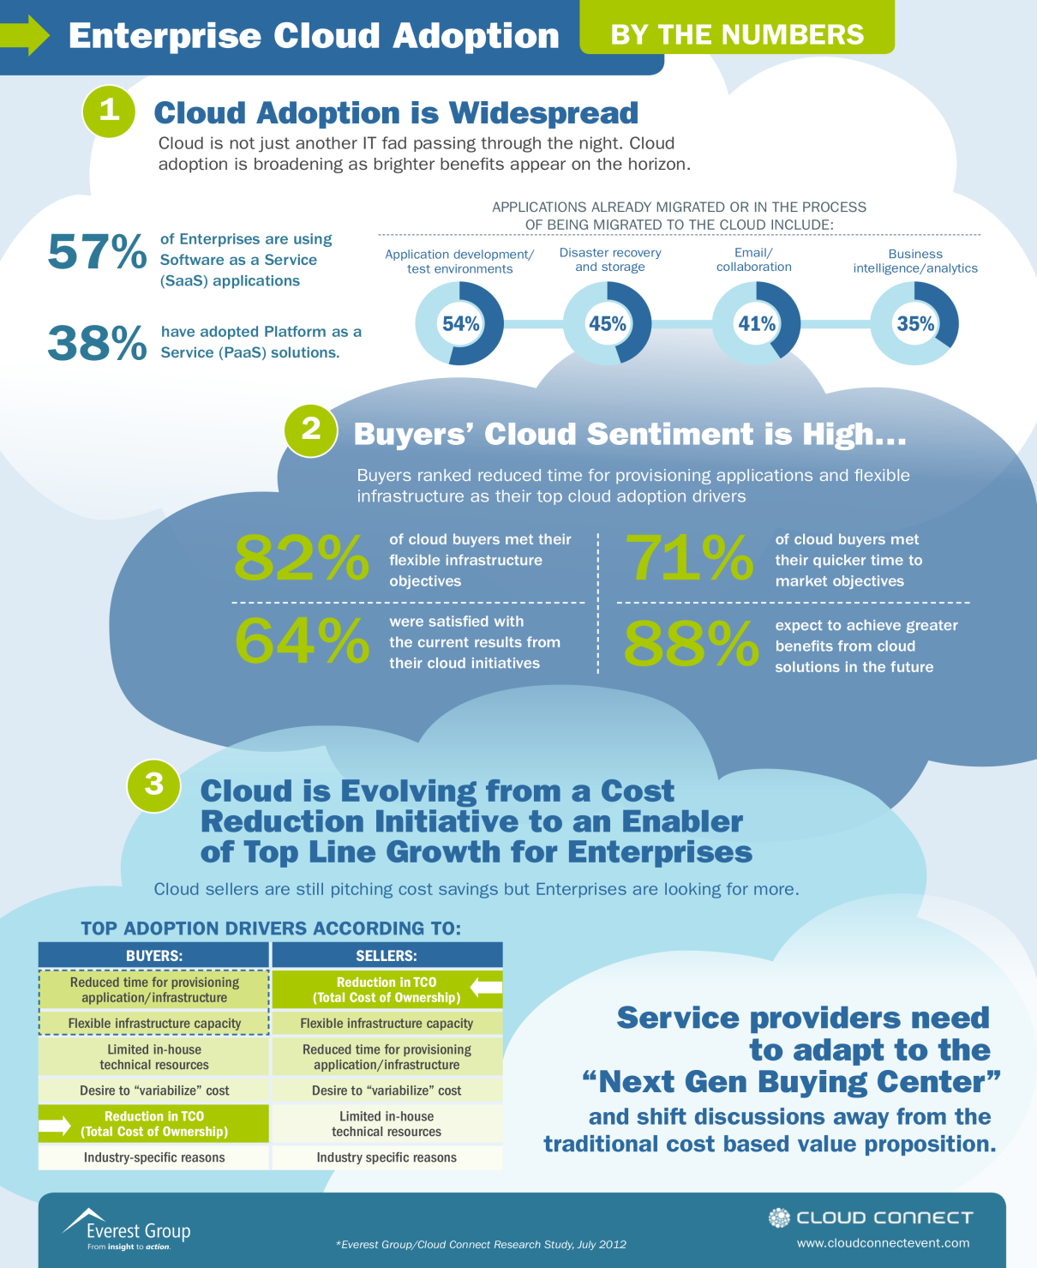

Figure 19 Enterprise Cloud Adoption[36]

**Future of Industry Adoption for Cloud**

Cloud computing can be defined in many ways, but in simple terms "the cloud" can be called as a symbol for the Internet, which is a quite familiar cliché, but when it combined with "computing," the meaning gets bigger and fuzzier. Several scientists and service vendors define cloud computing as “an updated version of Service oriented computing with virtualization”: basically virtual servers available over the Internet. In this regard Charles Babcock definition of Cloud Computing makes sense very well which says, "one of the secrets of cloud computing is that cloud software reflects a new architecture that best exploits the clustered resources around it. It exploits them in such a way that one instance of the software potentially can serve hundreds or thousands of users, and a handful of instances can serve hundreds of thousands." Cloud Computing is required to concentrate on the dynamic, exponentially growing demands for real-time, reliable data processing of 'Internet of Things’. The future of cloud computing services is heading towards offerings of flexible development and deployment environments. Figure 19 summarizes this understanding of cloud computing adoption in the industry.

The cloud, with its vast agility of software access to end users, has created challenging software delivery problems like cost efficiency delivery, scalability, and the need for “codification” of critical processes. For example IIS, WebSphere, database servers, etc. typically provide a wealth of tooling to network folks in support of applications. Here cloud providers and integrators may determine the future adoption of cloud computing. These future clouds normally support the following functions: “open platform stacks, provide generic interfaces between components, support infrastructure abstraction, and utilize standard communication frameworks”. Based on CCT research, there are several proposed solutions available which are known as Cloud Middleware such as Carbon 3.0, WS02, SaaSGrid, Sky Computing, Altocumulus etc.[37]

## Current IT Infrastructure at NOVEC

### Overview

This section provides the in depth research that the CCT performed throughout the duration of this project by review many scholarly articles, websites, and books while conducting interviews with GMU faculty members, cloud experts, NOVEC/LM stakeholders, and Cloud Service Providers (CSPs). This process also included frequent site visits to NOVEC/LM facilities to collect significant data. This in-depth research contributed significantly to the CCT’s technical analysis effort further described in section 4.

In the following sub-sections, the reader will find detailed information about the core applications at NOVEC, their main functionalities, dependencies, infrastructure descriptions, challenges, and possible cloud solutions that exist for those applications. During this process a detailed questionnaire was developed for extract information about each of the core applications and was delivered to the stakeholders prior to site visits.

### Current IT infrastructure System Viewpoint

For better presentation of NOVEC/LM IT infrastructure to the stakeholders and easier investigation of network connections CCT developed a system viewpoint (SV-1).

Macintosh HD:Users:bitarafa:Documents:Ali Documents:JOB:NOVEC:My work:CLOUD:SE Modeling:Models snapshots:SV1- High Level:System Viewpoint (SV-1).pdf

Figure 20 NOVEC/LM current IT System Viewpoint (SV-1)

As it comes from the figure, NOVEC has 6 offices. Manassas (MA) office is the main datacenter and Minnieville (MN) office is designed for Disaster Recovery purposes. All offices, except Stafford office, are connected through Fiber optics. Internet connection of all offices is provided via Manassas office. Color codes are used for better tracing of application servers in different offices. Figure 20 depicts the system view (SV-1) of interfaces among all applications and offices. Having this holistic view of the system, one can begin exploring each application in next chapters.

### Core Applications

The following sections describe each of the core applications at NOVEC.

#### Enterprise Resource Planning (ERP)

**Main Functionality:** Enterprise Resource Planning provided to NOVEC by vendor “Infor Lawson” is a unified solution for financial management, human capital management, procurement, and analytics that provides the robust functionality needed to improve efficiency and effectiveness of key organizational functions. It deals with NOVEC employees personal and financial data.

**Dependencies:** TheERP communicates with the CIS and the WMIS. The ORACLE database of the ERP sever is connected to ORACLE database of Work Management Information System (WMIS) database server through a Database Link. The interface between the ERP and the CIS is via automated file sharing. In this connection, files in the ERP will be exported in a format readable by CIS application and then be sent through the network to the CIS application. The CIS interface is shown below in figure 21.

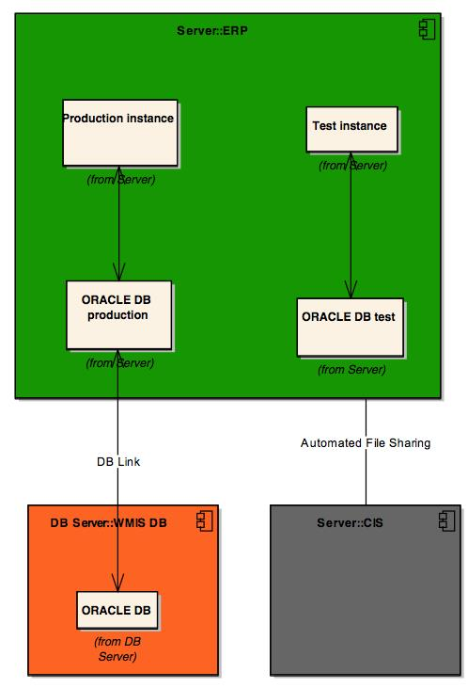

Figure 21 Interdependency of ERP with Other Applications

**Infrastructure Description:** There are two sets of machines for the ERP applications. The main one is located in Manassas office, and the other in Minnieville office for Disaster Recovery purposes. Each machine has two instances of the application, giving this opportunity to the ERP specialist to have both a production and a testing environment at the same time. In figure 22, the application layer and database layer are depicted.

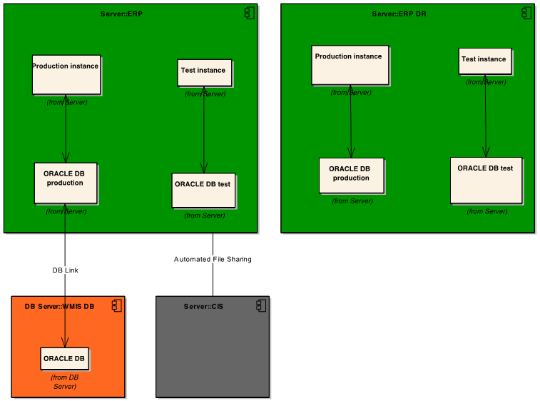

Figure 22 ERP Components

**Known Challenges:** There are not any known challenges the application currently experiences.

**Cloud Offerings:** The vendor (Infor Lawson) offers a SaaS based solution as well as an IaaS. It is also possible to move the application to an IaaS from a major cloud service provider such as Amazon.

#### Customer Information System (CIS)

**Main Functionality:** Customer Information System by Daffron closes the gap between NOVEC and its customers by providing means to store customers’ personal and financial data as well as their needs, preferences, and service orders.

**Dependencies:** TheCIS has several interfaces with other in-house and third party applications but as far as the 8 core applications, it communicates with the GIS system and the ERP system. The CIS application is running on IBM AS/400 platform and because of its nature of hardware and software architecture, most of its interfaces are through file sharing. Custom written codes will export files from the CIS application and send them through the network to the GIS application. The GIS application then reads the file and extracts the pieces of information. The interaction of the CIS application with the GIS system and the ERP system is shown in figure 23.

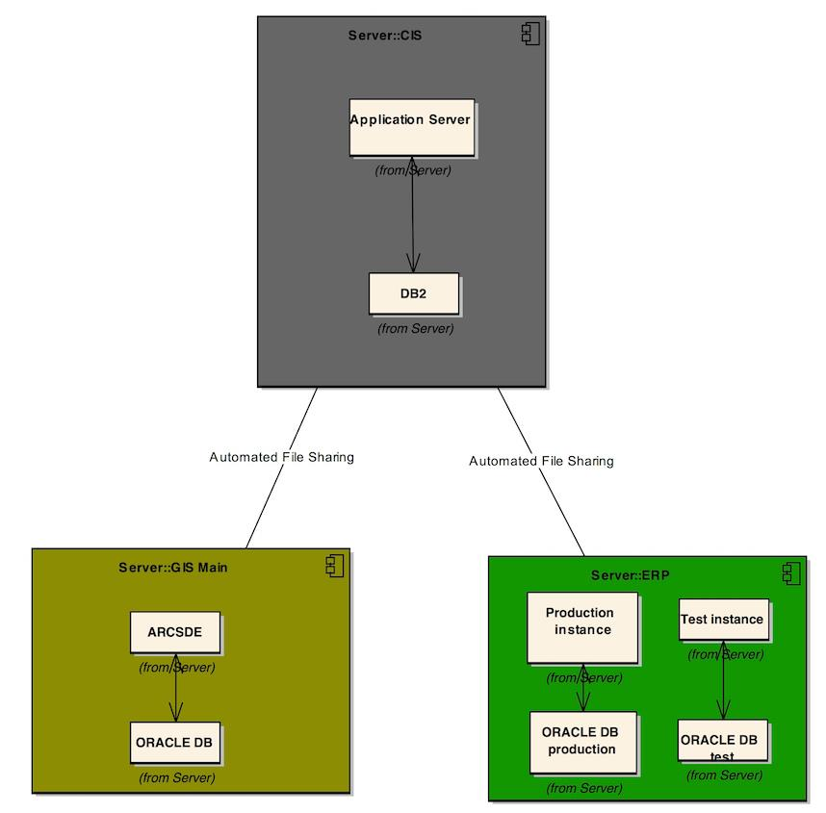

Figure 23 CIS Interdependencies with Other Applications

**Infrastructure Description:** The CIS offered by Daffron uses AS/400 system and the application has an application server and DB2 as its database. The main servers are located in Manassas and the second set are in Minnieville for DR purposes. Figure 24 shows these servers.

Macintosh HD:Users:bitarafa:Desktop:SE Architectural Models-CLOUD:Component Diagrams- Lower Level:CIS (Component Diagram).pdf

Figure 24 CIS Components

**Known Challenges:** Continuous resource increase and technology upgrades are needed to keep the performance of the application at an acceptable level for its users. The application is a legacy application and not virtualizable.

**Cloud Offerings:** The vendor, Daffron, does not offer any cloud solution, so adopting a cloud infrastructure from a service provider would be the only option, assuming that the application would be virtualizable.

#### Geographical Information System (GIS)

**Main Functionality:** Geographical Information System is a complex application being a product of two vendors: ESRI and Schneider Electric. The ArcFM solutions with which NOVEC employees work directly are solutions offered by Schneider Electric in their ArcFM Enterprise GIS package and built on top of ESRI ArcGIS platform (ArcGIS Server and ArcGIS Desktop). Schneider Electric’s ArcFM Enterprise GIS provides a graphical, data-rich environment, displaying the information utilities need for maximum reliability and efficiency. Developed as a complete enterprise solution for an entire organization, ArcFM GIS offers a map-centric, intuitive way to model, design, maintain and manage facility, and land based information. And because geographical information is built into the map data, the asset changes and updates are more apt to operate appropriately under the conditions in the geography, reducing the chance of outages and increasing reliability for NOVEC customers.

**Dependencies:** The GIS communicates with the CIS and the WMIS applications. Connection between the CIS and the GIS is discussed in CIS interfaces. The WMIS and the GIS are connected through Database Link. The GIS interdependencies are captured in figure 25.

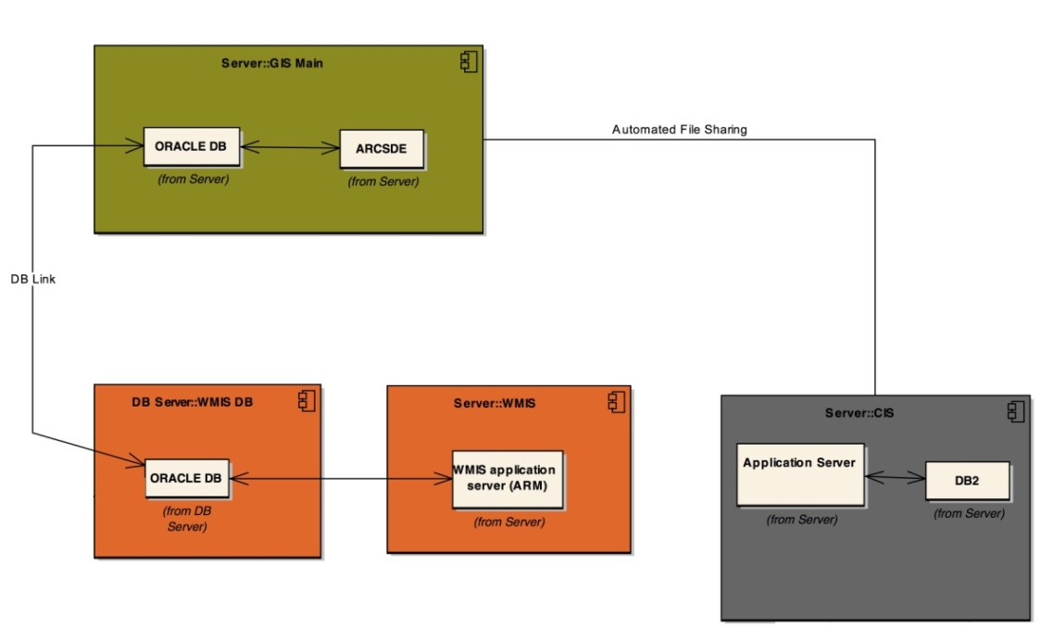

Figure 25 GIS Interdependencies with Other Applications

**Infrastructure Description:** GIS has client-server architecture. This application has five servers in Gainesville, Manassas, and Minnieville offices. GIS Main and GIS Analysis are located in Gainesville office. GIS main provides the main functionality of the application as well as the main geodatabase. Other servers and clients communicate to GIS Main in order to access the server application and main geodatabse repository. GIS Analysis has an application called FME on top of ARCMAP/ARCFM application that is in charge of exporting GIS data files in special formats for other applications. GIS Webserver, located in Manassas, gets the data from GIS Main and provides some of GIS functionalities through web browsers. Figure 26 shows the components of this application.

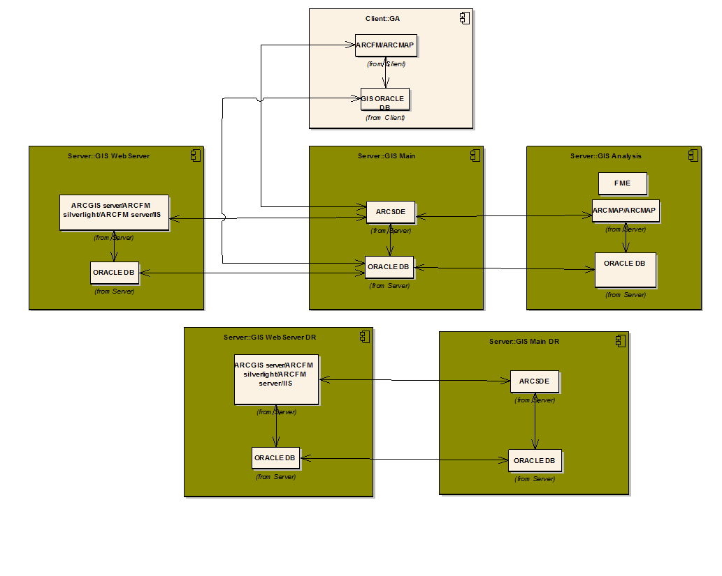

Figure 26 GIS Components

**Known Challenges:** NOVEC employees would like to see a faster response time for this application; however, the complex software architecture of the application is the main cause for the application response time to be at tolerating level; which is not something NOVEC could address in any way.

**Cloud Offerings:** There is no SaaS-based solution offered by the vendors that could replace the current GIS system in NOVEC. ESRI offers cloud infrastructure for ArcGIS Server through Amazon AWS.

#### Work Management Information System (WMIS)

**Main Functionality:** Work Management Information System is a business solution from “CGI” that provides a single business platform for initiating, tracking, designing, scheduling, reporting, and closing all types of work and also for the collection of critical operational data.

**Dependencies:** WMIS has interfaces with GIS and ERP applications. Both of these interfaces are discussed as part of the GIS and the ERP interdependencies. In short, ORACLE database in WMIS Database Server is connected to ORACLE databases of GIS Main and ERP servers. In figure 27, the WMIS interdependencies with other core applications are depicted.

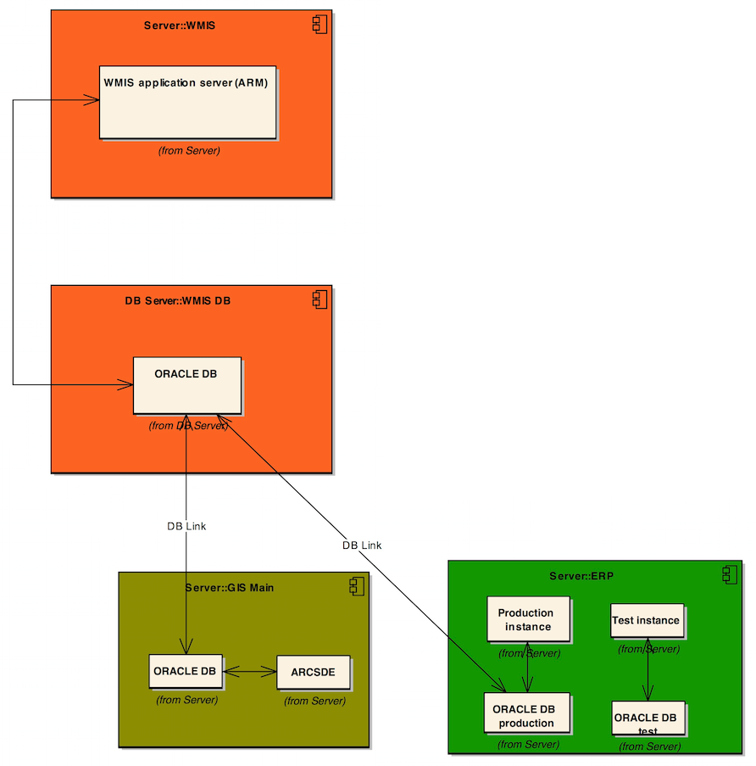

Figure 27 WMIS Interdependencies with Other Applications

**Infrastructure Description:** The WMIS has four machines; Three in Manassas (WMIS main, WMIS Train/Test, and WMIS DB server) and one in Minnieville (WMIS train/test DR DB server). WMIS application servers (ARM) are in virtualized environment. There is one instance of WMIS in main server machine and two instances of WMIS in test/train machine. Figure 28 captures these logical components of WMIS application.

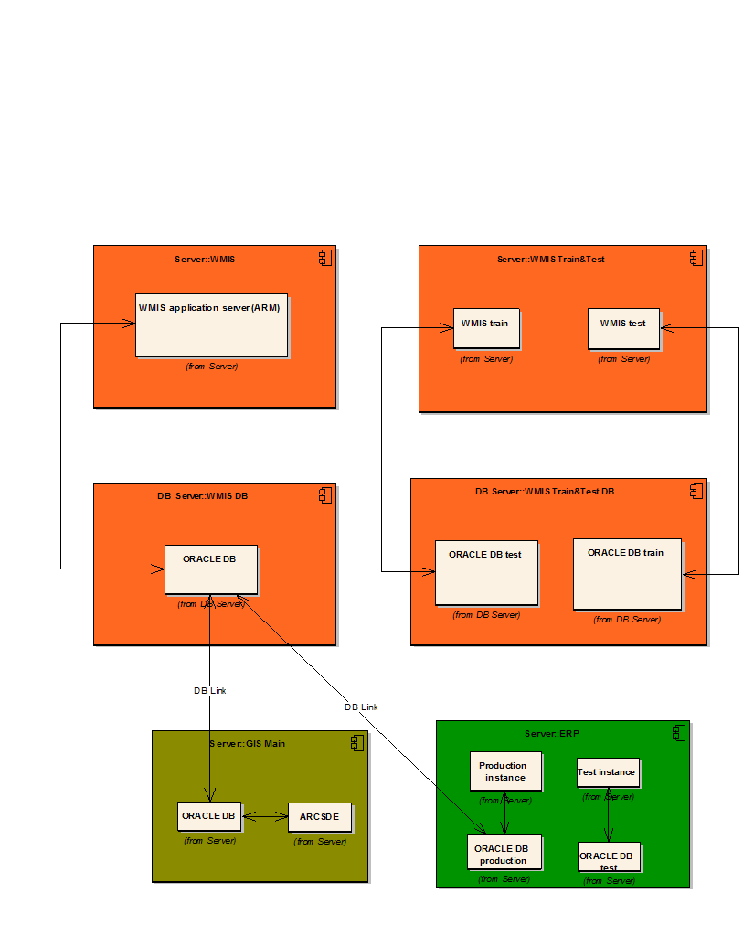

Figure 28 WMIS Components

**Known Challenges:** There are not any critical technical challenges that this application experiences. The application has been going through a major upgrade and testing phase which has been taking several months, highlighting the cumbersome maintenance efforts in general.

**Cloud Offerings:** The WMIS’s original vendor was “Logica” which was later bought by “CGI”. CGI, now, offers the WMIS to its new customers as part of a larger business tool box, Asset and Resource Management (ARM) Suite. NOVEC believes that they have no use for the other solutions offered in this suite rather than its Work Manager. Therefore, they will not be interested in investing in the ARM suite if ever offered as a cloud-based solution. CGI offers cloud infrastructure and expert guidance to successfully migrate to it. Another option would be to get cloud infrastructure from a cloud service provider like Amazon.

#### NOVEC’s Website

**Main Functionality:** The website is NOVEC’s face in the virtual world, introducing the company to people who search for it on the internet. It is also the point of contact for its customers to check their account activities, report power outages, place inquiries and track their inquiries.

**Dependencies:** TheWebsite has some interfaces with other applications but no interaction has been identified between website and the eight core applications.

**Infrastructure Description:** Website, as well as other web services, is based on 4 web server and database server machines; External web services server, which is an interface between intranet and Internet. IIS Web server and ColdFusion web servers provide website and corresponding applications, and finally an ORACLE database server as the database of website and other web services. Figure 29 depicts the website infrastructure and its components.

**Macintosh HD:Users:bitarafa:Documents:Ali Documents:JOB:NOVEC:My work:CLOUD:SE Modeling:Models snapshots:Component- Lower Level:SQ:Website (component).pdf**

Figure 29 Website Components

**Known Challenges:** The main challenge the website is facing is the occasional surge of customers trying to report power outages and NOVEC’s server resources and bandwidth not being enough to handle it.

**Cloud Offerings:** IaaS from any major cloud service providers such as Amazon

#### Document Imaging

**Main Functionality:** Document Imaging from ComSquared is an application that uses OCR capabilities to facilitate scanning of different types of documents including application forms, work request contracts and so. It stores records of the different business transactions in a centralized repository system and allows for searching those records and retrieving the scanned documents associated with them.

**Dependencies:** ComSquared document imaging retrieves some pieces of information from CIS system and merges them to its data repository. An ORACLE database in a database server (manhp8) is connected to CIS application. This interdependency is captured in figure 30.

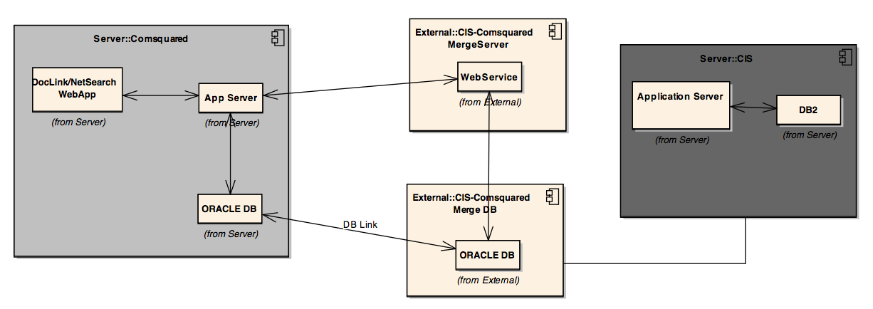

Figure 30 Document Imaging Interdependencies with Other Applications

**Infrastructure Description:** The system uses a UNIX server called “novecimg”. The desktop application that scans the documents is called “Image Director ST” and uses Panasonic scanners. The desktop application is configured with a secured ftp site to transmit the scanned documents to the server. The system uses a browser based interface to provide search capabilities. The browser based interface has two applications that can be used to search the documents repository: “NetSearch” web application and “DocLink” web application. There is a process running that merges information from the CIS, via an Oracle database, in the server database on “novecimg”. The reference between the document imaging system and the CIS is the account number.

**Known Challenges:** The application can handle maximum 20 concurrent users. This is a limit set by the architecture of the application itself that could hinder performance of it.

**Cloud Offerings:** IaaS from a major cloud service provider such as Amazon

#### Email

**Main Functionality:** Sending and receiving emails as well as storing contacts and calendar information.

**Dependencies:** Email is a stand-alone application and it does not have any interdependency with other applications.

**Infrastructure Description:** Email server, residing in Manassas office in a virtualized environment, provides email services to in-house and outside users.

**Known Challenges:** There are not any known challenges to this application.

**Cloud Offerings:** Microsoft 365 Outlook Exchange

#### Microsoft Office Suite

**Main Functionality:** Creating and editing Word documents, PowerPoint presentations, Excel sheets and charts, Access databases, and Visio diagrams.

**Dependencies:** MS Office suite is a stand-alone application installed in each client machines. It does not have any interdependency with other applications.

**Infrastructure Description:** N/A

**Known Challenges:** There are not any known challenges to this application.

**Cloud Offerings:** Microsoft Office 365

#### Core Applications Interface Diagram

Now that each application diagram has been introduced it is desirable to have a holistic view of the system. Figure 31 depicts the interface of core applications that have interface with each other.

Macintosh HD:Users:bitarafa:Documents:Ali Documents:JOB:NOVEC:My work:CLOUD:SE Modeling:Models snapshots:Component- Lower Level:SQ:Interface diagram (Component Diagram).pdf

Figure 31 Core Applications Interface Diagram

# Technical Analysis

This section provides a detailed description about the technical analysis work that CCT performed during this project. This section describes the methodology, analysis, and results for each of the steps listed in section 2.6. As described and shown in section 2.6, technical analysis phase includes the following analyses:

* Comparative Analysis
  + Major Considerations-based Analysis
  + Applications-based Analysis
* Utility Analysis
* Return on Investment (ROI) Analysis

## Challenges

Throughout the analysis phase of this project, several challenges were raised that required CCT to employ a plan of attack to overcome the challenge. These challenges along with corresponding solutions are as follows:

**Limited Domain Knowledge**

CCT members had limited domain knowledge. This disadvantage caused difficulties throughout the project.

Solution: CCT started to heavily rely on the client to provide critical data about core applications, current infrastructure, and major considerations perspectives. CCT also increased site visits frequency to capture more data.

**Vendors & CSPs not Responding**

In the process of completing the technical analysis phase, the CCT needed critical data about applications that only application vendors would be able to provide. Furthermore, certain data could be only extracted from CSPs such as Amazon, Google, etc. However, neither the application vendors nor CSPs were willing to release any information unless an account was opened. This caused many data mining issues for the CCT as these data were critical to the successful results for the technical analysis phase.

Solution: To make up for lack of aforementioned data, CCT started reviewing scholarly articles and conducted significant literature surveys about to find required data regarding the applications and CSPs. Furthermore, CCT conducted interviews with cloud experts and consultants from different firms, friends, and coworkers.

**Broad IT/Cloud Terms**

For almost all of the major considerations (i.e. cyber-security, agility, scalability, etc.), there were many definitions. These definitions were too broad for considerations. For example, for cyber-security, there were at least 20 types of definitions found in the literature surveys. This caused difficulty for CCT, as certain analyses such as the utility analysis required a unique and succinct definition.

Solution: To cope with the aforementioned challenge, CCT took several actions as follows:

* Defined only a unique and succinct way to define major considerations. Got client’s buy-in for these definitions ensuring these definitions meet NOVEC’s/LM’s needs.
* Defined the big picture in section 2.5 to scope the problem so that the expectation is set right. This meant that definitions for major considerations had to be high-level.
* Utilized SEOR GMU’s professors’ help such as Dr. Karla Hoffman[38], Dr. Paulo Costa[39], and Dr. Andy Loerch[40] to define these major considerations and utility analysis better.
* Decided to stay high-level and qualitative for utility analysis per professors’ instructions.

**NDA Requirement**

Initially, CCT intended to do a full Return on Investment (ROI) analysis for this project. As described in section 4.4, CCT needed detailed operating cost for NOVEC/LM. This meant that NOVEC/LM asked CCT to sign a Non-disclosure Agreement (NDA). Per Dr. Hoffman’s instructions, this was not possible since many other stakeholders such as other student and faculty would see the numbers with no NDA.

Solution: To cope with the aforementioned challenge, CCT decided to research the ROI calculation factors such as cost drivers and necessary elements of ROI for migration to cloud to help the client to understand what is involved in ROI calculation so the client can make better decisions.

## Comparative Analysis

Comparative analysis is the first stage of technical analysis. Figure 32, with a red rectangle, shows where in the project approach comparative analysis resides.

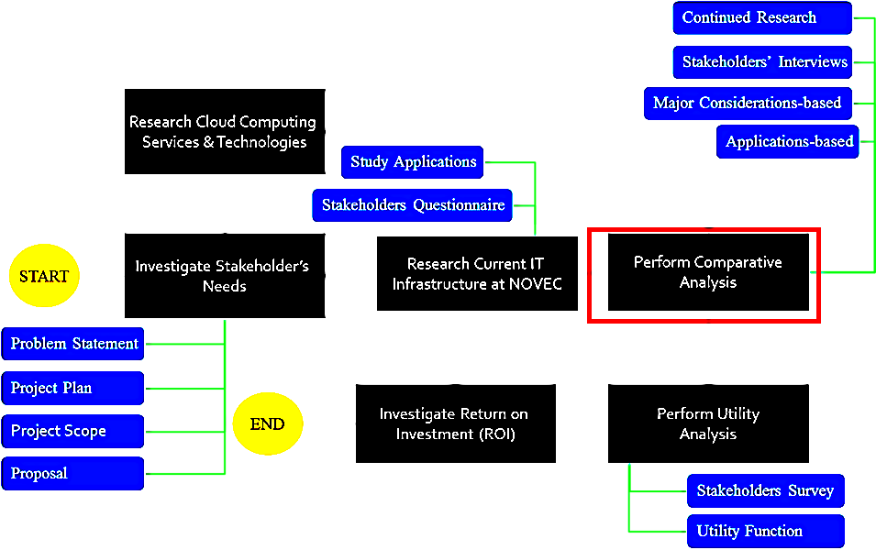

Figure 32 Comparative Analysis in Project Approach

As seen in figure 32, comparative analysis is composed of two analyses: major considerations-based (section 4.2.2) and applications-based (section 4.2.3) analyses. Furthermore, it is notable that comparative analysis is a required input for utility analysis (section 4.3) and ROI analysis (section 4.4).

The overall goal of comparative analysis is to establish a side-by-side comparison between current systems (status quo) and the cloud system in terms of the client’s needs (major considerations). Comparative analysis, moreover, includes analysis of applications and their particular cloud solutions and migration complexities. Comparative analysis will help the client understand the challenges that are ahead of them and provide a checklist or guidelines to consider when migrating the core applications to cloud.

### Methodology

To perform comparative analysis, CCT had to collect significant amount of data by literature surveys and performing site surveys. Figure 33 shows the methodology CCT employed to complete comparative analysis.

In the figure 33, the boxes on the left side represent the data inputs that were required for comparative analysis to be completed. The blue box in the middle represents the process of completing comparative analysis. Major considerations-based analysis receives certain input data shown by orange arrows plus blue arrows. Applications-based analysis received input data shown by green arrows plus blue arrows. These input data were the data that CCT utilized to complete comparative analysis. The red arrow between the orange and green ovals indicates that applications-based analysis was completed while considering the results from major considerations-based analysis. This is further described in section 4.2.2. The data shown on the right side of the figure below represent output data. Output data are the data that are used for utility analysis and ROI. Short description for each of the input datum is as follows:

* Stakeholders’ Needs: these are described in section 2.
* CSP Interviews: CCT contacted CSPs to investigate their infrastructure and status in handling NOVEC’s applications.
* Vendor Interviews: CCT contacted application vendors to collect software and hardware information and to see if there are any existing cloud solutions.
* Site Visits: CCT performed significant site visits to understand the current network and application configuration at NOVEC and collected significant data.
* Industry Adoption: this is described in section 3.1.3.7.
* Stakeholders’ Interviews: during site visits, CCT interviewed many of the stakeholders that directly interact with the core applications and collected significant data about their needs, expertise, and knowledge.
* Cloud Consultants Interviews: CCT contacted a few cloud consultants. These consultants provided in-depth perspective to CCT about cloud migration strategies that were used in comparative analysis.
* IEEE Paper: CCT studies significant number of IEEE papers to gather essential data to complete comparative analysis. These papers provide data about cloud challenges, application migration strategies, etc.
* Other Scholarly Articles: these articles included university research papers, scholarly magazine articles, etc. that provided valuable data about cloud challenges, application migration strategies, etc.
* Cloud Experts: these experts included family members, coworkers, and technicians that had significant cloud knowledge in the field.
* GMU Faculty: CCT met with few faculty members to gain understanding of certain systems engineering methodology, which helped CCT better develop a technical approach that fit within the schedule of this semester.

The description for output data is embedded and further described in sections 4.2.2 and 4.2.3 as outputs from comparative analysis. Figure 33 also shows how findings (outputs) from comparative analysis help (input) utility analysis and ROI analysis indicating that comparative analysis is the cornerstone of this project’s technical analysis phase.

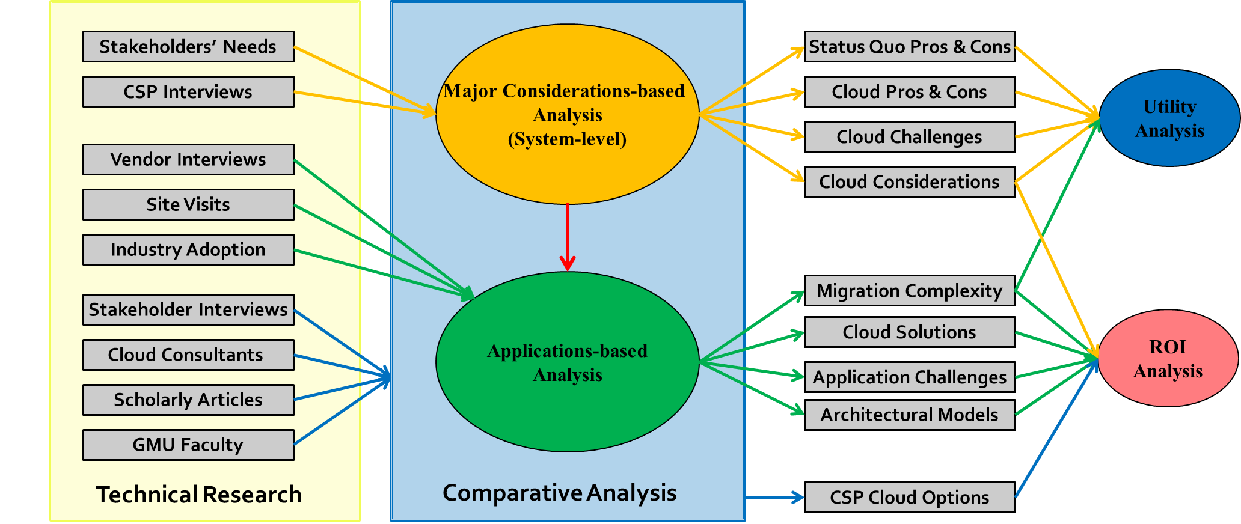

Figure 33 Comparative Analysis Methodology

### Major Considerations-based Analysis

#### Overview & Purpose

**Overview:**

Major-considerations-based analysis is a system-level analysis that provides the client with an understanding of the cloud in terms of advantages and disadvantages for each of the characteristics. Furthermore, this analysis provides specific considerations for each of the characteristics of each major consideration so the client understands options and risks.

Major considerations-based analysis is in format of a table for each major consideration and each of its characteristics as described in section 3.1.3. The table then compares pros and cons of status quo vs. cloud followed by certain considerations that the client need to evaluate. The following sections describe in details the results of the major considerations-based analysis.

**Purpose:**

Purposes of this analysis include:

* Provides a side-by-side comparison of status quo vs. cloud for the client to be aware of advantages and disadvantages
* Provides description of challenges and risks that are involved in migrating to cloud for the client to make more robust decisions
* Inputs to utility analysis since utility analysis is a system-level analysis

#### Major Considerations-based Analysis Results

Major considerations-based analysis results are provided below in the following sub-sections. Each sub-section focuses on one major consideration and its associated characteristics followed by a table that shows the high-level comparative analysis results along with a detailed textual description of the table. For example section 4.2.2.2.1 is about cyber-security (a major consideration) and physical system attack, authentication attack, denial of service attack, and malicious internet content (all cyber-security characteristics) followed by a table and detailed description of the table.

The elements of major considerations-based results table are as follows:

* Major Considerations: these are the areas of focus client asked the CCT to focus on.
* Characteristics: these are elements of each major consideration the CCT focused on.
* Status Quo (Pro and Cons): these are the pros and cons for the current infrastructure at NOVEC. They provide a perspective about how these characteristics look in the current system.
* Cloud (Pro and Cons): these are the pros and cons for the proposed future infrastructure at NOVEC on cloud. They provide a perspective about how these characteristics look in the cloud environment.
* Important to Note Items: these items are certain data that the client should be aware of when moving to cloud. These include possible tiering services, risks, and issues that potentially exist for certain characteristic.

#### Cyber-security

Based on the research section, the CCT has defined four characteristics for cyber-security attacks. Here is a comparison of current IT setup with cloud environment according to these characteristics.

**Physical System Attack**

Attack to physical system is one kind of threats to IT infrastructure, which always exists regardless of the size of datacenter. In table 2 the comparison of attack to the physical system both for status quo and cloud is given.

Table 2 Major Considerations-based Analysis for Physical System Attack

| Status Quo | | Cloud | | Important to Note |
| --- | --- | --- | --- | --- |
| Pros | Cons | Pros | Cons |  |
| As a utility company, NOVEC is not a target for physical attack. | There is not enough facilities installed to monitor unauthorized access to some data centers (e.g. Gainesville office) | CSPs have extensive surveillance facilities to protect their datacenters against physical attacks. | N/A |  |

Although no physical attacks have been reported at NOVEC, this issue should be considered and compared with cloud environment. Cloud Service Providers need to comply with several regulatory requirements for physical security in order to obtain the certifications. These requirements are usually very harsh so that customers can trust their CSP countermeasures for physical attacks.

**Authentication Attack**

According to the discussion in the research section, authentication attacks are related to accessibility of data or application to those who are permitted. There are some concerns regarding this topic when applications are migrated to cloud environment and one can capture them in table 3.

Table 3 Major Considerations-based Analysis for Authentication Attack

| Status Quo | | Cloud | | Important to Note |
| --- | --- | --- | --- | --- |
| Pros | Cons | Pros | Cons |  |
| LM/NOVEC is able to supervise users who maintain the servers and application data. | N/A | When using the cloud technology, one can utilize advanced authentication tools to manage and monitor accessibility of users to the data. | 1- CSP employees are able to manipulate data/application  2- Managing authentication keys is not easy  3- Data/Applications are more exposed to the Internet attackers | There are services offered in cloud that help in overcoming the authentications attacks. |

Although Cloud environment has some challenges, by using appropriate services, one can easily tackle them. For example, Amazon Identity and Access Management (AWS IAM)[41] is a service that can help managing the users and their roles and authentications.

**Denial of Service (DoS) Attack**

As discussed in research section, this happens when attacker tries to make an application or network unavailable to its users. This threat is of more importance in cloud environment than status quo for two reasons. First, attacker is able to provision huge computing resources to perform his attack. And second, the applications or network may be more exposed to attacker compared to in-premise. In table 4, comparison of DoS is captured for cloud and status quo.

Table 4 Major Considerations-based Analysis for Denial of Service Attack

| Status Quo | | Cloud | | Important to Note |
| --- | --- | --- | --- | --- |
| Pros | Cons | Pros | Cons |  |
| LMIT infrastructure is not exposed to attackers in the Internet | N/A | N/A | 1-Applications and network are exposed to the Internet attackers 2- Implementing a secure infrastructure requires extensive effort and time  3- Attacker has more computing resources in cloud to perform a DoS attack. |  |

**Malicious Internet Content**

This category of threats comprises the last characteristic of cyber-security and includes viruses, worms, Trojan horses, botnets, and spyware. While these threats may have not been a big concern for LM/NOVEC till now, it may be a big concern in cloud environment. Table 5 shows the comparison of status quo versus cloud in terms of malicious Internet content.

Table 5 Major Considerations-based Analysis for Malicious Internet Content

| Status Quo | | Cloud | | Important to Note |
| --- | --- | --- | --- | --- |
| Pros | Cons | Pros | Cons |  |
| Firewall and antiviruses are protecting NOVEC/LM IT from malware | Some applications are not protected from certain attacks. (SQL, LDAP injections, etc.) | Capable of protecting against all types of threats through implementations of different technologies before accessing the data | Firewall and antiviruses are protecting NOVEC/LM IT from malware |  |

#### Performance

Based on the research section, the CCT has defined four characteristics for performance.

**Application Response Time**

Application Response Time (ART) is the interval, perceived by the end user, between the instant at which the user at a terminal enters a request and the instant at which the first character of the response to that request is received at the terminal. It is calculated as the sum of Network Response Time and Transaction Response Time. Table 6 shows the analysis results for ART.

Table 6 Major Considerations-based Analysis for Application Response Time

| Status Quo | | Cloud | | Important to Note |
| --- | --- | --- | --- | --- |
| Pros | Cons | Pros | Cons |  |
| Applications currently running solely on client side do not experience any latency due to network response time. An example of such an application is MS Office. | Machine computing capacity and network capacity are predesigned and fixed. Thus, the application response time which is dependent on Network Response Time and Transaction Response Time varies with the throughput of the application and the throughput of the network. Whether it is Satisfactory, Tolerating, or Frustrating, there is not a quick way to increase resources to address it. Any resolution will take months or years to go through planning, approvals, and implementation. | Machine computing capacity and network capacity could be increased or decreased on demand to meet the desired Application Response Time for both the peak and the non-peak usage periods. | Applications that were previously running solely on client side but will be, in the future, accessed on cloud will experience latencies due to network response time even though it might not be very significant. An example of such an application is MS Office. | Application response time is measured in terms of latencies at the server side, the client side and within the network. |

After all, the end user is the one who will be affected by the performance of the application and the one who will be reporting how satisfied he/she is with its response time. Moving to cloud environment changes the ingredients of response time and it is important to measure and monitor them so make sure the end user has the best experience possible.

Network Response Time = Payload/Bandwidth + Application Turns * Round Trip Time

Transaction Response Time = Client Compute Time + Server Compute Time

**Technical Support**

When a technical difficulty arises, it is important to have support engineers as well as support documents that can address the problem and offer a solution as fast as possible. Table 7 shows the analysis results for technical support.

Table 7 Major Considerations-based Analysis for Technical Support

| Status Quo | | Cloud | | Important to Note |
| --- | --- | --- | --- | --- |
| Pros | Cons | Pros | Cons |  |
| With all the equipment in house and all the technical staff available within walking distance, support response time is easier to be negotiated based on the severity of the problem and the availability of the support staff. | There is heavy dependency on support staff expertise for resolving issues. | Cloud service providers give access to many well documented support manuals, best practice instructions, Q&A forums, and live chats in the virtual world which are free of extra charge and accessible to everyone. | The response time is dependent on the tier of support one applies for. The quality of service provided is unknown. And there are limited tiers of support packages available. | Many support responsibilities will be handed over to cloud provider for the part of the system moved to their side. |

Moving to cloud environment, many changes will happen in the way the technical support staff are reached, the time it takes to reach them, the way the problems need to be communicated, and the way the resolutions are offered.

**Fault Tolerance Maneuverability**

Fault tolerance is concerned with all the techniques necessary to enable a system to tolerate the software faults that are remained in the system after the software has actually been developed, and subsequently, to increase the availability of the system. Table 8 shows the analysis results for fault tolerance.

Table 8 Major Considerations-based Analysis for Fault Tolerance

| Status Quo | | Cloud | | Important to Note |
| --- | --- | --- | --- | --- |
| Pros | Cons | Pros | Cons |  |
| Complexity of the system hardware architecture is rather low and thus chances of failure are lower and preventing failure is achieved easier. | Changes in fault tolerance require new designs and developments that might take months or years to be done. | Not only is there a way to build a fault tolerant architecture in the cloud but also there are specific services that increase the fault tolerance of the system to ensure a higher availability. Unlike on premise fault tolerance architecture that is built once and used for decades, the cloud fault tolerance architecture can be easily manipulated in order to balance the needs of the business. In fact, cloud consumers can enroll into various services in order to add onto the fault tolerance of the system or they can opt out of services if there needs to be a better balance between the high level of fault tolerance and budgetary constraints. | Cloud by itself is not any more fault tolerant than on premise infrastructure. It is in fact more prone to failure due to the complexity of its hardware and network infrastructure. | The failures could arise from server, network, or power faults or from a mistake that an operational staff has made. |

In order to minimize the impact of failure on the system and application execution, failures should be anticipated and proactively handled before they interrupt the system and notify the end users. The system architecture design should account for fault tolerance. Cloud service providers have matured their fault tolerance architecture by offering several services that cloud consumers can opt in to or out of in order to change the level of availability assurance based on their technical needs and budgetary constraints.

**Maintenance Burden**

Maintenance burden is comprised of the man-hours and the administrative, the planning, and the execution effort involved in maintaining the hardware and the software of an application. Table 10 shows the analysis results for maintenance burden.

Table 9 Major Considerations-based Analysis for Maintenance Burden

| Status Quo | | Cloud | | Important to Note |
| --- | --- | --- | --- | --- |
| Pros | Cons | Pros | Cons |  |
| Not Known | For a client/ server architecture hosted on-premise, software maintenance, including patch updating and software upgrading, is resource consuming and cumbersome. Many man-hours are spent on acquiring patches and new versions of software from vendors and installing them on both the server machines and the client machines. Following the installation are customizing the upgraded versions and testing the new changes in order to verify the correctness and readiness of the application.  Additionally, hardware maintenance and keeping up with technology upgrades calls for another set of maintenance. | In a typical IaaS cloud, the cloud service provider maintains everything below the hypervisor layer (the server, storage and networking hardware and its virtualization). Also, If a SaaS version of the application is available or the application is moved to an IaaS offered by the same "application vendor", many maintenance responsibilities including system upgrades and tests could be handed over to the "application vendor". | Not Known | Maintenance includes both the hardware and the software maintenance of the application |

Maintenance burden on NOVEC employees varies with the type of cloud they decide to move on to. Generally speaking, IaaS would leave the most maintenance efforts and SaaS will leave the least maintenance efforts on NOVEC personnel, both of which are expected to have less maintenance burden than what is currently on NOVEC; as a result of outsourcing a part of the system to cloud environment.

Many applications have the option of a SaaS, a vendor IaaS, or an IaaS from another CSP. Maintenance burden on NOVEC increases as they move from a SaaS option to the Status Quo as shown in figure 34.

Figure 34 Maintenance Burden Increase

#### Disaster Recovery (DR)

Disaster recovery in cloud environment has lots of potentials and benefits for NOVEC/LM. In table 10, important factors of DR are compared for status quo and cloud.

Table 10 Disaster Recovery Major Considerations-based Analysis

|  | Status Quo | | Cloud | | Important to Note |
| --- | --- | --- | --- | --- | --- |
| Characteristics | Pros | Cons | Pros | Cons |  |
| RTO and RPO | N/A | 1- Currently, there is no requirement for RTO and RPO but experts estimate both of them to be one day.  2-In current IT setup, improving the RTO and RPO is cumbersome and time-consuming. | In the Cloud, one is able to improve RTO and RPO while decreasing the cost of DR implementation. | N/A |  |
| Time to perform backup | Performing backup in status quo is time-consuming and burdensome (1- daily backup 2- weekly/monthly cold-backup). IT employees need to physically perform the backup and take the tapes from one data center to another data center every day. | When using Cloud technology, one can benefit from scheduled and automatic backup without the need of employees' time and effort |  |
| Vulnerability of DR site to Natural Disasters | Since DR site and production site are close (about 12 miles), a disaster such as a tornado may affect both sites and make them inaccessible. | There are different availability zones, engineered in a way that if a disaster happens in one zone, the other is unlikely to suffer from that disaster |  |

The criteria discussed in table 10 are the most important things to consider for DR in the cloud. However there are other concerns such as accessibility to NOVEC data when Cloud DR Service is in use. These issues are important and are pointed out in Cloud Computing research section of this report. CSP’s can assure their customers about availability of their data based on their Service Level Agreement (SLA) and customers can trust CSP’s based on their certificates and good reputation.

#### Scalability

Based on the research the CCT has performed, scalability is defined with three characteristics. Below is a description of how these characteristics differ in the status quo vs. in the cloud.

**Auto-scaling**

Auto scaling is defined as following:

“Auto Scaling is a web service that enables the cloud to automatically launch or terminate web service that provides resizable compute capacity in the cloud instances based on user-defined policies, health status checks, and schedules. Web service that provides resizable compute capacity in the cloud instances are servers in the cloud. For applications configured to run on a cloud infrastructure, scaling is an important part of cost control and resource management. Scaling is the ability to increase or decrease the compute capacity of your application by either changing the number of servers (horizontal scaling) or changing the size of the servers (vertical scaling).”

In a classic business situation, when the web application starts to get more traffic, one option is to add more servers or increases the size of the existing servers to handle the additional load. Also, if the traffic to the web application starts to reduce the speed, one either terminates the under-utilized servers or decreases the size of the existing servers. Based on the research the CCT has done and depending on the infrastructure (LM for example), vertical scaling might involve changes to the server configurations every time one scales. With horizontal scaling, the customer can merely increase or decrease the amount of servers based to the application's demands. The decision when to scale vertically and when to scale horizontally is dependent on factors such as: “the use case, cost, performance, and infrastructure”.

When the customer scales using Auto Scaling they can add to the number of servers using automatically when the user order goes up to ensure that performance stays the same, and can decrease the number of servers when demand goes down to minimize costs. Auto Scaling helps in making efficient use of the resources by automatically doing the work of scaling.

Auto Scaling allows the customer to scale the resources “dynamically” and “predictably”:

**Dynamically:** based on conditions specified by the customer (for example, increasing CPU utilization of one’s Web service that provides resizable compute capacity in the cloud, instance)

**Predictably:** according to a schedule defined by the customer (for example, every Friday at 13:00:00).

Let's examine an instance where Auto Scaling works. “Suppose the customer has a web application that runs on a single cloud server. The single server performs well when it has regular traffic. However, occasionally the traffic to the applications increases up to three times the normal load. When that happens, one needs an additional cloud server to handle the increased traffic. For the application to scale gracefully with the additional traffic load, the customer will need to launch the second cloud server ahead of the time when the increased load occurs, and then terminate that server after traffic goes down to normal levels. This process works best where the application has predictable traffic patterns, so that the customer will know when to launch the additional server and when to terminate it.

However, what if the customer does not know when the next traffic spike will hit one’s application? Where traffic spikes are not possible to predict, the customer would need to launch two cloud servers and keep them running at all times, even when the second server rarely gets any traffic. Of course, the additional server will incur costs while it is running.

What happens in this example if one uses Auto Scaling? First, they will not have to keep the second server running all the time. Instead, customer can define the conditions that determine the increasing traffic to one’s application servers, and then tell Auto Scaling to launch a similar application server whenever those conditions are met. Second, the customer can define another set of conditions that determine the decreasing traffic to one’s application servers and then tell Auto Scaling to terminate a server when those conditions are met. The following diagram illustrates a set of simple Auto Scaling conditions.” [42] Figure 35 shows this process.

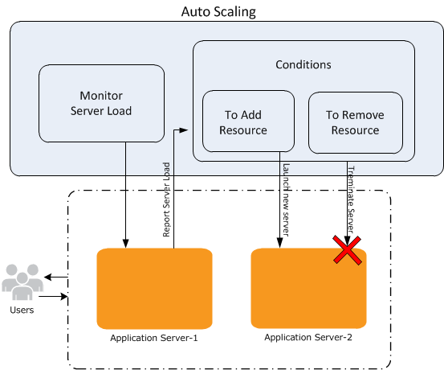

Figure 35 Auto Scaling Example Model[43]

**Number of Users**

Cloud also gives the customer the ability to have (almost) ultimate number of users on the server compared to the status quo where there is a limitation to the number of users.

Here are some of the advantages of using this capability in the cloud solution shown in figure 36.

Figure 36 Scalability (Number of Users) Advantages

**Adding more computers (IP addresses) will be effortless and not dependent on the number of current users**

A selection of connectivity options exist when using this capability of the cloud. One can connect to the Internet, to datacenter, or both, according to the cloud resources that one wants to expose publicly and those that one would like to keep private.

This system allows all the users to connect directly to the Internet. The customer can launch instances into a publicly accessible subnet where they can send and receive traffic from the Internet.

**The flexibility to optionally connect the cloud server to the corporate data center using a VPN connection makes the cloud an extension of one’s own data center.**

This solution creates a secure connection to the corporate datacenter – All traffic to and from instances in the cloud can be routed to the corporate datacenter over an industry standard, encrypted IPsec VPN connection.

This concept allows the client to combine “connectivity methods” to match the needs of the applications (full cloud solution or partial cloud solution) one can connect the cloud to the Internet and the corporate datacenter to direct all traffic to its proper destination. Also for the most major cloud providers, there's no additional charge for using this capability.[44]

**Real-time Scaling**

This capability is defined as: “The customer gets the ability to perform scalability in (almost) real time. To scale an application that is running instances of the virtual machines, The customer can add or remove role instances to accommodate the work load.”

When the client scales an application, that is running on Virtual Machines, up or down, new machines are not created or deleted, but are turned on or turned off from the set of previously created virtual machines. The customer can identify scaling based on average percentage of CPU usage or based on the number of operations in a queue.

The CCT recommends taking the following considerations into account before scaling the application:

* The client must add Virtual Machines that they make to an availability set in order to scale the application that uses those virtual machines.
* The Virtual Machines that the client adds to the set can be at first turned on or turned off, but they will be turned on in a scale-up operation and turned off in a scale-down operation.

Scaling is affected by the usage of the applications and the computer core usage. Virtual Machines use more cores. Table 11 shows the analysis results for scalability.

Table 11 Scalability Major Considerations-based Analysis

|  |  |  |  |  |  |
| --- | --- | --- | --- | --- | --- |
|  | **Status Quo** | | **Cloud** | |  |
| **Characteristics** | **Pros** | **Cons** | **Pros** | **Cons** | **Important to Note** |
| **Auto Scaling** | N/A | This capability does not exist in the current infrastructure. Auto scaling will be an added value to the system if chosen to migrate to cloud. The status quo scaling is done manually and it is not automatic. | 1) Auto scaling takes the work out of capacity planning, allowing Cloud Monitoring alerts or scheduled events to create and delete servers. This can be implemented in countless deployment scenarios regardless of the choice of cloud provider or cloud model. 2) One can ensure that the number of Amazon Virtual servers that are being used increases seamlessly during demand spikes to maintain performance, and decreases automatically during demand lulls to minimize costs 3) Auto Scaling carries no additional fees also other similar providers offer this capability free of charge. | If decide to use the cloud solution provided by LM, this function might cost extra. |  |
| **Number of users it can handle simultaneously** | N/A | N/A | 1)Adding more computers (IP addresses) will be effortless and not dependent on the number of current users 2) the flexibility to optionally connect the cloud server to the corporate data center using a hardware VPN connection, making the cloud an extension of one’s data center. 3) There's no additional charge for using this capability. | There might be a cost associated to it if the number of users exceeds the limits. |  |
| **Real-Time Scaling** | N/A | This capability does not exist in the current infrastructure. Real Time scaling will be an added value to the system in case chosen to migrate to the cloud. The status quo scaling is done manually and it is not automatic. | This allows cloud providers to offer cost-reduced computing for smaller computing needs and quick scaling if more computing is needed. |  | Cloud architectures take virtualization to the next level by enabling real-time scaling of computing capacity. |

#### Agility

Based on the research the CCT has done, agility of cloud is defined using three characteristics. Below is a description of how these characteristics vary in the status quo vs. in the cloud.

**Implement and test ideas faster:**

Based on survey done by IBM, more than 80 percent of respondents agree that agility is moderately or more than moderately linked to improving corporate revenue, cost and risk profiles, with 66 percent identifying business agility as a priority.[45]

“Extremely agile,” companies outperform others across all agility dimensions, particularly “recognizing shifts in customer trends/demand,” “launching new products or functionalities,” “managing the execution of programs,” and “scaling resources in order to meet demand.”

An independent survey initiated by VMware of 600 corporate decision makers on the subject of business agility produced the following results in figure 37:

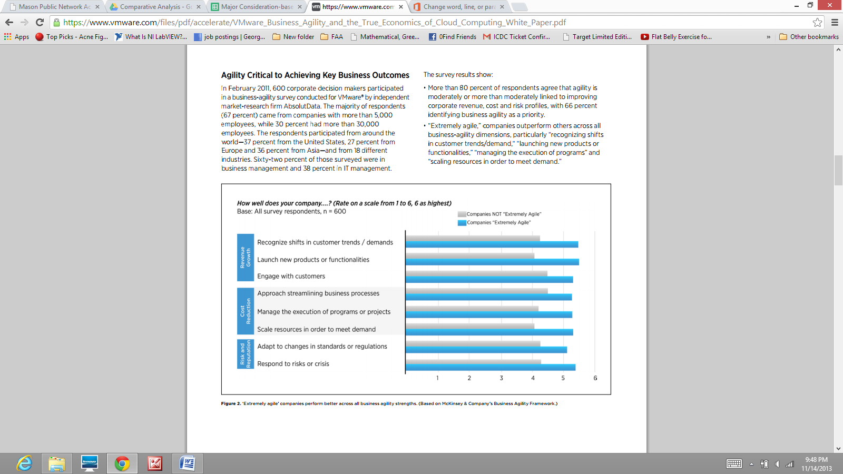

Figure 37 The Relationship between the Agility and the Performance of the Company in Terms of Testing New Ideas and Implementation[46]

Business agility is the capability of a company to adapt “rapidly” and cost-efficiently in answer to changes in the business environment. According to McKinsey & Company, the leading global management consulting firm, the benefits of agility include: “faster revenue growth”, “greater and more lasting cost reduction”, and “more effective management of risks and reputational threats”.[47]

Forward-thinking enterprises are utilizing cloud computing as a strategic way that is not just for IT, but to enable full business transformation, eventually changing how they function their business. In a couple of years, many companies will consider how cloud allowed them to create a much better connection between IT transformation and business transformation. That will be the win in this cloud age.

**Smart Budget Allocation**

Cloud can make the entire organization more “business agile” and “responsive,” according to 63 percent of business leaders that responded to the above survey.

Companies with “enterprise-wide deployments” assume in their internal processes that cloud can help achieve 10 percent greater business agility outcomes, such as in areas of “key revenue growth” and “cost reduction”.

Companies with “enterprise-wide cloud deployments” are three times more likely to achieve business agility that is “much better than the competition.” Figure 38 shows this.

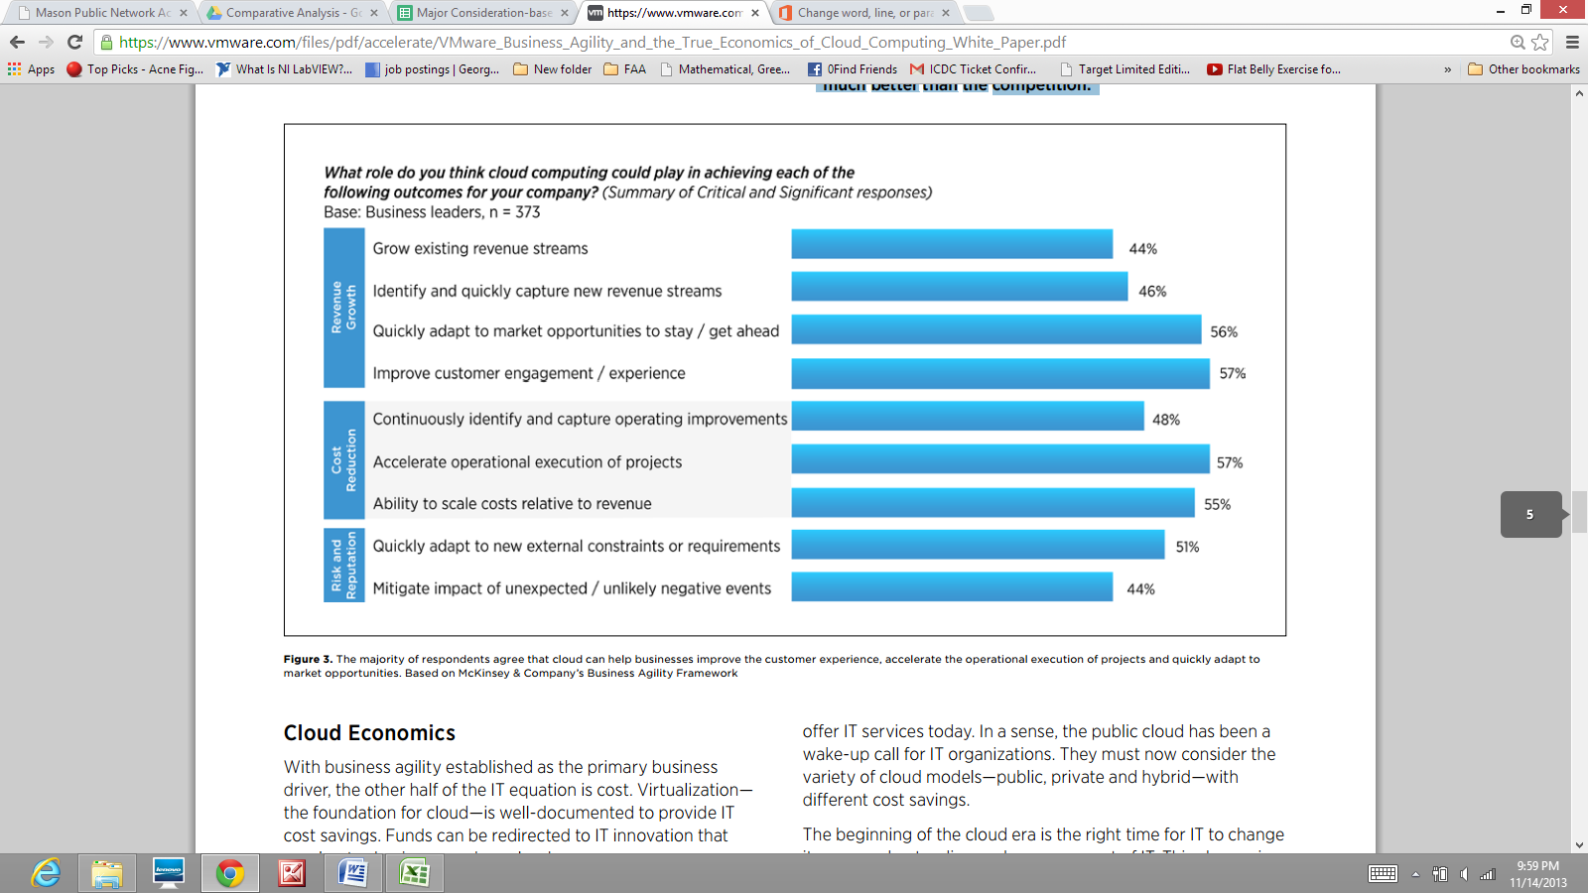

Figure 38 Cost/Budget Allocation in Cloud[48]

Table 12 shows the analysis results for agility.

Table 12 Agility Major Considerations-based Analysis

|  |  |  |  |  |  |
| --- | --- | --- | --- | --- | --- |
| Major Consideration | Status Quo | | Cloud | |  |
| **Characteristics** | **Pros** | **Cons** | **Pros** | **Cons** | **Important to Note** |
| **Implement and test ideas faster** | N/A | This capability does not exist in the current infrastructure. This will be an added value to the system. | The test projects will no longer be delayed while one waits for hardware to be delivered and set up | Might not be an added value to the customer at the present time considering the setup of the applications. |  |
| **Speed & Business Agility** | N/A | This capability does not exist in the current infrastructure. This will be an added value to the system for future use. | This is because clouds are such optimized, efficient platforms that the cloud hosting provider can offer their services at significantly lower costs than unvirtualized on-premises servers. This is a business model that turns out to map very closely to the needs of small and mid-market organizations. It doesn’t require capital expenditure or any other significant initial investment, and it only climbs when the organization needs to scale additional resources. | Additional resources might not be required at the present time with the current infrastructure of the customer. To use the full capability of this cloud concept agile recourse management might be necessary |  |
| **Smarter Budget Allocation** | This capability does not exist in the current infrastructure. This will be an added value to the system for future use | This capability does not exist in the current infrastructure. This will be an added value to the system for future use | 1) This is because clouds are such optimized, efficient platforms that the cloud hosting provider can offer their services at significantly lower costs than un-virtualized on-premises servers. 2) This is a business model that turns out to map very closely to the needs of small and mid-market organizations.3) It doesn’t require capital expenditure or any other significant initial investment, and it only climbs when the organization needs to scale additional resources. | complexities raised from CapEx VS. OpEx budget analysis. |  |

#### Integration

**Maintaining Level of Integration**

NOVEC is concerned about keeping the same level of integration in between the applications; meaning the applications that directly talk to each other online be able to still talk to each other without having to take an offline route for sharing information. Examples of offline routes include file sharing and hardcopy sharing. Table 13 shows the analysis results for integration.

Table 13 Major Considerations-based Comparative Analysis for Integration

| Status Quo | | Cloud | | Important to Note |
| --- | --- | --- | --- | --- |
| Pros | Cons | Pros | Cons |  |
| The integration is set, intact, and satisfying. | Not Known | There is opportunity, in the migration process, for introducing new ways of interfacing with other applications to make the interaction of applications even smoother. | A whole new set of configuration is needed to make the integration possible. | An integration plan is needed to identify in which order to migrate the applications to cloud in order to not interrupt the function of applications that are dependent on each other. |

Although it is possible to move the applications to cloud and still keep the integration intact, it is a whole project of its own to define application dependencies and migrate them in steps to make sure those dependencies are not interrupted. Moving to cloud, brings up an opportunity to define new ways of integration between applications, however, many configurations need to be done before the integration is completed.

### Applications-based Analysis

#### Overview & Purpose

**Overview**

Applications-based analysis is an analysis that deep dives into the applications while considering the results from major considerations-based. This analysis provides insights to the client in applications areas such as what possible cloud solutions exist for each application, which solution is the best solution, how complex migrating each application to cloud is, and what challenges for each application exist that the client needs to be aware of. Ultimately, applications-based analysis results will help with ROI analysis.

Applications-based analysis has three parts: application migration complexity analysis, architectural analysis, and results. Application migration complexity analysis considers two aspects of complexity:interdependency and cloud readiness (more details in section 4.2.3.2). Architectural analysis revolves around showing the current architecture of NOVEC’s IT infrastructure involving the core applications. This analysis provides an in-depth view of the integration and dependency among applications, which help with the applications-based analysis. The last part includes the result of applications-based analysis. These results are in tabular format for each application similar to major considerations-based analysis results. Each table presents an application with most appropriate cloud solution (i.e. SaaS vs. IaaS, private vs. public) followed by the rationale and challenges that exist for each application for migrating it to cloud. The table also includes the complexity analysis results. Each table is then followed by a textual description as to why certain decisions were made as stated in the table.

**Purpose**

Purposes of this analysis include:

* Based on major considerations-based analysis and NOVEC/LM’s application stakeholders interviews (site visits), decide a cloud solution for each application to make the client aware of possible options
  + SaaS vs. IaaS
  + Private vs. Cloud
  + Rationale for cloud solution.
* Capture challenges to overcome for each application prior to migration to cloud.
* Determine level of complexity for each application for migration to cloud.
* Develop architectural system view models to analyze dependencies of the applications.
* Input to utility analysis for determining the alternatives based on the level of complexity.
* Input to ROI analysis as the cost of cloud is calculated based on available cloud options for each of the applications.

#### Application Migration Complexity Analysis

At first there were two alternatives in the solution space: Full Cloud (All applications on Cloud) and Status Quo (None of the applications on Cloud).

After much research and consultation with GMU faculty, the CCT decided to introduce a third alternative to the solution space in the hope of adding more value to the customer. The third alternative was named “Partial Cloud Solution”. Partial Cloud Solution is defined as the situation where the customer decides to migrate some of the applications to the cloud compared to all or none.

To identify the best applications that can shape the Partial Cloud, CCT conducted a “Complexity Analysis”.

The complexity analysis shows the “difficulty” of each application in regards to cloud migration and virtualization.

There are two factors that were studied: Dependency and Readiness.

**Dependency** is defined as the relationship and the level of integration required for each application; the higher the level of integration with other applications, the higher the dependency.

**Readiness** is defined as the amount of work that has already been done to virtualized that application or if a similar solution currently exists in the market.

Figure 39 shows the results of the complexity analysis.

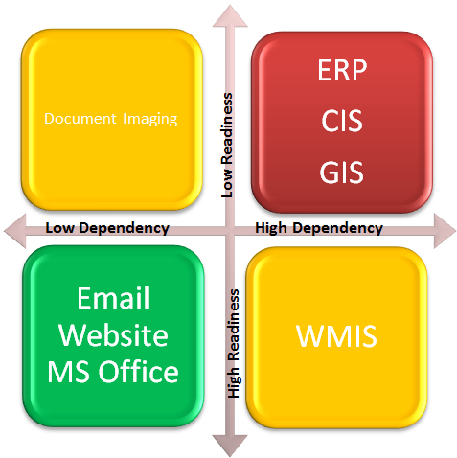

Figure 39 Complexity Analysis

To better facilitate the study, CCT drafted a graph (Figure Above) to best categorize the applications into three areas.

**GREEN: least Complex 🡪 shapes the Partial Cloud Solution.**

**YELLOW: Medium Complexity**

**RED: Most Complex**

Figure 40 shows the alternatives chosen based on the outcome of the complexity analysis results.

Partial Cloud Solution

Figure 40 Full Cloud Solution Based on Complexity Analysis

#### Architectural Analysis

CCT performed an architectural modeling to determine the level of integration, interdependency, and security among all core applications. For more cohesion and better flow of this document, these architectural models are presented in section 3.2.2.

#### Applications-based Analysis Results

Applications-based analysis results are provided below in the following sub-sections. Each sub-section focuses on one core application and its associated cloud solutions in a table that shows the high-level comparative analysis results along with a detailed textual description of the table.

The elements of applications-based results table are as follows:

* Core Applications: these are the applications that the client asked CCT to focus on.
* Delivery Model: this the layer of infrastructure of the cloud that the application is most suited for (e.g. SaaS)
* Deployment Model: this shows the level of data scrutiny in the cloud (e.g. Private Cloud).
* Rationale: this column explains why certain clout layer and type are chosen for particular application.
* Challenges: these are issues, risks, or need to understand items that the client should take into consideration when migrating a particular application to cloud.
* Complexity of Migration: this column summarizes the results from section 4.3.3.2 for each application.

#### ERP

Table 14 ERP Applications-based Results

| Delivery Model | Deployment Model | Rationale | Challenges | Complexity of Migration |
| --- | --- | --- | --- | --- |
| 1. Infor SaaS | 1. Private | 1. Benefits in terms of Performance (software and hardware maintenance), scalability (scaling down), and agility (smarter budget allocation) | 1. Matching the current application response time might be a challenge due to substantial changes in the network architecture. NOVEC has to adjust its bandwidth in order to support simultaneous access to cloud. | 1. Interdependency: HIGH;  Readiness: LOW |

ERP is not a client-server application. Clients access ERP through web portals.

The ERP has 50 +/- users and does not currently utilize 100% of the hardware capacity it has in house; therefore, there is no need to scale up the system in near future.[49] However, scaling it down, in cloud, might offer return on investment if the cost of transition is not exorbitant.

The ERP personnel do not do massive development works that would require a sudden need for increasing the capacity of test and development environment; therefore, the agility of cloud, in terms of being able to test and develop ideas faster, does not directly offer any value to this application. However, moving to a cloud-based infrastructure and scaling down the resources, offers benefits in terms of smarter budget allocation.

The ERP personnel have to perform daily and weekly backups to be able to recover data in case of a disaster, which if moved to cloud, will be taken care of automatically along with the recovery of the application itself.

This application currently has a pretty satisfying response time (almost instant). The only instance where they might experience slower response time is when they are upgrading test instances on the servers. But, this only happens approximately once every 2 years! Also, ERP users do not experience any server or network failures as this application runs on UNIX HP boxes which are pretty sturdy platforms. Maintenances take place during non-peak hours and do not disturb the users of the application. It is apparent that moving to cloud, in general, does not offer much benefit to the performance of this application, however, moving to a SaaS based solution from the current vendor “Infor” will hand over to “Infor” patch updating, software upgrading, and regular maintenance of the ERP system as well as its hardware maintenance; resulting in reduced maintenance burden at NOVEC’s side.

In fact, “Infor” is currently offering a major upgrade program called “Upgrade X Program” which is a simple and cost effective way to upgrade to “Infor 10x” in the cloud.[50] The program includes:

* An ROI analysis
* Modernized solution in the Cloud
* Infor 10x technology stack, including Infor Ming.le™ and Infor ION
* Upgrade or migration by Infor Consulting Services
* Comprehensive support

Infor Business Cloud gives the customer complete choice in their enterprise solution deployment options - from cloud to hybrid.

NOVEC can adopt an IaaS from Infor or it can enroll into a SaaS solution. By adopting an IaaS, Infor will manage all of the key infrastructure components. This includes Hardware, OS licenses, IT operations.

By switching to SaaS version of ERP, NOVEC gets a reinvented solution hosted and managed in Infor Business Cloud. After going live, hosting, upgrades, and management are taken care of for the customer. Infor Business Cloud offers below benefits as well:

* Customer no longer has to worry about keeping their technology current.
* Customer will always have access to the latest features and enhancements for their solution.
* Customer can reduce the burden on their IT staff and focus on more strategic activities
* Customer can decrease total cost of ownership.

Reducing the maintenance burden from the IT staff is the main drive to choose a SaaS based ERP from the current vendor “Infor”. It is easy to see that the maintenance burden decreases as one explores choices from getting an IaaS from a cloud service provider to an IaaS from Infor to a SaaS from Infor.

The ERP has security sensitive data of NOVEC employees including social security numbers. In the industry, about 80% of the time, protecting vendor, employee, or customer data results in strict security plans initiatives and subsequently choosing a private cloud over a public one. Security breaches are still reported for private clouds.[51] With security being one of the most important concerns of NOVEC in this migration, all the input and output data from this application must be encrypted and sent through secure connections. Table 14 shows the analysis results for ERP.

#### CIS

Table 15 CIS Applications-based Results

| Delivery Model | Deployment Model | Rationale | Challenges | Complexity of Migration |
| --- | --- | --- | --- | --- |
| 1. N/A | N/A | Application is not virtualizable. Benefits in terms of performance (response time), scalability (scaling down), agility (smarter budget allocation) and disaster recovery assuming the application would be virtualizable | Security of CIS data | Interdependency: HIGH;  Readiness: LOW |

CIS is a client-server application. It does not currently experience server or network failures, meaning it has a pretty fault tolerant architecture set up. There used to be constant complaints reported to the CIS higher managers about the slow response time of the application. However, investing upfront for technology and resources that could fulfill the CIS users' daily has resolved the issue.[52] However, this is a temporary resolution that will work for the next 3 or 4 years to come. As they get closer to the end of the period, it is expected that the CIS users will experience degraded performance again.

The reason is there are currently 150,000 customers for NOVEC whose information is kept in the CIS system. The amount of information the application handles and the functionality of it is constantly growing; demanding for periodic technology upgrade and resource increase. The CIS resources are currently underutilized as a result of upfront investment on hardware and technology. In 2011, NOVEC bought 45K worth of resources (OS, Servers) and 3 years of maintenance from IBM through Daffron which would serve them well until 2015. All those hardware and technology will then be moved to the disaster recovery/test site once the 3-4 year period is up and it is time for buying new ones. The old resources in DR site are then sent back to IBM if possible. The CIS would undoubtedly benefit from a cloud infrastructure in terms of its performance and scalability. There will also be agility benefits in terms of smarter budget allocation as the CIS resources will be scaled down in order to not leave the resources under-utilized and not to have to invest upfront.

The CIS uses its disaster recovery computers for testing purposes on an almost daily basis. Therefore the test environment is up and running all the time. So going to cloud might not add too much value in terms of developing and testing ideas faster. Yet, it is apparent that, by getting their infrastructure from a cloud service provider, the burden of purchasing and maintaining hardware, moving them to DR site once the new set of technology is purchased and retiring them after a few years would be taken off the CIS personnel. Likewise, the need for daily and weekly backups to enable data recovery in case of a disaster would be wiped off the tasks list.

This application is not virtualizable and the vendor does not offer any cloud-based solution. Therefore no cloud solution is proposed for this application that could meet its needs at this time. However, assuming it would be virtualizable, getting infrastructure from any CSPs (IaaS) would offer to the CIS benefits in terms of performance, scalability, agility, and disaster recovery. It is important to note that CIS contains very security-sensitive data of NOVEC customers that need to be protected in the best way possible when moving to the cloud environment. Hence, when CIS is moved to the cloud environment, all the input and output data from this application should be encrypted and sent through secured connections. Table 15 shows the analysis results for the CIS.

#### GIS

Table 16 GIS Applications-based Results

| Delivery Model | Deployment Model | Rationale | Challenges | Complexity of Migration |
| --- | --- | --- | --- | --- |
| Amazon IaaS  ESRI Managed Services-IaaS | Private | Benefits in terms of performance (hardware maintenance), disaster recovery, scalability, and agility. | Setting up a fault tolerant architecture is a challenge as cloud is less fault tolerant than the on-premise solution due to its complexity. Matching the current application response time is a challenge due to substantial changes in the network. Also, NOVEC has to increase its bandwidth in order to support simultaneous access to cloud. | Interdependency: HIGH;  Readiness: LOW |

Rationale: GIS is a client-server application with most of the processing done at the client side. The server side of it consists of I/O intensive software with frequent read/write operations. Response time of the GIS system has always been a concern for this application.[53] Response Time is hindered mostly due to the complexity of the GIS application itself (the technology used by the vendor ESRI). Having more hardware resources and processing power on the server side does not help with its response time. In addition frequent incidents of degraded performance is experienced in Leesburg and Minniville offices. Network delay is the underlying cause which needs to be further investigated and properly addressed before attempting to migrate to cloud as accessing the application on a cloud environment makes it even more prone to network delay. Moving to a cloud environment, therefore, does not offer any benefits in terms of having a shorter response time.

The GIS servers could fail because of data “cut up” (data not in good condition and not accessible from the client side). But, such an incident has not been happening since the beginning of the implementation phase of the application. The GIS staff believes that even if it happens, redundancy will not help with preventing/resolving the issue. The application seems to be pretty fault tolerant in its cozy structure in NOVEC’s data center and not in need for a more fault tolerant and higher availability architecture. However, the CCT still strongly suggests that NOVEC should consider building a redundant, fault tolerant architecture when moving the application to a cloud infrastructure as the cloud environment has a much more complex architecture; exposing the application servers and network to new failures.

There are daily and monthly backups scheduled for maintenance and disaster recovery preparation of the GIS for which the system goes down. Moving to a redundant cloud infrastructure, these backups will be done automatically and the system will not need to go down, resulting to higher availability. Furthermore, it takes off the hardware maintenance burden off the GIS personnel.

The GIS personnel believe that scalability of cloud would be appealing to them if it helps with the performance of the application. There are daily peak usages around 8-10 AM and 1-3 PM where the CCT believes auto scaling could serve a purpose. Scalability of cloud also offers agility in terms of cost benefits through scaling down the system for holidays and stand-by periods.

Many companies are currently using SaaS-based GIS system. The current setup of the GIS in NOVEC, being based on components from both ESRI and Schneider Electric, makes it infeasible to use a solely SaaS-based solution. The main component of the GIS system, ArcFM from Schneider Electric, is not yet available in the cloud environment. ESRI offers a SaaS-based solution called "ArcGIS Online" which is a tool for making the map viewing available as a web service. Both companies are beginning to provide some SaaS products, but it will be a long time, if ever, until there will be a SaaS solution that could replace all components of the current GIS system which is a combination of products from the two vendors.

ESRI offers a cloud infrastructure for “ArcGIS Server”, which is the application used at the server side of the GIS system, through Amazon Web Services.[54] ESRI provides Amazon EC2 and ArcGIS Server users with a fully configured and deployment-ready GIS Server solution. Licensing of ArcGIS Server in the Amazon cloud is subject to the same rules as in on-premise or traditional data centers. ArcGIS Server users are given a choice to deploy their ArcGIS Server software licenses on traditional data centers (per physical core) or on-premise servers or on Amazon EC2 (mapping physical core licenses to virtual cores in the Amazon EC2 environment). Whatever the deployment, the ArcGIS Server user is responsible for the infrastructure costs.[55]

The user has the choice of taking care of the deployment process by him/herself or asking ESRI Managed Services team to take care of it. ESRI Managed Services offer maintenance services which together will reduce the maintenance burden of NOVEC employees during and after deployment. Therefore, CCT suggests that NOVEC would hand over the responsibility to ESRI Managed Services. CCT has asked ESRI for further details on ESRI Managed Services. The vendor has not yet provided any response. Table 16 shows the analysis results for GIS.

#### WMIS

Table 17 WMIS Applications-based Results

| Delivery Model | Deployment Model | Rationale | Challenges | Complexity of Migration |
| --- | --- | --- | --- | --- |
| CGI IaaS | Private | Benefits in terms of performance (software and hardware maintenance) and disaster recovery | Matching the current application response time is a challenge due to substantial changes in the network. NOVEC might have to increase its bandwidth in order to support simultaneous access to cloud. | Interdependency: HIGH;  Readiness: HIGH |

WMIS is a client-server application. There are not currently any issues with performance due to resource limitations. However, network connection quality might be the underlying cause for degraded performance experienced occasionally in Minnieville and Stafford offices.[56] There are no failures currently experienced because of lack of redundancy. It is not difficult to see that the application itself is not calling for an increase in performance. However, the maintenance burden is still heavy on the WMIS personnel and can be significantly reduced if moved to cloud. WIMIS has been undergoing a major upgrade for months. The last step of the upgrade (the production environment) is scheduled to take place in December 2013 after which all of the WIMIS servers and databases will run on version 1.4.1.

It is an internal application used by a limited number of users (250) and not much change is expected to be seen in the number of users and subsequently required resources. The WMIS's application server is already on a virtual machine and they can easily add more resources if needed. Scalability offered by cloud environment, therefore, is not new to this application and does not bring much value to it.

There is no disaster recovery plan in place for the WMIS application servers. Only the database servers have duplicates on Minnieville that are used as DR as well. There is an obvious need for improving the DR plan of this application and LM is planning to fix this issue in near future. By moving to cloud environment, this problem will be taken care of automatically.

The WMIS can be deployed on a cloud infrastructure offered by its current vendor “CGI” and an option available for NOVEC would be for CGI to host the application in a managed environment on their behalf or if they wish they could manage it themselves in a hosted model.  This would require some additional effort to update the integration message queues that are used by NOVEC to point at the cloud environment but CGI has found this not to be a significant effort.

CGI does not currently support a SaaS model and at this stage they are still exploring whether they will be able to offer this function. For WMIS application, by deploying all of its functions in a multi-tenant environment, it has the potential to breach NERC/CIP regulations, so CGI is yet to offer a SaaS model of the WMIS. [57]

By adopting an IaaS model from CGI, NOVEC can hand over to the vendor the majority of the WMIS maintenance burden.

There are no security sensitive personal data kept in this application, yet the information has business value for NOVEC. The WMIS, therefore, should be migrated to a secure cloud environment with all its data encrypted. Table 17 shows the analysis results for the WMIS.

#### NOVEC’s Website

Table 18 NOVEC's Website Applications-based Results

| Delivery Model | Deployment Model | Rationale | Challenges | Complexity of Migration |
| --- | --- | --- | --- | --- |
| Amazon IaaS | Private | Benefits in terms of Performance (response time in the high traffic time, hardware maintenance), scalability (scaling up for storm times using load balancing), agility (smarter budget allocation), and disaster recovery. | The website interfaces with on premise applications through the "my account" section. Only the content of the website, therefore, could be moved on cloud. The website still needs to hit the internal servers for "my account" interactions. | Interdependency: LOW;  Readiness: HIGH |

The website has response time of 2-3 seconds for its pages available to public and response time of 10 seconds for the application "my account" that is accessible only for NOVEC customers. 99% of the time the website traffic is steady. Only 1% of the time that a storm happens and everybody wants to go to "my account" and report their loss of power, it takes up to 5 minutes for “my account” section to give response. The bottleneck for response time is mostly due to the design of the website, the volume of its contents, and lack of sufficient resources for high traffic times.[58] CCT expects that going onto cloud would improve the response time of the website using the load balancing technology offered for high traffic times. Also, moving the static content of the website up into cloud CDNs would free up some of NOVEC's bandwidth as the website would not need to hit the DMZ servers on premise for pages available to public. The website would only need to use the NOVEC bandwidth for interfacing with NOVEC's other internal applications for accessing "my account" data.

www.novec.com does not experience frequent incidents of failure which would demand for a more fault tolerant architecture. The website is already using a redundant system and if anything happens with any of the virtual servers, it takes 15 minutes to bring it back up. The CCT believes that NOVEC website, which is the interface for customers to reach their accounts and report power outages, is an application that must have near 100% availability and therefore it is mandatory for it to keep onto a redundant and fault tolerant architecture once moved to the cloud.

Scalability of the cloud, its load balancing technology, and abundance of resources will ensure NOVEC customers to experience less delay in high traffic times.

There are daily incremental and weekly full backups scheduled for [www.novec.com](http://www.novec.com/). All backups are on tapes and they will be sent to Gainesville office. Although there is a backup plan for data, there is no DR plan for website. As a result of virtualized environment of website, it is relatively easy to set up a DR site for it, yet it requires a redundant set of servers far from the main site (so they won’t be affected by the same disaster.) Cloud’s various services for disaster recovery will be well appreciated for NOVEC’s website.

Agility of the cloud in terms of accelerating test and production lifecycles does not offer much value to NOVEC’s website. There are test servers already up and maintained 100% of the time which eliminates the need for setting up test servers when needed. However, since the test servers are not used the whole time that they are up and maintained, there is potential in Return of Investment (ROI) if the test infrastructure is moved to the cloud and paid for only when being used.

www.novec.com interfaces with other applications only through web services; ready to be moved on to cloud. If moved to an IaaS from Amazon, the hardware maintenance would be handed over to the CSP, but management of the provisioned servers will still be NOVEC’s responsibility. It is notable that NOVEC is using cloud CDN provided by CommonSpot for the static contents of the website. CommonSpot has taken over the server provisioning and maintenance of the static contents. It requires further investigation to know how static contents on CommonSpot should integrate with the rest of the website on Amazon IaaS. Table 18 shows the analysis results for website.

#### Document Imaging

Table 19 Document Imaging Applications-based Results

| Delivery Model | Deployment Model | Rationale | Challenges | Complexity of Migration |
| --- | --- | --- | --- | --- |
| Amazon IaaS | Private | Benefits in terms of Disaster Recovery and performance (maintenance) | Setting up tight security measures for the sensitive documents the application deals with and building a fault tolerant architecture on cloud | Interdependency: LOW;  Readiness: LOW |

This application is used for scanning, archiving, and retrieving NOVEC’s documents including sensitive documents. It can handle 20 concurrent users which might be the underlying reason for the performance issues currently experienced. If so, moving to cloud environment would not help with the performance as the main obstacle is the architecture of the application itself. The CCT suspects that with the network latency added to the application response time, it is possible that the application experience worsened performance. Moving will, however, hand over some of the maintenance work to CSP, increasing the performance of the whole system.

Unless there is a surge of new customers, demanding for scanning and storing lots of contract documents, it does not seem to be a need for a scalable application.

The vendor does not offer any cloud solution, so the only option would be choosing an infrastructure from a cloud service provider. With the high sensitivity of the documents involved, the CCT suggests a private cloud. Tightened security measures need to be applied to it too.

NOVEC can move the whole application on a cloud infrastructure or it can only move its archived documents to cloud storage (Amazon S3).

Disaster recovery is one major consideration that will be highly improved once moved to a cloud infrastructure. The CCT does not know of any disaster recovery servers currently in place for this application. Cloud infrastructures provide the means for easily recovering data in case of any disaster. Therefore, it might be of high value for NOVEC to trade performance (to a degree) with disaster recovery benefits. Detailed information is needed to identify the root cause of current performance issues and how it changes once moved to the cloud. Only then, NOVEC would have a complete picture of the problem and the benefits of adopting a cloud infrastructure. Table 19 shows the analysis results for Document Imaging.

#### Email

Table 20 Email Applications-based Results

| Delivery Model | Deployment Model | Rationale | Challenges | Complexity of Migration |
| --- | --- | --- | --- | --- |
| Office 365 Enterprise- SaaS | Public | Benefits in terms of performance (maintenance) and disaster recovery. | Security of the email system will be a challenge for the company as Microsoft does not offer a private cloud. | Interdependency: LOW;  Readiness: HIGH |

Currently, employees can use email via an Internet Browser or Microsoft Outlook installed on each machine. No issues have been reported regarding performance due to resource limitations. Email is used by a limited number of users (450) and not much change is expected to be seen in the number of users and subsequently required resources. Besides, Email application server is already on a virtual machine and NOVEC can easily add more resources if needed. Scalability offered by cloud environment, therefore, is not new to this application and does not bring much value to it.

Using a cloud-based email system, the emails, which are exchanged internally between NOVEC employees, will have to travel a longer distance to get to the recipients, meaning the network latency effect will be bolder on the application response time. However, it is expected that cloud service providers’ powerful network hardware will not let the network latency difference be too sensible to the end users. The maintenance of the email system will be handed over to the SaaS provider as well as its technical support. Microsoft is the leading cloud-based email provider, so the assumption is that they should have taken care of many of the common software bugs. Yet, it is possible that if technical support is needed, it will not be as flexible and fast as it currently is to resolve the problem. The CCT is not expecting to see a huge change in the performance of the application itself except for the hardware and software maintenance of the email system that will be completely handed over to the vendor.

Email is the main way of communication at NOVEC. There is no disaster recovery plan in place for Email servers, causes a high risk situation. This issue can easily be addressed in the cloud since the vendor (Microsoft) has a comprehensive disaster recovery plan in place.

Microsoft Outlook Exchange is offered only in the public cloud. Email communications usually contain information of business value to NOVEC and occasionally security sensitive data. Surely, email demands for a secure configuration in the cloud to make up for the unavailability of a private cloud. Table 20 shows the analysis results for email.

MS Outlook Exchange is offered through different plans which will be listed in the next section.

#### Microsoft Office

Table 21 Microsoft Office Applications-based Results

| Delivery Model | Deployment Model | Rationale | Challenges | Complexity of Migration |
| --- | --- | --- | --- | --- |
| Office 365 Enterprise- SaaS | Public | Performance (software maintenance) and disaster recovery will be benefited. | Network latency will be added to the application response time although it might not be sensible to the end user for most of the time.  Office WebApps that are cloud version of MS Office have limited functionalities compared to the desktop version Office suite. There is no private cloud for this application. | Interdependency: LOW;  Readiness: HIGH |

Microsoft Office is an application that’s installed on each client machine with each user’s files stored on his/her own machine and shared with other applications as an email attachment or through other templates. The user stays with the current version’s capabilities until it is time for a version upgrade when each user needs to install and configure the new version.

Unlike for other applications where there is a server that could be moved to an IaaS infrastructure and be benefited, at least, for its hardware maintenance, it is meaningless to consider an IaaS option for MS Office. By moving to a SaaS model of Office, software maintenance burden will be taken off from NOVEC responsibilities and users get to use the latest features and updates of the application whether they like it or not. On the other hand, users might experience slower response time as a result of network latencies. The files, however, are in the SkyDrive of Microsoft and could be accessed online from any devices; and not just the user’s own laptop or desktop. Office 365 comes with IT-level web support and 24/7 phone support for critical issues. So the performance benefits are basically a tradeoff yet not a significant one.

Disaster recovery of files is a huge benefit for this application. Currently, if a user’s machine crashes, all his files will be lost, at least for a while if not permanently. By adopting a SaaS model, all files are stored in a separate place than the user’s machine and the cloud service provider ensures the recovery of all files in case of any failures or disasters on their side.

Microsoft Office 365 will be a totally new environment to work in with Office Web Apps as its main components. The service is considered a SaaS and hosted only in public cloud. Beside the inflexible deployment model, the Web Apps have less functionality than desktop MS Office suite. For more information about differences of the desktop version and the cloud version of Office, refer to references. [59]

There are two options available that will best suite the number of employees NOVEC has and their needs: Office 365 Enterprise E1, Office 365 Enterprise E3, and Office 365 ProPlus. Below is a short description of their features and differences that will help NOVEC in choosing their best option.

Office 365 Enterprise E1: It has all the Office 2013 Web Apps (creating and editing Word, Excel, Power Point, and OneNote) and there is no limit on the number of users it can have. It also includes Exchange Online and there is 50 GB mailbox for email, contacts, and calendar events for each user. This plan costs $8 per user per month.

Office 365 Enterprise E3: It has all the Office 2013 Web Apps (creating and editing Word, Excel, Power Point, and OneNote) as well as the Desktop version of Office 2013. There is no limit on the number of users it can have and each user can install Office 2013 suite on up to 5 devices. It also includes Exchange Online and there is 50 GB mailbox for email, contacts, and calendar events for each user. Some other capabilities of Enterprise E3 would be the ability to host a website, cloud storage, Web meetings, Office Web Apps, and the ability to recover deleted emails from any date. This plan costs $20 per user per month.

Office 365 ProPlus: It comes with the latest Office Desktop application suite. Office Web Apps are not included in this plan. Neither is the Exchange Online. This plan costs $12 per user per month. Exchange Online could be added to this plan for $4 per user per month. Table 21 shows the analysis results for MS Office.

#### Summary

Table 22 shows the summary of results from application-based analysis.

Table 22 Applications-based Analysis Results Summary

| Application | Delivery Model | Deployment Model | Rationale | Challenges | Complexity of Migration |
| --- | --- | --- | --- | --- | --- |
| ERP | 1. Infor SaaS | 1. Private | 1. Benefits in terms of Performance (software and hardware maintenance), scalability (scaling down), and agility (smarter budget allocation) | Matching the current application response time might be a challenge due to substantial changes in the network architecture. NOVEC has to adjust its bandwidth in order to support simultaneous access to cloud. | Interdependency: HIGH;  Readiness: LOW |
| CIS | N/A | N/A | Application is not virtualizable. Benefits in terms of performance (response time), scalability (scaling down), agility (smarter budget allocation) and disaster recovery assuming the application would be virtualizable | Security of CIS data | Interdependency: HIGH;  Readiness: LOW |
| GIS | ESRI Managed Services-IaaS | Private | Benefits in terms of performance (hardware maintenance), disaster recovery, scalability, and agility. | Setting up a fault tolerant architecture is a challenge as cloud is less fault tolerant than the on premise due to its complexity. Matching the current application response time is a challenge due to substantial changes in the network. Also, NOVEC has to increase its bandwidth in order to support simultaneous access to cloud. | Interdependency: HIGH;  Readiness: LOW |
| WMIS | CGI IaaS | Private | Benefits in terms of performance (software and hardware maintenance) and disaster recovery | Matching the current application response time is a challenge due to substantial changes in the network. NOVEC might have to increase its bandwidth in order to support simultaneous access to cloud. | Interdependency: HIGH;  Readiness: HIGH |
| NOVEC Website | Amazon IaaS | Public | Benefits in terms of Performance (response time in the high traffic time, hardware maintenance), scalability (scaling up for storm times using load balancing), agility (smarter budget allocation), and disaster recovery. | The website interfaces with on premise applications through the "my account" section. Only the content of the website, therefore, could be moved on cloud. The website still needs to hit the internal servers for "my account" interactions. | Interdependency: LOW;  Readiness: HIGH |
| Document Imaging | Amazon IaaS | Private | Benefits in terms of Disaster Recovery and performance (maintenance) | Setting up tight security measures for the sensitive documents the application deals with and building a fault tolerant architecture on cloud | Interdependency: LOW;  Readiness: LOW |
| Email | Office 365 Enterprise- SaaS | Public | Benefits in terms of performance (maintenance) and disaster recovery. | Security of the email system will be a challenge for the company as Microsoft does not offer a private cloud. | Interdependency: LOW;  Readiness: HIGH |
| MS Office | Office 365 Enterprise- SaaS | Public | Benefits in terms of performance (software maintenance) and disaster recovery. | Network latency will be added to the application response time although it might not be sensible to the end user for most of the time.  Office WebApps that are cloud version of MS Office have limited functionalities compared to the desktop version Office suite. There is no private cloud for this application. | Interdependency: LOW;  Readiness: HIGH |

## Utility Analysis

Utility analysis is the second stage of technical analysis. Figure below shows, with a red rectangle, where in the project approach the utility analysis resides.

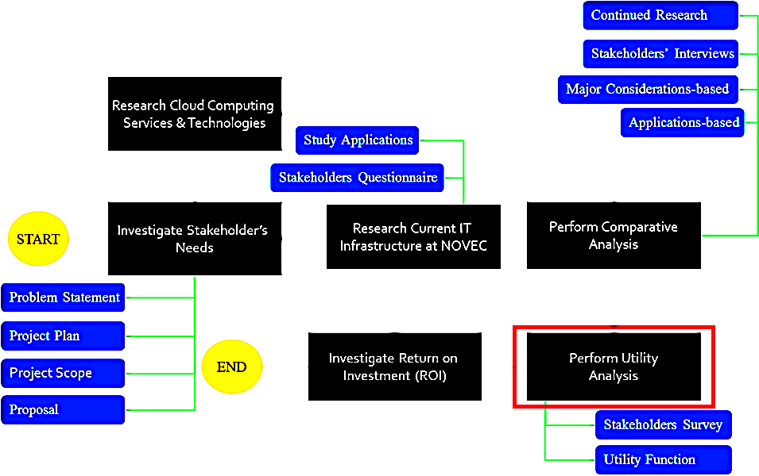

Figure 41 Utility Analysis in Project Approach

As seen in figure 41, utility analysis spans around two major activities: a stakeholder’s survey and the development of the utility function.

The overall goal of utility analysis is to compare possible cloud migration strategies at the system level to allow for the client to make a more informed decision. This analysis will suggest the best alternative that maximizes client’s utility, while considering the necessary attributes and their importance deduced from client elicitation. There are three proposed alternatives: status quo (do not move any applications to cloud), partial cloud (move only the least complex applications to the cloud), and full cloud (move all applicable applications to cloud). For more details about alternatives, refer to section 4.3.4.

### Methodology

To perform utility analysis, the CCT utilized the results from the comparative analysis specifically major considerations-based analysis (section 4.2.2) to determine the rationale behind the scoring system used in utility analysis. Figure 42 shows the methodology the CCT employed to complete utility analysis. The CCT employed Multi-attribute Utility Analysis (MAUA) as a technique to calculate utility for each alternative.

For utility analysis, CCT utilized major considerations (i.e. performance, agility, scalability, etc.) as MAUA attributes. Furthermore, the characteristics of each major consideration were utilized as a scoring mechanism to compete the analysis as described in section 4.3.5. A survey was developed and submitted to NOVEC/LM stakeholders for determination of each attribute importance. A value hierarchy and utility function were derived from the survey. Lastly, a “pairwise qualitative comparison” scoring system was utilized to determine the utility of each alternative. This process is further described in sections 4.3.2 to 4.3.6. Lastly, a sensitivity analysis on both weights and utilities of the attributes was performed to determine the sensitive parameters in the utility model (section 4.3.7).

In figure 42, the boxes on the left side represent the data inputs that were required for utility analysis to be completed. The blue box in the middle represents the process of completing utility analysis. Utility analysis receives certain input data shown by blue arrows. These input data were the data that CCT utilized to complete comparative analysis. The data shown on the right side of the figure below represent output data. Short description for each of the input datum is as follows:

* Stakeholders’ Survey: this is the survey that was submitted to all NOVEC/LM stakeholders to determine the importance of each attribute.
* Attributes: these are the criteria on which MAUA was based. These attributes are system-level major considerations along with their associated system-level characteristics.
* Alternatives: these are the cloud implementation strategies MAUA is evaluating. There are three alternatives: status quo, partial quo, and full cloud.
* Applications Complexity: this is directly taken from section 4.2.3.2. This helped with determination of partial cloud alternative.
* Major Considerations-based Results: these results from section 4.2.2 are used in the MAUA as rationales for why certain alternatives receive a particular score.

The description for output data is embedded and further described in sections 4.3.6 as outputs from comparative analysis.

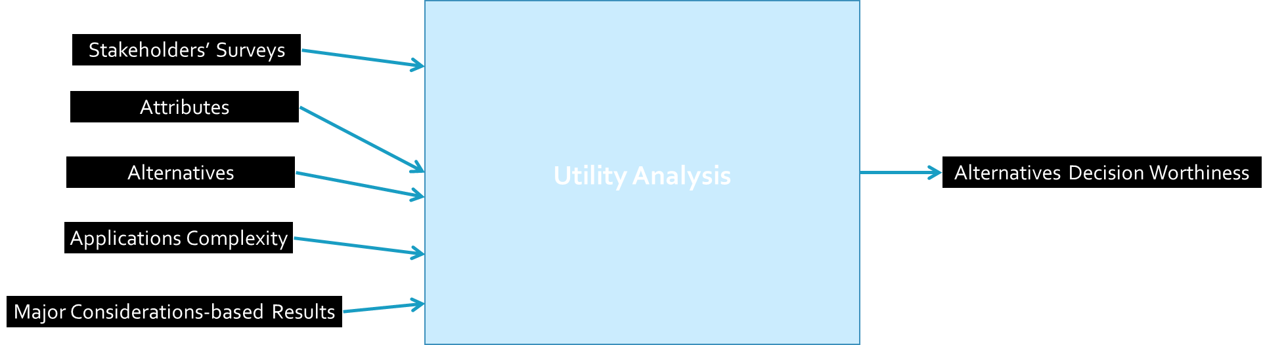

Figure 42 Utility Analysis Methodology

### Value Hierarchy (VH)

In order for the CCT to complete MAUA, it needed to determine what was most important to the client (i.e. how valued each attribute was for the client). NOVEC/LM has already stated that they are interested in assessing cloud migration based on the major considerations (i.e. performance, agility, scalability, etc.). It was necessary for the CCT to gather the importance of each of the attributes. Resultantly, a Value Hierarchy (VH) figure below was derived.

The CCT determined a list of criteria derived from major considerations, as identified by the client, along with their associated system-level characteristics. These attributes were system-level because MAUA evaluates the utility of the system not individual applications. Figure 43 shows these attributes and the associated weights (importance).

In order to determine the weight of each attribute, CCT developed a survey (Appendix C) and submitted to the client for distribution among stakeholders. The client decided to distribute the survey among only the LM stakeholders with the rationale that LM was investigating this project and that LMIT is in charge of the IT and would, therefore, provide more valuable and relevant results. 15 LMIT stakeholders participated in the survey. The numbers below each attribute in the figure 43 were derived from the stakeholders via the survey.. The numbers represent the importance (value) of each attribute in stakeholders’ perspective aka weights. A larger number represents a greater importance for stakeholders.

The CCT utilized a standard average normalization method to translate the survey’s results into weights for each attribute. This normalization process is depicted in Appendix D.



Figure 43 MAUA Value Hierarchy

### Utility Function (UF)

Derived from VH, the CCT created a Utility Function (UF). UF is a necessary element of MAUA. UF is simply a function created by multiplying the importance (aka weight = WAttribute) of each attribute to utility of that criterion (UAttribute). WAttribute is already determined based on the VH, however, UAttribute for each alternative needs to be evaluated as well. The process of calculation of UAttribute is described and shown in section 4.3.5. The equation below shows the derivation of UF where CS = Cyber-security, P = Performance, DR = Disaster Recovery, S = Scalability, A = Agility, I = Integration, and T = Total.

$U_{T}=W_{CS}U_{CS}+W_{P}U_{P}+W_{DR}U_{DR}+W_{S}U_{S}+W_{A}U_{A}+W_{I}U_{I} \underset{⇒}{Based on VH}$

$$U_{T}=0.191U_{CS}+0.178U_{P}+0.162U_{DR}+0.125U_{S}+0.142U_{A}+0.240U_{I}$$

CCT utilized the above equation to score each alternative and ultimately rank them.

### Alternatives

For MAUA, there need to be alternatives to be evaluated. Initially, the CCT had two alternatives only: status quo and full cloud solution. However, after meeting with Dr. Loerch, CCT decided to add another alternative that suggested migrating only the least complex core applications to the cloud as a another solution. Please, note that these alternatives will be carried through the ROI analysis as well. These three alternatives are described further in the following sub-sections.

#### Status Quo (SQ)

Status Quo (SQ) is the alternative that indicates the utility of NOVEC/LM if it did not move any of the core applications to cloud. Because MAUA is a decision making process technique, it may be best if NOVEC/LM does not move any of the core applications to cloud meaning a cloud solution may not increase the value of the system. Major considerations-based analysis results fully details out SQ alternative.

#### Partial Cloud (PC)

Partial Cloud (PC) is the alternative that the CCT added based on Dr. Loerch’s suggestion. PC is derived based on the application complexity analysis (section 4.2.3.2). PC suggests that NOVEC/LM move only the least complex applications (MS Office, Website, and Email) to cloud and leave the rest of the core applications on premise.

#### Full Cloud (FC)

Full Cloud (FC) is the alternative that suggests moving all the application core applications to cloud. A major difference between PC and FC is in the amount of infrastructure that remains on premise vs. when migrating to cloud.

### Scoring System

One of the critical elements of MAUA is the scoring system. The scoring system utilizes the UF and definition of each attribute’s utility to rank all the alternatives. In MAUA, an alternative with the highest score is the best alternative. In a typical MAUA, a quantitative method is defined for determining the range of scores one can assign to each attribute for each alternative. However, for this project, the attributes defined cannot be quantified. Hence, CCT, with Dr. Loerch’s guidance, developed a qualitative scoring system that utilizes characteristics of each attribute to score each alternative.

The CCT employed a “pairwise comparison” scoring system that utilizes SQ alternative as the baseline. This means that the score of each attribute for FC and PC alternatives depends on how they compare against the SQ (aka as the baseline).

The scoring system looks into each attribute’s characteristics and performs a pairwise comparison between FC and PC against SQ. The better the pairwise comparison for any alternative, the higher score it will receive. These scores then would be summed across an attribute for each alternative and would constitute the utility of that attribute. There were two important considerations in order for this summation to work across characteristics for one attribute. Firstly, these characteristics are assumed to be independent and are equally important for utility calculation purposes. Secondly, not all attributes have equal number of characteristics meaning the utility for those attributes with different number of characteristics must be normalized. For example, integration has only one characteristic, whereas performance has four. To take care of this inequality, the maximum number of four characteristics was considered. Hence, integration utility would be multiplied by 4 (since it has only one characteristic) and the utility of those with three characteristics were multiplied by ¾.

After all utilities for all attributes are calculated, they would be put into the UT equation to determine the overall (total) utility of an alternative. The alternative with the highest utility will be the best alternative.

It is important to note that baseline (SQ) will receive a constant score of 2 for each characteristic of the attributes. Table 23 describes pairwise comparison legend followed by the scoring system figure 44.

Table 23 MAUA Pairwise Comparison Legend

|  |  |  |
| --- | --- | --- |
|  | Score of 0 | Worse than status quo and also worse than the other worse (worst) |
|  | Score of 1 | Worse than status quo but better than other worse |
|  | Score of 2 | Status quo or the same |
|  | Score of 3 | Better than status quo but worse than the other better |
|  | Score of 4 | Better than status quo and also better than the other better (best) |
|  | N/A |  |

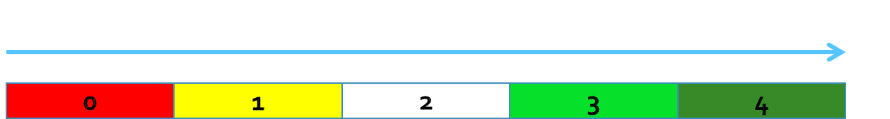

Figure 44 MAUA Scoring System

### Utility Analysis Results

The results of MAUA are in tabular format like comparative analysis shown in table 24.

Table 24 Utility Analysis Results

|  |  |  |  |  |  |  |  |  |
| --- | --- | --- | --- | --- | --- | --- | --- | --- |
| Status Quo (SQ) |  |  |  |  |  |  |  |  |
| **Attributes** | **WAttribute** | **Status Quo Total System Utility** | **Characteristics 1** | **Characteristics 2** | **Characteristics 3** | **Characteristics 4** | **UAttribute** | **Normalized** |
| Cyber-Security | 0.191 | Attack on physical system | Authentication attack | Denial of service | Malicious internet content | 8 | N/A |
| Performance | 0.178 | Technical Support | Fault Tolerance Maneuverability | Maintenance Burden | N/A | 4.5 | 6*3/4 |
| DR | 0.162 | Recovery Time Objective (RTO) | Recovery Point Objective (RPO) | Time to Perform Backup | Distance between DR and Production Sites | 8 | N/A |
| Scalability | 0.125 | Auto Scaling | Number of users it can handle simultaneously | Real-Time Scaling | N/A | 4.5 | 6*3/4 |
| Agility | 0.14 | "idea-to-cash" | Speed & Agility | Smarter Budget Allocation | N/A | 4.5 | 6*3/4 |
| Integration | 0.204 | Level of integration | N/A | N/A | N/A | 8 | 2*4 |
|  |  | 6.45 |  |  |  |  |  |  |
| Partial Cloud (PC) |  |  |  |  |  |  |  |  |
| **Attributes** | **WAttribute** | **Partial Cloud Total System Utility** | **Characteristics 1** | **Characteristics 2** | **Characteristics 3** | **Characteristics 4** | **UAttribute** |  |
| Cyber-Security | 0.191 | Attack on physical system | Authentication attack | Denial of service | Malicious internet content | 7 | N/A |
| Performance | 0.178 | Technical Support | Fault Tolerance Maneuverability | Maintenance Burden | N/A | 5.25 | 7*3/4 |
| DR | 0.162 | Recovery Time Objective (RTO) | Recovery Point Objective (RPO) | Time to Perform Backup | Distance between DR and Production Sites | 12 | N/A |
| Scalability | 0.125 | Auto Scaling | Number of users it can handle simultaneously | Real-Time Scaling | N/A | 6.75 | 9*3/4 |
| Agility | 0.14 | "idea-to-cash" | Speed & Agility | Smarter Budget Allocation | N/A | 6.75 | 9*3/4 |
| Integration | 0.204 | Level of integration | N/A | N/A | N/A | 4 | 1*4 |
|  |  | 6.82 |  |  |  |  |  |  |
| Full Cloud (FC) |  |  |  |  |  |  |  |  |
| **Attributes** | **WAttribute** | **Full Cloud Total System Utility** | **Characteristics 1** | **Characteristics 2** | **Characteristics 3** | **Characteristics 4** | **UAttribute** |  |
| Cyber-Security | 0.191 | Attack on physical system | Authentication attack | Denial of service | Malicious internet content | 8 | N/A |
| Performance | 0.178 | Technical Support | Fault Tolerance Maneuverability | Maintenance Burden | N/A | 6 | 8*3/4 |
| DR | 0.162 | Recovery Time Objective (RTO) | Recovery Point Objective (RPO) | Time to Perform Backup | Distance between DR and Production Sites | 16 | N/A |
| Scalability | 0.125 | Auto Scaling | Number of users it can handle simultaneously | Real-Time Scaling | N/A | 9 | 9*3/4 |
| Agility | 0.14 | "idea-to-cash" | Speed & Agility | Smarter Budget Allocation | N/A | 9 | 9*3/4 |
| Integration | 0.204 | Level of integration | N/A | N/A | N/A | 8 | 2*4 |
|  |  | 9.21 |  |  |  |  |  |  |

In the table above, UAttribute column is the summation of scores for that particular attribute per the scoring system defined in section 4.3.5. After UAttribute for all of the attributes for a particular alternative is calculated, it will be input to UF, described in section 4.3.3. The total utility (UT) for each alternative is shown in green text in blue cells.

It is important to note that characteristics for each attribute are derived from section 4.2.2 since MAUA utilizes major considerations-based analysis results. The rationale behind cell color coding of PC and FC alternatives are based on the results from major consideration-based analysis results. That is why major considerations-based analysis results are a direct input to utility analysis. Major considerations-based results only cover SQ and FC alternatives, however, as previously mentioned, the difference between FC and PC is in the amount of infrastructure and that is the only differentiating factor between the two for MAUA as well.

As the results show, the utilities for status quo and partial cloud solution are close. This is an expected result since only least complex applications are moving to the cloud for partial cloud thus not impacting the overall utility by much.

Another interesting finding from the utility analysis results is the fact that integration, based on the surveys from stakeholders, came to be the most important attribute. Initially, both CCT and the client anticipated that cyber-security would be the most important, however, after the survey’s results were consolidated, integration came to be the most important attribute. This prompted CCT to dive even deeper into the integration so it decided to develop architectural models to investigate integration in more details. The models are depicted in this report in section 4.2.3.3.

Based on the table above, FC is the best alternative with the highest UT of 9.21. This means that NOVEC/LM will maximize its utility (happiness/worthiness) if they choose to move all of the core applications to cloud. However, it is important to review the cost drivers for each of these options in section 4.4 to make the final trade-off and make the final recommendation.

### Sensitivity Analysis

To perform the sensitivity analysis, the CCT, per Dr. Costa’s instructions, conducted sensitivity on both weights and utilities of the attributes to determine which variables are more sensitive in the utility model. During each of these sensitivities, the CCT varied certain parameters that it thought would cause significant change in the results.

#### Weight Sensitivity

Four scenarios were explored for this analysis:

**Baseline**: Results per table 24.

**Scenario 1**: Swap the weights of the most important attributes. This means assign weight of 0.204 to cyber-security and 0.191 to integration. Rationale for this scenario was that initially both the CCT and the client thought that cyber-security would be the most important attribute.

**Scenario 2**: Assign the same weight to most important attributes. Integration and cyber-security total weight is equal to 0.395 (0.204 + 0.191). This means assign weight of 0.1975 to cyber-security and integration (0.1976 to make sum of weights 1). Rationale for this scenario was that integration and cyber-security were the two competing attributes, so assigning the same weight to both would take both into consideration.

**Scenario 3**: Assign the same weight to all attributes. This means assign weight of 0.166 to all and integration (0.167 to make sum of weights 1).

The results of weight sensitivity are shown in figure 45. As seen in the figure, manipulating critical attributes’ weights does not change the results at all. This is an expected result since the weights for the attributes based on the VH are pretty close. This sensitivity analysis concludes that the change in weights does not make status quo or partial cloud any better than full cloud thereby validating the robustness of the CCT’s MAUA results.

Figure 45 Weight Sensitivity Analysis

#### Utility Sensitivity

Four scenarios were explored for this analysis:

**Baseline**: Results per table 24.

**Scenario 1**: Increase the utility of level of integration (a characteristic of integration) for status quo and decrease utilities for partial and full cloud. The rationale for this scenario is that level of integration for cloud solutions is a complex topic and the CCT believed that this could be a possible outcome for NOVEC/LM when they migrate to the cloud.

**Scenario 2**: Increase the utility of technical support (a characteristic of performance) for status quo and decrease utilities for partial and full cloud. The rationale for this scenario is that technical support for cloud solutions is a complex topic and the CCT believes that this could be a possible outcome for NOVEC/LM when they migrate to the cloud.

**Scenario 3**: Increase the utility of level of integration (a characteristic of integration) and the utility of technical support (a characteristic of performance) for status quo and decrease utilities for partial and full cloud. The rationale for this scenario is that both of these could be an outcome based on scenarios 1 and 2.

The results of utility sensitivity are shown in figure 46. Unlike the weight sensitivity analysis, the utility sensitivity analysis provided a more significant change by varying utilities for technical support and level of integration characteristics. As seen below, for scenarios 1 and 3, it is actually advised that LM/NOVEC stay with the status quo and do not move the cloud as level of integration and technical support could potentially pose a problem as status quo’s utilities are the highest of the three for those two scenarios. This finding furthermore indicates that level of integration and technical support are two most sensitive characteristics as far as utilities are concerned in the utility model.

Figure 46 Utility Sensitivity Analysis

## Return on Investment (ROI)

### ROI Calculation in the Industry

Many businesses have talked about emerging trends through actions to make cost reduction and leverage IT service providers’ adoption of cloud-style services. Many enterprises and leading IT suppliers of software, hardware, and services, seeking to address their customer needs, have vigorously evaluated and followed a cloud-style strategy. The challenges and issues are in the change from the current traditional IT to the new potential capabilities of cloud computing. They must be expressed in a language that end users can understand, and relate to investment, cost improvements, or business performance.

**The following will go over the ROI definition based on Industry and then narrow it down to the definition chosen by CCT.**

Return on Investment (ROI) is possibly the most widely used measure of financial success in business.

ROI is defined as following: ROI is the proportionate increase in the value of an investment over a period of time. It can be measured in a variety of different ways, but there are just four basic ways to improve it: decrease the investment, increase revenue, decrease costs, and make the return faster. Using cloud computing, one can achieve any of these; but one cannot achieve them all at the same time.

How does cloud computing contribute to ROI? There are a number of fundamental drivers that impact on investment, revenue, cost, and timing that can be positively influenced by using cloud services. They relate to productivity, speed, size, and quality.

In order to calculate ROI, CCT useed the following formula:

$$\frac{Financial Improvement-Investment}{Investment}$$

This is a general formula for ROI but for cloud migration project each term can be decomposed to different cost components as follow.

Financial improvement can be obtained by 1- cost reduction due to cloud environment and 2- increase in business profit resulting from this new cloud technology.

Cost reduction: In order to implement a cloud solution for LM/NOVEC two types of costs are applicable: 1- On-time investment 2- on-going cost for getting CSP services. The first component will be considered in “investment” costs. In order to account for the second cost component, the difference of current on premise IT cost and cloud solution on-going cost can be considered as “IT Cost Reduction” due to the new cloud solution. This cost reduction is a kind of financial improvement.

On the right hand side of the nominator is investment. As discussed earlier this is a one-time cost and can be decomposed to two major parts. First is the migration cost and second decommissioning cost.

Migration cost is a big investment and accounts for several tasks required before all the applications are up and running in the new environment. Some of the tasks are:

* In-depth Cloud Readiness Assessment for each core application
* In-depth performance analysis
* In-depth integration analysis
* Opportunity cost due to new solution
* Training cost
* Etc.

Decommissioning cost is a cost that LM incurs due to abandoning their current data-center as well as some staffing cost.

Financial improvement has another part and that is increase in business profit due to the new technology. This is not a tangible cost since LM decision makers should evaluate the benefit of new environment in their business. For example how much does it have value for LM managers to be able to add another system to their existing system, e.g. management dashboard, in a period of one month instead of three months?

Although the benefits of cloud are hard to estimate, it is very important since cloud environment has a lot of advantages to offer. If these benefits are not valued or not estimated correctly by adopters then challenges of cloud most probably overshadow them and make this solution unfavorable.

There are four major metrics that can be used to evaluate the benefits of cloud for LM (see figure 47).

Utilization: how much LM can benefit by consolidating its servers in the cloud environment?

Time Compression: How much LM can benefit by reducing time-to-market for its new services and upgrades by being in Cloud environment?

Scale: How much LM can benefit by having more computing resources for doing more workload due to cloud capabilities?

Quality: How much the applications users are satisfy with the new solution?

Please note that for all of mentioned metrics LM may have negative values, meaning that the new environments has some drawbacks compared to current status. But usually, overall increase in business profit is expected even when a metric is has less values than status quo.

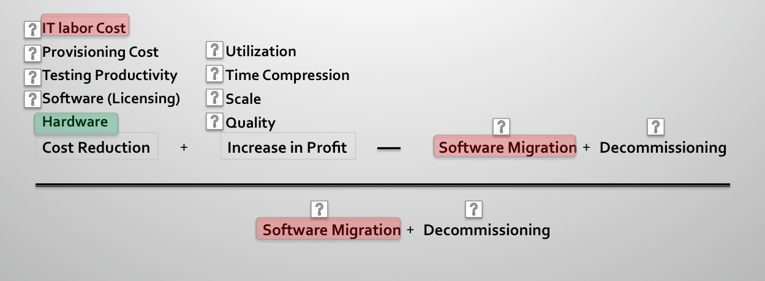

Figure 47 ROI Cost components for Migration to Cloud Environment

After comprehensive research of case studies, the CCT has found IT labor cost (on-going maintenance cost) and software migration cost (one-time considerable investment) are the most important cost drivers for ROI calculation (assuming that LM decision makers have estimated the increased benefit of cloud, as this component is very crucial as well). So these findings can be a starting point to assign specific projects to obtain dollar amounts for each of these cost components. The CCT, calculated one of these cost components (Hardware cost) in order to take LM Cloud migration ROI calculation one step further and also show that hardware cost reduction (which is usually advertised by cloud service providers) is not the cost driver for ROI in cloud migration projects. In next section, focus would be on the cost of owning and maintaining compute resources in cloud environment, which is referred to Hardware cost for the sake of simplicity.

### Hardware Cost

In this section, the CCT presents its methodology to estimate the hardware cost of cloud alternatives. One can break down the hardware cost into 5 categories as follow:

* **Servers**: this accounts for the cost of application and database servers including the cost of operating systems.
* **Storage**: this is the cost of all the storage capacity such as Direct Attached storage, Network Attached storage, backups, etc.
* **Network**: network cost includes the cost of load balancers, firewalls, switches, and Internet bandwidth.
* **Environment**: the cost of maintaining datacenters, heating and cooling, etc.
* **Administration**: the cost of maintaining the servers, patching, configuration, etc.

Based on the analysis, the CCT suggested cloud solution for each application. Since after contacting some vendors they did not provide costing for their services the CCT calculated the cost of owning and maintaining the hardware for those applications in Amazon cloud. It is assumed that application vendors charge similarly to Amazon IaaS cloud for providing compute resources and hardware infrastructure. This would be the best estimate of hardware cost based on available information.

In order to estimate the cost of the infrastructure in Amazon cloud, the CCT used AWS TCO calculator, which is a comprehensive TCO calculator.

In table 26 and table 27, the CCT shows how it estimated the cost for the two cloud alternatives: Full Cloud and Partial Cloud.

Table 26 Full Cloud Costing Alternative

|  |  |  |  |
| --- | --- | --- | --- |
|  | Suggested Solution | Cost estimate in Amazon IaaS | Comment |
| GIS | IaaS, ESRI Managed Services | Yes | Do not calculate the cost of these applications for suggested solution, instead one can estimate their cost in Amazon Cloud |
| WMIS | IaaS, CGI |
| ERP | SaaS, Infor |
| CIS | N/A |
| ComSquared | IaaS, Amazon | Yes | One can calculate the cost of these applications for the suggested solution which is Amazon Cloud |
| Website | IaaS, Amazon |
| Email | Office 365 | No | One can calculate the cost if these applications for suggested solution |
| Office | Office 365 |

Table 27 Partial Cloud Costing Alternative

|  |  |  |  |
| --- | --- | --- | --- |
|  | Suggested Solution | Cost estimate in Amazon IaaS | Comment |
| Website | IaaS, Amazon | Yes | One can calculate the cost of this application for the suggested solution which is Amazon Cloud |
| Email | Office 365 | No | One can calculate the cost if these applications for suggested solution |
| Office | Office 365 |

### Input Data

Table 28 shows the input values the CCT used to calculate TCO of compute resources in Amazon cloud infrastructure for Full Cloud alternative. Furthermore, table 29 shows the inputs CCT put in the calculator to get the aforementioned results for hardware cost.

Table 28 AWS TCO Calculator, Full Cloud

|  |  |  |  |  |  |  |  |
| --- | --- | --- | --- | --- | --- | --- | --- |
| **Factors** | **TOTAL** | GIS | WMIS | ERP | WEBSITE | CIS | COMSQUARED |
| **# of Web or Application Servers** | **14** | 5 | 2 | 2 | 2 | 2 | 1 |
| **# of Database Servers** | **3** | 0 | 2 | 0 | 1 | 0 | 0 |
| **Overall Storage (TB)** | **4** |  | | | | | |
| **Growth Rate (%)** | **10** | 10 | 10 | 10 | 15 | 10 | 5 |
| **Administrative Overhead (%)** | **15** | 20 | 15 | 20 | 15 | 15 | 5 |
| **Usage Pattern:  (Steady State=S, Unpredictable=U, Predictable Spikey=P)** | **Predictable Spikey** | P | P | P | U | P | P |
| **Bandwidth (Mbps)** | **50** |  | | | | | |
| **# of Telecommunication Providers** | **1** |  | | | | | |

Table 29 Input for AWS TCO Calculator

|  |  |  |
| --- | --- | --- |
| **Factors** | **TOTAL** | WEBSITE |
| **# of Web or Application Servers** | **2** | 2 |
| **# of Database Servers** | **1** | 1 |
| **Overall Storage (TB)** | **1** |  |
| **Growth Rate (%)** | **10** | 10 |
| **Administrative Overhead (%)** | **15** | 15 |
| **Usage Pattern:  (Steady State=S, Unpredictable=U, Predictable Spikey=P)** | **U** | U |
| **Bandwidth (Mbps)** | **50** |  |
| **# of Telecommunication Providers** | **1** |  |

### Assumptions

In order to use AWS TCO calculator CCT needed to average the specifications for application and database servers. CCT assumed the following specifications to be true for the servers (accepted by customer):

**Servers:**

* Each server has 2 processors
* Each Processor has 2 cores
* Each Processor's clock has 1.6GHz speed
* Each Server has 40GB of attached disk space
* Each Server has 8GB of RAM
* All of the servers are Windows
* All of the DB servers are ORACLE

**Storage:**

* Network attached Storage: 0.5TB
* Storage Area Network: 0.5TB
* Incremental Backup Storage: 1TB
* Long term Archival Storage: 2TB

### Cost Results

Figures 48 and 49 show the Hardware Cost results for both partial and full cloud alternatives. Amazon Calculator also estimates hardware cost for a typical enterprise having the specified compute resources on premise. This cost is given based on some assumptions that may or may not be applicable to LM/NOVEC IT infrastructure. Assuming that LM annual hardware cost is roughly around $150K, the hardware annual cost reduction would be around $110K. This amount is much less compared to IT Labor cost and software migration cost. This clearly shows that what Cloud Service Providers advertise is not the major cost component for determining ROI of cloud solutions and they usually show the hardware cost reduction of cloud.

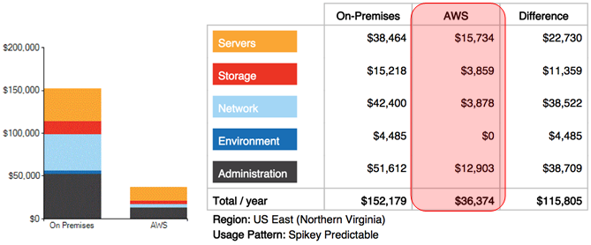

Figure 48 Annual Expenditure for Full Cloud

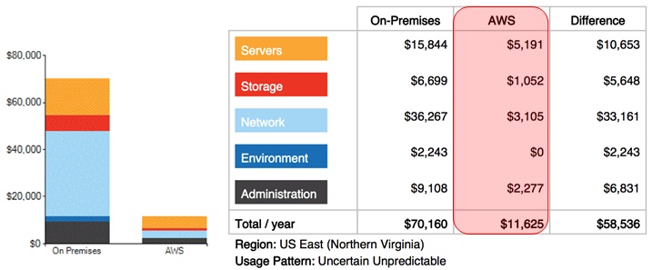

Figure 49 Annual Expenditure for Partial Cloud

**Summary of the results:**

The CCT collected the estimated costs for the following cloud services and solutions based on available information. There are lots of others factors that are discussed in ROI section of this report that need to be estimated in order to find the ROI for each cloud alternative.

Partial Cloud:

11K (excluding licensing)

1.2K

108K (including licensing)

Website

Email

Office

Technical Support

Full Cloud

36K (excluding licensing)

180K

108K (including licensing)

GIS

WMIS

ERP

CIS

Website

Comsquared

Email

Office

Technical support

# Conclusions

## Summary of Findings

Figure 50 below shows the summary of the CCT’s findings. It is important to note that the detailed findings from each analysis are described in section 4 of this report. Figure below is just the summary of all important findings.

The figure not only shows the finding summary in blue box, but it also shows how each finding addresses a problem from the problem statements described in section 2.1 and stated by the client indicating that all problems are addressed in this report for a robust conclusion. Furthermore, each finding is derived from a certain analysis methodology that the CCT developed such has comparative analysis shown on the right side of the blue box. The image shows from which analysis the finding was extracted. More details about the findings can be found in the associated analysis section 4 of this report.

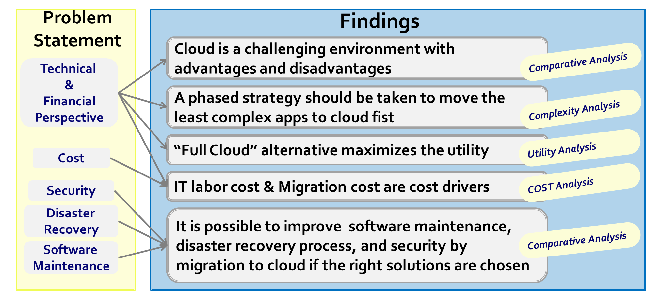

Figure 50 Findings Summary

## Lessons Learned

Throughout this project, the CCT learned valuable lessons. They include:

* Be conservative of how much you can deliver when you are in a domain in which you do not have much of knowledge
* Be Mindful of ‘change management’ and dedicate slack in the team schedule
* Establish an up-front scope with the client as early as possible
* Nail down a technical approach and stick with it
* Start the final report and presentation a lot earlier than their draft versions are due
* If information is not available from real sources (i.e. CSPs, application vendors, etc.), utilize scholarly articles, professors, and co-workers to your advantage
* You can never communicate ‘too much’ with the stakeholder, the more open communication, the better the final product

## Future Work

As the CCT developed technical artifacts, models, and reports, it became apparent that there are certain areas of this project that could potentially be a new project for this capstone course as a graduate project. These potential future work (follow-on work) items include:

* Implementing a cloud solution for each of the more complex applications (such as the GIS, the WMIS, and the ERP) to determine cloud migration assessment in more details (software architecture, data centers, etc.)
* More in-depth analysis of integration can be an additional item as integration can be quite complex
* Analysis of bandwidth must be performed to see if NOVEC’s network bandwidth can handle cloud internet-heavy processing
* An entire project could be dedicated for determining ROI starting where this project left off by using internal financial records of the company
* In-depth application-based requirements analysis can be a project in which the team develops a set of critical requirements for each application and performs technical analysis to see if the cloud environment can meet those requirements

## Resources Statistics

Throughout this project, the following number of resources was used:

* 6 NOVEC employees interviewed
* 11 CSPs & application vendors contacted
* 10 cloud consultants & experts contacted
* 7 professors contacted
* 126 articles, papers, books, and scholarly websites reviewed

## Authors’ Closing Remarks

The CCT is proud of the work that was initiated by NOVEC/LM and honored by GMU SEOR as this work increased every single of the CCT member’s domain knowledge and overall systems engineering skills for better careers ahead.

Utilizing systems engineering techniques such as utility analysis, architectural modeling, and cost analysis are unique abilities of systems engineers even though not widely adapted in the cloud readiness assessment industry. The CCT is proud of such systems engineering methodological thinking and results-oriented approach.

The CCT would also like to emphasize that the cloud computing industry, unlike the general perception, is a large and challenging one. Thus the CCT, with the client’s approval, has made assumptions to scope down the analysis in order to be able to finish it in a 2-month period. Some of the assumptions made for this analysis may seem controversial or unrealistic; however almost all of the assumptions made for this analysis have been made due to the unavailability of solid and consistent data or statistics and that the CCT has tried its best to collect the necessary data or statistics as much as possible. This is why the CCT took a high-level approach because it believes that one should first look at the system at the high-level first and determine the assessment before diving into lower level elements of the system referencing the “tip of the iceberg analogy”.

# Appendix A: Proposal

Appendix A is provided as an attachment with this report.

# Appendix B: Bi-weekly Status Reports (BSRs)

Appendix B is provided as an attachment with this report.

# Appendix C: Utility Analysis Survey

Appendix C is provided as an attachment in pdf format with this report.

# Appendix D: Utility Analysis Survey Results

Below is table 30 that summarizes the results of the survey and the process of averaging and normalizing the results to determine weights used to calculate utilities for this project. As shown in Appendix C, stakeholders were given score of 1 to 10 where 1 indicated the least important and 10 the most important. These results along with timestamps were captured by table below. As shown on the table, an average was taken and then normalized to determine the weights to do the utility analysis.

Table 30 Utility Analysis Survey Results

|  |  |  |  |  |  |  |
| --- | --- | --- | --- | --- | --- | --- |
| **Timestamp** | **Cyber-security** | **Performance** | **Disaster Recovery** | **Scalability** | **Agility** | **Integration** |
| 10/17/2013 12:38:54 | 10 | 10 | 10 | 8 | 8 | 10 |
| 10/18/2013 10:56:05 | 10 | 10 | 10 | 8 | 9 | 10 |
| 10/18/2013 10:57:31 | 8 | 9 | 7 | 4 | 3 | 10 |
| 10/18/2013 11:04:43 | 10 | 10 | 10 | 10 | 10 | 10 |
| 10/18/2013 11:19:58 | 10 | 10 | 10 | 5 | 7 | 10 |
| 10/18/2013 11:27:04 | 10 | 10 | 10 | 6 | 9 | 10 |
| 10/18/2013 12:57:08 | 10 | 10 | 10 | 10 | 10 | 10 |
| 10/18/2013 14:20:20 | 10 | 10 | 10 | 10 | 10 | 10 |
| 10/18/2013 16:16:30 | 10 | 10 | 10 | 10 | 10 | 10 |
| 10/18/2013 16:26:45 | 8 | 6 | 4 | 2 | 2 | 10 |
| 10/18/2013 16:29:05 | 8 | 8 | 6 | 1 | 3 | 10 |
| 10/18/2013 16:56:35 | 8 | 6 | 5 | 2 | 6 | 10 |
| 10/18/2013 17:01:10 | 10 | 6 | 5 | 4 | 6 | 10 |
| 10/18/2013 17:15:21 | 10 | 7 | 5 | 3 | 3 | 10 |
| 10/21/2013 10:11:41 | 8 | 9 | 7 | 9 | 7 | 9 |
| Average | 9.333 | 8.733 | 7.933 | 6.133 | 6.867 | 9.933 |
| Sum of Averages | 48.933 |  |  |  |  |  |
| Weights | 0.191 | 0.178 | 0.162 | 0.125 | 0.140 | 0.204 |
| Sum of Weights = 1 | 1 |  |  |  |  |  |
| Participants Count | 15 |  |  |  |  |  |

1. http://www.webopedia.com/TERM/C/cloud_computing.html
2. http://www.oxforddictionaries.com/us/definition/american_english/cloud-computing
3. Weiss, Todd R. "Cloud Computing: It's The Agility That Matters, No... - Input Output."*Cloud Computing: It's The Agility That Matters, No... - Input Output*. N.p., 08 Nov. 2011. Web. 18 Nov. 2013
4. Olavsrud, Thor. "How Cloud Computing Helps Cut Costs, Boost Profits." *CIO*. N.p., 12 Mar. 2013. Web. 18 Nov. 2013
5. Amies, Alex; Sluiman, Harm; Tong, "Infrastructure as a Service Cloud Concepts" , July 2012
6. http://www.cloudbzz.com/clouds-have-layers/
7. http://blog.appcore.com/blog/bid/167543/Types-of-Cloud-Computing-Private-Public-and-Hybrid-Clouds
8. http://cloud-services-review.toptenreviews.com/
9. World, Jon Brodkin | Network. “Gartner: Seven Cloud-computing Security Risks.” *InfoWorld*. N. p., 2 July 2008. Web. 19 Nov. 2013.
10. “Security Guidance for Critical Areas of Focus in Cloud Computing V3.0 : Cloud Security Alliance.” N. p., n.d. Web. 19 Nov. 2013.
11. Chenxi Wang. “Cloud Security Front And Center.” N. p., 18 Nov. 2009. Web. 7 Dec. 2013.
12. GFI. “SECURITY THREATS: A GUIDE FOR SMALL AND MEDIUM BUSINESSES.” n. pag. Print.
13. GFI. “SECURITY THREATS: A GUIDE FOR SMALL AND MEDIUM BUSINESSES.” n. pag. Print.
14. “High Profile Data Loss.” N. p., n.d. http://datalossdb.org//
15. “Google Searches Web’s Dark Side.” *BBC* 11 May 2007. *bbc.co.uk*. Web. 7 Dec. 2013.

   
16. "White Paper, Infrastructure as a Service." *Www.edtechmagazine.com*. CDW, n.d. Web
17. Linthicum, David. "How to Integrate with the Cloud." *InfoWorld*. N.p., 27 Apr. 2011. Web. 18 Nov. 2013
18. “Disaster Recovery - Computer Business Research.” N. p., n.d. Web. 19 Nov. 2013.
19. “Understanding RPO and RTO.” *Druva*. N. p., n.d. Web. 19 Nov. 2013.
20. Fremdt, S.; Beck, R.; Weber, S., "Does Cloud Computing Matter? An Analysis of the Cloud Model Software-as-a-Service and Its Impact on Operational Agility," *System Sciences (HICSS), 2013 46th Hawaii International Conference on* , vol., no., pp.1025,1034, 7-10 Jan. 2013
21. J. Raj, “The Art of Computer Systems Performance Analysis: Techniques for Experimental Design, Measurement, Simulation, and Modeling,” Wiley-Interscience, New York, 1991.
22. L. Bautista, A. Abran and A. April, "Design of a Performance Measurement Framework for Cloud Computing,” *Journal of Software Engineering and Applications*, Vol. 5 No. 2, 2012, pp. 69-75
23. J. Raj, “The Art of Computer Systems Performance Analysis: Techniques for Experimental Design, Meas-urement, Simulation, and Modeling,” Wiley-Interscience, New York, 1991.
24. L. Bautista, A. Abran and A. April, "Design of a Performance Measurement Framework for Cloud Computing,” *Journal of Software Engineering and Applications*, Vol. 5 No. 2, 2012, pp. 69-75
25. L. Bautista, A. Abran and A. April, "Design of a Performance Measurement Framework for Cloud Computing,” *Journal of Software Engineering and Applications*, Vol. 5 No. 2, 2012, pp. 69-75
26. Livshutz, Boris. "Business White Paper, Putting Critical Applications in the Public Cloud, The Very Latest Best Practices and Methodologies." *Www.appdynamics.com*. N.p., June 2011. Web
27. Sevcik, Peter, and Rebecca Wetzel. "Field Guide to Application Delivery Systems."*Www.netforecast.com*. Citrix, Juniper, Packeteer, Radware, Riverbed, Sept. 2006
28. Wetzel, Rebecca. "Better Cloud Application Response Time: An Overview of Partner Options." *Better Cloud Application Response Time: An Overview of Partner Options*. N.p., May 2012. Web. 18 Nov. 2013.
29. "IaaS Optimization." *Cloud WAN Optimization*. N.p., n.d. Web. 18 Nov. 2013 <http://www.riverbed.com/products-solutions/products/wan-optimization-steelhead/cloud-wan-optimization/IaaS-Optimization.html>
30. "AWS Support Features." *AWS Support Features*. N.p., n.d. Web. 18 Nov. 2013. <https://aws.amazon.com/premiumsupport/features/>
31. Bala, Anju, and Inderveer Chana. "Fault Tolerance- Challenges, Techniques and Implementation in Cloud Computing." IJCSI International Journal of Computer Science Issues, Vol. 9, Issue 1, No 1, January 2012
32. “AWS Architectures.” AWS Architectures. N.p., n.d. Web. 18 Nov. 2013. <<http://media.amazonwebservices.com/architecturecenter/AWS_ac_ra_ftha_04.pdf>>
33. Akhavan, Houman, Associate at Pariveda Solutions “Cloud Consultation” Personal interview, 01 Oct. 2013
34. “AWS Architectures.” AWS Architectures. N.p., n.d. Web. 18 Nov. 2013. <<http://media.amazonwebservices.com/architecturecenter/AWS_ac_ra_ftha_04.pdf>>
35. Barr, Jeff, Attila Narin, and Jinesh Varia. "AWS, Building Fault Tolerant Applications on AWS." Cloudfront, Oct. 2011
36. Picture source: http://enterprise.media.seagate.com/2012/09/inside-it-storage/why-enterprise-it-adopts-cloud-computing-its-very-emotional/
37. Sain, M., "The future of cloud integration: Cloud Middleware?," *Advanced Communication Technology (ICACT), 2013 15th International Conference on* , vol., no., pp.1,1, 27-30 Jan. 2013
38. Hoffman, Karla, Ph.D. "Major Consideration Discussions." Personal interview. 24 Oct. 2013.
39. Costa, Paulo, Ph.D "Decision Analysis." Personal interview. 2 Oct. 2013.
40. Loerch, Andy, Ph.D "Decision Analysis." Personal interview. 25 Oct. 2013.
41. Amazon. “AWS IAM.” N. p., n.d.
42. http://docs.aws.amazon.com/AutoScaling/latest/DeveloperGuide/WhatIsAutoScaling.html
43. Picture Source: http://docs.aws.amazon.com/AutoScaling/latest/DeveloperGuide/WhatIsAutoScaling.html
44. http://aws.amazon.com/about-aws/whats-new/
45. http://www.ibm.com/us/en/
46. Picture source: http://www.strategicalvision.com/?page_id=327
47. http://www.strategicalvision.com/?page_id=327
48. (Picture source: http://www.strategicalvision.com/?page_id=327)
49. Thammaiah, Manju “Decision Analysis.” Personal interview, 24 Oct. 2013
50. Dabravalskie, JR, Global Account Manager of Infor, “Decision Analysis” Phone interview, 7 Nov. 2013
51. "What's Holding Back the Cloud? Intel Survey on Increasing IT Professionals' Confidence in Cloud Security." *Www.intel.com*. Intel IT Center, May 2012
52. Sirini “Decision Analysis.” Personal interview, 24 Oct. 2013
53. Monjur “Decision Analysis.” Personal interview, 24 Oct. 2013
54. "Deploy ArcGIS for Server in the Cloud." *Cloud Options*. N.p., n.d. Web. 18 Nov. 2013. <http://www.esri.com/software/arcgis/arcgisserver/system-requirements/cloud-options>
55. "ESRI and Amazon Web Services." *ESRI and Amazon Web Services*. N.p., n.d. Web. 18 Nov. 2013. <http://aws.amazon.com/solutions/global-solution-providers/esri/>
56. Jbara, Ahmed Abu “Decision Analysis.” Phone interview, 28 Oct. 2013
57. Ridley, Steve, Executive Consultant of CGI & Michael Tevel, Director of Global Marketing of CGI, “Decision Analysis.” Phone interview, 5 Nov. 2013
58. Lucas, Beth “Decision Analysis.” Personal interview, 24 Oct. 2013
59. Microsoft. “Differences Between Using a Document in the Browser and in Word.” N. p., n.d. Web. 12 Nov. 2013.