**Federal Aviation Administration**

Fall 2013

**Terminal Decision Support Tool**

**Systems Engineering Graduate Capstone Course**

**Aiman Al Gingihy**

**Danielle Murray**

**Sara Ataya**

# Table of Contents

Table of Contents 2

Table of Figures 3

Table of Tables 3

Introduction 5

Background 5

Scope 5

Performance Gap/Shortfall 5

Stakeholders 7

Objectives 8

Deliverables 9

Gap Analysis 10

Scope 10

Methodology 11

Current State 13

Future State 19

Gap Description 20

Factors and Remedies 22

Relative Position Indicator 27

Lingering Gaps 30

Alternatives Analysis 31

Description of Alternatives 31

Description of Criteria 33

Hierarchy Value Computations 35

Alternatives to Criteria Comparison 37

Methods of Analysis 38

Group 2 38

Group 3 38

Results 49

Conclusions/Recommendation 49

Schedule 50

References 52

Acronyms 54

# Table of Figures

Figure 1: Example of Complex Merge 6

Figure 2: Project Work Flow for TDST 9

Figure 3: Airline Aircraft in NAS [24] 11

Figure 4: Comparison between conventional, RVAN & RNP routes [22] 15

Figure 5: Phases of Terminal Airspace 16

Figure 6: Aircraft Sequencing Procedure [21] 17

Figure 7: Comparison between different curved path approaches 18

Figure 8: US Airline RNAV/RNP Equipage as of Q2 FY13 [24] 19

Figure 9: Example of a Complex Merge 21

Figure 10: Traffic with and without TSS 23

Figure 11: TSS Toolset 24

Figure 12: Arrival traffic without TSS 26

Figure 13: Arrival Traffic with TSS 27

Figure 14: RPI Application 28

Figure 15: RPI in multiple merge situation 28

Figure 16: RPI on the Controller's scope 29

Figure 17: RPI Benefits [26] 30

Figure 18: Technology readiness level [27] 34

Figure 19: Utility vs Cost Graph 46

# Table of Tables

Table 1: List of Subject Matter Experts 7

Table 2: Stakeholders 8

Table 3: Shortfalls 22

Table 4: Comparison of Alternatives 33

Table 5: Attributes Hierarchy 36

Table 6: Alternatives with Scores 38

Table 7: Swing Weights for Level 2 Attributes 38

Table 8: Level 1 Criteria Swing Weight 39

Table 9: Results of weights elicitation using swing weights 40

Table 10: Calculated Value Function 41

Table 11 Fixed Cost of Alternatives 45

Table 12 Reoccurring Cost of Alternatives 45

Table 13 Sensitivity Analysis Scenarios 47

Table 14: Priority vs Capability Table 50

# Introduction

## Background

With the United States currently in the process of transforming its National Airspace System (NAS) to meet the challenges of the 21st century through Next Generation Air Transportation System (NextGen), airspace users are calling for a tool that is designed to help improve air traffic efficiency in some of the nation’s most congested airspace. A decision support tool is needed that allows controllers to maximize utilization of Performance Based Navigation (PBN) procedures which allow aircraft to fly from the Terminal Radar Approach Control Facilities (TRACON) arrival fix in a consistent, efficient, and predictable arrival path to the runway. A “gap” analysis is required to evaluate if current activities associated with the building of the PBN procedures will satisfy the needs of all stakeholders to include airline.

## Scope

This proposal will evaluate the current gap in the National Airspace System within the terminal environment by utilizing two key methods for analysis; i.e., a gap analysis and an alternatives analysis. A gap analysis involves determining, documenting, and approving the differences between business requirements and current capabilities and is a key analysis at a strategic level [in support of operational and tactical objectives]. An alternatives analysis looks at multiple alternatives so an agency can have a basis to fund the best project in a rational, defensible manner considering both risk and uncertainty. These analyses will then serve to inform an appropriate recommendation of what decision support tool may help fulfill this gap in the NAS. [1]

## Performance Gap/Shortfall

The shortfall for this project has originated due to the mission of the Federal Aviation Administration to move towards NextGen; the Next Generation Air Transportation System. “NextGen's promise is founded on shifting from ground-based to satellite-based operation. [23]

A key component of NextGen is Performance Based Navigation. PBN requires a certain level of performance from the aircraft and the air crew to fly a certain type of air traffic procedure. It used to be that aircraft could navigate primarily by ground-based navigational aids. These ground based navigation aids limited flexibility and are expensive to install and maintain. Using ground-based navaids, aircraft are forced to fly from one specific fixed location to another specific fixed location.

With the advent of satellite-based navigation (via NextGen), procedures are now developed using point in space rather than being tied to ground-based navaids. Advanced procedures such as Area Navigation (RNAV) and Required Navigation Performance (RNP) take advantage of this satellite-based technology. NAV and RNP gives greater aircraft flexibility in flight paths and profiles, and it enables them to fly more precise and efficient routes. This has the potential for flights to reduce the miles flown, save fuel, and improve efficiency. [23]

The use of a decision support tool in the terminal environment when coupled with RNAV and RNP procedures, will improve capacity, enhance efficiency, and lessen environmental impact. Below is an example of these types of satellite based arrival procedures. Both tracks (in red and blue) depict arrival paths for aircraft to fly to the runway. The blue shows a straight in RNAV approach while the red is a complex merge of both RNAV and RNP approaches.

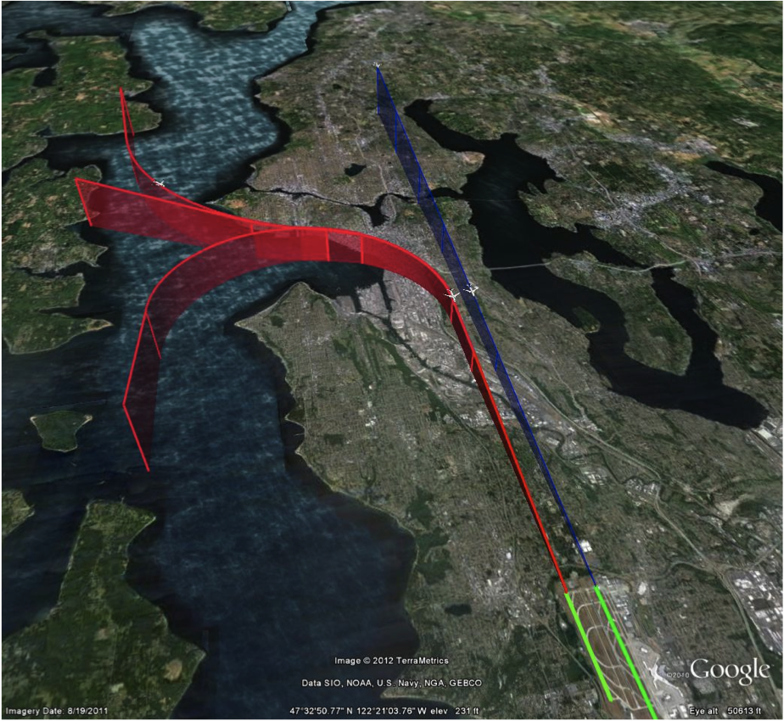

Figure 1: Example of Complex Merge

## Stakeholders

In order to address the shortfall, a number of stakeholders are identified and their direct role in is investigated throughout the report to ensure their needs are being met. The team also identified a list of Subject Matter Experts (a team of five individuals) and the team has been regularly engaged with these people. The respective areas of expertise and place of work are listed below.

|  |  |
| --- | --- |
| Subject Matter Expert | Organization |
| En Route Controller/TBFM SME | Federal Aviation Administration |
| Former Airline Pilot/Current FAA Manager | Federal Aviation Administration |
| Terminal Automation SME | MITRE Corporation |
| Terminal/PBN Automation SME | Federal Aviation Administration |
| Dr Lance Sherry, Executive Director of the Center for Air Transportation Systems Research | George Mason University |
| Paula Lewis, PA FAA - Assistant Administrator for Regions and Center Operations | George Mason University |
| Dr. Andrew Loerch, Associate Professor/Associate Chair SEOR Department | George Mason University |

Table 1: List of Subject Matter Experts

The list of TDST’s identified stakeholders are in the table below.

|  |  |
| --- | --- |
| Stakeholder | Role in this Problem Space |
| Airline Operators | Roughly 65% of airline operators have equipped their aircraft to be able to fly more efficient procedures but controllers do not have the ability to keep aircraft on these procedures Their goal is to save money by flying more efficient procedures. |
| FAA Controllers | The controller is the stakeholder who uses a decision support tool in order to keep aircraft on procedures. This tool will allow them to navigate complex merges in high density airports. |
| NATCA | NATCA is the FAA controller union and they must buy into any activity and subsequent implementation at facilities throughout the NAS. |
| FAA Headquarters | Headquarters is the party responsible for prototyping, developing, implementing, and sustaining the tool. |
| US Taxpayer | Tax dollars pay for lifecycle cost of decision support tool |
| Airline Passengers | Any savings that the airline realizes is normally passed onto the airline passenger. More efficient arrivals also mean streamlined travel for passengers. |

Table 2: Stakeholders

## Objectives

The primary objectives for the execution of the project are listed below. These bullets represent all areas the team will investigate towards meeting the end goal of this effort. The body of this proposal goes into more detail on each objective listed below.

* Identify Sponsor/Stakeholders/Subject Matter Experts
* Perform gap analysis to determine unmet need
* Identify potential decision tool(s) to evaluate based on the gap analysis
* Identify metrics and weigh them to perform alternative analysis
* Present results of all analyses
* Based on results, recommend and suggest implementation strategy
* Present recommendation to key subject matter experts for inputs and possible incorporation

The diagram below depicts the project work flow for TDST.

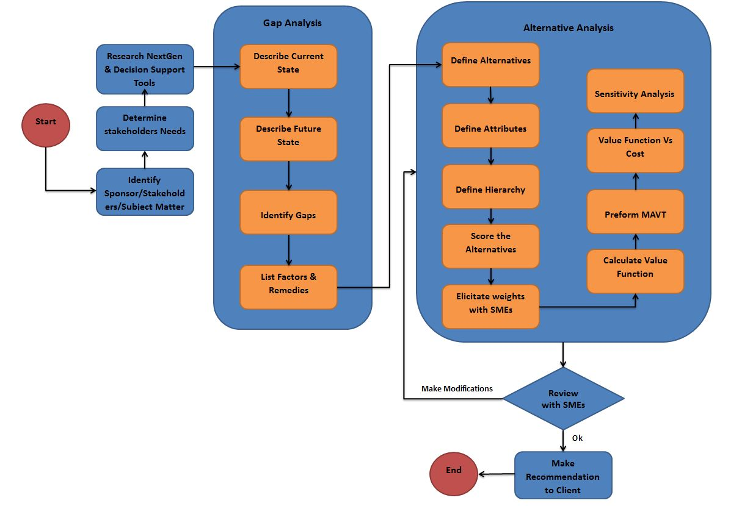

Figure 2: Project Work Flow for TDST

## Deliverables

Below are the identified deliverables in order to meet the outlined objectives and will be available on the project website.

* Preliminary Proposal
* Bi-Weekly Status Updates (internal)
* Final written report that details analysis, assumptions, techniques used, evaluation of options, results and overall recommendations
* Excel spreadsheet that details alternatives analyses
* PowerPoint briefing that communicates work and results
* Project Website

# Gap Analysis

## Scope

To scope this activity, the team is focusing on mixed equipage, complex operations at high density locations. This is due to the fact that merges are much more complex (difficult) for controllers at these types of locations. The following table lists the Core 30 airports identified by the FAA directly from their website. These Core Airports are the 29 large hub airports and Memphis International Airport.

* ATL - Hartsfield-Jackson Atlanta Intl
* BOS - Boston Logan Intl
* BWI - Baltimore/Washington Intl
* CLT - Charlotte Douglas Intl
* DCA - Ronald Reagan Washington National
* DEN - Denver Intl
* DFW - Dallas/Fort Worth Intl
* DTW - Detroit Metropolitan Wayne County
* EWR - Newark Liberty Intl
* FLL - Fort Lauderdale/Hollywood Intl
* HNL - Honolulu Intl
* IAD - Washington Dulles Intl
* IAH - George Bush Houston Intercontinental
* JFK - New York John F. Kennedy Intl
* LAS - Las Vegas McCarran Intl
* LAX - Los Angeles Intl
* LGA - New York LaGuardia
* MCO - Orlando Intl
* MDW - Chicago Midway
* MEM - Memphis Intl
* MIA - Miami Intl
* MSP - Minneapolis/St. Paul Intl
* ORD - Chicago O`Hare Intl
* PHL - Philadelphia Intl
* PHX - Phoenix Sky Harbor Intl
* SAN - San Diego Intl
* SEA - Seattle/Tacoma Intl
* SFO - San Francisco Intl
* SLC - Salt Lake City Intl
* TPA - Tampa Intl

Mixed equipage means that there is a mix of aircraft flying in the airspace. Below is the mix of aircraft in the United States.

|  |  |  |
| --- | --- | --- |
| Aircraft | Aircraft | Aircraft |
| B717 | B777 | DC9 |
| B727 | B1900 | DHC8 |
| B737-300/500 | A300/310 | EMB13/45-17/190 |
| B737-7/8/900 | A318/321 | MD10/11 |
| B747 | A330 | MD80/90 |
| B757 | ATR42/72 | SAAB-340 |
| B767 | CRJ1/2/7/8/900 | OTHER |

Figure 3: Airline Aircraft in NAS [24]

## Methodology

The gap analysis section will identify the gap between the current situation and the future state that terminal airspace air-traffic control procedures need to reach. We also present the remedies needed to close this gap. The Terminal Decision Support Tool team will conduct the gap analysis in three phases:

* State Description
* Gap Identification
* Remedies

The first phase, State Description, is divided into the current state and future state. The current state section takes a look at the current procedures in the top high density airports and the associated outcomes. The current state section will also provide information about the current terminal air space design philosophy. This will include types of procedures used by controllers and traffic management coordinators (TMCs) to merge and space air traffic in terminal airspace. The main topics include the following:

* Performance-based Navigation (PBN)
* Area Navigation (RNAV)
* Required Navigation Performance (RNP)

The current state will additionally explain the vectoring mechanism used to merge and space terminal air flow and the system shortfalls in the case of heavy air traffic or if aircraft are vectored off the procedures mentioned above. Finally, the supporting infrastructure aspect will be addressed to include components that interact with the operational environment such as automation and decision making tools. The current state section will also describe the existing terminal air traffic flow merging and spacing process outcome.

The next step is to identify the desired future state of the merging and spacing operations that achieves maximum efficiency and flexibility. The future state section describes the desired future state of the terminal air-traffic flow-merging and spacing system. The future state is derived from examining the shortfalls in the current state and the procedures that would be needed to alleviate the shortcomings. An evaluation of the costs and benefits of doing so are included in this report. The future state section will also include the outcome of the desired terminal air traffic flow merging and spacing system. The shortfalls in the current state will be the main driver for these outcomes. Some of the outcomes addressed include aircraft fuel burn, aircraft emissions, merging and spacing predictability and ability of controllers to leave aircraft on RNP curved path approaches.

Once the gap between the currents and future state is identified, factors responsible for such gap will be listed. Finally, in the remedies section we determine if the proposed tools (Relative Position Indicator, Terminal Sequencing and Spacing and a hybrid of the two) overcome the gap identified between the current and future state. If the proposed tools did not overcome any of the identified gap aspects, a list of these aspects will be identified.

Following the gap analysis, a full-on recommendation will be delivered to determine which courses of action(s) need to be taken to fulfill unmet need(s). Taking a look at the overarching enterprise architecture and based on TDSP research knowledge, TDST will verify that no glaring gaps are left unnoticed based on the needs of stakeholders and desired outcome.

## Current State

“Our current ATC system is outdated. It is a very large sky, but we don't use very much of it, and what we do use, we use pretty inefficiently. The airways we fly today are 8 nautical miles wide because they have to be.”[23]

The aviation industry strives to meet the continually changing needs for air travel. This is due to the fact that air travel continues to be a fundamental part of the transportation system in the US and air space is expected to get even busier over the next two decades. The FAA is revolutionizing the way aircraft are navigating the crowded national airspace (NAS) by creating a new vision called The Next Generation Air Transportation System (NextGen). FAA is proposing new navigation standards in order to transform the national airspace. The main component of this new vision is called Performance Based Navigation; which is a navigation framework designed to increase efficiency, capacity and safety of modern aviation. PBN framework will be explained in further detail in the next section. In keeping with the scope of TDST, the primary focus of this section will be on the terminal airspace procedures developed in support of NextGen (RNAV/RNP). The current state of the terminal environment will also be discussed.

### Performance Based Navigation

PBN is a framework for defining performance requirements in “navigation specifications.” The PBN framework applies to air traffic routes, instrument procedures and terminal airspace. It provides a basis for the design and implementation of automated flight paths as well as for airspace design and obstacle clearance. It also offers a straightforward means to communicate the performance and operational capabilities necessary for the utilization of such paths and airspace. Once the performance level is established on the basis of operational needs the aircraft's own capability determines whether the aircraft can safely achieve the specified performance and thus qualify for the operation. With PBN, aircraft use advanced flight management flight systems, on board inertial systems, heads up display systems and other satellite and ground systems to compute position, speed and other vital navigation information. The new approach automates the aircrafts entire navigation function from departure to landing

There are two key elements associated with PBN. The first is area navigation, better known as RNAV and the second is required navigation performance, known as RNP. Together, RNAV and RNP are the basic building block for PBN resulting in advancing the nation air traffic management system in the future as aircrafts are no longer mainly relaying on on-ground navigation equipment [17]

### Area Navigation (RNAV)

RNAV is the current method of navigation that permits an aircraft to fly a specified flight path within the coverage of space based navigation aids using the concept of “way points”. RNAV paths are used in lieu of routes defined by ground-based navigation aids. With RNAV, pilots are no longer flying zigzag paths from one ground navigation station to the other, instead they fly a direct path to their final destination which results in reduced flight distances and fuel cost. [18]

RNAV paths are implemented through a point-to-point navigation method provided by modem avionics that enables aircraft routing independent of the location of ground-based navigational aids. RNAV procedures are in use today by commercial, military, and general aviation aircraft throughout the world. RNAV avionics allow aircraft to fly a pre-programmed lateral profile stored in the aircraft's navigation database defined by a series of waypoints and path types between those waypoints (e.g., straight to the waypoint, curved along a fixed radius to the waypoint, etc). In today's commercial aviation fleet, almost all aircrafts are equipped with the capability to support advanced RNAV procedures -that is, procedures defined with required vertical and speed constraints associated with some or all of the waypoints. [18] [19]

RNAV departure procedures implemented at Atlanta in 2006 have shown a measured capacity gain of 9 to 12 departures per hour. RNAV procedures also result in reducing the workload associated with the routine voice communications between pilot and air traffic controllers. Atlanta RNAV departure procedures show a decrease of about 50 percent in voice communications required between the pilots and controllers. [23]

### Required Navigation Performance (RNP)

RNP is the second fundamental element of PBN navigation. [RNAV](http://en.wikipedia.org/wiki/Area_navigation) and RNP systems are fundamentally similar. The key difference between them is the requirement for on-board performance monitoring and alerting. A navigation specification that includes a requirement for on-board navigation performance monitoring and alerting is referred to as an RNP specification. RNP allows airplanes to fly even more precise and accurate paths. Through a concept called containment, aircraft can use onboard avionics and flight management systems to fly through a high way in the sky, traversing the airspace more efficiently. Pilots are able to fly this highway with pin point accuracy and repeatability. With RNP, more accurate paths can be placed within the limited terminal airspace, creating more lanes, more capacity and efficient terminal approaches. RNP provides the aircrafts with both lateral and vertical guidance which can be flown by the autopilot. This significantly reduces pilots work load while flying the complex curved path approaches in terminal airspace. In essence, RNP attempts to make the cleanest straight line as well as constant radius turns which allows aircrafts to efficiently handle cure-path approaches in the terminal airspace In addition to the safety benefits, these approaches provide several other significant advantages, a cast and 3-degree decent path had replaced what used to be dive and drive approach. Descending with a stable approach power setting can significantly improve the environmental impacts by reducing noise since aircrafts are no longer required to fly at low latitudes for long distances while approaching the airport. It also saves fuel and reduces emissions by minimizing changes in thrust. With its accuracy and reliability, RNP enable simultaneous approaches to closely spaced parallel run ways in reduced visibility conditions results in increase airport capacity. [18] [20]

It is estimated that RNP has the potential to cut global CO-2 emissions by 13 million metric tons. That is 1.2 billion gallons of fuel. RNP procedures at Portland have resulted in fuel savings of 150,000 gallons and a reduction of 7,500 tons of carbon emissions since implementation in 2006.[23]

The figure below articulates the differences between the different routing structure which span conventional routes, RNAV routes, and RNP routes. From the image, it is clear that the advanced routing demonstrates a clear gain in flexibility.

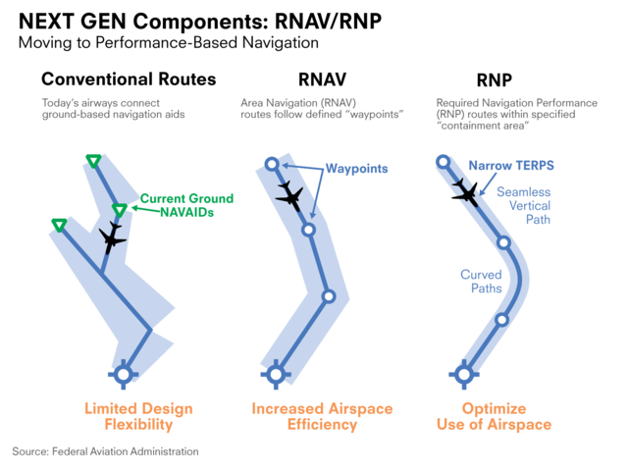

Figure 4: Comparison between conventional, RVAN & RNP routes [22]

### Current Transition of Aircraft into Terminal Airspace

The focus of this topic is how to enable PBN procedures in the Terminal Environment. Currently, a technology exists in the En Route environment, Time Based follow management (TBFM). This system is the technology and method used for adjusting capacity/ demand imbalances at select airports and arrival fixes. It establishes a schedule with an assumed runway assignment and runway sequence for each arriving flight. The TBFM schedule reflects a big picture view of Terminal Radar Approach Control Facilities (TRACON) operations in that it considers arrival demand, available airport capacity, and International Civil Aviation Organization (ICAO) flight plan information. It then identifies the need for flight-specific delay and distributes that delay along the flights path using speed control or modifying the RNAV and RNP paths. When aircraft crosses an adapted location in En Route airspace, the schedule for that aircraft is frozen (that is, it will not change automatically). Once a meter fix is reached along the navigation path, the aircraft enters the terminal airspace. At this point, the schedule is handled off to the terminal airspace controllers (figure below). Within the terminal air space, RNAV and RNP terminal procedures, including standard terminal arrivals (STARs) and curved path approaches, are followed by the aircrafts under controllers’ guidance. [3] [15]

The figure below shows the different phases aircraft go through as they approach the terminal airspace as discussed above. [13]

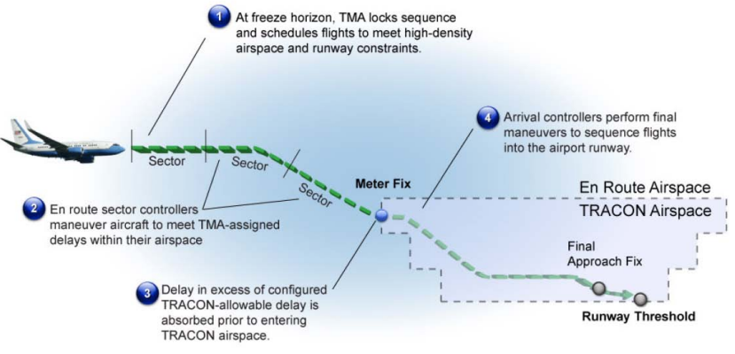

Figure 5: Phases of Terminal Airspace

Controllers take responsibility to sequence, space and merge aircrafts as they approach the merge points in the terminal airspace. The first ATC method used by controllers to manage this process is speed control since speed directives do not add distance to a path, and can be used easily on an RNAV procedure since it does not change the planned route of the aircraft. The figure below shows as example of the speed control process and its associated inefficiencies. [21]

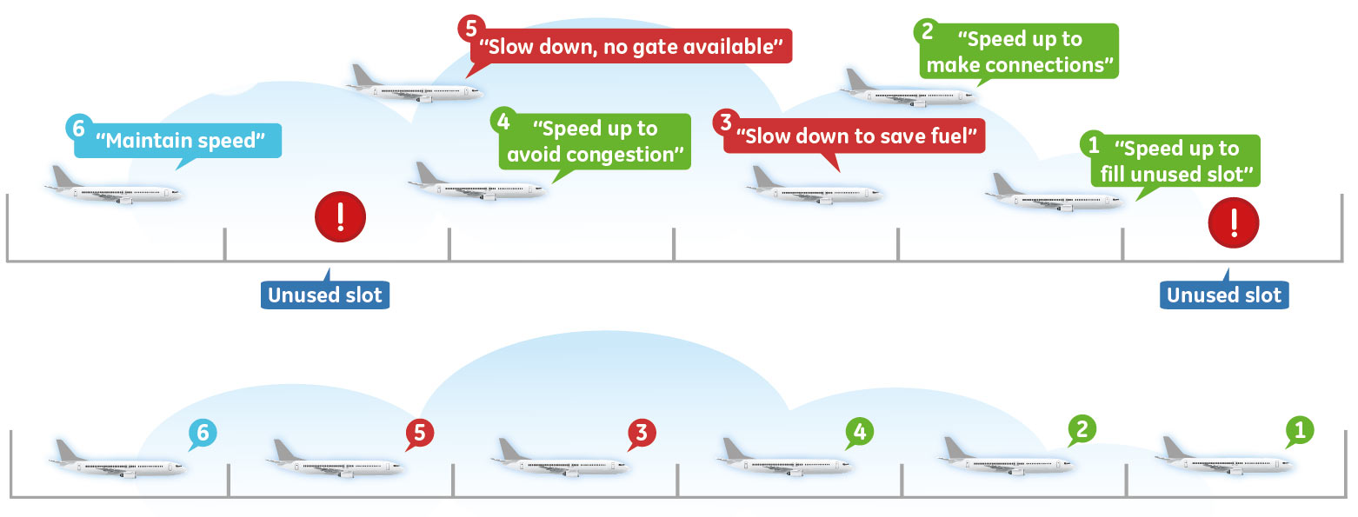

Figure 6: Aircraft Sequencing Procedure [21]

Although speed control has the least effect on the RNAV and RNP procedures, sometimes this method cannot be fully utilized because there is a limit to the amount of speed- control spacing adjustment that can be accomplished on a given segment of a route. As an alternative, controllers resort to vectoring to keep the aircraft on the routes, follow TBFM sequencing and scheduling plan, for spacing or conflict resolution purpose. Vectoring air flow means altering the lateral path flown for managing conflicts and merges. Vectoring, at terminal merge points, routinely interrupts or cancels PBN procedures. That’s why speed directives are preferred as opposed to lateral vectoring since they are less disruptive, do not add distance to a path, and can be used easily on an RNAV procedure.

The figure below show the performance impact RNAV and RNP procedures have on curved path approaches in terminal airspace which lead to less fuel burn and shorter flight times in today’s environment. It also shows how traditional radar vectors lead to more travel distance and less accurate merging points. The orange paths show the routes followed by the aircrafts when controllers rely on vectoring method to navigate aircrafts through curved path approaches. The navy paths are the routes followed by aircrafts when they follow an RNAV route which is a capability all aircrafts operating within the NextGen environment have. Finally, the violet path shows the routes aircrafts fly when they follow the RNP routes. Not every aircraft system can fly the RNP approaches. However, the percentage of aircrafts equipped with RNP on-board avionic systems is expected to increase in the next few years.

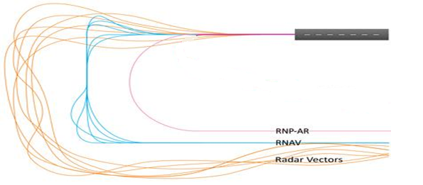

Figure 7: Comparison between different curved path approaches

### Current Equipage

Today’s current equipage rate of aircraft able to fly advanced approaches is about 60%. The goal is to increase this equipage rate and reap the benefits of flying these types of procedures by 2025. The intent is to make the aircraft fly as high and fast as long as possible given the altitude and speed constraints (i.e., for “expedited” flight paths) in the terminal area. The chart below demonstrates equipage rates as of Q2 FY13. For TDST’s purposes, we focus on the green and yellow bars. RF means that the aircraft is able to fly an RF leg and Advanced speaks all RNAV/RNP advanced procedures. This refers back to the 60% noted above. The FMC category simply means that the aircraft has a flight management computer onboard and GPS refers to standard GPS capabilities. These, too, are NextGen improvements but outside the scope of TDST.

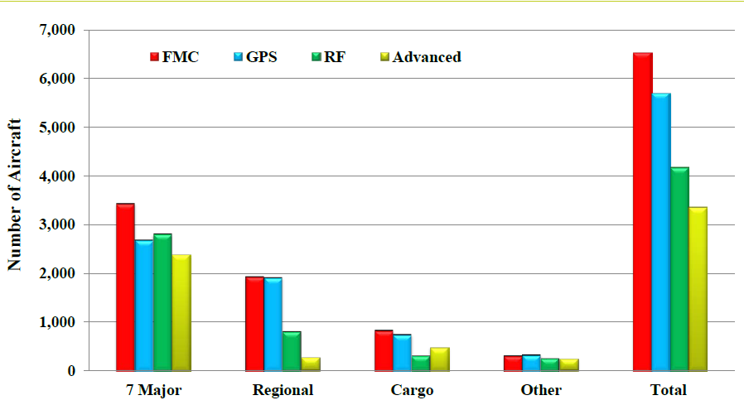

Figure 8: US Airline RNAV/RNP Equipage as of Q2 FY13 [24]

Another metric to note is currently utilization of these advanced procedures that have been developed so far. Currently about 10% of these advanced RNAV/RNP procedures are being flown throughout the NAS.

## Future State

As aviation continuous its crucial functions and as forecasts call for increase flights across the national air space, our national flight management system needs to evolve in order to meet the demand of the future. FAA statistics show that 5,000 planes are in the air at any time, 1 billion passengers per year, $1.3 trillion in economic activity and 5.6% of GDP. So, in order for the national airspace to absorb this type of expansion throughout the NAS, pilots will be required to fly more precise and efficient routes which will in return benefits the passengers, airline, traffic controllers and the economy. The expansion also necessitates a modernization of the national airspace. This modernization process will be driven by the following set of goals. For the purpose of satisfying the scope of TDST project, this section will focus on the terminal airspace:

* Enhance safety aspects
* Reduce carbon emissions
* Reduce flight delays
* Reduce noise impacts
* Increase accuracy of Time Based Management Scheduling (TBFM)
* Deliver a more efficient, consistent flow of traffic down to the runway
* Reduces voice communications and replace it with digital data communication
* Reduce miles flown in Terminal Radar Approach Control (TRACON) airspace

In order achieve these goals; aircraft need to follow the PBN procedures defined within the NextGen system. This includes adhering to the RNAV and RNP procedures in the terminal airspace since they represent the two fundamental elements of the PBN framework.

The biggest challenge in the terminal air flow management system is managing high air traffic. Future state is expected to equip controllers with more strategic management and tactical support mechanisms to achieve more efficient terminal arrival flow management procedures. As terminal air traffic starts to increase, controllers face more challenges in following the RNAV and RNP procedures. Therefore, controllers need to avoid the vectoring process, which cancels or interrupt the RNAV and RNP procedures, and start using merging conflict resolution tools that help them predict merging operation even when aircrafts are far from the merging points. Controllers sometimes identify the conflicts in merging routes too late and ask merging aircrafts to hold or redirect to wait for an opening, thus creating a large separation between the aircraft. This requires the need to have a conflict resolution tool to maximize the throughput or the terminal airspace allowing for an efficient way to manage heavy traffic in terminal airspace. While this process appears near the airport, the future state is expected to have this process initiated hundreds of mile away from the airport allowing pilots to following RNAV and RNP procedures, such as curved path approaches, which will reduce carbon emissions, flight delays, noise and fuel.

## Gap Description

As noted above in the current and future state, controllers managing merges on RNAV arrival rotes with high traffic density deal with unpredictable wind and complex speed changes. This is due to the altitude change along the arrival paths. The type of a merge (the number of turns and length of each route prior to the merge) requires more effort and creates a higher workload. The demand during high traffic periods can cause issues at merges that may require the controller to take aircraft off the RNAV routes for delay vectoring for sequencing. The top 30 airports are considered high traffic areas which mean that they continuously have high arrival rates of air traffic throughout the day.

In other situations, merges may occur just within the boundary of a control position and may require prior sequencing coordinated by other controllers. To achieve the expected benefits and efficiencies from these terminal routes, controllers may use automation to assist them in managing the traffic where the routes merge.

To date, automation is not available to controllers that allow them to be successful in these complex merge operations. To assist in sequencing and merging aircraft on RNAV routes, an automation tool must be developed and implemented to assist controllers in these complex merges. This decision support tool will help to enable controllers to routinely support the execution of performance based navigation procedures within the Terminal Environment. Below is a nominal depiction of a complex merge. From the image, it is clear that merging PVM192 and TAB18 is difficult as they are on two very different arrival paths and to the eye it cannot be clear which aircraft will arrive first.



Figure 9: Example of a Complex Merge

The agency has identified that a schedule-based method for sequencing and spacing aircraft in high-density terminal environments is considered a key operational improvement towards advancing the Federal Aviation Administration’s (FAA’s) Next Generation Air Transportation System (NextGen) concept in the mid-term timeframe.

Below the two distinct shortfalls associated with the scope of this gap analysis are called out.

|  |  |
| --- | --- |
| Current Shortfall | Description of Shortfall |
| Inability to continue efficient arrival operations into terminal airspace  Lack of automation for Terminal controllers that can support mixed equipage operations | There is an inability to continue efficient arrival operations—use of Performance-Based Navigation (PBN) procedures—into terminal airspace due to the highly tactical nature of terminal traffic management and the complexities associated with separating, sequencing, and spacing aircraft, particularly at terminal merge points, when the airspace is congested. Aircraft are often vectored off their routes, limiting PBN procedure use and introducing inefficiencies.  The combination of mixed equipage arrivals on different procedures is difficult for controllers to manage, particularly at merges onto the final approach course. As a result, controllers are unable to accommodate routine use of PBN approaches, such as Required Navigation Performance (RNP) Authorization Required approaches with Radius-to- Fix turns. |

Table 3: Shortfalls

As things currently stand, the main gap is that a tool to allow controllers to keep aircraft on the curved path approaches is not available to controllers. The result of pulling aircraft off of these approaches means that airlines lose the benefits derived by flying on such procedures; a key component of performance based navigation. The tool must appear on the controllers’ scope to help inform the placement of aircraft at the time of the merge. The complexity of the tool will depend on the environment to include whether the airport is high, medium, or low density.

The inability to support the consistent use of PBN procedures jeopardizes the investment the agency has made in the design and implementation of satellite based procedures. When operators are unable to benefit from their equipage investments they have already made, they are not going to be inclined to voluntarily equip to support other NextGen initiatives. This would then lead to a delay in achieving future NextGen milestones.

## Factors and Remedies

In order to address the current gap that exists, the Federal Aviation Administration will need to implement a decision support tool. Two tools have been identified that will serve the purpose in the overarching need; increasing the use of performance based navigation. These tools are Terminal Sequencing and Spacing and Relative Position Indicator. These two tools are quite different in nature but would address the current gap. Below is a description of each capability.

### Terminal Sequencing and Spacing

Terminal Sequencing and Spacing (TSS) introduces a capability that assists with the sequencing, spacing, and merging of aircraft in terminal airspace. This capability does so by scheduling aircraft to cross strategic points along their routes at designated times. Scheduling aircraft to capacity-constrained resources, such as airport runways, arrival or departure fixes, or points in the overhead stream, is one method for delivering a predictable and consistent sequence and spacing of traffic. A schedule-based method for sequencing and spacing aircraft in high-density terminal environments is considered a key operational improvement towards advancing the FAA’s NextGen concept in the mid-term timeframe.

The key components/elements of TSS includes

* The scheduling of aircraft over strategic merge points and runways
* the availability of automation-derived runway assignments and runway sequences to controllers,
* and the display of slot markers to gauge an aircraft’s position relative to where it needs to be to meet its scheduled time.

The figure below shows the different arrival paths aircraft will be placed upon both in today’s current operations (without TSS) and then with the use of the ground automation tool.

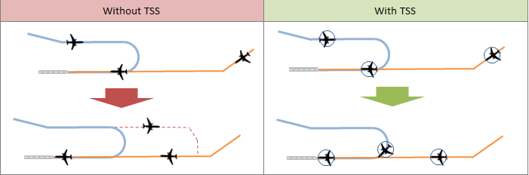

Figure 10: Traffic with and without TSS

TSS will be inherent in a ground automation scheduling system already implemented in key TRACONs throughout the NAS. The information it displays will take resident in a separate system called Standard Terminal Automation Replacement System (STARS)**.** These pieces of information or “tools” are called Computer Human Interface (CHI). The CHI elements are depicted and then described below.

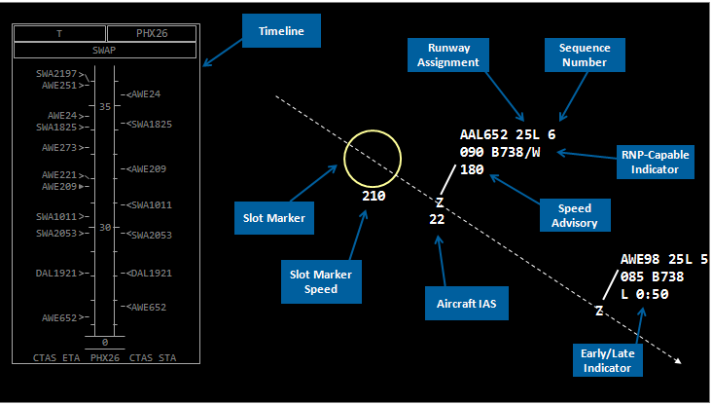

Figure 11: TSS Toolset

**Runway Assignment**

This display tool provides automated guidance that allows the TRACON controller to assign the runway to an aircraft in accordance with the scheduling plan. In the NASA-developed TSS prototype, the Runway Assignment is displayed in the first line of the data block. Display design of Runway Assignment needs to be integrated with all elements of the data block.

**RNP Capable Aircraft**

To support merging of RNP and non-RNP flights, information that identifies that an aircraft is RNP-capable and suggests that the crew is qualified is included in the flight plan for a flight if the operator desires to utilize RNP procedures. Scheduling automation is expected to always assign equipped and qualified flights to RNP procedures where applicable. Automation will also provide controllers with information on which runway and approach were assigned.

**Runway Sequence Number**

The Runway Sequence, as computed by automation, will be displayed to the TRACON controller via the TSS toolset when the data block is displayed. The TRACON controller can use this information to manage merges and estimate the spacing that is needed between successive flights at downstream merges. For example, if flight A is the leading flight and flight B is the trailing flight, and the sequence numbers respectively are 7 and 8, then the controller will know that only normal separation is needed between the flights. Alternatively, if the numbers are respectively 7 and 9, then the controller can try to maintain additional spacing between the aircraft so that the flight with sequence number 8 can be effectively merged into the flow.

**Timeline**

The Timeline is a graphical-oriented visualization of the temporal schedule (i.e., STAs and the ETAs). It can been seen in the left part of Figure 11. A Timeline (similar to the TGUI) for each CSP adapted for that position is available for display to the TRACON controller. The Timeline includes ETA and STA for each displayed flight. The Timeline provides the controller with additional situation awareness, as it can indicate where natural gaps exist in the overall schedule.

**Speed Advisory**

Speed Advisories provide the TRACON controller with automated guidance on the speed necessary to resolve an ETA-STA difference for the next downstream CSP for which a Speed Advisory is available. If the Speed Advisory is displayed, then it indicates to the controller that speed alone can be used to resolve the ETA-STA difference, and vectoring should not be needed.

**Early Late Indicator**

The Early/Late Indicator provides the TRACON controller with the aircraft’s ETA-STA difference to the runway threshold.

**Slot Marker**

The Slot Marker is a spatial visualization of the 4D schedule trajectory for a particular aircraft. The Slot Marker is a circle (of configurable size) that “flies” the schedule/solution speed profile along the aircraft’s lateral path and reaches each CSP at the STA. The Slot Markers are available for display on both the controller radar scope and TMC PGUI displays.

**Current Indicated Airspeed**

A calculated estimate of the aircraft’s current Indicated Airspeed is displayed to the controller to alleviate the need for the controller to convert ground speed to Indicated Airspeed.

As articulated above, TSS is a suite of capabilities that help to address the shortfalls listed in the gap description above. This capability has stemmed from research done at NASA Ames and further matured at MITRE Corporation. Additional Concept Engineering work will be conducted over the next year. Below is a final depiction that shows the benefits TSS provides by allowing controllers to streamline arrival of aircraft and increase predictability of operations. This was taken from a Human in the Loop Simulation (HITL) run by the TSS team. Feedback from the controllers who participated in the HITL buy in to the gains TSS provides with increasing efficiency of traffic in the terminal environment.

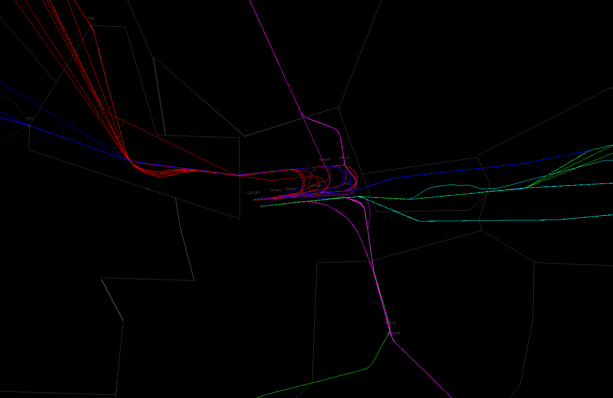

Figure 12: Arrival traffic without TSS

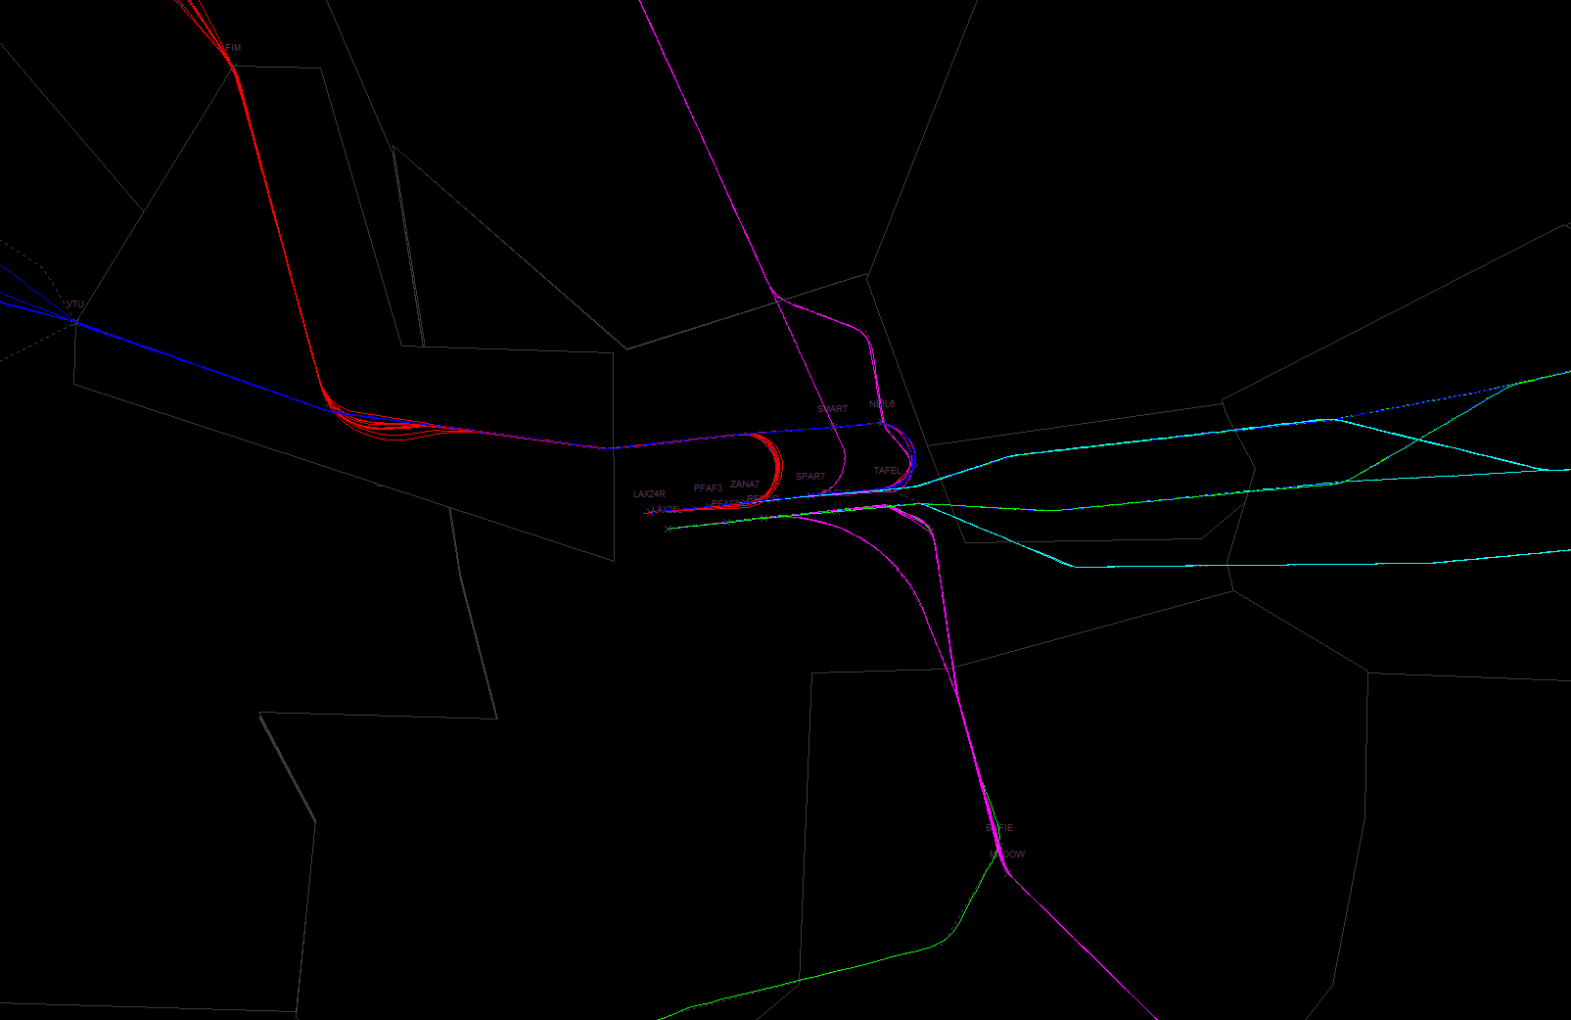

Figure 13: Arrival Traffic with TSS

From the two images, it is clearly seen that the arrival flow of traffic is much more streamlined with the advent of TSS versus that of the baseline operations (ie operations as they exist today). Aircraft are arriving in a more predictable manner in keeping with their estimate time of arrival.

## Relative Position Indicator

Relative Position Indicator (RPI) is another capability developed under contract by the FAA. RPI builds upon the functionality of and overcomes many of shortcomings of its foundational tool, the Converging Runway Display Aid (CRDA). RPI is a passive situational awareness aid and does not issue advisories or require controller response or reaction. RPI provides a means to illustrate multiple flows as a single flow to the controller. This allows the controller to see potential merge conflicts sooner and address through speed control. Below is an image of the RPI Application. The RPI projection does account accurately for turns. The qualification region (red box below) surrounding route allows for filtering of aircraft to display on other route to reduce clutter. [26]

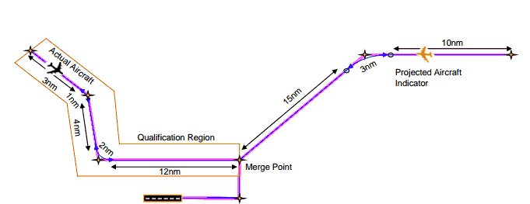

Figure 14: RPI Application

The figure below shows how a feeder controller could use RPI to assist in sequencing aircraft for multiple merges. In the example, the aircraft on the lighter traffic flows, Reference Path 1 and Reference Path 2, would project aircraft indicators onto the heavier or dominant flow, the Image Path. This allows the feeder controller to sequence aircraft on all three RNAV routes by scanning a single flow of aircraft and provides situational awareness to make calculated adjustments for sequencing using speed control. Even though Merge Point 2 may fall within the control area of the final controller, delegating the sequencing of the aircraft for both merge points to the feeder controller results in a reduced workload for the final approach controller and a reduction in vectoring aircraft for sequencing.

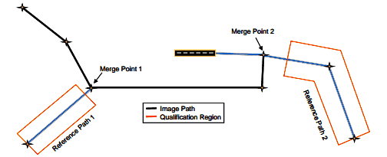

Figure 15: RPI in multiple merge situation

RPI does not include any requirement for the controller to take a particular action based solely on the displayed projected aircraft indicators. Instead, required action is based on the evaluation of the situation by the controller governed by Air Traffic Control Order 7110.65, which states that controllers must “give first priority to separating aircraft.” Therefore, with RPI, discretion is still left with the controllers based on their judgment of the situation

As a strategic tool, RPI serves to assist the traffic planner in the TRACON. One of the responsibilities of a Traffic Management Coordinator (TMC) is to make decisions about which aircraft to send to alternate runways in busy conditions or capacity-constrained conditions for purposes of runway load balancing. By utilizing RPI, the TMC can simultaneously project an aircraft onto multiple arrival flows to determine which flow best accommodates the aircraft. Once the best flow is identified, the TMC can instruct the radar controller to direct the aircraft towards the appropriate flow. With the assistance of RPI, the TMC is able to more easily identify the appropriate flow and the resulting merge will require less controller intervention. The figure below clearly depicts how this would appear on the scope.

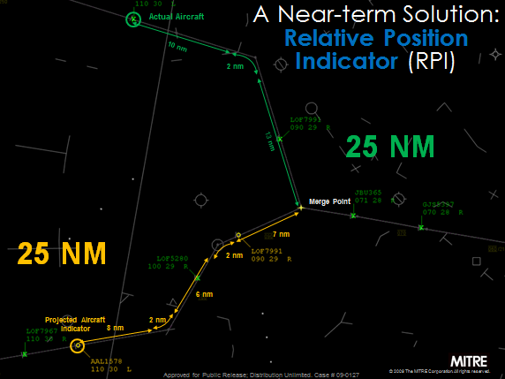

Figure 16: RPI on the Controller's scope

Noteworthy is that fact that RPI’s project algorithm accounts for circular arcs defined by Radius to Fix (RF legs). Since RF legs provide a fixed ground path, RPI projections are even more accurate when used with RNP procedures. [25] The image below shows the benefits of RPI. It allows for controllers to build gaps to more precisely merge traffic. It also reduces delay vectoring and elongation of the final approach by allowing the controller to merge more efficiently.

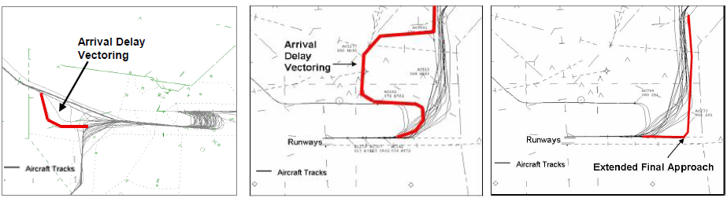

Figure 17: RPI Benefits [26]

RPI does not perform dynamic trajectory modeling, and does not take aircraft speed or environmental winds into account when computing indicator locations. RPI does not issue advisories or automated warnings/alerts to the controller. While this is not a problem, these facts show there is a trade off between a capability such as RPI versus that of TSS.

The MITRE Corporation’s Center for Advanced Aviation System Development (CAASD) developed the RPI concept as a means to conduct more efficient merging of RNAV arrival operations in busy terminal areas. This tool is able to be integrated with air traffic control terminal automation systems, including Standard Terminal Automation Replacement System (STARS) and Common Automated Radar Terminal System (CARTS).

## Lingering Gaps

Within the scope of this research, research points to the gap being fully addressed with the implementation of one of the suggested tools. This is based upon the assumption that the problem space is high density terminal environments (ie the core top 30 airports). It is within this airspace that the benefits will be realized by keeping aircraft on advanced procedures. It is within this airspace that controllers will need one of the tools identified in order to navigate complex merges within this airspace, thus allowing aircraft to stay on their advanced arrival procedures. This will then lead to an overall gain in enabling the use of PBN.

# Alternatives Analysis

One of the key objectives of this project is to perform an alternatives analysis that will evaluate the identified alternatives and help the decision makers with the best solutions for addressing the gap. This analysis has been performed by the team and includes great deal of subject matter expertise opinion. In this case, the subject matter expertise is vital as both technologies were tested using very different environments. Therefore, a great deal of the assessment must be qualitative and lends heavily on subject matter expertise.

The steps of this analysis follow those of the qualitative value model development followed by a quantitative analysis.

## Description of Alternatives

**Terminal Sequencing and Spacing (TSS):** This alternative has been identified as a key capability to address the gap that exists in enabling the use of Performance Based Navigation (PBN) by the Federal Aviation Administration (FAA). This capability leverages Traffic Based Flow Management (TBFM), a system that provides an absolute schedule and displays key information to controllers. Greater detail about this alternative was provided above in the gap analysis.

**Relative Position Indicator** **(RPI):** It is a passive situational awareness tool and does not issue advisories. It offers foresight into possible merge issues while relying on the controller to use speed control to achieve sequencing of aircraft. Greater detail about this alternative was provided above in the gap analysis.

**TSS Lite & RPI:** This is a proposed alternative for the sake of this alternatives analysis. This provides a “hybrid” option which has the potential to provide a great deal of benefit in enabling the use of PBN. While this alternative has not been researched independently it utilizes pieces of information that have been assessed. This option includes the RPI capability as well as two key pieces of information from TSS – runway assignment and sequence numbers. These two tools out of the TSS toolset have proven to provide benefit to controllers as individual pieces of information. This hybrid allows the controller to realize more benefit by adding some of the TSS information without having to be at a facility where TBFM is implemented.

The table below provides a simplistic comparison of the tools listed above.

|  |  |  |  |
| --- | --- | --- | --- |
|  | **Relative Position Indicator** | **TSS Lite + RPI** | **Terminal Sequencing and Spacing** |
| **Type of Display Aid** | Relative | Absolute | Absolute |
| **Mythology behind Display Aid** | Calculated Relative Position | Calculated Relative Position | Schedule Based Position |
| **Number of System Dependencies** | 1 (STARS) | 2 (STAR, ERAM, and TBFM) | 3 (STARS, ERAM, and TBFM) |
| **Equipage** | Mixed Equipage | Mixed Equipage | Mixed Equipage |
| **Environment** | Aids in Complex Merges within Terminal Environment | Aids in Complex Merges within Terminal Environment | Aids in Complex Merges within Terminal Environment |
| **Connection with TBFM** | Complement TBFM System | One piece of information inherent in TBFM | Developed within TBFM System |
| **User** | Benefits may vary based on controller experience (inexperienced can gain greater benefit) | Benefits may incrementally improve with additional information for controller | Precision of tools allows for inexperienced/ experienced controller to see benefits |
| **Incorporation of Winds for Solution?** | No | Yes | Yes |
| **Provide Trajectory Solution?** | No | Yes via sequence | Yes via speed and sequence |
| **Benefits** | * Reduces controller workload * Early Application of Speed Delay/Reduce Delay Vectoring * Enables OPD operations | * Provides two more pieces of information to controllers to help sequence a/c | * Further reduces controller Workload * Allow 95% a/c to stay on RNP curved path approach * Provide streamlined arrival solution; increasing predictability |

Table 4: Comparison of Alternatives

## Description of Criteria

In order to do a hierarchy value function, the criteria has been placed into three buckets; time, benefits, and operational suitability. Time speaks to how long it will take for specific aspects of the alternative to be available. Benefits speak to key benefits that are a priority for the agency to realize with the transition to NextGen. Operational Suitability is the degree to which a system can be placed satisfactorily in field use.

When determining the criteria, we worked to ensure that all measures are independent with little to no overlap. The criterion was vetted through three rounds with designated subject matter expert to include the sponsor. Below is the agreed upon criteria and a description of each measure. At the end of each description, is a numerical explanation of what is meant when placing the measure on a scale from 1 to 10. These numerical values were also vetted and approved by subject matter expertise.

### Time

**Time to Mature Capability**: This metric represents how mature the actual capability is at this point in time. This is a quantitative metric as both tools have undergone a maturity assessment as recently as September 30, 2013. In terms of the analysis, 1 = TRL 1, 2, 5=TRL 4, 10= TRL 9. TRL speaks to the Technical Readiness Level of the Capability. We are assuming that each capability would be brought to a max level of a TRL 9 before the next stage in the lifecycle. The figure below describes each level in the TRL framework [27].

[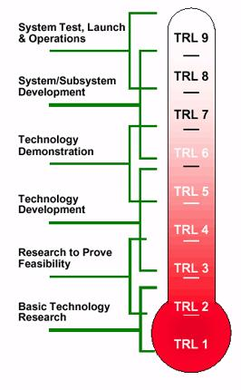](http://upload.wikimedia.org/wikipedia/commons/7/72/NASA_TRL_Meter.jpg)

Figure 18: Technology readiness level [27]

**Time to Adapt/Train**: This metric is based upon research and development performed to date. As RPI is incrementally more mature, this capability requires a much shorter timeframe than TSS. As such, it will take a longer time for site adaptation and training. For the purpose of this analysis, we recognize this time to be a reoccurring measure as this step will need to take place at each site. This number is quantitative based upon analysis. In terms of the analysis, 1= year or more, 5 = five months, and 10 = 1 month.

### Benefits

**Maintain/Increase Throughput:** Throughput is a measure of number of landings per hour on a given runway. This metric is a qualitative relationship based upon individual data derived from both TSS and RPI simulations. In terms of the analysis, 1= 0% increase to throughput, 5= 5% increase, 10= 10% increase or more to throughput.

**RNP Utilization/Predictability:** This metric represents a key objective – making arrivals as efficient as possible using PBN procedures. TSS provides a toolset which makes things as efficient as possible being that it is based upon an absolute schedule. RPI does provide greater efficiency compared to baseline operations but is not as efficient as TSS being that it is a relative tool. Included in this metric, is the ability of controllers to keep aircraft on RNP approaches. TSS has proved to be extremely efficient in keeping airplans on their RNP curved path approaches. While RPI has also proven effectiveness with allowing controllers to keep aircraft on PBN procedures, an evaluation of how many aircraft have been taken off their RNP curved path approach has not been conducted. Nonetheless, TSS demonstrates a clear gain in efficiency with controllers keeping aircraft on 95% of the time. In terms of the analysis, 1 = 50% of a/c stay on approach, 5 = 75% of a/c stay on approach, 10= 100% of a/c stay on approach.

**Fuel/Emissions:** This metric is based on both qualitative and quantitative data. While an apples to apples comparison of the two capabilities cannot be performed, data and subject matter expertise opinion demonstrates that TSS will provide more fuel and emissions savings than RPI. In terms of the analysis, 1 = 5% savings on fuel/emissions, 5 = 10% savings on fuel/emissions, 10 = 15% savings on fuel/emissions.

### Operational Suitability

**Reliability:** This is the ability of the system to perform and maintain its functions in routine circumstances, as well as unexpected circumstances. This includes off nominal situations where controllers are being faced with difficult situations where the system is being tested in terms of sensitivity and flexibility. This is a qualitative assessment based upon subject matter expertise. In terms of the analysis, 1= reliable 10% of the time, 5= reliable 75% of the time, 10= 100% of the time..

**Controller Acceptability**: This metric represents the amount of buy in controllers have provided in regards to both capabilities. Human factors element (reduce workload, etc)This metric is based upon controller involvement in both RPI and TSS simulations and their subsequent feedback which has been documented in simulation result reports. In terms of the analysis, 1= no buy in, 5 = somewhat buy in, 10 = greatly buy in.

**System Use**: This metric represents how many facilities will be able to use the capability. TSS is dependent on the facility having TBFM whereas RPI does not have a similar constraint. Both capabilities have a dependency on STARS. The factor of what facilities will gain benefit from either/or is also taken into account. The weights associated with this metric are qualitative based upon subject matter expertise of all factors listed above. In terms of the analysis, 1= 0 facilities able to use capability, 5 = 35 facilities able to use capability, 10 = 70 facilities or more able to use capability.

**Target Accuracy:** In specific terms, accuracy is a degree of closeness to the actual value. For this analysis, we focus on the level of accuracy the system gives in terms to the information it displays to the controllers. The more accurate the information, the more precisely they can deliver aircraft to the runway. This is also a qualitative assessment based upon subject matter expertise. In terms of the analysis, 1 = not accurate, 5 = somewhat accurate, 10 = very accurate.

**Collision Risk**: This metric was included to show that none of these capabilities truly have a collision risk. All of these tools are decision support tools to the controllers and controllers are ultimately responsible for separation of aircraft. In terms of the analysis, 1 = .001% risk 5 = .0001%, 10 = .00001% risk.

## Hierarchy Value Computations

Below is a decision tree (hierarchy) constructed to help decide which metrics are most important in helping to determine the best system to enable the use of performance based navigation. The metrics were then placed into buckets according to the appropriate grouping of attributes. The weights were vetted and decided upon by key subject matter experts to include the decision maker.

The team followed the guidelines below while developing the decision tree:

* Maintain independence among elements of hierarchy.
* Emphasize range of variation of elements during weight elicitation
* Always show effective weights to decision maker for verification
* Avoid pairwise comparisons for alternatives
* Use Objective Scoring if possible

Table 5: Attributes Hierarchy

## 

## Alternatives to Criteria Comparison

The table below represents a comparison of the defined alternatives to the criteria described above in a rating approach. Each alternative will be scored from 1 to 10. In all cases, 1 is least beneficial while 10 signifies the most benefit for each alternative. These weights have been determined through qualitative subject matter expertise that is based on experience developing the two technologies and running human in the loop simulations. A true quantitative analysis across the board is not possible due to the fact that both capabilities have been tested in very different environments. For more information about the scoring, refer to the description of criteria above.

|  |  |  |  |
| --- | --- | --- | --- |
|  | TSS | TSS Lite + RPI  (Runway assignments and sequence numbers plus RPI) | RPI |
| Time to Mature Capability  (1 = TRL 1) | 5 | 5 | 7 |
| Time to Adapt/Train  (1 = 1 year or more) | 7 | 8 | 9 |
| Maintain/Increase Throughput  (1 = no throughput) | 7 | 6 | 5 |
| RNP Utilization/Predictability  (1 = not efficient) | 9 | 7 | 6 |
| Fuel/Emissions  (1 = great amount of fuel burn) | 8 | 6 | 5 |
| Reliability  (1 = not reliable) | 6 | 7 | 8 |
| Controller Acceptability  (1 = not acceptable) | 9 | 8 | 6 |
| System Use  (1 = not available) | 5 | 5 | 10 |
| Target Accuracy  (1 = not accurate) | 9 | 7 | 6 |
| Collision Risk  (1 = .001% risk) | 9 | 10 | 10 |

Table 6: Alternatives with Scores

## Methods of Analysis

### Calculate Value Function

The weights were elicited with the SMEs using swing weights. The following steps explain the process that was followed to obtain the weights

1. Listed all level 2 attributes of the hierarchy in table 5 with their associated range of scores in the table below. The attributed were grouped according to their level 1 attributes [group 1 = time, group 2 = benefits, group 3 = operational sustainability]

|  |  |  |
| --- | --- | --- |
| Level 1 Grouping | Level 2 Criteria | Worst – Best Score |
| Group 1 | **Maturity** | 5 – 7 |
|  | **Adapt/Train** | 7 – 9 |
| Group 2 | **Throughput** | 5 – 7 |
|  | **RNP Utilization/Predictability** | 6 – 9 |
|  | **Fuel/Emissions** | 5 – 8 |
| Group 3 | **Reliability** | 6 – 8 |
|  | **Acceptability** | 6 – 9 |
|  | **System Use** | 5 – 10 |
|  | **Target Accuracy** | 6 – 9 |
|  | **Collision Risk** | 9 – 10 |

Table 7: Swing Weights for Level 2 Attributes

1. The table above was presented to the SMEs along with the full description of each attribute that was presented in the section “Description of Criteria” in this report above. For each group, the SMEs were asked to pick the attribute that gives the greatest improvement when “swings” to highest level. Then pick the attribute that gives the next highest increase of improvement when swung. Also the SMEs were asked to provide the percentage of increase in improvement in comparison with the first attribute for each attribute that comes next.
2. After this was done with the first group of level 2 attributes, moved to group 2 then group 3. After having covered all attributes of level 2, repeated the same procedure with the attributes of level 1 that are listed in table 8.

|  |  |
| --- | --- |
| Level 1 Criteria | Worst – Best Score |
| Time | 5 – 9 |
| Benefits | 5 – 9 |
| Operational Suitability | 5 – 10 |

Table 8: Level 1 Criteria Swing Weight

1. After all the ranking was elicited with the SMEs, the team assessed the weights by solving the following equations for each group of criteria

$$k_{2}=p_{n}k_{1}$$

$$k_{2}=p_{n}k_{1}$$

$$.$$

**.**

**.**

$$k_{n}=p_{n1}k_{1}$$

$$\sum_{i=1}^{n}{k_{i}=1}$$

Where $k_{i}=weight of attribute i,$ **and**

$$p_{n1}=percentage of improvemnt compared with attribute 1$$

1. After all the data and calculations were recorded from the different SMEs, an average weight was calculated as show in Table 6.

|  |  |  |  |
| --- | --- | --- | --- |
| Level 1  (Objective) | | Level 2  (Evaluation Measure) | |
|
| Criteria | **Weights** | **Criteria** | **Weights** |
| Time | 0.355731225 | **Maturity** | 0.5555556 |
| **Adapt/Train** | 0.4444444 |
| Benefits | 0.199604743 | **Throughput** | 0.3418182 |
| **RNP Utilization/Predictability** | 0.4272727 |
| **Fuel/Emissions** | 0.230909091 |
| Operational Suitability | 0.444664032 | **Reliability** | 0.219848053 |
| **Acceptability** | 0.163817664 |
| **System Use** | 0.138176638 |
| **Target Accuracy** | 0.226495726 |
| **Safety** | 0.251661918 |

Table 9: Results of weights elicitation using swing weights

1. After the weights were elicited, the value function for each level 2 attribute was calculated. The value function is a multiplication of level 2 weights with its associated level 1 weights.

|  |  |  |  |  |
| --- | --- | --- | --- | --- |
| Level 1  (Objective) | | Level 2  (Evaluation Measure) | | Bottom Row Weights (Value Function) |
|
| Criteria | **Weights** | **Criteria** | **Weights** |
| Time | 0.35573122 | **Maturity** | 0.5555556 | **0.197628458** |
| **Adapt/Train** | 0.4444444 | **0.158102767** |
| Benefits | 0.199604743 | **Throughput** | 0.3418182 | **0.06822853** |
| **RNP Utilization/Predictability** | 0.4272727 | **0.085285663** |
| **Fuel/Emissions** | 0.2309091 | **0.04609055** |
| Operational Suitability | 0.444664032 | **Reliability** | 0.21984805 | **0.0977585216** |
| **Acceptability** | 0.16381766 | **0.07284382284** |
| **System Use** | 0.13817663 | **0.06144218100** |
| **Target Accuracy** | 0.22649572 | **0.10071450286** |
| **Collision Risk** | 0.25166191 | **0.11190500320** |

Table 10: Calculated Value Function

1. After that, all scores were scaled on scale of 0 to 1 using the formula below

$$S_{attribute}(x) = \frac{x-worst}{best -worst}$$

Where $x$ is the atribute’s score, and

$worst$ is the worst score in the range 1-10 wich is 1

$best$ is the best score in the range 1-10 which is 10

1. Then, the team applied MAVT to all alternatives by multiplying the value function for each attribute with its associated scaled score of each alternative. The sum of the multiplication was calculated to find the MAVT score of each alternative.The results of the MAVT will be discussed in more detailes in the following sections.

### Alternatives Utilities

Utility of the alternatives being calculated using multi attribute value function (MAVT). The following equation was used

$$U(x_{1},x_{2},…..,x_{m})=\sum_{i=1}^{m}{k_{i}U_{i}\left(x_{i}\right)}$$

#### TSS 🡺 Total score = 0.685743193

|  |  |  |  |  |  |
| --- | --- | --- | --- | --- | --- |
| Level 1  (Objective) | Level 2  (Evaluation Measure) | Bottom Row Weights (Value Function) | Alternatives | | |
| **TSS** | | |
| Criteria | **Criteria** |  | **Scores** | **Scaling** | **Alternative Score** |
| Time | **Maturity** | 0.1976284 | 5 | 0.444444444 | 0.08783487 |
| **Adapt/Train** | 0.1581027 | 7 | 0.666666667 | 0.105401845 |
| Benefits | **Throughput** | 0.0682285 | 7 | 0.666666667 | 0.045485687 |
| **RNP Utilization/**  **Predictability** | 0.0852856 | 9 | 0.888888889 | 0.075809478 |
| **Fuel/Emissions** | 0.0460905 | 8 | 0.777777778 | 0.035848205 |
| Operational Suitability | **Reliability** | 0.09775852 | 6 | 0.555555556 | 0.05431029 |
| **Acceptability** | 0.07284382 | 9 | 0.888888889 | 0.064750065 |
| **System Use** | 0.061442181 | 5 | 0.444444444 | 0.027307636 |
| **Target Accuracy** | 0.100714502 | 9 | 0.888888889 | 0.089524003 |
| **Collision Risk** | 0.111905003 | 9 | 0.444444444 | 0.099471114 |
|  |  |  | **Total Alternative Utility** | | 0.685743193 |

#### TSS Lite and RPI 🡺 Total score =0.659355693

|  |  |  |  |  |  |  |
| --- | --- | --- | --- | --- | --- | --- |
| Level 1  (Objective) | Level 2  (Evaluation Measure) | Bottom Row Weights  (Value Function) | Alternatives | | | |
| **TSS Lite + RPI** | | | |
| Criteria | **Criteria** |  | **Scores** | | **Scaling** | **Alternative Score** |
| Time | **Maturity** | 0.197628458 | | 5 | 0.444444444 | 0.08783487 |
| **Adapt/Train** | 0.158102767 | | 8 | 0.777777778 | 0.122968819 |
| Benefits | **Throughput** | 0.06822853 | | 6 | 0.555555556 | 0.037904739 |
| **RNP Utilization/**  **Predictability** | 0.085285663 | | 7 | 0.666666667 | 0.056857109 |
| **Fuel/Emissions** | 0.04609055 | | 6 | 0.555555556 | 0.025605861 |
| Operational  Suitability | **Reliability** | 0.097758522 | | 7 | 0.666666667 | 0.065172348 |
| **Acceptability** | 0.072843823 | | 8 | 0.777777778 | 0.056656307 |
| **System Use** | 0.061442181 | | 5 | 0.444444444 | 0.027307636 |
| **Target Accuracy** | 0.100714503 | | 7 | 0.666666667 | 0.067143002 |
| **Collision Risk** | 0.111905003 | | 10 | 1 | 0.111905003 |
|  |  |  | | **Total Alternative Utility** | | 0.659355693 |

#### RPI 🡺 Total Score = 0.716280384

|  |  |  |  |  |  |
| --- | --- | --- | --- | --- | --- |
| Level 1  (Objective) | Level 2  (Evaluation Measure) | Bottom row weights  (Value Function) | Alternatives | | |
| **RPI** | | |
| Criteria | **Criteria** |  | **Scores** | **Scaling** | **Alternative Score** |
|  |
| Time | **Maturity** | 0.197628458 | 7 | 0.666666667 | 0.131752306 |
| **Adapt/Train** | 0.158102767 | 9 | 0.888888889 | 0.140535793 |
| Benefits | **Throughput** | 0.06822853 | 5 | 0.444444444 | 0.030323791 |
| **RNP Utilization/**  **Predictability** | 0.085285663 | 6 | 0.555555556 | 0.047380924 |
| **Fuel/Emissions** | 0.04609055 | 5 | 0.444444444 | 0.020484689 |
| Operational  Suitability | **Reliability** | 0.097758522 | 8 | 0.777777778 | 0.076034406 |
| **Acceptability** | 0.072843823 | 6 | 0.555555556 | 0.04046879 |
| **System Use** | 0.061442181 | 10 | 1 | 0.061442181 |
| **Target Accuracy** | 0.100714503 | 6 | 0.555555556 | 0.055952502 |
| **Collision Risk** | 0.111905003 | 10 | 1 | 0.111905003 |
|  |  |  | **Total Alternative Utility** | | 0.716280384 |

From the results shown above in the tables, the scoring of the alternatives is as follows:

**RPI > TSS > TSS Lite & RPI**

### Cost Added to Value Function

For this purposes of this analysis, cost was separated from the other values to include benefits. Below are two key metrics associated with cost.

**Cost of Implementation**: This metric is qualitative based on a rough order of magnitude cost assessment. The cost to implement RPI has been determined by MITRE Corporation and TSS is currently undergoing a cost estimate by another vendor. Notional results support the comparison of costs in the chart below. TSS will be substantially more expensive than RPI to implement.

**Cost of Adaptation/Training**: This metric is qualitative based on a rough order of magnitude cost assessment. The cost of adaptation and training has been determined for RPI by MITRE Corporation and TSS is currently undergoing a cost estimate. Notional results support the comparison of costs in the chart below. TSS will be substantially more expensive than RPI to provide the necessary adaptation and training at the facility level.

Cost is divided under two categories: cost of implementation, which is the fixed cost associated with each alternative and calculated based on software line of code SLOC. The cost of SLOC is $1,500/line.

|  |  |  |
| --- | --- | --- |
|  | SLOC | Fixed Cost |
| TSS | 45500 | $70M |
| TSS Lite/RPI | 8000 | $12M |
| RPI | 6500 | $10M |

Table 11 Fixed Cost of Alternatives

The other category for cost is, cost of adaptation and training. This cost is calculated based on the total number of days needed to get controlled qualified for using the proposed tool. Please note that these days are not exact but represent a relative time. The exact numbers are not known for adaptation and training but in vetting with subject matter experts, the relationship below in regards to time was determined.

|  |  |  |
| --- | --- | --- |
| Alternatives | Total days of training | Reoccurring Cost |
| TSS | 3 to 5 days | $450K |
| TSS Lite/RPI | 2 days | $350K |
| RPI | 1 day | $200K |

Table 12 Reoccurring Cost of Alternatives

In taking the individual costs of each system and calculating in the value function scores; the total costs are derived as depicted below.

|  |  |  |  |  |
| --- | --- | --- | --- | --- |
| Alternatives | Utility | Cost of implementation | Cost of Adaptation & Training | Total Cost |
| TSS | 0.68574 | $70,000,000 | $450,000 | $70,450,000 |
| TSS Lite & RPI | 0.65936 | $12,000,000 | $350,000 | $13,150,000 |
| RPI | 0.71628 | $10,000,000 | $200,000 | $10,250,000 |

Below is a graph depicting value versus the cost of the alternatives. This chart helps to quickly identify the dominated alternatives. This chart also helps the decision-maker visually assess the value added for the additional cost.

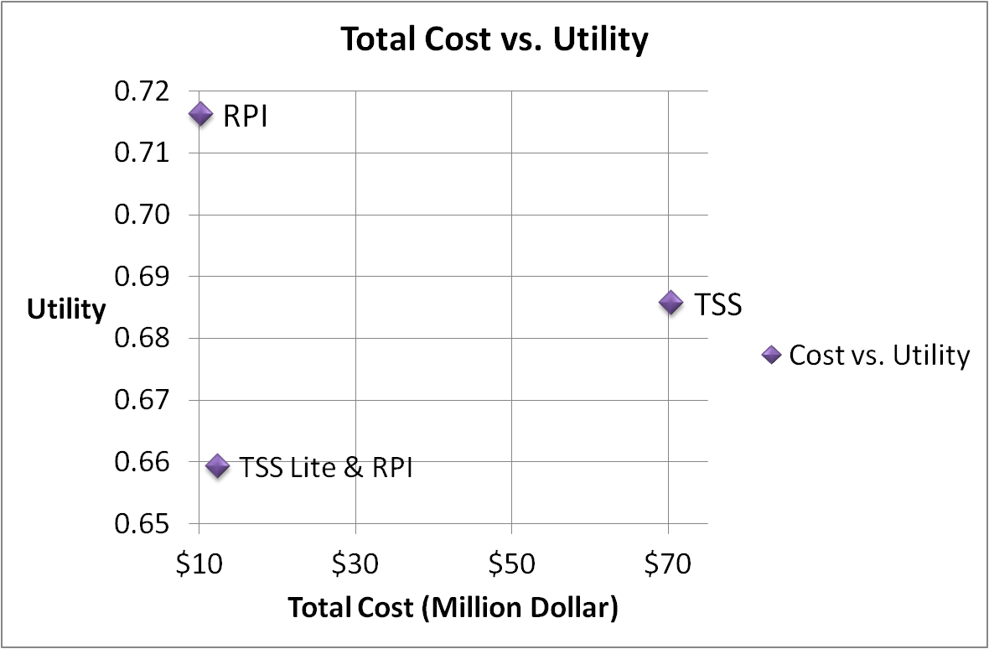

Figure 19: Utility vs Cost Graph

### Scenario and Sensitivity Analysis

#### Scenario Analysis

The scenario analysis was performed to check for the levels at which the results would change when different stakeholders are weighing the attributes. The table below articulates the various values that are derived when different perspectives are taken into considerations.

Original scenario: weights were elicited from the end user perspective

Scenario 1: Weights were elicited from customer’s perspective

Scenario 2: Weights were elicited from engineering designer perspective

Scenario 3: Time precedes benefits

Scenario 4: Equal Weights for Level 1 Attributes

|  |  |  |  |  |  |
| --- | --- | --- | --- | --- | --- |
| Alternatives | User Scenario | Agency  Scenario | Systems Engineering  Scenario | Benefits >  Time  Scenario | Equal Weights for Level 1 Attributes |
| TSS | 0.69 | 0.72 | 0.71 | 0.73 | 0.69 |
| TSS Lite + RPI | 0.66 | 0.63 | 0.68 | 0.66 | 0.64 |
| RPI | 0.72 | 0.62 | 0.72 | 0.68 | 0.68 |

Table 13 Sensitivity Analysis Scenarios

The chart below provides the visual context of the comparison of the values in the chart above.

In performing this analysis, the team has documented the following observations:

* TSS has the greatest amount of benefits
* RPI is the fastest solution in regards to time to develop and implement
* Reliability attribute has a great effect on calculations be careful when scoping

#### Sensitivity Analysis

The sensitivity analysis was performed to check for the levels at which the results would change when altering the preference of attributes. The table below articulates the various values that are derived when the preference is altered.

|  |  |  |
| --- | --- | --- |
| **Rank** | **Attribute** | **Steepness/Slope** |
| **1** | Maturity | 0.198 |
| **2** | Adapt/Train | 0.158 |
| **3** | Collision | 0.112 |
| **4** | Target Accuracy | 0.101 |
| **5** | Reliability | 0.098 |
| **6** | RNP Utilization/Predictability | 0.085 |
| **7** | Acceptability | 0.073 |
| **8** | Throughput | 0.068 |
| **9** | System Use | 0.061 |
| **10** | Fuel/Emissions | 0.046 |

## Results

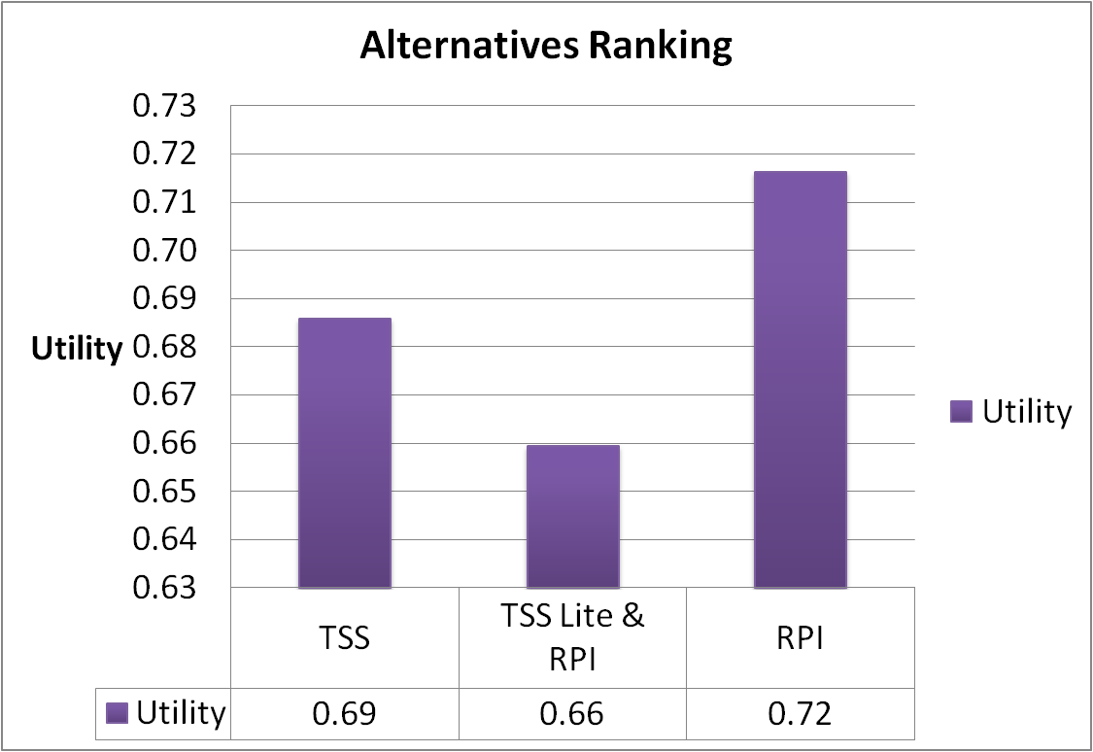

From the analysis performed, the results demonstrate the following order according to benefits

🡺 TSS > TSS Lite/RPI > RPI

## Conclusions/Recommendation

The scores differ considerably between the ATC perspective of values and FAA headquarters' perspective. The team recommends a meeting at the decision maker level to set clear priorities on what is **MOST** important. The alternative analysis framwork is already in place and the team would easily be run the analysis multiple times with the new weights after the stakholder agree on the priorities.

If cost is not an issue, one potential recommendation is a phased approach of RPI followed by TSS as this would allow agency to realize some sort of benefits in near term. The table below clearly articulates which capability “wins” depending on the priority of the decision maker.

|  |  |
| --- | --- |
| **If Decision Maker Priority Is….** | **Capability** |
| Time | RPI |
| Benefits | TSS |
| Cost | RPI |

Table 14: Priority vs Capability Table

# Schedule

The schedule, as shown below, was developed to keep the TDST on track throughout the course of the semester. This schedule was updated on a regular basis and key responsibilities were outlined in the resource section. To date, the schedule is 100% complete and the team stayed “on track” throughout the course of the semester.

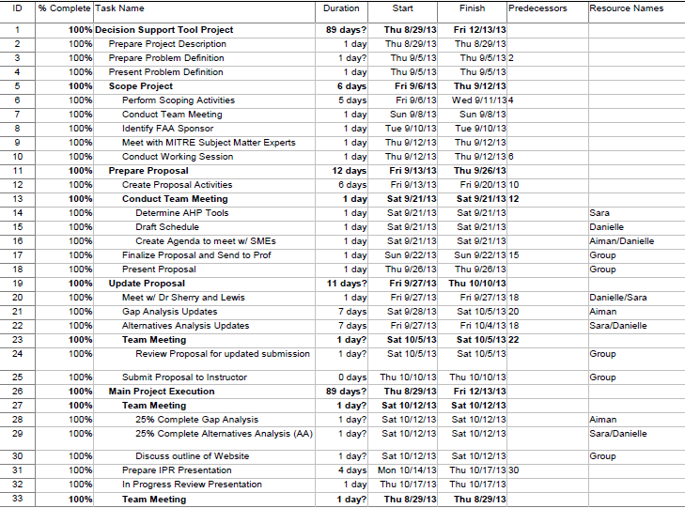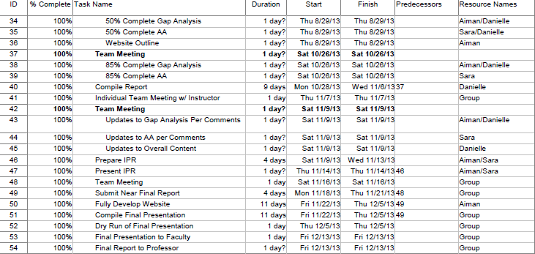

# References

[1] <http://en.wikipedia.org/wiki/>

[2] Relative Position Indicator Concept of Operations

[3] C. M. Johnson *et al.,* “Terminal Sequencing and Spacing (TSS) Concept of Operations,” The MITRE Corporation, McLean, VA, MP130330, Jul. 2013

[4] FAA, National Airspace System (NAS) System Engineering Manual, Version 3.1, Washington, DC, Oct. 2006.

[5] C. M. Johnson *et al.*, “Requirements Validation Plan for Time-Based Metering Using Area Navigation (RNAV) and Required Navigation Performance (RNP) Routes,” The MITRE Corporation, McLean, VA, MP100227, Jul. 2010.

[6] Jeffrey Shepley and Paul MacWilliams, "Relative Position Indicator," *ATCA Journal*, 2008

[7] Paul MacWilliams and Jeffrey Shepley, "A Site Study and Benefits Analysis of a TRACON Situational Awareness Aid," The MITRE Corporation, McLean, VA, 2007.

[8] Jeffrey Shepley, "Near-Term Terminal Area Automation for Arrival Coordination," The MITRE Corporation, McLean, VA, 2009.

[9] Becker, T.A.; Barker, D.R.; Smith, A.P., "Methods for maintaining benefits for merging aircraft on terminal RNAV routes," Digital Avionics Systems Conference, 2004. DASC 04. The 23rd , vol.1, no., pp.2.E.1,21-13 Vol.1, 24-28 Oct. 2004 doi: 10.1109/DASC.2004.1391278

[10] Klein, K.A.; Sprong, K.R.; Haltli, B.M.; Becker, T.A.; DeArmon, J.S., "Evaluating operational benefits of terminal RNAV: Las Vegas case study," Digital Avionics Systems Conference, 2004. DASC 04. The 23rd , vol.1, no., pp.2.C.1,21-11 Vol.1, 24-28 Oct. 2004 doi: 10.1109/DASC.2004.1391267

[11] <http://en.wikipedia.org/wiki/List_of_the_busiest_airports_in_the_United_States>

[12] <http://www.geaviation.com/systems/products-and-services/air-traffic-optimization-services/performance-based-navigation/learning-opd.html>

[13] <http://faaindustryforum.org/1%20-%20BOB%20TYO-Industry%20Forum%20Presentation%20TBFM-PM.pdf>

[14]<http://www.fly.faa.gov/Products/Training/Traffic_Management_for_Pilots/TFM_in_the_NAS_Booklet_ca10.pdf>

[15] <http://en.wikipedia.org/wiki/Continuous_descent_approach>

[16] <http://www.faa.gov/nextgen/library/media/getSmart_PBN.pdf>

[17] <http://www.faa.gov/news/fact_sheets/news_story.cfm?newsId=10856>

[18] <http://www.faa.gov/air_traffic/publications/atpubs/aim/aim0102.html>

[19] <http://www.aea.net/AvionicsNews/ANArchives/RNPJan08.pdf>

[20] <http://www.geaviation.com/systems/products-and-services/air-traffic-optimization-services/>

[21] <http://www.jpdo.gov/newsArticle.asp?id=60>

[22] <http://www.macnoise.com/faq/what-performance-based-navigation-pbn-rnavrnp>

[23] <http://www.gpo.gov/fdsys/pkg/CHRG-111hhrg51384/html/CHRG-111hhrg51384.htm>

[24] Herndon. Capt Albert A, "Promise and Limitations of PBN (RNAV and RNP)," The MITRE Corporation, McLean, VA, 2013.

[25] [http://www.caasd.org/library/documents/Relative%20Position%20Indicator[1].pdf](http://www.caasd.org/library/documents/Relative%20Position%20Indicator%5b1%5d.pdf)

[26] <http://www.atcguild.com/Seminar2011/Presentations/RPI%20for%20India%20October%202011-final.pdf>

[27] http://en.wikipedia.org/wiki/File:NASA_TRL_Meter.jpg

# Acronyms

|  |  |
| --- | --- |
| ACRONYM | Definition |
| ADS-B | Automatic Dependent Surveillance-Broadcast |
| ARTS | Automated Radar Tracking System |
| CAASD | Center for Advanced Aviation System Development |
| CARTS | Common Automated Radar Terminal System |
| ConOps | Concept of Operations |
| CRDA | Converging Runway Display Aid |
| DCA | Ronald Reagan Washington National Airport |
| DOC | Direct (Aircraft) Operation Costs |
| HFDS | Human Factors Design Standard |
| HITL | Human-In-The-Loop |
| IAD | Dulles International Airport |
| LOAs | Letters of Agreement |
| NAS | National Airspace System |
| OEP | Operation Evolution Partnership |
| P50 | Phoenix TRACON |
| PTL | Predicted Track Line |
| RF | Radius-to-Fix |
| RNAV | Area Navigation |
| RNP | Required Navigation Performance |
| RPI | Relative Position Indicator |
| SCT | Southern California TRACON |
| SIAP | Standard Instrument Approach Procedure |
| STARS | Standard Terminal Automation Replacement System |
| TBM | Time-Based Metering |
| TDST | Terminal Decision Support Tool |
| TMA | Traffic Management Advisor |
| TM | Traffic Management |