

USPS Project  
Final Report

Dallas Kuchel, Efrain Reyes, and Matt Stirling

December 13, 2013

Table of Contents

Introduction 1

Problem Statement 2

Project Objectives 3

Systems Engineering 3

Requirements Development 4

Model Requirements 5

Concept of Operations 12

Dynamic Routing Model 13

Modeling Approach 13

Clustering Algorithm 14

Routing Model Formulation 16

Scope 17

Modeling Assumptions 17

Model Outputs 18

Results 18

Model Performance 23

RouteSmart Comparison 23

System Prototype 24

Implementation Recommendations and Roadmap 27

Model Roadmap 27

Potential Impact and Benefits 27

Deliverables 28

References 28

Appendices

Appendix A Project Schedule 30

Appendix B Expanded Data Gathering Steps 31

Appendix C Clustering Algorithm 32

Appendix D Dynamic TSP Model 33

Appendix E Alternate Model Formulations 35

Appendix F USPS DRS System Requirements Specification 40

Appendix G USPS DRS Concept of Operations 84

Appendix H Maps of GMU DRS Routes 93

Figures

Figure 1: Requirements Development Process 4

Figure 2: High Level System Overview 13

Figure 3: Model Overview 14

Figure 4: Clustered Addresses 16

Figure 5: Model Performance Against Six Delivery Sets 23

Figure 6: Summary of Results 24

Figure 7: Our Model’s Routes 25

Figure 8: RouteSmart Routes 26

Figure 9: Project Schedule 30

Figure 10: Iterative Addition of Subtour Elimination Constraints 33

Figure 11: High Level System Overview 44

Figure 12: Route Stops for Arlington County. 93

Figure 13: GMU DRS Route 1: 64 Stops including depot. 94

Figure 14: GMU DRS Route 2: 77 Stops including depot. 95

Figure 15: GMU DRS Route 3: 47 Stops including depot. 96

Figure 16: GMU DRS Route 4: 48 Stops including depot. 97

Figure 17: GMU DRS Route 5: 45 Stops including depot. 98

Figure 18: GMU DRS Route 6: 50 Stops including depot. 99

Figure 19: GMU DRS Route 7: 42 Stops including depot. 100

Figure 20: GMU DRS Route 8: 44 Stops including depot. 101

# Introduction

The United States Postal Service (USPS) historically delivers mail and packages through over 200,000 nationwide static delivery routes. These routes are the same every day.

Competitors utilize a more dynamic routing method for their delivery drivers. They adopted technology to change each driver’s route daily to meet the delivery needs of that day while minimizing the cost of those routes through optimization. This technique is typically termed “dynamic routing”. These delivery companies have saved billions of dollars every year through their adoption of dynamic routing solutions.[1]

The Postal Service has been privately pursuing methods to make these static delivery routes more dynamic for the last four years.[2] Recently, the Postal Service issued an official ‘Request for Information’ regarding dynamic routing solutions.[3] The Postal Service is considering dynamic delivery for a number of reasons. As listed in the request for information, the Postal Service could use dynamic routing to consider the following initiatives:

Dynamic routing could enable Saturday delivery of only packages, same day delivery service, and a different delivery business model.

1. Dynamic routing could allow cost effective delivery of only packages on Saturday. Since the 1980s, various Postmaster Generals have argued in favor of eliminating Saturday delivery.[4] Recently, this proposal has gained more traction with policy decision makers.[5] If Congressman Issa’s proposal to end Saturday delivery were to pass into law, the Postal Service would be required to deliver only packages and premium mail services on Saturday. In this case, dynamic delivery routes would be more cost effective than the traditional delivery routes.
2. The Postal Service has recently teamed up with Amazon.com to offer Sunday delivery for Amazon orders in New York City and Los Angeles. These deliveries will rely on dynamic routing to allocate packages to trucks and determine routing for delivery. The same service will be expanding to other major cities as soon as next year. Dynamic routing will be essential for successful implementation of this effort.
3. Dynamic routing could expand same-day delivery service. Many businesses, including Amazon, Google, and Walmart, are all experimenting with same day delivery service as Internet retail portals push to compete with the a competitive advantage “brick and mortar” stores offer - immediacy. The Postal Service has created a same-day delivery pilot called MetroPost. This pilot program currently uses very limited and basic heuristics to plan delivery routes that change daily. A more robust dynamic routing solution might gain efficiencies over the current routing tools and allow the Postal Service to roll out this service to additional major metropolitan areas.
4. Dynamic routing could allow consideration for alternative delivery models with a pursuit of efficiency gains. For example, UPS currently loads its deliveries on trucks directly at the processing plants. The Postal Service sends all of its mail from each processing plant, unloads it at a delivery station, and then reloads it on delivery trucks again at those stations. Dynamic delivery might allow pursuit of alternative delivery models that increase efficiencies and reduce costs.
5. Breakthrough technologies often permit the entrepreneurs and innovators to build new business models and services around the new technology. Similarly, dynamic delivery might permit other creative solutions that are currently unimaginable.

The Postal Service declares some other needs in its request for information. In particular, they are in pursuit of a web-based, national desktop tool that could provide turn-by-turn instructions to personnel. Additionally, they desire a single, internal corporate solution.[6]

The Postal Service currently has a solution from RouteSmart technologies that is used in a limited capacity.[7] This solution is a desktop application, which uses solver algorithms to generate the turn-by-turn driving instructions. The Postal Service has expressed a need for fast solutions. Currently, the RouteSmart solution generates results for 150 deliveries in 5-10 minutes and results for 3200 deliveries in 6-7 minutes[8][9]. However, the system is costly. Therefore, the Postal Service is pursuing internal solutions for its long-term solution.[10]

# Problem Statement

The Postal Service is seeking to gain efficiencies in delivery methods. Specifically they are interested in the potential of dynamic delivery solutions. USPS is seeking more efficient delivery routing methods and wants to better understand the requirements and process for implementing an internal dynamic delivery solution.

# Project Objectives

Given a localized delivery area, analyze the potential of dynamic routing for the Postal Service within the constraints of Saturday only package delivery. Determine heuristics to solve these localized problems and develop a model to optimize a dynamic routing solution. The following objectives focused the group’s efforts in solving the stated problem.

* Develop a System Requirements Specification (SyRS) which identifies key systems requirements for Saturday package delivery.
* Formulate an algorithm to minimize the time/cost to deliver parcels given a daily delivery list.
* Develop a CONOPS for implementing a Dynamic Routing Solution.
* Assess potential solutions and implementation strategies for nationwide dynamic routing.
* Develop a system prototype, which integrates the modeling product with other software and presents optimized route information.

# Systems Engineering

The Systems Engineering (SE) aspect of this project addresses the need of the USPS to better understand the requirements and process for implementing a dynamic delivery solution. The intent of this approach is to apply SE principals to accomplish the following objectives with respect to providing input to the USPS.

* Provide a concise list of high-level functional requirements to focus ongoing efforts as well as provide a starting point for future development efforts.
* Provide a basis for risk analysis in determining prioritization of system capabilities and features.
* Provide a template by which the USPS can determine suitability of potential solutions, both third party and internal.

In order to accomplish the objectives stated above the project team accomplished the following objectives:

* Develop a Concept of Operations (CONOPS) for a potential Dynamic Routing System.
* Develop a Systems Requirements Specification (SyRS) that defines a set of High Level System Requirements.

## Requirements Development

In-order to set the expectations for a potential solution and provide a basis for the CONOPS and eventual prototype, requirements were developed and refined. This ensured that the Postal Service’s requirements for a dynamic delivery routing solution were met and that the team had a clear and concise definition of what the USPS is looking for in a Dynamic Routing Solution. Figure 1 below depicts the requirements development process the team implemented.

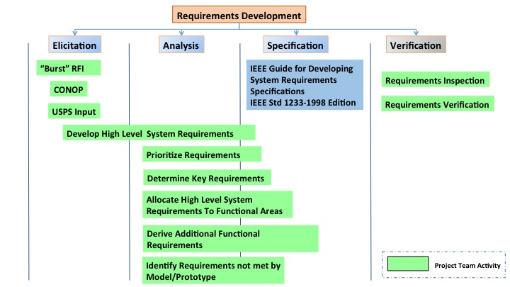

Figure 1: Requirements Development Process

The requirements development process entailed the traditional exercises of Elicitation Analysis, Specification and Verification.

### Elicitation

The basis for requirements development was the Postal Service’s Request for Information regarding dynamic delivery. The Team developed user scenarios providing input to the requirements process. Postal Service representatives provided input throughout the process that contributed to requirements development and refinement. Additionally, communication with Postal Service representatives allowed the team to identify high priority requirements.

### Analysis

Once the high-level system requirements were developed, the project team prioritized the requirements and identified certain key requirements based on stakeholder input. The next step of the process was to identify high-level functional areas for the system. The requirements developed were the primary input for this task. The team grouped requirements into logical categories that provide the basis for the system functional areas. Next, additional functional requirements were derived. This process was undertaken in areas were high-level requirements did not sufficiently define the particular problem being addressed. See the System Functional Areas section below for more information on the system functions.

### Specification

The *IEEE Guide for Developing System Requirements Specifications* provided the template for developing the SyRS. Refer to Appendix F: USPS System Requirements Specification for a comprehensive list of high-level system requirements developed.

### Verification

The project team inspected requirements for completeness and accuracy. A next step that the USPS can take, in follow up to this project, is to perform a through requirements inspection. Traditionally the verification exercise would entail development of a test plan based on the system requirements. This was out of scope for this project because the objective was to develop high-level requirements. These requirements do not provide enough detail at a lower level to sufficiently constrain the problem and produce verifiable test cases.

## Model Requirements

The following table specifies requirements that are allocated to the Dynamic Routing Model (or Core Processing as it is defined in the SyRS and CONOPS). The requirements specified were developed by the project team and relate the System Engineering activities with the Operational Research component of the project. These requirements were used to focus model development. Although a formal test plan was not developed these requirements were used as a basis to verify the functionality and performance of the model algorithm. In some instances it was not feasible for requirements to be addressed within the constraints of the course. These requirements however still represent needed system functionality and are defined in the SyRS. Requirements that have not been met in this iteration of the Model are highlighted in yellow below. The plan is that unmet requirements would provide the basis for future development of the Dynamic Routing System. This is a recommended action for the USPS. In general, the unmet requirements specified have also been identified as limitations in the current solution, RouteSmart, which the USPS is currently testing.

| **Requirement ID** | **Requirement Description** | **Priority** | **Traceability/Source** |
| --- | --- | --- | --- |
| SFREQ-2.0 | The DRS shall accept as input delivery deadlines and service times (time range for delivery) for delivery locations. These times shall be used as input constraints in route formulation and optimization. | Low | *USPS Request For Information regarding Dynamic Routing Strategy:* Section IV. Objectives. |
| SFREQ-7.0 | The DRS shall accept as input delivery vehicle types to be used for a given system run and formulate optimized routes based on the capacity of designated delivery vehicles. Vehicle load capacity shall be factored into route formulation and optimization. | Low | *USPS Request For Information regarding Dynamic Routing Strategy:* Section IV. Objectives. |
| SFREQ-10.0 | The DRS shall accept as input the number of carriers available for a given delivery station/depot and formulate optimized routes based on the available carrier workforce and route length constraints.  In the event that routes cannot be produced for each carrier within the given route length constraints then a reduced number of routes shall be produced. | High | *USPS Request For Information regarding Dynamic Routing Strategy:* Section IV. Objectives. |
| SFREQ-12.0 | The DRS shall formulate and optimize routes based on speed limit variables for a given delivery area. | High | *USPS Request For Information regarding Dynamic Routing Strategy:* Section IV. Objectives. |
| SFREQ-17.0 | The DRS shall accept as an input a maximum and minimum route length constraint. These route length constraints shall be configurable and the DRS shall formulate optimized routes based on the specified route length. Route length is defined in units of hours. | High | *USPS Request For Information regarding Dynamic Routing Strategy:* Section IV. Objectives. |
| SFREQ-18.0 | The DRS shall output total mileage for each route produced by the DRS on a given system run. | High | *USPS Request For Information regarding Dynamic Routing Strategy:* Section IV. Objectives. |
| SFREQ-19.0 | The DRS shall output total number of routes produced by the DRS on a given system run. | High | *USPS Request For Information regarding Dynamic Routing Strategy:* Section IV. Objectives. |
| SFREQ-20.0 | The DRS shall output total estimated route time for each route produced by the DRS on a given system run. | High | *USPS Request For Information regarding Dynamic Routing Strategy:* Section IV. Objectives. |
| SFREQ-25.0 | The DRS shall take as an input, configurable delivery/pickup times for each delivery/pickup location and use this information in determining total route time.  Delivery time is defined as the time it takes for a carrier to exit their vehicle, make delivery of the parcel(s), return to their vehicle and continue on their route. | Medium | *USPS Request For Information regarding Dynamic Routing Strategy:* Section IV. Objectives. |
| SFREQ-29.0 | The DRS shall take as input configurable service times (time range for delivery) for individual delivery/pickup locations and for the following designations:   * Destination type (normal vs. high rise). * Parking Availability (Applicable to delivery locations were reserved parking is based on time of day or reserved parking is not available). * Street Direction (Applicable to delivery locations on streets were street direction is based on time of day.) * Package Type (i.e. Express Mail, Regular Parcel, Priority Mail).   The DRS shall factor service times and delivery deadlines into route formulation and optimization. | Medium | *USPS Request For Information regarding Dynamic Routing Strategy:* Section IV. Objectives. |
| SFREQ-31.0 | The DRS shall factor in historical traffic data where applicable when determining standard and non-standard traffic conditions for route formulation and optimization. | Low | Derived based on system need. |
| SFREQ-40.0 | The DRS shall process at least 400 delivery locations simultaneously and formulate, optimize and report dynamic routes within >10 minutes of receiving a start request.  This constraint applies to system execution at the delivery station/depot level. | High | Derived based on system need and system prototyping. |
| SFREQ-42.0 | The DRS shall formulate and optimize routes that start and end at a specified depot and include return time from last stop in total route time. | High | Derived based on system need. |
| SFREQ-43.0 | The DRS shall formulate and optimize routes based on street direction for delivery locations. All route stops shall be determined based on traffic direction for given delivery location. | High | Derived based on system need. |
| SFREQ-44.0 | The DRS shall formulate and optimize routes so that delivery locations are visited once. If multiple deliveries are designated for a given location they shall be made on one stop. | High | Derived based on customer communication (email). |
| SFREQ-45.0 | The DRS shall implement an interface which allows front end users to input parcel pickup information including address, geocode and service time if applicable. | Low | *USPS Request For Information regarding Dynamic Routing Strategy:* Section IV. Objectives. |
| SFREQ-46.0 | The DRS shall take as input and factor the following configurable route attributes into dynamic route formulation and optimization:   * Start time * End time * Last Delivery * 15 minute break   30 minute lunch break | Low | *USPS Request For Information regarding Dynamic Routing Strategy:* Section IV. Objectives. |
| SFREQ-47.0 | The DRS shall produce routes, which visit each delivery location specified by the system input (within 400 locations constraint) and return to the starting Delivery Depot. This is defined as a complete tour. | High | Derived based on system need and prototyping. |
| SFREQ-48.0 | The DRS shall output a sequential list of delivery locations and parcel pickups for each route produced. Delivery locations shall be in geocode format and address format. | High | Derived based on system need and prototyping |
| SFREQ-56.0 | The DRS shall output the following route information in human readable format at the completion of each system run:   * Route Number (Identifier assigned to route by DRS) * Sequence Numbers for route stops * Addresses for each route stop * Geocode for each route stop * Delivery or Pickup designation * Number of packages delivered at route stop. * Number of packages picked up at route stop. * Total Route Time * Total Route Mileage * Mileage between each route stop.   Cumulative mileage at each route stop. | High | Derived based on system need and system prototyping. |

## Concept of Operations

This portion of the project focused on defining a CONOPS for a dynamic delivery solution, which meets key requirements as identified in the SyRS. Given the time constraints of this project, it was not feasible to develop a complete CONOPS that addresses all the system objectives as stated in the Postal Service’s RFI (and requirements derived from the RFI). The CONOPS delivered specifies how the system should work within the scope of key requirements. System design attributes will not be within the scope of the CONOPS. See Appendix G: USPS DRS Concept of Operations.

### High Level Functional Areas

The following high-level functional areas divide the system into logical functional areas. The CONOPS provides an overview of how these functional areas interact to accomplish the primary objectives of the desired Dynamic Routing System. The following areas provide the basis for the DRS core functional areas.

* Core Processing (Dynamic Routing Model)
* DRT Interface
* Data Management
* Data Archiving
* External Factors Management
* Carrier Interface

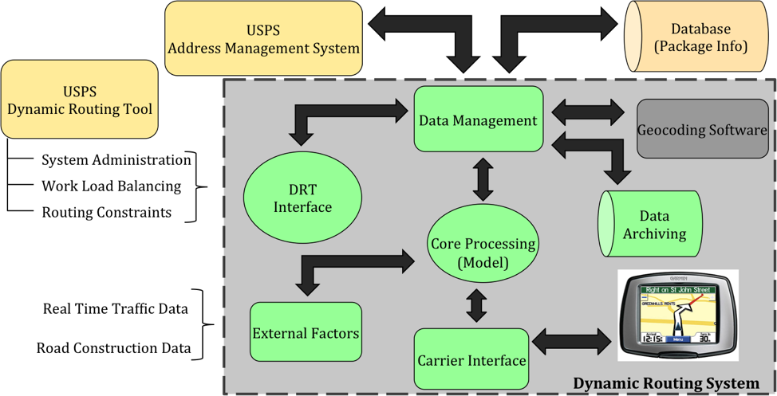

Figure : High Level System Overview

# 

# Dynamic Routing Model

## Modeling Approach

The team worked with the Postal Service to create a data set imitating the delivery needs for Saturday-only package delivery. The team confirmed with the Postal Service that this address information is identical to the data provided to their other temporary local Route Smart solution. The data set is a mock list of delivery addresses in Arlington County, VA, which could represent scenarios such as Saturday only deliveries or Sunday Amazon deliveries. The steps of data processing, full list of ZIP Codes included, and data sources are documented in Appendix A.

The Postal Service has indicated that a fast response is very valuable, illustrated by the fact that they are paying rates per route based on return time. Currently, after submitting a small list of addresses, USPS receives delivery instructions within 5-10 minutes for those addresses. Therefore, our model must quickly and produce timely results.

The team attempted to reduce the complexity of the assignment problem via the following methods:

1. Deliveries at the same address were considered one stop. Each delivery takes 2.5 minutes to complete (an assumption provided by USPS).
2. Creating clusters of addresses that are located close together to be delivered to by the same carrier.
3. Limit the next routing choice to connect to only the closest stops.

The processed data inputs to the optimization model. Figure 3. depicts the relationship between the model, coded in SAS, and the external functions. The addresses are geocoded before inputted to the SAS model. This step will eventually be eliminated as the Postal Service is in the process of geocoding all addresses.

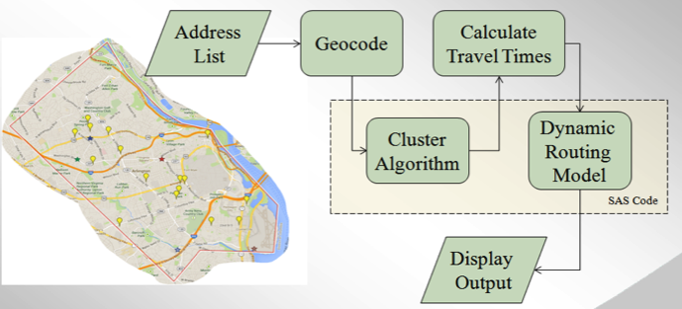

Figure : Model Overview

Additionally, the model interacts with the PCMiler program, which estimates road distances and travel times for pairs of addresses. To fully automate the model, an interface would be needed to facilitate this interaction.

## Clustering Algorithm

In working with the data and designing various models, the group discovered that Vehicle Routing Problem (VRP) algorithms for large problems solve too slowly to meet system objectives. The model must first allocate vehicles and then determine routing for each vehicle. The number of combinations grows quickly as the number of nodes increases making TSP and Vehicle Routing Problems (VRP) difficult to solve to optimality, even for small instances.

The group determined that a heuristic based approach is necessary to provide timely results. Heuristics are general rules that can eliminate bad solutions or search for better solutions. Generally, heuristics decrease the complexity of the problem and therefore the time needed to find good solutions, but cannot prove optimality.

Several approaches discussed in literature use a clustering approach to turn the Vehicle Routing Problem into several single Traveling Salesman Problems.[11] Since computation time for Vehicle Routing Problems with time constraints can increase exponentially with size, splitting the problem into several smaller problems significantly increases the speed of the algorithm. Solving multiple smaller TSPs will be faster than solving one large Vehicle Routing Problem.

The group developed SAS procedures to cluster the delivery points based on Euclidian distance. Each cluster represents the addresses assigned to a specific carrier. We then use heuristics to ensure that each route will take between 2 and 5 hours. The heuristic operates by splitting the addresses into clusters and estimating the delivery time for each cluster. If the delivery times are acceptable, then the cluster is accepted. If the delivery time is either too small or too large, the clustering algorithm re-runs with a new minimum cluster size. This process repeats until all cluster sizes fall within the allowable range. This workload balancing helps ensure minimum and maximum delivery route times for each carrier.

shows the clustered addresses. We see that nearby locations cluster while distant locations form separate clusters. We believe this clustering algorithm is an approach that balances the pursuit for a reasonable solution within the model’s given operational time constraints.

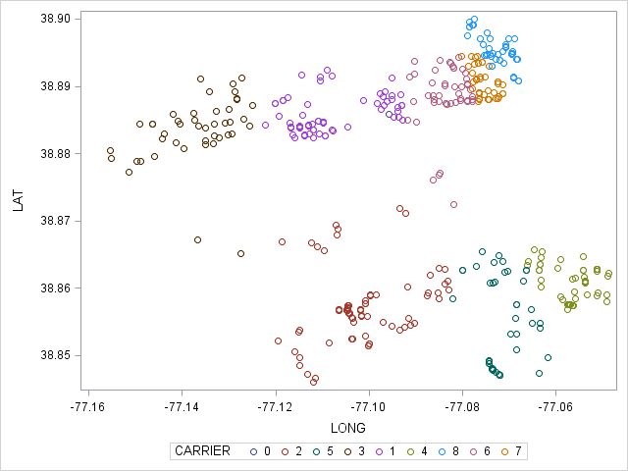

Figure 4: Clustered Addresses

After the cluster algorithm is complete, each cluster of addresses is solved as a single TSP. The TSP model determines the order of delivery addresses and ensures the carrier begins and ends at the station. Additionally, the model requires that the delivery route is a complete tour, giving each driver a loop that visits all addresses and returns to the station.

## Routing Model Formulation

Over the duration of the semester, the group has attempted numerous formulations for solving variations of TSP and VRP. The current formulation is for a single traveling salesman. The model dynamically adds cuts to eliminate subtours. This method produced more timely results than the other integer programming methods. Further information on each formulation is in Appendices.

There can be duplicates in the set of 400 randomly generated addresses. We combine these duplicates to count as a single address. We factor in a delay of 2.5 minutes per delivery. [12] This delay occurs twice if there are two deliveries to an address. The delay is included in post-processing summary outputs after the SAS TSP solver runs. This approach allows the TSP solver to exclude this constant amount from the relative objective gap calculations.

The basic formulation is as follows:

**Minimize**: Time to visit each delivery location and return to starting station.

**Subject To**:

* Driver must return to the station
* Each delivery location is visited once
* Route must form a complete tour
* Routing decision variables are binary

## 

The algorithm first solves the problem as a Linear Program with fractional solutions. This allows the model to obtain a feasible solution. Next, the model dynamically adds subtour elimination constraints until an integer feasible solution is reached.

This is accomplished using the PROC Optmodel procedure in SAS. Alternative solvers such as CPLEX and GUROBI should be explored to determine if solutions can be obtained more quickly.

## Scope

* This project solves a scenario of 400 mock delivery addresses, approximately the number of daily package deliveries for a single station in Arlington County.
* Dynamic delivery will be utilized on Saturdays for delivery of USPS packages.
* Dynamic delivery will be utilized on Sundays for delivery of Amazon packages.
* At this time, we are not considering time window requirements, such as delivering to a certain address before noon.

## Modeling Assumptions

* Drivers depart and return to the same station.
* Routes for drivers must be between 2 and 5 hours.
* Travel time calculator assumes standard traffic conditions and road limitations such as one-way streets.
* Using average cost factors as provided by USPS.
* 2.5 minute delay per delivery for driver to exit vehicle and deliver package.

## Model Outputs

The model ultimately produces two key pieces of information, the number of drivers used in the delivery routes and an ordered delivery list for each driver. The ordered delivery list will first inform the processing facility which packages need to go on which trucks. The ordered list will also allow the truck to be packed in an order that allows the driver to quickly removed packages when needed. Second, the ordered delivery list tells the drivers an efficient order to deliver packages. This information can be displayed graphically and in the future, can be converted into turn-by-turn directions via a GPS device.

# Results

The model outputs:

1. The number of carriers required to efficiently deliver all packages.
2. A list of addresses that each carrier will deliver to. This allows the sorting and processing facility to sort the proper packages into each delivery truck.
3. An ordered list of their deliveries for each carrier (driver) including the number of packages to be delivered to each address.
4. The driver will also receive turn-by-turn directions that will efficiently route him to each address in the proper order. The team has developed a system prototype that feeds the model results into Google Maps to create turn-by-turn directions, a format more useful for the drivers. See Prototype Development section for further details on the system prototype.

The following table outlines the requirements allocated to the Model and details the verification method and results for requirements if applicable.

| **Requirement ID** | **Requirement Description** | **Verification Method** | **Verification Status** |
| --- | --- | --- | --- |
| SFREQ-12.0 | The DRS shall formulate and optimize routes based on speed limit variables for a given delivery area. | Inspection | Pc-miler provides this functionality and was incorporated in data gathering activities. |
| SFREQ-17.0 | The DRS shall accept as an input a maximum and minimum route length constraint. These route length constraints shall be configurable and the DRS shall formulate optimized routes based on the specified route length. Route length is defined in units of hours. | Test | This has been verified by analyzing the total route length produced by the model and comparing to the original constraint. For our testing purposes this constraint was a minimum of 2 hours and a maximum of 5 hours.  Reference Model Performance section. |
| SFREQ-18.0 | The DRS shall output total mileage for each route produced by the DRS on a given system run. | Test | This has been verified by analyzing the total mileage produced by the model.  Reference Model Performance section. |
| SFREQ-19.0 | The DRS shall output total number of routes produced by the DRS on a given system run. | Test | This has been verified by analyzing the model output.  Reference Model Performance section. |
| SFREQ-20.0 | The DRS shall output total estimated route time for each route produced by the DRS on a given system run. | Test | Same verification as SFREQ-19 |
| SFREQ-25.0 | The DRS shall take as an input, configurable delivery/pickup times for each delivery/pickup location and use this information in determining total route time.  Delivery time is defined as the time it takes for a carrier to exit their vehicle, make delivery of the parcel(s), return to their vehicle and continue on their route. | Test | Reference Model Output data. Each Route has associating .csv file which specifies cumulative route time for each stop.  For the purposes of model testing this variable was set to 2.5 minutes. |
| SFREQ-40.0 | The DRS shall process at least 400 delivery locations simultaneously and formulate, optimize and report dynamic routes within >10 minutes of receiving a start request.  This constraint applies to system execution at the delivery station/depot level. | Test | Reference Model Performance section. |
| SFREQ-42.0 | The DRS shall formulate and optimize routes that start and end at a specified depot and include return time from last stop in total route time. | Test | Reference Model Map Data. |
| SFREQ-43.0 | The DRS shall formulate and optimize routes based on street direction for delivery locations. All route stops shall be determined based on traffic direction for given delivery location. | Test | Pc-miler provides this functionality and was incorporated in data gathering activities. |
| SFREQ-44.0 | The DRS shall formulate and optimize routes so that delivery locations are visited once. If multiple deliveries are designated for a given location they shall be made on one stop. | Test | Reference Model Output data. Each Route has associating .csv file which specifies number of deliveries made for each stop. Reference Model Map data for verification of no-revisits. |
| SFREQ-47.0 | The DRS shall produce routes, which visit each delivery location specified by the system input (within 400 locations constraint) and return to the starting Delivery Depot. This is defined as a complete tour. |  | Reference Model Output data. Each Route has associating .csv file which specifies number of deliveries made for each stop. |
| SFREQ-48.0 | The DRS shall output a sequential list of delivery locations and parcel pickups for each route produced. Delivery locations shall be in geocode format and address format. |  | Reference Model Output data. Each Route has associating .csv file which specifies ordering of deliveries for each route. |

## Model Performance

To test the robustness of our model, the group solved six different delivery lists. Five of the delivery lists contained 400 addresses and one contained 2,000. Model performance over these six runs is shown in Figure 5.

|  |  |  |  |  |  |  |  |
| --- | --- | --- | --- | --- | --- | --- | --- |
| Set | Deliveries | Grouper Time (s) | PC Miler (s) | OptSolver (s) | Total Time (m) | Carriers | Time per Carrier (m) |
| 1 | 400 | 3 | 35 | 412 | 7.50 | 8 | 0.94 |
| 2 | 400 | 4 | 31 | 432 | 7.78 | 8 | 0.97 |
| 3 | 400 | 5 | 30 | 277 | 5.20 | 8 | 0.65 |
| 4 | 400 | 4 | 32 | 460 | 8.27 | 8 | 1.03 |
| 5 | 400 | 4 | 44 | 900 | 15.80 | 7 | 2.26 |
| 6 | 2,000 | 31 | 221 | 3,480 | 62.20 | 28 | 2.22 |

Figure : Model Performance Against Six Delivery Sets

We see that four of the five delivery sets solved within the required 5-10 minute range. Additionally, the majority of the processing time is spent on the OptSolver. The times to run the clustering algorithm and PCMiler are relatively fast.

Since our solution first decomposes the deliveries into clusters that are solved sequentially, these clusters could be solved on different machines to provide results more quickly. Networking several computers is a cheap solution that could drastically improve model run times. This approach will be further discussed in the Next Steps portion of this report.

## RouteSmart Comparison

To compare the efficiency of our solution to the RouteSmart system, the team requested the client run the same set of addresses through RouteSmart. The client ran set number 3 through RouteSmart and provided our team with the results.

Our model solution determined a solution with eight carriers. These eight carriers travel a total of 95.4 miles and complete their routes in a total of 1,400 minutes. Our model provided this information in 5.5 minutes on a machine with a 4-core, 2.67 GHz processor and 16GB of RAM.

RouteSmart produced a very similar solution that delivered all packages with six carriers in 1295 minutes and over a distance of 87.9 miles.

|  |  |  |  |
| --- | --- | --- | --- |
| **System** | **Number of Carriers** | **Total Distance** | **Total Time** |
| Our Model | 8 | 95.4 | 1,400 |
| RouteSmart | 6 | 87.9 | 1,295 |

Figure : Summary of Results

For this delivery set, our model’s solution is **within 8% of the RouteSmart solution**. This impressive result verifies that our solution could be useful for the Postal Service.

Furthermore, the Postal Service can apply our solution at very little cost. The Postal Service pays a fee for each route obtained from RouteSmart, so implementing our inexpensive solution could potentially be a very cost effective long term alternative. The Postal Service has asked our group not to disclose financial information associated with RouteSmart, but has indicated that the high costs associated with the commercial solution make an internal solution highly desirable.

We believe our solution can be improved greatly by improving the clustering algorithm. Our solution called for 8 carriers, whereas RouteSmart called for 6. Given more time, our group would improve the clustering algorithm by seeking to reduce the number of carriers. Not only are there fixed costs associated with using additional trucks, but the total distance traveled will be greater.

A future suggestion is to conduct more comparisons to examine the robustness of our model as compared to RouteSmart. Fully automating our process will allow for many more comparisons.

## System Prototype

To demonstrate the functionality of the model, the team developed a system prototype. The system prototype inputs the localized data set as described in the data gathering section and processes the input as described in the sections above. The routes determined by the OR model processing are piped through java software which converts the route data (.csv format) into a Keyhole Markup Language file (KML). The KML is then imported to Google Maps or Google Earth to accomplish the route overlay on the mapping utility. Additionally Google Maps provides the functionality to determine turn-by-turn directions for each route stop on the map.

In order to facilitate converting the ordered list of route stops to an actual route which follows roads, the Google Maps interpolation algorithm was leveraged. The interpolation algorithm determined the path to take between route stops. In the future USPS would want to consider an implementation which allows complete control of the route path.

Figure 7 and Figure 8 show the routes determined by our model and the routes determined by RouteSmart. These graphics highlight our ability to present the routes in Google Maps. This same output data could be translated into turn-by-turn directions for delivery drivers and delivered to GSP devices in each truck.

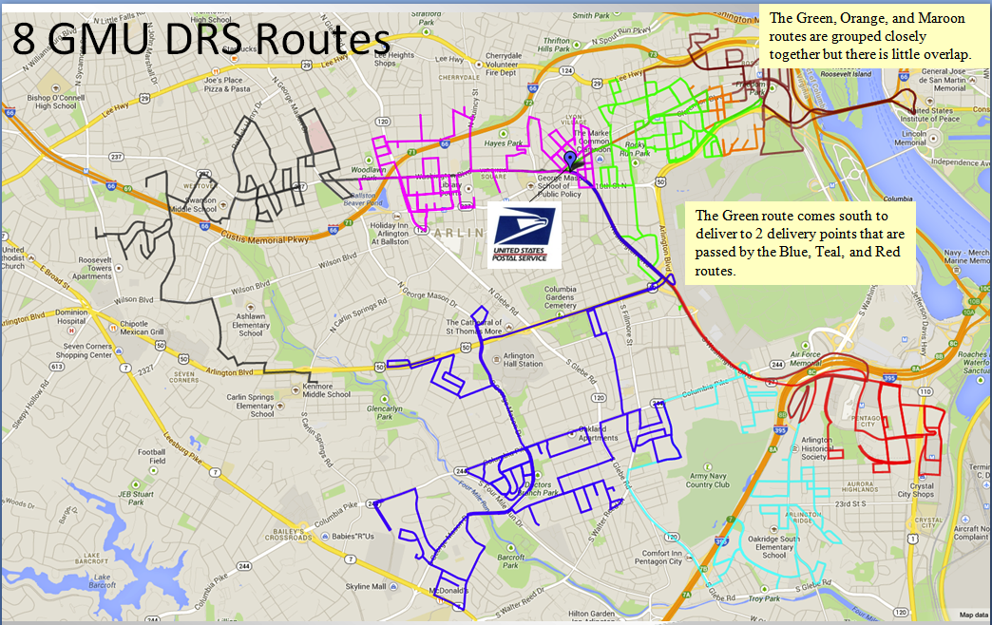

Figure : Our Model’s Routes

The colors in Figure 7 show the eight different carrier routes. We see that there is little overlap between the various routes. This characteristic is very desirable for the Postal Service.

Since our algorithm relies on geographic clusters, a carrier will deliver to locations that are nearby. However, in some instances, a driver will pass other delivery stops on his way to another neighborhood. For instance, we see the bright green route dips down to deliver 2 packages that are out of its primary delivery area. The blue, red, and teal routes pass these addresses on route to their other deliveries. Ideally, one of these three carriers would deliver these packages.

These observations lead us to believe that given more time, we could significantly improve our solution, in particular the clustering that determines which carriers should deliver which packages.

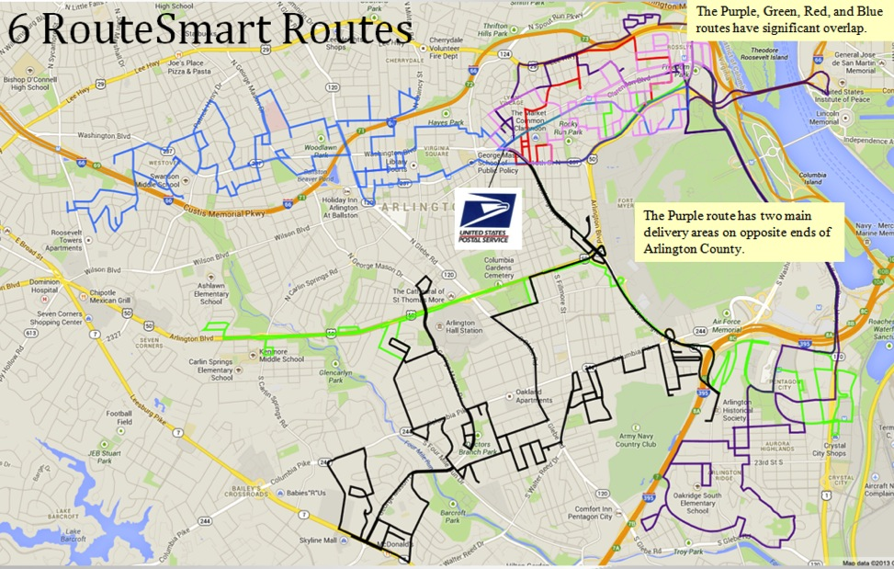

Figure : RouteSmart Routes

Figure 8 shows the routes determined by RouteSmart. First, we see that there are only 6 carriers. Fewer carriers are better for the Postal Service. This highlights the need for our group to refine our clustering algorithm to reduce the number of carriers utilized for delivery.

Next, we see that in Northeast Arlington, there is significant overlap among the Red, Purple, Pink, and Green carriers.

Additionally, the Purple carrier has two concentrations of deliveries, one in North Arlington and one in South Arlington. This may not be ideal as there will be time spent traveling to the opposite end of the county without making any deliveries.

Our main takeaway from analyzing RouteSmart’s results is that even commercial solutions will not deliver optimal solutions. They too will rely on heuristics and approximations to deliver useful results in an acceptable time window.

# Implementation Recommendations and Roadmap

Our group recognizes that our deliverables are far from a finished product. In order to fully implement this solution, there are many other components that must be addressed including automation of data processes and integration with GPS components.

## Model Roadmap

In its current state, the model relies on heuristics to approximate an efficient routing solution. Additionally, addresses are clustered together to simplify the vehicle routing problem to a single traveling salesman problem. Given the limited resources available to our team, we relied heavily upon the heuristics to simplify the problem.

With additional time, our group would improve the clustering algorithm to give each driver a higher workload and utilize fewer drivers. We believe that improving the clustering could yield valuable benefits to our ultimate solution and result in fewer miles driven and fewer hours.

We recommend further testing using other more powerful solvers such as Gurobi or CPLEX. For our project, we used SAS OR since the Postal Service already had licenses. Run times and/or optimality gap may improve with other solvers.

In solving TSP problems, it is not uncommon to network computers together to solve problems more quickly. With the clustering approach, the routing for each carrier could be solved on different machines to reduce run times. If faster run times are desired, this is an area we highly recommend exploring.

Furthermore, our solution and the RouteSmart solution are designed to be run at the single station level. Eventually, it may prove useful to have a solution that also considers the package sorting process thereby informing the distributors where to send each package. Whereas we are currently limited by the packages located at each delivery facility, eventually it may be possible to route packages to specific delivery facilities or to redraw boundaries such that addresses are delivered more efficiently.

# Potential Impact and Benefits

Our solution has the potential to enable the Postal Service to institute package delivery on Saturdays and Sundays. Static routes will no longer make sense with lower delivery volume of only packages on weekends. Dynamic routing will be essential to determine package allocation and routing. If fully implemented, our solution will allow the Postal Service to realize it’s near term goal of providing efficient package delivery on Saturdays, Sundays, or even other days. This solution could potentially change the way the Postal Service does business and allow the Postal Service the financial freedom to operate more efficiently.

Our solution has the potential to replace RouteSmart and become the preferred dynamic delivery model for the Postal Service. Our solution is only a prototype, but with the implementation steps laid out in this report, our solution and approach show that a fully developed and tested solution could be developed to provide dynamic routing information to delivery carriers. Our solution has demonstrated the ability to produce solutions comparable to the RouteSmart solution and can be developed and maintained at a lower cost.

# Deliverables

1. Algorithm that provides near-optimal routing to complete deliveries and associated model code.
2. PowerPoint briefing that communicates work and results.
3. System Requirements Specification (SyRS) that identifies key requirements within scope of Saturday delivery implementation.
4. Concept of Operations detailing how system should operate within scope of key requirements provided in the SyRS.
5. System Prototype and code, which incorporates OR model, developed and mapping utility to display OR model route output overlay on a map.
6. Written report that details the following:
   * Assumptions used in model development
   * Techniques used in model development
   * Prototype design
   * Optimization results
   * Comparison to RouteSmart solution
   * Solution recommendations

# References

Benavent, E., Martinez, A. “A Polyhedral Study of the Mulit-Station Multiple TSP”.

Departamento de Estadística e InvestigaciónOperativa, Universitat de València, C/Dr. Moliner, 50, 46100, Burjassot, Valencia, Spain.

IEEE Guide for Developing System Requirements Specifications

IEEE Std 1233-1998 Edition

Kara, I., Bektas, T. “Integer Linear Programming Formulations of Multiple Salesman Problem and its Variations”. European Journal of Operations Research 174 (2006) 1449-1458.

Kulkarni, R.V., Bhave, P.R., “Integer Programming Formulations of Vehicle Routing Problems”. European Journal of Operations Research 20 (1985) 58-67.

Sadiq, S. “The Traveling Salesman Problem: Optimizing Routes Using Genetic Algorithms”. SAS Global Forum 2012. Paper 161-2012.

SAS/OR® 9.22 User’s Guide: Mathematical Programming, “Example 11.4 Traveling Salesman Problem” http://support.sas.com/documentation/cdl/en/ormpug/63352/HTML/ default/viewer.htm#ormpug_milpsolver_sect020.htm

SAS/OR® 9.2 User’s Guide: The FASTCLUS Procedure, “Overview : FASTCLUS Procedure” http://support.sas.com/documentation/cdl/en/statug/63033/HTML/ default/viewer.htm#fastclus_toc.htm

1. Project Schedule



Figure 9: Project Schedule

1. Expanded Data Gathering Steps

The team worked with the Postal Service to create a data set imitating the delivery needs for Saturday only package delivery. The team confirmed with the Postal Service that this address information is identical to the data provided to their other temporary local Route Smart solution. The data set is a mock list of Saturday only package delivery addresses in Arlington County, VA and ZIP Codes 22201, 22202, 22203, 22204, 22205, 22205, 22206, 22207, 22209, 22210, 22212, 22213, 22214, 22215, 22216, 22217, 22219, 22222, 22225, 22226, 22227, 22230, 22240, 22241, 22242, 22243, 22244, 22245, and 22246. This data was gathered via the following steps:

1. National addresses were gathered and filtered for all Arlington ZIP Codeaddresses(SOURCE: Address Management System, USPS).
2. Delivery facilities’ addresses were gathered and filtered for just Arlington, VA. This will serve as potential starting points for each carrier. These addresses were pre-geocoded (Source: FMS, USPS).
3. The average daily package volume for the Arlington Post Offices was determined to be 2,000 across five stations(Source: EFlash, USPS).
4. The full list of Arlington addresses from step 1 was filtered to create a set of 2,000 random addresses. This will serve as 2,000 “deliveries” for the day.
5. The 2,000 addresses from step 4 were geocoded using http://www.gpsvisualizer.com/geocoder/. This is not a good permanent solution because the addresses process at the rate of about one per second. The best alternative could be to pre-geocode the entire address database (USPS has acknowledged they are currently working on this). Other alternatives would be to investigate other geocoding software.
6. Approach #1 - “Heuristic Method”. The list of geocoded “delivery” addresses were imported into SAS. Performed a heuristic that identifies “routes” that can run between each delivery stop and a) the nearest ten other stops and b) going to each of the starting points. This was used to limit the number of combinations run through the drive time software in step 7 below.
7. Run the combinations or “route” legs through PCMiler, which calculates the mileage and time for each drive leg. PC Miler is a computer program that calculates point to point distances via actual road drive times. One way streets, highways, local roads, and more are all taken into consideration by the program.
8. Clustering Algorithm

The group utilized the FASTCLUS procedure in SAS to group the addresses. The clustering is based on Euclidian distance on the attributes specified. In our case, latitude and longitude are given to the procedure, so actual straight line distance is used to determine clusters. The SAS users guide succinctly summarizes the results of the procedure by stating, “Observations that are close together are usually assigned to the same cluster, while observations that are far apart are in different clusters”. [13]

According to the SAS User’s Guide, The FASTCLUS procedure operates in four steps:

1. Observations called ***cluster seeds*** are selected.

2. If you specify the DRIFT option, temporary clusters are formed by assigning each observation to the cluster with the nearest seed. Each time an observation is assigned, the cluster seed is updated as the current mean of the cluster. This method is sometimes called ***incremental***, ***on-line***, or ***adaptive*** training.

3. If the maximum number of iterations is greater than zero, clusters are formed by assigning each observation to the nearest seed. After all observations are assigned, the cluster seeds are replaced by either the cluster means or other location estimates (cluster centers) appropriate to the LEAST= option. This step can be repeated until the changes in the cluster seeds become small or zero (MAXITER=).

4. Final clusters are formed by assigning each observation to the nearest seed.

The FASTCLUS procedure was selected over other methods due to its applicability in large data sets (>100 observations). The FASTCLUS procedure is useful for quickly obtaining good clusters. This trait helped the group meet the customer’s need for fast solutions.

1. Dynamic TSP Model

The group adapted a TSP formulation from the SAS User’s Guide to fit the needs of the client. After starting out with integer programming solutions to the TSP problem that were slow to produce results, an approach was adapted to dynamically generate subtour cuts. This is done by solving an LP relaxation of the problem, then finding violated subtours and adding them to the formulation iteratively. This process continues until the solution is a single tour.[14]

Figure 10 illustrates how the solution changes as subtours are removed through dynamically added cuts.**Error! Reference source not found.**

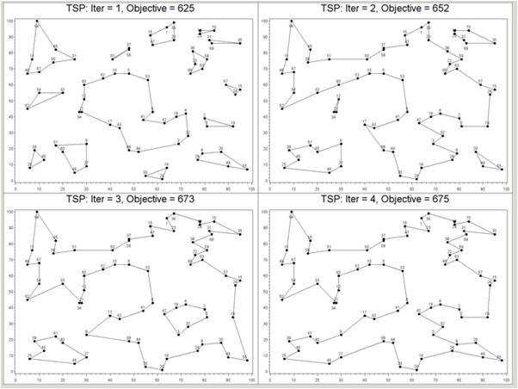

Figure 10: Iterative Addition of Subtour Elimination Constraints

The group experimented with this formulation by attempting to generate additional cuts to enforce minimum and maximum number of deliveries in the mTSP formulation. Allocating deliveries to vehicles will likely be a heuristic based and may result in good solutions, but optimal solutions may be unattainable. This is an area the group would like to explore in more detail in the future.

1. Alternate Model Formulations

This section documents formulations that were attempted in prior model versions. These formulations were eventually abandoned due to slow run times with large problems.

Vehicle Routing Problem

In the vehicle routing problem described by Kulkarni and Bhave, vehicles are routed to a set of customers from a single station. The objective is to minimize the cost required to visit all customers. Additional constraints may be added such as:

* Maximum number of customers allocated to a vehicle
* Maximum cost/time for each vehicle
* Load and capacity constraints (not used for this application)

The formulation for this problem provided by Kulkarni and Bhave is as follows:

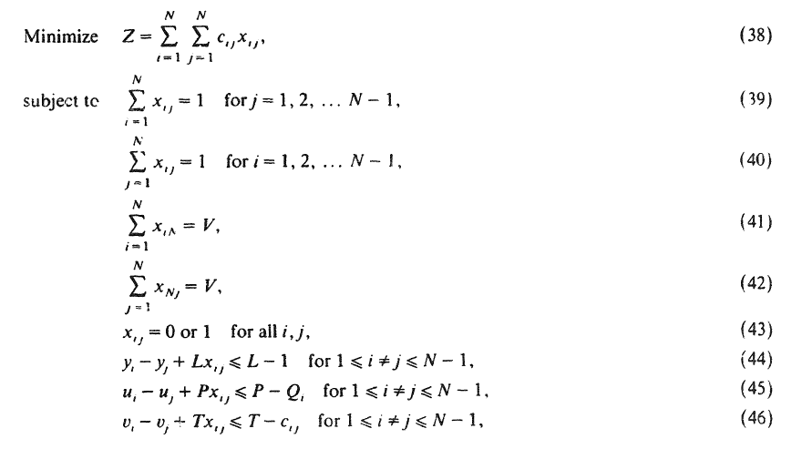

Where:

V = Number of vehicles

L = Maximum number of stops for a vehicle

P = Capacity of all vehicles

T = Maximum cost allowed for route of a vehicle

y, u, and v are arbitrary real numbers

c(i,j) = the cost of traveling from i to j

x(i,j) = 1 if route i,j is selected, 0 otherwise.

The authors describe their formulation by stating: “In the above formulation, (39)-(42) ensure that each node is being served only once and that all the V vehicles are being used. (44-46) are the subtour breaking constraints that also represent the node constraints, capacity constraints, and cost constraints respectively. In words these equations ensure that all the tours are starting and ending at the home city N and further every route serves at most the L nodes and the load and cost on every route are less than or equal to the vehicle capacity P and the maximum allowable cost T respectively.”

To adapt the formulation provided by the authors to our circumstances, we removed the capacity constraints.

This formulation provided useful constraints to enforce the maximum time requirement and maximum number of deliveries for each carrier. In some versions, we added these constraints to other formulations.

The model provided useful results for small problems. However, when we increased the number of customers, the model became very slow to provide results. For example, with only 30 locations, the formulation was exceeding the 5 minute run time desired by the Postal Service. For this reason, the group decided to attempt other formulations.

Fixed Destination Multi Station Multiple TSP

In the fixed destination version of MmTSP formulated by Kara and Bektas, travelers must return to their original station.

The formulation provided by Kara and Bektas for this problem is as follows:

Consider a complete directed graph G = (V, A), where V is the set of n nodes (vertices), A is the set of arcs and C = (cij) is the cost (distance) matrix associated with each arc (i, j) 2 A. The cost matrix C can be symmetric, asymmetric or Euclidean.

The multistation mTSP (MmTSP) is a generalization of the single station mTSP, such that there is more than one station and a number of salesmen at each station. Let the node set be partitioned such that V = D [ V0, where the first d nodes of V are station set D, there are mi salesmen located at station i initially and the total number of salesmen is m. Also, let V’ = {d + 1, d + 2,...,n} be the set of customer nodes.

For any traveler, ui is the number of nodes visited on that traveler’s path from the origin up to node i (i.e., the visit number of the ith node). L is the maximum number of nodes a salesman may visit; thus, 1 <= ui <= L for all i >= 2. In addition, let K be the minimum number of nodes a salesman must visit, i.e., if xi1 = 1, then K <= ui <= L must be satisfied.





The authors state “In this formulation, constraints (23) ensure that exactly mk salesmen depart from each station k in D. Constraints (24) ensure that each customer is visited exactly once. Route continuity for customer nodes and station nodes is represented respectively by constraints (25) and (26). Constraints (27)–(30) play the same role as in the non-fixed destination case, i.e., they are the bounding constraints and the SECs of the formulation”.

This team viewed this formulation as very promising. The formulation provided correct and timely results on a test data set of 30 addresses and 5 stations. However, once again, when the problem was expanded to a larger data set with 400 addresses, the run times significantly exceeded the run times desired by the client. Therefore, the group decided to explore heuristic-based approaches to solving the problem. Ultimately, the group decided to cluster the addresses into subsets that are separately solved using this formulation in a timely manner.

Single Station TSP

The group determined this model formulation by adapting a previous formulation for mTSP to single salesman version (m=1). The group adapted a formulation created by Kara and Bektas due to the timely and sensible results produced in trial runs.

The formulation is as follows:

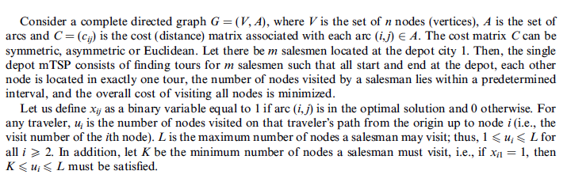 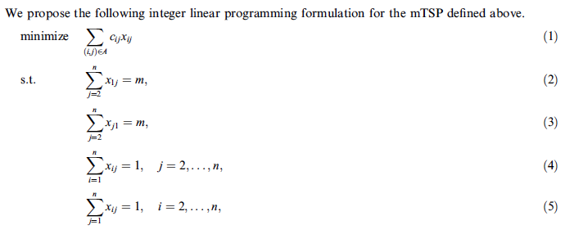

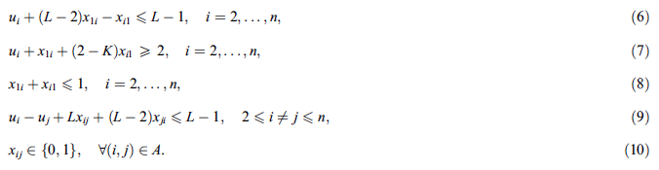

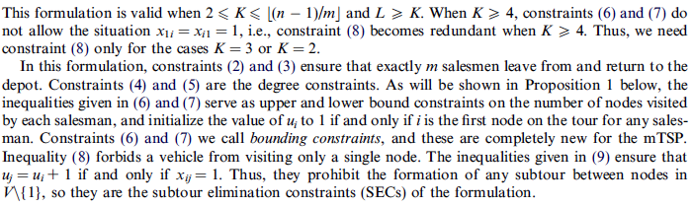

This formulation produced good, timely results. In the current version with only one salesman, there is also no constraint on minimum or maximum number of deliveries since the clustering algorithm has predetermined the packages for each carrier. The constraints with these conditions are voided and the model is converted to a normal TSP formulation.

The group used this formulation rather than a pure TSP formulation by modifying a model that the group was already using to attempt an mTSP formulation. Given more time, the group would attempt several formulations for the TSP from scratch.

1. USPS DRS System Requirements Specification

USPS Dynamic Routing System

System Requirements Specification

December 13, 2013

# Background

The United States Postal Service (USPS) historically delivers mail and packages through over 200,000 nationwide static delivery routes. These routes are the same every day.

Competitors utilize a more dynamic routing method for their delivery drivers. They adopted technology to change each driver’s route daily to meet the delivery needs of that day while minimizing the cost of those routes through optimization. This technique is typically termed “dynamic routing”. These delivery companies have saved billions of dollars every year through their adoption of dynamic routing solutions.[15]

The Postal Service has been privately pursuing methods to make these static delivery routes more dynamic for the last four years.[16] Recently, the Postal Service issued an official ‘Request for Information’ regarding dynamic routing solutions.[17] The Postal Service is considering dynamic delivery for a number of reasons. As listed in the request for information, the Postal Service could use dynamic routing to consider the following initiatives:

1. Dynamic routing could allow cost effective delivery of only packages on Saturday. Since the 1980s, various Postmaster Generals have argued in favor of eliminating Saturday delivery.[18] Recently, this proposal has gained more traction with policy decision makers.[19] If Congressman Issa’s proposal to end Saturday delivery were to pass into law, the Postal Service would be required to deliver only packages and premium mail services on Saturday. In this case, dynamic delivery routes would be more cost effective than the traditional delivery routes.
2. The Postal Service has recently teamed up with Amazon.com to offer Sunday delivery for Amazon orders in New York City and Los Angeles. These deliveries will rely on dynamic routing to allocate packages to trucks and determine routing for delivery. The same service will be expanding to other major cities as soon as next year. Dynamic routing will be essential for successful implementation of this effort.
3. Dynamic routing could expand same-day delivery service. Many businesses, including Amazon, Google, and Wal-Mart, are all experimenting with same day delivery service as Internet retail portals push to compete with the a competitive advantage “brick and mortar” stores offer - immediacy. The Postal Service has created a same-day delivery pilot called MetroPost. This pilot program currently uses very limited and basic heuristics to plan delivery routes that change daily. A more robust dynamic routing solution might gain efficiencies over the current routing tools and allow the Postal Service to roll out this service to additional major metropolitan areas.
4. Dynamic routing could allow consideration for alternative delivery models with a pursuit of efficiency gains. For example, UPS currently loads its deliveries on trucks directly at the processing plants. The Postal Service sends all of its mail from each processing plant, unloads it at a delivery station, and then reloads it on delivery trucks again at those stations. Dynamic delivery might allow pursuit of alternative delivery models that increase efficiencies and reduce costs.
5. Breakthrough technologies often permit the entrepreneurs and innovators to build new business models and services around the new technology. Similarly, dynamic delivery might permit other creative solutions that are currently unimaginable.

# Introduction

This document is the High Level System Requirements Specification (SyRS) for the USPS Dynamic Routing System (DRS). This is a living document and specifies certain high-level requirements and goals. The scope of this document is to provide an overview of functional system requirements and goals. A comprehensive system requirements definition is not within the scope of this document. The intent is for this document to provide a basis on which a more complete requirements definition can be developed.

## System purpose

The purpose of the USPS DRS is to provide a dynamic routing solution that is designed, developed and maintained by the United States Postal Service. The dynamic routing solution shall provide route formulation and optimization for designated delivery locations and provide Turn-by-Turn directions to USPS carriers.

## System scope

The USPS DRS will address the USPS’s need to gain efficiencies in delivery methods. Specifically the DRS will address implementation of a dynamic delivery solution. USPS is seeking more efficient delivery routing methods and wants to better understand the requirements and process for implementing an internal dynamic delivery solution. In order to satisfy these needs the DRS will interface to existing USPS applications to form a system of systems. The DRS will provide optimized dynamic routes based on the delivery data presented to the system. The DRS will produce turn-by-turn directions to facilitate carrier instructions for routes produced. Input for the DRS will be provided by internal USPS applications and output will be consumed by internal USPS applications. The following requirements sections provide further specification of the system scope.

## Definitions, acronyms, and abbreviations

* **DRS:** Acronym for Dynamic Routing System.
* **Application View:** This is related to the front-end user interface of the DRS, an Application view is defined as what data and functions the front-end user can view and has access too.
* **Highway Contract Route (HCR):** A route for carrying mail over the highway between designated points, given on contract to a private carrier and often requiring, in rural areas, delivery to home mailboxes. [20]
* **USPS Address Management System (AMS)**: The Postal Service’s master database of deliverable addresses.
* **Delivery Station:** A Postal Office or USPS Hub where the DRS is run.
* **USPS Dynamic Routing Tool (DRT):** The Postal Service’s internal application, which provides input to the routing solution including delivery address information and system constraints.
* **Core Processing (CP):** Core processing functional area of the DRS. This functional area implements the dynamic routing algorithm used by the system.
* **Geocode:** A delivery location formatted as a latitude/longitude pair.
* **Carrier Interface (Carrier Interface):** Carrier Interface functional area of the DRS.

## References

1. United States Postal Service CIO Dynamic Routing Strategy (Jan 2013)

# General system description

## System context

Figure 1 below depicts the DRS and the external systems/applications it interfaces to. The DRS provides the core dynamic routing functionality and interfaces to external system, which consume outputs and present information to front end and backend users.

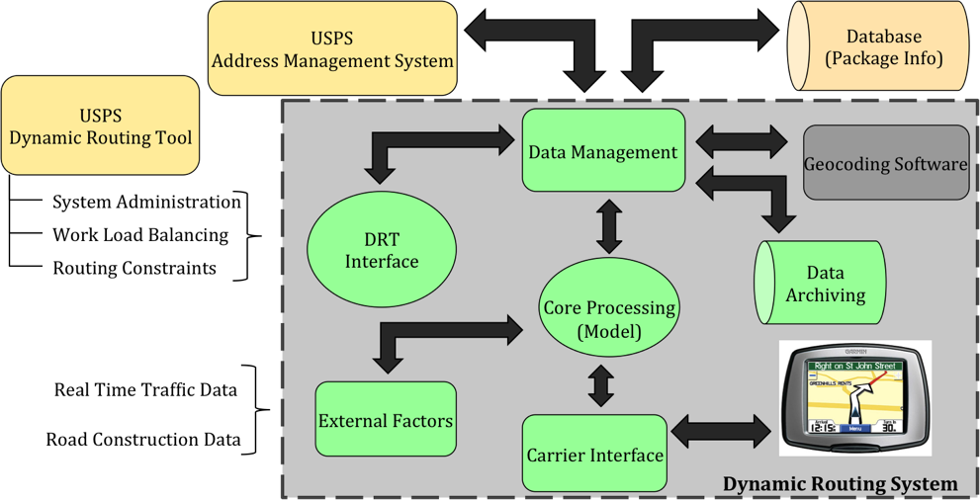

Figure 11: High Level System Overview

## Assumptions and dependencies

The DRS shall interface to internal USPS applications, specifically the USPS Dynamic Routing Tool (DRT) and the USPS Address Management System (AMS). It is assumed that these applications will provide sufficient interfaces and resources to input and receive output from the DRS.

## System Goals

The following table lists system goals that have been identified through the requirements development process. The USPS has stated that these capabilities are not required to fulfill the immediate need for the dynamic routing solution.

| **ID** | **Description** |
| --- | --- |
|  | As a goal the DRS will provide a web-based user interface application to front-end users. |
|  | As a goal The DRS will provide real time traffic alerts to carriers in the field and front end users. |
|  | As a goal the DRS will integrate real-time traffic and road construction data with portable devices used by carriers. |
|  | As a goal the DRS will provide a capability, which allows route formulation to include package delivery type (direct delivery or collection box). The DRS will allow package delivery type to be specified for packages of a certain type and size. Delivery type specification will only be available for locations, which support collection box deliveries. |
|  | As a goal the DRS front-end user interface will provide a National application view. The National view will provide summary information only for delivery stations nation wide. |
|  | As a goal the DRS will locate 95% of street addresses presented for dynamic route formulation in geocode format. This includes addresses, which would be designated on a HCR, rural routes and addresses added within the previous 90 days. |
|  | As a goal the DRS will provide the capability to add and retain new delivery locations in USPS databases as a latitude/longitude value. This functionality will be implemented as a post-processing step after completion of route formulation and optimization. |
|  | As a goal the DRS will geocode all addresses received by the system for dynamic routing and store geocoded addresses in external USPS databases. |
|  | As a goal the DRS will interface with a source, which provides real-time road construction data. This data will be factored into dynamic route formulation and optimization. |

# 

# System capabilities, conditions and constraints

## Functional Requirements

The following table specifies the high level functional requirements for the DRS system. Each requirement has a Functional Area, Priority and Traceability/Source designation.

* **Functional Area:** This defines the logical functional area that this requirement has been allocated too. Functional areas represent logical groupings based on required system capabilities and are not meant to be design components. It is reasonable for additional functional areas to be created or existing functional areas changed as the system requirements are developed fully.
* **Priority:** The priority is based on a High, Medium and Low designation.
  + **High** indicates that the requirement encapsulates a key capability or input/output, which is critical to meeting the primary system objectives. Additionally these requirements represent capabilities, which the USPS has indicated, as needed in initial system versions.
  + **Medium** indicates that the requirement is not critical to meeting system objectives but is needed in initial system versions.
  + **Low** indicates that this is an eventual requirement for future system versions but is not needed as of the writing of this version of the SyRS.
* **Traceability/Source:** This specifies the origin of the requirement during the requirements development process. The *USPS Request for Information (RFI) regarding Dynamic Routing Strategy* is the primary source of the requirements however requirements were also formulated based on communication with the USPS. Additionally some requirements were derived based on system need or prototyping activities.

| **Requirement ID** | **Requirement Description** | **Functional Area** | **Priority** | **Traceability/Source** |
| --- | --- | --- | --- | --- |
|  | The DRS shall provide an interface to allow for initiation of a system run by the front end user and provide the front end user feedback indicating success or failure of initiation.  A system run is defined as execution of the DRS for a specified delivery/pickup location set. | DRT Interface | High | Derived based on customer communication (email). |
|  | The DRS shall accept as input delivery deadlines and service times (time range for delivery) for delivery locations. These times shall be used as input constraints in route formulation and optimization. | Core Processing | Low | *USPS Request For Information regarding Dynamic Routing Strategy:* Section IV. Objectives. |
|  | The DRS shall interface to USPS databases for the purposes of obtaining parcel delivery location information. | Data Management | High | Derived based on customer communication (email). |
|  | The DRS shall interface with the USPS AMS to validate delivery/pickup location information. Delivery/Pickup location information shall be validated prior to dynamic route processing. | Data Management | High | Derived based on customer communication (email). |
|  | The DRS shall accept manual input of delivery/pickup location information and combine or modify delivery/pickup location set prior to route processing. Location information is defined as an address and geocode | Data Management | High | *USPS Request For Information regarding Dynamic Routing Strategy:* Section IV. Objectives. |
|  | In order to achieve workload balancing for carriers the DRS shall provide a function by which authorized users can adjust dynamic routes produced based on carrier workload considerations.  Workload is defined as the total number of hours, determined by the DRS, to complete one dynamic route. Workload specifications cannot exceed or be less than specified route length constraints. | DRT Interface | Medium | *USPS Request For Information regarding Dynamic Routing Strategy:* Section IV. Objectives. |
|  | The DRS shall accept as input delivery vehicle types to be used for a given system run and formulate optimized routes based on the capacity of designated delivery vehicles. Vehicle load capacity shall be factored into route formulation and optimization. | Core Processing | Low | *USPS Request For Information regarding Dynamic Routing Strategy:* Section IV. Objectives. |
|  | The DRS shall provide GIS based map data, to front end user, of delivery areas allocated to designate delivery depot. Map data shall identify route path and route stops visually. | DRT Interface | Medium | *USPS Request For Information regarding Dynamic Routing Strategy:* Section IV. Objectives. |
|  | The DRS shall support scheduling of multiple package pickups for a given delivery/pickup location data set. | DRT Interface | Medium | *USPS Request For Information regarding Dynamic Routing Strategy:* Section IV. Objectives. |
|  | The DRS shall accept as input the number of carriers available for a given delivery station/depot and formulate optimized routes based on the available carrier workforce and route length constraints.  In the event that routes cannot be produced for each carrier within the given route length constraints then a reduced number of routes shall be produced. | Core Processing | High | *USPS Request For Information regarding Dynamic Routing Strategy:* Section IV. Objectives. |
|  | The DRS shall provide as output printable Turn-by Turn directions for each route. Turn-by-Turn directions shall specify directions to and from each delivery location of a route. | DRT Interface | High | *USPS Request For Information regarding Dynamic Routing Strategy:* Section IV. Objectives. |
|  | The DRS shall formulate and optimize routes based on speed limit variables for a given delivery area. | Core Processing | High | *USPS Request For Information regarding Dynamic Routing Strategy:* Section IV. Objectives. |
|  | The DRS shall interface to a real-time traffic reporting mechanism for designated delivery area and archive traffic data for 360 days. | External Factors Mgmt. | Low | *USPS Request For Information regarding Dynamic Routing Strategy:* Section IV. Objectives. |
|  | The DRS shall interface to the USPS DRT for the purposes of providing access to carrier management administrative functions. | DRT Interface | Low | *USPS Request For Information regarding Dynamic Routing Strategy:* Section IV. Objectives. |
|  | The DRS shall retain route history and line of travel data for 360 days. Route history and line of travel data shall be in address format and geocoded format. | Data Archiving | High | *USPS Request For Information regarding Dynamic Routing Strategy:* Section IV. Objectives. |
|  | The DRS shall have the capability to define routes across customized boundaries. Customized boundaries are uniquely defined boundaries based on one or more zip codes, or partial zip codes. | DRT Interface | Medium | *USPS Request For Information regarding Dynamic Routing Strategy:* Section IV. Objectives. |
|  | The DRS shall accept as an input a maximum and minimum route length constraint. These route length constraints shall be configurable and the DRS shall formulate optimized routes based on the specified route length. Route length is defined in units of hours. | Core Processing | High | *USPS Request For Information regarding Dynamic Routing Strategy:* Section IV. Objectives. |
|  | The DRS shall output total mileage for each route produced by the DRS on a given system run. | Core Processing | High | *USPS Request For Information regarding Dynamic Routing Strategy:* Section IV. Objectives. |
|  | The DRS shall output total number of routes produced by the DRS on a given system run. | Core Processing | High | *USPS Request For Information regarding Dynamic Routing Strategy:* Section IV. Objectives. |
|  | The DRS shall output total estimated route time for each route produced by the DRS on a given system run. | Core Processing | High | *USPS Request For Information regarding Dynamic Routing Strategy:* Section IV. Objectives. |
|  | The DRS shall report on demand, fuel usage metrics. Fuel usage metrics shall be based on estimated and actual fuel usage for routes produced by the DRS. | DRT Interface | Medium | *USPS Request For Information regarding Dynamic Routing Strategy:* Section IV. Objectives. |
|  | The DRS shall provide the capability to import from a file, delivery/pickup location information in address and geocoded format. | DRT Interface | High | *USPS Request For Information regarding Dynamic Routing Strategy:* Section IV. Objectives. |
|  | The DRS shall provide the capability to export route information which includes the following:   * Route Number (Identifier assigned to route by DRS) * Sequence Numbers for route stops * Addresses for each route stop * Geocode for each route stop * Delivery or Pickup designation * Number of packages delivered at route stop. * Number of packages picked up at route stop. * Total Route Time * Total Route Mileage * Mileage between each route stop. * Cumulative mileage at each route stop. | DRT Interface | High | Derived based on customer communication (email). |
|  | The DRS shall take as an input the destination type for each delivery/pickup location. Destination type is defined as normal or high-rise. | DRT Interface | Medium | *USPS Request For Information regarding Dynamic Routing Strategy:* Section IV. Objectives. |
|  | The DRS shall take as an input, configurable delivery/pickup times for each delivery/pickup location and use this information in determining total route time.  Delivery time is defined as the time it takes for a carrier to exit their vehicle, make delivery of the parcel(s), return to their vehicle and continue on their route. | Core Processing | Medium | *USPS Request For Information regarding Dynamic Routing Strategy:* Section IV. Objectives. |
|  | The DRS shall report parcel volume metrics on demand. Parcel metrics include, quantity of parcels input into system, and quantity of parcels delivered. | DRT Interface | High | *USPS Request For Information regarding Dynamic Routing Strategy:* Section IV. Objectives. |
|  | The DRS shall integrate route stop information with a portable carrier device for each route produced on a given system run.  A portable carrier device is defined as the device used by carriers to instruct them on route stops and directions between route stops. | Carrier Interface | High | Derived based on system need. |
|  | The DRS shall provide an interface to accept front end user input of configurable service times (time range for delivery) and delivery deadlines. Configurable service times and delivery deadlines shall be based on the following factors:   * Destination type (normal vs. high rise). * Parking Availability (Applicable to delivery locations were reserved parking is based on time of day or reserved parking is not available). * Street Direction (Applicable to delivery locations on streets were street direction is based on time of day.) * Package Type (i.e. Express Mail, Regular Parcel, Priority Mail). | DRT Interface | Medium | *USPS Request For Information regarding Dynamic Routing Strategy:* Section IV. Objectives. |
|  | The DRS shall take as input configurable service times (time range for delivery) for individual delivery/pickup locations and for the following designations:   * Destination type (normal vs. high rise). * Parking Availability (Applicable to delivery locations were reserved parking is based on time of day or reserved parking is not available). * Street Direction (Applicable to delivery locations on streets were street direction is based on time of day.) * Package Type (i.e. Express Mail, Regular Parcel, Priority Mail).   The DRS shall factor service times and delivery deadlines into route formulation and optimization. | Core Processing | Medium | *USPS Request For Information regarding Dynamic Routing Strategy:* Section IV. Objectives. |
|  | The DRS shall provide a capability to front end users which allows for the following route attributes to be configurable:   * Start time * End time * Last Delivery * 15 minute break * 30 minute lunch break   These configurable attributes shall be factored into dynamic route optimization. | DRT Interface | Medium | *USPS Request For Information regarding Dynamic Routing Strategy:* Section IV. Objectives. |
|  | The DRS shall factor in historical traffic data where applicable when determining standard and non-standard traffic conditions for route formulation and optimization. | Core Processing | Low | Derived based on system need. |
|  | The DRS shall allow for road type restrictions to be specified and factored into dynamic route formulation and optimization.  Road type restrictions, at a minimum, pertain to the following:  One–way streets  Toll-Roads  Roads restricted to certain vehicle types.  HOV restrictions. | DRT Interface | High | *USPS Request For Information regarding Dynamic Routing Strategy:* Section IV. Objectives. |
|  | The DRS shall impose time penalties for left turns and U-turns when formulating and optimizing dynamic routes. Time penalties are defined as designated time increases factored into route optimization. The DRS shall mitigate the usage of these types of turns when formulating routes. | DRT Interface | High | *USPS Request For Information regarding Dynamic Routing Strategy:* Section IV. Objectives. |
|  | The DRS shall implement a interface which allows front end users access and viewing of Area data This data shall provide summary information and details of offices/hubs within the “area”. Information to be provided pertains to the following:   * Number of deliveries for each delivery station in the Area. * Number of packages for each delivery station in the Area. * Number of delivery stations in the Area. * Number of carriers available for each delivery station. * Route time summation based on routes produced by each delivery station.   Area in this context refers to delivery stations/depots within 50 miles of the local office from which the DRS is being executed. | DRT Interface | Low | *USPS Request For Information regarding Dynamic Routing Strategy:* Section IV. Objectives. |
|  | The DRS shall locate 95% of street addresses presented for dynamic route formulation. This includes address’s, which would be designated on a HCR, rural routes and addresses added within the previous week. | Data Mgmt. | High | *USPS Request For Information regarding Dynamic Routing Strategy:* Section IV. Objectives. |
|  | The DRS shall provide the capability to add delivery/pickup locations in USPS databases in address format. This functionality shall be implemented as a post-processing step after completion of route formulation and optimization. | Data Mgmt. | High | *USPS Request For Information regarding Dynamic Routing Strategy:* Section IV. Objectives. |
|  | The DRS shall provide a capability to validate route stop information prior to providing route instructions to carrier. Route Stop information pertains to the following data:   * Date of delivery * Time of delivery * Address and/or Latitude/Longitude * Type of package * Required delivery time (if applicable) | Data Mgmt. | Medium | *Derived based on system need.* |
|  | The DRS shall report package volume metrics, for designated delivery area, on demand. Metrics include quantity of parcels input into the system, and quantity of parcels delivered. | DRT Interface | Medium | *USPS Request For Information regarding Dynamic Routing Strategy:* Section IV. Objectives. |
|  | The DRS shall provide the capability to input customized delivery events and associated service times or delivery deadlines that can be adjusted based on geography and time. This information shall be provided prior to execution of route formulation and optimization. | DRT Interface, | Medium | *USPS Request For Information regarding Dynamic Routing Strategy:* Section IV. Objectives. |
|  | The DRS shall process at least 400 delivery locations simultaneously and formulate, optimize and report dynamic routes within >10 minutes of receiving a start request.  This constraint applies to system execution at the delivery station/depot level. | Core Processing | High | Derived based on system need and system prototyping. |
|  | The DRS shall implement USPS authentication protocols in conjunction with access and use of the DRS by front end users. | DRT Interface | High | Derived based on customer communication (email). |
|  | The DRS shall formulate and optimize routes that start and end at a specified depot and include return time from last stop in total route time. | Core Processing | High | Derived based on system need. |
|  | The DRS shall formulate and optimize routes based on street direction for delivery locations. All route stops shall be determined based on traffic direction for given delivery location. | Core Processing | High | Derived based on system need. |
|  | The DRS shall formulate and optimize routes so that delivery locations are visited once. If multiple deliveries are designated for a given location they shall be made on one stop. | Core Processing | High | Derived based on customer communication (email). |
|  | The DRS shall implement an interface which allows front end users to input parcel pickup information including address, geocode and service time if applicable. | Core Processing | Low | *USPS Request For Information regarding Dynamic Routing Strategy:* Section IV. Objectives. |
|  | The DRS shall take as input and factor the following configurable route attributes into dynamic route formulation and optimization:   * Start time * End time * Last Delivery * 15 minute break * 30 minute lunch break | Core Processing | Low | *USPS Request For Information regarding Dynamic Routing Strategy:* Section IV. Objectives. |
|  | The DRS shall produce routes, which visit each delivery location specified by the system input (within 400 locations constraint) and return to the starting Delivery Depot. This is defined as a complete tour. | Core Processing | High | Derived based on system need and prototyping. |
|  | The DRS shall output a sequential list of delivery locations and parcel pickups for each route produced. Delivery locations shall be in geocode format and address format. | Core Processing | High | Derived based on system need and prototyping. |
|  | The DRS shall format delivery location information for route formulation and optimization processing. | Data Management | High | Derived based on system need and prototyping. |
|  | The DRS shall provide carrier route data overlaid on a GIS based map of designated delivery area. | DRT Interface | Medium | *USPS Request For Information regarding Dynamic Routing Strategy:* Section IV. Objectives. |
|  | The DRS shall take as input, from the front end user, the number of carriers for which routes shall be produced. | DRT Interface | High | *USPS Request For Information regarding Dynamic Routing Strategy:* Section IV. Objectives. |
|  | The DRS shall take as input from front end user minimum and maximum route length constraints in units of hours. | DRT Interface | High | *USPS Request For Information regarding Dynamic Routing Strategy:* Section IV. Objectives. |
|  | The DRS shall provide, as output to the front end user, the total mileage calculated for each route produced by a given system run. | DRT Interface | High | *USPS Request For Information regarding Dynamic Routing Strategy:* Section IV. Objectives. |
|  | The DRS shall provide, as output to the front end user, the total number of routes produced by a given system run. | DRT Interface | High | *USPS Request For Information regarding Dynamic Routing Strategy:* Section IV. Objectives. |
|  | The DRS shall provide, as output to the front end user, the estimated route time calculated for each route produced on a given system run. | DRT Interface | High | *USPS Request For Information regarding Dynamic Routing Strategy:* Section IV. Objectives. |
|  | The DRS shall output the following route information in human readable format at the completion of each system run:   * Route Number (Identifier assigned to route by DRS) * Sequence Numbers for route stops * Addresses for each route stop * Geocode for each route stop * Delivery or Pickup designation * Number of packages delivered at route stop. * Number of packages picked up at route stop. * Total Route Time * Total Route Mileage * Mileage between each route stop. * Cumulative mileage at each route stop. | Core Processing | High | Derived based on system need and system prototyping. |
|  | The DRS shall provide an interface to front end user which supports input of configurable delivery/pickup times for each delivery/pickup location or location type (high rise vs. normal).  Delivery/Pickup time is defined as the time it takes for a carrier to exit their vehicle, make delivery of the parcel(s), return to their vehicle and continue on their route. | DRT Interface | Medium | *USPS Request For Information regarding Dynamic Routing Strategy:* Section IV. Objectives. |
|  | The DRS shall archive parcel volume metrics including, quantity of parcels input into the system, and quantity of parcels delivered. These metrics shall be kept for each delivery day and archived for 360 days. | Data Archiving | Low | *USPS Request For Information regarding Dynamic Routing Strategy:* Section IV. Objectives. |
|  | The DRS shall archive and maintain historical traffic data for designated delivery area for which the system is being executed. | Data Archiving | Low | *USPS Request For Information regarding Dynamic Routing Strategy:* Section IV. Objectives. |
|  | The DRS shall provide the front end user feedback as to the success or failure of a given system run. In the event of a failure the DRS shall provide a human readable message indicating the nature of the failure. | DRT Interface | High | Derived based on system need and system prototyping. |
|  | The DRS shall maintain fuel usage of vehicles used in conjunction with DRS routes. Fuel usage metrics shall be based on estimated and actual fuel usage for routes produced by the DRS. | Data Archiving | Low | *USPS Request For Information regarding Dynamic Routing Strategy:* Section IV. Objectives. |
|  | The DRS shall interface to a road construction reporting mechanism for designated delivery area. Construction data shall be factored into route formulation and optimization. | External Factors Mgmt. | Low | Derived based on system need. |

### Core Processing (Dynamic Routing Model)

The Core Processing (CP) functional area is encapsulates the processing necessary to formulate and optimize the dynamic routes produced by the system. This includes the algorithm and solver used in the definition of the optimization model. The optimization model is a general term here and pertains to the approach used to formulate and compute the dynamic route optimization. Additionally the CP functional area deals with producing dynamic route outputs and formatting route data for consumption.

The following table is a breakout of the high level functional requirements, defined in section 4.1, which have been allocated to the CP functional area.

| **Requirement ID** | **Requirement Description** | **Priority** | **Traceability/Source** |
| --- | --- | --- | --- |
| SFREQ-2.0 | The DRS shall accept as input delivery deadlines and service times (time range for delivery) for delivery locations. These times shall be used as input constraints in route formulation and optimization. | Low | *USPS Request For Information regarding Dynamic Routing Strategy:* Section IV. Objectives. |
| SFREQ-7.0 | The DRS shall accept as input delivery vehicle types to be used for a given system run and formulate optimized routes based on the capacity of designated delivery vehicles. Vehicle load capacity shall be factored into route formulation and optimization. | Low | *USPS Request For Information regarding Dynamic Routing Strategy:* Section IV. Objectives. |
| SFREQ-10.0 | The DRS shall accept as input the number of carriers available for a given delivery station/depot and formulate optimized routes based on the available carrier workforce and route length constraints.  In the event that routes cannot be produced for each carrier within the given route length constraints then a reduced number of routes shall be produced. | High | *USPS Request For Information regarding Dynamic Routing Strategy:* Section IV. Objectives. |
| SFREQ-12.0 | The DRS shall formulate and optimize routes based on speed limit variables for a given delivery area. | High | *USPS Request For Information regarding Dynamic Routing Strategy:* Section IV. Objectives. |
| SFREQ-17.0 | The DRS shall accept as an input a maximum and minimum route length constraint. These route length constraints shall be configurable and the DRS shall formulate optimized routes based on the specified route length. Route length is defined in units of hours. | High | *USPS Request For Information regarding Dynamic Routing Strategy:* Section IV. Objectives. |
| SFREQ-18.0 | The DRS shall output total mileage for each route produced by the DRS on a given system run. | High | *USPS Request For Information regarding Dynamic Routing Strategy:* Section IV. Objectives. |
| SFREQ-19.0 | The DRS shall output total number of routes produced by the DRS on a given system run. | High | *USPS Request For Information regarding Dynamic Routing Strategy:* Section IV. Objectives. |
| SFREQ-20.0 | The DRS shall output total estimated route time for each route produced by the DRS on a given system run. | High | *USPS Request For Information regarding Dynamic Routing Strategy:* Section IV. Objectives. |
| SFREQ-25.0 | The DRS shall take as an input, configurable delivery/pickup times for each delivery/pickup location and use this information in determining total route time.  Delivery time is defined as the time it takes for a carrier to exit their vehicle, make delivery of the parcel(s), return to their vehicle and continue on their route. | Medium | *USPS Request For Information regarding Dynamic Routing Strategy:* Section IV. Objectives. |
| SFREQ-29.0 | The DRS shall take as input configurable service times (time range for delivery) for individual delivery/pickup locations and for the following designations:   * Destination type (normal vs. high rise). * Parking Availability (Applicable to delivery locations were reserved parking is based on time of day or reserved parking is not available). * Street Direction (Applicable to delivery locations on streets were street direction is based on time of day.) * Package Type (i.e. Express Mail, Regular Parcel, Priority Mail).   The DRS shall factor service times and delivery deadlines into route formulation and optimization. | Medium | *USPS Request For Information regarding Dynamic Routing Strategy:* Section IV. Objectives. |
| SFREQ-31.0 | The DRS shall factor in historical traffic data where applicable when determining standard and non-standard traffic conditions for route formulation and optimization. | Low | Derived based on system need. |
| SFREQ-40.0 | The DRS shall process at least 400 delivery locations simultaneously and formulate, optimize and report dynamic routes within >10 minutes of receiving a start request.  This constraint applies to system execution at the delivery station/depot level. | High | Derived based on system need and system prototyping. |
| SFREQ-42.0 | The DRS shall formulate and optimize routes that start and end at a specified depot and include return time from last stop in total route time. | High | Derived based on system need. |
| SFREQ-43.0 | The DRS shall formulate and optimize routes based on street direction for delivery locations. All route stops shall be determined based on traffic direction for given delivery location. | High | Derived based on system need. |
| SFREQ-44.0 | The DRS shall formulate and optimize routes so that delivery locations are visited once. If multiple deliveries are designated for a given location they shall be made on one stop. | High | Derived based on customer communication (email). |
| SFREQ-45.0 | The DRS shall implement an interface which allows front end users to input parcel pickup information including address, geocode and service time if applicable. | Low | *USPS Request For Information regarding Dynamic Routing Strategy:* Section IV. Objectives. |
| SFREQ-46.0 | The DRS shall take as input and factor the following configurable route attributes into dynamic route formulation and optimization:   * Start time * End time * Last Delivery * 15 minute break   30 minute lunch break | Low | *USPS Request For Information regarding Dynamic Routing Strategy:* Section IV. Objectives. |
| SFREQ-47.0 | The DRS shall produce routes, which visit each delivery location specified by the system input (within 400 locations constraint) and return to the starting Delivery Depot. This is defined as a complete tour. | High | Derived based on system need and prototyping. |
| SFREQ-48.0 | The DRS shall output a sequential list of delivery locations and parcel pickups for each route produced. Delivery locations shall be in geocode format and address format. | High | Derived based on system need and prototyping |
| SFREQ-56.0 | The DRS shall output the following route information in human readable format at the completion of each system run:   * Route Number (Identifier assigned to route by DRS) * Sequence Numbers for route stops * Addresses for each route stop * Geocode for each route stop * Delivery or Pickup designation * Number of packages delivered at route stop. * Number of packages picked up at route stop. * Total Route Time * Total Route Mileage * Mileage between each route stop.   Cumulative mileage at each route stop. | High | Derived based on system need and system prototyping. |

### DRT Interface

The Dynamic Routing Tool (DRT) is an internal USPS application that handles the front-end user interface. The assumption is that this could change and a new application could be developed or the DRS could be developed to support the functions now encapsulated by the DRT. With that being said the requirements specified for this functional area are constructed in such a way were they are not invalidated if the DRT becomes obsolete. The DRT provides an UI to front-end users and allows users to, initiate system execution, input dynamic route constraints into the DRS, view DRS output and imported address data to the DRS.

The following table is a breakout of the high level functional requirements, defined in section 4.1, which have been allocated to the DRT Interface functional area.

| **Requirement ID** | **Requirement Description** | **Priority** | **Traceability/Source** |
| --- | --- | --- | --- |
| SFREQ-6.0 | In order to achieve workload balancing for carriers the DRS shall provide a function by which authorized users can adjust dynamic routes produced based on carrier workload considerations.  Workload is defined as the total number of hours, determined by the DRS, to complete one dynamic route. Workload specifications cannot exceed or be less than specified route length constraints. | Medium | *USPS Request For Information regarding Dynamic Routing Strategy:* Section IV. Objectives. |
| SFREQ-8.0 | The DRS shall provide GIS based map data, to front end user, of delivery areas allocated to designate delivery depot. Map data shall identify route path and route stops visually. | Medium | *USPS Request For Information regarding Dynamic Routing Strategy:* Section IV. Objectives. |
| SFREQ-9.0 | The DRS shall support scheduling of multiple package pickups for a given delivery/pickup location data set. | Medium | *USPS Request For Information regarding Dynamic Routing Strategy:* Section IV. Objectives. |
| SFREQ-11.0 | The DRS shall provide as output printable Turn-by Turn directions for each route. Turn-by-Turn directions shall specify directions to and from each delivery location of a route. | High | *USPS Request For Information regarding Dynamic Routing Strategy:* Section IV. Objectives. |
| SFREQ-14.0 | The DRS shall interface to the USPS DRT for the purposes of providing access to carrier management administrative functions. | Low | *USPS Request For Information regarding Dynamic Routing Strategy:* Section IV. Objectives. |
| SFREQ-16.0 | The DRS shall have the capability to define routes across customized boundaries. Customized boundaries are uniquely defined boundaries based on one or more zip codes, or partial zip codes. | Medium | *USPS Request For Information regarding Dynamic Routing Strategy:* Section IV. Objectives. |
| SFREQ-21.0 | The DRS shall report on demand, fuel usage metrics. Fuel usage metrics shall be based on estimated and actual fuel usage for routes produced by the DRS. | Medium | *USPS Request For Information regarding Dynamic Routing Strategy:* Section IV. Objectives. |
| SFREQ-22.0 | The DRS shall provide the capability to import from a file, delivery/pickup location information in address and geocoded format. | High | *USPS Request For Information regarding Dynamic Routing Strategy:* Section IV. Objectives. |
| SFREQ-23.0 | The DRS shall provide the capability to export route information which includes the following:   * Route Number (Identifier assigned to route by DRS) * Sequence Numbers for route stops * Addresses for each route stop * Geocode for each route stop * Delivery or Pickup designation * Number of packages delivered at route stop. * Number of packages picked up at route stop. * Total Route Time * Total Route Mileage * Mileage between each route stop.   Cumulative mileage at each route stop. | High | Derived based on customer communication (email). |
| SFREQ-24.0 | The DRS shall take as an input the destination type for each delivery/pickup location. Destination type is defined as normal or high-rise. | Medium | *USPS Request For Information regarding Dynamic Routing Strategy:* Section IV. Objectives. |
| SFREQ-26.0 | The DRS shall report parcel volume metrics on demand. Parcel metrics include, quantity of parcels input into system, and quantity of parcels delivered. | High | *USPS Request For Information regarding Dynamic Routing Strategy:* Section IV. Objectives. |
| SFREQ-28.0 | The DRS shall provide an interface to accept front end user input of configurable service times (time range for delivery) and delivery deadlines. Configurable service times and delivery deadlines shall be based on the following factors:   * Destination type (normal vs. high rise). * Parking Availability (Applicable to delivery locations were reserved parking is based on time of day or reserved parking is not available). * Street Direction (Applicable to delivery locations on streets were street direction is based on time of day.) * Package Type (i.e. Express Mail, Regular Parcel, Priority Mail). | Medium | *USPS Request For Information regarding Dynamic Routing Strategy:* Section IV. Objectives. |
| SFREQ-30.0 | The DRS shall provide a capability to front end users which allows for the following route attributes to be configurable:   * Start time * End time * Last Delivery * 15 minute break * 30 minute lunch break   These configurable attributes shall be factored into dynamic route optimization. | Medium | *USPS Request For Information regarding Dynamic Routing Strategy:* Section IV. Objectives. |
| SFREQ-32.0 | The DRS shall allow for road type restrictions to be specified and factored into dynamic route formulation and optimization.  Road type restrictions, at a minimum, pertain to the following:  One–way streets  Toll-Roads  Roads restricted to certain vehicle types.  HOV restrictions. | High | *USPS Request For Information regarding Dynamic Routing Strategy:* Section IV. Objectives. |
| SFREQ-33.0 | The DRS shall impose time penalties for left turns and U-turns when formulating and optimizing dynamic routes. Time penalties are defined as designated time increases factored into route optimization. The DRS shall mitigate the usage of these types of turns when formulating routes. | High | *USPS Request For Information regarding Dynamic Routing Strategy:* Section IV. Objectives. |
| SFREQ-34.0 | The DRS shall implement a interface which allows front end users access and viewing of Area data This data shall provide summary information and details of offices/hubs within the “area”. Information to be provided pertains to the following:   * Number of deliveries for each delivery station in the Area. * Number of packages for each delivery station in the Area. * Number of delivery stations in the Area. * Number of carriers available for each delivery station. * Route time summation based on routes produced by each delivery station.   Area in this context refers to delivery stations/depots within 50 miles of the local office from which the DRS is being executed. | Low | *USPS Request For Information regarding Dynamic Routing Strategy:* Section IV. Objectives. |
| SFREQ-38.0 | The DRS shall report package volume metrics, for designated delivery area, on demand. Metrics include quantity of parcels input into the system, and quantity of parcels delivered. | Medium | *USPS Request For Information regarding Dynamic Routing Strategy:* Section IV. Objectives. |
| SFREQ-39.0 | The DRS shall provide the capability to input customized delivery events and associated service times or delivery deadlines that can be adjusted based on geography and time. This information shall be provided prior to execution of route formulation and optimization. | Medium | *USPS Request For Information regarding Dynamic Routing Strategy:* Section IV. Objectives. |
| SFREQ-41.0 | The DRS shall implement USPS authentication protocols in conjunction with access and use of the DRS by front end users. | High | Derived based on customer communication (email). |
| SFREQ-50.0 | The DRS shall provide carrier route data overlaid on a GIS based map of designated delivery area. | Medium | *USPS Request For Information regarding Dynamic Routing Strategy:* Section IV. Objectives. |
| SFREQ-51.0 | The DRS shall take as input, from the front end user, the number of carriers for which routes shall be produced. | High | *USPS Request For Information regarding Dynamic Routing Strategy:* Section IV. Objectives. |
| SFREQ-52.0 | The DRS shall take as input from front end user minimum and maximum route length constraints in units of hours. | High | *USPS Request For Information regarding Dynamic Routing Strategy:* Section IV. Objectives. |
| SFREQ-53.0 | The DRS shall provide, as output to the front end user, the total mileage calculated for each route produced by a given system run. | High | *USPS Request For Information regarding Dynamic Routing Strategy:* Section IV. Objectives. |
| SFREQ-54.0 | The DRS shall provide, as output to the front end user, the total number of routes produced by a given system run. | High | *USPS Request For Information regarding Dynamic Routing Strategy:* Section IV. Objectives. |
| SFREQ-55.0 | The DRS shall provide, as output to the front end user, the estimated route time calculated for each route produced on a given system run. | High | *USPS Request For Information regarding Dynamic Routing Strategy:* Section IV. Objectives. |
| SFREQ-57.0 | The DRS shall provide an interface to front end user which supports input of configurable delivery/pickup times for each delivery/pickup location or location type (high rise vs. normal).  Delivery/Pickup time is defined as the time it takes for a carrier to exit their vehicle, make delivery of the parcel(s), return to their vehicle and continue on their route. | Medium | *USPS Request For Information regarding Dynamic Routing Strategy:* Section IV. Objectives. |
| SFREQ-60.0 | The DRS shall provide the front end user feedback as to the success or failure of a given system run. In the event of a failure the DRS shall provide a human readable message indicating the nature of the failure. | High | Derived based on system need and system prototyping. |

### Data Management

The primary roles of the Data Management area are data formatting and data validation. The Data Management area primarily interfaces with the DRT Interface, CP and the Data Archiving area. Additionally the Data Management area provides an interface to the USPS AMS, which is used to validate address information received by the DRS.

With respect to data validation, this functional area provides a mechanism by which optimized route data can be verified against existing databases for validity. Data verification ensures that route data is accurate and “drivable”.

| **Requirement ID** | **Requirement Description** | **Priority** | **Traceability/Source** |
| --- | --- | --- | --- |
| SFREQ-3.0 | The DRS shall interface to USPS databases for the purposes of obtaining parcel delivery location information. | High | Derived based on customer communication (email). |
| SFREQ-4.0 | The DRS shall interface with the USPS AMS to validate delivery/pickup location information. Delivery/Pickup location information shall be validated prior to dynamic route processing. | High | Derived based on customer communication (email). |
| SFREQ-5.0 | The DRS shall accept manual input of delivery/pickup location information and combine or modify delivery/pickup location set prior to route processing. Location information is defined as an address and geocode | High | *USPS Request For Information regarding Dynamic Routing Strategy:* Section IV. Objectives. |
| SFREQ-35.0 | The DRS shall locate 95% of street addresses presented for dynamic route formulation. This includes address’s, which would be designated on a HCR, rural routes and addresses added within the previous week. | High | *USPS Request For Information regarding Dynamic Routing Strategy:* Section IV. Objectives. |
| SFREQ-36.0 | The DRS shall provide the capability to add delivery/pickup locations in USPS databases in address format. This functionality shall be implemented as a post-processing step after completion of route formulation and optimization. | High | *USPS Request For Information regarding Dynamic Routing Strategy:* Section IV. Objectives. |
| SFREQ-37.0 | The DRS shall provide a capability to validate route stop information prior to providing route instructions to carrier. Route Stop information pertains to the following data:   * Date of delivery * Time of delivery * Address and/or Latitude/Longitude * Type of package   Required delivery time (if applicable) | Medium | *Derived based on system need.* |
| SFREQ-49.0 | The DRS shall format delivery location information for route formulation and optimization processing. | High | Derived based on system need and prototyping. |

### Data Archiving

In order to facilitate the need for retention of historical data the Data Archiving functional area provides a mechanism by which historical data can be retained and retrieved at any time. This functional area interfaces to the Data Management area and provides formatted route history, parcel metrics, historical fuel metrics and historical traffic data.

|  |  |  |  |
| --- | --- | --- | --- |
| **Requirement ID** | **Requirement Description** | **Priority** | **Traceability/Source** |
| SFREQ-15.0 | The DRS shall retain route history and line of travel data for 360 days. Route history and line of travel data shall be in address format and geocoded format. | High | *USPS Request For Information regarding Dynamic Routing Strategy:* Section IV. Objectives. |
| SFREQ-58.0 | The DRS shall archive parcel volume metrics including, quantity of parcels input into the system, and quantity of parcels delivered. These metrics shall be kept for each delivery day and archived for 360 days. | Low | *USPS Request For Information regarding Dynamic Routing Strategy:* Section IV. Objectives. |
| SFREQ-59.0 | The DRS shall archive and maintain historical traffic data for designated delivery area for which the system is being executed. | Low | *USPS Request For Information regarding Dynamic Routing Strategy:* Section IV. Objectives. |
| SFREQ-61.0 | The DRS shall maintain fuel usage of vehicles used in conjunction with DRS routes. Fuel usage metrics shall be based on estimated and actual fuel usage for routes produced by the DRS. | Low | *USPS Request For Information regarding Dynamic Routing Strategy:* Section IV. Objectives. |

### External Factors Management

The External Factors Management functional area deals with systems and inputs that originate outside of the USPS DRS system context. These external factors include but are not limited to, real time traffic data and road construction information. This functional area provides interfaces so that the input provided by these external systems can be factored into dynamic route formulation and optimization.

| **Requirement ID** | **Requirement Description** | **Traceability/Source** | **Requirement ID** |
| --- | --- | --- | --- |
| SFREQ-13.0 | The DRS shall interface to a real-time traffic reporting mechanism for designated delivery area and archive traffic data for 360 days. | Low | *USPS Request For Information regarding Dynamic Routing Strategy:* Section IV. Objectives. |
| SFREQ-62.0 | The DRS shall interface to a road construction reporting mechanism for designated delivery area. Construction data shall be factored into route formulation and optimization. | Low | Derived based on system need. |

### Carrier Interface

The Carrier Interface fulfills the need of the system to provide a navigation solution for carriers in the field. This area receives optimized route data from the Core Processing area and ports this data to the portable carrier device.

|  |  |  |  |  |
| --- | --- | --- | --- | --- |
| **Requirement ID** | **Requirement Description** | **Functional Area** | **Priority** | **Traceability/Source** |
| SFREQ-27.0 | The DRS shall integrate route stop information with a portable carrier device for each route produced on a given system run.  A portable carrier device is defined as the device used by carriers to instruct them on route stops and directions between route stops. | Carrier Interface | High | Derived based on system need. |

## Performance Requirements

The DRS shall process at least 400 delivery locations simultaneously and formulate, optimize and report dynamic routes within >10 minutes of receiving a start request. This constraint applies to system execution at the delivery station/depot level.

## Information Management Requirements

The DRS shall implement USPS authentication protocols in conjunction with access and use of the DRS User Interface Application

1. USPS DRS Concept of Operations

USPS Dynamic Routing System

Concept of Operations (CONOPS)

December 13, 2013

Table of Contents

1.Scope 1

1.1 Identification 1

1.2 Document overview 1

1.3 System overview 1

2.Referenced documents 1

3.background 1

4.System Concepts 2

4.1 System Objectives 2

4.2 High Level Overview of System Operations 3

4.3 Modes of Operation 5

5.Summary of impacts 5

6.Glossary 5

# Scope

## Identification

This CONOPS document applies to the United States Postal Service Dynamic Routing System (DRS).

## Document overview

The intent of this CONOPS document is to provide a high level functional overview of the USPS DRS. The USPS has expressed a desire to further their insight into the dynamic routing problem

## System overview

The purpose of the USPS DRS is to provide the USPS a system, which can produce dynamic routes for a set of delivery and pickup locations and specify turn-by-turn directions to USPS Mail Carriers. The USPS DRS is a software-intensive system and as such does not contain a major hardware component aside from a portable computer used by the USPS Mail Carriers. The USPS DRS is intended for use at the delivery station/depot level, meaning that USPS locations designated as depots will access, use and maintain the USPS DRS. The overarching need of the DRS is to provide a cost-effective solution to package delivery outside of the USPS static routing system.

The USPS currently is testing solutions, one of which is the software RouteSmart. Additionally the USPS employs a Dynamic Routing Tool (DRT), which handles much of the front-end user interfaces and data input to the RouteSmart software. The USPS DRS must integrate with the existing DRT software. The USPS DRS with be referred to as the DRS within the remainder of this document.

# Referenced documents

1. United States Postal Service CIO Dynamic Routing Strategy (Jan 2013)

# background

The United States Postal Service (USPS) historically delivers mail and packages through over 200,000 nationwide static delivery routes. These routes are the same every day.

Competitors utilize a more dynamic routing method for their delivery drivers. They adopted technology to change each driver’s route daily to meet the delivery needs of that day while minimizing the cost of those routes through optimization. This technique is typically termed “dynamic routing”. These delivery companies have saved billions of dollars every year through their adoption of dynamic routing solutions.[21]

The Postal Service has been privately pursuing methods to make these static delivery routes more dynamic for the last four years.[22] Recently, the Postal Service issued an official ‘Request for Information’ regarding dynamic routing solutions.[23] The Postal Service is considering dynamic delivery for a number of reasons. As listed in the request for information, the Postal Service could use dynamic routing to consider the following initiatives:

1. Dynamic routing could allow cost effective delivery of only packages on Saturday.
2. The Postal Service has recently teamed up with Amazon.com to offer Sunday delivery for Amazon orders in New York City and Los Angeles. These deliveries will rely on dynamic routing to allocate packages to trucks and determine routing for delivery. The same service will be expanding to other major cities as soon as next year. Dynamic routing will be essential for successful implementation of this effort.
3. Dynamic routing could expand same-day delivery service.
4. Dynamic routing could allow consideration for alternative delivery models with a pursuit of efficiency gains. For example, UPS currently loads its deliveries on trucks directly at the processing plants. The Postal Service sends all of its mail from each processing plant, unloads it at a delivery station, and then reloads it on delivery trucks again at those stations. Dynamic delivery might allow pursuit of alternative delivery models that increase efficiencies and reduce costs.

# **System Concepts**

## System Objectives

The following list itemizes the capabilities needed by the USPS for the DRS. The USPS CIO Dynamic Routing Strategy was the primary source for these objectives.

* Interface to the existing USPS Dynamic Routing Tool (DRT)
* Interface to existing USPS databases to get delivery/pickup address information
* Flexible interface to allow for future integration of USPS internal applications.
* Provide tools to achieve workload balancing for USPS Carriers.
* Reporting of vehicle usage based on package size and load balancing
* Provide GIS based mapping and routing.
* Accept input of different vehicle types for package delivery and optimize routes for the various vehicles.
* Process dynamic routes for => 2,000 delivery/pickup locations in =< 10 minutes.
* Provide scalability in DRS system design to upgrade processing power with respect to number of delivery locations processed within a given time period.
* Provide capability to schedule multiple packages and drop-offs
* Provide optimization of associated delivery station/depot carrier workforce.
* Provide printable Turn-by-Turn directions.
* Full reporting and tracking of actual miles per route and actual time to completion per route.
* Incorporation of traffic reporting and speed limit variables into routing algorithm.
* Archiving of route history and line of travel data, including latitudes and longitudes.
* Provide the capability to route across ZIP Code boundaries (including uniquely defined boundaries based on one or more, or partial Zip Codes)
* Report route length, number of routes, mileage, and fuel management for delivery/pickup locations processed.
* Ability to import and export route data including address information and latitude/longitude information.
* Ability to specify as inputs, number of stops on route, amount of route time, types of destinations (i.e. high rise versus houses, and other)
* Provide reporting of parcel volumes (quantity of parcels input into system, quantity of parcels delivered)
* Handle boundary routes and out-of-boundary routes
* Integrate communications, routes, and data with GPS navigation devices.
* Optimize one route across multiple service areas where pickups are done in multiple service areas (intermediate routes).
* Allow customized delivery deadlines for select packages (for example, Express Mail by noon, all other packages when possible)
* Customized start, end, last delivery, break, and lunch times for routes when factoring historical traffic data.
* Route restrictions based on road-type such as one-way streets, toll roads, and HOV restrictions.
* Time penalties for turns (left turns and U-turns)
* Locate 95% of street addresses including highway contract, rural route and newly added addresses or ability to accept latitudes/longitudes and retain for future routing use.
* Ability to capture and validate delivery points and related data

## High Level Overview of System Operations

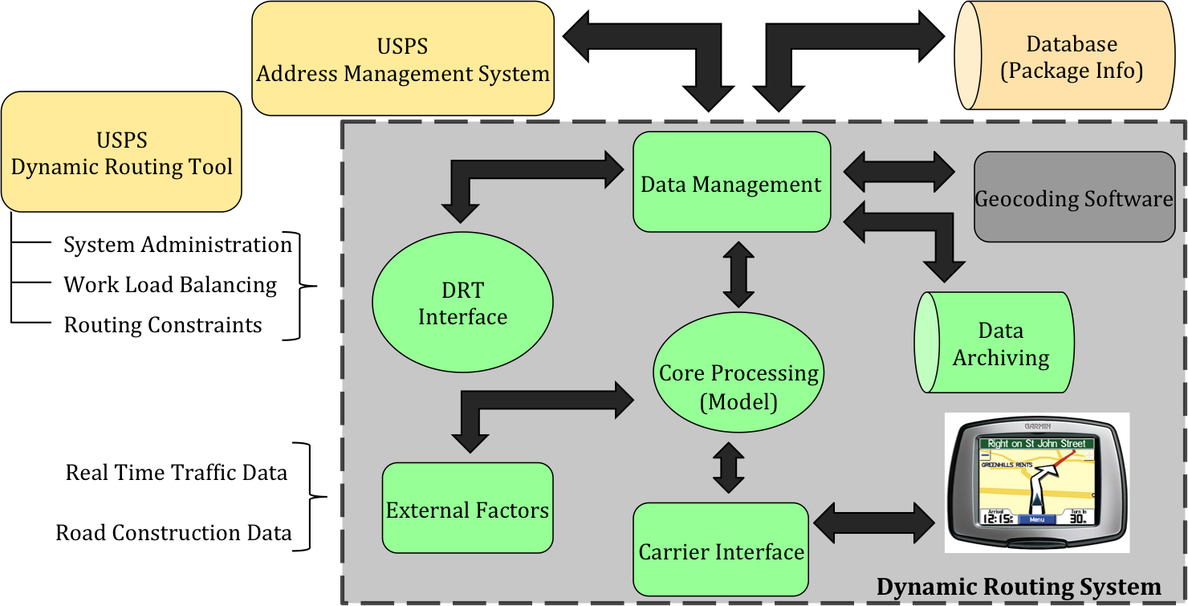

In-order to facilitate describing the overall system; the major system capabilities are separated into logical functional areas. The functional areas are as follows:

**DRT Interface:** Encapsulates interfaces to existing USPS internal applications. Provides front-end user input to the Data Management functional area for formatting and further processing.

The DRS system is initiated by a system call via the DRT UI. The DRT Interface provides an API by which the DRT can forward system requests and input delivery data and constraints. The DRT Interface forwards information received to the Data Management area where it is formatted before being sent to Core Processing. Additionally the DRT Interface provides access to DRS internals including Data Management and Data Archiving functionality.

**Data Management:** Handles constraint and data input to the Core Processing functional area. Receives outputs from the Core Processing functional Area. Data Management also Interfaces to the Data Archiving functional area to provide data to be retained.

**Core Processing:** Encapsulates the processing algorithms needed to formulate and optimize dynamic routes based on the input constraints and location data. Takes input from Data Management as well as the External Factors functional area. Core Processing output is disseminated to the Data Management and Carrier Interface functional areas.

**Data Archiving:** Facilitates the retention of needed data, not limited to, route history, historical traffic data and vehicle usage metrics. Interfaces to the Data Management functional area to receive data inputs.

**External Factors Management:** This functional area provides a basis for integration of external systems, which aid the Core Processing algorithms. These include but are not limited to Real Time Traffic Data reporting and Road Construction reporting.

**Carrier Interface:** The Carrier Interface functional area interfaces to the Core Processing area. Its primary function is to translate the processing outputs into consumable data used by the Carrier portable devices.

## Modes of Operation

The following list specifies the modes of operation for the USPS DRS system. These modes of operation apply to the administrator user class. Currently this is the only user class for the system.

* **Normal Operations:** This mode pertains to normal system usage at a delivery station/depot. This is the general operating mode of the system and the system will operate in this mode the majority of the time.
* **Special Operations:** This mode pertains to heightened system usage when delivery/pickup location inputs are higher than normal. An example of this type of operation would be during the Holiday season, in December, where package delivery and pickup is increased.
* **Training:** This mode pertains to the training of USPS employees on the DRS. The DRS system will include a mode which allows for training operations without affecting the normal operability of the system.
* **Maintenance Operations:** This mode pertains to the maintenance of the DRS. The system will undergo routine maintenance and on-demand maintenance when required. The system will either be offline or in a limited state during this mode of operation.

# **Summary of impacts**

* The USPS DRS will enable the Postal Service to institute package delivery on Saturdays and Sundays.
* Static routes will no longer make sense with lower delivery volume of only packages on weekends.
* The USP DRS will allow the Postal Service to realize it’s near term goal of providing efficient package delivery on Saturdays, Sundays, or even other days.
* The USPS DRS could potentially change the way the Postal Service does business and allow the Postal Service the financial freedom to operate more efficiently.

# **Glossary**

* **DRS:** Acronym for Dynamic Routing System.
* **Delivery Station:** A Postal Office or USPS Hub where the DRS is run.
* **USPS Dynamic Routing Tool (DRT):** The Postal Service’s internal application, which provides input to the routing solution including delivery address information and system constraints.
* **Core Processing:** Core Processing functional area of the DRS. This functional area implements the dynamic routing algorithm used by the system.

1. Maps of GMU DRS Routes

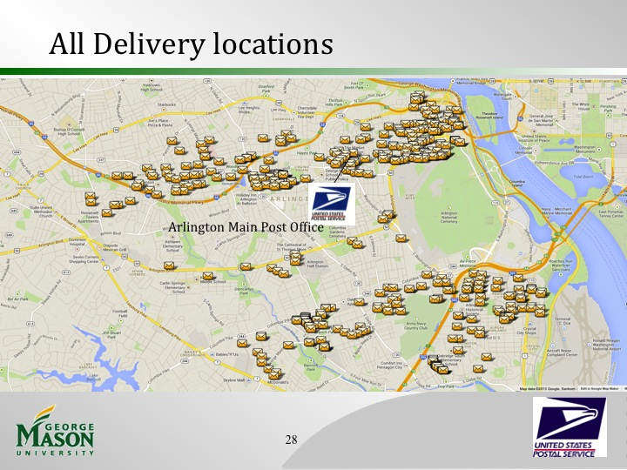

Figure : Route Stops for Arlington County.

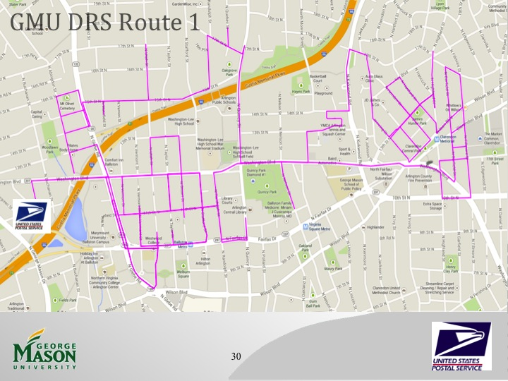

Figure : GMU DRS Route 1: 64 Stops including depot.

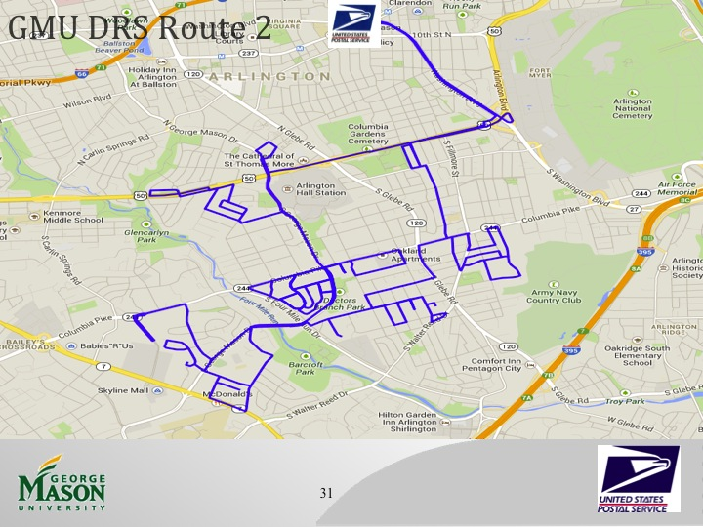

Figure : GMU DRS Route 2: 77 Stops including depot.

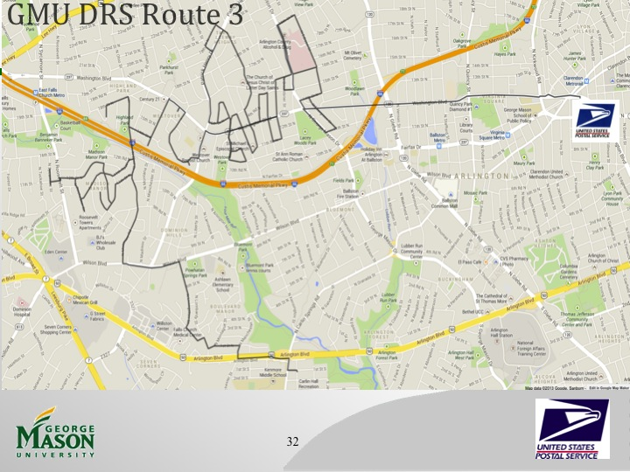

Figure : GMU DRS Route 3: 47 Stops including depot.

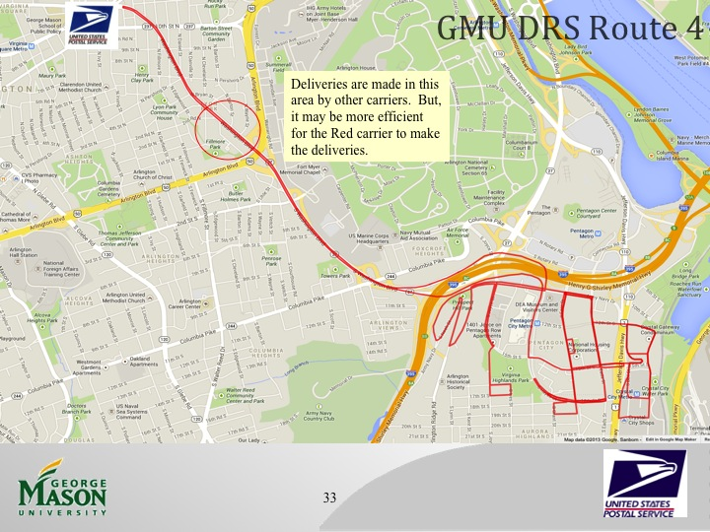

Figure : GMU DRS Route 4: 48 Stops including depot.

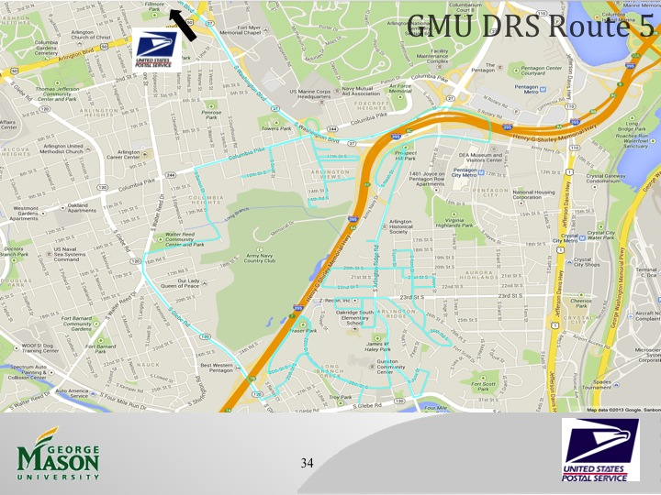

Figure : GMU DRS Route 5: 45 Stops including depot.

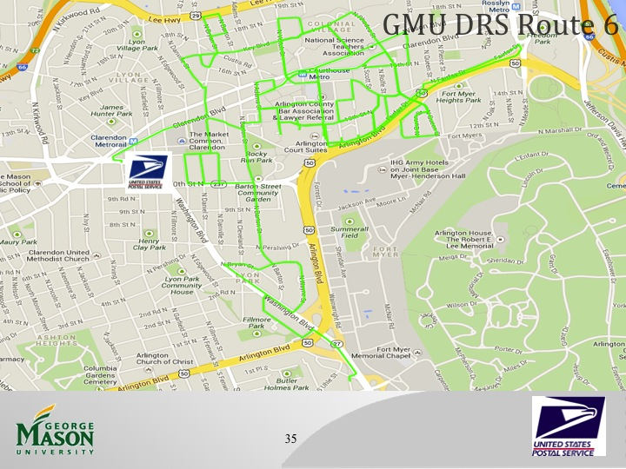

Figure : GMU DRS Route 6: 50 Stops including depot.

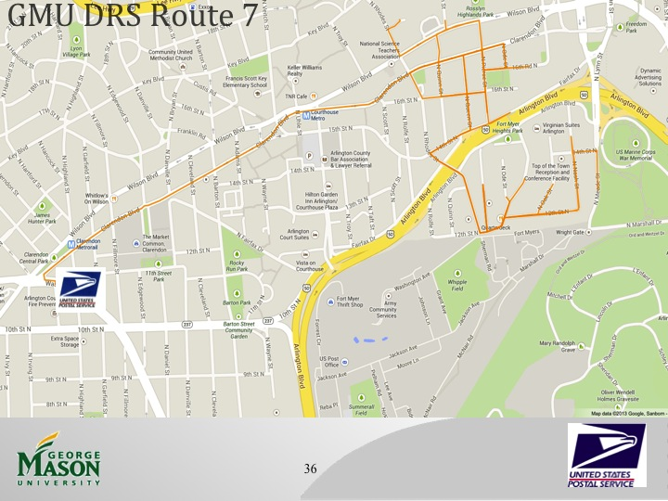

Figure : GMU DRS Route 7: 42 Stops including depot.

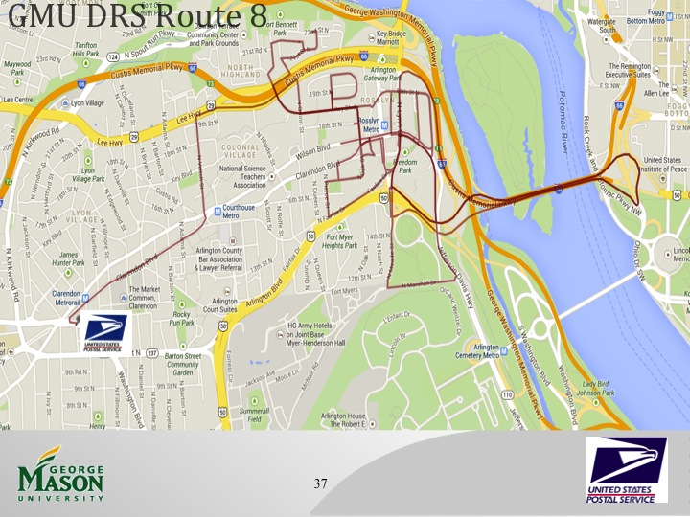

Figure : GMU DRS Route 8: 44 Stops including depot.

1. <http://www.wired.com/business/2013/06/ups-astronomical-math/>
2. Conversation with Tom Stewart – USPS Program Manager of Delivery and Retail Technology
3. <https://www.fbo.gov/index?s=opportunity&mode=form&id=a99f16df9e15bc20614aba5a22fe25d3&tab=core&_cview=0>
4. <http://www.cato.org/pubs/pas/pa047.html>
5. <http://www.federaltimes.com/article/20130724/DEPARTMENTS02/307240010/House-panel-votes-end-Saturday-mail-delivery>
6. https://www.fbo.gov/utils/view?id=16ce2a8d8819c6bf4fe060438fb81fd2
7. Conversation with Tom Stewart – USPS Program Manager of Delivery and Retail Technology
8. Conversation with Angela Lawson – USPS Dynamic Delivery Support
9. RouteSmart is likely able to deliver faster run times for a larger problem by leveraging multiple CPUs to solve the problem more quickly. USPS has the option to obtain faster results at a higher cost.
10. iBid
11. http://support.sas.com/resources/papers/proceedings12/161-2012.pdf
12. Postal Service representatives in charge of their current solution provided this delivery time assumption.
13. http://support.sas.com/documentation/cdl/en/statug/63033/HTML/default/viewer.htm#statug_fastclus_sect002.htm
14. http://support.sas.com/documentation/cdl/en/ormpug/63352/HTML/default/viewer.htm#ormpug_milpsolver_sect020.htm
15. <http://www.wired.com/business/2013/06/ups-astronomical-math/>
16. Conversation with Tom Stewart – USPS Program Manager of Delivery and Retail Technology
17. <https://www.fbo.gov/index?s=opportunity&mode=form&id=a99f16df9e15bc20614aba5a22fe25d3&tab=core&_cview=0>
18. <http://www.cato.org/pubs/pas/pa047.html>
19. <http://www.federaltimes.com/article/20130724/DEPARTMENTS02/307240010/House-panel-votes-end-Saturday-mail-delivery>
20. <URL:http://www.dictionary.reference.com/browse/highway+contract+route>
21. <http://www.wired.com/business/2013/06/ups-astronomical-math/>
22. Conversation with Tom Stewart – USPS Program Manager of Delivery and Retail Technology
23. <https://www.fbo.gov/index?s=opportunity&mode=form&id=a99f16df9e15bc20614aba5a22fe25d3&tab=core&_cview=0>