Determining the Efficacy of Modifications to T-AGS 60 Ships (DEMoTAGS)

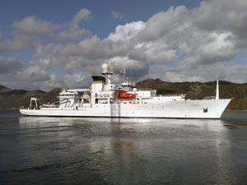

**DCMil Study Team Final Report**

6 May 2013

**Team 2:**

Christina Graziose

Dave Lund

Milan Nguyen

Contents

Preface 4

Background 4

System 5

Problem 6

Literature Search 6

Approach 6

Data Collection 7

Data Analysis 7

Outlier Analysis 7

Monthly Fuel Consumption 8

Monthly Data (other) 10

Outlier Analysis Results 15

Recorded Data Analysis 15

Underway Mode Fuel Consumption 16

Propulsion Fuel Consumption 23

Monetary Savings 30

Model Development 31

Assumptions 31

Model Objectives 32

Why Is That Important (WITI)? 32

Essential Elements of Analysis (EEAs) 34

Modeling Options 35

Model Design 37

Database Design 39

Tables 39

Queries 42

Speed Power Curve 44

Calculating Power 46

Estimating Hotel Load 47

Estimating Brake Specific Fuel Consumption 49

Estimating Sea State Factors 50

Model Output Analysis 54

Findings and Conclusions 59

Recommendations 59

Deliverables 60

Website 60

Management 60

Resource Allocation 61

Schedule 61

**Appendix A – Data Collection** 62

**Appendix B – Meeting Minutes with Customer** 63

**08 February 2013 Meeting Minutes** 63

**22 February 2013 Meeting Minutes** 65

**Appendix C - Literature Search** 68

**Analysis** 68

**Website** 68

**Background Information on T-AGS Vessels** 69

**Websites** 69

**Working Papers and/or Articles** 70

**Fuel Consumption Calculations** 70

**Website** 70

**Working Paper and/or Articles** 70

**Appendix D – Model Overview** 72

**Appendix E – Issues Encountered During Project** 74

**Sea State Factors** 74

**Estimating Skeg Modification Dates** 74

**Statistical Analysis** 75

**Appendix F – Predicted vs. Recorded Fuel Consumption t-test Analysis Results** 76

**Appendix G – Analysis of “Other” Modifications on Fuel Consumption** 78

**Appendix H – ANOVA Results for Predicted Fuel Consumption** 79

# Preface

The following items address key factors of the study:

1. The project problem was to determine whether the modifications made to the vessel’s skeg improved fuel consumption.
2. The contribution to the problem was to produce a methodology for computing ship fuel consumption based on data that the Navy has readily available. An analysis was provided to support the customer’s question as to whether or not the skeg modifications improved T-AGS fuel consumption.
3. The deliverables provided were a final report that documented The DCMIL Study Team’s (hereafter referred to as “the Team”) methodology and findings, an Access database containing data and data processing techniques used to implement the methodology, a standalone word document providing an overview of the mathematical model (i.e., “cheat sheet”), and a final presentation.
4. The customer was updated on the project status through discussions in the form of in-person meetings and teleconferences. The meeting minutes from these meetings are contained in Appendix B.
5. The risks for successfully completing the project were:
   1. Receiving the necessary data.
   2. Time management.
6. The approach to mitigate the risks was:
   1. Receiving the necessary data: Maintained a close working relationship with the customer via frequent meetings and teleconferences to address any data problems or data needs.
   2. Time management: Developed and followed a project schedule. The project leader was responsible for delegating work and maintaining the schedule. Well defined group member roles and responsibilities were assigned.

# Background

The US Navy operates a fleet of 6 T-AGS Class Oceanographic Survey vessels, powered by two azimuthing Z-drives that provide both propulsion and directional control of the vessel. Recent ship modifications have included the addition of a larger skeg. A skeg is essentially a fin located along the bottom-rear centerline of the ship, and its purpose is to provide greater directional stability. An increase in the size of the skeg makes the ship more resistant to turning. This results in less steering corrections that need to be made using the Z-drives and greater overall propulsive efficiency, which in turn, should lower fuel consumption. The disadvantages of a larger skeg are a larger wetted surface area thus greater drag and a slight increase in flow irregularity into the propellers that can cause some propeller inefficiency.

Prior to acceptance of the modifications, towing tank and computational fluid dynamics analyses were performed. The analyses suggested a level of fuel savings would occur in response to the modifications. However, since the modifications have been made to the vessel, no comprehensive analysis of the performance improvements has been performed. The purpose of our analysis will be to validate that the ship modifications have indeed increased efficiency by lowering fuel consumption.

# System

Based on the background information and in preparation of scoping the project’s problem, the Team identified the system of interest. A system diagram identifies the attributes acting on the system, and the systems diagram was developed (see figure below). The system diagram was used to gain a better understanding of the system and identifying all the variables that act on the vessel. This diagram allowed the Team to develop and scope the project’s problem.

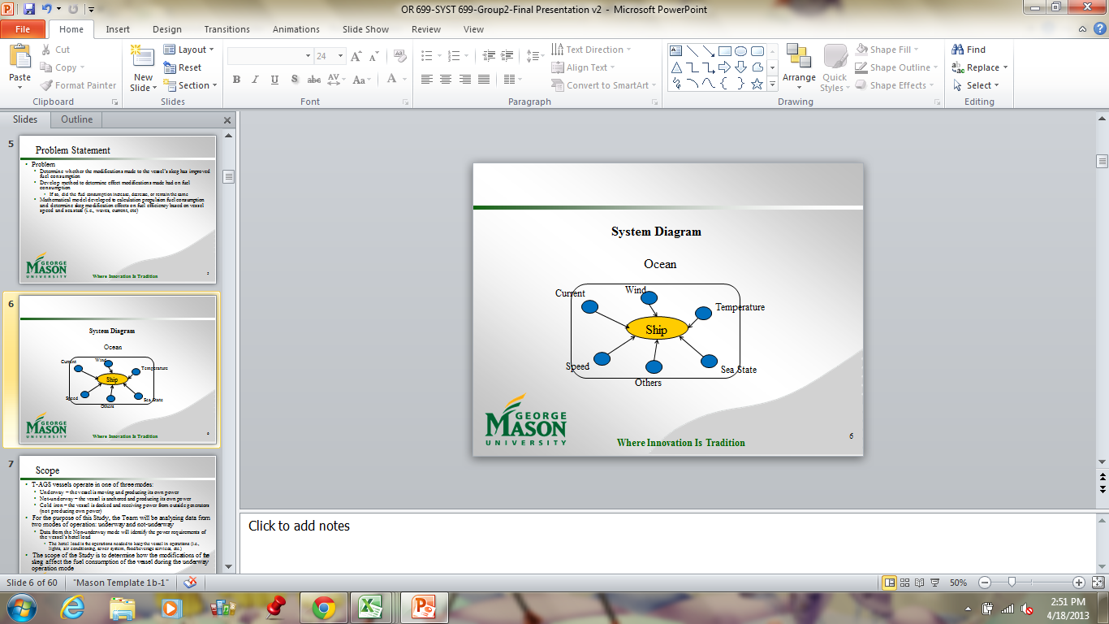

Figure 1. System Diagram

The project was focused on a vessel and its fuel consumption (the system of interest, denoted by the yellow circle in the figure about) and it operates in the ocean. Through discussion with the customer and research, the Team determined that there are multiple attributes that act on the system affecting the fuel consumption. Some of the attributes are: the ocean’s current, wind speed and direction, temperature of the ocean, sea state, and many more. The Team identified a large number of attributes acting on the system and due to the restricted timeframe, not all attributes could be analyzed. Instead, the Team identified two attributes to be analyzed: vessel speed, and sea state. These attributes were selected because they had an additive effect on the vessel’s fuel consumption. Both the sea state and vessel speed are assumed to be influenced by the wind speed and direction, ocean current, and sea temperature. Therefore, to develop a mathematical model that would incorporate as many variables as possible, variables with additive effect would provide the most value.

# Problem

The purpose of the study was to determine whether the modifications made to the vessel’s skeg had improved fuel consumption. The Team was tasked to develop a method to determine whether the modifications made to the T-AGS vessels had an effect on fuel consumption, and if so, did the fuel consumption increase, decrease, or remain the same. Propulsion fuel consumption was modeled to determine how the skeg modification affects the fuel efficiency of the TAG-S vessels based on vessel speed and sea state.

# Literature Search

To better understand the T-AGS Class Oceanographic Survey Vessels, the Team performed literature search. The literature search is contained in the Appendix C, in the form of an annotated bibliography. Documents on calculating fuel consumption were critical to the completion of the study. These documents aided the Team in determining all the variables that affect fuel consumption (i.e., speed, sea state, etc.) and how the approach for calculating fuel consumption relates to those variables.

# Approach

This study was completed through three tasks. The figure below provides an overview of the study’s approach. The light blue box indicates the general efforts to be performed during each task while the darker blue box identifies the results of each task. The proceeding sections discuss each task in detail.

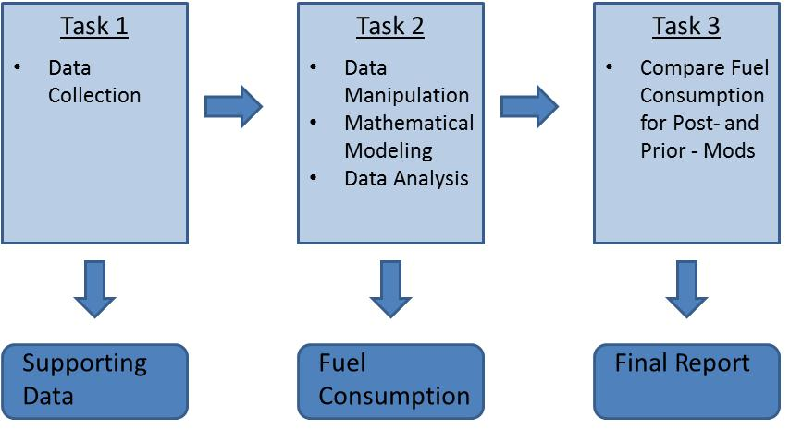

Figure 2. Study Approach Overview.

# Data Collection

The completion of Task 1, data collection, was critical to the remainder of the study; it provided the foundation needed to complete Tasks 2 and 3. The customer was the prime data supplier for the purpose of this study.

The customer provided the Team with data recorded by each vessel’s port engineer. Because each vessel has its own port engineer, data inconsistencies were present. Three data categories, Monthly Consumption and Operating Hours, Power vs. Speed, and Vessel’s Ship log were provided to the Team (reference Appendix A for information on all the data types provided within each category). The Monthly Consumption and Operating Hours data contained approximately 700 rows of data (about 120 data points for each vessel), the ship log data contained more than 42,000 rows, and the power vs. speed table included six relationships between the power and speed of the vessel. During Task 2, the Team combed through the data and identified data anomalies. Data anomalies were presented to the customer for removal concurrence.

The following data types were used during the study:

* Ship Name
* Date of Reporting of the Monthly Consumption and Operating Hours data
* Barrels of fuel consumed while underway and not underway
* Number of hours spent in each of the three modes of operation
* Average Speed
* The date and time of the ship log reporting
* Sea State
* Power vs. Speed

# Data Analysis

Task 2 consisted of data manipulation, data analysis, and model development. The purpose of the mathematical model was to calculate the vessel fuel consumption based on speed and sea state. The main tools used during Task 2 were Microsoft Access, Excel, and Minitab. The model was created through Access; Excel was used for regression and statistical analysis and plotting data; and Minitab was used for statistical analysis.

## Outlier Analysis

The collected data had two types of data recorded at different time intervals. The first was the monthly fuel consumption for underway (UW) and not-underway (NUW), with a single data entry indicating the monthly fuel consumption for each vessel by month. The second data type included the sea state and average vessel speed. The sea state and vessel speed had several data entries recorded multiple times a day for each vessel.

### Monthly Fuel Consumption

Prior to any data analysis and model development, the Team manipulated the data to ensure consistency and preparation of the database. The first step to prepare the data for the mathematical model was to identify data outliers. In order to determine which mathematical approach to use, the Team first needed to determine if the data was normally distributed. An Anderson-Darling normality test was performed to determine if the data was normally distributed. The Anderson-Darling indicated that the data was not normally distributed for all vessels; the p-value was less than 0.05.

Since the data was determined to be not normally distributed, the Team identified data outliers by means of boxplots and fences. Boxplots are dependent on the median, rather than the average of the data, and is able to handle non-normal data. Boxplots were created for each combination of operating mode (UW and NUW) and vessels, for a total combination of 12 boxplots. Fences, which aided in identifying outliers, were calculated to be 1.5 times the difference of the inner quartiles; equations are below.

$$Upper Fence=\left[Quartile 3\right]+1.5*(Quartile 3-Quartile 1)$$

$$Lower Fence=\left[Quartile 1\right]-1.5* (Quartile 3-Quartile 1)$$

Thus anomalies are 150% less than the first quartile or 150% greater than the third quartile. If the calculated lower fence was negative, a value of zero was used instead. The following figures show the boxplots for UW and NUW fuel consumption.

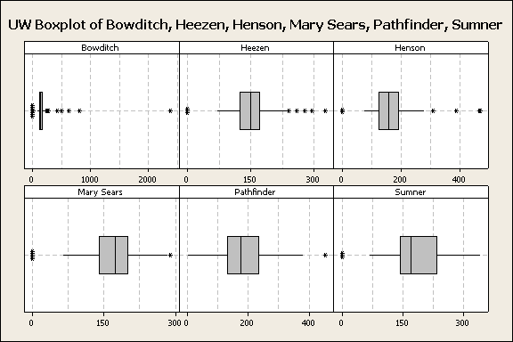

Figure 3. Boxplots for UW Fuel Consumption (gal/hr)

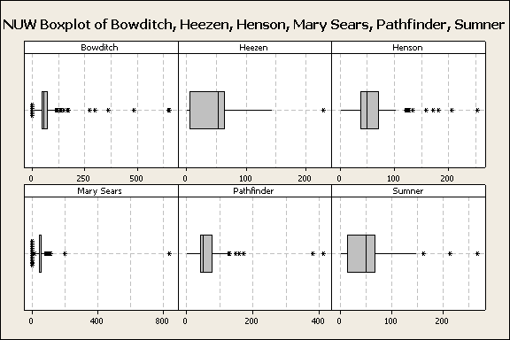

Figure 4. Boxplot for NUW Fuel Consumption (gal/hr)

The following table identifies the lower upper range of fuel consumption (gal/hr) data to be considered for each vessel during UW.

Table 1. Ranges of Consideration for UW Fuel Consumption

|  |  |  |
| --- | --- | --- |
| **Vessel** | **Lower Range For Consideration (gal/hr)** | **Higher Range For Consideration (gal/hr)** |
| Bowditch | 51.24 | 234.88 |
| Heezen | 57.12 | 237.12 |
| Henson | 25.57 | 287.75 |
| Mary Sears | 53.90 | 287.35 |
| Pathfinder | 0 | 384.84 |
| Sumner | 12.16 | 363.18 |

These values were used to determine outliers in the monthly fuel consumption data. Any data points outside of these ranges were not used in the mathematical model. The table below identifies the lower upper range of fuel consumption (gal/hr) data to be considered for each vessel during NUW.

Table 2. Ranges of Considerations for NUW Fuel Consumption

| **Vessel** | **Lower Range For Consideration (gal/hr)** | **Higher Range For Consideration (gal/hr)** |
| --- | --- | --- |
| Bowditch | 1.66 | 113.67 |
| Heezen | 0 | 147.53 |
| Henson | 0 | 117.33 |
| Mary Sears | 22.70 | 72.95 |
| Pathfinder | 0 | 122.76 |
| Sumner | 0 | 147.49 |

Unlike the fuel consumption range for UW, the NUW had a larger amount of lower ranges that were calculated to be negative and therefore a value of zero was used. Similar to the UW data, these values were used to determine the monthly fuel consumption outliers.

For the NUW outliers, since it was assumed that the hotel load was not affected by the modification, the Team was able to “estimate” what the month’s average fuel consumption should have been. This estimate was developed through a time series moving average of like months; this means that for any given year, if a month’s (i.e., March) fuel consumption was identified to be an outlier, all like months for all other years fuel consumption was averaged (i.e., averaged all the fuel consumptions for the month of March across all years (all years weighted equally) excluding the March value that was deemed an outlier). This allows the estimated hotel load to take into consideration any seasonal effects. The table below identifies the estimated hotel load for each vessel by month.

Table 3. Estimated Hotel Load (gal/hr)

|  |  |  |  |  |  |  |
| --- | --- | --- | --- | --- | --- | --- |
| **Months** | **Estimated Fuel Consumption (gal/hr)** | | | | | |
| **Bowditch** | **Heezen** | **Henson** | **Mary Sears** | **Pathfinder** | **Sumner** |
| January | 51.91 | 59.50 | 58.57 | 49.80 | 56.60 | 81.57 |
| February | 65.96 | 62.01 | 44.95 | 49.08 | 45.35 | 69.93 |
| March | 52.19 | 57.03 | 56.85 | 51.69 | 56.57 | 60.65 |
| April | 57.72 | 51.27 | 48.18 | 47.98 | 54.31 | 54.51 |
| May | 64.30 | 60.15 | 61.35 | 48.78 | 64.65 | 55.15 |
| June | 44.64 | 61.90 | 53.72 | 47.63 | 59.80 | 61.14 |
| July | 41.67 | 72.12 | 48.22 | 52.05 | 64.14 | 51.35 |
| August | 52.92 | 62.46 | 46.45 | 54.94 | 54.11 | 43.27 |
| September | 59.03 | 58.21 | 43.35 | 45.48 | 56.12 | 46.80 |
| October | 49.31 | 59.10 | 40.58 | 55.57 | 72.25 | 60.33 |
| November | 52.17 | 61.49 | 43.96 | 50.64 | 55.05 | 36.43 |
| December | 53.97 | 47.14 | 61.79 | 55.56 | 59.56 | 49.81 |

The estimated hotel load replaced the outliers identified in NUW. The process used to calculate the estimated hotel load and the results were approved by the customer prior to incorporation.

### Monthly Data (other)

The team also performed outlier analysis (by means of boxplots) on the vessel speed data. The table below contains the results of the outlier analysis.

Table 4. Ranges of Consideration for Vessel Speed

| **Vessel** | **Lower Range For Consideration (kts)** | **Initial Upper Range For Consideration (kts)** | **Final Upper Range for Consideration (kts)** |
| --- | --- | --- | --- |
| Bowditch | 0 | 17.5 | 17.5 |
| Heezen | 0 | 16 | 16 |
| Henson | 0 | 21.25 | 18 |
| Mary Sears | 0 | 18.5 | 18 |
| Pathfinder | 0.5 | 18.9 | 18 |
| Sumner | 0 | 30 | 18 |

Any calculated lower range values that were negative were replaced with a value of zero. Some of the calculated upper range speed values were determined to be too high for this type of vessel (“Initial Upper Range for Consideration” in the table above). Therefore, the customer suggested that the upper range for vessel speed not exceed 18 kts (“Final Upper Range for Consideration” in the table above). Typically, the T-AGS vessels have a maximum speed of 16 kts, but in perfect conditions (ideal wind speed/direction and ocean current), a maximum speed of 18knts could be achieved. The Team verified that low speeds are expected when the vessels are surveying the ocean. When appropriate, the average speed of 0 kts identifies that the vessel was in NUW mode. While the Pathfinder has a lower range of 0.5 kts, average speeds of 0 kts were still used to identify UW. Any recorded speed greater than 18 kts were removed from the mathematical model.

The final outlier analysis performed was to extract monthly data for a month that did not have sufficient data. The Team determined that this was necessary to provide a realistic analysis on monthly data – analyzing months with 30 days of data to months with two days of data would not produce useful results. Therefore, the Team removed monthly data with less than 75 percent of its daily data. The percentage of daily data was based on the month’s actual number of days rather than averaging 30 days a month. The table below provides the results of this analysis.

Table 5. Monthly Data Analysis

| **Site Name** | **Total Months** | **Months with No Data** | **Months Missing  > 75% Data** | **Usable Months** |
| --- | --- | --- | --- | --- |
| USNS Bowditch | 96 | 30 | 33 | 33 |
| USNS Heezen | 96 | 14 | 38 | 44 |
| USNS Henson | 96 | 41 | 45 | 10 |
| USNS Mary Sears | 96 | 4 | 46 | 46 |
| USNS Pathfinder | 96 | 42 | 34 | 20 |
| USNS Sumner | 96 | 3 | 48 | 45 |

The data gathered in Task 1 contained eight years of data, for a total of 96 months. Each vessel had months completely excluded from the data (e.g., there was no data collected for that vessel during that timeframe), this data is recorded in the “Months with No Data” column. After removing the monthly data with less than 75 percent of the daily data, the Team counted the number of months that were removed (recorded in “Months Missing > 75% Data” column) and the total number of months that remained (“Usable Months” column) for model analysis.

The customer recommended that the Team analyze the effect of removing monthly data with less 75 percent of the daily data. The analysis would determine the model sensitivity to exclusion of months missing sizable amounts of data. The Team calculated the total variability and average variability of removing months with less than 65, 75, and 85 percent of daily data. The total data variability was determined by calculating the sum squared and average data variability was calculated by the sample variance. Each analysis was performed on the recorded propulsion data. The figure below contains the results of the sum of squares analysis on the recorded propulsion data.



Figure 5. Sum of Squares for Recorded Propulsion Fuel Consumption

The results were as expected, utilizing month with more data provided a smaller total variance. The Bowditch vessel had the least data variability amongst all the vessels while the Sumner had the greatest data variability. Since each vessel did not have the same number of months included in the analysis, the Team determined that the total variability may not appropriate analysis: the variable of months could influence the total variability.[1] The Team determined the average data variability for each vessel. The figure below contains the results of analysis on the recorded propulsion fuel consumption.



Figure 6. Sample Variance for Recorded Propulsion Fuel Consumption

The average data variability provided an inverse bell curve and appears to provide the analysis the Team wanted. The average data variability allows the Team to determine, on average, which percentage of monthly data required for analysis was lower. On average, the 75 percent monthly data required had a similar or less than average data variability that the 65 and 85 percent.

Next, the Team determined the effect the percentage of month data requirement had on the number of months available for analysis; reference the table below for results.

Table 6. Daily Percentage Requirement Effect on Usable Months

|  |  |  |  |  |  |
| --- | --- | --- | --- | --- | --- |
|  | **Number of Usable Months By Daily Percentage** | | | **Differences** | |
| **65%** | **75%** | **85%** | **65 to 75** | **75 to 85** |
| USNS Bowditch | 29 | 27 | 21 | -7% | -22% |
| USNS Heezen | 28 | 26 | 20 | -7% | -23% |
| USNS Henson | 12 | 7 | 4 | -42% | -43% |
| USNS Mary Sears | 49 | 38 | 29 | -22% | -24% |
| USNS Pathfinder | 17 | 16 | 12 | -6% | -25% |
| USNS Sumner | 35 | 32 | 21 | -9% | -34% |

Reducing the required daily data requirement from 75% to 65% had a large impact on quantity of monthly data for the Henson and Mary Sears vessels, 42 and 22 percent, respectively. All other vessels experienced less than a 10% decrease in the number of usable months when the daily data requirement was 75 percent instead of 65 percent. However, all vessels were impacted by increasing the daily data requirement from 75 to 85 percent. The increase from 75 to 85 percent resulted in a large decrease in the number of usable months. The Henson experienced the largest decrease in usable month (43 percent); however, the number of usable months with the 75 percent requirement was seven which was lowered to four with the 85 percent requirement.

To complete the sensitivity analysis, the Team determined how the skeg modifications affected fuel consumption on the recorded propulsion fuel consumption means for the 65, 75,[2] and 85 percent daily data requirement. Those results are contained in the tables below.

Table 7. 65% Daily Data Requirement

|  | **Before** | **After** | **Difference** |
| --- | --- | --- | --- |
|
|  |
| USNS Bowditch | 102.08 | 70.31 | -31% |
| USNS Heezen | 112.82 | 78.02 | -31% |
| USNS Henson | 130.24 | 73.04 | -44% |
| USNS Mary Sears | 130.65 | 139.65 | 7% |
| USNS Pathfinder | 195.74 | 60.27 | -69% |
| USNS Sumner | 178.00 | 97.32 | -45% |

Table 8. 75% Daily Data Requirement

|  |  |  |  |
| --- | --- | --- | --- |
| **Propulsion Data** | **Before** | **After** | **Difference** |
|
| USNS Bowditch | 98.60 | 70.83 | -28% |
| USNS Heezen | 104.71 | 78.02 | -25% |
| USNS Henson | 83.88 | 73.04 | -13% |
| USNS Mary Sears | 133.80 | 140.15 | 4.7% |
| USNS Pathfinder | 195.74 | 52.00 | -73% |
| USNS Sumner | 182.83 | 98.77 | -46% |

Table 9. 85% Daily Data Requirement

|  |  |  |  |
| --- | --- | --- | --- |
|  | **Before** | **After** | **Difference** |
|
| USNS Bowditch | 106.50 | 71.25 | -33% |
| USNS Heezen | 119.48 | 74.85 | -37% |
| USNS Henson | 79.19 | 102.49 | 29% |
| USNS Mary Sears | 135.03 | 129.60 | -4% |
| USNS Pathfinder | 196.92 | 52.34 | -73% |
| USNS Sumner | 172.27 | 102.18 | -41% |

Although the change in daily data requirement did result in changes to the overall average of fuel consumption for each vessel, the 85 percent daily data requirement resulted in the Henson vessel having only one data point for certain data categories. With the exception of two vessels, the number of months excluded when using the 75 percent daily data requirement vs. the 65 percent was minimal. Also, the average data variance indicated that the 75 percent daily data requirement was similar to or less than the 65 and 85 percent daily data requirement average variance. With the results of this analysis, the Team was confident in using the 75 percent of monthly data required for model development.

## Outlier Analysis Results

At the conclusion of the data manipulation, approximately 0.37 percent (132 of 35,534), 5.97 percent (44 of 737), and 19.95 percent (147 of 737) of the vessel speed, UW, and NUW data, respectively, were determined to be outliers. Approximately 50 percent or more of the monthly analysis was removed for each vessel due to lack of data. Sensitivity analysis indicated that utilizing 75 percent for determining which monthly data needed to be removed was appropriate; the calculated average variability for 75 percent was equal to or less than the average variability for 65 and 85 percent. Although the Team analyzed and removed identified outliers, the data may still contain outliers which could affect the results of the mathematical model. If outliers remain in the data, potential risks such as unrealistic results could arise.

## Recorded Data Analysis

This section addresses the main question of the project, did the modifications made to the skeg result in a decrease in fuel consumption? To determine if the skeg modifications had an effect on the vessels’ fuel consumption, the Team utilized the monthly data provided by the customer (rather than the data calculated by the mathematical model). The reason for not using the model’s data is because the recorded data incorporates all external variables that would influence the vessel fuel consumption (i.e., speed, sea temperature, sea state, wind speed, etc.).

The Team performed multiple analyses at different levels of detail to determine if fuel consumption savings occurred. Averages of the fuel consumption data before and after the skeg modifications were used to determine if the modifications had an effect on the fuel consumption. Analysis was performed for both the UW mode and the propulsion fuel consumption at the following levels of details: overall, seasons, and (similar) months. The succeeding sections discuss the fuel consumption savings from skeg modification analysis in detail.

### Underway Mode Fuel Consumption

The UW mode incorporates the power (and therefore the fuel consumption) needed for the vessel’s hotel load. As previously mentioned, one of the assumptions made during the course of the project was that the skeg modifications did not affect the fuel consumption of the hotel load – the power and fuel needed for the hotel load is the same regardless of the modification.

The table below provides the average recorded fuel consumption for each vessel before and after their respective skeg modification dates (“Before” and “After” columns, respectively). The next column, “Difference” identifies the difference between the two fuel consumption calculations in a percentage. A negative difference identifies that the fuel consumption value post-skeg modification was lower than the fuel consumption before the modification. The values in this column are color coded: green font denotes a desired while the red font denotes an undesired effect on fuel consumption.

Table 10. Results of UW Overall Average Fuel Consumption Analysis

|  | **Before** | **After** | **Difference** |
| --- | --- | --- | --- |
|
|  |
| USNS Bowditch | 161.12 | 124.19 | -23% |
| USNS Heezen | 162.30 | 142.86 | -12% |
| USNS Henson | 126.93 | 122.30 | -4% |
| USNS Mary Sears | 186.25 | 190.29 | 2.2% |
| USNS Pathfinder | 231.78 | 140.97 | -39% |
| USNS Sumner | 235.09 | 163.58 | -30% |

All vessels experienced a decrease in fuel consumption post-skeg modification with the exception of the Mary Sears. The USNS Mary Sears vessel’s before and after fuel consumption was almost identical with the fuel consumption post modification being slightly higher. This minor difference could be due to limited data available on the pre-skeg data for the vessel; the skeg modification date for the Mary Sears vessel was March 2006. This resulted in only two years of pre-skeg data compared to about five years post-skeg data. Next, the Team analyzed the data in a more detailed level, by seasons. The table below contains the month to season relationship used for the purpose of the project.

Table 11. Month to Season Relationship

| **Season** | **Month** | | |
| --- | --- | --- | --- |
| Winter | December | January | February |
| Spring | March | April | May |
| Summer | June | July | August |
| Fall | September | October | November |

Similar to the overall fuel consumption analysis, the Team determined the average fuel consumption recorded for pre- and post-skeg modification (“Before” and “After” columns, respectively), and the difference between the two fuel consumptions (“Difference”). The table below contains the results of the seasonal fuel consumption analysis for the Bowditch vessel.

Table 12. Bowditch - Average UW Fuel Consumption Seasonal Analysis

|  |  |  |  |
| --- | --- | --- | --- |
| **USNS Bowditch** | | | |
|  | **Before** | **After** | **Difference** |
| Winter | 168.26 | 128.69 | -24% |
| Spring | 155.80 | 143.44 | -8% |
| Summer | 153.80 | 117.93 | -23% |
| Fall | 155.11 | 103.11 | -34% |

The Bowditch skeg modification resulted in lower fuel consumption for all seasons. The following table provides the results of the seasonal fuel consumption analysis for the Heezen vessel.

Table 13. Heezen - Average UW Fuel Consumption Seasonal Analysis

|  |  |  |  |
| --- | --- | --- | --- |
| **USNS Heezen** | | | |
|  | **Before** | **After** | **Difference** |
| Winter | 164.03 | 139.87 | -15% |
| Spring | 135.50 | 138.70 | 2% |
| Summer | 112.25 | 144.28 | 29% |
| Fall | 196.39 | 146.33 | -25% |

The Heezen vessel had fuel reduction in the winter and fall seasons. The spring and summer months had a slight increase in fuel consumption. The table below provides the results of the seasonal fuel consumption analysis on the Henson vessel.

Table 14. Henson - Average Fuel Consumption Seasonal Analysis

|  |  |  |  |
| --- | --- | --- | --- |
| **USNS Henson** | | | |
|  | **Before** | **After** | **Difference** |
| Winter | N/A | 129.51 | N/A |
| Spring | 126.93 | N/A | N/A |
| Summer | N/A | N/A | N/A |
| Fall | N/A | 93.46 | N/A |

The Henson data, post outlier analysis, did not have enough data to determine if a reduction in fuel consumption occurred for any seasons. However, the overall analysis on average fuel consumption indicated that the Henson vessel may have a reduction in fuel consumption. The results of the Mary Sears seasonal fuel consumption analysis is contained in the following table.

Table 15. Mary Sears - Average UW Fuel Consumption Seasonal Analysis

|  |  |  |  |
| --- | --- | --- | --- |
| **USNS Mary Sears** | | | |
|  | **Before** | **After** | **Difference** | |
| Winter | 208.17 | 210.61 | 1% | |
| Spring | 146.06 | 169.51 | 16% | |
| Summer | 272.51 | 195.83 | -28% | |
| Fall | 177.86 | 180.78 | 2% | |

Only the summer seasonal months experienced a reduction in fuel consumption post skeg modifications. All other seasons had an increase in fuel consumption post skeg modification. The winter and fall seasons had very minimal increases in fuel consumption, one and two percent, respectively. The table below contains the results of the seasonal fuel consumption analysis for the Pathfinder vessel.

Table 16. Pathfinder - Average UW Fuel Consumption Seasonal Analysis

|  |  |  |  |
| --- | --- | --- | --- |
| **USNS Pathfinder** | | | |
|  | **Before** | **After** | **Difference** |
| Winter | 292.18 | N/A | N/A |
| Spring | 174.77 | 153.64 | -12% |
| Summer | 228.38 | 138.69 | -39% |
| Fall | N/A | 131.15 | N/A |

Similar to the Henson vessel, there was not enough data to determine if a change in fuel consumption occurred during the winter and fall seasons. The spring and summer seasons did have a reduction in the fuel consumption post-skeg modifications. The Sumner seasonal fuel consumption analysis results are contained in the table below.

Table 17. Sumner - Average UW Fuel Consumption Seasonal Analysis

|  |  |  |  |
| --- | --- | --- | --- |
| **USNS Sumner** | | | |
|  | **Before** | **After** | **Difference** |
| Winter | 238.00 | 170.66 | -28% |
| Spring | 258.77 | 147.59 | -43% |
| Summer | 242.74 | 161.66 | -33% |
| Fall | 209.35 | 173.33 | -17% |

The Sumner vessel experienced fuel consumption reductions for all seasons. Finally, the Team analyzed the fuel consumption at the monthly level. For this analysis, the Team averaged identical months (e.g., all January, all February, etc.) before and after the modification date. The table below provides the Bowditch monthly averaged fuel consumption pre- and post-skeg modification and the difference between the two fuel consumptions. As mentioned previously, the data manipulation resulted in a decent amount of data removed due to being an outlier. The data that remained, when sorted down into the level of detail needed to perform the monthly analysis often resulted in some vessels only have one data point per data grouping. If a data grouping had no data points available, an “N/A” is recorded in the respective column as well as the “Difference” column.

Table 18. Bowditch - Average UW Fuel Consumption Monthly Analysis

|  |  |  |  |
| --- | --- | --- | --- |
| **USNS Bowditch** | | | |
| **Month** | **Before** | **After** | **Difference** |
| January | 181.93 | 156.84 | -14% |
| February | 158.02 | 134.29 | -15% |
| March | 185.60 | 152.08 | -18% |
| April | 137.66 | 126.18 | -8% |
| May | 144.13 | N/A | N/A |
| June | 154.93 | 156.35 | 1% |
| July | 141.15 | N/A | N/A |
| August | 165.32 | 79.51 | -52% |
| September | N/A | N/A | N/A |
| October | 144.88 | 108.85 | -25% |
| November | 165.34 | 100.24 | -39% |
| December | N/A | 89.34 | N/A |

The available data identified that the Bowditch vessel should experience consumption for seven months. There was not enough data to determine if a reduction in the fuel consumption occurred for four months. The largest fuel consumption reduction occurred in November with a 39 percent reduction.

The table below provides the results of the Heezen fuel consumption monthly analysis.

Table 19. Heezen - Average UW Fuel Consumption Monthly Analysis

|  |  |  |  |
| --- | --- | --- | --- |
| **USNS Heezen** | | | |
| **Months** | **Before** | **After** | **Difference** |
| January | 169.11 | 141.55 | -16% |
| February | 156.41 | 110.67 | -29% |
| March | N/A | N/A | N/A |
| April | 135.50 | 152.80 | 13% |
| May | N/A | 131.65 | N/A |
| June | 112.25 | 135.01 | 20% |
| July | N/A | 110.77 | N/A |
| August | N/A | 170.31 | N/A |
| September | N/A | 146.55 | N/A |
| October | N/A | 161.87 | N/A |
| November | 196.39 | 141.08 | -28% |
| December | N/A | 165.73 | N/A |

Based on the available data, there was only enough information to determine if fuel consumption reductions occurred for five months. Of those five months, three of those months had a fuel consumption reduction. The largest reduction occurred during February with a reduction of 29 percent.

The table below contains the results for the Henson monthly fuel consumption analysis.

Table 20. Henson - Average UW Fuel Consumption Monthly Analysis

|  |  |  |  |
| --- | --- | --- | --- |
| **USNS Henson** | | | |
| **Months** | **Before** | **After** | **Difference** |
| January | N/A | 162.11 | N/A |
| February | N/A | 150.57 | N/A |
| March | 137.70 | N/A | N/A |
| April | 116.15 | N/A | N/A |
| May | N/A | N/A | N/A |
| June | N/A | N/A | N/A |
| July | N/A | N/A | N/A |
| August | N/A | N/A | N/A |
| September | N/A | N/A | N/A |
| October | N/A | N/A | N/A |
| November | N/A | 93.46 | N/A |
| December | N/A | 102.69 | N/A |

Similar to the Henson’s seasonal analysis, there was not enough available data to determine if fuel consumption reductions occurred for any month. However, it was previously determined that an overall fuel consumption reduction may exist for the Henson vessel.

The table below identifies the results of the average fuel consumption monthly analysis for the Mary Sears vessel.

**Table 21. Mary Sears - Average UW Fuel Consumption Monthly Analysis**

|  |  |  |  |
| --- | --- | --- | --- |
| **USNS Mary Sears** | | | |
| **Months** | **Before** | **After** | **Difference** |
| January | 223.55 | 185.57 | -17% |
| February | 192.78 | 227.30 | 18% |
| March | 171.59 | 158.57 | -8% |
| April | 137.98 | 145.56 | 5% |
| May | 111.18 | 198.94 | 79% |
| June | N/A | 203.00 | N/A |
| July | N/A | 179.72 | N/A |
| August | 272.51 | 197.01 | -28% |
| September | N/A | 181.67 | N/A |
| October | 158.75 | 175.60 | 11% |
| November | 196.96 | 182.48 | -7% |
| December | N/A | N/A | N/A |

The Team was able to determine if the skeg modifications affect the fuel consumption for eight months. Four of the eight months resulted in a reduction of fuel consumption. The largest fuel consumption reduction occurred in August with a reduction of 28 percent. Although the average fuel consumption indicated that Mary Sears had an increase in fuel consumption, the analysis indicated there was some reductions in fuel consumption but the increases were greater than the decreases. The results of the average UW monthly fuel consumption analysis for the Pathfinder vessel are contained in the table below.

**Table 22. Pathfinder - Average UW Fuel Consumption Monthly Analysis**

|  |  |  |  |
| --- | --- | --- | --- |
| **USNS Pathfinder** | | | |
| **Months** | **Before** | **After** | **Difference** |
| January | N/A | N/A | N/A |
| February | 292.18 | N/A | N/A |
| March | N/A | 159.68 | N/A |
| April | N/A | 138.74 | N/A |
| May | 174.77 | 177.39 | 2% |
| June | N/A | 123.48 | N/A |
| July | N/A | 163.31 | N/A |
| August | 228.38 | 121.66 | -47% |
| September | N/A | 121.22 | N/A |
| October | N/A | 141.08 | N/A |
| November | N/A | N/A | N/A |
| December | N/A | N/A | N/A |

The Team was able to determine if the skeg modifications had an effect on the fuel consumption for only two months. Only one of those months, August, had a fuel reduction of 47 percent.

The following table contains the results of the Sumner average fuel consumption monthly analysis.

**Table 23. Sumner – Average UW Fuel Consumption Monthly Analysis**

|  |  |  |  |
| --- | --- | --- | --- |
| **USNS Sumner** | | | |
| **Months** | **Before** | **After** | **Difference** |
| January | 246.84 | 150.42 | -39% |
| February | 174.56 | 180.78 | 4% |
| March | N/A | 130.38 | N/A |
| April | 231.74 | 171.22 | -26% |
| May | 180.79 | 134.75 | -25% |
| June | 192.47 | 180.58 | -6% |
| July | 197.77 | 110.78 | -44% |
| August | N/A | 225.56 | N/A |
| September | N/A | 160.62 | N/A |
| October | 245.81 | 179.93 | -27% |
| November | 162.98 | 172.34 | 6% |
| December | N/A | N/A | N/A |

The Sumner vessel had fuel reductions in six months. Four months did not have enough data to determine if the skeg modification had any effect on fuel consumption. The largest fuel consumption occurred during July with a reduction of 44 percent. The remaining two months had an increase in fuel consumption.

Overall, with a few exceptions, the UW average fuel consumption had decreased as a result of the skeg modification. If the average fuel consumption increased, it was a minimal increase and did not affect the overall reduction in fuel consumption (with the exception of Mary Sears). Although not all fuel consumption savings were identified to be significant, this could be due to the limited data available. As more data becomes available, it will allow for additional statistical analysis to be performed and determine if the reductions are significant.

### Propulsion Fuel Consumption

Similar to the UW fuel consumption analysis, the Team also performed an analysis on the propulsion fuel consumption. The propulsion data was calculated by subtracting the hotel load from UW fuel consumption.

The table below provides the average recorded propulsion fuel consumption for each vessel before and after their respective skeg modification dates (“Before” and “After” columns, respectively). The next column, “Difference” identifies the difference between the two fuel consumption calculations in a percentage. A negative difference identifies that the fuel consumption value post-skeg modification was lower than the fuel consumption before the modification. The values in this column are color coded: green font denotes a desired while the red font denotes an undesired effect on fuel consumption.

**Table 24. Results of Propulsion Overall Average Fuel Consumption**

|  | **Before** | **After** | **Difference** |
| --- | --- | --- | --- |
|
|  |
| USNS Bowditch | 98.60 | 70.83 | -28% |
| USNS Heezen | 104.71 | 78.02 | -25% |
| USNS Henson | 83.88 | 73.04 | -13% |
| USNS Mary Sears | 133.80 | 140.15 | 4.7% |
| USNS Pathfinder | 195.74 | 52.00 | -73% |
| USNS Sumner | 182.83 | 98.77 | -46% |

Similar to the UW analysis, all vessels, with the exception of Mary Sears, experienced a reduction in fuel consumption post skeg modifications. The UW analysis indicated that Mary Sears had a 2.2 percent increase in fuel consumption compared to the 4.7 percent increase shown in the table above.

Next, the Team performed the propulsion seasonal average fuel consumption. The same month to season relationship used in the UW analysis was used for the propulsion analysis. The following table identifies the results of the Bowditch average seasonal fuel consumption analysis.

**Table 25. Bowditch – Average Propulsion Fuel Consumption Seasonal Analysis**

|  |  |  |  |  |
| --- | --- | --- | --- | --- |
| **USNS Bowditch** | | | | |
|  | **Before** | **After** | **Difference** |
| Winter | 104.55 | 70.11 | -33% |
| Spring | 84.41 | 81.30 | -4% |
| Summer | 108.77 | 81.52 | -25% |
| Fall | 83.80 | 54.21 | -35% |

Similar to the UW analysis, the Bowditch vessel experienced a fuel reduction during all seasons post skeg modifications. The following table provides the results of the seasonal fuel consumption analysis for the Heezen vessel.

**Table 26. Heezen – Average Propulsion Fuel Consumption Seasonal Analysis**

|  |  |  |  |  |
| --- | --- | --- | --- | --- |
| **USNS Heezen** | | | | |
|  | **Before** | **After** | **Difference** |
| Winter | 105.58 | 71.49 | -32% |
| Spring | 66.08 | 86.92 | 32% |
| Summer | 39.92 | 80.16 | 101% |
| Fall | 154.25 | 75.76 | -51% |

Both the UW and propulsion analysis determined that fuel reductions occurred for the winter and fall months after the skeg modifications and an increase was experienced in the spring and summer months. The table below provides the results of the seasonal fuel consumption analysis on the Henson vessel.

**Table 27. Henson – Average Propulsion Fuel Consumption Seasonal Analysis**

|  |  |  |  |
| --- | --- | --- | --- |
| **USNS Henson** | | | |
|  | **Before** | **After** | **Difference** |
| Winter | N/A | 74.67 | N/A |
| Spring | 83.88 | N/A | N/A |
| Summer | N/A | N/A | N/A |
| Fall | N/A | 66.55 | N/A |

After all outliers and months without sufficient data were removed, there was not sufficient data to determine if fuel reductions occurred during any seasons for the Henson vessel. The UW analysis had an identical resultant. The results of the Mary Sears seasonal fuel consumption analysis is contained in the following table.

**Table 28. Mary Sears – Average Propulsion Fuel Consumption Seasonal Analysis**

|  |  |  |  |
| --- | --- | --- | --- |
| **USNS Mary Sears** | | | |
|  | **Before** | **After** | **Difference** |
| Winter | 155.75 | 156.96 | 1% |
| Spring | 93.71 | 119.61 | 28% |
| Summer | 219.31 | 147.98 | -33% |
| Fall | 125.42 | 129.82 | 4% |

The Mary Sears vessel experienced a reduction in fuel consumption post-skeg modifications only during the summer season. Similar to the UW analysis, all other seasons had a slight increase in the fuel consumption after the skeg modifications.

The table below contains the results of the seasonal fuel consumption analysis for the Pathfinder vessel.

**Table 29. Pathfinder – Propulsion Fuel Consumption Seasonal Analysis**

|  |  |  |  |  |
| --- | --- | --- | --- | --- |
| **USNS Pathfinder** | | | | |
|  | **Before** | **After** | **Difference** |
| Winter | 250.18 | N/A | N/A |
| Spring | 143.66 | 71.70 | -50% |
| Summer | 193.38 | 44.09 | -77% |
| Fall | N/A | 42.20 | N/A |

Two of the seasons, spring and summer, had a reduction in the fuel consumption after the skeg modifications. The winter and fall seasons did not contain enough data to determine if the skeg modifications effected the fuel consumption. The Sumner seasonal fuel consumption analysis results are contained in the table below.

**Table 30. Sumner – Average Propulsion Fuel Consumption Seasonal Analysis**

|  |  |  |  |  |
| --- | --- | --- | --- | --- |
| **USNS Sumner** | | | | |
|  | **Before** | **After** | **Difference** |
| Winter | 163.87 | 99.74 | -39% |
| Spring | 206.27 | 82.43 | -60% |
| Summer | 195.12 | 112.69 | -42% |
| Fall | 190.59 | 100.09 | -47% |

Similar to the UW analysis, the Sumner vessel had fuel consumption savings during all seasons. The largest fuel consumption reduction occurred during the spring months, 60 percent reduction.

After completing the propulsion monthly analysis, the Team analyzed the fuel consumption data at the monthly level. The following table provides the results of the Bowditch monthly analysis for propulsion fuel consumption.

**Table 31. Bowditch – Average Propulsion Fuel Consumption Monthly Analysis**

|  |  |  |  |
| --- | --- | --- | --- |
| **USNS Bowditch** | | | |
| **Month** | **Before** | **After** | **Difference** |
| January | 128.87 | 109.50 | -15% |
| February | 86.31 | 65.76 | -24% |
| March | 109.23 | 84.88 | -22% |
| April | 73.04 | 74.14 | 2% |
| May | 70.96 | N/A | N/A |
| June | 114.70 | 133.44 | 16% |
| July | 86.10 | N/A | N/A |
| August | 125.50 | 29.60 | -76% |
| September | N/A | N/A | N/A |
| October | 54.10 | 58.16 | 8% |
| November | 113.50 | 52.24 | -54% |
| December | N/A | 39.41 | N/A |

The UW analysis indicated that all the months, with available data, had reductions in fuel consumption post-skeg modification. The propulsion analysis indicated that the months July and August had a slight increase in fuel consumption. The propulsion analysis determined that five months had reductions in fuel consumption, four months did not have sufficient data, and three months had increases in fuel consumption.

The table below provides the results of the Heezen fuel consumption monthly analysis.

**Table 32. Heezen – Average Propulsion Fuel Consumption Monthly Analysis**

|  |  |  |  |
| --- | --- | --- | --- |
| **USNS Heezen** | | | |
|  | **Before** | **After** | **Difference** |
| January | 103.77 | 68.51 | -34% |
| February | 108.28 | 48.25 | -55% |
| March | N/A | N/A | N/A |
| April | 66.08 | 114.56 | 73% |
| May | N/A | 73.10 | N/A |
| June | 39.92 | 65.87 | 65% |
| July | N/A | 52.58 | N/A |
| August | N/A | 108.24 | N/A |
| September | N/A | 84.54 | N/A |
| October | N/A | 114.23 | N/A |
| November | 154.25 | 60.01 | -61% |
| December | N/A | 100.70 | N/A |

Similar to the UW analysis, the propulsion analysis determined that three months had a reduction in fuel consumption, two months had an increase in fuel consumption, and seven months did not have sufficient data to determine if a change in fuel consumption occurred. The largest fuel consumption reduction occurred during November with a reduction of 61 percent.

The table below contains the results for the Henson monthly fuel consumption analysis.

**Table 33. Henson – Average Propulsion Fuel Consumption Monthly Analysis**

|  |  |  |  |
| --- | --- | --- | --- |
| **USNS Henson** | | | |
|  | **Before** | **After** | **Difference** |
| January | N/A | 121.86 | N/A |
| February | N/A | 119.07 | N/A |
| March | 88.56 | N/A | N/A |
| April | 79.19 | N/A | N/A |
| May | N/A | N/A | N/A |
| June | N/A | N/A | N/A |
| July | N/A | N/A | N/A |
| August | N/A | N/A | N/A |
| September | N/A | N/A | N/A |
| October | N/A | N/A | N/A |
| November | N/A | 66.55 | N/A |
| December | N/A | 28.87 | N/A |

The Henson vessel did not have enough information to determine if the skeg modification had an effect on the fuel consumption for any month.

The table below identifies the results of the average fuel consumption monthly analysis for the Mary Sears vessel.

**Table 34. Mary Sears – Average Propulsion Fuel Consumption**

|  |  |  |  |
| --- | --- | --- | --- |
| **USNS Mary Sears** | | | |
|  | **Before** | **After** | **Difference** |
| January | 170.95 | 133.04 | -22% |
| February | 140.55 | 172.91 | 23% |
| March | 119.55 | 104.57 | -13% |
| April | 85.33 | 92.96 | 9% |
| May | 58.78 | 153.77 | 162% |
| June | N/A | 161.31 | N/A |
| July | N/A | 122.67 | N/A |
| August | 219.31 | 147.07 | -33% |
| September | N/A | 135.96 | N/A |
| October | 106.49 | 116.80 | 10% |
| November | 144.36 | 130.18 | -10% |
| December | N/A | N/A | N/A |

The results of the propulsion analysis mimicked the UW results. The Mary Sears vessel had a fuel reduction in four months, four months had an increase in fuel consumption, and four months did not have sufficient data to determine if the skeg modifications affected the fuel consumption.

The results of the average UW monthly fuel consumption analysis for the Pathfinder vessel are contained in the table below.

**Table 35. Pathfinder – Average Propulsion Fuel Consumption Monthly Analysis**

|  |  |  |  |
| --- | --- | --- | --- |
| **USNS Pathfinder** | | | |
|  | **Before** | **After** | **Difference** |
| January | N/A | N/A | N/A |
| February | 250.18 | N/A | N/A |
| March | N/A | 61.44 | N/A |
| April | N/A | 70.39 | N/A |
| May | 143.66 | 84.57 | -41% |
| June | N/A | 10.08 | N/A |
| July | N/A | 67.87 | N/A |
| August | 193.38 | 37.31 | -81% |
| September | N/A | 45.57 | N/A |
| October | N/A | 38.84 | N/A |
| November | N/A | N/A | N/A |
| December | N/A | N/A | N/A |

The Team was only able to determine the effect the skeg modification had on fuel consumption for two months for the Pathfinder vessel. The UW analysis indicated that a small increase in fuel consumption post-skeg modification occurred during the month of May. The propulsion analysis determined that the skeg modification resulted in a fuel consumption reduction for the months of May and August. August had the largest fuel reduction of 81 percent.

The following table contains the results of the Sumner average fuel consumption monthly analysis.

**Table 36. Sumner – Average Propulsion Fuel Consumption Monthly Analysis**

|  |  |  |  |
| --- | --- | --- | --- |
| **USNS Sumner** | | | |
|  | **Before** | **After** | **Difference** |
| January | 147.84 | 115.09 | -22% |
| February | 174.56 | 92.06 | -47% |
| March | N/A | 49.59 | N/A |
| April | 231.74 | 104.50 | -55% |
| May | 180.79 | 103.95 | -43% |
| June | 192.47 | 108.13 | -44% |
| July | 197.77 | 68.53 | -65% |
| August | N/A | 210.13 | N/A |
| September | N/A | 98.21 | N/A |
| October | 245.81 | 96.57 | -61% |
| November | 162.98 | 117.91 | -28% |
| December | N/A | N/A | N/A |

The Sumner propulsion analysis indicated that four months did not have sufficient data to determine if the skeg modification affected the fuel consumption (the UW analysis indicated that a slight fuel increase occurred for two months.). The other eight months all resulted in a lower fuel consumption post-skeg modification. The largest reduction in fuel consumption was 65 percent during the month of July.

In conclusion, the overall and seasonal propulsion fuel consumption analysis mirrored the results of the UW overall and seasonal analysis. However, the monthly analysis of the propulsion and UW are slightly different. Some possible reasons for the inconsistencies between the monthly analyses are due to data inaccuracies (e.g., hotel load needed to be estimated for some months) or outliers may still exist in the data.

### Monetary Savings

In addition to analyzing the fuel consumption data to determine if the skeg modifications decreased fuel consumption, the Team analyzed the data to determine approximately the monetary savings due to the skeg modifications. In the previous sections, the Team determined that on average, all vessels (with the exception of Mary Sears) had a reduction in fuel consumption. Therefore, it is anticipated that monetary savings should exist. To approximate the monetary savings, the Team determined the current price of diesel fuel (as of 15 April) to be $3.86. With the cost of diesel fuel known, the Team was able to estimate the monetary savings for the UW and propulsion fuel consumption. The table below contains the results of the UW analysis.

**Table 37. UW Monetary Savings**

|  |  |  |  |  |
| --- | --- | --- | --- | --- |
|  | **Before** | **After** | **Difference** | **Savings ($/gal)** |
| USNS Bowditch | 161.12 | 124.19 | -23% | -$0.88 |
| USNS Heezen | 162.30 | 142.86 | -12% | -$0.46 |
| USNS Henson | 126.93 | 122.30 | -4% | -$0.14 |
| USNS Mary Sears | 186.25 | 190.29 | 2.2% | $0.08 |
| USNS Pathfinder | 231.78 | 140.97 | -39% | -$1.51 |
| USNS Sumner | 235.09 | 163.58 | -30% | -$1.17 |

As previously mentioned, all vessels except Mary Sears had a reduction in fuel consumption. Therefore, all vessels (excluding Mary Sears) had monetary savings. The savings were determined as price per gallon. The Pathfinder had the largest cost savings of $1.51 per gallon and Henson had the lowest savings of $0.14 per gallon.

The results of the cost savings for propulsion are contained in the table below.

**Table 38. Propulsion Monetary Savings**

|  | **Before** | **After** | **Difference** | **Savings ($/gal)** |
| --- | --- | --- | --- | --- |
| USNS Bowditch | 98.60 | 70.83 | -28% | -$1.09 |
| USNS Heezen | 104.71 | 78.02 | -25% | -$0.98 |
| USNS Henson | 83.88 | 73.04 | -13% | -$0.50 |
| USNS Mary Sears | 133.80 | 140.15 | 4.7% | $0.18 |
| USNS Pathfinder | 195.74 | 52.00 | -73% | -$2.83 |
| USNS Sumner | 182.83 | 98.77 | -46% | -$1.77 |

Similar to the UW cost savings analysis, the Pathfinder continued to have the largest cost savings for propulsion fuel consumption. The Pathfinder had a cost savings of $2.83 per gallon. As the cost of diesel fuel continues the rise, the savings will also rise. Therefore, not only did the skeg modifications result in lower fuel consumption but the modifications also provided monetary savings.

# Model Development

One of the main deliverables of the project was a mathematical model that the customer could use in the future. In order to properly develop the mathematical, the Team first identified the model objectives and essential elements of analysis.

## Assumptions[3]

The following assumptions used during the course of the project are:

* When the vessel is in NUW mode, the power generated is assumed to support the hotel load[4].
* The amount of power to support the hotel load before and after the skeg modifications are assumed to be the same.
* No additional power was generated beyond what was needed to support the hotel load or to power the propulsion of the vessel.
* The weight of diesel fuel is a constant value of 7.2 lbs/gal; the weather did not affect the weight of the fuel.
* The only modification made to each vessel was the skeg modification. Any additional modifications are assumed to have no effect on the fuel consumption. In addition, each vessel is assumed to maintain regular maintenance and not have significant wear and tear due to vessel age or possible degradation that could affect fuel efficiency.[5]
* The weight of each vessel remains static.

## Model Objectives

1. Navy Objective: Minimize fuel consumption of T-AGS oceanographic survey vessels.
2. Team Objective: Come up with an accurate model for computing fuel consumption.
3. Team Objective: Ensure accuracy of our data.
4. Team Objective: Compute the power consumption of the Z-Drives.
5. Team Objective: Identify the relationship between speed and power.
6. Team Objective: Identify the relationship between power and fuel consumption.
7. Team Objective: Identify the skeg modification date for each ship via changes in fuel consumption.

### Why Is That Important (WITI)?

1. Navy Objective: Minimize fuel consumption of T-AGS oceanographic survey vessels.
   1. *WITI: Because it saves the Navy money. (means objective)*
      1. WITI: So the Navy can operate within its budget.
         1. *WITI: So tax payer money is not wasted. (fundamental objective)*
         2. *WITI: So the program does not run out of money. (fundamental objective)*
2. Team Objective: Come up with an accurate model for computing fuel consumption.
   1. WITI: Because it will provide the customer with valuable information to evaluate whether the ship modifications were a good investment.
      1. WITI: So the Navy can make good decisions on whether to perform the same modifications on other ships.
         1. WITI: So the Navy does not waste money.
            1. WITI: So the Navy can save money.
3. Team Objective: Ensure accuracy of model produced data.
   1. WITI: Provide validity to model produced study.
      1. WITI: To provide the customer with a credible answer and valuable information to evaluate whether the ship modifications were a good investment.
         1. *WITI: So the Navy can make good decisions on whether to perform the same modifications on other ships. (means objective)*
            1. WITI: So the Navy does not waste money.

WITI: So the Navy can save money.

1. Team Objective: Compute the power consumption of the Z-Drives.
   1. WITI: Because the purpose of adding a skeg was to reduce the power consumption of the Z-Drives.
      1. WITI: Reducing the power consumption of the Z-Drives reduces ship fuel consumption.
         1. WITI: Reducing ship fuel consumption saves the Navy money.
2. Team Objective: Identify the relationship between speed and power.
   1. WITI: This will allow the Team to compute power consumption at any speed.
      1. WITI: Power consumption is an input variable for computing fuel consumption.
         1. WITI: The Team requires the ability to compute fuel consumption for modeling purposes.
3. Team Objective: Identify the relationship between power and fuel consumption.
   1. WITI: This will allow the Team to convert monthly fuel consumption data into hourly power consumption using the Ship Log data.
      1. WITI: Knowing specific power consumption with provide the Team the ability to compute specific fuel consumption.
         1. WITI: This will increase the accuracy of the model for computing fuel consumption.
            1. WITI: Provide the customer with an accurately computed fuel consumption.
4. Team Objective: Identify the skeg modification date for each ship via changes in fuel consumption and Z-Drive power consumption.
   1. WITI: If the Team estimated skeg modification date matches the skeg modification date contained in the port engineer database, will provide converging evidence that the skeg modifications caused an identifiable change in fuel and power consumption.
      1. WITI: This will add validity to the model for computing fuel consumption.
         1. WITI: Purpose of the project is to provide the customer with a credible answer and valuable information to evaluate whether the ship modifications were a good investment.
            1. WITI: So the Navy can make good decisions on whether to perform the same modifications on other ships.

WITI: So the Navy does not waste money.

WITI: So the Navy can save money.

### Essential Elements of Analysis (EEAs)

1. EEA 1: Create a Speed-Power Curve. This can be done by taking data points for power levels at various speeds. A regression line can be created to model the relationship between speed and power.
   1. MOE 1.1: Measure the quality of fit for the regression curve using the R2 value.
2. EEA 2: Use hourly power consumption data to generate monthly fuel consumption data based off of average speed data taken from the Ship Logs.
   1. MOE 2.1: When the hourly power consumption data are used to calculate predicted monthly fuel consumption, does the predicted monthly fuel consumption agree with the actual monthly fuel consumption data?
3. EEA 3: Calculate the hotel load of each ship in kWh.
   1. MOE 3.1: Is the hotel load consistent between each of the six ships?
4. EEA 4: Calculate the power consumption of the Z-Drives of each ship in kWh.
   1. MOE 4.1: Is the power consumption of the Z-Drives consistent between each of the six ships?
5. EEA 5: Identify the fuel consumption rate of each ship.
   1. MOE5.1: Do the fuel consumption rates agree between each of the six ships?
6. EEA 6: Identify the effect that sea state has on power consumption.
   1. MOE 6.1: Does sea state affect the power consumption of each ship in similar manner?
7. EEA 7: Identify the skeg modification date for each ship.
   1. MOE 7.1: Does the date we find match the date that the customer will find and provide in the future?

## Modeling Options

During the data manipulation process, the Team gained an understanding of which approach and mathematical models would be used. One of the possible models considered was the HOMER Energy Model (referred to as “HOMER”). HOMER is a powerful tool that allows the users to analyze hybrid systems; a hybrid system is a mix of generators, batteries, wind turbines, solar photovoltaics, and other inputs to power a connected load. Some of HOMER’s results include the amount of fuel consumed, the number of hours each generator operates, and the overall costs associated with each hybrid system.[6] The Team initially thought the HOMER model could be used to determine the amount of fuel required to power the vessel’s hotel load. However, when the supporting data was received from the customer, the data did not indicate the exact amount of power needed for the hotel load. Instead, the data consisted of monthly average of fuel consumed – which would be an output of HOMER, not an input. Also, since the HOMER model is based on land-based hybrid systems, the Team would not be able to incorporate any sea state information into the calculation. Therefore, it was determined that HOMER would not be a viable tool for this study.

Through the literature research, the Team identified the following mathematical equations that were used in the study. As the Team continues the data manipulation, each equation will be applied if the data necessary for the equation has been provided and if the equation will produce the necessary results.

Maximum Engine Fuel Consumption Estimate:

*GPH = (Specific Fuel Consumption * HP) / Fuel Specific Weight[7]*

The data provided by the customer included monthly data on the amount of time the vessel was in each operating mode and the number of barrels of fuel used for each operating mode. The ship log data includes average speed randomly recorded each day. In order to determine the propulsion fuel consumption, the Team must compute power based on the speed of the vessel; the Team produced a regression curve for speed vs. power that estimated the power consumption at any speed. The regression curve allowed the Team to calculate the total ship power consumption when the vessel is UW and NUW. Propulsion power was then isolated as follows:

*Propulsion Power = UW Power – NUW Power*

The propulsion power was used in the model as an input variable in addition to other variables. The model for propulsion fuel consumption was:

*Propulsion Fuel Consumption = β1*Propulsion Power + β2*Sea State*

*Where β1, and β2 are some constant*

The dependent variable propulsion fuel consumption is affected by independent variables propulsion power and sea state. Power consumption is an input variable for fuel consumption. Sea state creates additional resistance for the vessel, and therefore, adds potential variability to the propulsion fuel consumption.

In conclusion, the mathematical model was supported by a combination of equations discovered through the literature research and the regression curves of the customer’s data. The method used to complete the study was made up of the following steps:

1. Given: the monthly hours of time spent in each mode.
2. Given: the monthly gallons of fuel consumed in each mode.
3. Use data from steps one and two to calculate the monthly gallons per hour in each mode.
4. Use hourly ship log data to aggregate the amount of time the vessel was in each mode during the month.
5. Cross-check the monthly hours from step one against the monthly hours computed in step four.
6. Given: the power consumption in kW at various vessel speeds.
7. Use regression on the data given in step six to model the relationship between speed and power.
8. Given: the average speed of the vessel over several hours.
9. Use the speed-power curve from step seven against the average speed of the vessel to determine the associated power in kW.
10. Multiply the power spent by the number of hours the vessel was cruising at the particular speed to determine the power consumption in kW.
11. Convert power consumption from kW to horsepower.
12. Convert horsepower into gallons per hour using the fuel consumption formula.
13. Aggregate the hourly gallon figures into monthly quantities.
14. Cross-check the monthly gallons from step two against the monthly gallons computed in step 13.
15. Aggregate the power consumption figures from step 10 to determine UW and NUW power consumption in kW.
16. Calculate the propulsion power in kW by subtracting the NUW power consumption from the UW power consumption.
17. Estimate sea state factors.
18. Determine propulsion fuel consumption in gal/hr based on input factors: propulsion power and sea state.
19. For each ship, perform comparative analysis on daily propulsion fuel consumption in order to identify the date of the ship modifications.

## Model Design

The goal of the model was to predict ship fuel consumption based off of power consumption. Speed and sea state are the major parameters used to calculate power consumption. The model was implemented using Microsoft Access in order to easily store and query the data. There were three major sets of data that were provided by the study customer: Monthly Consumption and Op Hours, Ship Logs, and Speed versus Power data. These data were imported into the database.

The pedigree of the data was imperfect due to data being entered by hand by Navy personnel; therefore, there were errors in the data. During the data manipulation phase, the Team spent a great deal of time combing through the data to fix obvious errors using best judgment and outlier analysis.[8] Although, previously mentioning of outliers being removed from the data, all original data was left intact and any changes to data were made in a separate column. This method allows the user to easily write a query to identify any data that was changed by comparing the two columns, and it allows for the original data to be restored easily if necessary.

The model development process was implemented using database queries. These queries provided the ability to quickly perform calculations across all the data. The queries were built according to the following model diagram.



Figure 7. Mathematical Model Flowchart Steps

The bulk of the mathematical model process is conducted in queries 103 and 104, which calculates Hourly Fuel Consumption and aggregate hourly into Monthly Fuel Consumption, respectively. These monthly fuel consumption figures are referred to as the “predicted” values, since they are modeled values computed from the speed of the ship. In parallel to queries 103 and 104, query 102 calculates Monthly Fuel Consumption. This query calculates the monthly fuel consumption for each vessel based on the recorded monthly data. These monthly fuel consumption figures are referred to as the “actuals,” since the figures are a direct computation based on monthly consumption data. The purpose of this step was to provide baseline data to compare the predicted model output against.

Once the modeled and baseline calculations were completed, the Team computed the monthly fuel consumption residuals (queries 105 and 106) and plotted them to identify if fuel consumption trends existed. Trends were found, and they are explained later on, in the Output Analysis section.

For additional information on the queries included in the mathematical model, reference Appendix D. The data collected in Task 1, Data Collection, was used for model input: Speed Power Data, Hourly Ship Log Data, and Monthly Fuel Data (identified by the blue boxes in the Model Flowchart figure). The outlier analysis for both the mathematical model and baseline processes was mentioned previously in the Data Manipulation section.

## Database Design

The database was designed around the data that was provided by the customer. There were three major sets of data that were provided by the study customer: Monthly Consumption and Op Hours, Ship Logs, and Speed versus Power data. The three tables that were created to house these data are called MonthlyConsumption, ShipLog, and PowerVersusSpeed.

### Tables

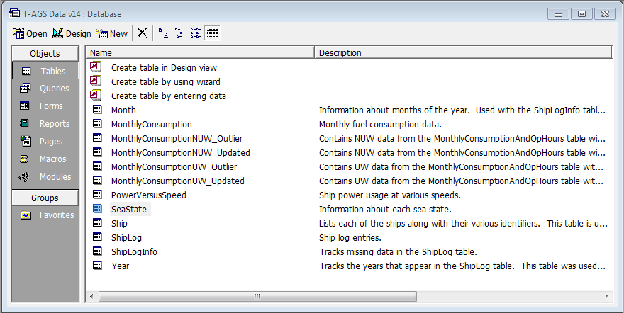

Figure 8. List of Tables within Model

The MonthlyConsumption table is a direct import of the MonthlyConsumptionAndOpHours spreadsheet that was provided by the customer. The team found the data in this table had a lot of variability which could render subsequent analysis inconclusive, so the team decided to identify and exclude outliers. The data had to be split into UW and NUW in order to be able to identify UW outliers and NUW outliers separately. The UW data from the MonthlyConsumption table was copied into the MonthlyConsumptionUW_Outlier table and the outlier records were identified and flagged. Then the non-outlier records were copied into the MonthlyConsumptionUW_Updated table. The same was done for the NUW data.

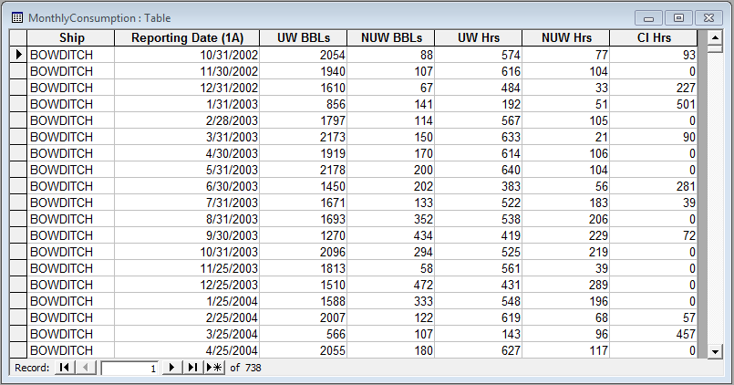

Figure 9. MonthlyConsumption Table

The ShipLog data had to be preprocessed in Excel before it was imported into Access. The reason for this was that an [Hours] column needed to be created. Each ShipLog record had a date and time stamp, but the duration between ShipLog entries was not captured, and it is difficult for queries to determine this sort of information on the fly. So, Excel was used to calculate the time between ShipLog records. Once the data was imported into Access, it became apparent that the [Avg Speed] and [Sea State] columns contained errors. The Team’s approach to handling this was to back-up the original data into two columns called [Avg Speed Orig] and [Sea State Orig]. This way, the data in the [Avg Speed] and [Sea State] columns could be modified while maintaining the ability to easily trace or restore the data.

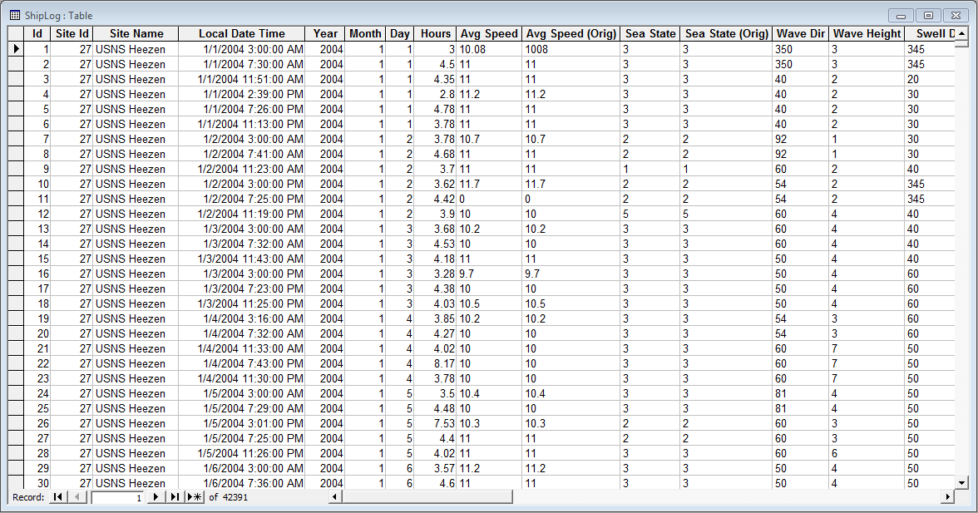

Figure 10. ShipLog Table

The PowerVersusSpeed table was a direct import of the PowerVersusSpeed spreadsheet that was provided by the customer. The data in this table was for informational purposes. Analysis was done in Excel to produce a Speed Power regression formula. This formula was built into the queries to perform the calculations necessary to convert speed into power.

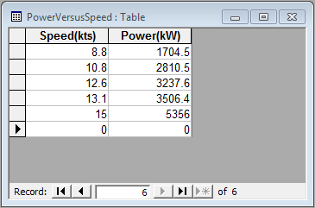

Figure 11. PowerVersusSpeed Table

The Ship and SeaState tables are definition tables. The Ship table is a unique listing of the six vessels and contains all the identifiers necessary to join other tables together. The SeaState table is a unique listing of the nine sea states as well as some supplemental data that pertains to sea states. The SeaState table can be joined to the ShipLog table to provide more detailed sea state information for each ShipLog record.

The ShipLogInfo table was built as a supplement to the ShipLog table. Once the Team noticed how much data was missing from the ShipLog table, a concern arose that this could cause inaccurate data points for months that were missing large amounts of data. Therefore, a query was made to identify the magnitude of missing data for each month and record it in the ShipLogInfo table. This table could then be used to exclude months that were missing too much data.

The Month and Year tables were primarily built to support the construction of the ShipLogInfo table. They are merely a list of valid months and years, respectively.

### Queries

Once the tables were built, queries were created in order to implement the model. The core set of queries are numbered 101 to 106. These queries build on each other and perform the calculations that drive the model.

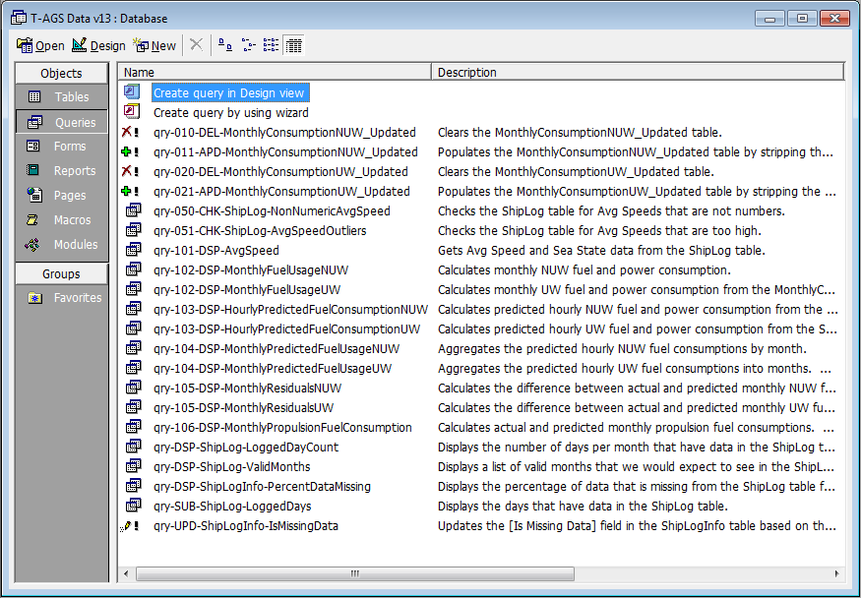

Figure 12. List of Queries Contained in Model

The qry-101-DSP-AvgSpeed pulls the pertinent data from the ShipLog table, which includes average speed and sea state.

The qry-102-DSP-MonthlyFuelUsageUW uses the MonthlyConsumption table to pull the pertinent monthly fuel totals as well as compute monthly fuel consumption in terms of gallons per hour. This data was considered to be the “actuals”. It is the real fuel consumption in the sense that it is based on recorded fuel quantities.

The qry-103-DSP-HourlyPredictedFuelConsumptionUW was the first step in producing predicted fuel consumption values. This query computed hourly fuel consumption that are a function of average speed and sea state. For each ship log entry, this query takes the average speed and plugs it into the Speed-Power regression formula in order to convert speed into power. The power, expressed in kW, was then multiplied by the sea state factor in order to account for extra power necessary to overcome the recorded sea state. This calculation was done using the equation:

*[UW Power] = (2.8837*[Avg Speed]3 - 39.889*[Avg Speed]2 +*

*247.63*[Avg Speed] + 800) * [Sea State Factor]*

The power in kW is then converted to horsepower using the 0.746 kW/hp conversion factor. This computation was done using the equation:

*[UW HP] = [UW Power] / 0.746*

Once the power was expressed in terms of horsepower, it could be plugged into the fuel consumption formula. This formula requires the specific fuel consumption of the engine in lbs/hp/hr. This value was estimated using engine specification documents for marine propulsion engines with similar horsepower to the engines found on the T-AGS 60 class ships. The formula also requires the fuel weight, which is 7.2 lbs/gal for diesel. The fuel consumption formula was:

*[UW Consumption] = BSFC * [UW HP] / FW*

*Where,*

*BSFC = Brake Specific Fuel Consumption = 0.36 lbs/hp/hr*

*FW = Fuel Weight = 7.2 lbs/gal*

The qry-104-DSP-MonthlyPredictedFuelUsageUW was the next step in producing predicted fuel consumption values. This query took the hourly data computed from query 103 and aggregated it into months. This was necessary to be able to compare the predicted values to the actuals, which are also in terms of months.

The qry-105-DSP-MonthlyResidualsUW was used for output analysis. It computed the residuals between the predicted and actuals for total fuel consumed per month.

The qry-106-DSP-MonthlyPropulsionFuelConsumption was also used for output analysis. It computed thee predicted and actual propulsion fuel consumptions per month. This was done by taking the UW fuel consumption and subtracting out the NUW fuel consumption. Query 105 was leveraged to compute the predicted propulsion fuel consumption, and the MonthlyConsumption table was used to compute the actual propulsion fuel consumption.

### Speed Power Curve

One of the fundamental components of our model was the ability to convert speed into power. In the Ship Log data, the Team was given the average speed of each ship over time periods that spanned several hours. This average speed data was the main input to the model. The average speed data is what eventually gets converted into power, and then converted from power into fuel consumption. But before speed can be converted into power, the Speed Power Curve needed to be developed. The Speed Power Curved expressed the relationship between speed and power for the T-AGS 60 class vessels. To help generate this curve, the customer provided some data points for speed versus power.

In order to formulate a curve from the speed versus power data points, regression was used. The regression was performed in Excel by charting the data and using trend lines. Several different types of regression were used including: linear, exponential, power, logarithmic, and polynomial. During the initial efforts, linear regression was a poor fit with an R2 value of 0.925. Logarithmic regression curved the wrong way. The curve had a concave increase instead of convex increase and had an R2 value of 0.888. The power function was also not great because the fit grew worse at higher speeds. The chart below shows the results of the different types of regression analysis.



Figure 13. Speed Power Curve

The Team decided that the exponential and third order polynomial were the best fits based on the fit and the high R2 values. The result of the third order polynomial is graphically displayed in the chart below.



Figure 14. Third Order Polynomial Speed Power Curve

As the model development and analysis progressed, the Team realized that the curves were not modeling the hotel load, which could significantly impact the accuracy of the model. The Team approximated the average hotel load to be 800 kW (reference section for additional information). This means that regardless of speed, the predicted power consumption for each vessel should be at least 800 kW. The Speed Power Curve was updated to reflect the hotel load at 0 knots. The addition of this data point caused the polynomial function to improve and the exponential function to worsen. The third order polynomial curve became the clear choice with an R2 value of 0.984. This can be seen from the following chart.



Figure 15. Fit Speed Power Curves with Hotel Load

Therefore, the function used in the model to convert speed into power was:

*y = 2.8837x3 - 39.889x2 + 247.63x + 800*

Where, *x* is speed in knots and *y* is power in kilowatts.

As an aside, it makes sense that the third order polynomial function fits the data well because speed and power have a cubic relationship. This can be derived using physical equations. In physics, the following equation is used to calculate power:

*Power = Force * Velocity*

In the case of seagoing vessels, the primary force acting on the vessel is the force of drag through water. The formula for the force of drag is:

*Forced = (1/2) * Fluid Density * Velocity2*

When the drag equation is incorporated into the power equation, it results in a cubic function where power is expressed as the cube of velocity:

*Power = [(1/2) * Fluid Density * Velocity2] * Velocity*

*= (1/2) * Fluid Density * Velocity3*

### Calculating Power

The Speed Power Curve was used to convert speed into power in kilowatts, but in order to compute fuel consumption the power must be converted into horsepower. The Team was able to convert speed into horsepower through the use of the following conversion:

*1 hp = 0.746 kW*

Therefore, in order to convert *k* kilowatts into *h* horsepower:

*h = k / 0.746*

Once the power was expressed in horsepower, the new power value was plugged straight into the fuel consumption formula. The fuel consumption formula used was:

*FC = BSFC * HP / FW*

*Where,*

*FC = Fuel Consumption (gal/hr)*

*BSFC = Brake Specific Fuel Consumption (lbs/hp/hr)*

*HP = Horsepower (hp)*

*FW = Fuel Weight (lbs/gal)*

### Estimating Hotel Load

Hotel load was calculated from the Monthly Consumption and Op Hours data. The data was expressed per ship per month for UW and NUW, and it identifies the number of barrels of fuel consumed over how many hours. For hotel load, only the NUW data was of interest.

In order to calculate the hotel load, the formulas from the previous section were used in reverse order. First barrels were converted into gallons. It was estimated that there are 42 gallons in a barrel. Next the NUW gallons were divided by the NUW hours to get NUW fuel consumption in gal/hr. This fuel consumption was then plugged into the fuel consumption formula to calculate the horsepower. By manipulating the fuel consumption formula, the powered consumed was calculated using the following equation:

*HP = FC * FW / BSFC*

*Where,*

*FC = NUW Fuel Consumption (gal/hr)*

*BSFC = 0.36 (lbs/hp/hr)*

*FW = 7.2 (lbs/gal) for diesel*

Next, power was converted from horsepower to kilowatts, which provided the hotel load. In order to convert *h* horsepower into *k* kilowatts, the following conversion formula was used:

*k = h * 0.746*

The above computations were used to convert NUW fuel consumption into power in kW across the board for every month of every ship. The computations were done using an Access query, and the results were exported to Excel and Minitab to perform the hotel load analysis.

The Team developed histograms of the average hotel load experienced for each vessel. The purpose of the histograms was to support the decision that the average hotel load was approximately 800 kW.



Figure 16. Hotel Load Histograms

The Team also calculated the mean, median, variance, and standard deviation of each vessels hotel load (see table below). The main reason for this calculation was to support the estimate of average hotel load of 800 kW.

Table 1. Hotel Load Statistics

| **Site Name** | **Mean** | **Median** | **Variance** | **Std Dev** |
| --- | --- | --- | --- | --- |
| USNS Bowditch | 801.85 | 773.45 | 81,467.61 | 285.43 |
| USNS Heezen | 880.39 | 879.24 | 117,575.94 | 342.89 |
| USNS Henson | 747.64 | 704.97 | 107,703.43 | 328.18 |
| USNS Mary Sears | 759.08 | 783.30 | 14,885.72 | 122.01 |
| USNS Pathfinder | 871.33 | 792.55 | 114,787.98 | 338.80 |
| USNS Sumner | 831.04 | 783.30 | 141,582.38 | 376.27 |
| Overall | 814.18 | 783.30 | 96,540.78 | 310.71 |

The above histograms and table illustrate that the average vessel hotel load was around 800 kW. The mean estimates the hotel load to be a slightly above 800 kW and the median estimates the hotel load to be slightly below 800 kW, so the Team chose 800 kW as an even approximation.

### Estimating Brake Specific Fuel Consumption

Brake Specific Fuel Consumption (BSFC) refers to the engine fuel consumption rate. It is a measure of the pounds of fuel that the engine consumes per horsepower per hour. For example, if an engine has a BSFC of 0.36 and it is producing 1000 HP, then this means that the engine would be consuming 360 lbs of fuel per hour. BSFC is a manufacturer specification that is different for every engine.

The T-AGS 60 uses twin 4000 HP General Electric CDF 1944 engines. Since the Team was not able to obtain the manufacturer specifications, the BSFC needed to be estimated in order to properly use the fuel consumption calculations to develop the mathematical model. In order to estimate BSFC for a T-AGS 60 class vessel, a Caterpillar engine was used as a surrogate. The Caterpillar manufactures a comparable marine propulsion engine that produces 3634 HP. The engine model is C280-8 and the engine specifications were posted on their website. The chart and table below show how BSFC changes as engine speed and power increase.

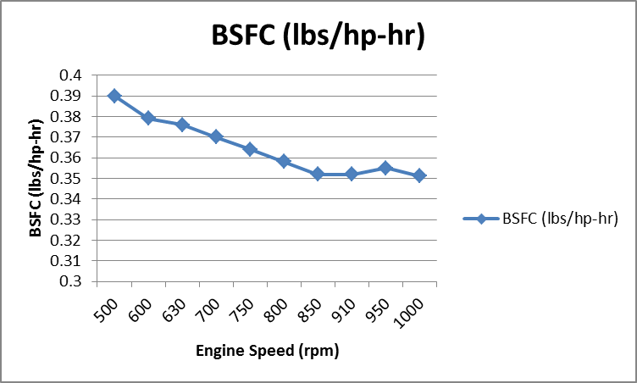

Figure 17. Brake Specific Fuel Consumption for Caterpillar C280-8 Marine Propulsion Engine

Table 2. Brake Specific Fuel Consumption for Caterpillar C280-8 Marine Propulsion Engine

|  |  |  |  |
| --- | --- | --- | --- |
| **Caterpillar C280-8 Marine Propulsion Engine (3,634 HP)** | | | |
| **Engine Speed (rpm)** | **Power (bhp)** | **BSFC**  **(lbs/hp-hr)** | **Fuel Rate (gal/hr)** |
| 500 | 386 | 0.39 | 21.5 |
| 600 | 667 | 0.379 | 36 |
| 630 | 773 | 0.376 | 41.4 |
| 700 | 1,060 | 0.37 | 55.9 |
| 750 | 1,303 | 0.364 | 67.7 |
| 800 | 1,582 | 0.358 | 80.6 |
| 850 | 1,897 | 0.352 | 95.1 |
| 910 | 2,328 | 0.352 | 116.8 |
| 950 | 2,649 | 0.355 | 133.9 |
| 1,000 | 3,090 | 0.351 | 154.8 |
| Average | | 0.365 | |

The team chose 0.36 as an approximate BSFC to use in the model. The BSFC was not varied in respects to vessel speed changes, and the use of a single BSFC value was approved by the customer. But, this would be a possible area of improvement for the model.

### Estimating Sea State Factors

Sea state data was provided for each entry in the ShipLog table. From discussions with the customer, sea state was thought to be one of the significant factors that would affect ship fuel consumption. In order to model sea state effects in the model, the Team decided to scale the ship’s power consumption proportional to the sea state. Higher sea states would require more power in order to overcome the resistance created by the head waves.

During the process of determining how the different sea state levels would affect power and fuel consumption, each sea state level needed to be defined. The following table is based off of the World Meteorological Organization (WMO) sea state definitions.

Table 3. Sea State Table

| **Sea State** | **Wave Height (m)** | **Wave Height (ft)** | **Description** |
| --- | --- | --- | --- |
| 0 | 0 | 0 | Calm (glassy) |
| 1 | 0.1 | 0.33 | Calm (rippled) |
| 2 | 0.5 | 1.64 | Smooth (wavelets) |
| 3 | 1.25 | 4.1 | Slight |
| 4 | 2.5 | 8.2 | Moderate |
| 5 | 4 | 13.12 | Rough |
| 6 | 6 | 19.69 | Very rough |
| 7 | 9 | 29.53 | High |
| 8 | 14 | 45.93 | Very high |
| 9 | 20 | 65.62 | Phenomenal |

The Team could not find any data on how sea state would impact ship propulsion power. But, a study was found that used a computer simulation to model the effects of head waves on a ship. In that study was a diagram that related wave height to total resistance on the ship. The Team used this diagram to estimate the resistance for each sea state. The diagram is shown below, with guidelines that the Team drew to ascertain the values from the graph.

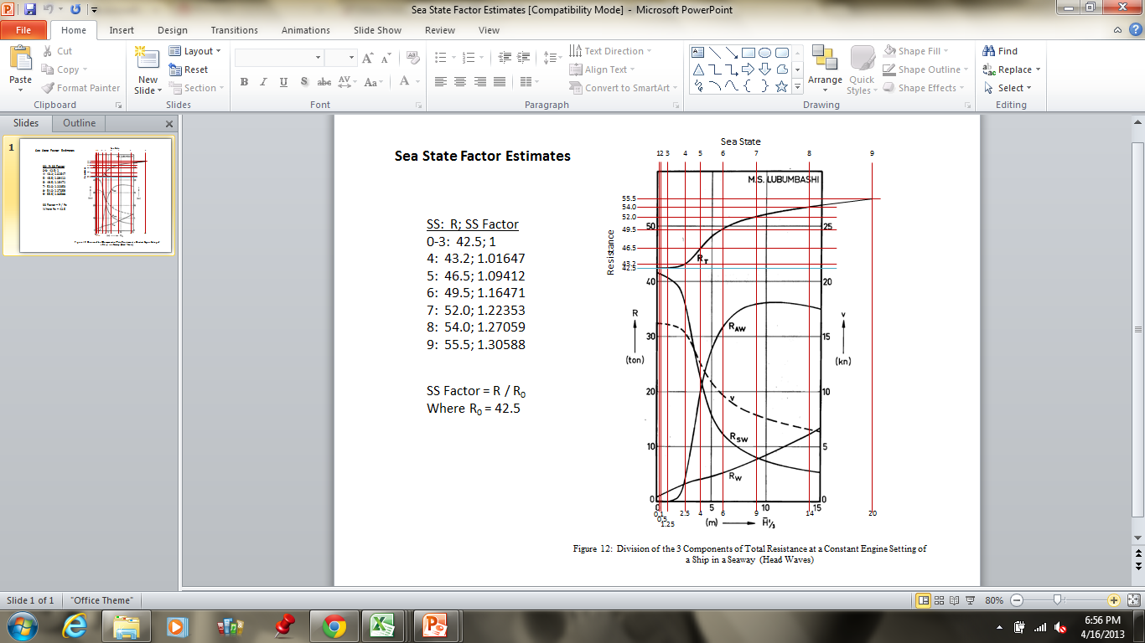

Figure 18. Sea State vs. Resistance

In order to calculate the sea state factors, the Team calculated the proportional increases in resistance for each sea state. For example, the resistance at sea state 0 is 42.5 and the resistance at sea state 4 is 43.2, which is a 1.6% increase in resistance. Power increases proportional to the resistance, so the additional power needed to overcome resistance at that sea state is 1.6%. The factor of 1.016 was assigned to the sea state level of four and this process was used to determine the remaining factors for each sea state level. The sea state factors were used to scale the predicted propulsion power in the model. Below is the general form for this calculation, and the following table shows the complete results of the calculations.

*Sea State Factor = Rs / R0*

*Where,*

*Rs = Total Resistance at sea state s*

*R0 = Total Resistance at sea state 0*

Table 4. Sea State Factors

|  |  |  |
| --- | --- | --- |
| **Sea State** | **Total Resistance** | **Sea State Factor** |
| 0 | 42.5 | 1.000 |
| 1 | 42.5 | 1.000 |
| 2 | 42.5 | 1.000 |
| 3 | 42.5 | 1.000 |
| 4 | 43.2 | 1.016 |
| 5 | 46.5 | 1.094 |
| 6 | 49.5 | 1.165 |
| 7 | 52.0 | 1.224 |
| 8 | 54.0 | 1.271 |
| 9 | 55.5 | 1.306 |

While reviewing the sea state data, it was found that sea states 0 through 8 were experienced by the vessels. The following table provides a histogram of the recorded sea states. The histograms identify the frequency of occurrences of each sea state for each vessel.



Figure 19. Sea State Histogram

|  |  |  |  |  |  |  |  |  |  |  |  |  |  |  |  |  |  |  |  |  |  |  |  |  |  |  |  |  |  |  |  |  |  |  |  |  |  |  |  |  |  |  |  |  |  |  |  |  |  |  |  |  |  |  |  |  |  |  |  |  |  |  |  |  |  |
| --- | --- | --- | --- | --- | --- | --- | --- | --- | --- | --- | --- | --- | --- | --- | --- | --- | --- | --- | --- | --- | --- | --- | --- | --- | --- | --- | --- | --- | --- | --- | --- | --- | --- | --- | --- | --- | --- | --- | --- | --- | --- | --- | --- | --- | --- | --- | --- | --- | --- | --- | --- | --- | --- | --- | --- | --- | --- | --- | --- | --- | --- | --- | --- | --- | --- |
| Table . Count of Sea States 0 through 3   |  |  |  |  | | --- | --- | --- | --- | | **Site Name** | **Sea State  0-3** | **Total** | **Percent 0-3** | | USNS Bowditch | 4,327 | 6,021 | 0.72 | | USNS Heezen | 5,838 | 7,948 | 0.73 | | USNS Henson | 1,940 | 2,772 | 0.70 | | USNS Mary Sears | 7,270 | 11,686 | 0.62 | | USNS Pathfinder | 4,167 | 5,652 | 0.74 | | USNS Sumner | 4,139 | 8,312 | 0.50 | | Overall | 27,681 | 42,391 | 0.65 | | Table . Count of Sea States 0 through 4   |  |  |  |  | | --- | --- | --- | --- | | **Site Name** | **Sea State  0-4** | **Total** | **Percent 0-4** | | USNS Bowditch | 5,599 | 6,021 | 0.93 | | USNS Heezen | 7,402 | 7,948 | 0.93 | | USNS Henson | 2,566 | 2,772 | 0.93 | | USNS Mary Sears | 10,715 | 11,686 | 0.92 | | USNS Pathfinder | 5,350 | 5,652 | 0.95 | | USNS Sumner | 7,111 | 8,312 | 0.86 | | Overall | 38,743 | 42,391 | 0.91 | |

The histograms indicate that sea states three and four appeared the most often in the data. The above tables illustrate that 65 percent of the sea states have values of zero through three, which have a Sea State Factor of one and, therefore, would not have any effect on fuel consumption. In addition, 91 percent of the sea states have values of zero through four, which have Sea State Factors of one or nearly one and, therefore, would have a negligible effect on fuel consumption. This explains why in the model, with the way the sea state factors are currently set, sea state does not have a large impact on fuel consumption.

# Model Output Analysis

Once the model was developed, the Team analyzed the data for accuracy. The Team graphed the data calculated by the mathematical model vs. the recorded data and performed t-tests to determine if the mathematical model results were statistically equivalent to the recorded data. Analysis of Variance (ANOVA) was used to test the average fuel consumption amongst all vessels.

During the process of assigning sea state factors, the Team analyzed the ratio of the predicted to recorded fuel consumption data for assessing how well the model imitated real-life data. For this measurement, a ratio of .7 to 1.3 indicated that the predicted data could be “equivalent to” the recorded data. This ratio takes into consideration that models do not precisely represent real-world and because only two factors that affect sea state were taken into consideration. Once the predicted-to-recorded fuel consumption ratios were within .7 to 1.3, the Team continued the mathematical model analysis.

The graphs below demonstrate the mathematical model results compared to the recorded data for each vessel.



Figure 20. Bowditch - Predicted and Recorded Propulsion Consumption



Figure . Heezen - Predicted and Recorded Propulsion Consumption



Figure 22. Henson - Predicted and Recorded Propulsion Consumption



Figure 23. Mary Sears - Predicted and Recorded Propulsion Consumption



Figure 24. Pathfinder - Predicted and Recorded Propulsion Consumption



Figure 25. Sumner - Predicted and Recorded Propulsion Consumption

Overall, the graphics indicate that the mathematical model produced results that closely mimic the recorded real-life data. The goal of the model was to predict ship fuel consumption based on power consumption. Speed and sea state were determined to be the major additive parameters for fuel consumption. The underlying hypothesis of the model was as follows: Predicted fuel consumption will not be affected by the skeg modifications since it is computed from speed, but actual fuel consumption will be affected by the skeg modifications. Because of this hypothesis, predicted fuel consumption was expected to deviate from actual fuel consumption when the skeg modifications occurred. During the analysis, the Team determined that the mathematical model overestimated the fuel consumption prior to modifications and was nearly identical to the real-life fuel consumption data post modifications.

The Team then performed t-tests to determine if the predicted fuel consumption was statistically equivalent to the recorded fuel consumption. The table below contains the results of the t-test analysis.

Table 1. Predicted vs. Recorded Statistical Analysis

|  |  |  |
| --- | --- | --- |
| **Recorded vs. Predicted Fuel Consumption** | | |
| **Paired T-test** | **P-Value < 0.05?** | **95% CL** |
| USNS Bowditch | No | Reject H0 |
| USNS Heezen | Yes | Fail to reject H0 |
| USNS Henson | No | Reject H0 |
| USNS Mary Sears | Yes | Fail to reject H0 |
| USNS Pathfinder | No | Reject H0 |
| USNS Sumner | No | Reject H0 |

The team used the paired t-test procedure to compare the mean difference between the recorded and predicted fuel consumption for each vessel. The null hypothesis was a mean difference between the predicted and recorded fuel consumption did not exist, µpredicted = µrecorded. The alternative hypothesis was a mean difference between the predicted and recorded fuel consumption existed, µpredicted ≠ µrecorded.

For the following four vessels, Bowditch, Henson, Pathfinder and Sumner, the team failed to reject the null hypothesis, there was no difference in the means between the predicted and recorded fuel consumption since the p-values for each of these vessels were greater than 0.05 at the α = 0.05 level of significance. Thus there was a lack of sufficient evidence to state that there was a difference between the predicted and recorded fuel consumption at the 95% level of confidence for Bowditch, Henson, Pathfinder and Sumner.

For the following two vessels, Heezen and Mary Sears, the team rejected the null hypothesis that there was no difference in the means between the predicted and recorded fuel consumption since the p-values for each of these vessels were less than 0.05 at the α = 0.05 level of significance. Thus the team rejected the null hypothesis in favor of the alternative hypothesis. There was strong evidence that a difference between the predicted and recorded fuel consumption for Heezen and Mary Sears existed. This analysis indicated that the mathematical model developed was sufficient for predicting fuel consumption in the real world.

Finally, ANOVA was used to test if the predicted average fuel consumption amongst all vessels were equal. The average fuel consumption for before all modifications, post-skeg modification, and post- all modifications were analyzed for each vessel with applicable data.[9] The null hypothesis was:

$$H_{o}: μ_{fuel consumption vessel 1} = μ_{fuel consumption vessel 2}=…=μ_{fuel consumption vessel 6}$$

The alternative analysis was that not all of the average fuel consumption amongst vessels was the same. The analysis indicated that the null hypothesis was to be rejected for each case; the calculated p-value was less than 0.05, the α level of significance.

# Findings and Conclusions

The purpose of the study was to develop a method and determine whether the modifications made to the vessel’s skeg had an effect on the fuel consumption, and if so, did the fuel consumption increase, decrease, or remain the same. The Team created a mathematical model in Microsoft Access that predicts the vessel’s fuel consumption based on its speed and sea state level encountered.

The model development involved analyzing the speed vs. power consumption, estimating the sea state effect on fuel consumption, and estimating the vessel’s engine fuel consumption. The finished model closely resembles the real world data. The Team performed t-tests to determine if the model calculations were statistically equivalent to the real world recorded data. With 95 percent confidence, the predicted and recorded data were statistically equivalent for four of the six vessels.

The second part of the problem was to determine if the skeg modifications resulted in fuel consumption reductions. Overall, all vessels (with the exception of Mary Sears) experienced a reduction in fuel consumption post-skeg modifications. Based on the fuel consumption savings, the Team determined the expected monetary savings. Using the cost of diesel fuel of $3.86 (current cost as of 15 April), all vessels, with the exception of Mary Sears, had a cost savings with the Pathfinder having the largest savings of over $2 per gallon.

# Recommendations

The Team identified recommendations for possible future analysis. The first recommendation is to analyze the effects sea stats has on the fuel consumption of the T-AGS vessel. This recommendation is twofold, the first would be to address the fact that this subject is not widely studied and the Team experienced difficulties in determining the exact factor to associate to each sea state. In order to completely determine the sea state affect, it is anticipated that modeling, to possibly include, simulation would be needed. Not only would this analysis improve the quality of the model developed during this project, but it would serve was a benchmark for all other vessels interested in determining the effect of sea state. The second aspect of this recommendation would be to perform a sensitivity analysis on the sea state effect. Based on the factors the Team associated with each sea state during this project, the sea state did not have a large impact on the fuel consumption. If the first part of the recommendation cannot be accomplished, the second part would provide insight into the effect sea state could have on the fuel consumption.

The second recommendation would be to improve the quality of the data recorded from the T-AGS vessel. As discussed in the outlier analysis, a large amount of data (especially monthly outlier analysis) was removed due to outliers or lack of data. Possible suggestions for data quality improvements are to research possible methods of automating the data collection and/or performing daily or weekly data analysis to capture outliers early. If outliers are captured early, there is a potential that the data could be corrected.

The final recommendation would be to continuously update and improve the mathematical model developed during the project. The model developed only incorporated sea state and speed in the calculation of fuel consumption. Other possible variables that would be of interest to determine their effect on fuel consumption would be the wind speed/direction, water temperature, and vary the weight of the vessel during the mission. In order to analyze the effect of the weight of the vessel on fuel consumption, data on when the vessel was refueled and the amount of fuel would need to be known. Also, the model does not vary the BSFC factor in respects to the vessels speed. Updating the model to incorporate (possibly) different BSFC factor for each vessel speed could improve the predicted fuel consumption. Most likely, the best approach for determining the BSFC factor for each speed would be to develop a regression analysis (similar to the speed vs. power curve) so that a BSFC factor can be calculated regardless of vessel speed.

# Deliverables

The Team provided the customer with a final report documenting the results of the study, the Microsoft Access file used during the mathematical modeling of the problem, and a model cheat sheet that provides a brief overview of all tables and queries contained in the model (included in the final report as Appendix D). These deliverables were provided to the customer electronically on 6 May 2013.

## Website

All deliverables and more information about this study can be found at <https://sites.google.com/site/tagsfuelstudy/home>.

# Management

The subsequent sections discuss how the Team will allocate resources and the study’s proposed schedule.

## Resource Allocation

The Team was composed of two operations research analysts and one systems engineer. Each team member was assigned specific roles and responsibilities that they are accountable for completing to ensure that the study is competed in a timely manner and is of Customer’s quality standards. The roles and responsibilities of each team member are identified in the table below.

Table 1. Roles and Responsibilities

|  |  |  |
| --- | --- | --- |
| **Role** | **Responsibilities** | **Personnel** |
| Study Lead | Manage schedule  Assign tasks  Primary contact with customer | Tina Graziose |
| Operations Research Analysts | Data analysis | Dave Lund  Milan Nguyen |
| Systems Engineer | Data analysis | Tina Graziose |
| Web Developer | Design webpage | Dave Lund |

## Schedule

The following figure illustrates the schedule for the study.

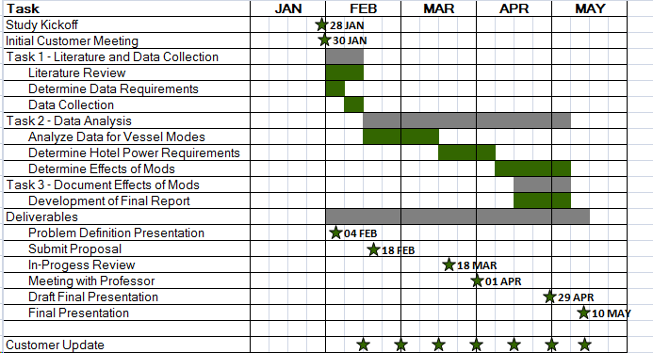

Figure 26. Study Schedule

**Appendix A – Data Collection**

The following data types were included in the ship log data.

* site ID,
* site name,
* the local data and time,
* the average speed since the last reporting,
* gyro error,
* gyro course,
* true course,
* mag course,
* compass course,
* variation,
* deviation,
* error,
* wind direction,
* wind speed,
* visibility,
* weather,
* barometer,
* dry bulb,
* wet bulb,
* sea temp,
* dew point,
* cloud amount,
* cloud height,
* cloud type,
* wave direction,
* wave height,
* swell direction,
* swell height, and
* sea state.

The following information was provided in the monthly consumption and operating hours:

* name of the ship,
* the report date,
* monthly average of fuel used (in barrels) for UW and NUW modes, and
* monthly average of hours spent in each operating mode.

The following information was provided in the power vs. speed:

* Speed (kts)
* Power (kW)

**Appendix B – Meeting Minutes with Customer**

**08 February 2013 Meeting Minutes**

The Team met with the customer on 8 February from 1700-1800. The following discussions were of importance;

* The vessels operate in one of three modes:
  + Underway (vessel is moving and generator their own power)
  + Not-underway (vessel is anchored and producing own power)
  + Cold iron (vessel is docked and not producing its own power)
* The relationship between kilowatts (kW) and horsepower (HP) is approximately .746 kW/HP
* To determine the fuel usage, the Team will need to also determine how much of the power generated by the vessel goes to the Z-drives and how much power goes to the hotel load.
* Additional variables that may need to be considered are:
  + Actual load of the ship
  + Ocean movement (i.e., waves, current, etc.)
* A simple way to imagine how the ship works is to use the following diagram;

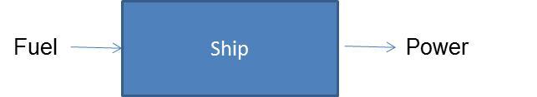

The customer provided the Team with the following assumptions that can be used to complete the study:

* When the vessel is in not-underway mode, the Team assumes the power generator is used to support the hotel load.
* The Team assumes an appropriate method for determining the power used for propulsion would be to subtract the power used when in not-underway from the power used when in underway mode.
* The Team assumes the amount of power to support the hotel load before and after the skeg modifications are assumed to be the same.
* The Team is to assume no additional power is generator beyond what is needed to support the hotel load or power the propulsion of the vessel.
* The Team assumes the weight of diesel fuel is 7.2 lbs/gal
* Until further notice, the Team will assume the engine fuel consumption for a diesel engine is 0.4 lbs/hr/hp
* For the purposes of this study, the Team assumes that the weather does not affect the weight of the fuel.

The customer agreed to provide the Team the following data information:

* Speed and power curves of the vessel
* The monthly reports for each mode of the vessel to include the fuel consumption for each mode.
* Historical data on the vessel’s speed
  + This information will be used to develop a distribution or analyze the speed data by ship, date/time, and speed.

**22 February 2013 Meeting Minutes**

1. Were you able to connect Dr. Loerch? If so, what changes have been made to the project?

As of 22 February, Dr. Loerch and Mr. Opas were unable to connect to discuss the projects workload; no changes have been made. If the project workload does change, Mr. Opas will inform the team immediately.

1. When was the skeg modifications implemented on each vessel? Right now, we are not sure which data is associated with pre- and post-modifications.

Unfortunately, the exact date that the modifications were made to each vessel is not known; the modifications may have occurred over the last 5-6 years. Each vessel has a different port engineer that records ship logs and each port engineer provides different levels of detail thus, making it difficult to determine the exact date of the modifications. Mr. Opas suggested for the Team to parse the data and estimate the date of modifications of each vessel based on the characteristics of the data; i.e., the fuel consumption data may have a drastic change that does not seem to fit the previous month’s fuel consumption. A double line could be a good model for determining the date of modifications – develop a line based on the data and the point in which the data starts to deviate from the line would indicate when the modification was made. Through the model, the team might be able to get a good estimated modification date. However, Mr. Opas stated that if the Team is unable to determine the date of the skeg modifications for each vessel by early April, he will provide the Team with possible skeg modification dates.

1. The power curve that you provided is in terms of kW.  Does this actually mean kW per hour?

The power vs. speed curve should be in terms of kW vs. speed. The data can be viewed as kW/nm/hour for purposed of integrating to get an energy number; energy multiplied by time equals power.

In the ship logs, the only data recorded that indicate a mission is the speed. An assumption that may need to be made is that in between the reports, the vessels are doing something. Also, the average speed recorded is the average speed experienced since the last report. For example, if the average speed recorded at 0700 was 8 kts and 10 kts was recorded at 1000, the vessel’s average speed between 0700 and 1000 was 10 kts. It was discussed that the Team could assume that the average speed recorded is the midpoint speed, or it could be assumed that the average speed was maximum speed. If the latter assumption is made, the Team would have two points (the recorded speed and the previous recorded speed) to interpolate the average speed for the hours between each recording. If the Team assumes that the average speed recorded is the midpoint, the Team would be dealing with more than two points when determining the average hourly speed between recordings.

Mr. Opas stated that he will look into gathering data on the daily vessel report. The daily vessel report records the number of miles traveled each day. If the information is provided, the Team could use this information to double check the average speed of the vessel.

The Team stated that some vessels were recorded to have an average speed of 1 kt and questioned whether this was correct or improperly recorded. Mr. Opas stated that the low speed is correct; vessels will travel at the speed when certain equipment are in use. The Team acknowledged and explained that the data will be reviewed and any data that appears to be an anomaly will be identified and provided to Mr. Opas for a final acceptance to be removed from the analysis.

1. In our last meeting, you mentioned that we would need to determine how to incorporate sea state into our fuel consumption calculations.  We noticed in the data you provided us, there is a sea state data column populate with numerical values.  What do these values mean?

Next biggest variable that contributes to the fuel consumption (besides the operating mode) is sea state. These vessels are small so they are easily affected by sea state. In the data provide, sea state is recorded as numbers 1-9 to identify the characteristics of the sea. A sea state of 0 indicates calm, no waves. The higher the number the worse the sea sate. For example, as sea state increases from 1, to 2, to 3, the sea state is increasing worsening. Sea states of 4 and 5 are pretty bad for the small boats, fuel consumption will especially be affected when the sea state is recorded as a 4 or 5.

* 1. Since we will be incorporating sea state into the calculations, it is safe to assume that we will not need the following data types: wind/visibility, weather, barometer, dry/wet bulb, sea temperature, dew point, and all data related to clouds?

Mr. Opas agreed that these variables could be excluded for this study due to the short period of performance. He did indicate that, time permitting, if the Team wanted to add another variable to the study, the next variable that he thinks would have the next biggest impact on fuel consumption would be the sea temperature. However, including sea temperature may be a stretch for this project. Sea temperature is recorded from the engine room.

* 1. While these values will not be incorporated into the study, how are the wave and swell height measured (i.e., feet, km)?

These variables are recorded in feet.

1. Could you briefly discuss the Gyro course (and gyro error), true course, mag course, and compass course? We just want a full understanding of all data before we determine if the data is or isn’t needed for our calculation.

Mr. Opas stated that these courses may not be needed in the project calculation. The gyro course is the course that ship’s navigation system indicates. The gyro error incorporates how the magnetic fields affect the gyro course; the last time that the ship’s navigation system was calibrated also affects the gyro error.

1. Just as a clarification, the variation, deviation, and error are related to the course of the vessel? Which course, true, mag, or compass course?

All these values are related to the courses; as previously discussed, the ships course may not need to be included in this study.

Other comments:

Regarding question #3 – The Team was having trouble imagining how to determine the power consumed for underway. Mr. Opas stated that the monthly data will be handy for determining the underway power consumption.

One example was, if the vessel used 100 gal/ hr during not-underway, the underway would require the use of 100 gal/hr plus whatever power is needed for propulsion. The power curve previously provided could then be used to integrate over the speeds, which should help give the power needed.

The Team then asked how to integrate power into power/hr? It was suggested to use equations we previously found as starting point – these equations were discussed during the 8 February meeting.

To incorporate speed into the fuel consumption calculation, use the speed power curve and history of what they did for speed, put into kW and then put that into gal/HP. Mr. Opas explained that if we try and try and still can’t get the power equations to work, if we show him the work, he will help us out.

The term “model” is sometimes widely used, the Team asked what type of “model” Mr. Opas is expecting from this study. Mr. Opas explained that a mathematical model would be sufficient for this project, he is not looking for a three-dimensional model of the system. He expressed an expectation for a model that allows the user to provide input and produces an output; i.e. Monte Carlo, discrete modeling, and projecting forward based on historical data, just to name a few mathematical models. Currently the Team anticipates using Access and Excel for completing the study. Mr. Opas agreed to the selected tools.

Mr. Opas also suggested determining possible statistical analysis that can be performed on the data.

**Appendix C - Literature Search**

This section identifies the results of the literature search performed throughout the duration of the project. The literature search includes researched websites and working papers needed for background information on the T-AGS vessels, developing a process for calculating fuel consumption, and performing analyses on the data. Documents on calculating fuel consumption were critical to the completion of the study. These documents aided the Team in determining all the variables that affect fuel consumption (i.e., speed, sea state, etc.) and how the approach for calculating fuel consumption relates to those variables. The literature search results are in the form of an annotated bibliography.

**Analysis**

**Website**

1.3.5.14. Anderson-Darling Test." *Engineering Statistics Handbook*. N.p., n.d. Web. 20 Feb. 2013. <http://www.itl.nist.gov/div898/handbook/eda/section3/eda35e.htm>.

This website contains information on the Anderson-Darling Test, the test the Team used to determine if the data was normality distributed. The content of the website provided the information needed to perform the analysis and an understanding for interpreting the analysis results.

*Chapter 7: Variability*. N.p., n.d. Web. 22 Apr. 2013. <http://www.purplemath.com/modules/boxwhisk3.htm>.

Per the customer’s request, the Team analyzed the data variability of excluding monthly data with less than 65, 75, and 85 percent of its data. This website provided information on the multiple processes for which data variability could be calculated. Through the use of the website, the Team determined to calculate the total and average data variability.

"One-Way Analysis of Variance (ANOVA)." <https://onlinecourses.science.psu.edu/stat800/book/export/html/58>.

This website provides information for performing and understanding the ANOVA statistical analysis. The information in this website was used when performing the ANOVA test to determine if the average predicted fuel consumption amongst all vessels were equal.

Stapel, Elizabeth. "Box-and-Whisker Plots: Interquartile Ranges and Outliers." Purplemath. Available from [http://www.purplemath.com/modules/boxwhisk3.htm. Accessed 20 February 2013](http://www.purplemath.com/modules/boxwhisk3.htm.%20Accessed%2020%20February%202013).

This reference was used to gain a better understanding of the boxplots analysis. The website also indicated that the standard for determining outliers was 1.5 the inner quartile range (Q3 – Q1). John Turkey, the inventor of the boxplot and whiskers analysis, determines that outliers could be defined to be 1.5 times the inner quartile range and this standard has been commonly used since.

**Background Information on T-AGS Vessels**

**Websites**

“Azimuth Thruster.” Wikipedia. 13 January 2013. <<http://en.wikipedia.org/wiki/Azimuth_thruster>>

The website provides a definition and a brief history on the azimuthing thrusters. This article was used to help familiarize the Team with the definition and purpose of a Z-drive.

“Azimuth Thrusters.” Thrustmaster of Texas, Inc. Web. 29 January 2013. <<http://www.thrustmastertexas.com/products/azimuthThrusters.html>>

The website provides mechanical details for various types of azimuth thrusters. This website was used to help familiarize the Team with the definition and purpose of a Z-drive.

“Steerable Azimuth Thrusters.” ZF Friedrichshafen AG. Web. 29 January 2013. <<http://www.zf.com/corporate/en/products/product_range/further_product_ranges/boats/azimuth_thrusters/azimuth_thrusters.html>>

This website provides product information about the various types of Z-drives. This website was used to help familiarize with the definition and purpose of a Z-drive.

“TAGS 60 Pathfinder Survey Ship.” Federation of American Scientists. Web. 29 January 2013. <<http://www.fas.org/programs/ssp/man/uswpns/navy/intel/tags60.html>>

The website includes an article that details the history, mission, and capabilities of the T-AGS 60 Pathfinder survey ship. This article provides a fairly in-depth overview and assessment of the Pathfinder capabilities and specifications. It provides some useful power generation specifications that are useful in computing fuel consumption.

“UNOLS Fleet Improvement Committee Meeting.” The National Science Foundation. 01 October 2008. <<http://www.unols.org/meetings/2008/200810fic/200810ficmi.pdf>>

This document contained the meeting minutes for the UNOLS Fleet Improvement Committee Meeting. The meeting includes a discussion on proposed fuel cost savings due to adding skegs to the T-AGS 60 class ships. This document provides fuel and cost savings estimates which may be useful for benchmarking our calculations against.

“USNS Pathfinder (T-AGS 60).” Military Sealift Command Ship Inventory. 30 July 2001. <<http://www.msc.navy.mil/inventory/ships.asp?ship=135&type=OceanographicSurveyShip>>

This is a US Navy website that provides some general specifications of the USNS Pathfinder T-AGS 60 class oceanographic survey ship. This website was useful for familiarizing the Team with Navy T-AGS 60 class ships.

**Working Papers and/or Articles**

Gent, A. Edward. “T-AGS 60 Class Oceanographic Survey Ships.” Hydro International. Volume 6, Number 5. 06 June 2002. <<http://www.hydro-international.com/issues/articles/id222-TAGS__Class_Oceanographic_Survey_Ships.html>>

This website provides an article that details the ship characteristics and mission capabilities of the T-AGS 60 class oceanographic survey ships. This article is most useful for background information.

**Fuel Consumption Calculations**

**Website**

“Caterpillar C280-8 Specification Sheet.” Caterpillar Marine Power Systems. Web. 14 April 2013. <http://marine.cat.com/cda/files/1377782/7/Cat%20C280-8%20Spec%20Sheets.pdf>

This pdf document, obtained from the web, provides manufacturer specifications for the Caterpillar C280-8 marine propulsion engine. The engine comes in 4 different models; those models are 3084 HP, 3299 HP, 3393 HP, and 3634 HP. Each model has its own specification sheet with related performance data.

“Fuel Consumption by Containership Size and Speed.” The Geography of Transport Systems. Web. 07 February 2013. <<http://people.hofstra.edu/geotrans/eng/ch8en/conc8en/fuel_consumption_containerships.html>>

This website provides containership fuel consumption quantities at various cruising speeds. This website will be important for exploring the relationship between ship speed and fuel consumption.

**Working Paper and/or Articles**

Becker, Brett. “Calculating Fuel Consumption.” Boating Magazine. Web. 07 February 2013. <<http://www.boatingmag.com/skills/calculating-fuel-consumption>>

The website provides an explanation on how to calculate boat fuel consumption. It provides a basic formula for estimating fuel consumption, and it also provides examples using common boat engine types. This article was used to help formulate some initial fuel consumption estimates. These calculations helped provide a better understanding of the type of data we need, and it fostered intelligent discussion with the customer.

Fonte, Samuel Vince A. “A Cost Estimation Analysis of U.S. Navy Ship Fuel-Saving Techniques and Technologies.” Naval Postgraduate School. September 2009.

<<http://www.dtic.mil/dtic/tr/fulltext/u2/a510113.pdf>>

This is master’s thesis that explores fuel-saving techniques and technologies for naval ships. The document develops methods for estimating savings and performs sensitivity analysis on fuel price. This paper contains analysis on subject matter similar to the study, and it may provide some ideas on what sort of things to consider and how to go about the study analysis.

Glenn, Marshall. “How to Calculate Fuel Usage in a Boat Sharing Relationship.” Nautical Monkey. 12 June 2011. <<http://blog.nauticalmonkey.com/2011/06/how-to-calculate-fuel-usage-for-your-watercraft/>>

This article provides additional information on how to calculate boat fuel usage. It provides a basic formula for estimating fuel usage, and it also provides examples. This article was used to help formulate some initial fuel consumption estimates. These calculations helped provide a better understanding of the type of data we need, and it fostered intelligent discussion with the customer.

Journée, J.M.J. “Prediction of Speed and Behaviour of a Ship in a Seaway.” Delft University of Technology. 1976.

This paper details the methodologies and results associated to a computer simulation that was written to model the effects of head waves on seagoing vessels.

**Appendix D – Model Overview**

The model was implemented using Microsoft Access in order to easily store and query the data. There were three major sets of data that were provided by the study customer: Monthly Consumption and Op Hours, Ship Logs, and Speed versus Power data. These data were imported into the database. Below is an overview of the tables.

**Month**: Stores information about months of the year. Used with the ShipLogInfo table to help identify missing data in the ShipLog table.

**MonthlyConsumption**: Monthly fuel consumption and hours of operation data. The data in this table is a direct import of the data provided by the study customer.

**MonthlyConsumptionNUW_Outlier**: Contains NUW data from the MonthlyConsumptionAndOpHours table with the outlier records identified.

**MonthlyConsumptionNUW_Updated**: Contains NUW data from the MonthlyConsumptionAndOpHours table with the outlier records taken out.

**MonthlyConsumptionUW_Outlier**: Contains UW data from the MonthlyConsumptionAndOpHours table with the outlier records identified.

**MonthlyConsumptionUW_Updated**: Contains UW data from the MonthlyConsumptionAndOpHours table with the outlier records taken out.

**PowerVersusSpeed**: Stores ship power usage at various speeds. The data in this table is a direct import of the data provided by the study customer.

**SeaState**: Information about each sea state. This includes the maximum wave height associated with each sea state and a factor that is used to scale ship power consumption while traveling in that sea state.

**Ship**: Lists each of the ships along with their various identifiers. This table is used to connect other tables together when different ship identifiers are used.

**ShipLog**: Ship log entries. The data in this table is a direct import of the data provided by the study customer.

**ShipLogInfo**: Tracks missing data in the ShipLog table.

**Year**: Tracks the years that appear in the ShipLog table. This table was used to build the ShipLogInfo table.

The queries pertaining to the model are described below.

**qry-101-DSP-AvgSpeed**: Gets Avg Speed and Sea State data from the ShipLog table. Null and invalid data is filtered out as well.

**qry-102-DSP-MonthlyFuelUsageUW**: Calculates monthly UW fuel and power consumption from the MonthlyConsumption table. The results of this query are considered the “actuals”.

**qry-103-DSP-HourlyPredictedFuelConsumptionUW**: Calculates predicted hourly UW fuel and power consumption from the ShipLog table.

**qry-104-DSP-MonthlyPredictedFuelUsageUW**: Aggregates the predicted hourly UW fuel consumptions into months. The results of this query are considered the “predicted” values.

**qry-105-DSP-MonthlyResidualsUW**: Calculates the difference between actual and predicted monthly UW fuel consumptions. Hotel load has not been removed at this stage.

**qry-106-DSP-MonthlyPropulsionFuelConsumption**: Calculates actual and predicted monthly propulsion fuel consumptions. Hotel load is removed during this stage to provide an estimated propulsion fuel consumption.

Other queries that were used mainly for table setup and data checking are described as follows.

11

**qry-010-DEL-MonthlyConsumptionNUW_Updated**: Clears the MonthlyConsumptionNUW_Updated table.

**qry-011-APD-MonthlyConsumptionNUW_Updated**: Populates the MonthlyConsumptionNUW_Updated table by stripping the records tagged as outliers in the MonthlyConsumptionNUW_Outlier table.

**qry-020-DEL-MonthlyConsumptionUW_Updated**: Clears the MonthlyConsumptionUW_Updated table.

**qry-021-APD-MonthlyConsumptionUW_Updated**: Populates the MonthlyConsumptionUW_Updated table by stripping the records tagged as outliers in the MonthlyConsumptionUW_Outlier table.

**qry-050-CHK-ShipLog-NonNumericAvgSpeed**: Checks the ShipLog table for Avg Speeds that are not numbers.

**Appendix E – Issues Encountered During Project**

**Sea State Factors**

The main issue encountered during the project was determining the sea state factors. During this part of the project, the Team spent a great deal of time estimating and researching the factors. During a meeting with the professors, it was recommended to analyze sea state regression and correlations as possible means for incorporating sea state in the fuel consumption calculation. The regression and correlation tests indicated that fuel consumption does not show dependence on sea state as expected. These results may be due to the fact that sea state data needed to be averaged into monthly data to have uniform time units to perform the regression and correlation tests. Thus using regression analysis as a method to incorporate sea state into the model was inconclusive.

**Estimating Skeg Modification Dates**

Prior to receiving the exact skeg modification dates contained in the port engineer database, the Team approximated the skeg medication dates for each vessel. For this process, the Team created graphs (for each chart) plotting the fuel consumption vs. recorded date. The Team anticipated that the fuel consumption would experience a drastic change post-skeg modification. Although outliers were previously removed from the data, the vessels did not have a clearly defined change in fuel consumption. Upon receiving the exact skeg modification dates, the Team determined that the estimated modifications dates, for some vessels, were within 6 to 12 months of the actual modification dates. The table below identifies the Team approximated and actual skeg modification dates.

**Table 2. Team Estimated and Actual Skeg Modification Dates**

|  |  |  |
| --- | --- | --- |
| **Vessel** | **Estimated Skeg Mod Date** | **Actual Skeg Mod Date** |
| Bowditch | November 2009 | May 2008 |
| Heezen | September 2010 | January 2007 |
| Henson | July 2009 | February 2008 |
| Mary Sears | January 2012 | March 2006 |
| Pathfinder | July 2007 | December 2006 |
| Sumner | August 2006 | June 2007 |

The Team was not confident in the estimated modifications dates for the Mary Sears and Heezen vessels – the estimated dates for the vessels were the furthest from the actual dates. All analysis performed was based on the modification dates recorded in the port engineer database.

**Statistical Analysis**

During the data analysis, the Team intended to perform statistical analysis to determine if the fuel reductions (post-skeg modifications) were significant. The intended methodology was to perform t-tests. Unfortunately, in order to perform t-tests one of the following conditions must be met: the before and after data are from two independent subjects or the before and after data must have the same number of data points. Since the Team was performing t-tests on individual vessels, the before and after data would be based on the same subject. Also, the fuel consumption data (even prior to the outlier analysis) did not have the same number of data points before and after the skeg modifications. Therefore the Team was not able to perform t-tests to determine if the skeg modifications resulted in significant fuel consumption savings. The Team was unable to locate a statistical analysis that could be performed on the data available.

The Team also wanted to determine if the “other” modifications resulted in significant fuel reductions. The ANOVA statistical analysis would have been used to analyze each vessel’s before all modifications, post-skeg, and post-other modifications data. However, similar to the issues encountered with the t-tests, ANOVA requires independent samples to be tested.

**Appendix F – Predicted vs. Recorded Fuel Consumption t-test Analysis Results**

The results of the t-tests to determine if the model calculated fuel consumption (predicted fuel consumption) was statistically different than the recorded fuel consumption are below.

**Paired T-Test and CI: Bowditch PPFC, Bowditch RPFC**

Paired T for Bowditch PPFC - Bowditch RPFC

N Mean StDev SE Mean

Bowditch PPFC 27 77.55 26.63 5.13

Bowditch RPFC 27 86.26 41.74 8.03

Difference 27 -8.71 24.86 4.79

95% CI for mean difference: (-18.55, 1.12)

T-Test of mean difference = 0 (vs not = 0): T-Value = -1.82 P-Value = 0.080

**Paired T-Test and CI: Heezen PPFC, Heezen RPFC**

Paired T for Heezen PPFC - Heezen RPFC

N Mean StDev SE Mean

Heezen PPFC 26 69.45 34.93 6.85

Heezen RPFC 26 87.26 40.92 8.03

Difference 26 -17.80 21.42 4.20

95% CI for mean difference: (-26.46, -9.15)

T-Test of mean difference = 0 (vs not = 0): T-Value = -4.24 P-Value = 0.000

**Paired T-Test and CI: Henson PPFC, Henson RPFC**

Paired T for Henson PPFC - Henson RPFC

N Mean StDev SE Mean

Henson PPFC 7 78.4 33.6 12.7

Henson RPFC 7 76.1 38.1 14.4

Difference 7 2.23 9.47 3.58

95% CI for mean difference: (-6.53, 10.99)

T-Test of mean difference = 0 (vs not = 0): T-Value = 0.62 P-Value = 0.556

**Paired T-Test and CI: Mary Sears PPFC, Mary Sears RPFC**

Paired T for Mary Sears PPFC - Mary Sears RPFC

N Mean StDev SE Mean

Mary Sears PPFC 38 101.23 35.35 5.73

Mary Sears RPFC 38 137.81 43.05 6.98

Difference 38 -36.59 28.12 4.56

95% CI for mean difference: (-45.83, -27.34)

T-Test of mean difference = 0 (vs not = 0): T-Value = -8.02 P-Value = 0.000

**Paired T-Test and CI: Pathfinder PPFC, Pathfinder RPFC**

Paired T for Pathfinder PPFC - Pathfinder RPFC

N Mean StDev SE Mean

Pathfinder PPFC 16 83.2 65.9 16.5

Pathfinder RPFC 16 79.0 65.6 16.4

Difference 16 4.27 13.92 3.48

95% CI for mean difference: (-3.15, 11.69)

T-Test of mean difference = 0 (vs not = 0): T-Value = 1.23 P-Value = 0.239

**Paired T-Test and CI: Sumner PPFC, Sumner RPFC**

Paired T for Sumner PPFC - Sumner RPFC

N Mean StDev SE Mean

Sumner PPFC 32 128.3 54.3 9.6

Sumner RPFC 32 130.3 65.6 11.6

Difference 32 -2.01 33.54 5.93

95% CI for mean difference: (-14.10, 10.09)

T-Test of mean difference = 0 (vs not = 0): T-Value = -0.34 P-Value = 0.737

**Appendix G – Analysis of “Other” Modifications on Fuel Consumption**

The skeg modification data indicating the dates for which each the modifications were performed on each vessel also identified additional modifications referred to as “other” modifications) dates. The other modifications included Gondola, Bubble Fence, and Bilge Keel (no additional information was provided on the other modifications). The Team performed analysis to determine if the other modifications affected the fuel consumption. In order to determine if the other modifications resulted in fuel consumption reductions, the Team grouped the fuel consumption data into three categories: pre-all modifications, between skeg and other modifications, and post-all modifications. Unfortunately, some vessels had identical skeg and other modifications dates or contained no fuel consumption data for post-skeg and post-other data categories. Only the Heezen vessel had fuel consumption data for all three categories and different modification dates for the skeg and other modifications. The table below contains the results of the analysis.

Table . Fuel Consumption Post-Skeg and Post-Other Modifications

|  |  |  |  |
| --- | --- | --- | --- |
|  | **Average Fuel Consumption Post- Skeg Mod** | **Average Fuel Consumption Post- Other Mod** | **Difference** |
|
| USNS Heezen | 91.95 gal/hr | 65.64 gal/hr | 27.31 |

As determined in the recorded data analysis, it was already known that a reduction in fuel consumption occurred between pre- and post-skeg modification. Therefore, for this analysis, the Team only analyzed the post-skeg and post-other modification data. For Heezen, the average fuel consumption post-skeg modification but prior to other additional modifications was 91.95 gal/hr; the average fuel consumption post-other additional modifications was 65.64 gal/hr. Thus the additional modifications resulted in an additional fuel consumption reduction of 27.31 gal/hr. Therefore, the other modifications appear to provide additional fuel consumption reductions.

**Appendix H – ANOVA Results for Predicted Fuel Consumption**

This appendix provides the minitab produced results for each ANOVA case.

**One-way ANOVA: Predicted Pre-Mod versus Vessel**

Source DF SS MS F P

Vessel 5 66643 13329 8.00 0.000

Error 48 79932 1665

Total 53 146575

S = 40.81 R-Sq = 45.47% R-Sq(adj) = 39.79%

Individual 95% CIs For Mean Based on

Pooled StDev

Level N Mean StDev ----+---------+---------+---------+-----

1 15 82.86 31.72 (---*--)

2 9 92.64 41.51 (---*----)

3 2 93.98 37.00 (---------*--------)

4 14 96.43 33.07 (---*---)

5 3 203.24 35.72 (-------*-------)

6 11 156.44 58.24 (---*---)

----+---------+---------+---------+-----

60 120 180 240

Pooled StDev = 40.81

*1=Bowditch, 2=Heezen, 3=Henson, 4=Mary Sears, 5=Pathfinder, 6=Sumner

**One-way ANOVA: Predicted Post-Mod1 versus Vessel_1**

Source DF SS MS F P

Vessel_1 5 46041 9208 7.29 0.000

Error 76 96049 1264

Total 81 142091

S = 35.55 R-Sq = 32.40% R-Sq(adj) = 27.96%

Individual 95% CIs For Mean Based on

Pooled StDev

Level N Mean StDev ---------+---------+---------+---------+

1 12 68.00 19.05 (-------*-------)

2 8 53.15 12.16 (---------*---------)

3 5 76.12 41.12 (-----------*------------)

4 24 103.55 37.38 (----*-----)

5 13 54.97 27.65 (-------*-------)

6 20 111.62 47.54 (------*-----)

---------+---------+---------+---------+

50 75 100 125

Pooled StDev = 35.55

*1=Bowditch, 2=Heezen, 3=Henson, 4=Mary Sears, 5=Pathfinder, 6=Sumner

**One-way ANOVA: Predicted Post-Mod2 versus Vessel_2**

Source DF SS MS F P

Vessel_2 3 33477 11159 8.71 0.000

Error 50 64087 1282

Total 53 97565

S = 35.80 R-Sq = 34.31% R-Sq(adj) = 30.37%

Individual 95% CIs For Mean Based on

Pooled StDev

Level N Mean StDev ------+---------+---------+---------+---

1 12 68.00 19.05 (-------*--------)

2 9 59.95 31.58 (---------*---------)

3 13 54.97 27.65 (-------*-------)

4 20 111.62 47.54 (------*-----)

------+---------+---------+---------+---

50 75 100 125

Pooled StDev = 35.80

1. For example, if comparing the total fuel consumed on similar vehicles that are operated for different amounts of time, the vehicle that is in operation longer would mostly likely have a higher fuel usage. To accurately compare the total fuel used, it would be better analyzed at the average gallons per hour. The analysis would provide a better understanding of which car has better fuel consumption.
2. It should be noted that the Recorded Data Analysis section will go into great detail on the analysis performed on the 75 percent daily data requirement for recorded UW and propulsion data.
3. All documented assumptions have previously been discussed and approved by the customer.
4. A hotel load is the amount of power needed to support the everyday operations of the vessel and the needs to keep the vessel a livable area.  For example, the hotel load would include the power needed for the air conditioning, lights, medical needs, kitchen/cooking appliances, etc.
5. During the identification of skeg modification dates, other modifications were identified. The Team was able to perform a simple analysis on the other modifications – discussed in Appendix G.
6. http://homerenergy.com/
7. http://www.boatingmag.com/skills/calculating-fuel-consumption
8. Exact details on the outlier analysis were previously discussed in the Outlier Analysis section. All data alterations were presented and approved by the customer.
9. As previously discussed, Bowditch, Sumner has the same skeg and other modifications date; Henson and Mary Sears do not have available data post-other modifications; and Pathfinder has identical data points for post-skeg and post-other modifications.