PARKme System

Statement of Work (SOW)

George Mason University
SYST 798, Prof. Speller

Craig Emmerton
Earl Morton
Shaun McDonald
David Richards
Nikki Torres-Avila

Table of Contents

Table of Contents 2
1.0 SCOPE 4
1.1 Introduction 4
1.2 Purpose 4
1.3 Background 4
1.3.1 Operator 5
1.3.2 User 5
1.3.3 Context Diagram 5
2.0 APPLICABLE DOCUMENTS 6
3.0 SYSTEM REQUIREMENTS 6
3.1 Functional Requirements 6
3.1.1 Software 6
3.1.1.1 Space Inventory 6
3.1.1.2 Optimization 6
3.1.1.3 Unusable Spaces 6
3.1.1.5 Time 6
3.1.1.6 Historical Data 7
3.1.1.7 Graphical User Interface (GUI) 7
3.1.2 Security 7
3.1.2.1 System 7
3.1.2.2 Monitoring 7
3.1.2.3 Unusable Spaces 7
3.1.3 Input Requirements 7
3.1.3.1 Card Reader Interface 7
3.1.3.2 Software 7
3.1.4 Output Requirements 8
3.1.4.1 Reports 8
3.1.4.1.1 Usage Report 8
3.2 Non-Functional Requirements 8
3.2.1 Mean Time Between Failures (MTBF) 8
4.0 SCHEDULE 8
4.1 Period of Performance 8
4.2 Major Milestones 8
5.0 TRAVEL 9
6.0 MATERIALS 9
7.0 LIST OF DELIVERABLES 9
APPENDIX A – ACRONYMS 10

1.0 SCOPE

1.1 Introduction

This Statement of Work (SOW) defines the tasks required to develop a System Requirements Specification (SRS) for the PARKme system. This project is motivated by the need to increase efficiency of campus parking at the George Mason University (GMU) campus. The PARKme system proposes to provide real-time data concerning the availability of parking spaces on campus. This project will evaluate Commercial-Off-The-Shelf (COTS) components for the purpose of defining the requirements and providing initial design for the PARKme system.

This SOW is written as an internal document and from the perspective of the product developer of which role we are assuming. This document will serve as the stepping point for development of the System Requirement Specification and a solution neutral intent specification.

1.2 Purpose

This effort shall encompass the development of the requirements along with initial design and system modeling.

This effort shall encompass both the software and hardware design activities necessary to provide a proof of concept for the PARKme system. These activities include but are not limited to the following items:

- Concept of Operations (CONOPS)
- System Requirement Specification (SRS)
- Stakeholder Specification
- System Design Document (SDD)
- Work Breakdown Structure (WBS)

The project team shall develop a functional model using CORE. The purpose of the CORE model will be to support the definition of system requirements, including functional, non-functional and internal/external interface requirements.

1.3 Background

Often times finding a parking spot at the university can be a frustrating and time consuming process. Currently there is no system in place to assist with parking matters.

The PARKme system is intended to alleviate the frustration associated with parking by providing real time information to assist the user with there parking needs. The system will monitor and track parking space usage and relay this information to the users through a variety of methods

1.3.1 Operator

The operator is an individual(s) who uses the PARKme system to provide a service to the user. The operator shall have reserved privileges different from those of other users and their primary roles include administration tasks of the system and data collection.

1.3.2 User

The user is defined as a person who wishes to use the information concerning the locations monitored by the PARKme system in order to assist in parking and enforce campus-parking rules. Users are separated into two groups: those that wish to park and those that are campus staff and use the system for parking enforcement.

1.3.3 Context Diagram

The following diagram shows the conceptual context for the system at its most high level.
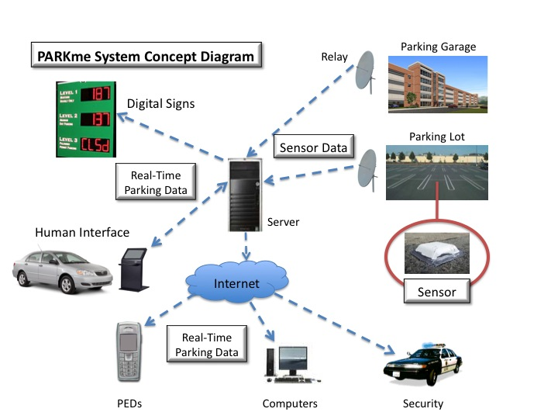

Figure 1.3-1 – The PARKme System Concept Diagram
2.0 APPLICABLE DOCUMENTS

PARKme System Proposal – Shaun McDonald

References
NSWC Dahlgren Division, Contract Statement of Work (SOW) Guidance.

NetLogo Website (http://ccl.northwestern.edu/netlogo/).

CORE Product Description (http://www.vitechcorp.com/products/workstation.html).
Colored Petri Net (CPN) software.

3.0 SYSTEM REQUIREMENTS

3.1 Functional Requirements

PARKme shall provide the following functional capabilities:

3.1.1 Software

The system shall consist of proprietary software to allow the following functionality:

3.1.1.1 Space Inventory

The system shall maintain an inventory of all parking spaces and flag them as occupied or unoccupied an update on a real time basis.

3.1.1.2 Optimization

The system shall contain algorithms to distinguish which available spaces are the best based on user preferences and destinations.

3.1.1.3 Unusable Spaces

The system shall provide a method for setting a space as out of service.

3.1.1.5 Time

The system shall maintain and track the amount of time a user has occupied a space.

3.1.1.6 Historical Data

The system shall maintain historical data of parking activities in order to provide usage information.

3.1.1.7 Graphical User Interface (GUI)

The system shall provide a GUI for the programming of the system which includes parking space layout as well as providing an interface for interacting with the PARKme software.

3.1.2 Security

The system shall provide security to include:

3.1.2.1 System

The system shall provide security to prevent intruders from accessing or tampering with the PARKme system.

3.1.2.2 Monitoring

The system shall provide equipment to monitor parking spaces and report them as empty or occupied.

3.1.2.3 Unusable Spaces

The system shall provide customers with a means to allow them to report unusable spaces.

3.1.3 Input Requirements

The system shall provide multiple input methods. The input methods include the following:

3.1.3.1 Card Reader Interface

Shall provide an interface to communicate with GMU identification cards

3.1.3.2 Software

The system shall be accessible using a standard QWERTY keypad.

3.1.4 Output Requirements

3.1.4.1 Reports

The system shall provide the following output reports. The system shall be capable of providing these reports through both a hard copy (printed) as well as a soft copy (files stored on a media device).

3.1.4.1.1 Usage Report

The system shall provide usage reports that can be broken down by time of day, day, week, month and year.

3.2 Non-Functional Requirements

3.2.1 Mean Time Between Failures (MTBF)

The system shall experience no more than one (1) failure for every 96 hours of use, where a failure is defined as an event in which a reset of the computers is required or where a space’s occupancy is misidentified for more than five consecutive updates.

4.0 SCHEDULE

4.1 Period of Performance

The period of performance shall be 28 August 2008 to 12 December 2008.

4.2 Major Milestones

DATE | DESCRIPTION
28 August | Project Proposal
18 September | Status Report 1
25 September | Preliminary Architecture and Schedule Status Report
02 October | Formal Architecture and Schedule Report
20 November | Dry Run of Final Presentation
12 December | Formal Project Presentation

5.0 TRAVEL

The project team shall travel as required to perform this task order. The following travel is anticipated during the period of performance of this task order:

Destination | # of Trips | # of Days | # of Personnel | Type of Meeting
GMU | 1 | 1 (12 Dec) | 5 | Final Project Briefing

6.0 MATERIALS

CORE student licenses shall be furnished by GMU. NetLogo licenses are freely available to the public. CPN is also freely available.

7.0 LIST OF DELIVERABLES

- PARKme Statement of Work (SOW)
- PARKme Concept of Operations (CONOPS)
- PARKme System Requirements Specification (SRS)
- PARKme Stakeholder Analysis Report
- PARKme Analysis of Alternatives (AoA)
- PARKme System Engineering Management Plan (SEMP)
- PARKme Risk Management Plan (RMP)
- PARKme System Design Document (SDD)
- PARKme Technology Strategy
- PARKme Business Case
- Any Documentation Concerning Modeling and Prototypes
- PARKME Final Presentation
- PARKME Final Report

APPENDIX A – ACRONYMS

The following are acronyms used in this document:

AoA – Analysis of Alternatives
CONOPS – Concept of Operations
COTS – Commercial-off-the-Shelf
GMU – George Mason University
GUI – Graphical User Interface
MTBF – Mean Time Between Failures
RMP – Risk Management Plan
SDD – System Design Document
SEMP – System Engineering Management Plan
SOW – Statement of Work
SRS – System Requirements Specification
WBS – Work Breakdown Structure

