OR 680/SYST 798 SENIOR

RESEARCH PROJECT

PROGNOS FINAL REPORT

Integration Strategy for PROGNOS

Knowledge Exchange Module Interfaces

(ISP-KEMI)

Date: May 07, 2010

Sponsor: Dr. Paulo Costa & George Mason University (GMU)

PROGNOS Development Team

By: PROGNOS Team

Richard Rockweiler

Nhan Nguyen

Lisa Kim

Cheol Young Park

_____________________________________________________________________________________

Department of Systems Engineering and Operations Research

George Mason University

Fairfax, VA 22030-4444

Version Modification Table

|  |  |  |  |
| --- | --- | --- | --- |
| **Version** | **Date** | **By** | **Comments** |
| 0 | 03/28/10 | Nhan Nguyen | Initial Outline |
| 1 | 04/28/10 | Nhan Nguyen | Draft |
| 2 | 04/29/10 | Young Park | Added Simulation Section |
| 3 | 05/01/10 | Richard Rockweiler | Revised and filled in information for missing sections |
| 4 | 05/01/10 | Lisa Kim | Added Ontology Section and feedback from the team |
| 5 | 05/07/10 | Richard Rockweiler | Added Dr. Laskey’s feedback |
|  |  |  |  |

EXECUTIVE SUMMARY

The PROGNOS Knowledge Exchange Module (KEM) team has been tasked by the George Mason University, Department of Systems Engineering and Operations Research, C4I, to provide a system engineering approach to integrate FORCEnet’s Command and Control (C2) and Intelligence Surveillance and Reconnaissance (ISR) systems to the predictive naval situation awareness system, PROGNOS. FORCEnet is future Navy implementation of Network Centric Warfare, comprised of many Navy C2 and ISR systems and systems of systems. PROGNOS is designed to bridge “stovepiped” systems from data interchange to knowledge interchange and is divided into five different modules: Reasoning, Knowledge Storage, Knowledge Management, Knowledge Exchange, and Simulation. The team will focus on the PROGNOS Knowledge Exchange module which will be the primary interface to external systems.

Due to the quantity and complexity of the systems that PROGNOS is required to interoperate with, the team narrowed down our external systems to two: the Distributed Command Ground System – Navy (DCGS-N) and the Net Enabled Command Capability (NECC) system. The DCGS-N is the fleet variant of the Department of Defense (DoD) DCGS Family of Systems that provides integration of ISR support capabilities previously accessed from a variety of stand-alone systems. The NECC system, formerly known as the Global Command and Control Family of Systems, is the next generation DoD C2 system. Global Command and Control System-Maritime’s (GCCS-M) objective is to satisfy Fleet C4I requirements through the rapid and efficient development and fielding of C4I capability.

Using the Vee System Engineering model, a common and widely used system engineering approach, the team has developed a System Requirements Document (SRD) that captures the sponsor’s originating requirements and the team’s derived functional, interface, and performance requirements. The team has also developed SysML architecture diagrams that depict some DODAF operation and system views. We have developed requirements and architecture which fed into the System Requirements Document (SRD) and the Interface Control Document (ICD). The ICD describes the systems that the Knowledge Exchange Module must interface with and defines the interfaces. To verify and validate the requirements and the KEM, we provided a detailed scenario walkthrough for architecture verification and validation and a simulation that translates simulated DCGS-N XML message to PROGNOS ontology to verify key XML related requirements and validate the DCGS-N interface approach.

The KEM team’s scenario and simulation only provides a limited verification and validation. To fully integrate PROGNOS with FORCEnet, the system Vee approach has to be applied many times for other external systems with different standards and formats. The PROGNOS team suggests that the Department of System Engineering and Operation Research continue our work and further define other types of external system interfaces by repeating our approach.

TABLE OF CONTENTS

1 INTRODUCTION 7

2 BACKGROUND 8

2.1 FORCEnet Overview 8

2.2 PROGNOS Overview 10

2.2.1 Reasoning Module 11

2.2.2 Knowledge Management Module 11

2.2.3 Knowledge Storage Module 11

2.2.4 Simulation Module 11

2.2.5 Knowledge Exchange Module 11

2.3 Ontology 13

2.3.1 JC3IEDM 14

2.3.2 UCore 14

2.4 Metadata 15

2.5 Taxonomy 15

3 Purpose 15

4 Sponsor 15

5 Sponsor Problem Statement 16

6 Scope 16

7 Assumptions 16

8 Limitations 16

9 Technical Approach 16

9.1 Sponsor Needs 17

9.2 Develop and Analyze Requirements 17

9.3 Develop Architecture 18

9.4 Interface Control Document 18

9.5 Verification and Validation 18

9.5.1 Operational Scenario Walkthrough 18

9.5.2 Knowledge Exchange Module (KEM) Simulation 19

10 Conclusion 22

11 Recommendation for future work 22

12 Acknowledgement 22

13 Selected References 22

Appendix A – System Requirements Document 23

Appendix B – System Architecture 24

Appendix C – Interface Control Document 25

TABLE OF FIGURES

Figure 1 – Problem we are facing today 8

Figure 2 – PROGNOS and FORCEnet Integration Diagram 10

Figure 3 – PROGNOS block diagram 12

Figure 4 – Ontology Definition Diagram 13

Figure 5 – The “Vee” system engineering process model 17

Figure 6 – Scenario Activity Diagram 19

Figure 7 – KEM Simulation Process 20

Figure 8 – KEM Simulation 21

# INTRODUCTION

Today we are living in an era called the “Information Age”, an era where information is a necessity for countries and serves as a measure of political power. Information is also a status symbol and provides recognition and placement in society. The demand for increasing information has given rise to technological advancement, resulting in the development of more and more complex systems to meet this demand. The Department of Defense and the United States Navy have taken advantage of the information age and have developed systems for each unique warfighter functional area to include Command and Control (C2); Intelligence, Surveillance, and Reconnaissance (ISR); and Logistics. The systems and the sensors connected to these systems generate a vast amount of information that is overwhelming the warfighter and the warfighter is having major challenges in converting the vast amount of data into knowledge and actionable intelligence. The systems were acquired and planned in a disjointed fashion resulting in “stovepipe” systems, custom designed for a specific purpose. The systems serve their defined purpose; however, since they were developed in a divergent fashion, sharing data between these systems is a significant technical challenge due to incompatible message formats and protocols. To improve operational efficiency and accelerate the decision cycle, the Navy must bridge the stovepipes and improve data and information interoperability. Compounding this challenge and contributing to the “fog of war” is the vast amount of data that must be processed to convert data to information and eventually to knowledge. FORCEnet and the network operational constructs from the other services such as Constellation C2 (Air Force) and LandWarNet (Army), need to bridge the “stovepipes” and convert the vast amount of data available to any combatant commander to actionable intelligence and enhanced situation awareness. To address the interoperability issues, a system is needed to address incompatibility among different systems’ protocols, messages format, and security levels. The PROGNOS Knowledge Exchange Module will provide the bridge between the incompatible protocols and message formats. The PROGNOS system, as a whole, will use a probabilistic ontology based on UCore to deterministically analyze the vast amounts of data to create the vital knowledge and actionable intelligence. Figure 1 illustrates the U.S. Navy plans for transitioning the systems of today to a web centric common operating environment.

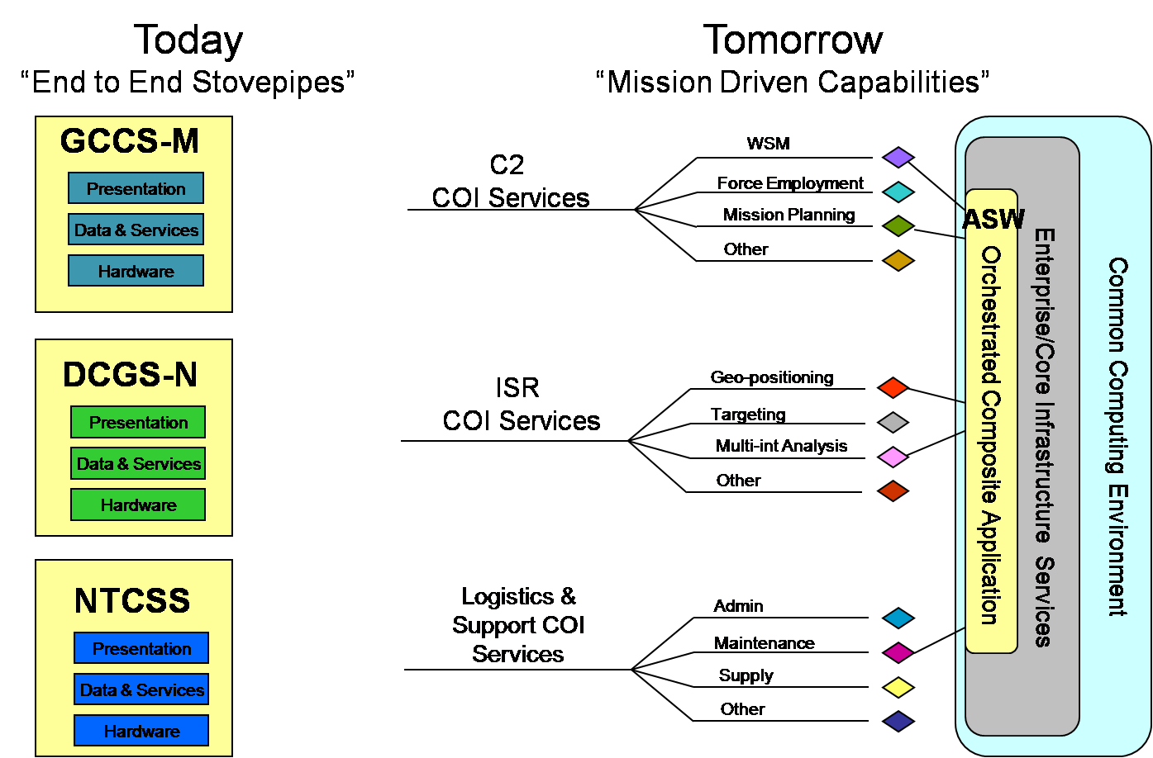[1]

Figure 1 – Problem we are facing today

# BACKGROUND

This section provides the background information on PROGNOS. An overview of FORCEnet and PROGNOS is presented in this section as well as definitions of ontology, metadata, taxonomy, JC3IEDM, and UCore.

## FORCEnet Overview

FORCEnet is the US Navy/US Marine Corps alignment and integration effort for three major elements: (1) Department of Navy Transformation, Joint Interoperability, and Network Centric Warfare; (2) Innovation, demonstration, testing, and assessment to achieve Chief of Naval Operations’ (CNO) goal of “Speed to Capability”; (3) Operational requirements, architectures, standards, compliance, and oversight of Naval programs to achieve Joint War-fighting capability.[2] FORCEnet is an operational construct composed of multiple different automation systems, network infrastructure systems, and telecommunications systems provided by multiple Navy program offices and contractors. It is not a homogenous network or program; rather it serves as a framework to define the Navy tactical network and to define the policies to support standards development, compliance, and interoperability. FORCEnet connects diverse automation systems that support multiple battlespace functions to include Intelligence, Surveillance, and Reconnaissance (ISR); operational Command and Control (C2); and logistical functions. These systems are connected via multiple transmission systems to include satellite, Line of Sight (LOS) radio systems, and fixed telecommunication infrastructure. The automation systems, network infrastructure, and transmission systems are supported by multiple Navy programs that were acquired and planned in a disjointed fashion resulting in “stovepiped” systems, custom designed for a specific purpose. The systems serve their defined purpose; however, since they were developed independently without consideration of interoperability, sharing data between these systems is a significant technical challenge due to incompatible message formats and protocols.

## PROGNOS Overview

PROGNOS, a system for Predictive Naval Situation Awareness currently being developed at George Mason University’s C4I Center, is a project to improve situation awareness for the U.S. Navy and to “enable predictive analysis with principled hypothesis management”[3]. “PROGNOS will integrate four state-of-the-art enabling technologies into a distributed system architecture that represents domain knowledge as a modular collection of probabilistic ontologies, combine these “knowledge nuggets” dynamically into complex situation models, and apply theoretically sound, computationally efficient hypothesis management and inference to combine evidence and background knowledge to reason about the current situation. PROGNOS will also interoperate with other FORCEnet systems by interacting via semantically enabled services.”[4] Figure 2 illustrates the data interoperability required between PROGNOS and FORCEnet. Their interface is shown as a handshake from the Knowledge Exchange Module to any systems among the FORCEnet Peers.

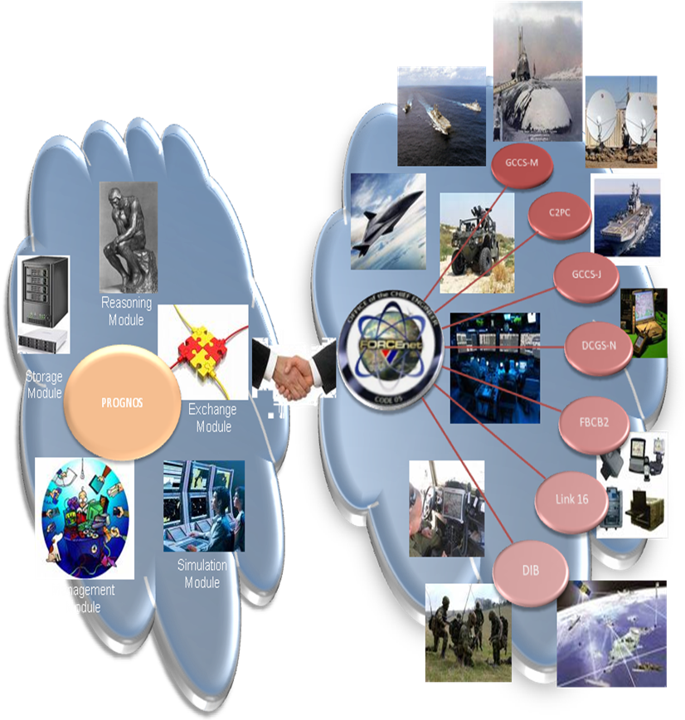

Figure 2- PROGNOS and FORCEnet Integration Diagram

To ensure data interoperability, PROGNOS must understand the messages being sent by FORCEnet systems and vice versa. The Knowledge Exchange Module must translate for the different protocols and message formats and standards used by the different FORCEnet systems. FORCEnet systems use multiple formats to include XML, ontologies, Variable Message Format (VMF), United States Message Text Format (USMTF), and Tactical Data Link (TDL) based systems.

PROGNOS is broken down into five essential modules responsible for different system functionalities and different capabilities.

### Reasoning Module

The Reasoning Module is the heart of the PROGNOS System. “It is composed of a Multi-Entity Bayesian Network (MEBN) reasoner that interacts with the other modules and coordinates the execution of Situation-Specific Bayesian Network (SSBN) construction, which includes interleaved hypothesis management and inference…”[5]

### Knowledge Management Module

The Knowledge Management Module is the brains of the PROGNOS System. The Knowledge Manage Module “… is responsible for understanding the situation at hand and defining how to proceed in face of a situation.”[6] “The module contains a set of probabilistic ontologies that capture domain knowledge...”[7] The Knowledge Management Module is comprises of two libraries – a Task-Specific Probabilistic Ontology and a Task-Neutral Probabilistic Ontology. The Task-Neutral Probabilistic Ontology contains knowledge applicable to any task. The Task-Specific Probability Ontology contains knowledge specific to a particular task.

### Knowledge Storage Module

The Knowledge Storage Module stores the entities and attributes necessary to implement the PROGNOS probabilistic ontology. “...every track and its respective data are stored within a schema based on and dynamically linked to the PROGNOS system’s MPO (Main Probabilistic Ontology).”[8]

### Simulation Module

The Simulation Module supports computerized military exercises, operation simulation, and “what-if” scenario planning. The simulation module “… sends geographical data (coordinates, known or probable) and status (friend, foe, unknown, etc.) of fictitious entities that are going to be used to evaluate the system’s response”[9].

### Knowledge Exchange Module

The Knowledge Exchange Module external system interfaces include FORCEnet and other platform’s sensors and tactical C2 systems. It provides the translation for any systems that do not follow the PROGNOS message standards or protocols. Figure 3 illustrates the Knowledge Exchange Module as the translator block in the middle between PROGNOS and the five categorized systems. The FORCEnet systems and its peers will fall under one of these five types of systems -- ontology based systems, XML based systems, VMF based systems, USMTF based systems and TDL based systems.



Figure 3 – PROGNOS block diagram

#### Ontology Based System

Future ontology systems may send messages via a XML, RDF, and OWL formatted messages. Using a Web Ontology Language (OWL) based communications assumes some common ontological structure between OWL and some other ISR or C2 system. Lower layer transport mechanisms will be IP/TCP/HTTPS/SOAP. As will be part of our assumption is that the Net Enabled Command and Capability system will be implemented and transition to an ontology based system.

#### Extensible Markup Language (XML) based system

An XML based system would be any system that uses XML formatting as a means of transporting data from one system to the other. Messages will be formatted in accordance with DDMS and Community of Interests (COIs) defined in the DoD Metadata Registry. Lower layer transport mechanisms will be IP/TCP/HTTPS/SOAP. We are assuming, based on DoD documentation, that Distributed Command and Ground System – Navy (DCGS-N) and NECC will be XML communication based systems.

#### Variable Message Format (VMF) based system

To support connectivity with Army and Marine Corp ground force Blue Force Tracking systems, PROGNOS will need to interact with VMF based systems. VMF is a binary encoded format defined by MIL-STD-6017. VMF is used by Force Battle Command Brigade and Below (FBCB2) and Advanced Field Artillery Tactical Data System (AFATDS) among other systems.

#### United States Message Text Format (USMTF) based system

Formal reports and guidance in DoD are published in the USMTF format. USMTF is a text format defined by MIL-STD-6040. To receive intelligence analysis reports, PROGNOS must support USMTF.

#### Tactical Data Link (TDL) based system

TDL refers to a series of standards primarily used by aircraft for Position Location Information tracking and sometimes communication. The most common one currently in use is Link-16/TADIL-J. TADIL-J is used for aircraft tracking; however, it can support more than aircraft tracking to include Position, Location Information (PLI) reporting and voice communications.

## Ontology

An ontology is a formal representation of the knowledge by a set of concepts within a domain and the relationships between those concepts as the DoD 8320.2-G defines. As shown by Figure 3, ontology describes a specific domain of knowledge. The domain of knowledge is modeled by a conceptualization that consists of classes (or sets), attributes (or properties), and relationships (or relations among class members). The conceptualization, in turn, is specified by the ontology.

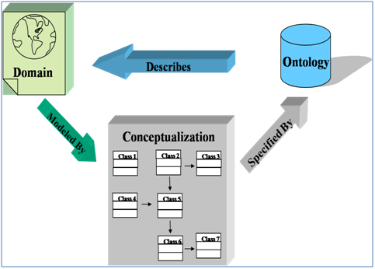[10]

Figure 4. Ontology Definition Diagram

Ontologies not only model the information in a domain, but also provide a deterministic logic so that automation systems can automatically categorize the data and analytical results based on the attributes and relationships between classes. The ontology conceptualization is the critical component that enables a computer to deterministically create knowledge from data.

In the scope of knowledge exchange, there are three linguistic levels of information exchange – syntactic, semantic, and pragmatic. First, in the syntax level, the sender and receiver system can have same rules or constructing and transmitting message. Second, in the semantic level, both sender and receiver system can not only have common rules governing composition and transmitting of message but also assign and share the same meaning. Therefore, they derive the same inferences from the same information. Third, in the pragmatic, both sender and receiver system can agree how information in message get to be used. The team project focused on the first two levels. A common understanding helps support consistent treatment by both humans and software agents of the information associated with a domain.[11] In short, the role of ontology is to enable data to be understandable between systems and to support data interoperability in part of DoD Net-Centric Data Strategy goals.

The term Community of Interest (COI) refers to “collaborative groups of users who must exchange information in pursuit of their shared goals, interest, missions, or business processes and who therefore must have shared vocabulary for the information they exchange.”[12] A COI vocabulary is to “provide a standard framework for exposing COI data to various systems and users to perform monitoring, operations, analysis, or other activities.”[13] According to DoD Net-Centric Data Strategy, COIs will be encouraged to develop an ontology that best reflects the community understanding of their shared data. Any community that establishes ontology expressed in XML schema will publish to the DoD Metadata Registry to increase understanding across the Enterprise and promote possible reuse.[14]

### JC3IEDM

The Joint Consultation, Command and Control Information Exchange Data Model (JC3IEDM) is a North Atlantic Treaty Organization (NATO) standard that defines NATO coalition interoperability via an XML defined schemas. JC3IEDM is a common specification for C2 data to be exchanged. JC3IEDM enables an automated exchange of data and connects C2 databases. Support of the JC3IEDM schema will be critical to support NATO interoperability. However, NECC and DCGS-N do not appear to be using the JC3IEDM schema and are basing their approach off of UCore, DoD Discovery Metadata Specification (DDMS), and Community of Interest (COI) schema. For PROGNOS to communicate with NATO coalition systems, the Knowledge Exchange Module will need to support a JC3IEDM translator.

### UCore

Universal Core (UCore) is a federal information sharing initiative that supports the National Information Sharing Strategy and all associated Departmental / Agency strategies. UCore enables information sharing by defining an implementable specification (XML Schema) containing agreed upon representations for the most commonly shared and universally understood concepts of who, what, when, and where. UCore is based on three primary standards – the DoD Discovery Metadata Specification, the Intelligence Community Information Security Marking (IC-ISM), and the Geographical Markup Language (GML). DDMS provides enterprise level data discovery. The IC ISM provides security related metadata for trusted net-centric accessibility. Geography Markup Language (GML) is the XML grammar defined by the Open Geospatial Consortium (OGC) to express geographical features. GML serves as a modeling language for geographic systems as well as an open interchange format for geographic transactions on the Internet.

## Metadata

Metadata is defined as data about data. In the context of semantic web approaches, it is XML schemas that define the tags that enable data definition. In most cases, the tags define the purpose for the specific data entries; however, the metadata can describe other information such as creation data, data creator, and applicable data standards.

The DoD Net-Centric Data Strategy (NCDS) and Directive 8320.2 require data sharing across the DoD, including the use of metadata.

*Data assets shall be made visible by creating and associating metadata (“tagging”), including discovery metadata, for each asset. Discovery metadata shall conform to the Department of Defense Discovery Metadata Specification (reference (d)). DoD metadata standards shall comply with applicable national and international consensus standards for metadata exchange whenever possible. All metadata shall be discoverable, searchable, and retrievable using DoD-wide capabilities. [15]*

The Department of Defense Discovery Metadata Specification (DDMS) provides a metadata discovery standard to find relevant data. DDMS is an XML defined schema to query for needed information using metadata. Queries are against an enterprise catalog or a federated search engine hosted on the Defense Information System Agency’s Net Centric Enterprise Services (NCES) server infrastructure.

## Taxonomy

Taxonomy is a key component of ontologies and provides the categorization (relationship) of related items. They are hierarchical in portraying the relationships between items (classes). Taxonomies are crucial to ontologies to ensure that queries are targeted at the correct level of the taxonomy tree. Refer to the conceptualization block in Figure 4 for an example of taxonomy.

# Purpose

The purpose of the PROGNOS KEM project is to define the external systems interface for the PROGNOS Knowledge Exchange module, and provide an integration approach to integrate PROGNOS with FORCEnet.

# Sponsor

The sponsor of this project is Dr. Paulo Costa and the George Mason University’s System Engineering Operations Research department.

# Sponsor Problem Statement

A Systems Engineering approach is needed to integrate PROGNOS with FORCEnet due to the complexity of the multiple systems and systems of systems interfaces. This requires the team to identify integration challenges and propose a formal methodology to achieve integration.

# Scope

The KEM team will provide an interface definition for PROGNOS with XML communication based C2 and ISR systems. Additionally, the KEM team will provide an integration approach to integrate PROGNOS with Distributed Common Ground System-Navy (DCGS-N) and Net Enabled Command Capability (NECC).

# Assumptions

In order define the knowledge exchange module external interface with FORCEnet systems; the PROGNOS team made the following assumptions:

* DCGS-N will support XML/SOAP based communication
* NECC will be implemented and will transition to an ontology-based approach
* The external interface is focused only on FORCEnet systems

# Limitations

The KEM team faced some limitations. The primary limitation is that the PROGNOS system is still in the early stages of development and the internal PROGNOS ontology is not yet defined. Another limitation is that DCGS-N and NECC are still in the early stages of development. Some of the documentation used for the architecture, System Requirements Document (SRD), and Interface Control Document (ICD) may be overcome by future events.

# Technical Approach

The KEM team used the Vee systems engineering model approach. In our PROGNOS Vee model, we modified it to comprise of primarily two processes: the Definition and Decomposition process and the Verification and Validation Testing process. The first process includes four stages. The first stage is executed to understand the sponsor needs and develop originating requirements. The second stage is to analyze the originating requirements and derive system level requirements. The third stage is to develop architecture once we understood the sponsor needs and derived originating requirements. Finally, the fourth stage is to develop system specification, where we decided to develop an Interface Control Document (ICD). These stages do not have to occur in sequential order, but can be worked in parallel. The product of the Definition and Decomposition process will be the System Requirements Document (SRD), the system architecture diagrams, and the system Interface Control Document (ICD). The second process, the Verification and Validation Testing process, is a bottom up approach, where verification and validation test the lower level components first, then roll up to the system level and verify and validate the system. The KEM team provides verification and validation to the system via a detailed scenario walk through with a simulation demo demonstrating the feasibility of data exchange between PROGNOS and DCGS-N. Figure 5 below illustrates the PROGNOS systems engineering Vee model.

Figure 5 – The “Vee” system engineering process model

## Sponsor Needs

Through several meeting with our sponsor, the team captured the sponsor needs and problem statement. The sponsor needs are:

* Define external interfaces to the PROGNOS Knowledge Exchange module
* Provide an integration approach that will ensure successful integration of PROGNOS and FORCEnet

## Develop and Analyze Requirements

The team gathered 13 sponsor originating requirements. Through several iterations and exchanges with our sponsor, the team derived 47 additional system requirements. There are 60 total requirements. 6 are composite requirements, 37 are constraint requirements, 14 are functional requirements, and 4 are performance requirements.

The team followed the Vee model approach because it allowed the team to breakdown a complex system one layer at a time so it is more manageable. The requirements were developed and stored using the system engineer tool, CORE. More details on these requirements are documented in the System Requirements Document (SRD) in Appendix A.

## Develop Architecture

After the team analyzed the sponsor needs and originating requirements, the team developed several DoDAF operation views and system views along with several SysML diagrams.

Refer to the Appendix B for the architecture diagrams.

## Interface Control Document

As part of the system specification process, the team developed an Interface Control Document (ICD) that defined the interface with the DCGS-N and the NECC system. For more information and details on the ICD please refer to Appendix C.

## Verification and Validation

The team verified and validated the architecture and approach by conducting a detailed walkthrough of the scenario using a SysML flow activity diagram. The scenario provided the team with insight into what standards and formats that PROGNOS must interoperate with. The team also developed a JAVA simulation to provide verification of the XML based requirements and to provide a partial validation of the PROGNOS to DCGS-N interface.

### Operational Scenario Walkthrough

The scenario is listed below and the associated activity flow diagram is shown in figure 5.

1. Human Intelligence (HUMINT) report received about possible Weapons of Mass Destruction (WMD) in Oman. Information received via DCGS-N and originates from CIA. Anticipate message format being a XML formatted message IAW a schema defined in the DoD Meta-Data Registry.
2. UAV dispatched to confirm. UAV is tracked via NECC or alternatively tracked via Link-16.
3. UAV arrives to loiter and detects excessive radiation activity. UAV video via DCGS-N.
4. F18 fighter aircraft dispatched to bomb facility. F18 tracked via NECC (Link 16 feed).
5. BDA performed by spy satellite. BDA received via NRO satellite and received on DCGS-N.
6. Mission complete.

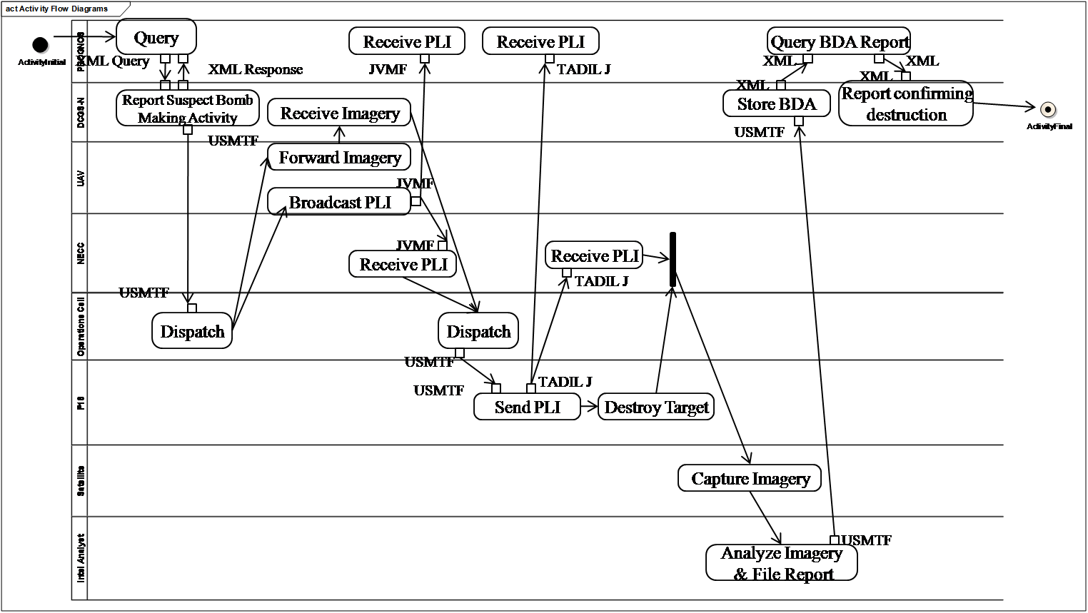

Figure 6 – Scenario Activity Diagram

### Knowledge Exchange Module (KEM) Simulation

The KEM simulation verified key XML requirements and partially validated the DCGS-N interface. Because of time constraints, the scope of the KEM simulation was limited. The simulation focused on just a single, simple query-response situation and the translation from XML to Web Ontology Language (OWL).

The simulation measured two key criteria -- interoperability and feasibility. We demonstrated interoperability to DCGS-N by implementing DCGS-N as accurately as possible by replicating standards and designs mandated by DCGS, UCore, DDMS, and ISR COI schema. We also demonstrated feasibility by partially implementing KEM and demonstrating interoperability with the DCGS schema.

Figure 7 – KEM Simulation Process

Figure 7 shows the KEM Simulation. To simulate KEM, four components are considered —the host system, KEM system, web server, and an external system. Host system is the PROGNOS UnBBayes-MEBN and serves as the reasoning module. KEM is the core of the simulation and will provide the message translation. The External system is the DCGS-N FORCEnet system. The fourth component is a web server which will transport OWL ontology information and XML.

The Host system generates a query message. The message moves from Host system to the KEM. The KEM changes the message into XML format. The KEM uses the web server to encapsulate the XML information into SOAP and HTTPS. The KEM generates a XML Query message for the external system (DCGS-N). The XML Query moves from KEM to DCGS-N. DCGS-N sends a XML response to the web server. The XML Response is sent to the KEM. The KEM changes the XML to PROGNOS core ontology so the PROGNOS Reasoning Module can understand.

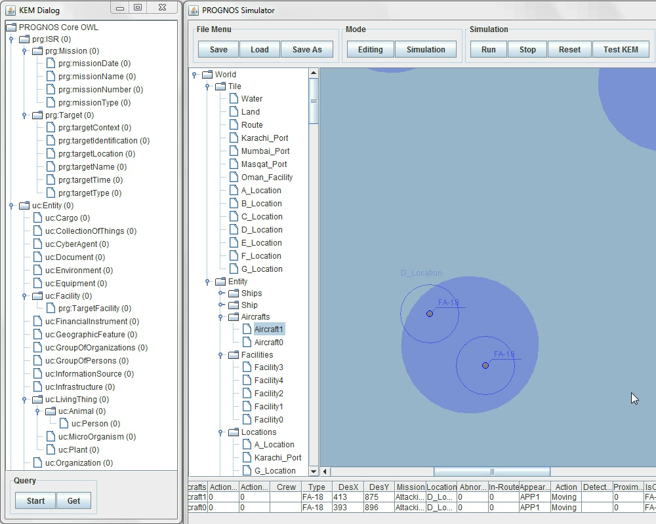

Figure 8 – KEM Simulation

Figure 8 shows the simulation. The left column of the screen is the Knowledge Exchange Module (KEM). In the KEM panel, there is a tree structure representing the PROGNOS core ontology. The right panel of the screen is the external, java simulated DCGS-N system. Below are the steps of the simulation.

1. From the right lower corner, two FA-18s are moving towards a target, a bomb making facility.
2. PROGNOS queries about a bomb making facility.
3. User clicks target entity on PROGNOS Core ontology.
4. User clicks “Start” button to query.
5. An information box appears to inform the user about “query starts” and “response received”. The simulation automatically changes the response into PROGNOS Core ontology.
6. User clicks the “Get” button. The information is transferred about the target from DCGS-N to PROGNOS KEM. As the PROGNOS is doing a query on the identified target, it receives the status of the target as “destroy”.
7. The simulation finishes.

# Conclusion

The KEM team provided an integration approach to integrate PROGNOS with DCGS-N and NECC. Additionally, we defined external interfaces for the PROGNOS Knowledge Exchange Module and delivered a system architecture, an Interface Control Document, a System Requirement Document, Simulation, Final Report, and a Project Website. The KEM team validated our integration approach through scenario analysis and simulation.

# Recommendation for future work

The KEM team recommends the following for future Knowledge Exchange Module work.

* Expand the analysis to incorporate other DoD COI schemas in addition to UCore
* Define VMF, TDL, and USMTF interfaces
* Implement SOAP interface
* Devise interface definition for the Naval Tactical Command Support System (NTCSS) logistics system

# Acknowledgement

The PROGNOS KEM team would like to extend our thanks to Dr. Paulo Costa and Dr. Kathryn Laskey, for their continuous guidance and direction throughout the semester.

# Selected References

The following are documentations and literature that is used for references and to gather necessary information for this project.

* Costa, Laskey, Chang. PROGNOS: Applying Probabilistic Ontologies to Distributed Predictive Situation Assessment in Naval Operations.
* Costa, K.B. Laskey, K.J. Laskey, Wright. Probabilistic Ontology for Net-Centric Fusion.
* FORCEnet: Official U.S. Navy Website, <http://forcenet.navy.mil/>.
* NESI:Net-centric Enterprise Solutions for Interoperability, <http://nesipublic.spawar.navy.mil/>.
* Vistology Website, <http://vistology.com/>.
* UCore website, <https://ucore.gov/>.

# Appendix A – System Requirements Document

# Appendix B – System Architecture

# Appendix C – Interface Control Document

1. Miller, Chris, “PEO C4I Overview and Way Ahead for AFCEA NOVA”, 5 April 2007, slide 13.
2. CNO N61R, “Navy Vision For FORCEnet To Support Joint Functional Capabilities, 22 April 2004.
3. George Mason University C4I Center / SEOR Department, “Probabilistic Ontologies for Net-Centric Operations Systems”, June 2009, slide 8.
4. Costa, Laskey, and KC Chang. “PROGNOS: Applying Probabilistic Ontologies to Distributed Predictive Situation Assessment in Naval Operations”, June 2009.
5. Costa, Laskey, Chang. PROGNOS: Applying Probabilistic Ontologies to Distributed Predictive Situation Assessment in Naval Operations, page 6.
6. Ibid, page 7.
7. Ibid, page 7.
8. Ibid, page 6.
9. Ibid, page 7.
10. Jessica De Steno, Rita Martin. “The Army Net-Centric Data Strategy USMTF Ontology, U.S. army Communications Electronics Command (CECOM LCMC) Software Engineering Center (SEC)”, November 2007.
11. Jessica De Steno, Rita Martin. “The Army Net-Centric Data Strategy USMTF Ontology, U.S. army Communications Electronics Command (CECOM LCMC) Software Engineering Center (SEC)”, November 2007.
12. Ibid
13. Ibid
14. Ibid
15. Department of Defense Directive 8350.2, April 23, 2007.